OPERATING SYSTEM

PROGRAMMING EXERCISE -1

NAGAVENI L G

PES2UG21CS315

F SEC

Write a program to create a child process which lists all the executing user process (avoid creation of zombie process)

Code:

#include <stdio.h>

#include <unistd.h>

#include <sys/wait.h>

int main() {

pid_t pid = fork();

if (pid == 0) {

// Child process

execlp("ps", "ps", "-ef", NULL);

} else {

// Parent process

waitpid(pid, NULL, 0);

}

return 0;

}

#include<stdio.h>

#include<unistd.h>

#include<sys/wait.h>

int main(){

pid_t pid =fork();

if(pid==0){

//child process

execlp("ps","ps","-ef",NULL);

}

else{

//parent process

waitpid(pid,NULL,0);

}

return 0;

}

OUTPUT

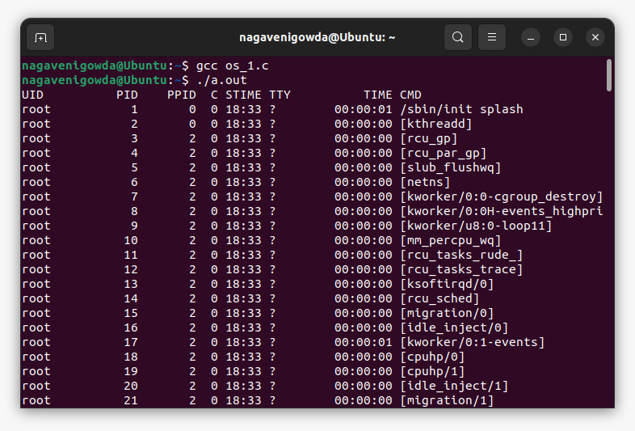

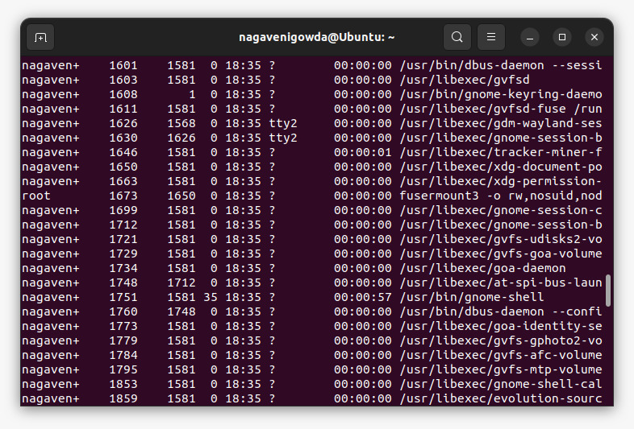

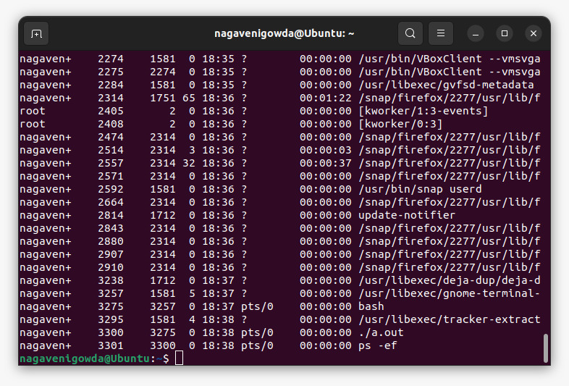

THANK YOU 😊