NAME : NAGAVENI L G

SRN : PES2UG21CS315

SEC :4F

PROBLEM STATEMENT:

Write a kernel module that lists all current tasks in a Linux system beginning from the **init** task. Refer to Chapter 2 in the text book (T1) for creating Linux kernel modules. Output the task name (known as executable name), state and process id of each task in a **tree** structure

SOLUTION:

1.Installing Linux Kernel Headers

To compile the kernel code ,linux headers which can be installed using following command

Install the kernel header files (already present in ubuntu)

(I used the first command)

1. sudo apt-get install linux-headers-$(uname -r) (If you are using apt)
2. sudo dnf install kernel-headers-$(uname -r) (If you are using dnf)

Installing Linux Headers

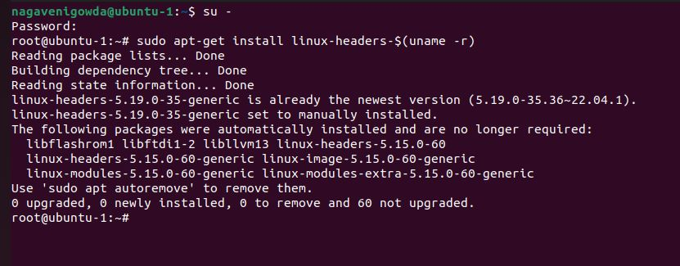

Installing make

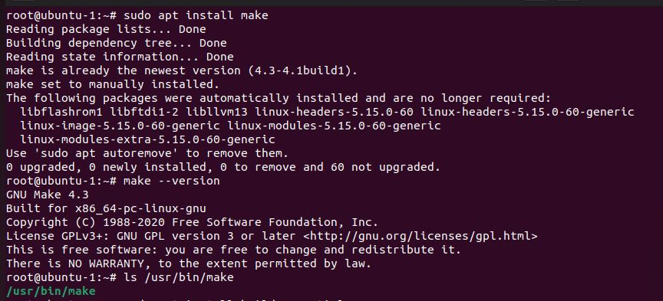

Installing build -essential---command is a package of essential tools and utilities that are required for building and compiling software

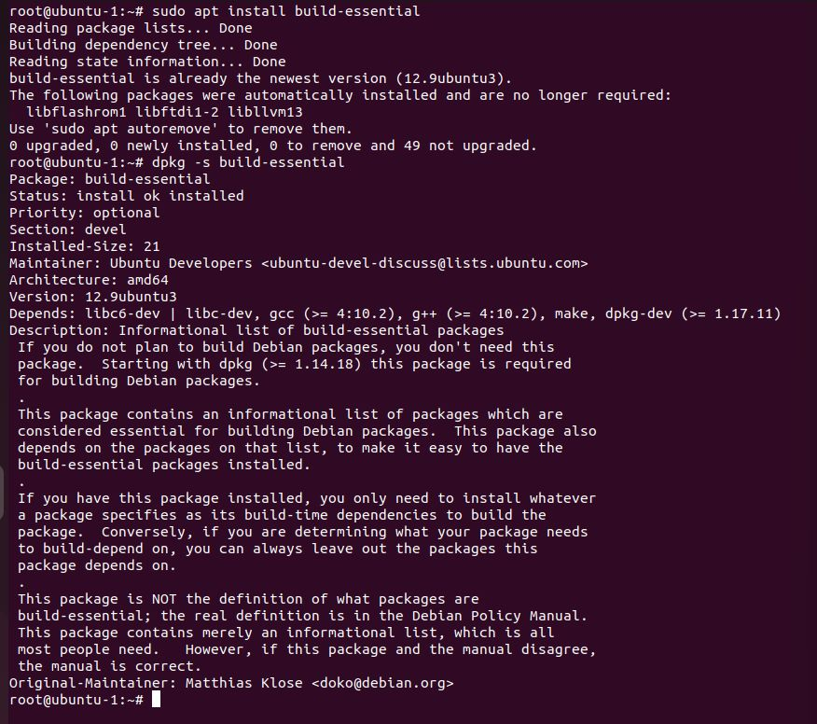

2.Creating a Makefile

mkdir OS

cd OS

make : compile kernel code using this command

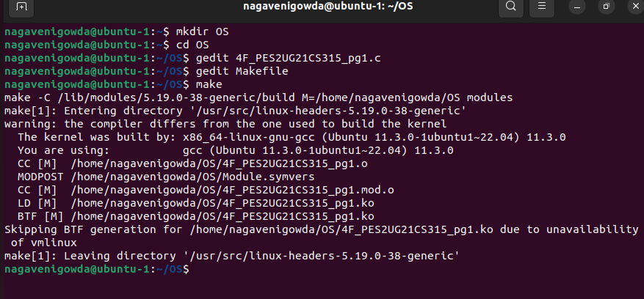

3.Write Some Code

gedit 4F_PES2UG21CS315_pg1.c

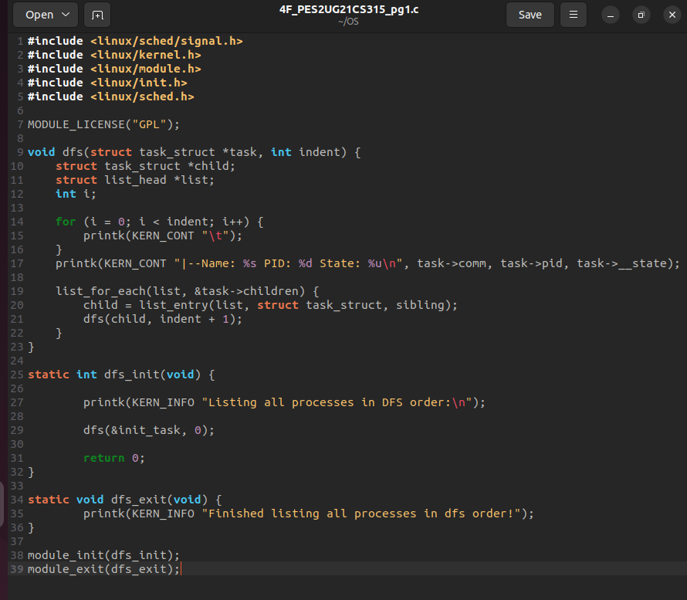

gedit Makefile

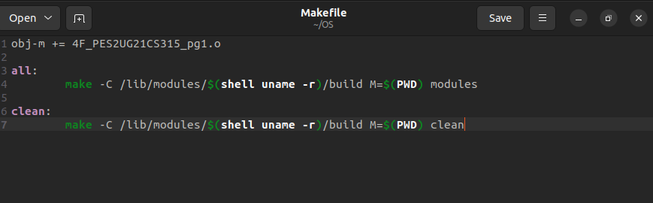

4 .Compile The Code

make

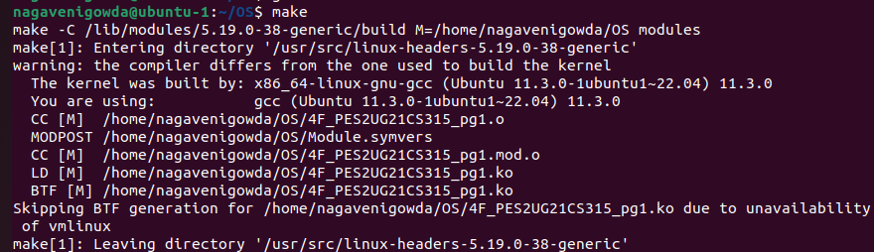

5.Screenshot of files which are created after compiling the code

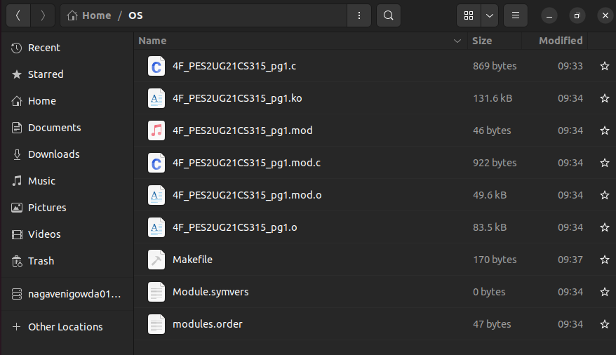

6.Loading The Kernel Module

sudo insmod my_module.ko

sudo dmesg

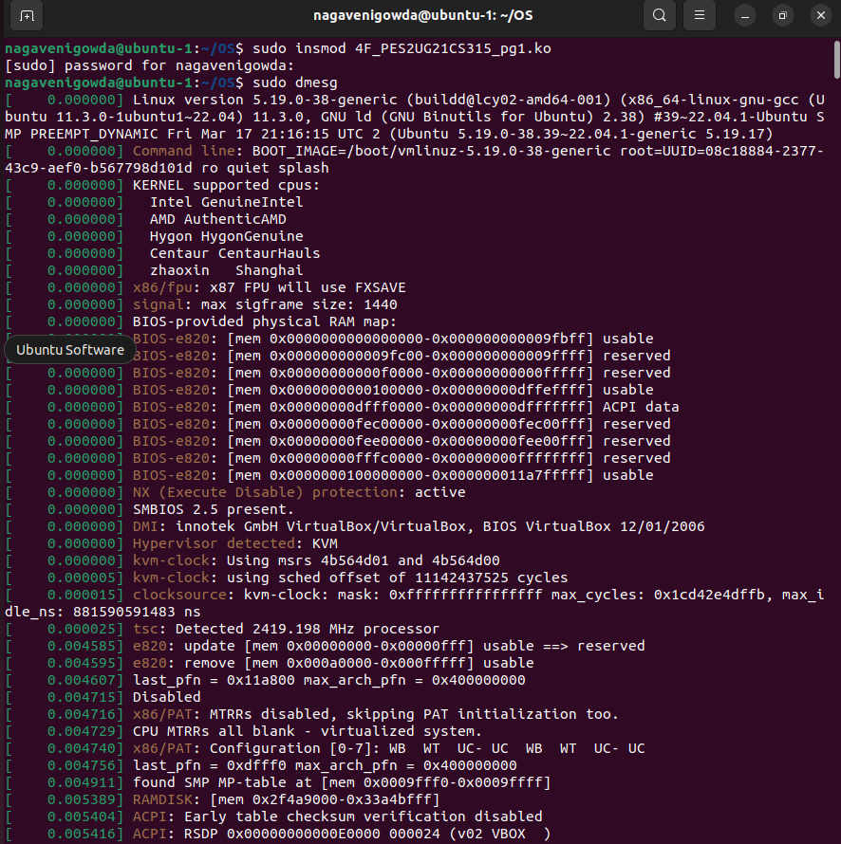

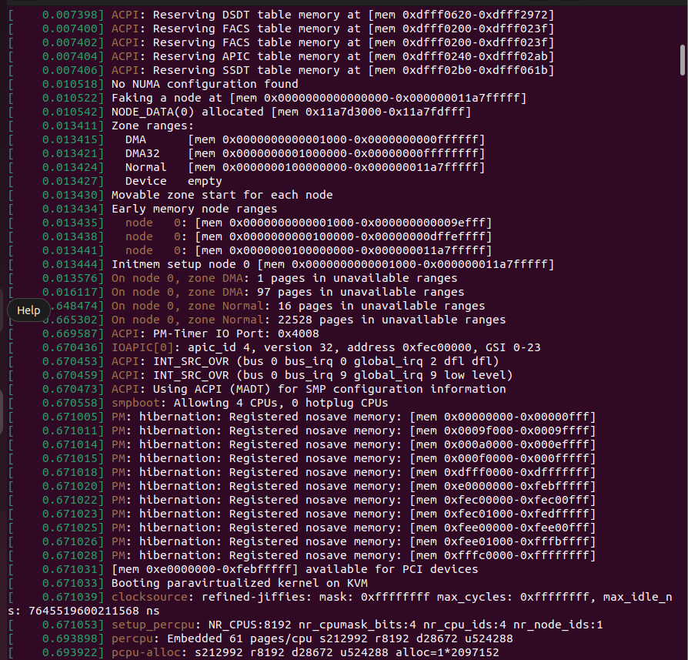

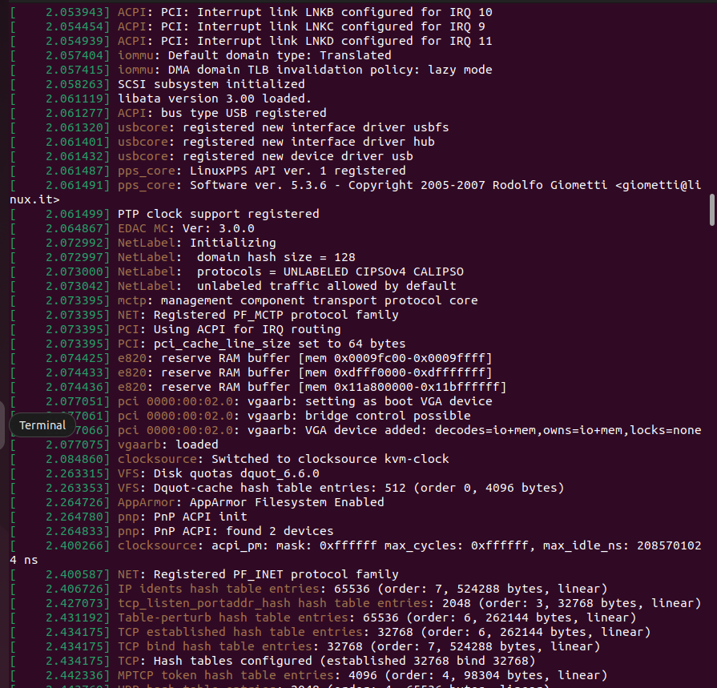

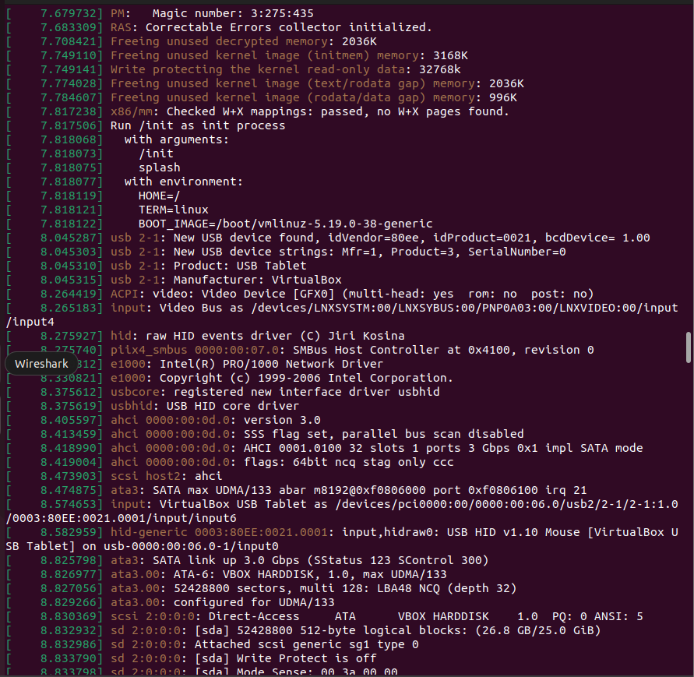

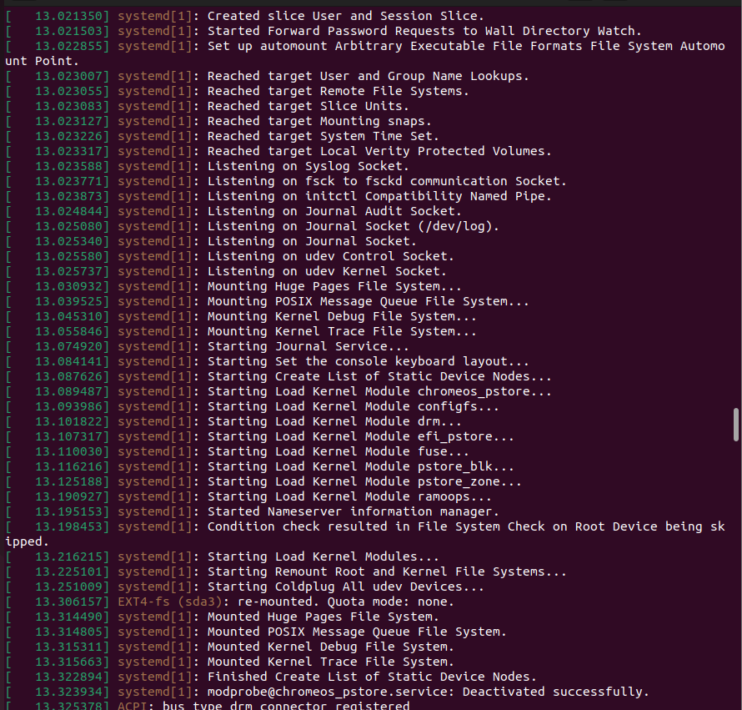

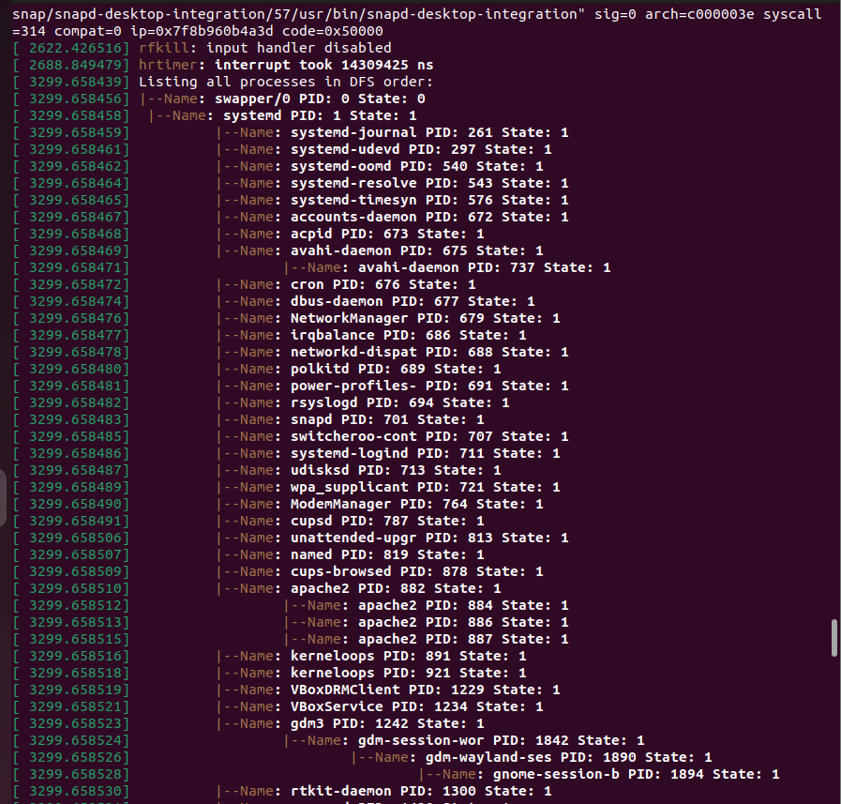

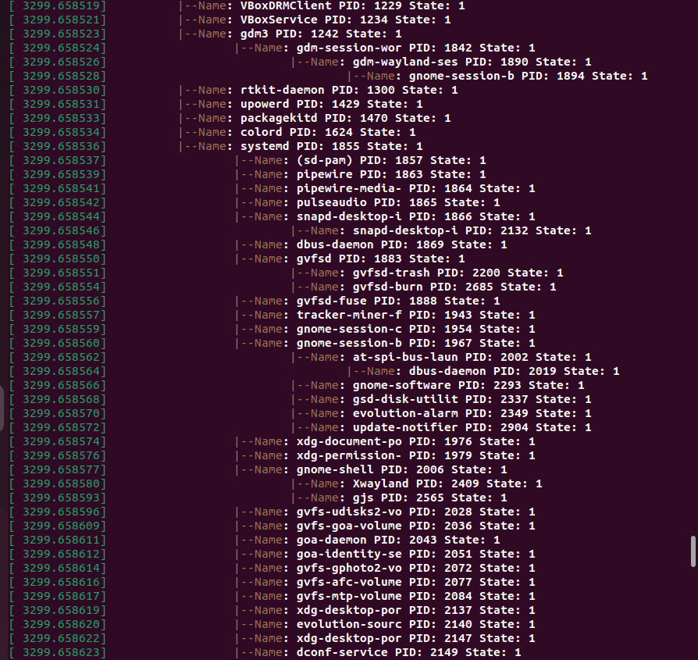

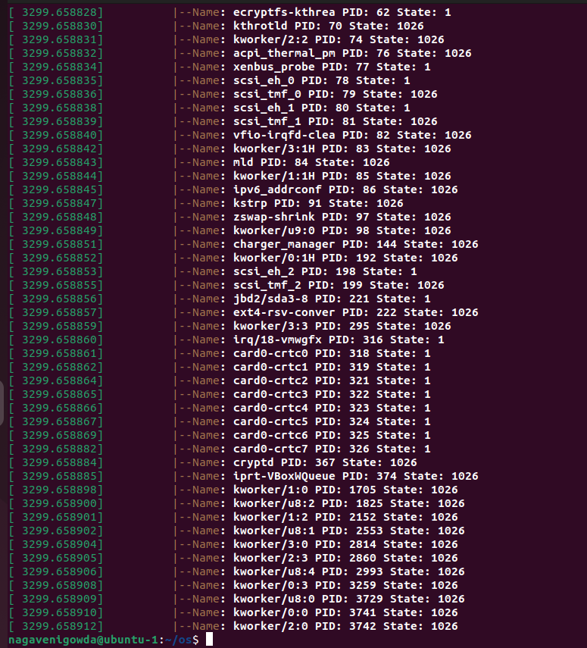

lsmod

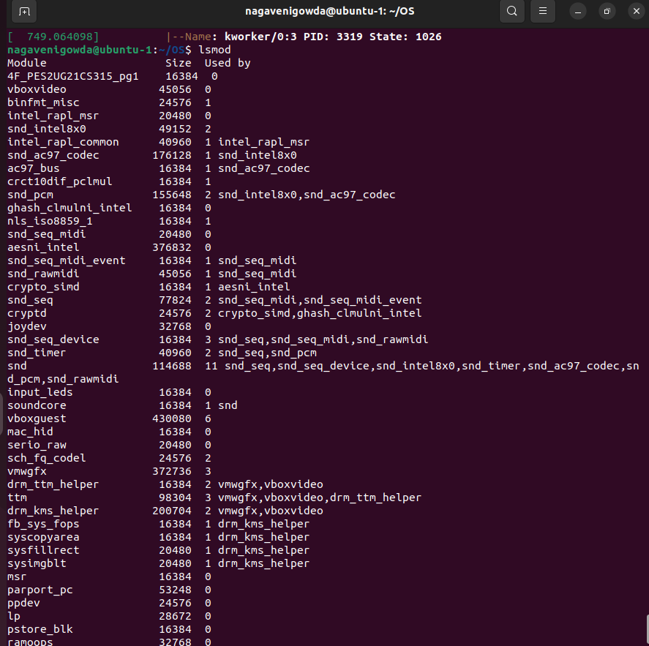

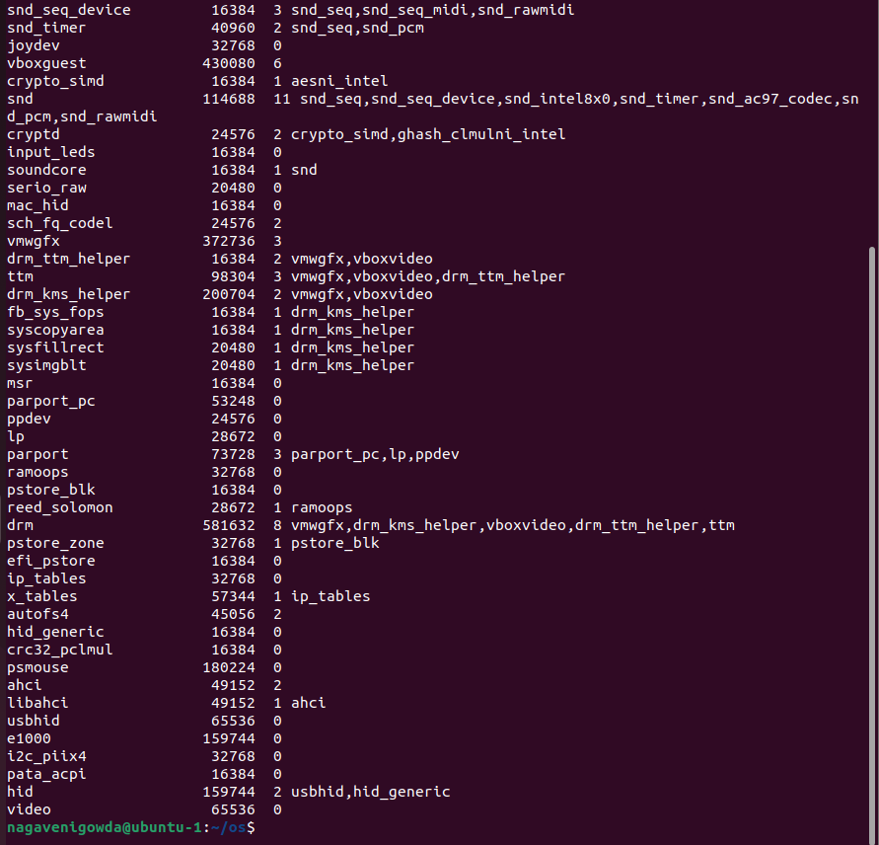

rmmod

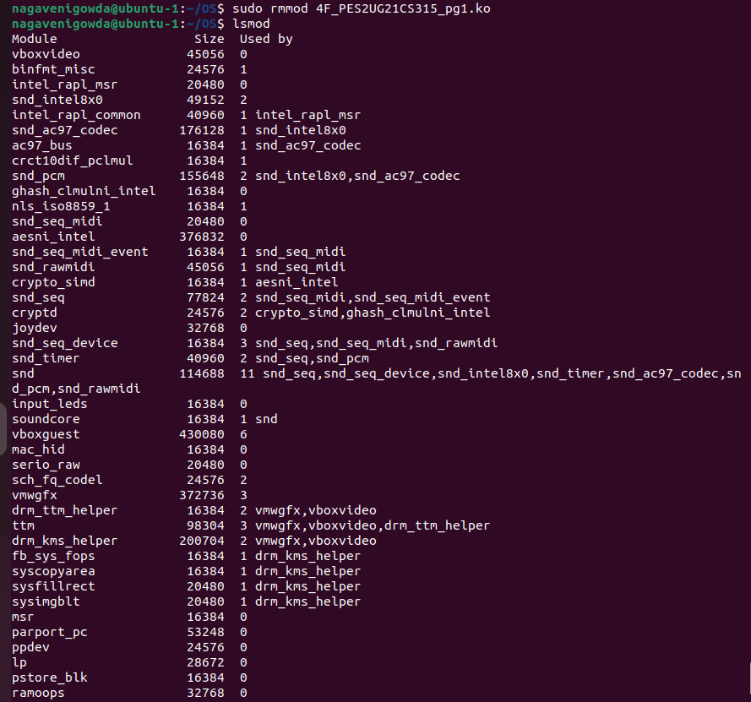

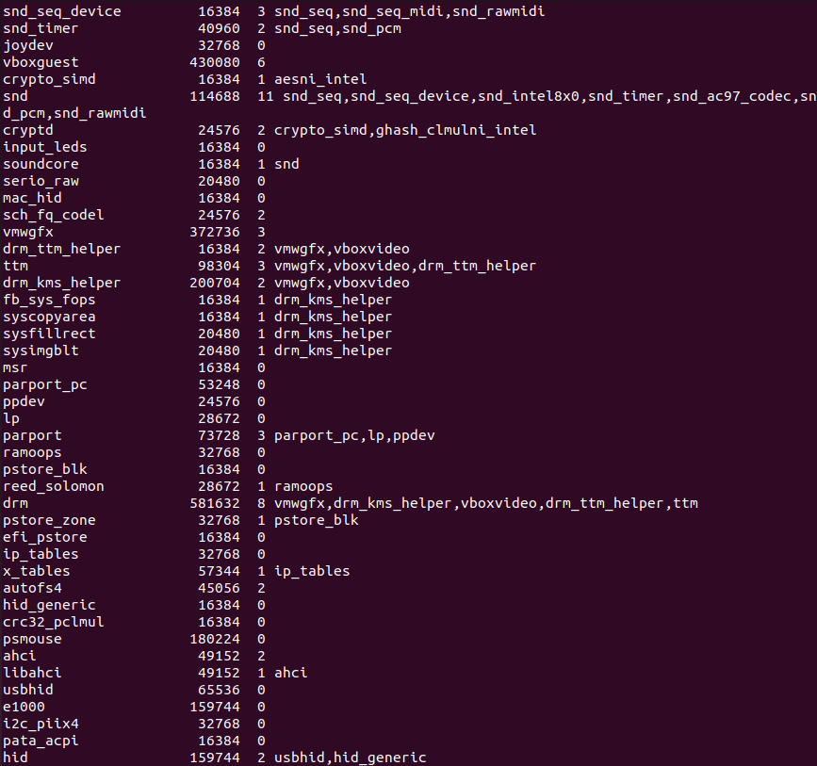

THANK YOU 😊