**UE21CS351A: Database Management System**

**USER REQUIREMENT SPECIFICATION OF**

**BLOOD BANK MANAGEMENT SYSTEM**

## **TEAM MEMBERS:**

NAGAVENI L G PES2UG21CS315

NAVYA H U PES2UG21CS325

# DATE OF SUBMISSION: 8 -10 -2023

**Table of Contents**

**ER DIAGRAM**

**RELATIONAL SCHEMA**

**1.Introduction**

* Purpose of the project
* Scope of the project

**2.Project Description**

* Project overview
* Major project functionalities

**3.System Features and Function Requirements**

* System Feature 1 (Description of feature and **Functional Requirement** **)
* System Feature 2 (Description of feature and **Functional Requirement** **) and so on.

\*\***Functional Requirement**: Primarily includes the entities involved and the necessary input required for execution of a particular feature.

**ER DIAGRAM**

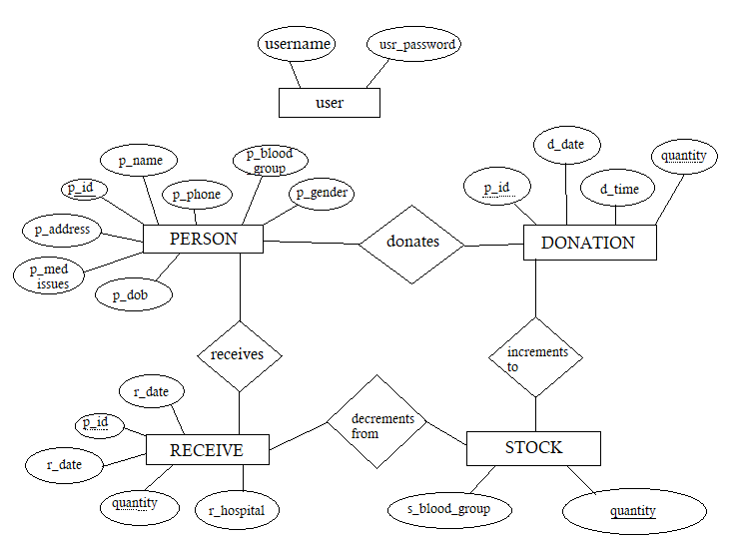

**RELATIONAL SCHEMA**

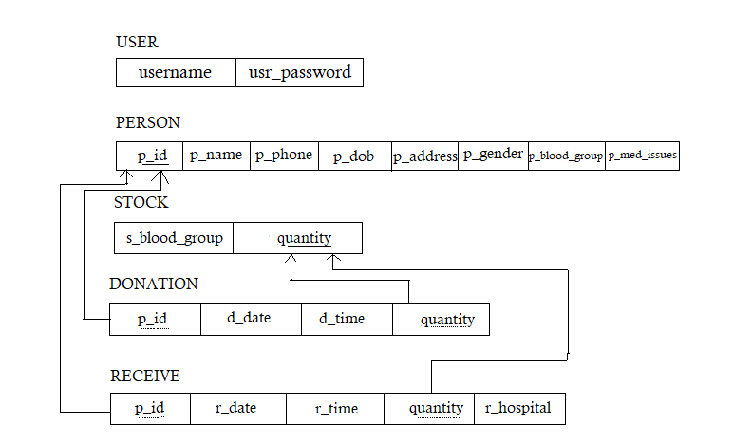

**1 . INTRODUCTION:**

***Blood Bank Management System*** (BBMS) is a crucial component of healthcare institutions, hospitals, and blood donation centers. It is essential for ensuring the availability, safety, and efficient distribution of blood and its components to patients in need. In the context of a Database Management System (DBMS), a Blood Bank Management System plays a vital role in organizing and managing vast amounts of data related to blood donations, inventory, donors, recipients, and more.

## **a Purpose of the project:**

The purpose of the Blood Bank Management System (BBMS) project is to develop a comprehensive and efficient software solution for managing all aspects of blood bank operations within healthcare institutions, hospitals, and blood donation centers. This project aims to enhance blood bank operations by automating processes, centralizing data, ensuring secure access, and optimizing resource allocation.

1. **b Scope of the project :**

The project scope covers the following components:

1. **Login Component**: Ensures secure access for authorized personnel.
2. **Person Componen**t: Centralizes personal details of donors and recipients.
3. **Donor Component**: Records donation information, including date, time, and quantity.
4. **Receiver Component:** Documents blood receipts, ensuring patient safety.
5. **Stock Component**: Provides real-time inventory monitoring for each blood group.

These components collectively create an efficient, secure, and user-friendly system for managing blood bank operations, improving patient care and simplifying blood bank tasks.

1. **PROJECT DESCRIPTION**
2. **a Project Overview :**

**Existing System**

Despite the immense technological advancement, blood bank systems use manual date for storing valuable data. Even it is time consuming to retrieve any data if required. Consequently, one of the major issues in blood bank systems, as talked in many articles and research papers it has lack of data security. People doubt whether their personal information and medical records are safely secured or not. Therefore our project aims to develop blood bank management system along with database security and encryption.

**Proposed System**

1. Admin/User has to login first.

2. All the personal details of the person is recorded and stored in the database. Admin can search for any personal details. He can retrieve any donation/receive history.

3. They can even have the complete information about the stock present in the blood bank.

1. Apart from this, we will be using concepts of database encryption to make sure that the person’s information is kept secure and confidential. This will help us keep their donation and receive records protected from any threats from individuals with potentially malicious intentions or unforeseen hazards to the security of the data.

**2.b Major Project Functionalities**

Here are the major project functionalities :

1. **Login Component**:

**Secure Authentication**: Provides secure access for authorized blood bank personnel through username and password authentication.

**User Roles**: Defines different user roles with varying levels of access and permissions to ensure data security and confidentiality.

1. **Person Component:**

**Donor and Recipient Profiles**: Allows the creation and maintenance of comprehensive profiles for both donors and recipients.

**Personal Details**: Captures and stores personal information, including contact details, medical history, and eligibility criteria.

1. **Donor Component:**

**Donor Registration**: Enables the registration of donors into the system with unique identification.

**Donation Record**: Records details of blood donations, such as donation date, time, and the quantity donated.

**Donation History**: Tracks and maintains a history of all donations made by each donor.

1. **Receiver Component:**

**Blood Receipt Recording**: Documents details of blood receipt, including the date, time, quantity, and information about the receiving hospital.

**Matching and Verification**: Ensures that the received blood matches the donor records, enhancing patient safety.

1. **Stock Component:**

**Real-time Inventory Monitoring**: Provides real-time tracking of blood inventory levels for each blood group.

**Inventory Control**: Sets automatic reorder points to prevent shortages and optimize stock levels.

**Availability Checks**: Allows staff to check the availability of each blood group easily.

**3.System features And Functional Requirements**

**System Feature 1: User Authentication**

**Description**: This feature allows employees to log in securely using their usernames and passwords.

**Functional Requirement**:

**Entities Involved**: Users (Blood Bank Personnel)

**Inputs Required**:

Username: Unique identifier for each user.

Password: Secure login credentials for user authentication.

**System Feature 2: Donor Registration**

**Description**: This feature enables the registration of blood donors.

**Functional Requirement:**

**Entities Involved**: Donor

**Inputs Required**:

Donor's Name: Full name of the donor.

Phone Number: Contact information for the donor.

Date of Birth: Donor's date of birth.

Address: Donor's address.

Gender: Donor's gender.

Blood Group: Blood type of the donor.

Medical Issues: Any medical issues or conditions to be mentioned.

**System Feature 3: Blood Donation Recording**

**Description**: This feature records blood donations.

**Functional Requirement:**

**Entities Involved**: Donor

**Inputs Required:**

Unique Person ID: A unique identifier for each donor.

Donation Date: Date of the blood donation.

Donation Time: Time of the blood donation.

Quantity: The number of units of blood donated (bottles).

**System Feature 4: Blood Receipt Recording**

**Description:** This feature documents blood receipt details.

**Functional Requirement:**

**Entities Involved:** Receiver, Hospital Staff

**Inputs Required:**

Unique Person ID: A unique identifier for each recipient.

Receipt Date: Date of blood receipt.

Receipt Time: Time of blood receipt.

Quantity: The number of units of blood received (bottles).

Hospital Name: Name of the receiving hospital.

**System Feature 5: Real-time Blood Stock Monitoring**

**Description**: This feature provides real-time monitoring of blood stock levels.

**Functional Requirement:**

**Entities Involved**: Blood Bank Staff

**Inputs Required:**

Blood Group Name: Name of the blood group for which stock levels are checked.

**Thank You**

**----------------------------------------------------------------------------**