- Frontend Development(Client-Side):
Frontend development deals with everything the user sees and interacts with in a web application.
Languages: HTML, CSS, JavaScript
Frameworks/Libraries: React.js, Angular, Vue.js, Bootstrap, Tailwind CSS
Example:
Suppose you open Amazon’s website.
The product list, search bar, Add to Cart button, and user-friendly layout are all part of the frontend.

Backend Development(Server-Side):
Backend Development focuses on the logic, database and server.
The things users don’t see but that power the application.
Languages: Java, Python, Node.js, PHP, C#, Ruby.
Frameworks: Spring Boot(Java), Django(Python), Express.js(Node.js)
Databases: MySQL, PostgreSQL, MongoDB
Example:
1.When you click “Add to Cart ”, the backend receives the request, updates your cart in the database and confirms the operation.
2. When you log in, it verifies your credentials from the database using backend logic.

Full-Stack Development:
A Full-Stack Developer works on both frontend and backend, meaning they can build the entire web application end-to-end.
Combines frontend (HTML, CSS, JS + React/Angular)
With backend (Java/Spring Boot, Node.js/Express, Python/Django)
Example:
Imagine a developer building a food delivery app (like Swiggy or Zomato).

- [ User / Client (Browser) ]
|
| Request (e.g., open website)
|
-------------------------
| Web Server |
-------------------------
|
| Response (HTML, CSS, JS)
|
[ Web Page shown on Browser ]

- The user types a website address (e.g., www.google.com) in the browser.
The browser sends a request to the web server.
The web server finds the correct web page (HTML file).
The server sends the page back to the browser.
The browser reads the HTML, CSS, and JavaScript files.
Finally, the browser displays the web page on the screen.
Example: When you type www.youtube.com, the browser contacts YouTube’s server and displays the home page.

- Tools Required for Web Development are:

VSCODE
Web Browser
Node.js
Git
Live Server (VS Code Extension)

- Web Server: A web server is a computer that stores and delivers web pages to users when they request them through a browser.
Examples of Web Servers:
Apache HTTP Server
Microsoft IIS
Google Web Server (GWS)
- Frontend Developer:
Designs the user interface — works with HTML, CSS, and JavaScript.
Backend Developer:
Builds the logic and connects the website to the database. Works with languages like Java, Python, PHP, etc.
Database Administrator:
Manages the database, ensures data is safe, fast, and organized.
- Install and Configure VS Code for HTML, CSS, and JavaScript:
Steps:
Download and install VS Code from https://code.visualstudio.com/ .
Open VS Code and install extensions(Live Server, HTML, CSS ).
Create a folder → add files: index.html, style.css, script.js.
Open index.html and click “Go Live” to preview it in the browser.
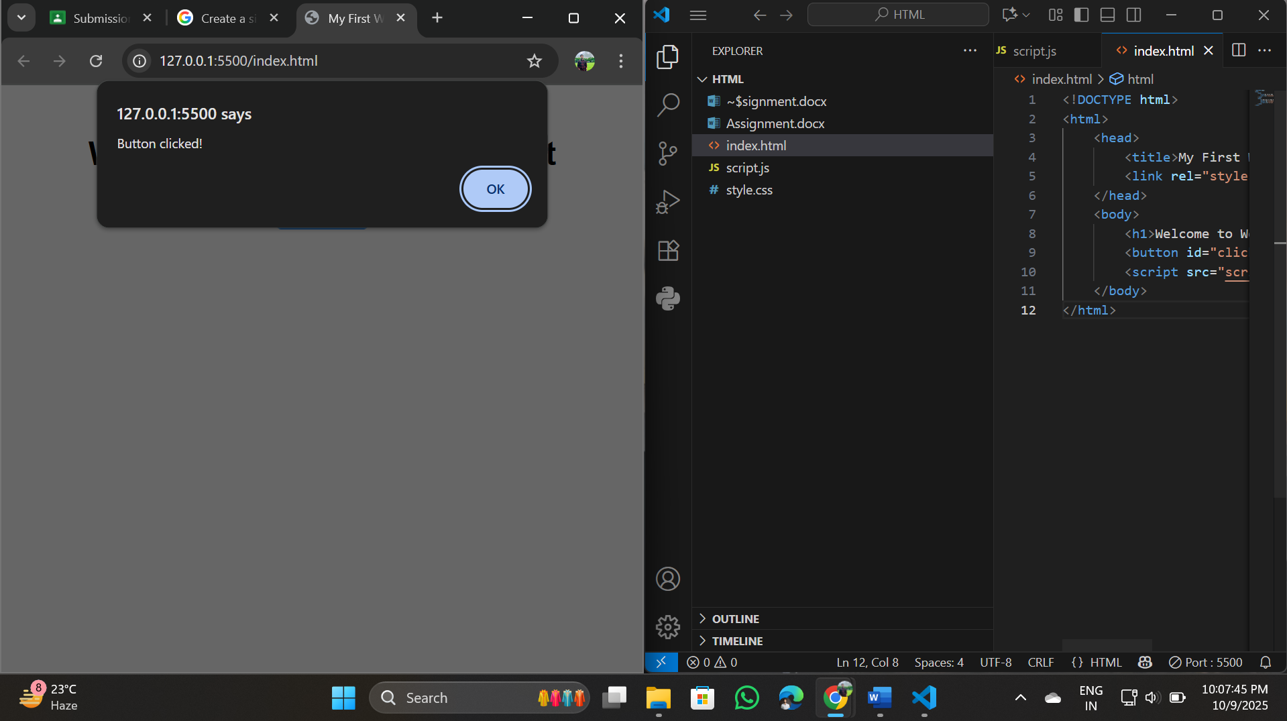
- Static Websites:
The Websites which are not interactive and with simple HTML pages, They don’t use javascript.
Example:
A portfolio website with fixed text and images.
Dynamic Websites:
The websites which are interactive and uses javascript . Changes content based on user input or data from a database.
Example:
Facebook, where each user sees different posts.
- Five Web Browsers and Their Rendering Engines:
Google Chrome : Blink
Mozilla Firefox : Gecko
Microsoft Edge : Blink
Apple Safari : Webkit
Opera : Blink
Rendering Engine:
It is the part of a browser that reads HTML, CSS, and JS and displays the web page visually.
Different browsers use different engines, so sometimes pages look slightly different.
- Basic Web Architecture Flow Diagram:
[ Client (Browser) ]
|
| Sends request (HTTP)
v
[ Web Server ]
|
| Communicates with
v
[ Database ]
^
|
| Uses
v
[ APIs / Backend Code ]
|
| Sends data back
v
[ Client Displays Web Page ]

