Bug Reporting Best Practices
Quality checklist for clear, reproducible defects

Why quality matters
Clear bug reports reduce clarification cycles and help the team prioritize work. A report should be factual, concise, reproducible, and useful to someone who did not observe the original issue.
Good reporting is not about writing a long description. It is about capturing the right details: context, steps, expected behavior, actual behavior, environment, impact, and evidence.
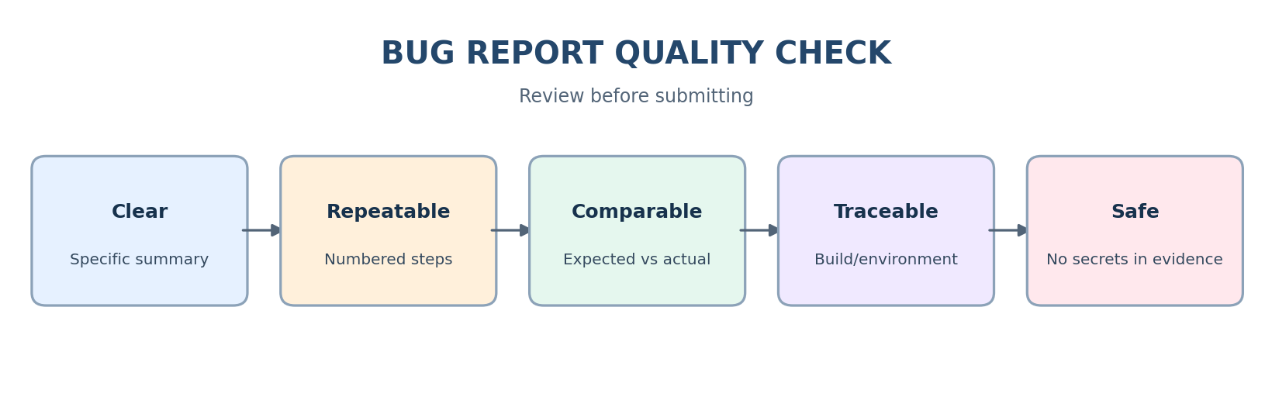

Writing and reproducibility
- Use a summary that identifies the area/action and failure.
- Include preconditions such as account state, feature flags, and test data.
- Number steps in the exact order performed.
- Separate expected result from actual result.
- Record exact error text when it helps explain the behavior.
- Describe what was observed; avoid guessing the root cause.

Evidence and privacy
Choose evidence that demonstrates the problem: screenshot, short video, console output, log excerpt, or API request/response. Include enough context to understand the failure without unrelated material.
Redact passwords, tokens, cookies, personal information, and secrets. Never commit real credentials into a repository. Use approved storage for evidence.

Severity and priority
Severity describes impact. Priority describes urgency. A defect can be high severity but lower priority in a specific context, or lower severity but urgent due to a release deadline, business visibility, or compliance concern.
Use team definitions and give a rationale. Product and engineering stakeholders may adjust priority during triage. Avoid treating the mapping as automatic.

Common mistakes
- Vague summary such as “broken” or “not working.”
- Missing steps, preconditions, expected result, or actual result.
- Missing build, browser, operating system, or test data details.
- Combining unrelated issues in one ticket.
- Attaching evidence that does not show the issue or includes secrets.
- Using emotional, accusatory, or blame-focused language.

Final review checklist
- The report is understandable without a verbal explanation.
- The issue can be reproduced from the recorded steps.
- Evidence supports the actual result.
- Severity and priority follow team definitions.
- Sensitive information is removed.
- The report is not a duplicate and contains one defect.

