Bug Life Cycle Notes
Statuses, transitions, and retest guidance

Purpose and lifecycle overview
A bug life cycle records the state of a reported defect as it moves through triage, investigation, repair, retesting, and closure. It gives QA, developers, and project stakeholders a shared view of ownership and progress.
Teams may customize the status names and transitions in their tracking tool. Always follow the project's actual workflow instead of assuming every team uses identical states.
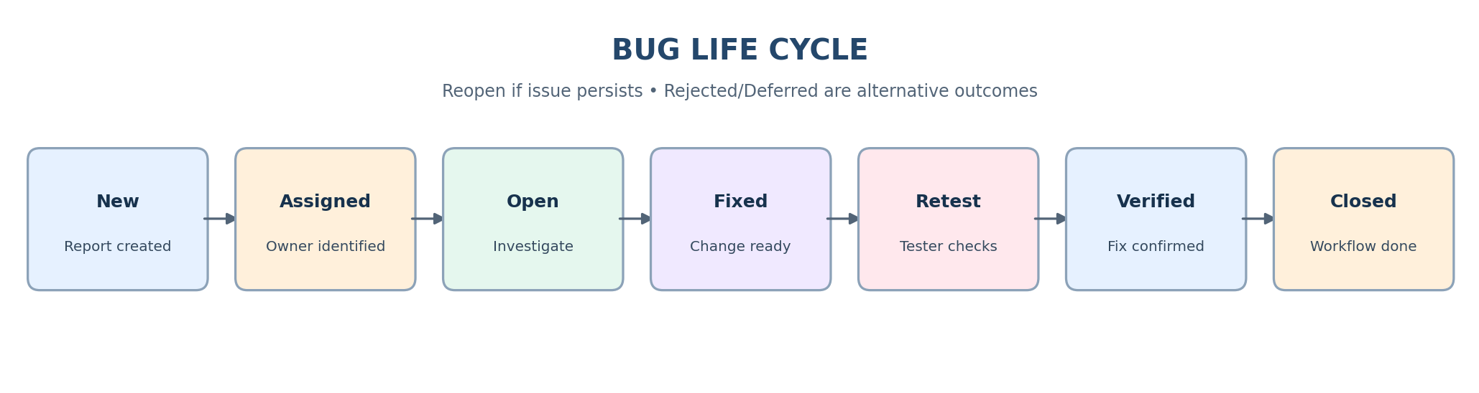

Status definitions
New means the issue has been logged and awaits triage. Assigned means an owner has been identified. Open means the issue is accepted for investigation or work.
Fixed means the developer reports that a change is ready for validation. Retest is the tester's validation step. Verified means the reported behavior is corrected in the tested build. Closed means the workflow is complete.
Reopen is appropriate when the defect persists or the fix is incomplete. Rejected should include a reason, such as expected behavior or a duplicate. Deferred means the issue is accepted but planned for a future release.

Typical transition and example
Typical path: New → Assigned → Open → Fixed → Retest → Verified → Closed. The path may change if triage rejects or defers the issue.
Example: a tester reports that valid login credentials produce an error. After triage, the issue is assigned to a developer. The developer marks it fixed, and the tester retests in the target build. If the dashboard opens correctly, the tester verifies and closes it. If the error remains, the tester reopens the report and adds fresh evidence.

Retest checklist
- Confirm the target build/version and environment.
- Repeat the original steps and test the reported condition.
- Check the expected result and inspect for side effects in related behavior.
- Record the actual result and attach evidence where appropriate.
- Verify only when the defect is corrected; otherwise reopen with details.

Common workflow mistakes
Do not close an issue solely because a developer marked it fixed. Retesting is needed to confirm the behavior.
Do not reject an issue without explaining why. Do not defer without recording the rationale and release target if known.
Keep status accurate and comments factual. Avoid recording secrets or sensitive data in the tracker.

