Bug Report Template
Reusable defect reporting form and example

Purpose
A good bug report allows another person to understand the problem and reproduce it without guessing missing steps. Complete the template using observed behavior, not assumptions about the underlying cause.
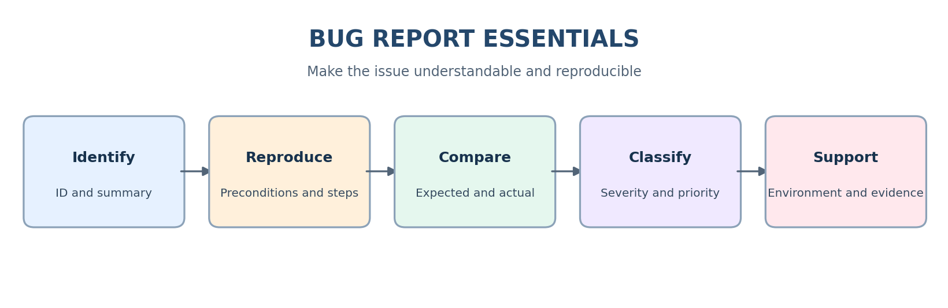

Reusable template
Bug ID: [Tracker-generated ID]
Summary: [Area/action + observed failure]
Description / Impact: [Context and affected function/users]
Preconditions: [Account state, setup, flags, test data]
Steps to Reproduce: 1. [First action] 2. [Second action] 3. [Action that exposes the issue]
Expected Result: [Behavior required]
Actual Result: [Observed behavior]
Severity: [Critical/Major/Minor/Trivial]
Priority Recommendation: [P1/P2/P3]
Priority Rationale: [Business urgency and impact]
Environment: [App/build, OS, browser/device and versions]
Attachments: [Evidence, with secrets redacted]
Reporter / Date / Status: [Traceability fields]

Example of a clear report
Summary: Checkout — total does not update after item quantity increases.
Precondition: The cart contains one available test product and its unit price is known.
Steps: 1. Open the cart. 2. Increase the quantity from one to two. 3. Observe the displayed subtotal and total.
Expected: The subtotal and total reflect quantity two and any applicable fees or discounts. Actual: The displayed total remains unchanged. Severity and priority should be set according to the project definitions and business impact.

Evidence and privacy
Use screenshots or short videos that show the relevant state. Logs or API request/response data can be useful when the defect concerns integration or backend behavior.
Redact passwords, access tokens, session cookies, personal information, and production secrets. Use test data and approved storage. Do not attach large unrelated logs when a focused excerpt is sufficient.

Pre-submission checklist
- Summary is specific and concise.
- Steps are numbered and reproducible.
- Expected and actual results are separate.
- Environment and build are recorded.
- Severity/priority have a rationale.
- Evidence is useful and safe to share.
- One defect is described and duplicates were checked.

