Day 8: Bug Life Cycle & Bug Reporting
Bug Report Template and Workflow Guide

Purpose: Learn to track defects through a defined life cycle, write reproducible bug reports, classify severity and priority, and communicate issues clearly.
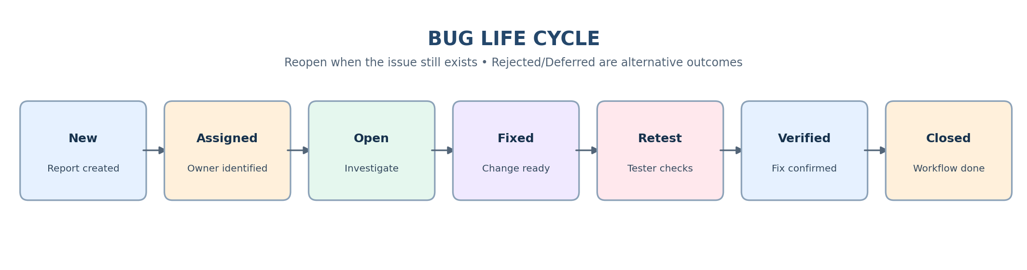

Learning Objectives
- Understand common bug life-cycle states and transitions.
- Write clear, reproducible defect reports.
- Classify issues using severity and priority.
- Communicate defects objectively with supporting evidence.

1. Project Overview
Day 8 focuses on defect workflow and communication. A useful report states what happened, how to reproduce it, expected versus actual behavior, and the environment/evidence needed for investigation.
Execution integrity: the sample reports are illustrative practice examples, not proof that the described issues were reproduced in a live application.

2. Bug Life Cycle
A bug life cycle tracks a suspected defect from first report through investigation, fix validation, and closure. Status names and allowed transitions vary by team and tracking tool.
Status | Meaning
New | Suspected defect reported; awaiting triage.
Assigned | Owner identified.
Open | Accepted for investigation/work.
Fixed | Developer reports fix ready for testing.
Retest | Tester checks fix in suitable build/environment.
Verified | Tester confirms behavior is corrected.
Closed | Workflow is complete.
Reopen | Issue persists or fix is incomplete.
Rejected | Not accepted as a valid defect; record reason.
Deferred | Accepted but planned for a future release; record rationale.
Typical path: New → Assigned → Open → Fixed → Retest → Verified → Closed. If the defect persists during retest, reopen it with fresh evidence. Fixed does not mean verified.

3. Effective Bug Reporting Workflow
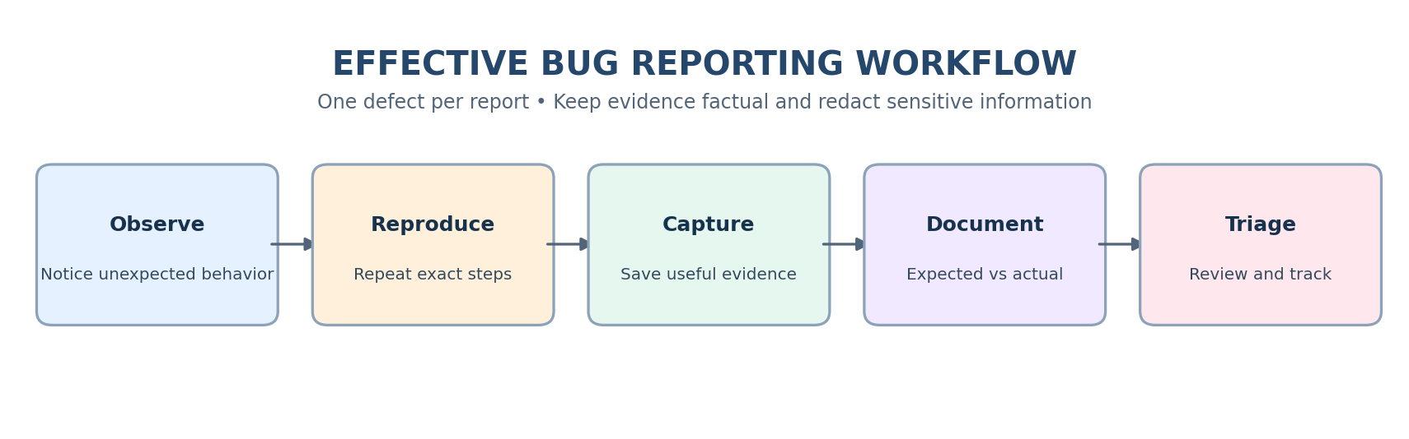
- Observe unexpected behavior.
- Reproduce it with repeatable steps, when possible.
- Capture relevant screenshot, video, log, or API evidence.
- Write expected and actual results separately.
- Record environment, severity, priority recommendation, and impact.
- Submit the report and track it through triage and resolution.

4. Bug Report Components
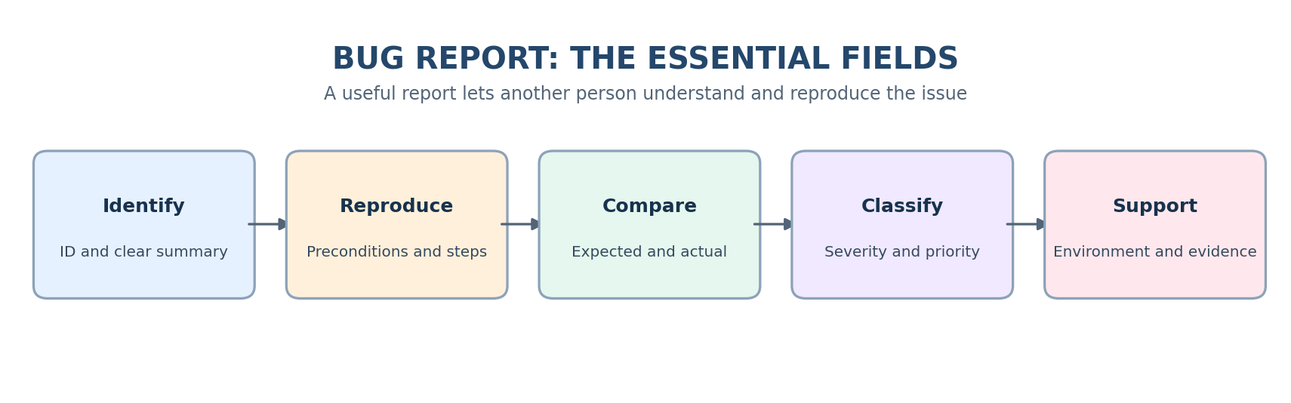
Component | What to include
Bug ID | Unique identifier from tracker/sheet.
Summary | Concise line naming area/action and failure.
Description / Impact | Context and affected function/users.
Preconditions | Required account state, setup, flags, or data.
Steps to Reproduce | Numbered actions in exact order performed.
Expected Result | Intended behavior based on requirements.
Actual Result | Observed behavior; exact error text if useful.
Severity | Impact, using team definitions.
Priority | Urgency recommendation; confirm in triage.
Environment | Application/build, OS, browser/device, versions.
Attachments | Evidence with secrets redacted.
Reporter / Date / Status | Traceability and workflow tracking.

5. Severity vs Priority
Severity describes how much impact a defect causes. Priority describes how soon it should be addressed. They are related but not interchangeable.
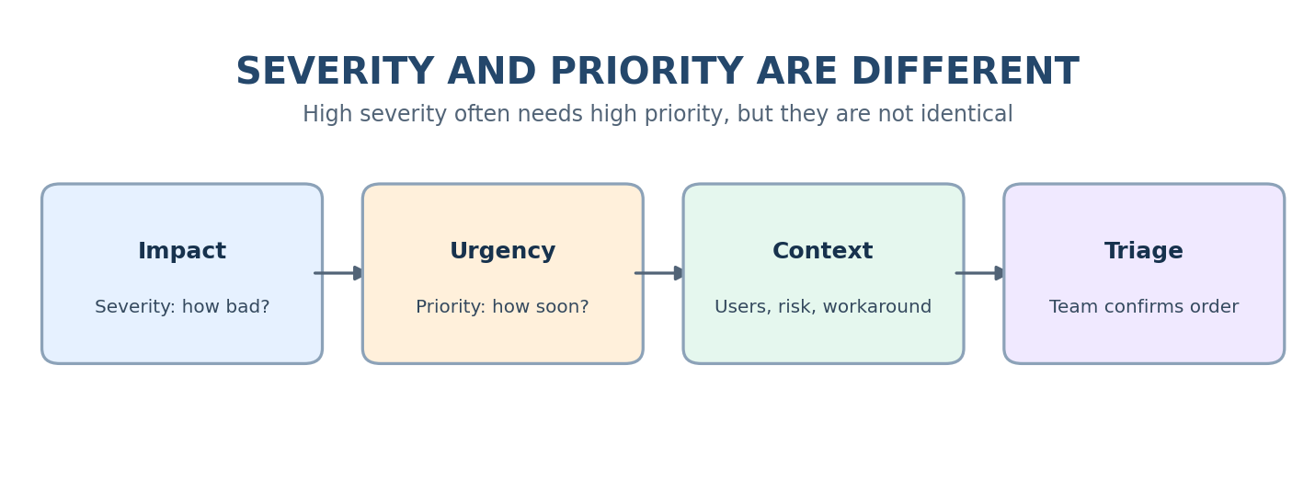
- Critical severity: system crash, data loss/corruption, or core flow completely blocked.
- Major severity: important functionality unavailable or incorrect.
- Minor severity: limited issue; workaround may exist.
- Trivial severity: cosmetic issue or typo with negligible functional impact.
- P1 / High: immediate attention due to urgent business or release risk.
- P2 / Medium: address in current release/iteration.
- P3 / Low: schedule when capacity permits.
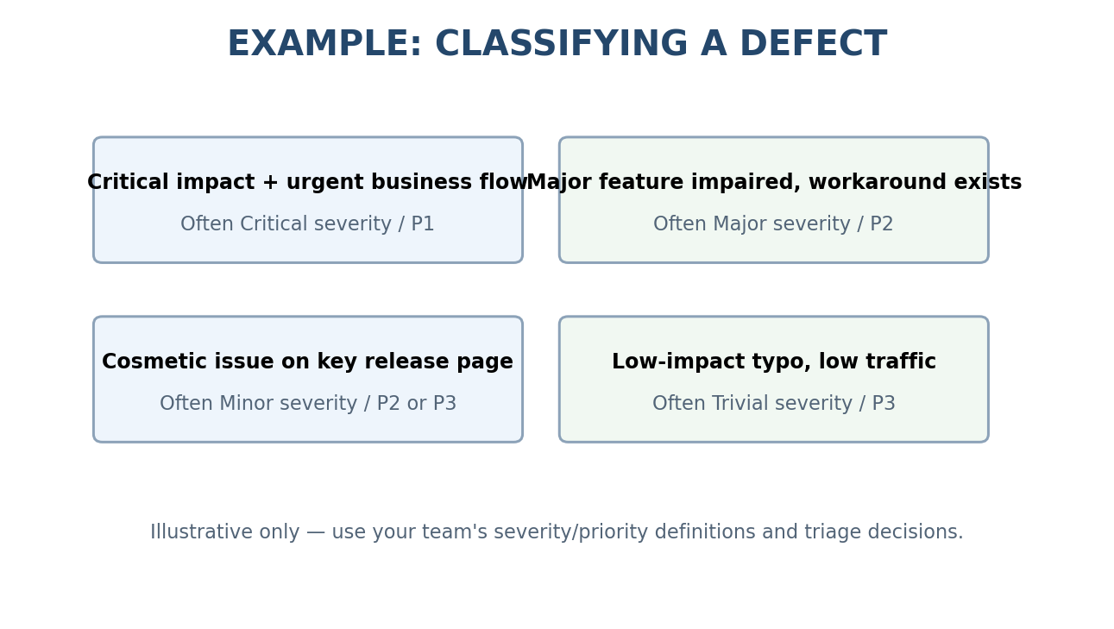
Scenario | Severity | Priority | Reason
Checkout crashes for all customers | Critical | P1 / High | Core purchase flow blocked
Password reset fails for all users | Major | P1 / High | Account recovery blocked
Incorrect compliance notice | Major/Critical | P1 / High | Compliance risk
Common search returns incorrect results | Major | P2 / Medium | Important feature impaired
Rare optional export fails | Minor/Major | P2/P3 | Depends on business impact/workaround
Misaligned icon | Minor | P3 / Low | Cosmetic
Low-traffic internal typo | Trivial | P3 / Low | Low impact
These are examples, not universal mappings. Follow the team's definitions and document the rationale.

6. Writing Effective Reports and Common Mistakes
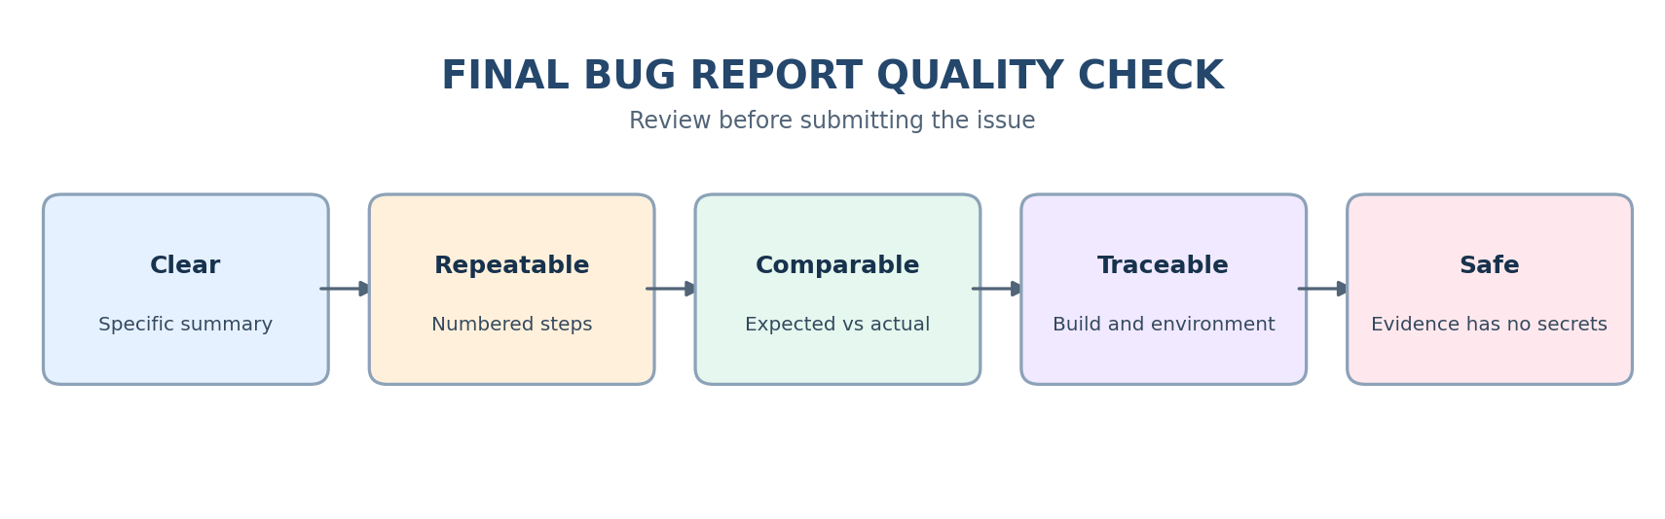
- Use a specific summary; avoid “Not working.”
- Include preconditions and numbered reproducible steps.
- Separate expected and actual results.
- Record environment/build and useful exact error text.
- Attach relevant evidence; redact credentials, tokens, personal data, and secrets.
- Report one defect per ticket; check for duplicates.
- Use neutral language and describe observations rather than assumed root cause.
- Avoid missing steps, unclear results, unrelated issues, and evidence that does not show the problem.

7. Practice Assignment
- Review a demo application and identify candidate defects.
- Create 20 reports using the template.
- Add suggested severity and priority with rationale.
- Include preconditions, steps, expected/actual results, and environment.
- Capture evidence only for issues you actually reproduce.
- Review for clarity, duplicates, privacy, and completeness.

8. GitHub Folder Structure
```text
Day-8-Bug-Life-Cycle-and-Bug-Reporting/
├── README.md
├── README-Google-Docs.docx
├── Bug-Life-Cycle/
│ ├── Bug-Life-Cycle-Notes.md
│ └── Bug-Life-Cycle-Google-Docs.docx
├── Bug-Reporting/
│ ├── Bug-Report-Template.md
│ └── Bug-Report-Template-Google-Docs.docx
├── Severity-Priority/
│ ├── Severity-vs-Priority-Guide.md
│ └── Severity-vs-Priority-Examples.xlsx
├── Practice-Bug-Reports/
│ ├── 20-Sample-Bug-Reports.md
│ └── 20-Sample-Bug-Reports.xlsx
├── Best-Practices/
│ ├── Bug-Reporting-Best-Practices.md
│ └── Bug-Reporting-Best-Practices-Google-Docs.docx
└── README-Diagrams/
├── bug-life-cycle.png
└── bug-reporting-workflow.png
```

