DAY 10

Alternative Bug Tracking Tools
& Test Management

Learning Objectives
- Compare common bug-tracking and test-management tools.
- Record the TestRail project and test-management structure used in practice.
- Understand how execution results and defect references support traceability.
- Summarize test execution through metrics and a generated report.
- Document tool recommendations based on the exercise.

1. Tools Comparison Matrix
The comparison below summarizes the tools considered for the Day 10 learning activity. Exact features and pricing can vary by edition, hosting model, and current vendor plan; the matrix is a practical high-level comparison rather than a live pricing quotation.
Tool | Main use | Strengths | Considerations
Bugzilla | Defect tracking | Mature issue fields, search, configurable workflows | Interface and administration may feel less modern.
MantisBT | Defect tracking | Lightweight, open-source option, simple issue workflow | Less integrated test-management experience by default.
Azure DevOps | Work items and delivery lifecycle | Boards, queries, repos, pipelines, test-related workflows | Broad platform; setup can be more involved.
GitHub Issues | Issue tracking near source code | Simple collaboration, labels, milestones, pull-request links | Dedicated test-case management may require extensions or another tool.
Redmine | Project and issue tracking | Projects, trackers, workflows, plugins | Capabilities depend on configuration and plugins.
TestRail | Test case and execution management | Cases, sections, runs, results, reporting, defect references | Dedicated defect tracking is typically handled in a linked tracker.
Zephyr | Test management in Jira ecosystem | Test cases and execution aligned with Jira workflows | Exact capabilities depend on the Zephyr product/edition.
qTest | Test management | Test planning, execution, traceability, reporting | Commercial platform with organization-specific setup.
Spreadsheet | Basic test tracking | Accessible and flexible for a small exercise | Manual maintenance, weak workflow controls, and harder traceability at scale.

Practical distinction: a bug tracker records and follows defects; a test-management tool organizes test cases and execution. Some platforms cover both areas, while others work best when linked together.

2. TestRail Project Setup
The project used for the exercise was named Shopper Stack Release Q1. The project workspace exposed Project Overview, Test Cases, Test Runs & Results, Milestones, and Reports. The login test cases were grouped under Login and Authentication.
The project was used to keep reusable test definitions separate from the run that records the results of a specific execution cycle.

Project overview evidence
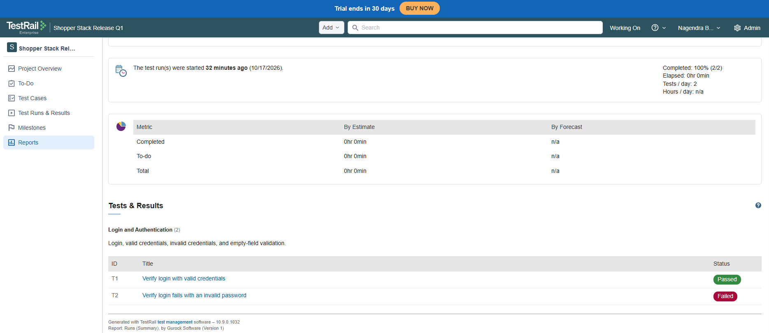
The TestRail project overview for Shopper Stack Release Q1.

3. Test Management Structure
The recorded structure followed this hierarchy:
Level | Recorded item | Purpose
Project | Shopper Stack Release Q1 | Top-level workspace for this QA exercise.
Section | Login and Authentication | Groups related login scenarios.
Test case T1 | Verify login with valid credentials | Checks successful authentication.
Test case T2 | Verify login fails with an invalid password | Checks rejection of invalid credentials.
Test run R1 | Login Regression - Run 1 | Groups T1 and T2 for one execution cycle.
Results | T1 Passed; T2 Failed | Records the saved outcome of each case.
Jira defect | SHOP-35 | Tracks the login behavior issue associated with T2.

T1 included the precondition that a registered active test account exists and the application is accessible. Its steps covered opening the login page, entering the registered username, entering the correct password, and selecting Login. T2 followed the same sequence with an incorrect password; the expected final behavior was an error message and no authenticated session.

Test case repository evidence
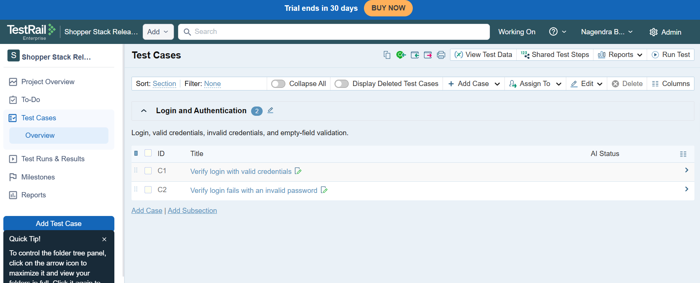
The section contains the valid-credentials and invalid-password login cases.

4. Testing Metrics Dashboard
The TestRail run dashboard showed two selected test cases, one Passed and one Failed. Both cases had saved results, so the execution rate was 100%, while the pass rate was 50% and the fail rate was 50%.
Metric | Calculation | Value | Interpretation
Total tests | Passed + Failed + Blocked + Retest + Untested | 2 | Two cases were included.
Executed tests | Total − Untested | 2 | Both cases had a result.
Execution rate | Executed ÷ Total × 100 | 100% | All selected cases have recorded results.
Pass rate | Passed ÷ Executed × 100 | 50% | One of two recorded results passed.
Fail rate | Failed ÷ Executed × 100 | 50% | One of two recorded results failed.

Execution rate is not the same as product quality: it shows that results were recorded, not that all tests passed. The report's Completed field showed No, so the run's completion/closure state was distinct from having results for every case.

Execution dashboard evidence
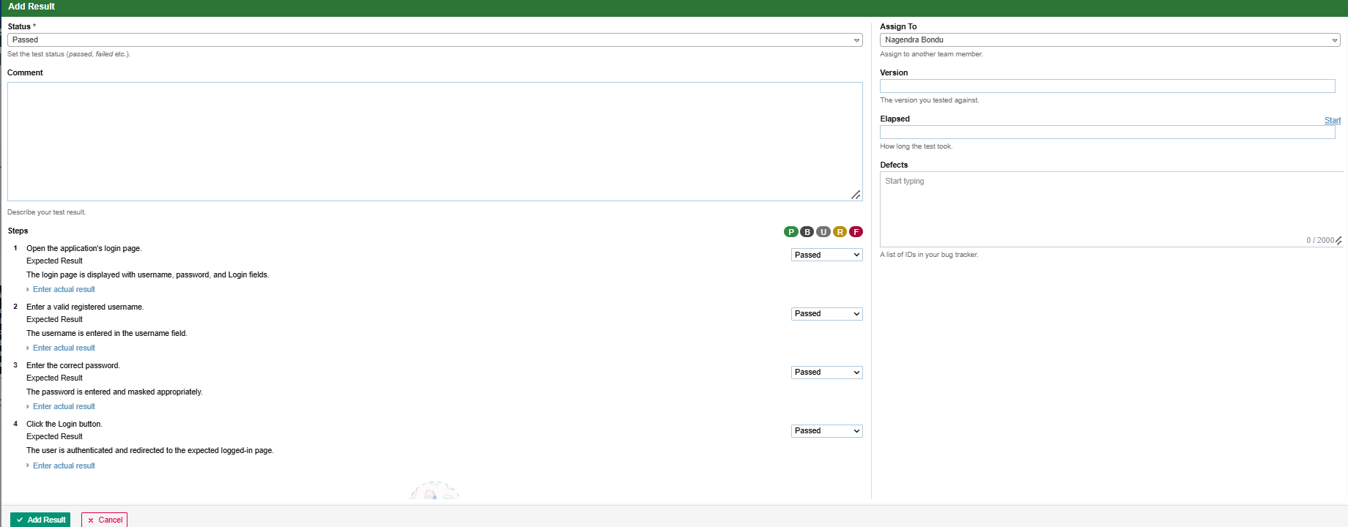
Login Regression - Run 1 was created with two cases.

5. Test Execution Reports
A TestRail report named Day 10 - Login Test Execution Summary was generated for Login Regression - Run 1. It summarized the run and included activity, progress, and a results table with T1 as Passed and T2 as Failed. The report description referenced Jira issue SHOP-35.
The Add Result form supported an overall status, comments, step-level outcomes, assignment, version, elapsed time, and a Defects field. The failed T2 result showed SHOP-35 under Defects, recording the cross-reference between TestRail and Jira.

Failed Test Follow-up: Logging the Defect in Jira
After T2, “Verify login fails with an invalid password,” was marked Failed in TestRail, the issue was logged in Jira in the Shopper Stack V2 project. Jira issue SHOP-35 was created with the summary “Login behavior is incorrect when an invalid password is entered.” The issue description recorded the precondition, reproduction steps, expected behavior, and actual-result details.
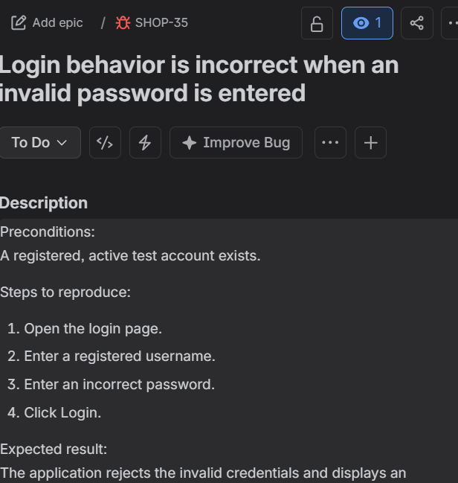
Jira defect SHOP-35 logged for the failed invalid-password test.
The Jira issue key SHOP-35 was then entered in the Defects field for the failed TestRail result. This connects the failed execution record to the defect record and supports traceability between the test outcome and its investigation.

Defect traceability evidence
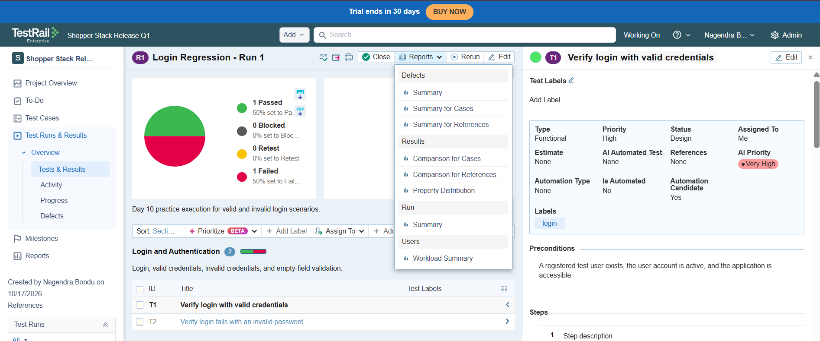
The failed T2 result references SHOP-35 in the Defects area.

Generated report evidence
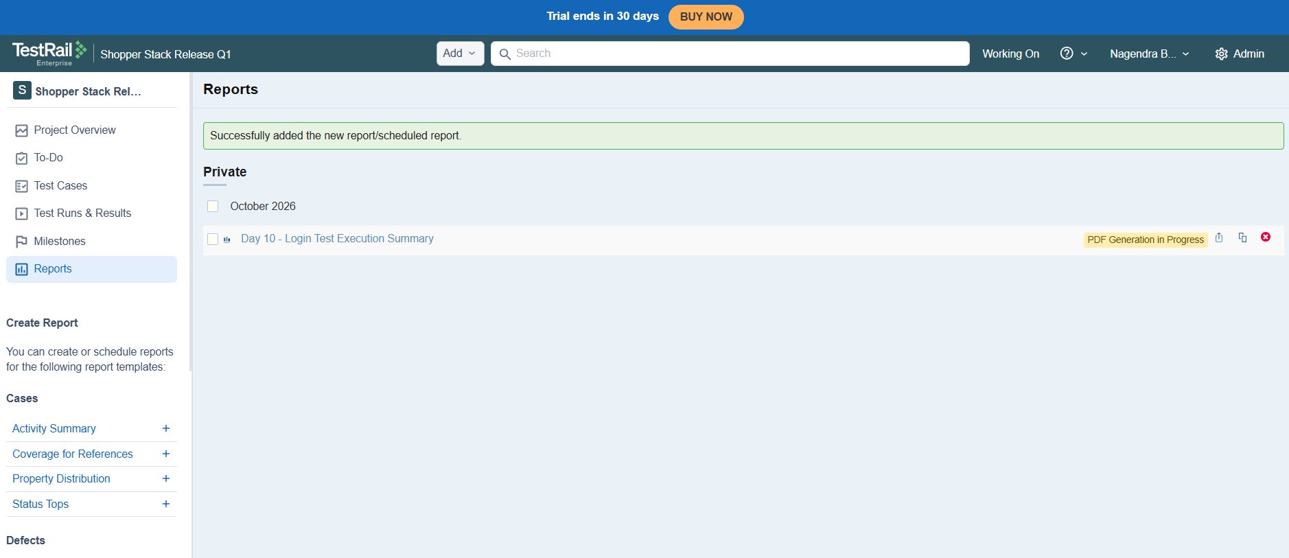
The generated report summarizes the login regression run.

Report results and metrics evidence
The report details show T1 Passed and T2 Failed.
The Jira issue was created in Shopper Stack V2 with key SHOP-35 and summary “Login behavior is incorrect when an invalid password is entered.” The actual result in a real defect should reflect the behavior observed during testing. The existence of a saved result or reference does not, by itself, prove that the reported behavior was reproduced or that automatic integration synchronization is configured.

6. README and Tool Recommendations
For this practice exercise, TestRail was suitable for organizing the two login cases, creating a run, recording outcomes, and generating a report. Jira was used to track the defect and provide a reference from the failed result.
Need | Practical recommendation | Reason
Dedicated test cases and runs | TestRail or an equivalent test-management platform | Supports reusable cases, execution results, and reporting.
Defect lifecycle | Jira, Azure DevOps, Bugzilla, MantisBT, or Redmine | Tracks issue status, ownership, reproduction details, and resolution.
Source-code-centered issue tracking | GitHub Issues | Keeps lightweight work items close to code and pull requests.
Small learning project | A spreadsheet can be a temporary alternative | Low setup effort, though traceability and reporting require manual maintenance.

Recommendation from the completed work: keep test cases and execution results in a test-management tool, track confirmed defects in a bug tracker, and connect them with issue references. Reports then summarize the current recorded status. This separation makes it easier to explain what was tested, what happened, and which issue is under investigation.

Conclusion
Day 10 covered tool comparison, TestRail project setup, test-management structure, execution metrics, defect traceability, and report generation. The saved run showed one Passed result and one Failed result, with Jira issue SHOP-35 referenced from the failed case. The result should be interpreted against the observed application behavior, and the run's completion state should not be inferred only from the execution percentage.

