Day 9: JIRA & Bug Tracking Tools
Beginner-friendly usage guide for project setup, bug tracking, Agile boards, JQL filters, and dashboards.

1. Learning Objectives
- Understand JIRA and its main features.
- Create a JIRA practice project.
- Understand Bug, Story, Task, Epic, and Sub-task issue types.
- Create and manage bugs with clear reproduction steps and evidence.
- Understand workflows and status transitions.
- Explore Scrum and Kanban boards.
- Use JQL to search for issues and save filters.
- Build a custom dashboard with available reporting gadgets.
- Explore components, versions/releases, and time tracking where available.

2. What Is JIRA?
JIRA is an Atlassian work-management and issue-tracking tool. QA teams use it to record defects, assign work, follow status changes, search issues, and report progress. Backlogs, sprints, boards, and roadmaps depend on project setup and permissions.

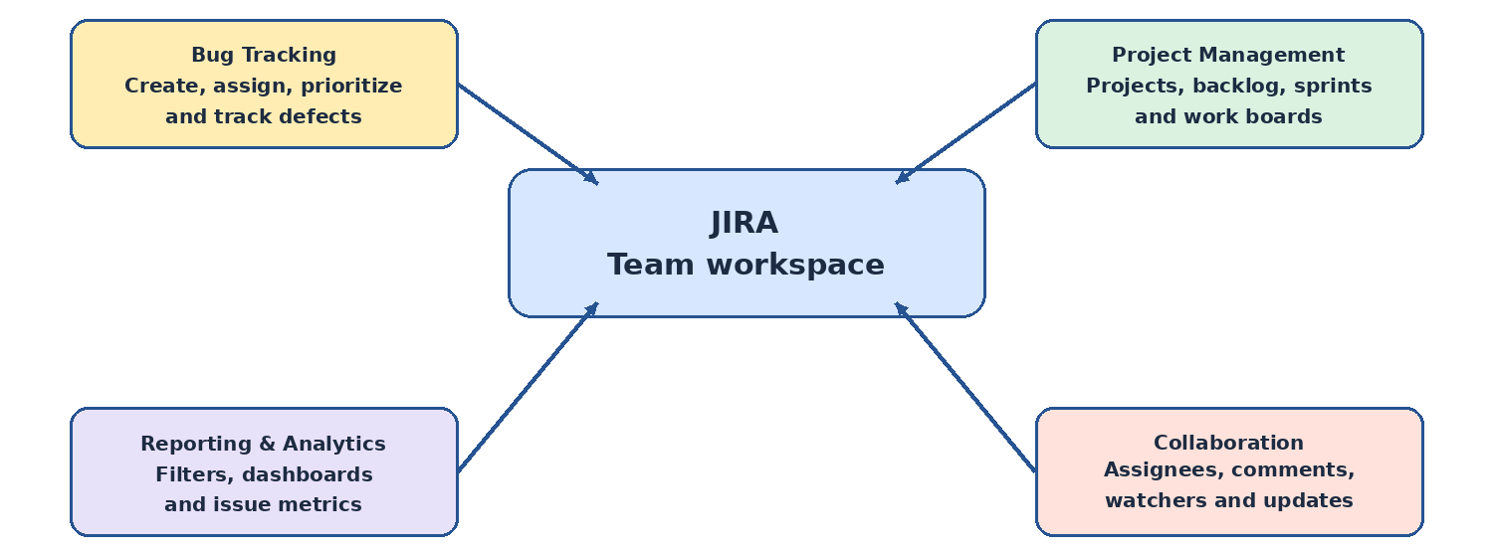

5. Issue Types in JIRA
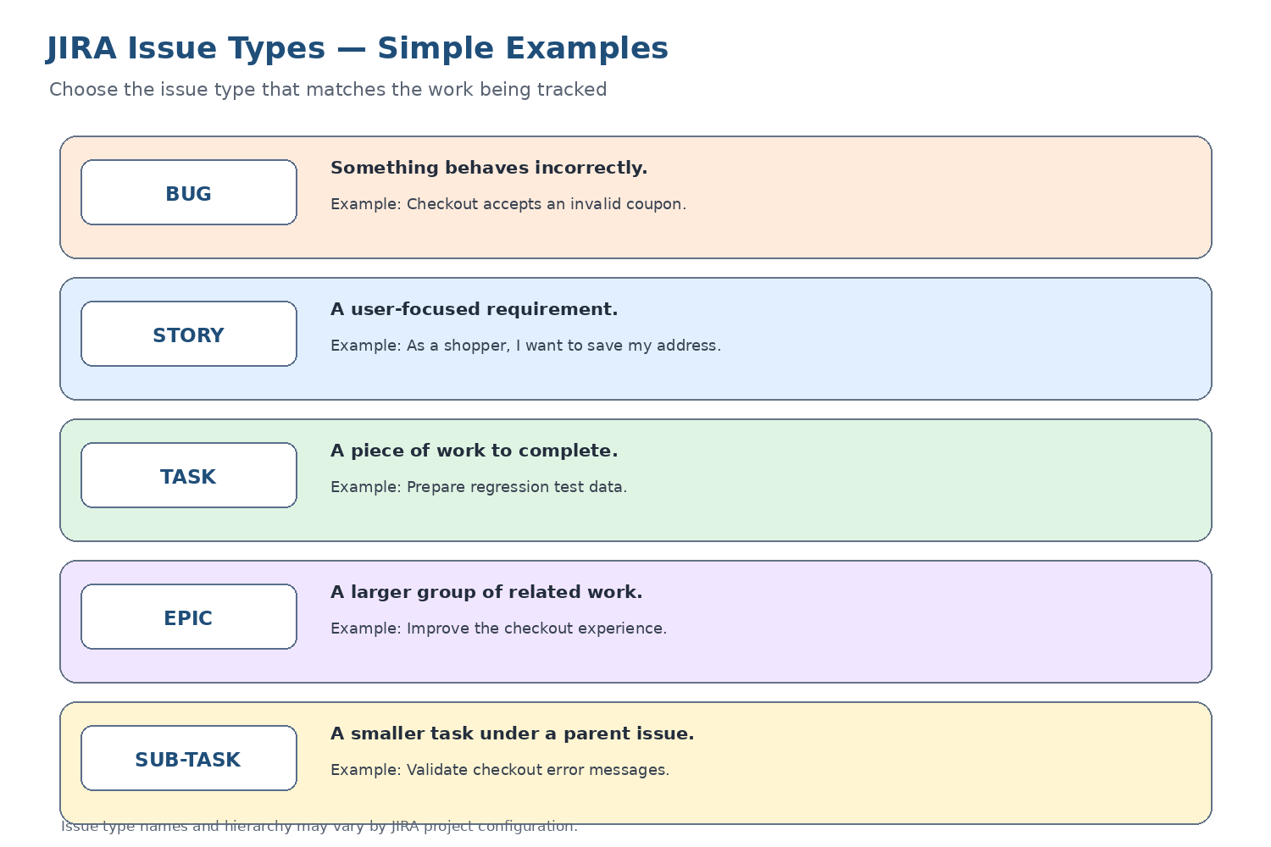

6. Create and Manage Bugs
Search for duplicates first. A useful bug report should let another tester reproduce the problem without guessing.
Field | What to enter
Summary | Short, specific description of the observed problem.
Environment | Browser, operating system, device, version, or test environment.
Preconditions | Required setup or test data.
Steps to reproduce | Numbered actions that consistently reproduce the issue.
Expected result | What should happen.
Actual result | What happened instead.
Priority / severity | Use team definitions; they are not necessarily identical.
Attachment | Relevant screenshot, log, or recording with sensitive data removed.
Labels / components / versions | Use project metadata where available.
- Create at least 20 practice bugs in your own JIRA project.
- Record the actual JIRA issue key for every created bug; spreadsheet examples alone do not count.
- Add attachments, labels, related issue links, or watchers only when useful and permitted.

7. JIRA Workflow and Retesting
A workflow defines statuses and the transitions that move an issue between them. This is an example; your project may use different statuses.
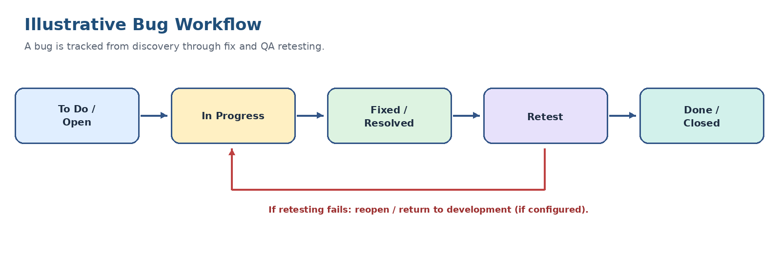
Figure 3. Example bug lifecycle with a retest-failure path.
- To Do / Open: waiting to be worked on.
- In Progress: being investigated or fixed.
- Fixed / Resolved: a fix has been recorded.
- Retest: QA verifies the fix.
- Done / Closed: the team's completion rules are met.
- If retesting fails, reopen or return the issue to development if configured.

8. Scrum and Kanban Boards
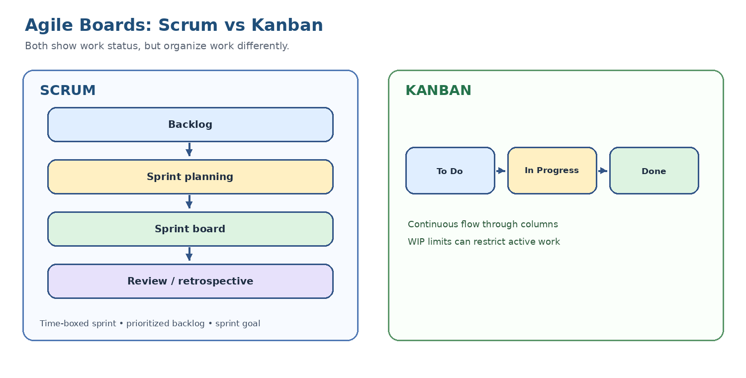
Figure 4. Clear comparison of Scrum and Kanban.
Scrum | Kanban
Work is planned for a time-boxed sprint. | Work flows continuously through columns.
Backlog and sprint planning are central. | WIP limits can restrict active work.
Burndown and velocity may be available. | Cycle time and throughput can help evaluate flow.
Sprint board tracks selected sprint work. | Board highlights work status and bottlenecks.
For your deliverable, configure or explore a Scrum board and sprint tools where available. Record the board name, backlog/sprint observations, and settings you could access.

9. JQL Filter Examples
JQL means Jira Query Language. Run queries in issue search and adapt project keys, priority values, and status names to your project.
Purpose | Example JQL
Find bugs | issuetype = Bug
Find unresolved bugs | issuetype = Bug AND resolution IS EMPTY
Find issues assigned to you | assignee = currentUser()
Created in last 7 days | created >= -7d ORDER BY created DESC
Find in-progress issues | status = "In Progress"
Find either of two statuses | status IN ("To Do", "In Progress")
Find high-priority bugs | issuetype = Bug AND priority = High
Sort unresolved bugs | issuetype = Bug AND resolution IS EMPTY ORDER BY priority DESC, created ASC
- Run each query and check the returned results.
- Save useful queries as filters with clear names.
- Share filters only with appropriate users/groups if permissions allow.
- Record any changes needed because field values differ in your project.

10. Custom Dashboard and Bug Metrics
- Create a practice dashboard if your account permits it.
- Add available gadgets such as Filter Results, Issue Statistics, Pie Chart, or Created vs Resolved.
- Configure each gadget with the intended saved filter and fields.
- Verify that the dashboard shows the correct project and issue scope.
- Record the dashboard name and the gadgets actually added.
Metric / view | Question it answers
Bugs by status | How many bugs are open, in progress, or done?
Bugs by priority | How are bugs distributed by urgency?
Filter results | Which bugs need follow-up?
Created vs resolved | Are issues being created faster than they are resolved?
Gadget availability varies. Confirm filter scope before interpreting a chart as a project-wide metric.

11. Deliverables Checklist
- ☐ JIRA project created; record project name and key.
- ☐ 20+ bugs actually logged; record actual issue keys.
- ☐ Scrum board configured or available configuration documented.
- ☐ Custom dashboard created and available gadgets configured.
- ☐ JQL filter examples tested and useful filters saved.
- ☐ README usage guide reviewed.
This guide explains how to complete the tasks. It does not claim that a live JIRA project, 20 issues, board, or dashboard has already been created. Mark a deliverable complete only after verifying it in your own account.

