Test Automation Basics & Tools
DAY 11

Learning Objectives
- Understand what test automation means.
- Know the benefits and problems of automation.
- Choose which tests are worth automating.
- Recognize common testing tools.
- Understand basic automation frameworks.
- Learn the parts of a first Java + Selenium test.
- Understand the test automation pyramid.

1. What Is Test Automation?
Test automation means using a program to run test steps and check the results. It helps testers repeat the same checks without doing every step by hand. Manual testing is still important.

Manual Testing vs Automation Testing
Manual testing | Automation testing
A person follows the steps and checks the result. | A script follows steps and checks the result.
Good for exploring a new feature and checking usability. | Good for repeated tests and regression checks.
Repeating many tests takes time. | Writing and updating scripts takes time.
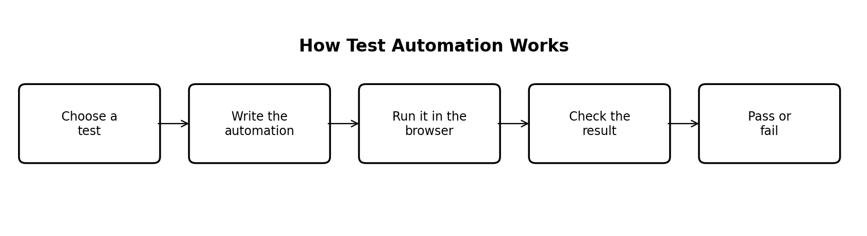
Figure 1. How test automation works.

Benefits
- Run the same test many times.
- Get results faster for repeated checks.
- Check important features after a change.
- Run tests with different input data.
- Reduce repeated manual work once scripts are working well.

Challenges
- Scripts take time to create.
- Scripts need updates when the application changes.
- A test may fail because of timing or test data, not a product bug.
- The team needs skills to read and fix scripts.
- Automated tests cannot judge every user experience.

What Is Automation ROI?
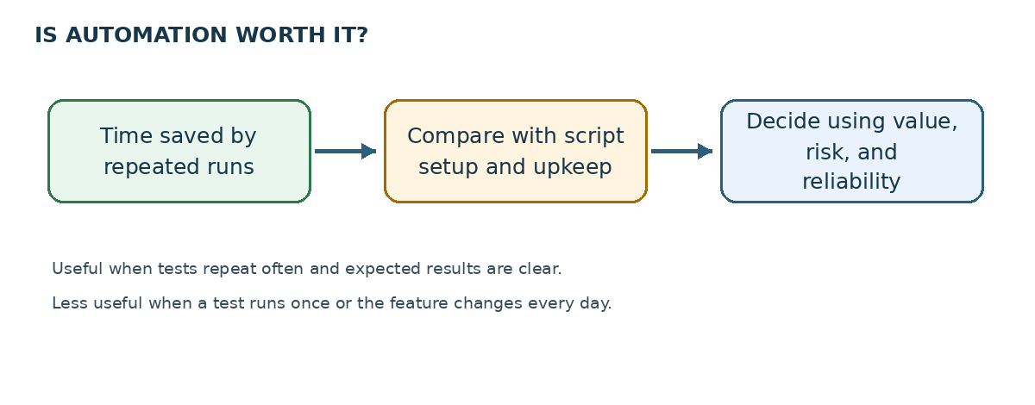
Figure 5. A simple way to think about automation value.
ROI means checking whether automation saves more time or cost than it takes to build and maintain.
ROI (%) = (Benefit − Cost) / Cost × 100
Include how often a test runs, time saved, script creation, and maintenance when estimating cost and benefit.

2. When Should a Test Be Automated?
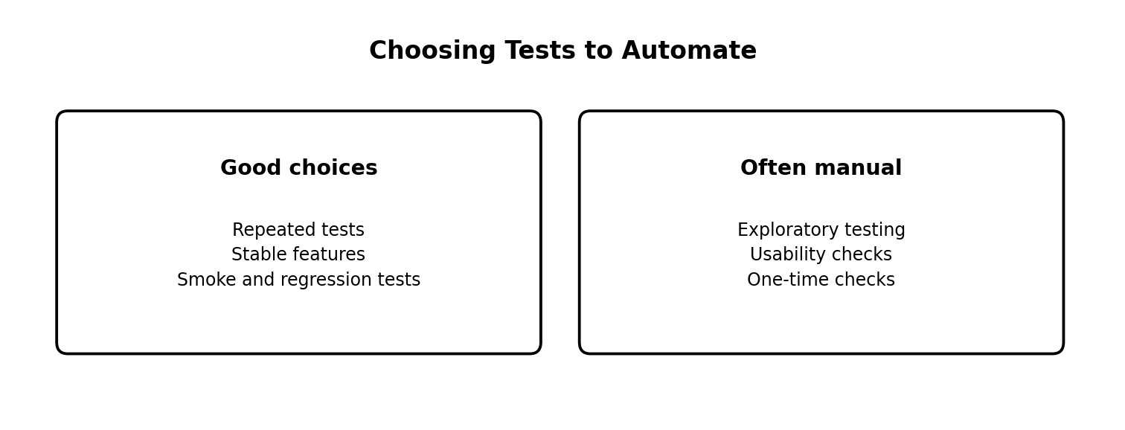
Figure 2. Choosing tests to automate.

Good choices for automation
- Regression tests that run again after code changes.
- Smoke tests that check main features after a build.
- Stable features with clear expected results.
- The same test run with many sets of data.
- Important workflows that need frequent checking.

Tests often better done manually
- Exploratory testing: the tester investigates the application to find unexpected problems.
- Usability testing: a person judges whether the application is easy to use.
- One-time checks that will not be repeated.
- Features changing so often that scripts need constant repair.
- Tests where the expected result is not clear yet.
These are guidelines. A team decides based on risk, time, and maintenance cost.

Quick Automation Checklist
Question | What it tells us
Will this test be repeated often? | Repeated tests may be worth automating.
Is the expected result clear? | The script needs a clear result to check.
Is the feature stable? | Stable features usually need less script repair.
Is the test data ready? | Good test data makes results more reliable.
Is the benefit worth the effort? | Automate when the value is worth the cost.

3. Automation Tools Comparison
Tool | Used for | Simple example
Selenium | Websites in a browser | Check a login page in Chrome.
Appium | Mobile apps | Test an Android or iOS app.
Cypress | Web applications | Check actions and results on a website.
Playwright | Browser automation | Test a website in different browsers.
JUnit | Running Java tests | Organize Java tests and check results.
TestNG | Organizing Java tests | Group tests and run selected test cases.
Postman | API testing | Send a request and check the response.
REST Assured | API testing using Java | Write API checks in Java tests.
Choose the tool that fits the application, language, browser or device, team skills, and project needs.

4. Common Automation Frameworks
A framework is an organized way to build and manage automation tests. It helps keep tests easier to reuse and update.
- Data-Driven Framework: the same test runs with different input data, such as several usernames and passwords.
- Keyword-Driven Framework: test steps use action names such as Open Browser or Click Login.
- Hybrid Framework: combines more than one framework approach.
- Page Object Model (POM): keeps page details, such as locators and page actions, in separate classes. This makes website tests easier to update.
POM is a design pattern. It is not a test runner by itself.

5. Java + Selenium Environment Setup
The basic tools for this demo are Java JDK, IntelliJ IDEA, Maven, Selenium Java, JUnit or TestNG, and Chrome browser.
- Check Java with java -version.
- Create a Maven Java project in IntelliJ IDEA.
- Add Selenium and JUnit or TestNG dependencies to pom.xml.
- Create a test class under src/test/java.
- Run the test from IntelliJ IDEA or Maven.
- new ChromeDriver() can use Selenium Manager to manage the browser driver in supported setups. A manually maintained driver folder is not needed for this basic example.
- If the test does not start, check dependency versions, browser version, error message, and network access.

Example Maven dependencies
<dependencies>
<dependency>
<groupId>org.seleniumhq.selenium</groupId>
<artifactId>selenium-java</artifactId>
<version>YOUR_SELENIUM_VERSION</version>
</dependency>
<dependency>
<groupId>org.junit.jupiter</groupId>
<artifactId>junit-jupiter</artifactId>
<version>YOUR_JUNIT_VERSION</version>
<scope>test</scope>
</dependency>
</dependencies>
Replace the placeholder versions with compatible versions selected for the project.

6. First Selenium Script
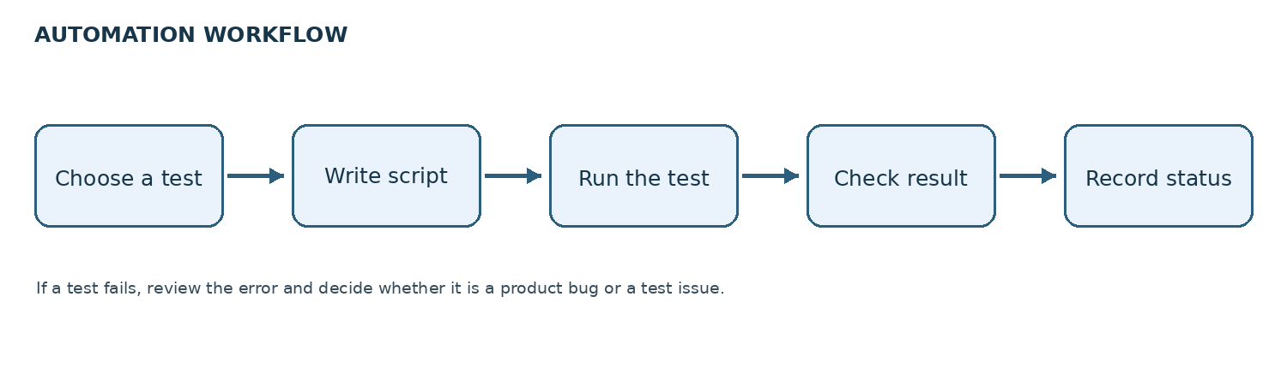
Figure 6. A test moves from selection to recorded result.
This example opens a public demo page, checks its title, and closes the browser.
import org.junit.jupiter.api.Test;
import org.openqa.selenium.WebDriver;
import org.openqa.selenium.chrome.ChromeDriver;
import static org.junit.jupiter.api.Assertions.assertEquals;
class FirstSeleniumTest {
@Test
void verifyPageTitle() {
WebDriver driver = new ChromeDriver();
try {
driver.get("https://example.com");
assertEquals("Example Domain", driver.getTitle());
} finally {
driver.quit();
}
}
}

What each part does
- new ChromeDriver() starts Chrome.
- driver.get(...) opens the website.
- driver.getTitle() reads the page title.
- assertEquals(...) checks whether the actual title matches the expected title.
- driver.quit() closes the browser, even if the check fails.
This is a demo script. Its result should only be recorded as passed after it has actually been run.

7. Test Automation Pyramid
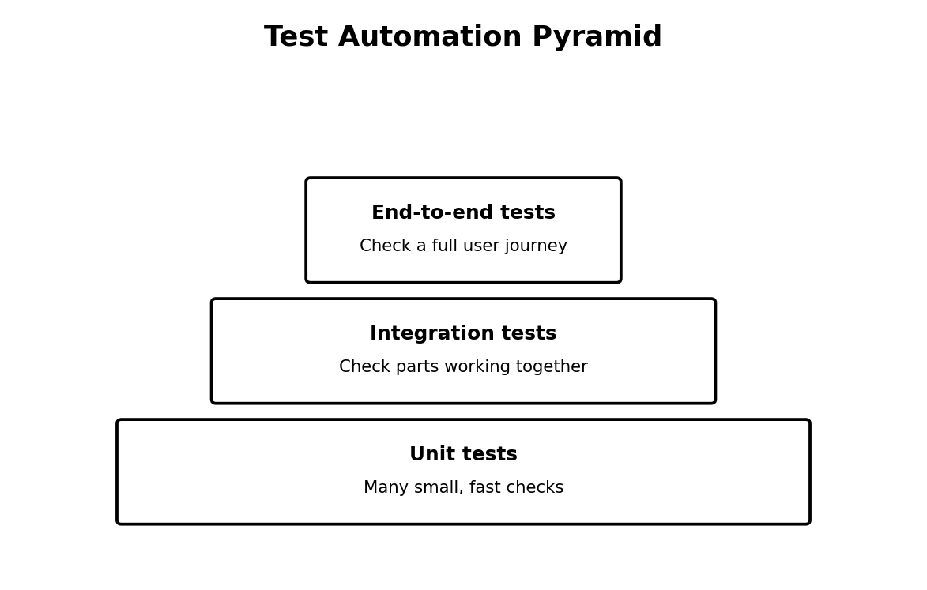
Figure 3. Test automation pyramid.
- Unit tests: check one small part of the code. They are usually fast, so teams can have many of them.
- Integration tests: check whether parts of the application work together.
- End-to-end tests: check a full user journey, such as logging in and completing a purchase. They are usually slower and fewer in number.
A good test suite uses all suitable levels. Not every check needs to be done through the browser.

8. Basic Automation Strategy
1. Choose important tests: start with repeated and high-risk workflows.
2. Set clear expected results: every test should know what success looks like.
3. Select tools: choose tools based on whether the application is web, mobile, API, or another type.
4. Keep tests readable: use clear names and reusable methods.
5. Prepare test data: use known data and avoid tests interfering with each other.
6. Run and record results: record passed, failed, and blocked tests and keep useful error details.
7. Maintain scripts: update scripts when the application changes and investigate flaky failures.
8. Review value: check time saved, test reliability, maintenance effort, and important features covered.

