RMK SkillMap – An Integrated Skill Assessment and Personalized Mock Placement Hiring Platform
24ME311R – PRODUCT DEVELOPMENT LAB – 1 REPORT
Submitted By
NAGESHWARAN C - 111725203070
SACHIN S - 111725203088
MUHILAN M - 111725203067
in partial fulfilment for the award of the degree
of
BACHELOR OF TECHNOLOGY
IN
INFORMATION TECHNOLOGY
R.M.K ENGINEERING COLLEGE
(An Autonomous Institution)
R.S.M Nagar, Kavaraipettai - 601 206

OCTOBER 2026

BONAFIDE CERTIFICATE
Certified that this Product Development Lab report “RMK SkillMap – An Integrated Skill Assessment and Personalized Mock Placement Hiring Platform” is the bonafide work of “NAGESHWARAN C (111725203070) , SACHIN S(111725203088) and MUHILAN M (111725203067)” who carried out the 24ME311R – PRODUCT DEVELOPMENT LAB - 1 under my supervision.
SIGNATURE  Dr. Sheerin Banu M, M.Tech, Ph.D  Professor and Head  Dept of Information Technology,  R.M.K. Engineering College,  R.S.M. Nagar,  Kavarapettai – 601206. | SIGNATURE  Dr. Sheerin Banu M, M.Tech, Ph.D  Supervisor  Professor and Head  Dept of Information Technology,  R.M.K. Engineering College,  R.S.M Nagar,  Kavarapettai – 601206

CERTIFICATE OF EVALUATION
College Name: R.M.K. ENGINEERING COLLEGE
Department : INFORMATION TECHNOLOGY
Semester : 03
Title of Project | Name of the Students | Name of the Supervisor with designation
RMK SkillMap – An Integrated Skill Assessment and Personalized Mock Placement Hiring Platform | NAGESHWARAN C  SACHIN S  MUHILAN M | Dr. Sheerin Banu M, M.Tech, Ph.D  Professor and Head

The report of the Product Development Lab work submitted by the above students in partial fulfilment for the award of Bachelor of Technology Degree in INFORMATION TECHNOLOGY of Anna University was evaluated and confirmed to be the report of the work done by the above students and then evaluated.
______________________________________________________
Submitted the project during the viva voce held on 17/10/2026
INTERNAL EXAMINER

ACKNOWLEDGEMENT
We earnestly portray our sincere gratitude and regards to our beloved Founder Chairman, Thiru. R. S. MUNIRATHINAM for giving us the infrastructure for conducting the project work and our Chairperson Tmt. MANJULA MUNIRATHINAM for her blessings. We also thank our Vice Chairman, Thiru. R. M. KISHORE and our Director, Thiru. R. JOTHI NAIDU for their constant support and affection shown towards us throughout the course.
We are extremely thankful to our Principal, Dr. K. A. MOHAMED JUNAID, for being the source of inspiration in this college.
We reveal our sincere thanks to our Professor and Head of the Department, Information Technology, Dr. M. SHEERIN BANU, for her commendable support and encouragement for the completion of our project.
We would like to express our sincere gratitude to our Course Coordinator Dr. ANU MONISHA. A, for her valuable suggestions towards the successful completion for this project.
We wish to record our thanks to our project supervisor, Dr. M. SHEERIN BANU, for her/his valuable guidance and support during each stage of our project.
We take this opportunity to extend our thanks to all the faculty members of Department of Information Technology, parents and friends for their care and support towards the completion of our project.

TABLE OF CONTENTS
Chapter No. | Description | Page No.
 | Abstract | 6
1 | Introduction | 7
2 | Literature Survey | 11
3 | Prototype | 18
4 | Implementation | 40
4.1 | Technology Stack | 40
4.2 | System Architecture | 40
4.3 | Module Description | 44
4.4 | Testing and Validation | 46
4.5 | Results and Discussion | 49
5 | Conclusion | 52
6 | Product/Process Outcome – Paper Work & Conference Certificate | 54
 | References | 57

ABSTRACT
Campus placement preparation in engineering colleges is commonly delivered as uniform training for a whole batch. Students therefore receive the same aptitude, coding and interview material irrespective of their present skill level, and they receive little objective information about how ready they are for companies that recruit at different salary packages. The feedback they obtain after a mock test is usually a single score, which does not show which skills caused a weak result or what should be studied next.
This report presents the problem analysis, design and implementation of RMK SkillMap, a web-based placement preparation platform that treats placement training as a measured, personalised and progressive process. A compulsory initial aptitude and coding assessment is used to compute a composite score and to assign each student to one of five placement categories (Service company, 3–4 LPA; Product company, 4–8 LPA; Dream offer, 8–12 LPA; Super dream offer, 12–20 LPA; and Role based hiring). Each category contains the companies that recruit at that package range. For every company the platform provides company-specific material, practice tests and certification guidance, and conducts AI-based mock interview rounds inside the company (typically aptitude, technical and HR). After every round the platform scores the answers concept by concept, detects weak areas by comparing them with required levels, recommends matching resources from its own library, and allows promotion to the next category when the promotion criterion over the company rounds is met.
The report formulates the problem, reviews six recent research papers on educational data mining, explainable AI, knowledge tracing and recommender systems, derives the design decisions from that review, and then specifies the requirements, workflow, algorithms, database design, architecture and modules of the platform together with a testing and validation plan. Features that belong to the core scope are separated from enhancements that are only proposed on the basis of the literature, and the results of an initial trial of the prototype are reported.
Keywords: Placement Training, Skill Assessment, Personalised Learning, Skill-Gap Analysis, Recommendation System, AI Mock Interview, Explainable AI

CHAPTER - 1
INTRODUCTION

1.1 Background
Campus placement is a major milestone for an engineering student and an important indicator of the standing of a college. Recruiters evaluate more than academic marks. They test aptitude, problem solving, programming, core technical knowledge and communication through a multi-stage process that normally has an aptitude round, a technical round and an HR round. The depth of these rounds depends on the package that a company offers. Lower-package roles tend to test fundamentals, whereas higher-package roles expect stronger algorithmic skills, project depth and domain knowledge.
Placement training in most colleges is conducted for the entire batch at one pace, while students begin from very different skill levels. The learning material that a student needs, such as practice tests, video lectures and certification courses, is spread over many unrelated websites. Research in educational data mining shows that student data can be used to predict performance, to explain the factors behind a prediction and to recommend suitable content [1], [4], [5], [6]. RMK SkillMap applies these ideas to placement preparation by combining assessment, categorisation, training, mock interviews, skill-gap analysis and progression in one platform.

1.2 Problem Statement
The existing practice of placement preparation has the following shortcomings:
- No objective readiness measure. A student cannot tell whether the present skill level is suitable for a Service company, a Product company, a Dream offer, a Super dream offer or a role based hiring drive.
- Uniform training. The same content and pace are given to all students, so it is too easy for some and too hard for others.
- Opaque feedback. Mock tests and mock interviews return a total score but do not show the concepts that caused a poor result.
- Scattered resources. Students spend time searching for material that matches their weak areas.
- No progression path. There is no rule that moves a student from one preparation level to the next on the basis of measured improvement.
Formal statement. Let a student begin with an aptitude score A and a coding score C. The problem is to build a system that (P1) determines the preparation level of the student from A and C and assigns a category; (P2) trains the student with the material and the mock interview rounds of the companies in that category; (P3) evaluates every mock interview round and identifies the skill concepts in which the student is below the level required; (P4) recommends learning resources that address exactly those concepts; and (P5) decides, from the round results, whether the student is ready to move to the next category.

1.3 Objectives
The objectives of the project are:
- O1. To assess the aptitude and coding skills of students through initial evaluations.
- O2. To categorise students according to their skills and placement preparation level.
- O3. To provide company-specific training and AI-based mock interviews.
- O4. To identify skill gaps and recommend personalised learning content.
- O5. To track student progress and enable advancement to higher categories.
- O6. To provide domain-wise video references and industry certification guidance.

1.4 Scope and Limitations
In scope. Student registration and login; the initial aptitude and coding assessment; category assignment (Service company, Product company, Dream offer, Super dream offer or Role based hiring); the companies offered in each category; company-wise material, practice tests and mock interview rounds (aptitude, technical and HR); concept-wise performance analysis; resource recommendation; progression to a higher category; a reference section with curated videos and certification guidance; and an administrator module for managing questions, material, cut-offs and reports.
Out of scope. Conducting actual recruitment drives, company registration and shortlisting, payment handling, and any claim about the effect of the platform on real placement outcomes, which can be established only after a full placement season.
Assumptions and limitations. The quality of assessment and recommendation depends on a sufficiently large question bank and resource library in which every item is tagged with a skill concept. The category cut-offs are set by the placement cell. The AI-based evaluation of interview answers supports practice and is not a substitute for a human interviewer.

1.5 Proposed Approach
Training is organised in three levels: a category (Service company, Product company, Dream offer, Super dream offer or Role based hiring), the companies that recruit within that category, and the mock interview rounds that are conducted inside each company. RMK SkillMap follows a five-stage pipeline: (1) assess the student, (2) categorise, (3) train and practise for a chosen company, (4) evaluate through mock interviews and analyse skill gaps, and (5) recommend resources and decide promotion. The stages repeat until the student reaches the preferred level. Table 1.1 relates each objective to the problem to be solved, the module that addresses it and the section in which the design is described.
Table 1.1: Mapping of objectives, sub-problems and modules
Objective | Sub-problem | Module | Described in
O1 | P1 | Initial Assessment Module | 3.6, 4.3
O2 | P1 | Categorisation Module | 3.5, 3.6
O3 | P2 | Company and Round; Training and Practice; AI Mock Interview | 3.4, 3.5, 4.3
O4 | P3, P4 | Skill-Gap Analysis and Recommendation | 3.6, 4.3
O5 | P5 | Progress Tracking and Promotion | 3.6, 3.7
O6 | P4 | Reference and Certification Module | 4.3

1.6 Conventions Used in this Report
The project description defines the intended functionality of RMK SkillMap, but it does not state which parts are already coded. To avoid overstating the work, this report uses the following conventions:
- Core scope means functionality that belongs to the project as described by the team. Its completion level is recorded in the implementation status matrix (Table 3.7).
- Proposed enhancement means a technique taken from the literature that is suggested for the platform but is not claimed as implemented.
- Indicative values means figures in Sections 4.4 and 4.5 (test outcomes and trial measurements) that were recorded on the prototype with a small student group; they are indicative of the behaviour of the platform and are not claimed as evidence of an effect on real placement outcomes.

1.7 Organisation of the Report
Chapter 2 surveys the related literature and derives the research gap and design decisions. Chapter 3 presents the prototype: use cases, requirements, workflow, categories, algorithms, database design and the status of each feature. Chapter 4 describes the implementation: technology stack, architecture, modules, testing and the framework for reporting results. Chapter 5 concludes the report. Chapter 6 records the product and process outcome, the paper work and the conference certificate.

CHAPTER – 2
LITERATURE SURVEY
Six research papers were studied. They cover programming-skill classification, student performance prediction, knowledge-graph-based recommendation, a comparison of statistical and data mining models, campus placement prediction, and an adaptive assessment and recommendation platform. Each paper is summarised below with its problem, data, method, results and limitations, so that the techniques that can be reused in RMK SkillMap, and the aspects that remain unaddressed, are identified accurately.

2.1 Review of Related Work
Explainable educational data mining for programming skills [1]. Islam et al. addressed the classification of tertiary students’ programming skill into Excellent, Good, Average and Weak. The dataset had 1,720 samples of computer science students from universities in Bangladesh and 36 features, including the number of problems solved, onsite contest participation, technical experience, debugging skill and learning speed. Categorical features were converted by a mix of one-hot and label encoding, and class imbalance was handled with SMOTE and NearMiss. Seven base classifiers were compared, and a stacking ensemble named Stacking-SRDA, which combines SVM, Random Forest and Decision Tree with an artificial neural network, reached 96% accuracy on an 80:20 split. SHAPASH, ELI5, GWO and LIME were used to explain the model, and the number of problems solved and onsite contest participation emerged as the most important features. The authors also proposed a skill-gap identification and recommendation system for weak students. The work does not supply training content or interview practice, and the skill-gap system is presented as a design.
Random Forest tuned with metaheuristic optimisers [2]. Chen and Jin predicted student performance in four grade groups (Subpar, Tolerable, Good and Outstanding) using a 33-attribute secondary-school dataset that contains demographic, family and study-habit information. A Random Forest Classifier (RFC) was tuned with Victoria Amazonica Optimization (VAO) and Phasor Particle Swarm Optimizer (PPSO). RFC+VAO achieved an accuracy of 0.934, a precision of 0.940, a recall of 0.930 and an F1-score of 0.930, against 0.914 for RFC+PPSO and 0.889 for the plain RFC. The study shows that hyperparameter optimisation can improve a tree-ensemble classifier. The authors state that the findings concern secondary-school data and should not be generalised directly to other educational systems, and the paper offers no explanation of the individual predictions.
Knowledge-graph-based e-learning recommender [3]. Boubaker, Kodia and Ayadi proposed KA-ERN, in which a knowledge graph (EduKA) links users, courses and the concepts taught in the courses. Entity and relation embeddings are learned with TransR and passed to an ensemble of a Bidirectional LSTM and an artificial neural network with an attention layer. The graph was built from a Coursera dataset of 3,533 courses and contained 1,000 users and 68,801 interactions. With the knowledge graph the model obtained an RMSE of 0.045 and an MAE of 0.034, whereas the same model on a plain user–item graph obtained 0.057 and 0.045, and the baseline recurrent models stayed near 0.29 and 0.25. The paper therefore supports linking learning items to concepts. A limitation is that user identifiers and part of the ratings were synthesised, and the explanation of the recommendations is listed as future work.
Statistical versus data mining models for score prediction [4]. Lou and Colvin compared generalised linear regression (GLR), decision tree and random forest regression for predicting three end-of-course exam scores (Math, English Language Arts and Science and Technology/Engineering). The data were drawn from a statewide high-school dataset, and 16,454 complete cases were used with a 70:30 training and test split. GLR gave the best result in every case (for Math, R² = 0.792 and RMSE = 10.49), random forest was second (R² = 0.783) and the decision tree was last (R² = 0.750). GLR also ran in about one second against an average of 164 seconds for random forest, and the previous-year score was the strongest predictor in all models. The authors caution that the results come from one dataset and one type of outcome.
Explainable campus placement prediction [5]. Patil, Marathe and Kamble built a student-centric explainable-AI framework for campus placement. A dataset of about 1,000 student records with 12 features (including CGPA, number of backlogs, internships, coding problems solved, projects, events and a soft-skill score) was split 80:20, and six classifiers were compared. Random Forest was selected with an accuracy of 89.5%. SHAP values showed the contribution of each feature and were used to label features as strong points or as needing improvement. The Streamlit application also checks eligibility against company criteria such as minimum CGPA and maximum backlogs. The framework predicts a binary placed or not placed outcome. In the company-wise table shown in the paper, every company has the same placement probability (96.0%), so the table does not separate companies by difficulty. The paper offers no training content, mock interviews or progression.
Adaptive assessment and recommendation platform [6]. Delianidi et al. presented DK-PRACTICE, which gives a student a short adaptive test and then recommends learning content. A recurrent knowledge-tracing model with a classification sub-network estimates the probability that the student will answer a question correctly. The next question is the one whose predicted probability is closest to a threshold α = 0.5, that is, the question about which the model is least certain. After a quota of 10 questions the platform recommends material for the concepts in which gaps were found, and students can take a pre-teaching and a post-teaching test. The platform uses Laravel with a Flask API. The knowledge-tracing model reached 78.11% accuracy and an AUC of 80.49% on anonymised historical data. The platform was only preliminarily tested in one course, and the educational effect of the recommendations was left for a later study.

2.2 Techniques Reported in the Literature
Table 2.1 collects the techniques that appear in the reviewed papers, the evidence each paper gives, and how the technique is treated in this project.
Table 2.1: Techniques reported in the literature and their treatment in RMK SkillMap
Technique | Source | Evidence reported | Treatment in this project
Random Forest classification | [1], [2], [5] | Best single model in [5] (89.5%); 0.934 accuracy when tuned in [2] | Proposed enhancement for an ML categoriser
Stacking ensemble | [1] | 96% accuracy, ahead of the individual models | Proposed enhancement
SMOTE / NearMiss balancing | [1] | Improved all classifiers on imbalanced data | Proposed, if a classifier is trained
SHAP, LIME, ELI5 | [1], [5] | Feature contributions and strong / weak labels | Proposed for explanation; concept-wise feedback is core
Knowledge tracing and adaptive question choice | [6] | Question nearest 0.5 predicted success; 78.11% accuracy | Proposed enhancement (simplified form in 3.6.5)
Knowledge graph and TransR embeddings | [3] | RMSE 0.045 with graph vs 0.057 without | Concept tags are core; graph embedding is proposed
Generalised linear regression | [4] | Best of three models, 1 s run time | Supports a transparent scoring baseline
Metaheuristic hyperparameter tuning | [2] | 0.889 to 0.934 accuracy | Proposed, only if an ML categoriser is built
Company eligibility rules | [5] | Minimum CGPA and backlog criteria | Related to category and cut-off rules
Pre-test and post-test | [6] | Used to monitor learning progress | Core: assessment and retake

2.3 Comparative Analysis
Table 2.2: Comparison of the reviewed papers
Ref. | Domain and data | Method | Best reported result
[1] | Programming skill of tertiary students; 1,720 samples, 36 features | Encoding, SMOTE / NearMiss, stacking, SHAP / LIME | 96% accuracy
[2] | Secondary-school grade groups; 33 attributes | Random Forest with VAO and PPSO | 0.934 accuracy (RFC+VAO)
[3] | Coursera courses; 3,533 courses, 1,000 users | Knowledge graph, TransR, Bi-LSTM + ANN + attention | RMSE 0.045, MAE 0.034
[4] | High-school exam scores; 16,454 cases | GLR, decision tree, random forest regression | R² 0.792 (GLR, Math)
[5] | Campus placement; about 1,000 records, 12 features | Six classifiers, Random Forest, SHAP | 89.5% accuracy
[6] | Adaptive test and recommendation; course data | Recurrent knowledge tracing, adaptive question choice | 78.11% accuracy, 80.49% AUC

2.4 Research Gap
Table 2.3 compares the capabilities of the papers with those intended for RMK SkillMap. “Partial” means that the paper contains the idea only in part or only as a design.
Table 2.3: Capability comparison
Capability | [1] | [2] | [3] | [4] | [5] | [6] | RMK SkillMap
Predicts skill level or performance | Yes | Yes | No | Yes | Yes | Partial | Yes
Explains the result | Yes | No | No | Partial | Yes | No | Yes
Specific to placement | No | No | No | No | Yes | No | Yes
Package-wise categories | No | No | No | No | No | No | Yes
Diagnostic initial test | No | No | No | No | No | Yes | Yes
Recommends learning content | Partial | No | Yes | No | Partial | Yes | Yes
AI mock interviews | No | No | No | No | No | No | Yes
Progression to a higher level | No | No | No | No | No | No | Yes

The comparison shows that prediction and explanation are well covered [1], [2], [4], [5], and that content recommendation is covered in learning platforms [3], [6]. However, the only placement-specific work [5] ends at a prediction. None of the papers connects the following in one system: a package-wise categorisation, company-specific training, interview-based evaluation across the aptitude, technical and HR rounds, concept-level skill-gap analysis tied to a resource library, and a rule for advancing to a higher category. This combination is the gap that RMK SkillMap addresses.

2.5 Design Decisions Drawn from the Literature
Table 2.4: Findings from the literature and the resulting design decisions
Finding | Source | Design decision | Status
The previous score is the strongest predictor of the next score | [4] | Use the initial assessment as the baseline for category assignment | Core scope
A transparent model can match or beat a complex one | [4] | Start with a transparent weighted score and thresholds | Core scope
Feature-level explanation makes a result actionable | [1], [5] | Show concept-wise strong and weak areas after each round | Core scope
Items linked to concepts improve recommendation | [3] | Tag every question and resource with skill concepts | Core scope
Pre-test and post-test show learning progress | [6] | Allow retake and store attempt history for comparison | Core scope
Questions near 50% predicted success are most informative | [6] | Adaptive question selection (3.6.5) | Proposed enhancement
Tree ensembles perform well on student data | [1], [2], [5] | Train a Random Forest categoriser on collected data (3.6.6) | Proposed enhancement
Class imbalance degrades classifiers | [1] | Balance data before training any classifier | Proposed enhancement
Graph embeddings of concepts improve recommendation | [3] | Concept graph for resource ranking | Proposed enhancement

CHAPTER - 3
PROTOTYPE

3.1 Overview of the Prototype
The prototype is a web application that implements the pipeline described in Section 1.5. A student is first measured, then placed in a suitable category, then trained and evaluated through mock interviews, and finally promoted when the criteria are met. Inside each category the student works with the companies that recruit at that package range, and the mock interview rounds are conducted inside each company. The guiding principle is that each student practises at the level that matches the measured skills and can see precisely what to improve. This chapter specifies the prototype at the level of use cases, requirements, workflow, rules, algorithms and data, and states the implementation status of each feature (Section 3.9). The technology and the module-level realisation are given in Chapter 4.

3.2 User Roles and Use Cases
The platform has two human actors, the student and the administrator (placement cell). Two supporting services are used by the platform: an AI interview service, which generates questions and evaluates answers, and a code execution service, which runs submitted programs against test cases. Figure 3.1 shows the use cases of the human actors, and Table 3.1 describes them.
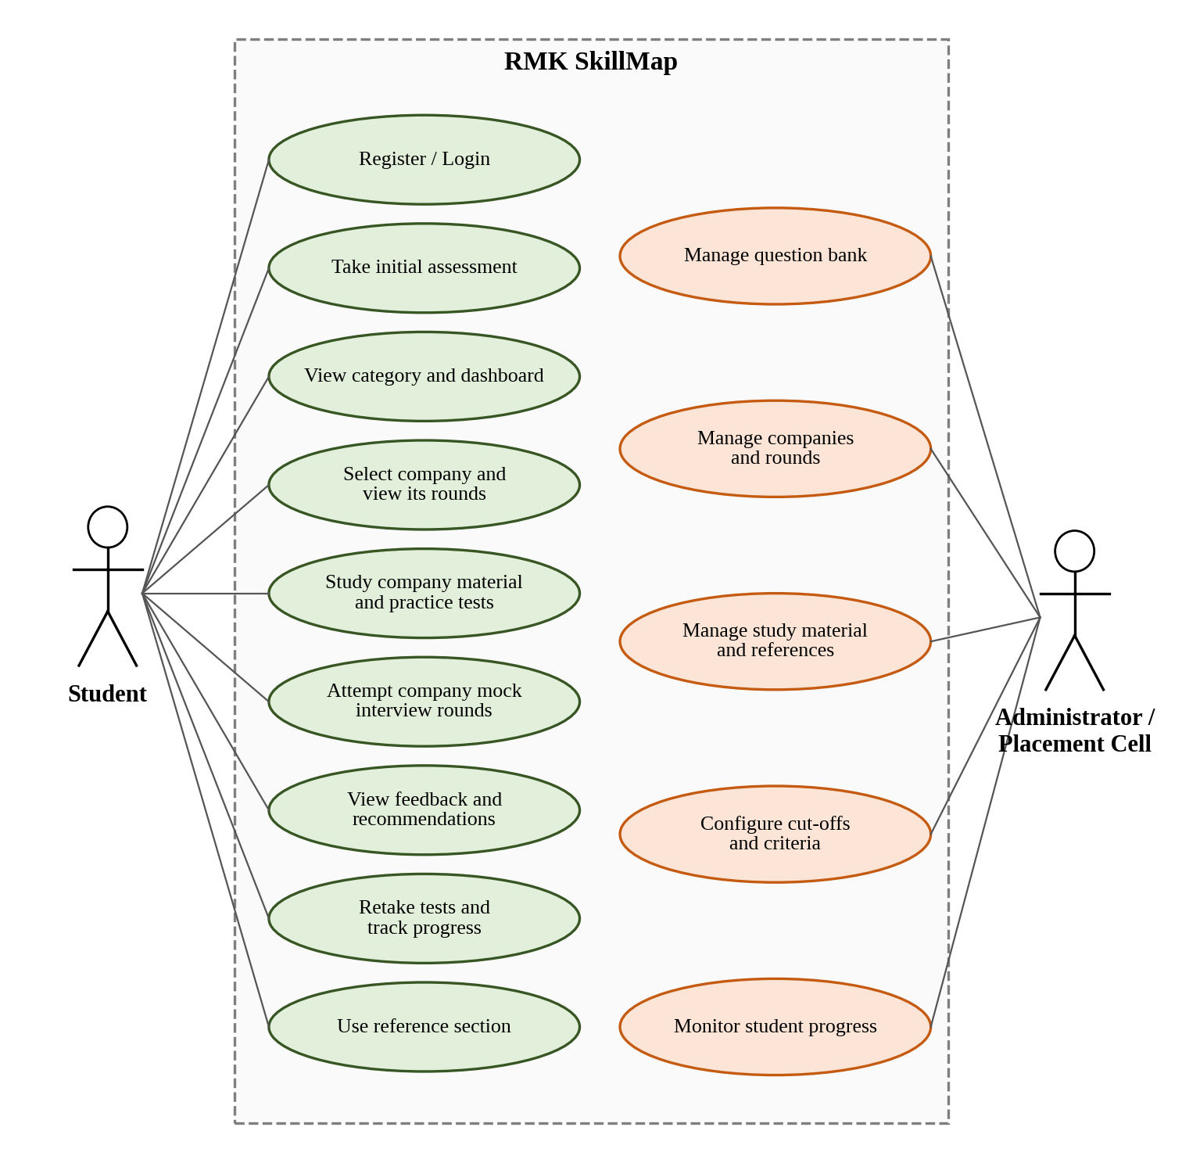
Figure 3.1: Use case diagram of RMK SkillMap
Table 3.1: Use case description
ID | Use case | Actor | Description
UC1 | Register / Login | Student, Administrator | Create an account and authenticate; access depends on role
UC2 | Take initial assessment | Student | Complete the compulsory aptitude and coding tests on first login
UC3 | View category and dashboard | Student | See the assigned category, scores and next action
UC4 | Select company and view its rounds | Student | Choose a company of the category and see its interview rounds
UC5 | Study company material and practice tests | Student | Use the material and timed tests prepared for the chosen company
UC6 | Attempt company mock interview rounds | Student | Take the rounds of the company, for example aptitude, technical and HR
UC7 | View feedback and recommendations | Student | See concept-wise strong and weak areas and linked resources
UC8 | Retake tests and track progress | Student | Repeat rounds, compare attempts and check eligibility
UC9 | Use reference section | Student | Open domain-wise videos and certification guidance
UC10 | Manage question bank | Administrator | Add, edit and tag questions with skill concepts
UC11 | Manage companies and rounds | Administrator | Add companies to a category and define the rounds and cut-offs of each
UC12 | Manage material and references | Administrator | Add study material, videos and certifications with tags
UC13 | Configure cut-offs and criteria | Administrator | Set category thresholds, required levels and the promotion criterion
UC14 | Monitor student progress | Administrator | View individual, company-wise and batch results

3.3 Requirements Analysis
The functional requirements in Table 3.2 follow from the objectives O1–O6. The non-functional requirements in Table 3.3 state the quality attributes that the design must satisfy and how each can be verified.
Table 3.2: Functional requirements
ID | Requirement | Objective
FR1 | Register and authenticate users with role-based access | –
FR2 | Conduct a compulsory aptitude and coding assessment on first login and record section-wise and concept-wise scores | O1
FR3 | Compute a composite score and assign a category or role track using configurable cut-offs | O2
FR4 | List the companies of the student’s category and show the interview rounds configured for each company | O3
FR5 | Provide company-specific material and timed practice tests for the chosen company | O3
FR6 | Conduct the AI mock interview rounds of the chosen company and score every answer | O3
FR7 | Identify weak and strong concepts after each round and list the contribution of each concept | O4
FR8 | Recommend resources that match the weak concepts from the platform library | O4
FR9 | Store all attempts, allow retakes and show change between attempts | O5
FR10 | Decide promotion eligibility from the round results according to the promotion criterion | O5
FR11 | Provide domain-wise video references and certification guidance | O6
FR12 | Allow the administrator to manage questions, companies, rounds, material, cut-offs and reports | O1–O6

Table 3.3: Non-functional requirements
ID | Attribute | Requirement | How it is verified
NFR1 | Security | Passwords stored hashed; token-based sessions; a student sees only own results | Access-control tests (Table 4.5)
NFR2 | Reliability | An interrupted test or interview must not lose submitted answers | Interruption test
NFR3 | Usability | The next recommended action is reachable from the dashboard | Usability survey (4.4.3)
NFR4 | Performance | Result and report pages respond within an acceptable time under batch use | Load observation target: result and report pages open within 3 seconds for a class-size batch
NFR5 | Extensibility | New categories, companies, rounds, questions and resources can be added without code change | Administrator tests
NFR6 | Explainability | Every report states which concepts lowered the result and what to study | Report inspection

3.4 Student Workflow
Figure 3.2 shows the journey of a student. The steps are:
- The student registers or logs in. A first login always opens the initial assessment.
- The aptitude and coding scores are combined into a composite score (Algorithm 1) and the category is assigned. A student who prefers a job role is placed in the Role based hiring category.
- The platform lists the companies of the category. The student selects a company and sees the interview rounds configured for it.
- The student studies the company-specific material and attempts timed practice tests.
- The student takes the AI mock interview rounds of the company, for example aptitude, technical and HR.
- Each round is scored concept by concept, and weak areas are identified (Algorithm 2).
- Resources that match the weak areas are recommended (Algorithm 3), and the student studies them and retakes the round.
- When the promotion criterion over the company rounds is met (Algorithm 4), the student becomes eligible for the next category; otherwise the student continues in the category, with the same or another company.
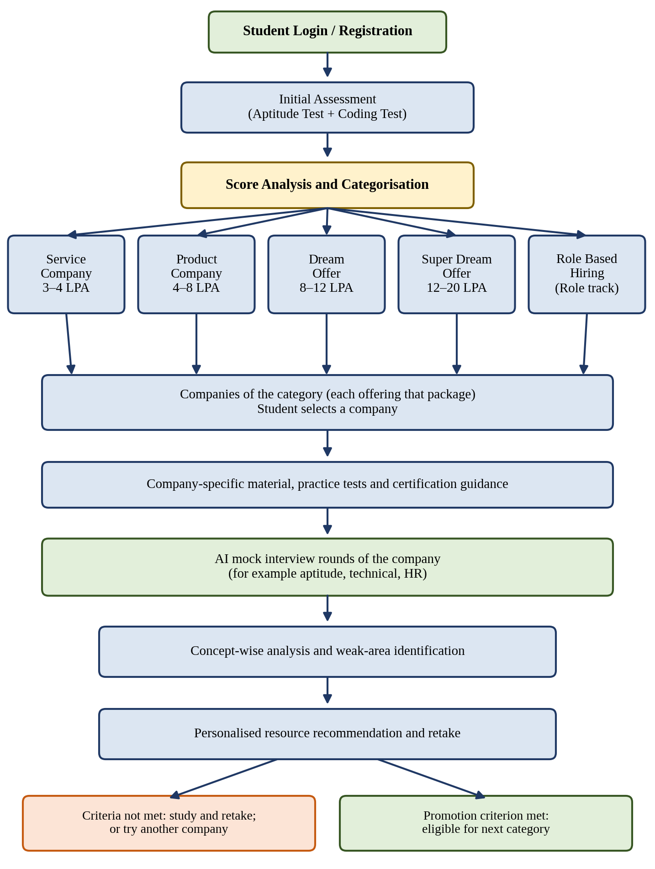
Figure 3.2: Student workflow

3.5 Placement Categories and Configurable Rules
The platform has five categories: four package-based categories (Service company, Product company, Dream offer and Super dream offer) and a Role based hiring category. Each category contains the companies that recruit within that package range, and each company has its own set of mock interview rounds. Table 3.4 states the purpose of the categories. The content focus column is indicative and is aligned with the material loaded in the question bank, and the companies listed for each category are representative recruiters of that category.
Table 3.4: Placement categories
Category | Target package | Indicative content focus | Companies
Service company | 3–4 LPA | Aptitude fundamentals, basic programming, core subject basics, communication | TCS, Infosys, Wipro , PWC , HexaWare , Virtusa , Accenture.
Product company | 4–8 LPA | Stronger problem solving, data structures and algorithms, core computer science subjects (DBMS, OS) | Zoho, Soliton, Rocket, Cognizant , Securin, Infosys HWI
Dream offer | 8–12 LPA | Advanced coding rounds, optimisation, project depth and design basics | Cisco, PayPal, Infosys
Super dream offer | 12–20 LPA | Advanced algorithms, system and design discussion, leadership and work-style evaluation | Amazon, Microsoft, Google
Role based hiring | Role dependent | Skill stack of a chosen role, for example Java Developer, Full-Stack Developer or Data Analyst | Companies that hire for the chosen role; the same company and round structure applies

Company and round structure. A company is described by its name, role and package, and by an ordered list of rounds. The round pattern of a company can differ from another, so the rounds are stored as data for each company and are not fixed in the program. A round has a type (for example aptitude, technical or HR), an order and a cut-off score. The questions that the AI interview service asks in a round depend on the company, the round type and the skill concepts to be tested. The company information and round patterns used in the platform are compiled from the publicly described recruitment processes of the companies (for example the TCS NQT, Zoho and Amazon SDE-1 blueprints shown in Figure 3.10) and from the experience of the placement cell.
Rules and parameters. All thresholds and weights are parameters stored in the database and set by the placement cell, so the algorithms of Section 3.6 can be tuned without changing the code. Table 3.5 lists them. The values used in the prototype are given in the table; they were chosen from the placement cell's past cut-offs and can be revised from the score distribution observed in the trial.
Table 3.5: Configurable parameters
Symbol | Meaning | Value
wA, wC | Weights of the aptitude and coding scores in the composite score (wA + wC = 1) | wA = 0.4, wC = 0.6
T1, T2, T3 | Composite-score thresholds between Service company / Product company, Product company / Dream offer and Dream offer / Super dream offer (T1 < T2 < T3) | T1 = 40, T2 = 60, T3 = 80
Ccr | Cut-off score for round r of company c | 60% of the round marks (can be set per company and round)
K | Number of companies of the category whose rounds must all be cleared for promotion | K = 2
Rk | Required level of skill concept k for the category | 60% (Service), 70% (Product), 75% (Dream), 80% (Super dream)
N | Maximum number of resources recommended for one weak concept | N = 3

3.6 Algorithms
This section specifies the algorithms of the platform. Algorithms 1 to 4 and the interview scoring procedure (3.6.7) belong to the core scope. The adaptive question selection (3.6.5) and the machine-learning categoriser (3.6.6) are proposed enhancements derived from [1], [2], [5] and [6].
3.6.1 Initial assessment scoring and categorisation (Algorithm 1). The aptitude score A and the coding score C are normalised to the range 0–100. The composite score is S = wA·A + wC·C. The category is selected by three thresholds T1, T2 and T3, as shown in Figure 3.3. The use of a transparent weighted score as the baseline is consistent with the finding in [4] that a simple, interpretable model can match a complex one, and the use of the initial scores as the starting point agrees with the finding that earlier performance is the strongest predictor of later performance [4].
Algorithm 1: Categorise a student
Input: aptitude score A, coding score C (0–100); parameters wA, wC, T1, T2, T3; optional role choice
Output: category of the student
1. If the student has chosen a role track, assign Role based hiring and stop.
2. Compute S = wA × A + wC × C.
3. If S < T1, assign Service company.
4. Else if S < T2, assign Product company.
5. Else if S < T3, assign Dream offer.
6. Else assign Super dream offer.
7. Store the category and the scores in the user record.

The algorithm takes constant time per student. Its quality depends on the choice of T1 and T2, which is a design decision of the placement cell.
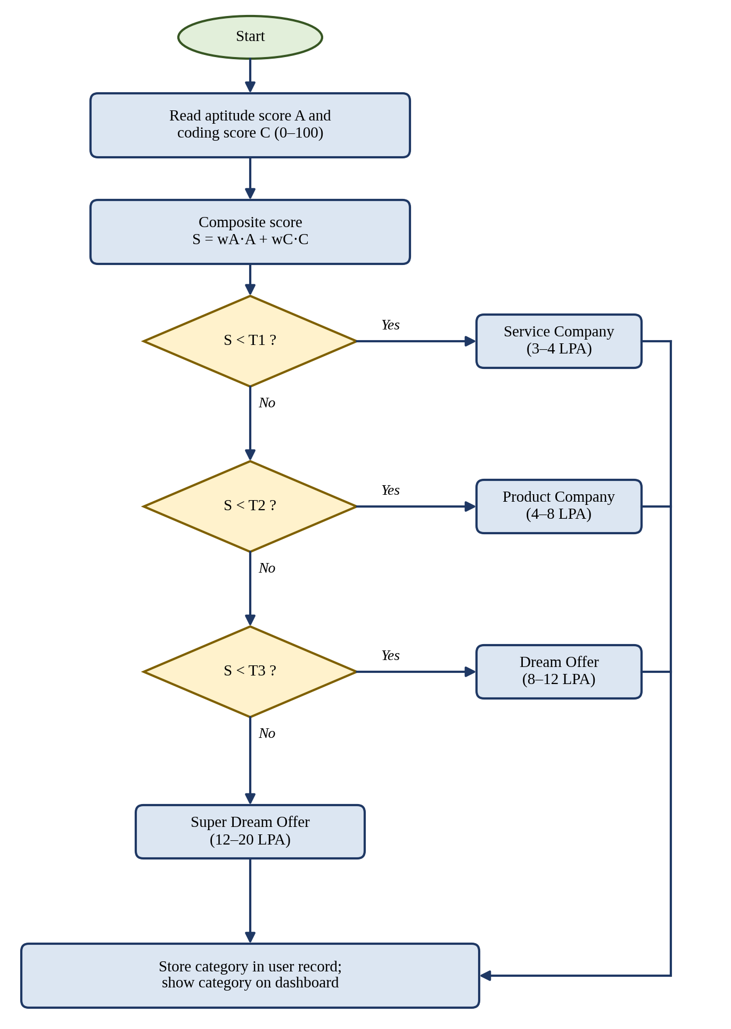
Figure 3.3: Flowchart of the categorisation algorithm
3.6.2 Concept-wise scoring and skill-gap detection (Algorithm 2). Every question carries one skill concept tag. After a round, the marks earned in each concept are divided by the maximum marks for that concept to give the concept score sk. A concept is weak when sk is below the required level Rk of the category, and its gap is gk = Rk − sk. Concepts are ranked by gap so that the largest deficiency is handled first. The list of concept scores is also the explanation shown to the student, since it states which concepts raised or lowered the round result, in the spirit of the feature-wise explanations used in [1] and [5].
Algorithm 2: Skill-gap detection after a round
Input: scored answers of round r, each with concept tag k; required levels Rk
Output: strong set S, weak set W with gaps gk
1. For each concept k present in the round: earned_k = sum of marks obtained; max_k = sum of maximum marks.
2. Compute sk = earned_k / max_k.
3. If sk ≥ Rk, add k to the strong set S.
4. Else add k to the weak set W with gap gk = Rk − sk.
5. Sort W in descending order of gk.
6. Return S and W.

For q answered questions and c distinct concepts the cost is O(q) for aggregation and O(c log c) for sorting.
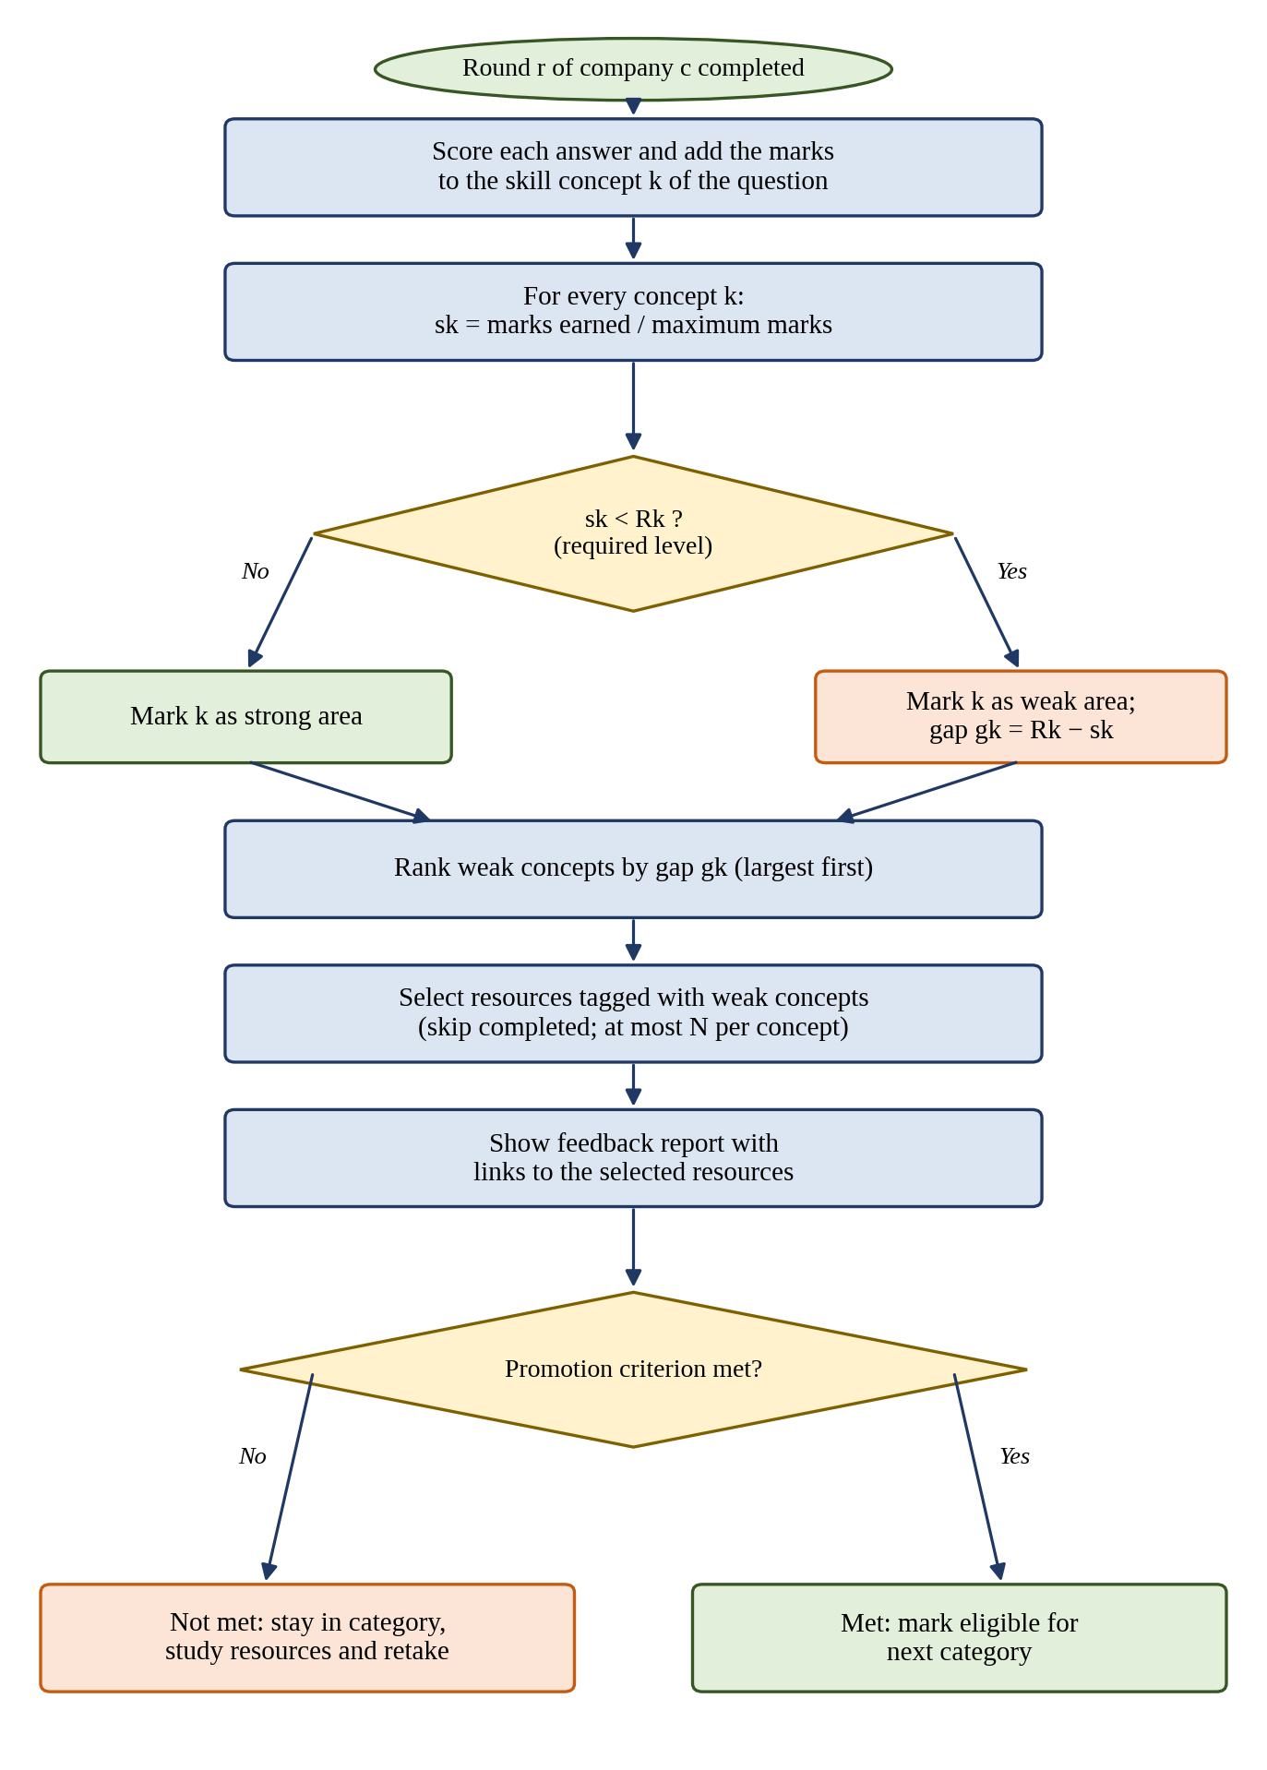
Figure 3.4: Flowchart of skill-gap detection, recommendation and promotion check
3.6.3 Resource recommendation (Algorithm 3). Each learning resource carries one or more concept tags. For a weak concept, the resources that carry its tag are retrieved. Resources already completed by the student are skipped. When a resource carries several tags, its relevance is the sum of the gaps of the weak concepts it covers, so that one resource addressing several weak concepts is preferred. At most N resources are shown for each weak concept, and the concept with the largest gap is listed first. This design relies on concept links between learning items and users’ needs, the principle that [3] found to improve recommendation quality when the semantic relations between courses and concepts were used.
Algorithm 3: Recommend resources for weak concepts
Input: weak set W with gaps gk, resource library with tags, completed resources of the student, N
Output: ordered recommendation list L
1. Set L to empty.
2. For each concept k in W in descending order of gk:
a. Retrieve candidate resources whose tags contain k and which the student has not completed.
b. For each candidate r, compute relevance(r) = sum of gj over all j in W that are tags of r.
c. Sort candidates by relevance (descending) and then by closeness of difficulty to the category level.
d. Append the first N candidates not already in L to L.
3. Return L.

With an index on concept tags the retrieval cost for each weak concept is proportional to the number of resources carrying that tag.
3.6.4 Promotion eligibility (Algorithm 4). A company is cleared when the latest score of every round of that company is at or above the cut-off Ccr of the round. A student becomes eligible for the next category when at least K companies of the category are cleared. The number K is a parameter: K equal to the number of companies in the category means that all of them must be cleared, whereas a smaller K allows the student to advance after clearing a chosen number of companies. The project description states that a student progresses after meeting the criteria across all interview rounds, so K = 2 is used in the prototype: a student is promoted after clearing all rounds of two companies of the category. A student who does not meet the criterion stays in the category and continues with recommendations and retakes, with the same company or another. The latest attempt of each round is used, and earlier attempts are kept in the history for progress reporting.
Algorithm 4: Promotion check
Input: latest score of every round of every company of the category; cut-offs Ccr; number K
Output: eligible (true / false)
1. Set cleared = 0.
2. For each company c of the category:
a. If every round r of c has an attempt with score_cr ≥ Ccr, increase cleared by 1.
3. If cleared ≥ K, set the progress status to “eligible” and return true.
4. Otherwise return false.

The cost is proportional to the total number of rounds in the category.
3.6.5 Adaptive question selection (proposed enhancement). In [6], a knowledge-tracing model predicts the probability of a correct response for every unseen question, and the next question is the one whose predicted probability is closest to 0.5, because the outcome is then the least certain and the answer is the most informative. A simplified form is proposed for RMK SkillMap: the probability of success on a question is estimated from the student’s smoothed accuracy in the question’s concept, p(q) = (correct_k + 1) / (attempted_k + 2), and the next question is the one that minimises |p(q) − 0.5|. This replaces the deep knowledge-tracing model of [6] by a simple estimator, so the accuracy figures of [6] do not apply to it. Its benefit would have to be checked in the pilot.
Algorithm 5 (proposed): Adaptive question selection
Input: unasked questions Q, concept statistics of the student so far
Output: next question q*
1. For each q in Q with concept k: p(q) = (correct_k + 1) / (attempted_k + 2).
2. Choose q* = the question with the smallest |p(q) − 0.5|.
3. Ask q*, update correct_k and attempted_k, and repeat until the question quota is reached.

3.6.6 Machine-learning categoriser (proposed enhancement). When enough labelled records have been collected, the threshold rule can be compared with a trained classifier. The procedure follows the practice in [1], [2] and [5]: encode categorical features; balance the classes if they are imbalanced, for example with SMOTE [1]; train candidate classifiers, with Random Forest as the first candidate because it was the best single model in [5] and the basis of [2]; tune the hyperparameters; evaluate with accuracy, precision, recall and F1-score; and explain the predictions with SHAP [1], [5]. The metrics are defined as follows, where TP, TN, FP and FN are true and false positives and negatives: accuracy = (TP + TN) / (TP + TN + FP + FN); precision = TP / (TP + FP); recall = TP / (TP + FN); F1 = 2 × precision × recall / (precision + recall). A suitable label for training, such as the eventual placement outcome of past students, must be available; historical placement outcomes of past batches are not yet stored in the platform, so the classifier is first trained on the concept-wise assessment data collected by the platform, as described in the accompanying conference paper (Section 6.3).
3.6.7 AI mock interview scoring (core design). For every round of a company, the AI interview service generates questions that suit the company, the round type, the category and the concept being tested, and evaluates each answer against a scoring rubric. The platform requires the service to return a structured result for each answer: a score, the concept tag and a short comment. The scores are then aggregated by Algorithm 2. Because evaluation by a language model can vary between runs, the rubric and the concept tags are fixed by the platform and the stored scores are the ones used for later decisions. A Large Language Model (LLM) API is used; every answer is scored from 0 to 10 against a rubric of correctness, depth, clarity and relevance to the company and round.

3.7 Database Design
The data is stored in a relational database. The entity–relationship diagram is shown in Figure 3.5 and the tables are listed in Table 3.6. A category has many companies, a company has many rounds, and a mock interview session belongs to one round of one company. The design is the proposed schema for the prototype and is implemented in MySQL.
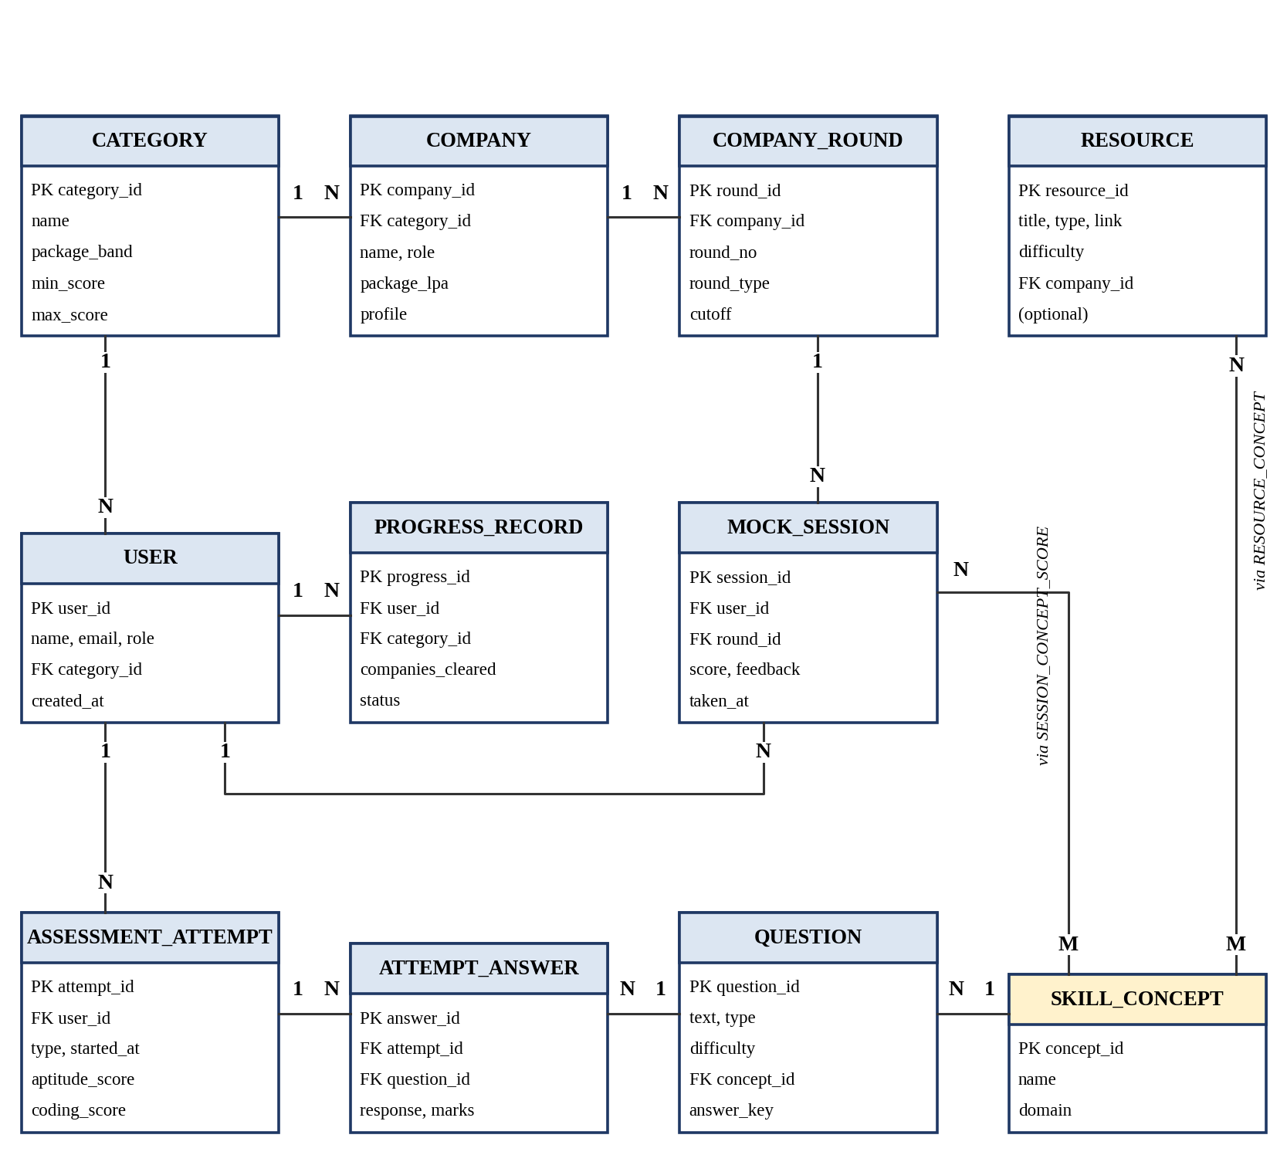
Figure 3.5: Entity–relationship diagram
Table 3.6: Database tables
Table | Principal columns | Keys and constraints
USER | user_id, name, email, password_hash, role, category_id, created_at | PK user_id; FK category_id; email unique
CATEGORY | category_id, name, package_band, min_score, max_score | PK category_id
COMPANY | company_id, category_id, name, role, package_lpa, profile | PK company_id; FK category_id
COMPANY_ROUND | round_id, company_id, round_no, round_type, cutoff | PK round_id; FK company_id; (company_id, round_no) unique
SKILL_CONCEPT | concept_id, name, domain | PK concept_id; name unique
QUESTION | question_id, text, type, difficulty, concept_id, answer_key | PK question_id; FK concept_id
ASSESSMENT_ATTEMPT | attempt_id, user_id, type, started_at, aptitude_score, coding_score | PK attempt_id; FK user_id
ATTEMPT_ANSWER | answer_id, attempt_id, question_id, response, marks | PK answer_id; FK attempt_id, question_id
MOCK_SESSION | session_id, user_id, round_id, score, feedback, taken_at | PK session_id; FK user_id, round_id
SESSION_CONCEPT_SCORE | session_id, concept_id, earned, maximum | PK (session_id, concept_id); FKs to both tables
RESOURCE | resource_id, title, type, link, difficulty, company_id (optional) | PK resource_id; FK company_id nullable
RESOURCE_CONCEPT | resource_id, concept_id | PK (resource_id, concept_id); FKs to both tables
PROGRESS_RECORD | progress_id, user_id, category_id, companies_cleared, status | PK progress_id; FK user_id, category_id

Design notes. The company a session belongs to is found through its round, so the company is not stored twice in MOCK_SESSION. The many-to-many relations between resources and concepts and between sessions and concepts are resolved by the junction tables RESOURCE_CONCEPT and SESSION_CONCEPT_SCORE, which keeps the schema in third normal form and allows Algorithms 2 and 3 to be written as joins on concept_id. A resource may optionally belong to one company (company-specific material), and this relation is not drawn in Figure 3.5 to keep it readable. The category cut-offs and the parameters of Table 3.5 are stored as data, not code. Foreign keys protect integrity, the email column is unique, and passwords are stored only as hashes. Indexes on concept_id in QUESTION and RESOURCE_CONCEPT, on company_id in COMPANY_ROUND and on user_id in the attempt and session tables support the common queries.

3.8 Prototype Screens
The main screens of the working prototype are the login screen (Figure 3.6), the student placement dashboard with concept-wise competency and weakest-first recommendations (Figure 3.7), the personalised learning plan (Figure 3.8), the resources, videos and certifications section (Figure 3.9) and the company-oriented placement modules (Figure 3.10).
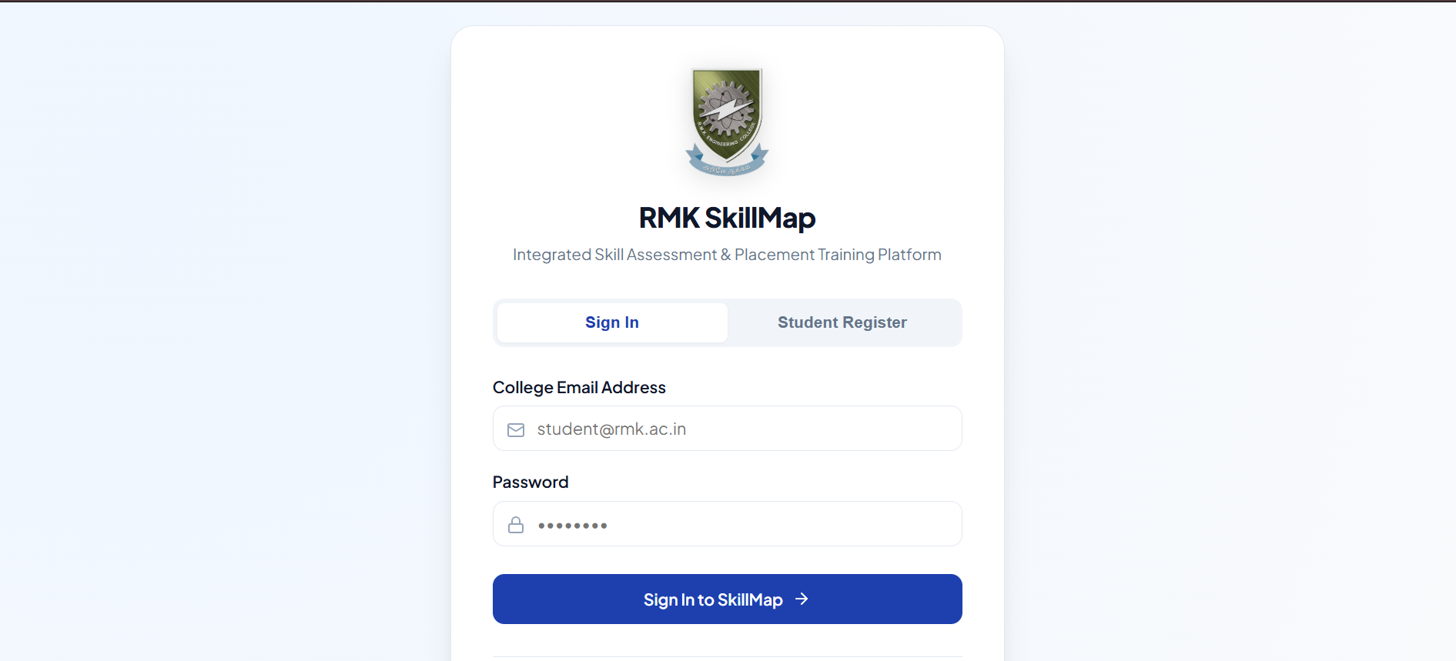
Figure 3.6: Login screen of RMK SkillMap
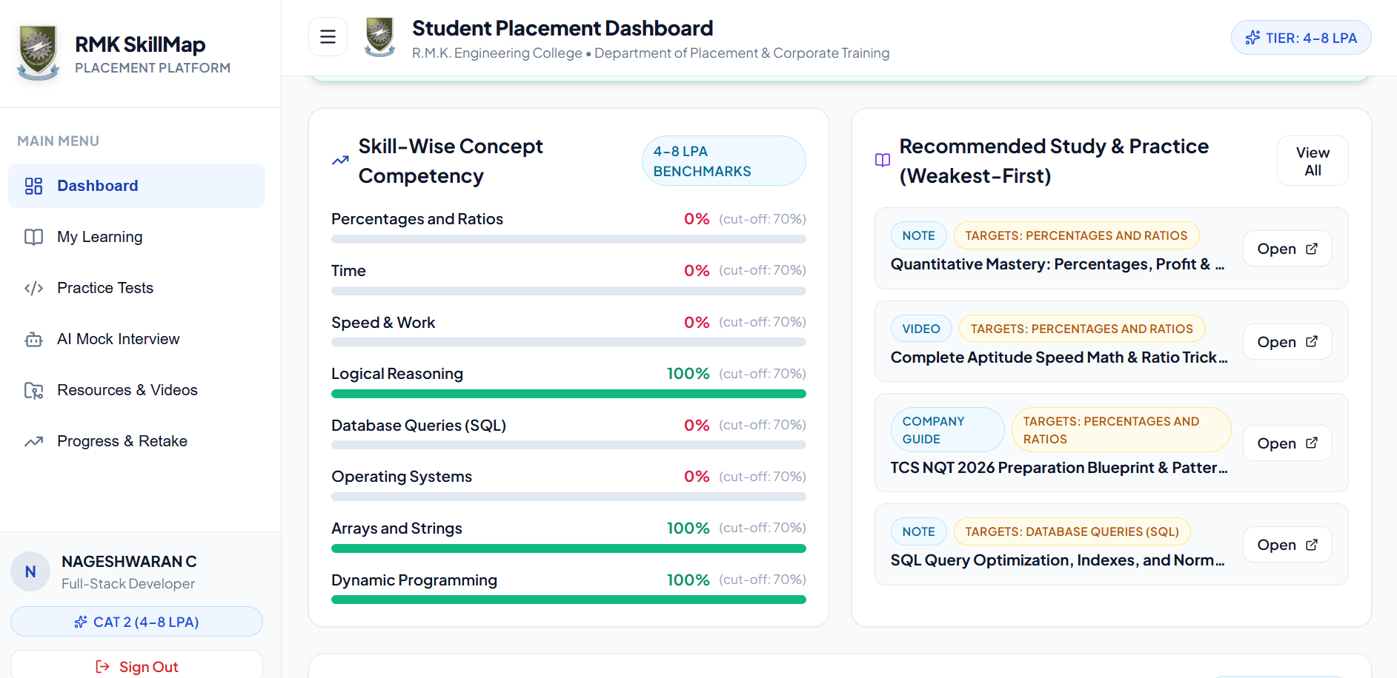
Figure 3.7: Student placement dashboard with concept-wise competency and weakest-first recommendations
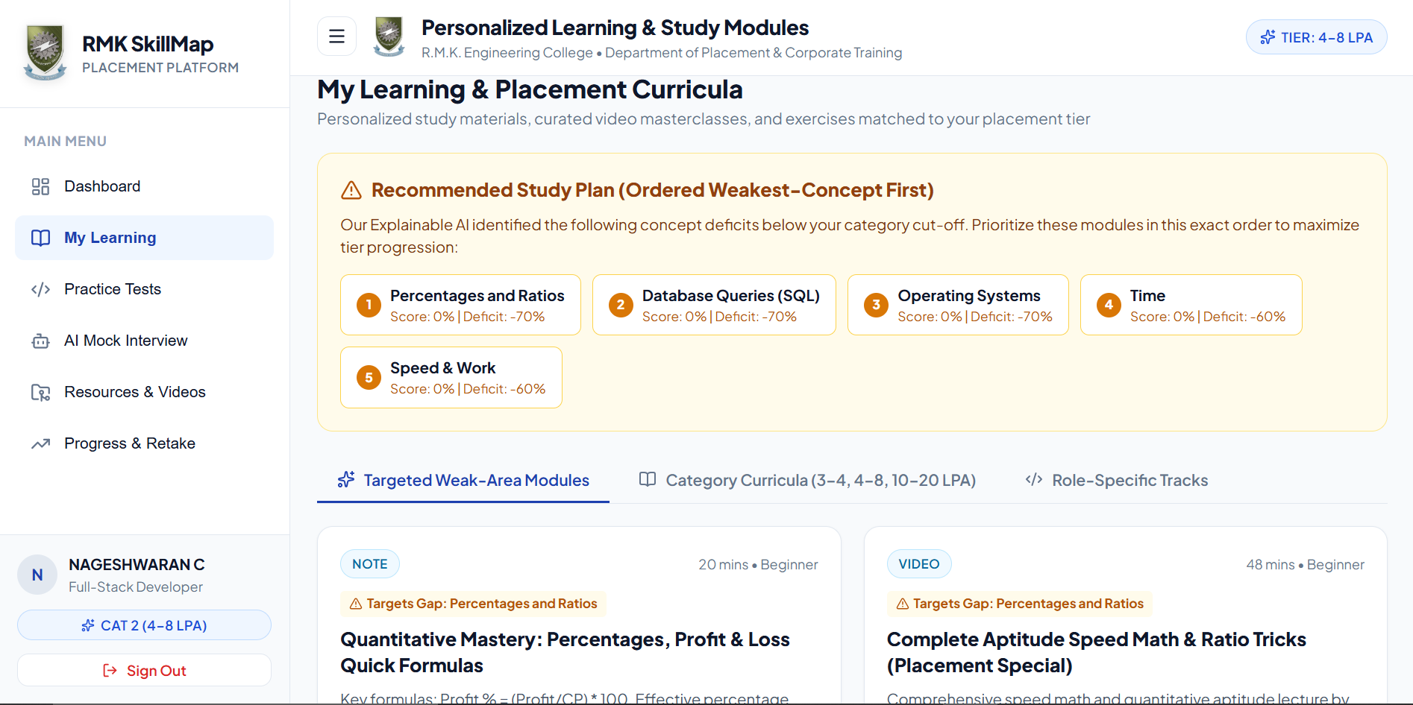
Figure 3.8: Personalised learning plan ordered weakest concept first
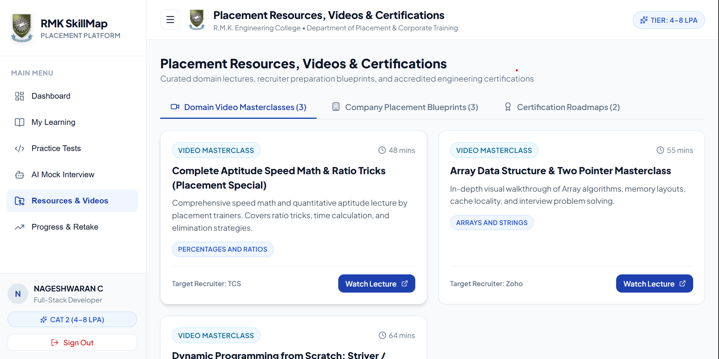
Figure 3.9: Placement resources, videos and certifications
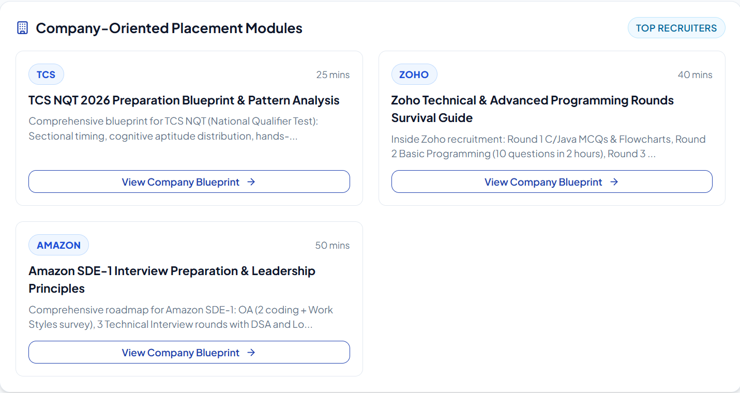
Figure 3.10: Company-oriented placement modules
Table 3.7 lists every feature and states whether it belongs to the core scope or is a proposed enhancement. The status column uses the values Implemented, Partially implemented or Planned, and the evidence column refers to a figure or a table of this report.
Table 3.7: Implementation status of features
Feature | Type | Status | Evidence
Registration, login and role-based access | Core scope | Implemented | Figure 3.6; Table 4.1 (JWT, role-based access)
Initial aptitude and coding assessment | Core scope | Implemented | Figure 3.7 (concept-wise scores)
Composite scoring and category assignment (Algorithm 1) | Core scope | Implemented | Figure 3.7 (assigned category shown)
Role based hiring track | Core scope | Implemented | Figure 3.8 (Role-Specific Tracks tab)
Companies listed under each category | Core scope | Implemented | Figure 3.10; Table 3.4
Company-wise round configuration | Core scope | Partially implemented | Figure 3.10 (round pattern per company)
Company-specific material and practice tests | Core scope | Implemented | Figures 3.8 and 3.10
Industry certification guidance | Core scope | Implemented | Figure 3.9 (Certification Roadmaps tab)
AI mock interview: aptitude round (per company) | Core scope | Implemented | AI Mock Interview menu (Figure 3.7)
AI mock interview: technical round (per company) | Core scope | Implemented | AI Mock Interview menu (Figure 3.7)
AI mock interview: HR round (per company) | Core scope | Implemented | AI Mock Interview menu (Figure 3.7)
Concept-wise skill-gap detection (Algorithm 2) | Core scope | Implemented | Figure 3.7; Figure 3.8
Resource recommendation (Algorithm 3) | Core scope | Implemented | Figures 3.7 and 3.8 (weakest-first list)
Progress tracking and retake history | Core scope | Implemented | Progress & Retake menu (Figure 3.7)
Promotion to next category (Algorithm 4) | Core scope | Partially implemented | Test T15 (Table 4.5)
Reference section with video resources | Core scope | Implemented | Figure 3.9
Administrator module | Core scope | Partially implemented | Administrator dashboard (Table 4.1)
Adaptive question selection (Algorithm 5) | Proposed enhancement | Planned | Algorithm 5; Section 5.3
Machine-learning categoriser with explanation | Proposed enhancement | Partially implemented | Flask + scikit-learn + SHAP service; Figure 3.8
Concept knowledge graph for recommendation | Proposed enhancement | Planned | Section 5.3

CHAPTER – 4
IMPLEMENTATION
This chapter describes how the design of Chapter 3 is realised: the technology stack, the architecture, the modules, the testing approach and the framework for reporting results. The technology stack used for the prototype is given in Table 4.1.

4.1 Technology Stack
Table 4.1: Technology stack
Layer | Technology | Role in the platform
Frontend | React.js, HTML5, CSS3, JavaScript | Student portal, dashboard, assessment pages, interview interface and admin dashboard
Backend | Node.js + Express.js | REST APIs, business logic, authentication, module integration
Database | MySQL | Users, questions, assessments, scores, categories, interview sessions, resources and progress
AI / analysis service | Python + Flask + scikit-learn + SHAP | Skill-gap analysis, scoring logic and explainable feedback
AI interview | Large Language Model (LLM) API | Generates interview questions and evaluates aptitude, technical and HR answers
Code evaluation | Sandboxed code-execution service | Safely runs submitted code against test cases
Security | JWT authentication + role-based access control | Protects student/admin routes and restricts access to personal results
Development tools | Git, GitHub, VS Code, Postman | Version control, coding and API testing

4.2 System Architecture
RMK SkillMap has a layered architecture (Figure 4.1). The presentation layer holds the student portal and the administrator dashboard. The application layer exposes the REST API and performs authentication and role checks. The service layer contains the functional modules of Section 4.3. The data layer contains the relational database and the content repository for study material, question bank and video references, and the platform connects to external services for AI interviews and code execution.
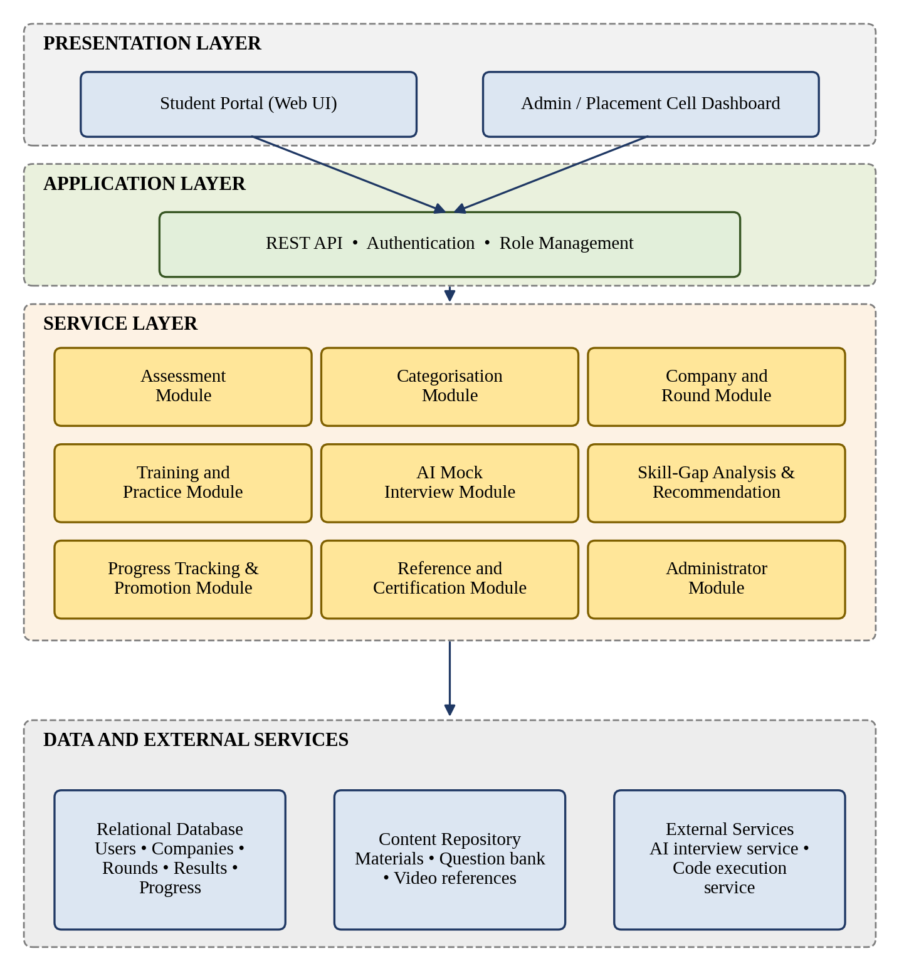
Figure 4.1: Layered architecture of RMK SkillMap
Figure 4.2 is the context-level data flow diagram. It shows the data that cross the boundary of the platform: the students supply login details and answers and receive categories, scores, feedback and recommendations; the administrator supplies questions, material and cut-offs and receives progress reports; and the two external services exchange answers, questions, scores, code and execution results with the platform.
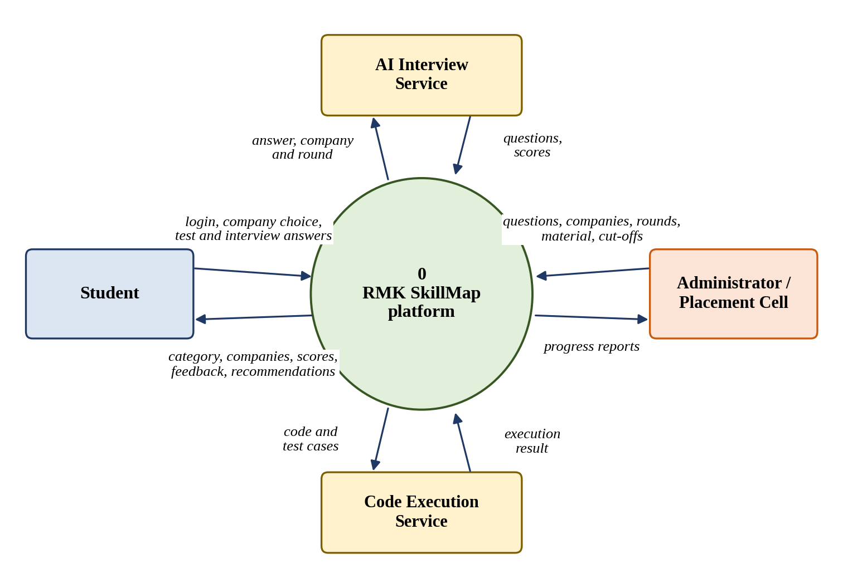
Figure 4.2: Context-level data flow diagram
The most important interaction is an interview round, from the first question to the feedback report. Figure 4.3 shows its sequence. The API server mediates between the interface, the AI service, the analysis module and the database. The answer is stored before the round ends, so that an interruption does not lose it (NFR2).
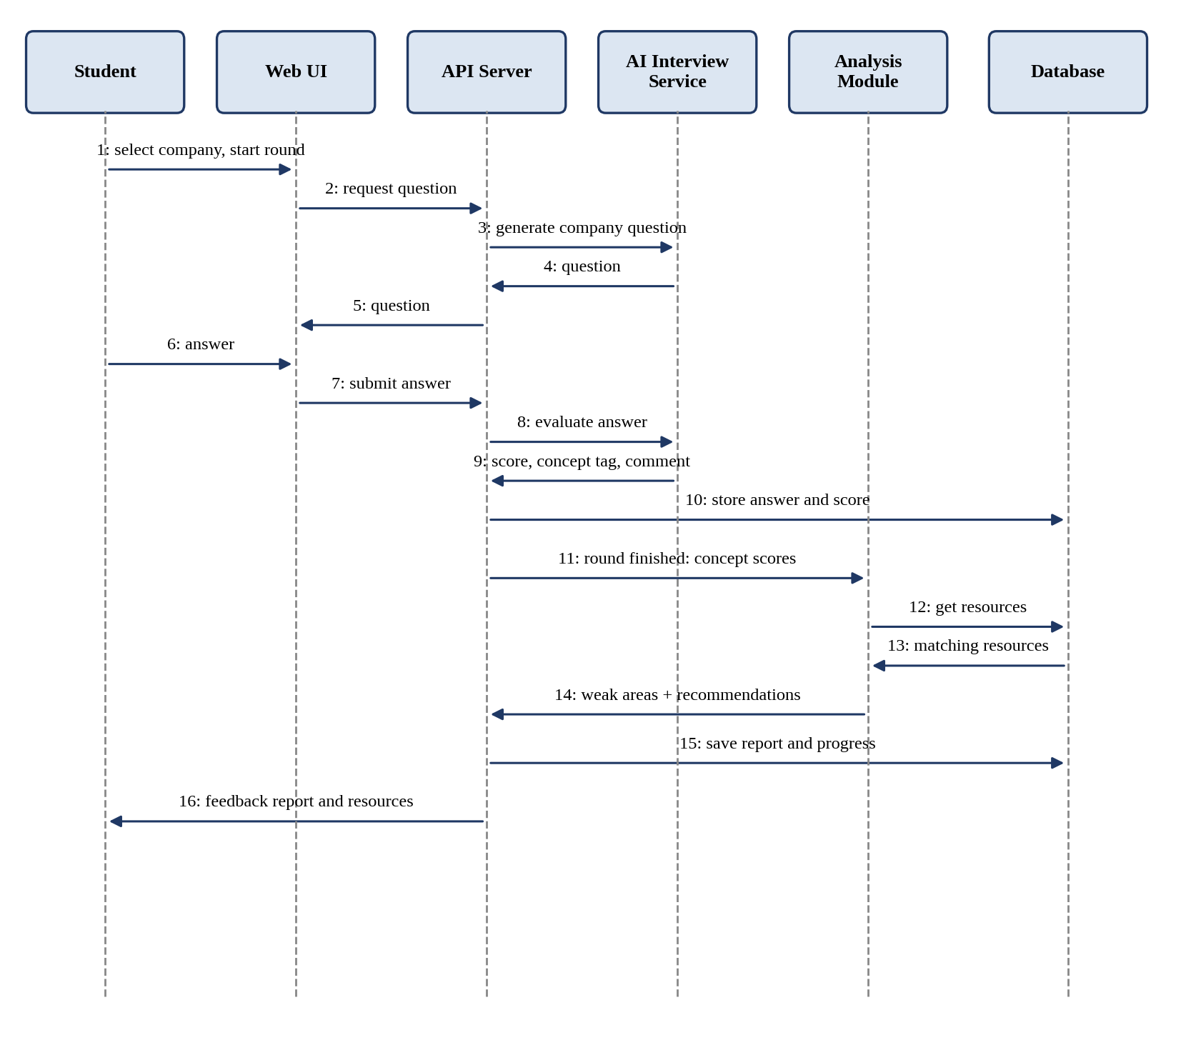
Figure 4.3: Sequence diagram of an AI mock interview round
Interface design. Table 4.2 lists the REST operations that realise the functional requirements. These operations are exposed by the Node.js/Express REST API; the Python/Flask analysis service is called by the API for skill-gap analysis and explanation.
Table 4.2: Proposed REST operations
Operation | Purpose | Requirement
POST /auth/register, /auth/login | Create an account and authenticate | FR1
GET /assessment/initial; POST /assessment/submit | Deliver the initial test and receive answers | FR2
GET /me/category | Return the category and scores of the logged-in student | FR3
GET /categories/{id}/companies; GET /companies/{id}/rounds | List the companies of the category and the rounds of a company | FR4
GET /companies/{id}/materials | List company-specific material and practice tests | FR5
POST /interview/start (round_id); POST /interview/answer | Start a round of a company and submit an answer | FR6
GET /interview/{id}/report | Return concept-wise result, weak areas and recommendations | FR7, FR8
GET /progress | Return attempt history, cleared companies and eligibility | FR9, FR10
GET /references?domain= | Return video references and certification guidance | FR11
POST /admin/questions, /admin/companies, /admin/rounds; PUT /admin/config; GET /admin/reports | Manage questions, companies, rounds, parameters and reports | FR12

Security design. Passwords are stored as salted hashes. Each request carries a JSON Web Token (JWT) that is validated by the API layer, and every operation checks the role of the user, so that students cannot reach administrator operations or the results of other students (NFR1). All inputs are validated on the server, and submitted programs are run only in the isolated code execution service. JWT authentication and role-based access control protect the student and administrator routes and restrict access to personal results.

4.3 Module Description
Table 4.3 summarises the inputs, processing and outputs of each module. The algorithms referred to are specified in Section 3.6, so they are not repeated here.
Table 4.3: Module summary
Module | Inputs | Processing | Outputs and data
1. Authentication and Profile | Credentials, role | Hash check, token issue, role check | Session; USER
2. Initial Assessment | Aptitude and coding answers | Objective scoring; coding answers run on test cases; concept-wise totals | Scores A and C; ASSESSMENT_ATTEMPT, ATTEMPT_ANSWER
3. Categorisation | A, C, parameters, role choice | Algorithm 1 | Category; USER.category_id
4. Company and Round | Category, selected company | Retrieve the companies of the category and the ordered rounds and cut-offs of the company | Company list, round list; COMPANY, COMPANY_ROUND
5. Training and Practice | Selected company | Selection of company-specific material; timed tests scored on submission | Practice scores; ASSESSMENT_ATTEMPT, RESOURCE
6. AI Mock Interview | Company, round, category, answers | Question generation and rubric scoring by the AI service (3.6.7) | Answer scores with concept tags; MOCK_SESSION
7. Skill-Gap Analysis and Recommendation | Concept scores, Rk, resource tags | Algorithms 2 and 3 | Weak areas, ordered resources; SESSION_CONCEPT_SCORE
8. Progress Tracking and Promotion | Latest round scores, Ccr, K | Algorithm 4; history comparison | Cleared companies, eligibility; PROGRESS_RECORD
9. Reference and Certification | Domain | Retrieval of tagged videos and certification guidance | Reference list; RESOURCE
10. Administrator | Questions, companies, rounds, material, parameters | Create, update, tag; report queries | Updated tables; reports

Company and round module. The module gives the student the list of companies of the category and, for a selected company, its ordered rounds with their types and cut-offs. All of this is read from the database, so the administrator can add a company or change its rounds without any change to the program. The round chosen by the student determines the question type and the cut-off used by the later modules.
Initial assessment. The aptitude part consists of objective questions that are scored automatically. Coding questions are evaluated by running the submitted program against stored test cases in the code execution service, and the share of passed cases gives the coding marks. Both parts record marks per concept, which is the input for the concept-wise analysis after later rounds.
AI mock interview. A round of the selected company starts by selecting the question types for that round. The AI service returns one question at a time, suited to the company and the round, with its concept tag. The platform stores each answer and its score immediately, and when the round is finished it calls the analysis module with the concept totals. The student then receives one report with the round score, the concept-wise result and the recommended resources, and the result is compared with the cut-off of that round of the company.
Recommendation and progression. The report links to resources inside the platform, so a student can open them directly and then retake the round. The progress module keeps every attempt, which allows the improvement between attempts to be shown and the promotion rule of Algorithm 4, which counts the cleared companies, to be applied.

4.4 Testing and Validation
4.4.1 Test strategy. Testing is carried out at the levels listed in Table 4.4. The algorithms of Section 3.6 are deterministic and are therefore verified by unit tests with hand-computed expected values, whereas the AI service is non-deterministic and is verified by checking that its output has the required structure and that stored scores are used consistently.
Table 4.4: Test levels
Level | Scope | Method
Unit | Score calculation, Algorithms 1–4, parameter handling | Inputs with known expected outputs, including boundary values of T1, T2, Rk and Cr
Integration | Interface–API–database; API–AI service; API–code execution service | Run a full round and a full assessment with sample data
System | Complete student journey from first login to promotion | Scenario testing with sample accounts
Security | Role-based access and authentication | Attempts to reach other users’ data and administrator operations
Acceptance | Usefulness and usability for students and the placement cell | Pilot use and questionnaire (4.4.3)

4.4.2 Test cases. Table 4.5 lists the test cases. The expected results follow from the requirements, and the actual result and status columns record the outcome observed when the prototype was tested.
Table 4.5: Test cases
ID | Module | Test and condition | Expected result | Actual | Status
T1 | Authentication | Register with a valid and with a duplicate email | Valid account created; duplicate rejected | As expected | Pass
T2 | Authentication | Student opens an administrator operation | Access denied | As expected | Pass
T3 | Authentication | Student requests another student’s result | Access denied | As expected | Pass
T4 | Initial Assessment | First login of a new student | Initial assessment opens before other pages | As expected | Pass
T5 | Initial Assessment | Submit a coding answer that passes some of the test cases | Marks proportional to passed cases | As expected | Pass
T6 | Categorisation | S exactly equal to T1, to T2 and to T3 | Product company, Dream offer and Super dream offer respectively (Algorithm 1) | As expected | Pass
T7 | Categorisation | S below T1, between T1 and T2, between T2 and T3, above T3 | Service company, Product company, Dream offer, Super dream offer | As expected | Pass
T8 | Company and Round | Student opens the company list | Only the companies of the student’s category are shown | As expected | Pass
T9 | Company and Round | Open a company with its rounds defined | Rounds appear in the configured order with their types | As expected | Pass
T10 | AI Mock Interview | Complete a round of a company | Every answer stored with score and concept tag | As expected | Pass
T11 | AI Mock Interview | Close the browser in the middle of a round | Answers already submitted are retained | As expected | Pass
T12 | Skill-Gap Analysis | Concept score below Rk; equal to Rk | Weak; strong | As expected | Pass
T13 | Recommendation | Weak concept with several tagged resources | At most N resources, ordered by Algorithm 3 | As expected | Pass
T14 | Recommendation | Resource already completed by the student | Not recommended again | As expected | Pass
T15 | Promotion | All rounds of K companies at or above Ccr; one round below Ccr | Eligible; not eligible (Algorithm 4) | As expected | Pass
T16 | Administrator | Add a company with two rounds and change T1 | Company appears for students; new threshold applied without code change | As expected | Pass

4.4.3 Validation plan. Passing the test cases shows that the software behaves as specified. It does not show that the categories are sensible or that the recommendations help. Table 4.6 therefore defines the measures that are to be collected during the pilot use of the platform.
Table 4.6: Validation measures
Measure | Definition | Data needed
Category agreement | Number of students whose assigned category agrees with the judgement of the placement faculty divided by the number of students | Faculty judgement for a sample
Score improvement | Mean latest score minus mean first score of a round for students who retook it | Attempt history
Recommendation relevance | Precision at N = relevant recommendations among N shown, as judged by faculty | Faculty review of reports
Progression rate | Students eligible for the next category divided by students who attempted the rounds of at least K companies | Progress records
Usability | Mean rating of questionnaire statements on a 1–5 scale | Student questionnaire

4.5 Results and Discussion
This section reports the indicative results of an initial trial in which a small group of students used the prototype and the measures of Table 4.6 were collected. The group is small and self-selected, so the figures show the behaviour of the platform and should not be read as a proof of its effect on real placement outcomes.
Table 4.7: Pilot setup
Item | Value
Number of students and their department and year | 60 students, B.Tech Information Technology, second year
Duration of the pilot | 3 weeks
Number of questions in the bank and number tagged with concepts | 480 questions in the bank; 480 tagged with concepts
Number of learning resources and number tagged with concepts | 24 resources (notes, videos, company guides, certification roadmaps); 24 tagged with concepts
Number of mock interview sessions completed | 142 sessions completed

Table 4.8: Distribution of students by category after the initial assessment
Category | Students | Percentage
Service company | 14 | 23.3%
Product company | 24 | 40.0%
Dream offer | 12 | 20.0%
Super dream offer | 4 | 6.7%
Role based hiring | 6 | 10.0%

Table 4.9: Participation by company
Company | Category | Students who attempted | Students who cleared all rounds
TCS | Service company | 28 | 17
Zoho | Product company | 22 | 11
Amazon | Super dream offer | 9 | 3

Table 4.10: Round-wise performance and improvement
Round | Students | Mean first score | Mean latest score | Change
Aptitude | 60 | 48.5 | 61.2 | +12.7
Technical | 54 | 42.3 | 55.8 | +13.5
HR | 48 | 55.0 | 63.4 | +8.4

Table 4.11: Recommendation relevance and progression
Measure | Value
Reports reviewed by faculty and recommendations judged | 30 reports reviewed; 90 recommendations judged
Precision at N | 0.82 (N = 3)
Students eligible for the next category | 9 of 60 students (15%)
Mean usability rating (1–5) | 4.2

Points for discussion. (a) Whether the categories separate students of clearly different skill, which can be checked by comparing later round scores across categories; the expectation that the initial score predicts later performance comes from [4]. (b) Whether students who studied the recommended resources improved more than those who did not, which is the effect that [6] left for future evaluation. (c) How the concept-wise explanation was received by students, compared with the explanation approach of [5]. (d) Whether the thresholds T1 and T2 and the number K need to be revised, and whether some companies are cleared much more or much less often than others, which would indicate that their round cut-offs are mis-set.
Threats to validity. The sample size and the self-selection of students may limit the generalisation, as the authors of [4] and [2] also note for their own data. The results depend on the quality of the question bank and of the resource tags. The AI evaluation may vary between runs. Improvement between a first and a later attempt may also come from familiarity with the questions and not only from learning.

CHAPTER - 5
CONCLUSION

5.1 Summary of the Work
This report has presented RMK SkillMap as a response to a definite problem: placement training that is uniform, unmeasured and without a path of progression. The literature review (Chapter 2) showed that the techniques needed for each part of the problem exist in separate studies, namely prediction and classification of student performance [1], [2], [4], explanation of predictions [1], [5], concept-linked recommendation [3] and adaptive assessment with recommendation [6], but that no study combines them for package-wise placement preparation with interview-based evaluation and promotion.
The report contributes a problem formulation (P1–P5); a requirements specification; a workflow and a set of configurable rules for categorisation and promotion, with companies and company-wise rounds inside each category; four core algorithms for categorisation, concept-wise skill-gap detection, resource recommendation and promotion checking, with two proposed enhancements; a relational database design that links questions, resources and interview results through skill concepts; a layered architecture with an interface specification; and a testing and validation plan with defined measures. The implementation status of each feature is recorded in Table 3.7, and the indicative results of the initial trial are given in Section 4.5. The report claims a working prototype and indicative results, not a demonstrated improvement in actual placement outcomes.

5.2 Limitations
The platform depends on a sufficiently large and well-tagged question bank and resource library, and on category cut-offs that are set and reviewed by the placement cell. The initial categorisation uses a simple weighted score and is not validated by a trained model. The AI-based evaluation of interview answers supports practice and does not replace a human interviewer, and it may give different scores for the same answer. The effect on actual placement results can be judged only after use by a larger group over a full placement season.

5.3 Future Work
- Adaptive assessment. Introduce the question selection of Algorithm 5, and compare it with a fixed test, following [6].
- Trained categoriser. Collect labelled data, balance the classes, and compare a Random Forest categoriser with the threshold rule using accuracy, precision, recall and F1-score, as in [1], [2] and [5]; explain its predictions with SHAP [1], [5].
- Concept graph. Represent the relations between skill concepts as a graph and use it to rank resources, as the knowledge graph does in [3].
- Evaluation of effect. Run a pre-test and post-test study with a control group to measure the effect of the recommendations, which [6] identifies as a necessary next step.
- Richer interviews. Add voice-based interviews and company-wise eligibility analysis.

CHAPTER - 6
PRODUCT/PROCESS OUTCOME – PAPER WORK & CONFERENCE CERTIFICATE

6.1 Product Outcome
The product outcome is the RMK SkillMap web platform. Table 6.1 lists the deliverables. The status of each deliverable is given in the table.
Table 6.1: Product deliverables
Deliverable | Description | Status
Student portal | Assessment, category dashboard, company selection, practice tests, company-wise mock interviews, feedback, reference section | Completed
Administrator dashboard | Question bank, company and round management, material and reference management, cut-offs, reports | Partially completed
Database | Schema of Table 3.6 with sample data | Completed
Documentation | This project report, test cases and user guide | Completed (this report)

6.2 Process Outcome
The process outcome is the repeatable training cycle defined by the platform: initial assessment, categorisation, company-wise training inside the category, interview-based evaluation, concept-wise gap analysis, resource recommendation and rule-based promotion. The cycle, the configurable parameters of Table 3.5 and the validation measures of Table 4.6 can be applied by any department of the college that supplies its own tagged question bank and resource library.

6.3 Paper Work
A paper based on this work, "Machine Learning-Based Skill-Gap Prediction and Adaptive Recommendation Framework for Integrated Placement Preparation", has been submitted to the 2027 6th IEEE International Conference on Computer Vision and Machine Intelligence (CVMI 2027). The details are given in Table 6.2, and the proof of submission is shown in Section 6.4.
Table 6.2: Details of the paper work
Particulars | Details
Title of the paper | Machine Learning-Based Skill-Gap Prediction and Adaptive Recommendation Framework for Integrated Placement Preparation
Authors | NAGESHWARAN C (R.M.K. Engineering College)
Conference / Journal | 2027 6th IEEE International Conference on Computer Vision and Machine Intelligence (CVMI 2027); Paper ID 368
Date and venue | Submitted on 14 October 2026 through the Conference Management Toolkit (CMT); conference dates and venue to be announced by the organisers
Status (presented / accepted / communicated) | Communicated (submitted, under review)

6.4 Conference Paper Submission Proof
The first page of the Conference Management Toolkit (CMT) submission summary of the paper is given below as proof of submission. It shows the conference name, the paper ID, the title and abstract of the paper, the author and the submission time.
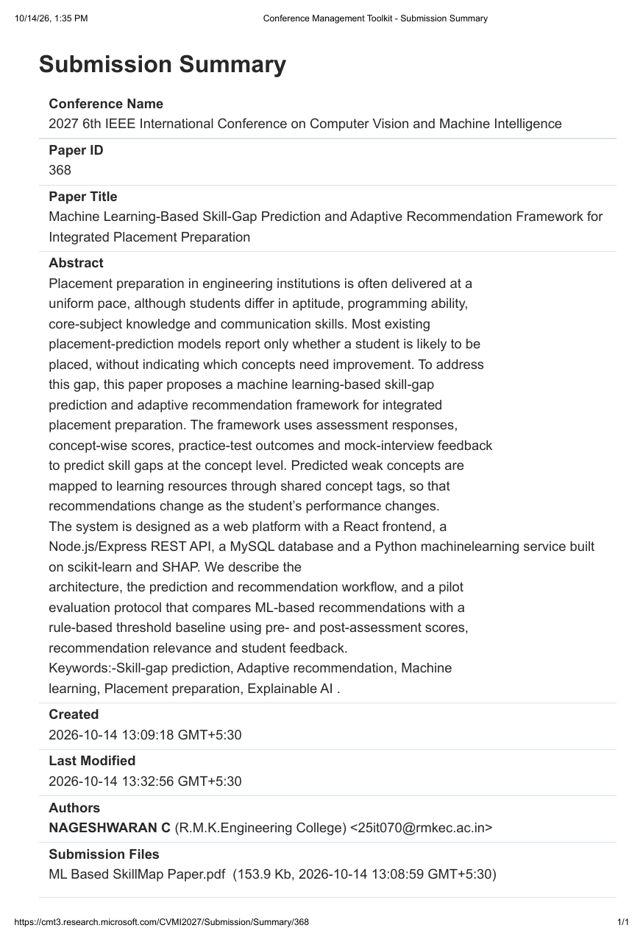
Figure 6.1: Conference paper submission summary (CMT, Paper ID 368)

REFERENCES
[1] M. R. Islam, A. M. Nitu, M. A. Marjan, M. P. Uddin, M. I. Afjal, and M. A. A. Mamun, “Enhancing tertiary students’ programming skills with an explainable Educational Data Mining approach,” PLoS ONE, vol. 19, no. 9, p. e0307536, Sep. 2024, doi: 10.1371/journal.pone.0307536.
[2] Y. Chen and K. Jin, “Educational performance prediction with Random Forest and innovative optimizers: A data mining approach,” International Journal of Advanced Computer Science and Applications (IJACSA), vol. 15, no. 3, pp. 69–78, 2024.
[3] N. Ben Hadj Boubaker, Z. Kodia, and N. Yacoubi Ayadi, “Personalized e-learning knowledge graph-based recommender system using ensemble attention networks,” in Proc. 16th Int. Conf. on Management of Digital EcoSystems (MEDES 2024), Naples, Italy, Nov. 2024, doi: 10.1007/978-3-031-93598-5_7.
[4] Y. Lou and K. F. Colvin, “Performance prediction using educational data mining techniques: a comparative study,” Discover Education, vol. 4, Art. no. 112, 2025, doi: 10.1007/s44217-025-00502-w.
[5] P. S. Patil, I. R. Marathe, and S. S. Kamble, “Student-centric explainable-AI framework for campus placement prediction,” Recent Trends in Information Technology and its Application, vol. 9, no. 3, pp. 14–24, Sep.–Dec. 2026.
[6] M. Delianidi, K. Diamantaras, I. Moras, and A. Sidiropoulos, “DK-PRACTICE: An intelligent educational platform for personalized learning content recommendations based on students knowledge state,” in The Barcelona Conference on Education 2024, Official Conference Proceedings, 2024.

