Part 1.

1. List the main entities and their key attributes based on the problem description:

* Student management (ManagementID: int(PK))
* The system (SystemID: int (PK); Attendance)
* Users ( UsersID: int (PK), Phone: varchar, Address: varchar , Email : varchar , Name: varchar)
* Manages( ManagesID: int (PK), Name: varchar, Role : varchar, Email : varchar, Phone: varchar)
* The university ( UniversityID: int (PK), StudentsID: int (FK), Quantity: int )
* Students (StudentsID: int (PK), Phone: varchar, Email: varchar, Name: varchar)
* Order( OrderID: int (PK), UsersID: int (FK), OrderDate: date, OrderStatus: varchar)

1.2

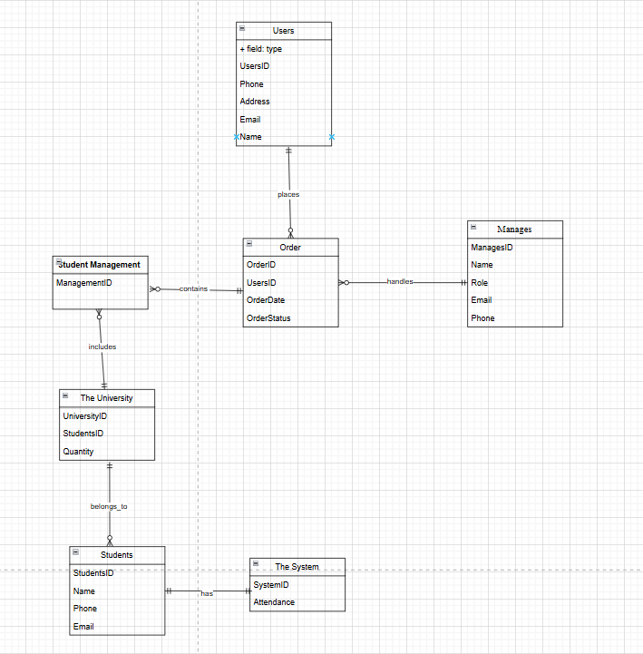

1.3

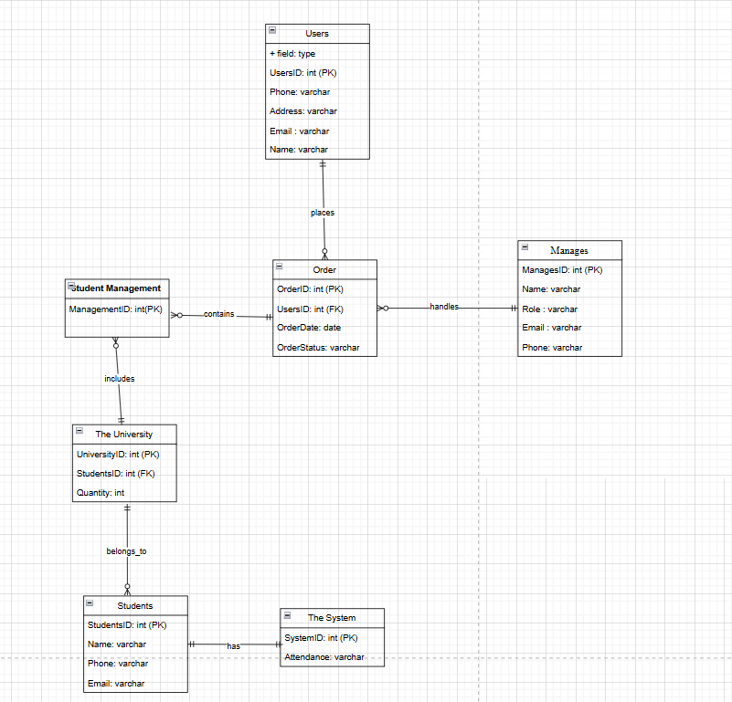

1.4

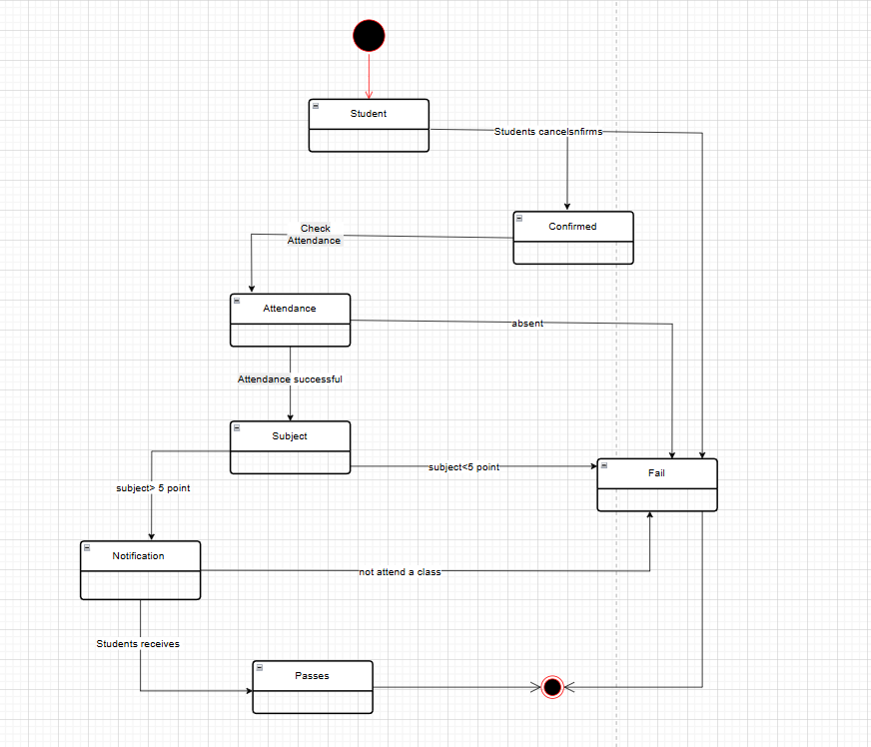

Part 2

2.1

2.2

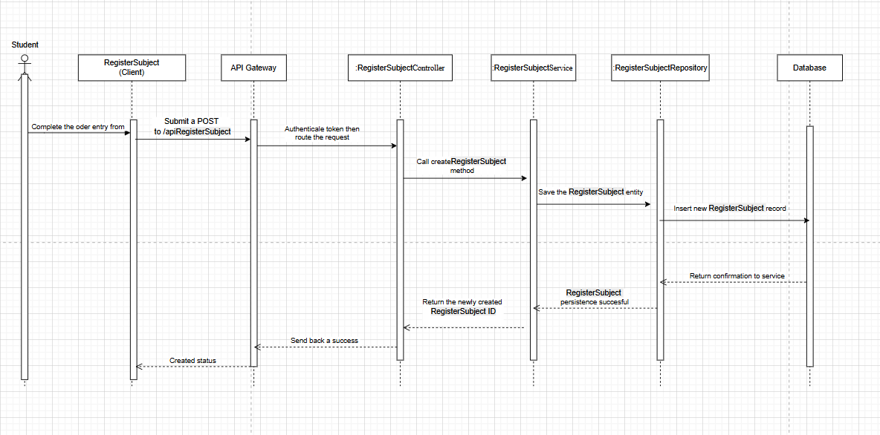

Part 3

3.1 **Name:** Prototype Pattern (Creational)

3.2

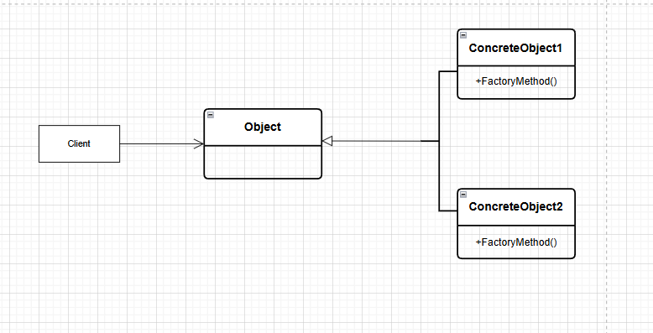

3.3

Specifies the kinds of object to create using a prototypical instance and create new object by copying this prototype