Introduction & Installation

* Install Centos via vagrant

<https://linuxacademy.com/blog/linux/vagrant-cheat-sheet-get-started-with-vagrant/>

* + **Steps:** 
    - **Create Your Vagrant Project**



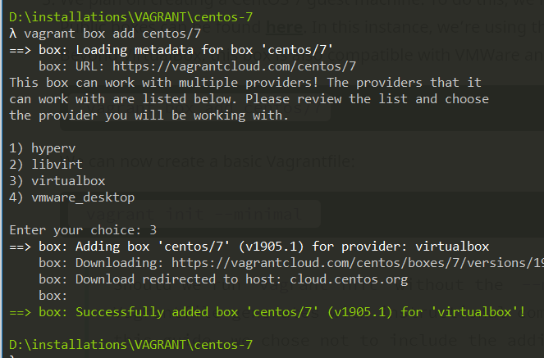

*(boxes are in C:\Users\Mehdi\.vagrant.d)*

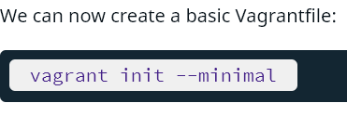

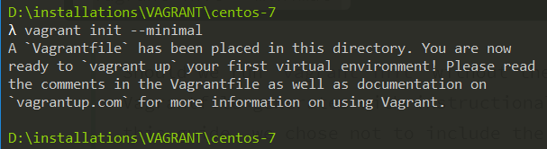

* + - **Configure the Guest Machine via the Vagrantfile**
      * A file is generated called ***Vagrantfile***
      * Update it to this

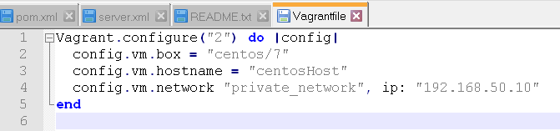

* + Run the command:

**

* + Finally, ssh into the machine

**

* Create a new user jenkins
* Install docker
* Download a Docker Jenkins image
  + Follow .txt files
  + I didn’t follow the docker compose file method
* Retrieve the Jenkins password for admin login
  + *sudo docker ps*

**

* + *sudo docker logs priceless_shannon*

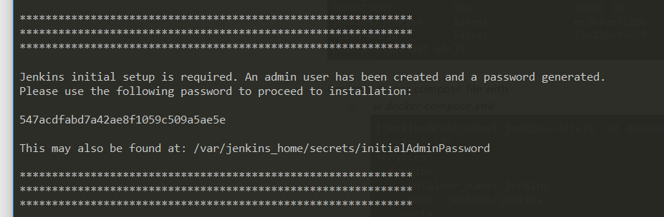

* Use @IP address is vagrant file with port 8080

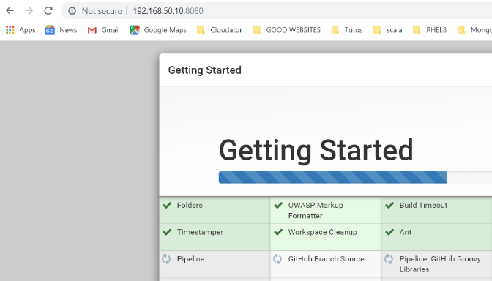

* Create jenkins user

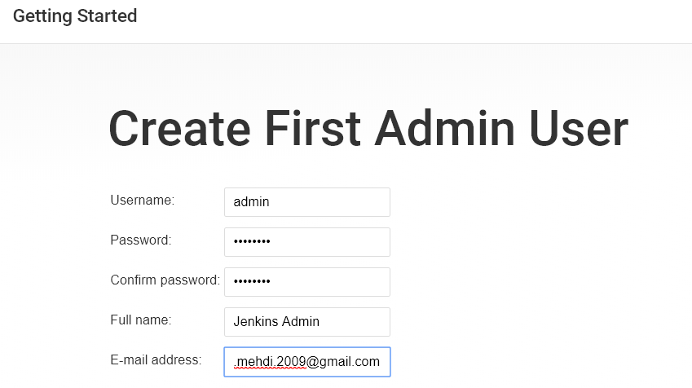

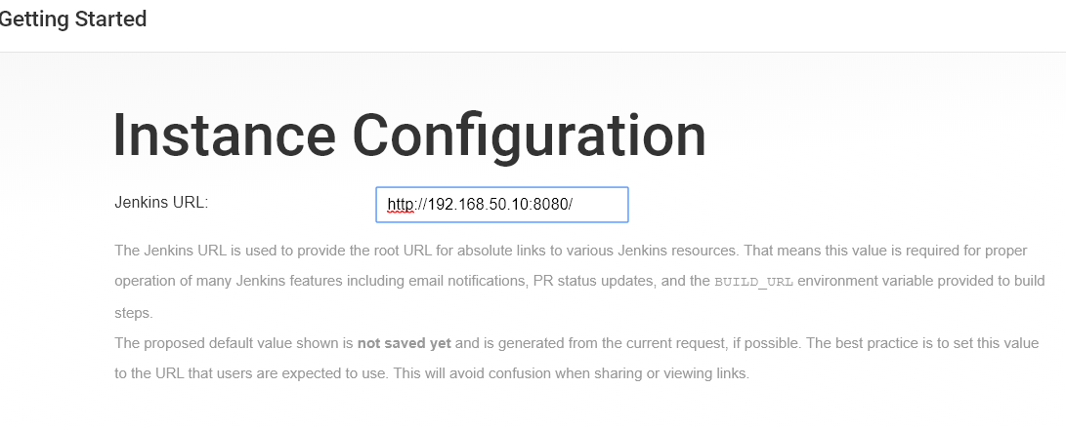

* **Create a local DNS for the Jenkins**
  + On you windows machine, find hosts file in system32/drivers

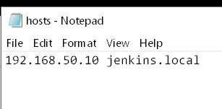

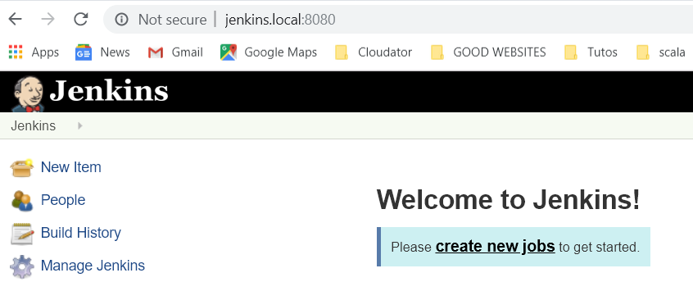

* **Some commands**
  + *docker-compose stop*
  + *docker ps*
  + *docker-compose start*
  + *docker-compose restart jenkins*