School Event Python Exercise
Build a snack sales program for a school movie night. Reuse the supplied snack_shack package to collect a quantity, calculate a total, and display a receipt.

Set up your program
Create a new folder called school_event containing school_event.py (your main program file) and your snack_shack package folder .
Write your code in school_event.py. Leave the supplied package files unchanged. You are running school_event.py so you can run that program from VScode like any other file (it is not a package).

Build the program
1. Create a main() function. Display the event title and call display.display_welcome().
2. Ask “What snack are we selling? ”. Keep asking until the name is not empty or only spaces. Display a helpful error each time.
3. Call validation.get_valid_quantity(). It already retries text, decimals, and empty numeric input. Additionally, add a loop in your program to reject zero and negative quantities Keep looping until a valid quantity > 0 is entered.
4. Call pricing.calculate_total(quantity). Use its default price of $4.00 per snack.
5. Call display.display_receipt(item_name, quantity, total). Finish with “Thanks for supporting our school movie night!”
6. Add the main guard so main() runs when the file is executed directly. Importing school_event must not prompt for input or print anything.
Function reminder: display_receipt(item_name, quantity, total) prints the snack name, quantity, and total formatted to two decimal places. Use module_name.function_name() with the supplied imports.

Successful run
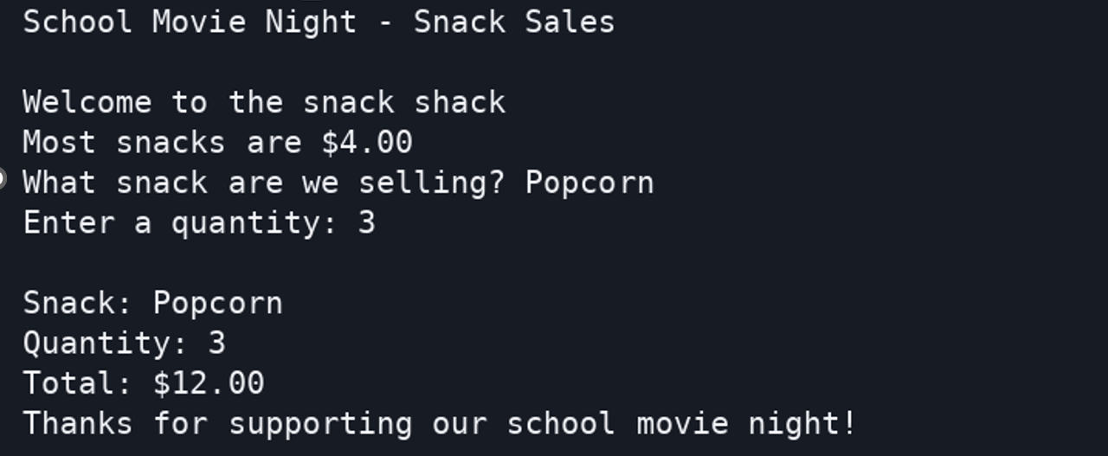

Test Invalid Input
Your program must recover from invalid entries and display a receipt only after both inputs are valid. Error wording can vary; the behaviour should match the sample run.
Snack name tests: press Enter without typing, then enter three spaces, then Popcorn. The first two attempts must be rejected. The spaces are invisible in the terminal capture below.
Quantity tests: enter three, 2.5, an empty entry, 0, -2, and finally 3. The first five attempts must be rejected. Three snacks at $4.00 should total $12.00.
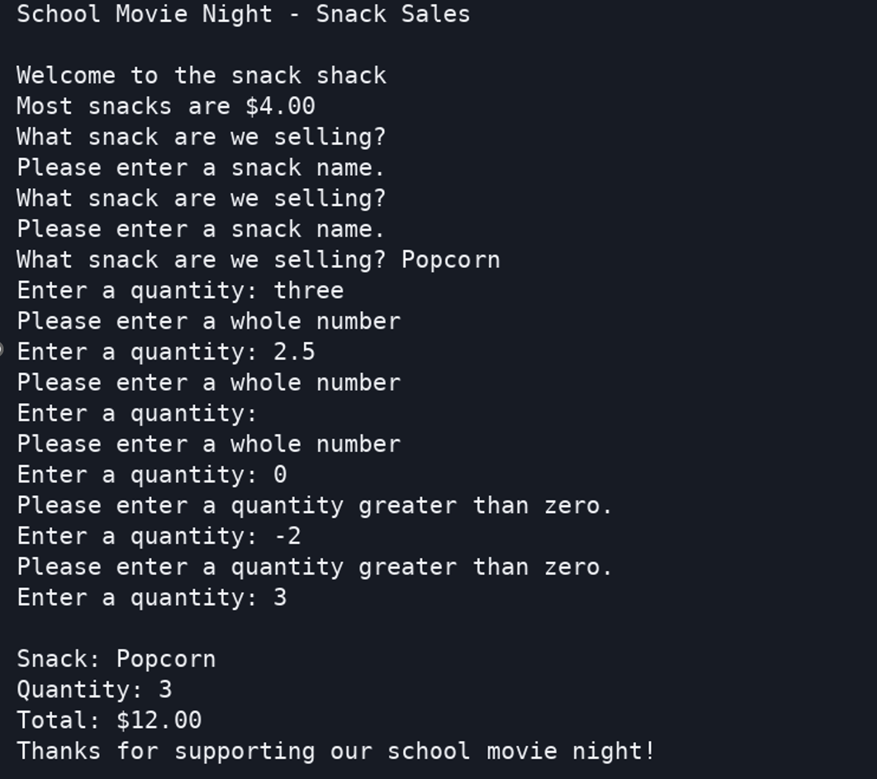
Before you finish: confirm the program accepts another snack name and quantity, such as Nachos and 5, for a $20.00 total.

