Project Phase-I – Remaining Sections
BCSE355L — Cloud Architecture Design | Project Phase-I
Name: Nishit Jain Reg. No.: 24BIT0068
Project: SentinelGraph — An Explainable Graph Neural Network Framework for Detecting and Mitigating Cloud Resource Abuse and Identity-Based Privilege Escalation in Multi-Tenant AWS Environments
Course Instructor: Dr. Priya V | Submission Deadline: 30 July 2026

1. Abstract
Multi-tenant cloud platforms like AWS let hundreds of unrelated tenants share the same compute, storage, and networking fabric, and that shared fabric is exactly what makes resource abuse so hard to catch. A tenant quietly mining crypto inside its own quota, or an IAM role that slowly escalates its own permissions through a chain of individually-legitimate API calls, rarely trips a volumetric threshold or a signature-based intrusion detector, because nothing about any single request looks wrong on its own — the problem only becomes visible when you look at the relationships between tenants, roles, and resources over time.
Existing cloud-security work falls short here in a consistent way: detection methods treat each request, session, or workload independently rather than as part of a connected tenant-resource graph; explainability is repeatedly named as necessary but almost never implemented, leaving security teams with black-box flags they have to trust blindly; most detection effort concentrates on loud, volumetric attacks rather than stealthier resource abuse; and identity-based privilege escalation is handled, when it's handled at all, using non-relational classifiers that ignore the access graph entirely.
This project proposes SentinelGraph, a graph neural network (GraphSAGE/GAT) trained over a unified tenant-resource-identity graph built from IAM activity, network telemetry, and resource-usage patterns. Alongside each detection, the model produces an attention-weight-based explanation of exactly why a tenant or role was flagged, and those explanations feed a PID-style adaptive mitigation layer that throttles or quarantines based on both anomaly severity and real-time resource headroom. The pipeline is built on AWS CloudTrail, VPC Flow Logs, and CloudWatch for ingestion; S3 and RDS for storage; Lambda for graph construction and scoring; SageMaker for model training and inference; IAM and Cognito for access control; and SNS and QuickSight for alerting and an explainable risk dashboard.

2. Novelty Summary
What I think actually separates SentinelGraph from the six papers I reviewed isn't any single component — GNNs, explainability techniques, and adaptive mitigation all exist individually in prior work. It's that none of the reviewed literature puts all of them together over one graph that spans both resource abuse and identity-based privilege escalation at the same time. Here's how that breaks down against the specific categories the guidelines ask for:
- New Feature: A single tenant-resource-identity graph that unifies two problems the literature always keeps separate — stealthy resource abuse (crypto-jacking, theft-of-service, noisy-neighbor behavior) and identity-based privilege escalation — instead of running two disconnected detectors.
- Better Algorithm: A GraphSAGE/GAT-based GNN replaces the non-relational classifiers (tree ensembles, tabular deep nets) that every reviewed paper relies on, so the model can actually learn from who is connected to what, not just isolated feature vectors.
- Better Architecture: Detection output is wired directly into a resource-aware mitigation controller inspired by Xing et al.'s RAM framework, rather than stopping at a detection score the way most reviewed systems do — closing the loop between “we found something” and “we did something about it.”
- Better AWS Integration: The whole pipeline maps onto native AWS services end to end (CloudTrail/VPC Flow Logs → S3 → Lambda → SageMaker → Step Functions → SNS/QuickSight) instead of being a purely academic pipeline bolted onto a static dataset, which is roughly where most of the reviewed papers stop.
- Better Security: Every flagged decision comes with an attention-based, human-readable justification — the exact piece Dilworth (2024) and Almulla & Albuali (2026) both name as missing from the field — so security teams can verify a decision instead of trusting a black box.
- Better Automation: Mitigation reacts automatically to risk scores computed from Shehab et al.'s (2025) Risk = Likelihood × Severity model, rather than requiring an analyst to manually assign severity to a threat category ahead of time.
- Better Accuracy: Combining network-level and identity-level signals in one graph should let the model catch abuse patterns that stay within quota (and would slip past workload-threshold methods like RAM) as well as privilege-escalation paths that non-relational classifiers like Mehmood et al.'s LightGBM model can't represent.
- Better Scalability: Graph construction and inference are split across serverless Lambda functions and a SageMaker endpoint, so the pipeline scales with the number of tenants and resources rather than assuming a single fixed-size data center the way Xing et al.'s CloudSim testbed does.

3. Proposed Architecture

3.1 Diagram 1 — AWS Cloud Architecture
This diagram shows how the AWS services interact end to end — from log ingestion across multi-tenant workloads, through storage and graph-construction processing, to authentication, notification, and monitoring layers.
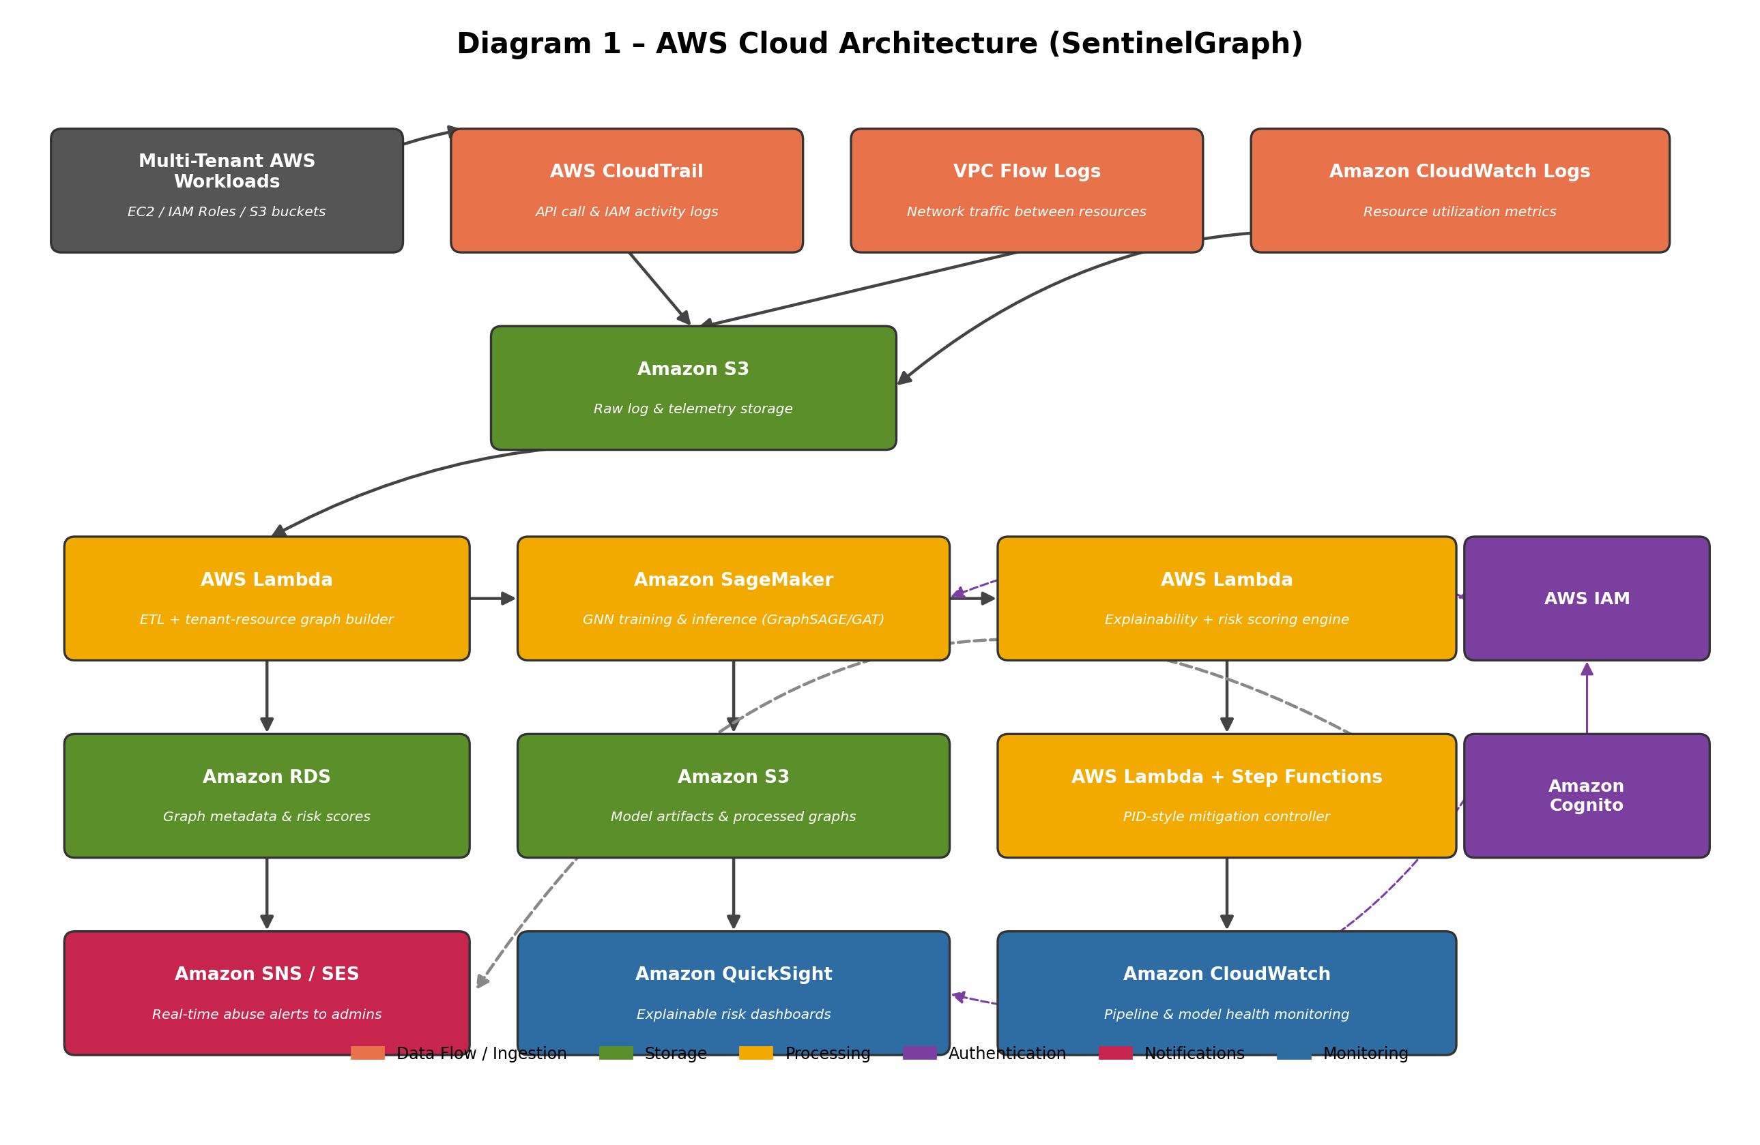

3.2 Diagram 2 — Complete System Architecture
This diagram traces the overall project workflow: how activity across multiple tenants gets collected, turned into a single tenant-resource-identity graph, scored and explained by the GNN engine, prioritized by risk, and finally acted on by the mitigation controller — with a feedback loop back into the model and mitigation sensitivity.
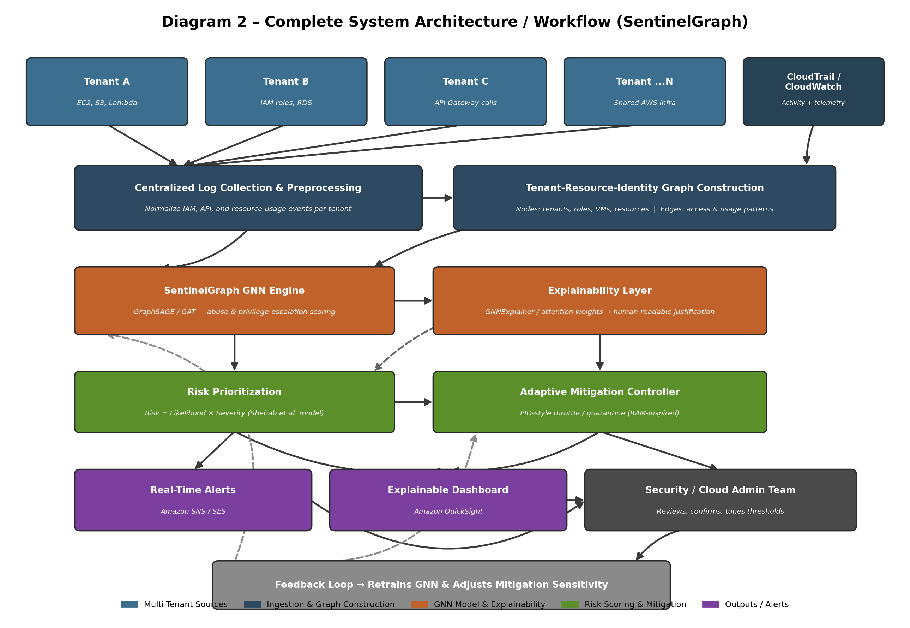

4. Dataset Details
The project draws on two complementary datasets — one covering network-level resource-abuse behavior, the other covering identity and access behavior — since no single existing dataset combines both signals the way the tenant-resource-identity graph needs.

4.1 Dataset 1 — Resource-Abuse / Network Traffic
Field | Details
Dataset Name | CSE-CIC-IDS2018
Source | Joint project between the Communications Security Establishment (CSE) and the Canadian Institute for Cybersecurity (CIC), hosted on AWS as a realistic enterprise-network emulation.
URL | https://www.unb.ca/cic/datasets/ids-2018.html
Size | Roughly 450 GB of raw PCAP/log data across 10 days of captured traffic, distributed via AWS.
Number of Records | About 16.23 million labeled flow records (16,232,943 flows), with benign traffic making up close to 83% and attack traffic the remaining ~17%.
Number of Features | 80 per-flow features extracted using CICFlowMeter-V3 (79 numerical fields plus one timestamp field).
Data Type | Structured, tabular network flow data (CSV), derived from raw packet captures (PCAP).
License | Free to use for academic and research purposes; distributed by CIC/UNB under their standard research-use dataset policy (attribution required, no redistribution for commercial use).
Purpose of Using the Dataset | Supplies the resource-abuse side of the training data — volumetric and behavioral attack patterns (DoS, DDoS, botnet, brute force, infiltration) that map onto the tenant-resource edges of the SentinelGraph graph, so the GNN learns what abusive resource-consumption patterns look like structurally.
Preprocessing Required | Merge the 10 daily CSV files into a single frame; drop near-duplicate/constant-value columns; normalize numerical features; encode the 15-class label column (14 attack types + benign) into a binary abuse/non-abuse label for the primary task, keeping the multi-class label for later fine-grained analysis; map source/destination IP-port pairs onto synthetic tenant and resource node IDs so the flow data can be projected onto the tenant-resource-identity graph.

4.2 Dataset 2 — Identity & Insider-Activity Logs
Field | Details
Dataset Name | CERT Insider Threat Dataset (Release r4.2)
Source | Carnegie Mellon University’s CERT Division / Software Engineering Institute — a synthetic but behaviorally realistic simulation of a mid-sized organization’s IT environment.
URL | https://kilthub.cmu.edu/articles/dataset/Insider_Threat_Test_Dataset/12841247 (official CMU CERT dataset request/download page)
Size | Around 1,000 simulated users and 1,003 computers, logged continuously from January 2010 to May 2011 (roughly 17 months).
Number of Records | Approximately 32.8 million individual event records across all log files, with 70 users assigned malicious insider scenarios and a few thousand of those records labeled as ground-truth anomalous activity.
Number of Features | Varies by log file — logon.csv, device.csv, http.csv, email.csv, file.csv and psychometric.csv each carry their own 4–10 raw fields (user ID, timestamp, PC ID, activity type, and so on); once aggregated into daily/session vectors per user, this typically yields 20–50 engineered features depending on the aggregation scheme used.
Data Type | Structured, multi-modal log data (CSV) — logon/logoff events, file access, email metadata, device connections, web browsing, plus an organizational LDAP structure file describing roles and reporting lines.
License | Available to researchers on request through CMU’s CERT/SEI dataset portal under a research-use license agreement; not redistributable outside the terms of that agreement.
Purpose of Using the Dataset | Supplies the identity/privilege-escalation side of the graph — the user–role–resource access relationships and the LDAP organizational structure become the node and edge set for modeling lateral movement and privilege escalation, which the CSE-CIC-IDS2018 traffic data alone cannot represent.
Preprocessing Required | Join the six per-modality log files on user ID and timestamp; convert raw event streams into daily or session-level activity vectors per user; build the identity graph by connecting users to roles (via the LDAP file) and roles to the resources/files/devices they touched; align the 70 malicious-user “answer” files to produce ground-truth privilege-escalation labels; downsample or reweight the benign majority class given the roughly 1:14 malicious-to-normal user imbalance.

5. AWS Services Planning
The table below lists every AWS service planned for SentinelGraph and what role it plays in the pipeline.
AWS Service | Purpose
Amazon EC2 | Hosts the tenant-simulation testbed and the lightweight web dashboard front end used to demo SentinelGraph.
Amazon S3 | Stores raw CSE-CIC-IDS2018 / CERT logs, processed tenant-resource-identity graphs, and trained GNN model artifacts.
AWS CloudTrail | Captures IAM and API-level activity across simulated tenants — the primary feed for building the identity/privilege-escalation edges in the graph.
Amazon VPC Flow Logs | Captures network-level traffic between simulated tenant resources, feeding the resource-abuse side of the graph.
Amazon CloudWatch | Supplies resource-utilization metrics (CPU, network, storage) for the mitigation controller and monitors the health of the pipeline itself.
AWS Lambda | Runs the ETL/graph-construction jobs, the explainability + risk-scoring engine, and the event-driven glue between pipeline stages.
Amazon SageMaker | Trains and hosts the GraphSAGE/GAT-based GNN model as a real-time inference endpoint.
AWS Step Functions | Orchestrates the adaptive mitigation workflow — sequencing detection, risk prioritization, and throttle/quarantine actions.
Amazon RDS | Stores structured graph metadata, per-tenant risk scores, and historical scoring records for auditability.
AWS IAM | Enforces least-privilege access across every service in the pipeline and supplies the ground-truth role/permission structure the graph itself models.
Amazon Cognito | Authenticates dashboard users — cloud administrators and the security review team — before they can view risk explanations or override mitigation actions.
Amazon SNS / SES | Pushes real-time abuse and privilege-escalation alerts to security teams via notification and email.
Amazon QuickSight | Renders the explainable risk dashboard — attention-weight justifications, per-tenant risk trends, and mitigation history.

