# Sign Up

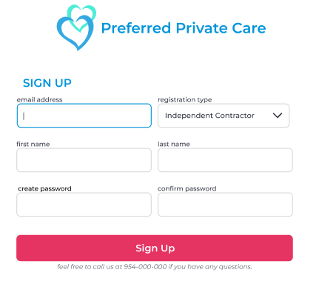

* Email Address, Registration Type, First Name, Last Name, Create Password, Confirm Password
* Table: Auth_user

Email, is_superuser, first_name, last_name, password

* Action

Sign up: If you click the Sign Up button, the input data values are stored in the “auth_user” table.

# Login

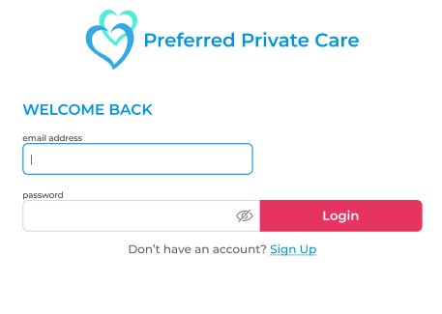

* Email Address, Password
* Table: auth_user
* Action
  + Sign Up: Go to “Sign up” page.
  + Login: It determines whether the entered email is an employee or a caregiver and moves to the corresponding page.

# Caregiver Dashboard

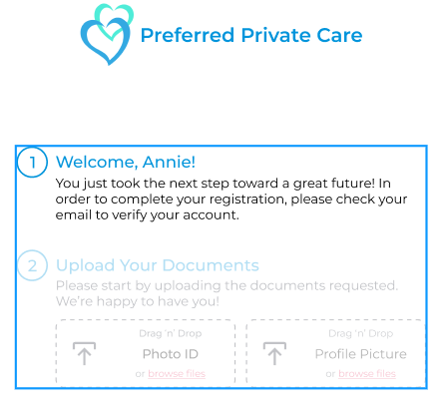

* Action

If you registered as a caregiver, you must proceed with email verification.

If the email is verified, you can start uploading the documents requested.

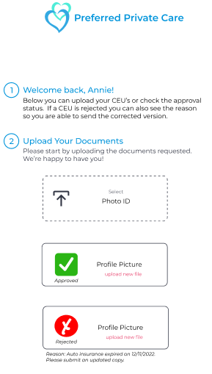

I don't know where to save the files uploaded in the database.

# Admin Dashboard

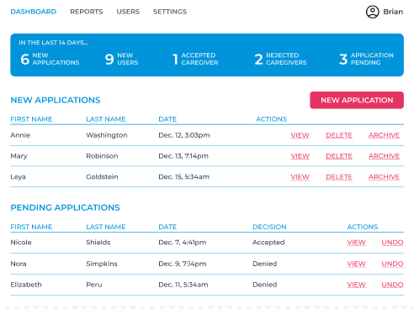

* Currently on hold

# New Applicant

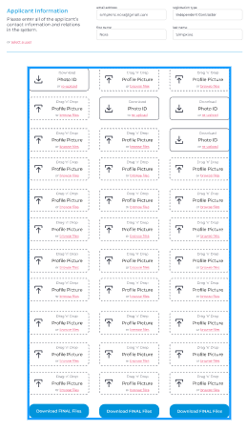

* Email Address, Registration Type, First Name, Last Name
* Table: pdfprocessor_record_application

Join: pdfprocessor_record, pdfprocessor_recordfile

* Action
  + Selete User: Open User List Modal
  + File Upload

# Applicant Details

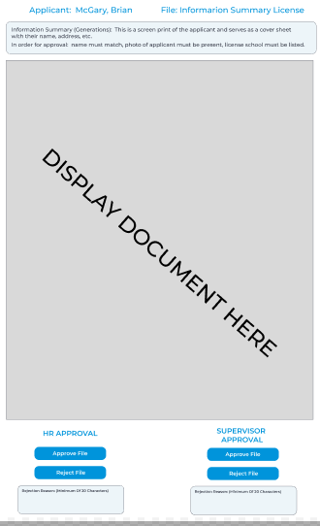

* Applicant name, File Name, Application Comments
* Table: pdfprocessor_record_application

Join: pdfprocessor_record, pdfprocessor_recordfile

* Action
  + HR Approval: Approve File, Reject File, Reject Reason
  + Supervisor Approval: Approve File, Reject File, Reject Reason

# User Profile

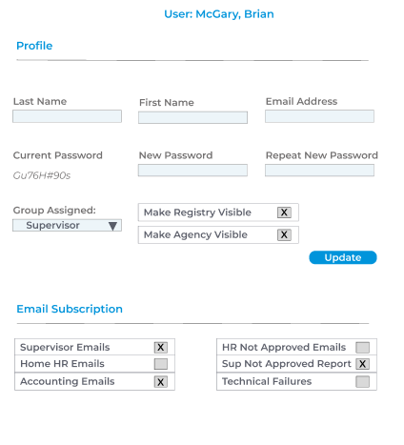

* Last Name, First Name, Email Address, Current Password, New Password, Repeat New Password, Group Assigned
* Table: auth_user

Join: auth_group

* Action
  + Update
  + Email Subscription

# Reports

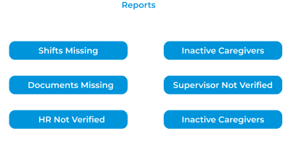

* Type: Shifts Missing, Inactive Caregivers, Document Missing, Supervisor Not Verified, HR Not Verified, Inactive Caregivers
* Table: reportmanager_reportrecord
* Action
  + Save: Save the data values for the selected daily reports type.

# Settings

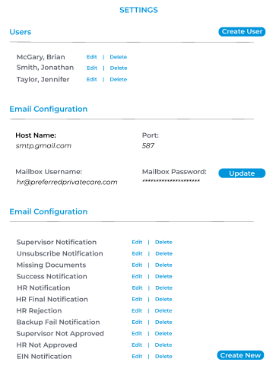

* Users
  + Table: Auth_user
  + Action: Create, Edit, Delete
* Email Configuration
  + Table: myemail_emailcredeintials
  + Host Name, Port, MailBox Username, Mailbox Password
* Email Configuration
  + Table: myemail_registrymailpayload OR myemail_agencymailpayload
  + Action

Create New, Edit, Delete

# Email Configuration

