

Hello.

Now, Map application, Navigation and National defence etc., Navigation Satelite System is indispensable item.

So, I talk about Japanses NSS, Michibiki.



Do you know Mitibiki?

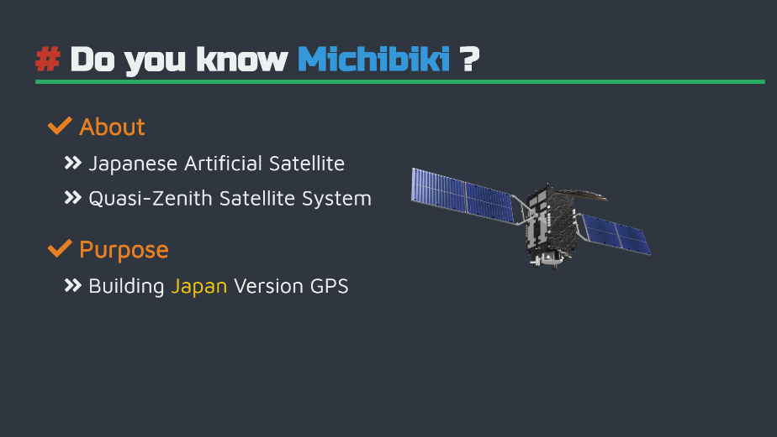

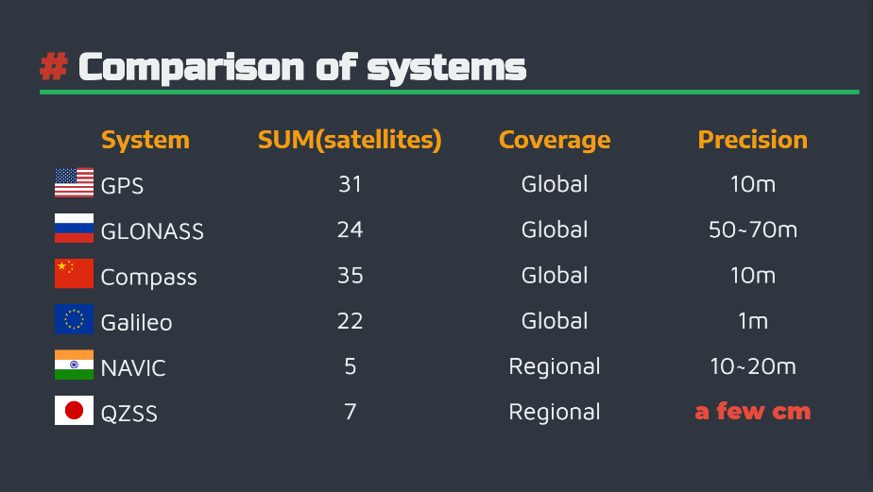

Please have a look at this chart.

This is Navigation Satelite System of World.

In 2011 the Government of Japan has decided to accelerate the QZSS deployment in order to reach a 4-satelites constellation by the late 2010s, while aiming at a final 7-satelites constellation in the future.

GPS Precision is about 10m. But Michibiki is a few cm.

Government of Japan aims improve of QZSS accuracy.

Michibiki is Japanses Artifical Satelite. The Cabinet Office government of Japan launched to construct a system of Quasi-Zenith Satelite System(QZSS).

Purpose of GPS is Complements GPS for satelite positioning, navigation and timing service that is more precise and statble.



This system costs 3 hundred billion!

But this system will givce you a good life.

The system has merit and demerit.

About merit.

Services have always been offered in a statble way. and Increasing the nunber of QZSS to improve positioning errors!

But that has Demerit.

After all, very Expensive!



Thank you