REGIONAL CLINIC NETWORK
PATIENT CARE ANALYTICS PIPELINE
An end-to-end synthetic data engineering project integrating clinic scheduling, laboratory results, wearable/remote-monitoring signals, and consultation notes into a single Patient 360 analytical layer, with an illustrative predictive-monitoring workflow.
Attribute | Value
Dataset | Synthetic multi-clinic integrated event dataset
Records | 7750
Patients | 240
Data fields | 22
Primary objective | Improve clinic operations visibility and demonstrate patient-risk analytics
Implementation | Python / Pandas / Matplotlib / Scikit-learn
Educational / academic prototype. All records and monitoring-priority labels are synthetic and must never be used for clinical decision-making.

1. Executive Summary
This project implements an end-to-end data engineering pipeline for a six-clinic outpatient network, using a synthetic integrated dataset of 7,750 event records covering 240 unique patients. Four operational streams — clinic visits, laboratory results, wearable/remote-monitoring signals, and consultation notes — are combined with a patient registry into a single event table.
The pipeline computes operating KPIs including an average clinic wait time of 20.2 minutes, a synthetic no-show rate of 8.6%, and an overall abnormal laboratory-result rate of 20.7%. Patient-level aggregation produces a Patient 360 layer that feeds dashboards and a synthetic "priority monitoring" classification workflow.
A rule-based synthetic label flags 63 of 240 patients (26.3%) for priority monitoring, based on age, chronic-condition status, abnormal lab rate, consultation severity, and wearable vitals. A logistic regression model trained on Patient 360 features reaches 85% hold-out accuracy (AUC 0.947), illustrating a feature-engineering-to-evaluation workflow rather than a validated clinical tool.

Key engineering outcomes
- Centralized synthetic event landing structure across four source types
- Data-quality validation (duplicates, missing values, referential checks)
- Patient 360 aggregation layer
- Clinic-level wait-time and no-show analytics
- Laboratory and wearable-signal analytics
- Rule-based synthetic priority-monitoring label + logistic regression demonstration

2. Business Problem & Objectives
Outpatient clinic data is typically fragmented across scheduling, laboratory, remote-monitoring, and consultation systems. This project simulates collecting, validating, standardizing, and integrating that data at the patient level to support operational analytics and an illustrative predictive workflow.
- Reduce patient wait times through clinic-level monitoring.
- Improve visibility into visit volume and no-show behavior.
- Integrate lab and wearable data into a unified Patient 360 view.
- Enable analytics on consultation severity and follow-up patterns.
- Demonstrate a reproducible feature-engineering and classification pipeline.

3. End-to-End Data Engineering Architecture
Source systems → Ingestion → Raw landing layer → Data quality gate → Transformation → Curated (Patient 360) layer → Warehouse / analytics → BI + ML

Source systems (simulated)
- Clinic scheduling system
- Laboratory information system
- Wearable / remote patient monitoring devices
- Consultation / EMR notes
- Patient registry

Recommended production technology mapping
Layer | Recommended technologies | Purpose
Ingestion | REST APIs, Kafka | Collect batch and near-real-time events
Raw / Bronze | Cloud object storage | Immutable source preservation
Processing | Spark / Python | Cleaning and transformation
Orchestration | Airflow | Scheduling and monitoring
Warehouse / Gold | Snowflake / BigQuery | Analytics-ready data
BI | Power BI / Tableau | Dashboards and reporting
ML | Scikit-learn | Feature and model workflow
Security | IAM, encryption, audit logs | Protect sensitive health data

4. Integrated Dataset Design
Each source system is represented as an event row in one combined table; the source_type field distinguishes the originating stream, and common patient attributes are carried on every event for single-table analysis.
Field | Purpose
record_id | Unique event identifier
source_type | clinic_visit / lab_result / wearable_signal / consultation
patient_ref | Patient business key
age_years, gender, blood_group | Patient demographics
home_city, chronic_condition | Patient profile attributes
event_date | Date of the source event
clinic, visit_status, wait_time_minutes | Visit / scheduling fields
lab_test_name, lab_result_value, lab_flag | Laboratory information
resting_hr_bpm, spo2_percent, skin_temp_f, daily_steps | Wearable signals
symptom_severity, diagnosis_category, follow_up_days | Consultation information
priority_monitoring_flag | Synthetic educational monitoring target

5. Data Quality & Preparation
The pipeline runs duplicate detection, missing-value inspection, identifier checks, and numeric-range validation as a quality gate ahead of aggregation.
Quality metric | Observed value
Rows | 7,750
Columns | 22
Unique patients | 240
Unique event IDs | 7,750
Duplicate rows | 0
Missing cells | 75,455
Missing cells are expected: each event type only populates the fields relevant to its source (e.g. wearable events do not carry lab fields).

6. Operational Analytics — Wait Time
The dataset contains 860 clinic-visit events. Average wait time across completed visits is 20.2 minutes.
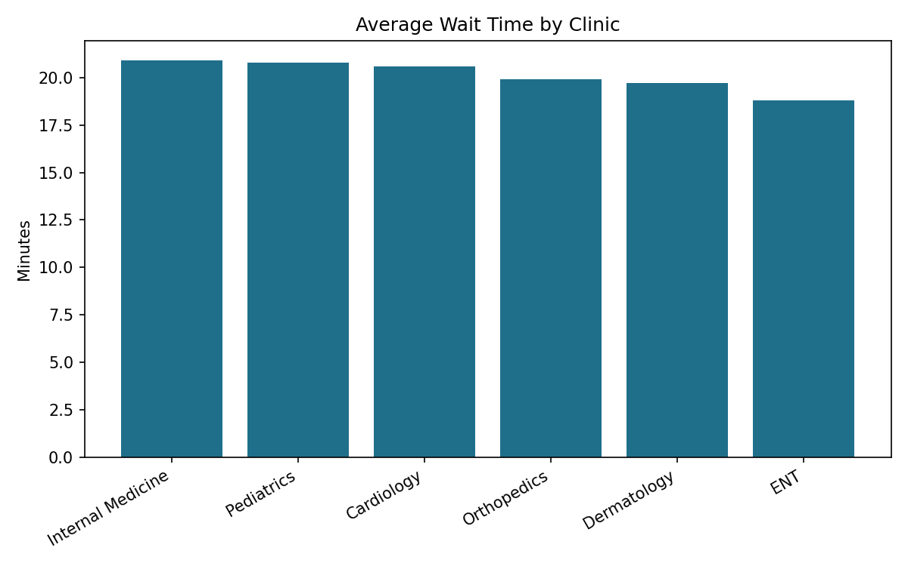
Clinic | Visits | Avg wait (min)
Internal Medicine | 124 | 20.9
Pediatrics | 127 | 20.8
Cardiology | 125 | 20.6
Orthopedics | 126 | 19.9
Dermatology | 115 | 19.7
ENT | 109 | 18.8
Wait-time variation is a signal for staffing and queue-design investigation; the synthetic dataset does not establish causes.

7. Visit Volume & No-Show Analytics
The synthetic no-show rate is 8.6%. Daily visit volume supports staffing and capacity-planning analysis.
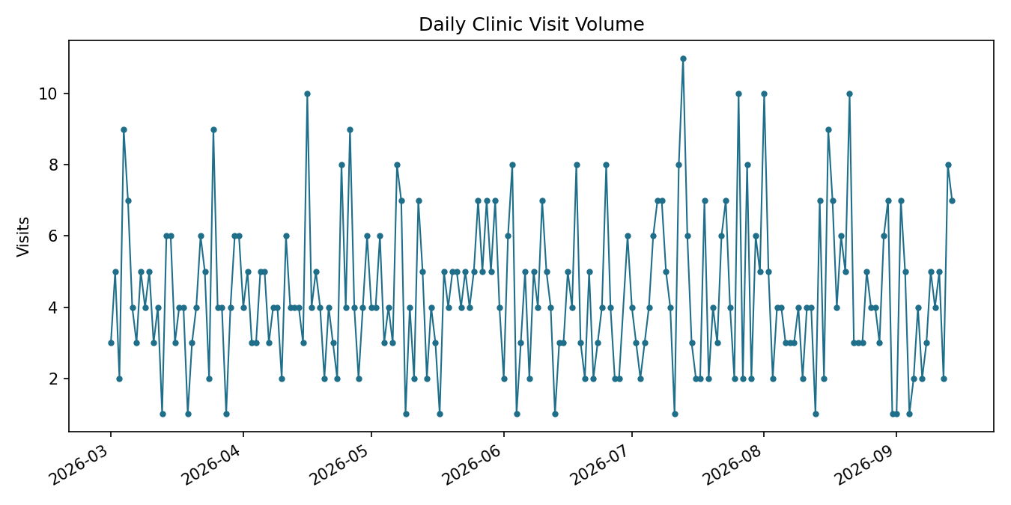
Production extension: combine historical visit demand with calendar effects, clinic capacity, and provider schedules to support forecasting.

8. Laboratory Analytics
The dataset contains 1150 laboratory-result events. Overall, 20.7% are flagged abnormal.
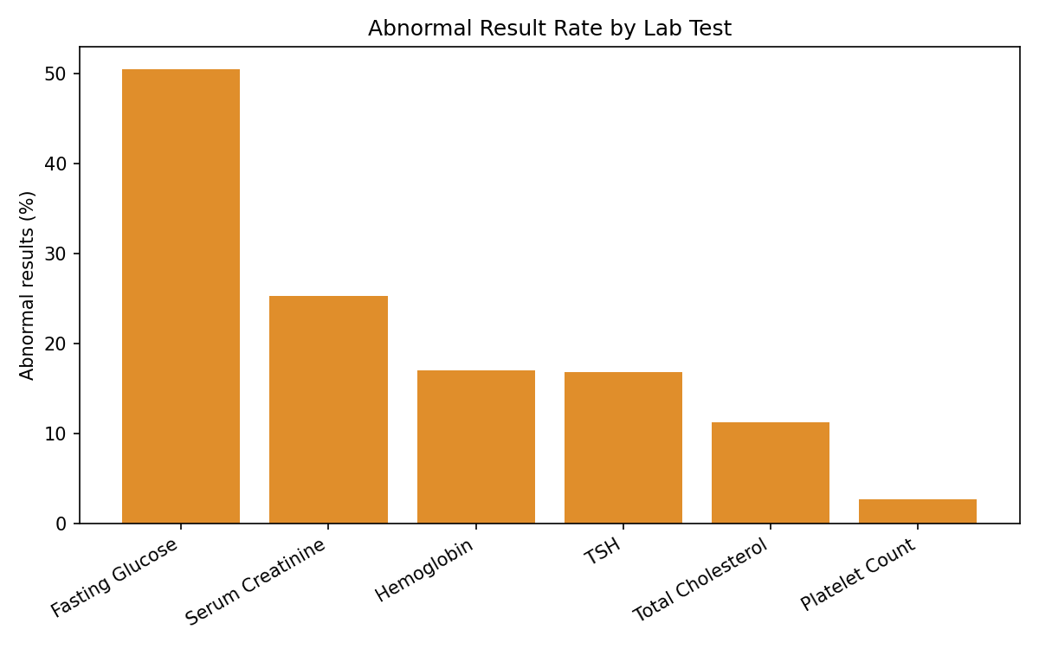
Test | Tests | Abnormal rate (%)
Fasting Glucose | 194 | 50.5
Serum Creatinine | 178 | 25.3
Hemoglobin | 206 | 17.0
TSH | 202 | 16.8
Total Cholesterol | 187 | 11.2
Platelet Count | 183 | 2.7

9. Wearable / Remote Monitoring Analytics
The wearable stream contains 5,200 readings, aggregated to daily summaries for downstream analytics.
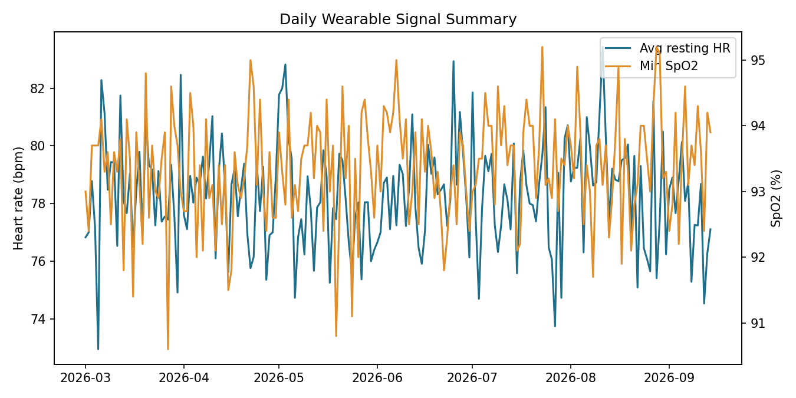

10. Consultation Analytics
The consultation stream contains 540 records, summarized by severity to understand consultation demand.
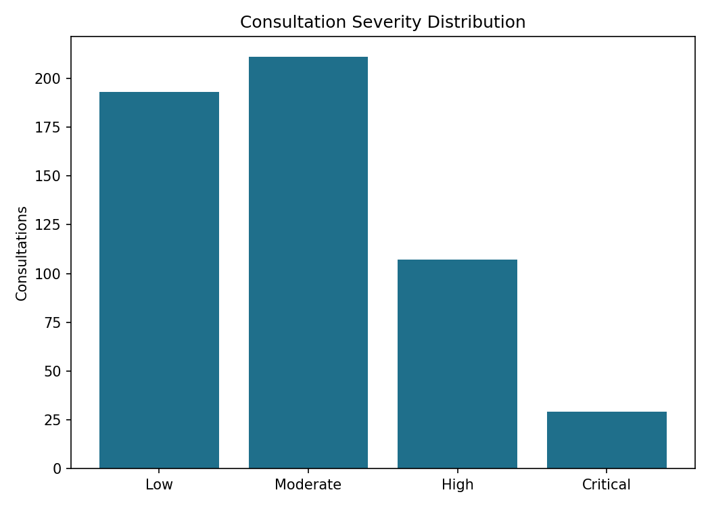
Severity counts are descriptive analytics from synthetic records, not clinical acuity measurements.

11. Patient 360 Analytical Layer
Event-level records are aggregated to one analytical row per patient, combining demographics with visit, lab, wearable, and consultation-derived features.
Patient | Age | Condition | Visits | Avg wait | Abnl labs | Avg HR | Min SpO2 | Max sev. | Priority
CLNT-0001 | 9 | Hypertension | 7 | 26.6 | 0.0% | 79.9 | 91.7 | 1 | No
CLNT-0002 | 71 | Asthma | 2 | 22.7 | 0.0% | 76.3 | 93.1 | 1 | No
CLNT-0003 | 60 | Arthritis | 4 | 25.4 | 25.0% | 78.4 | 92.6 | 2 | No
CLNT-0004 | 40 | Type 2 Diabetes | 0 | — | 0.0% | 79.6 | 93.8 | 2 | No
CLNT-0005 | 40 | Thyroid Disorder | 1 | 7.9 | 14.3% | 77.1 | 93.7 | 3 | No
CLNT-0006 | 79 | Asthma | 5 | 17.5 | 0.0% | 79.8 | 91.9 | 0 | No
CLNT-0007 | 8 | Arthritis | 4 | 19.9 | 0.0% | 77.1 | 92.2 | 2 | No
CLNT-0008 | 64 | — | 4 | 17.9 | 50.0% | 74.1 | 94.1 | 1 | No

12. Predictive Analytics Workflow
A synthetic priority-monitoring classification demonstrates how the pipeline can feed a machine-learning stage. Features are engineered from Patient 360, numeric features are standardized, and a logistic regression model is trained and evaluated.
Patient 360 → Feature selection → Train/test split → Scaling → Logistic Regression → Evaluation
Metric | Value
Patients flagged priority (synthetic) | 63 of 240
Hold-out accuracy | 85.0%
Hold-out ROC AUC | 0.947

Model governance considerations
- A real deployment requires clinical validation and an approved target definition.
- Privacy controls, fairness analysis, and calibration checks are required before any operational use.
- Model monitoring, drift detection, and human oversight must accompany any live scoring.
A synthetic model score must never be interpreted as medical advice.

13. Security, Privacy & Governance
- Separate identifiable data from analytical datasets where possible.
- Use role-based access control for clinicians, analysts, and engineers.
- Encrypt object storage, databases, and network traffic.
- Maintain data lineage from source event to dashboard/model feature.
- Log access to sensitive patient information and set retention/deletion policies.

14. ETL / Orchestration Workflow
Extract sources → Validate schemas & identifiers → Write raw/bronze data → Clean & standardize → Build curated facts/dimensions → Refresh Patient 360 → Refresh BI dashboards → Generate ML features & scores

15. Recommended Data Warehouse Model
Dimensions: dim_patient, dim_clinic, dim_date
Facts: fact_visit, fact_lab_result, fact_wearable_reading, fact_consultation
Gold analytical view: patient_360

16. Key Findings from the Synthetic Dataset
- The integrated file contains 7,750 event records covering 240 unique patients.
- Clinic visits have an average wait time of 20.2 minutes, a directly measurable operational KPI.
- The synthetic no-show rate is 8.6%, enabling attendance and capacity analytics.
- The synthetic abnormal lab-result rate is 20.7%, enabling test-level comparison.
- The Patient 360 layer consolidates visit, laboratory, wearable, and consultation features.
- 63 patients are flagged priority-monitoring in the synthetic target, enabling an ML workflow demonstration (accuracy 85%, AUC 0.947).

17. Implementation Files
Artifact | Purpose
clinic_network_events.csv | Single integrated synthetic clinic dataset
patient_360.csv | Patient-level aggregated analytical layer
generate_data.py / analyze.py | Executable Python data-engineering and analytics implementation

18. Conclusion
This project demonstrates moving from fragmented clinic, laboratory, wearable, and consultation data sources toward a unified data engineering platform. The prototype covers ingestion representation, quality validation, transformation, Patient 360 creation, KPI analytics, visualization, and a synthetic predictive-monitoring workflow.
The architecture is designed so the same logical stages could be implemented at production scale with streaming ingestion, cloud object storage, distributed processing, workflow orchestration, a cloud warehouse, governed BI, and a managed ML platform.
Important limitation: all records and monitoring-priority labels in this project are synthetic. They demonstrate data engineering concepts only and must not be used for clinical decisions.

