1. 实验目的
掌握数据库DDL和DML操作，熟悉SQL Server中数据库、表的创建及数据操作方法，
理解TPC-C模型及其应用场景，并能够进行基本的数据库查询操作。

2. 实验环境
数据库：SQL Server 2022
工具：SQL Server Management Studio (SSMS)
操作系统：Windows 11

3. 实验内容与过程
任务一：DDL操作（TPCC数据库）
- 了解什么是TPCC性能测试，创建一个TPCC数据库；

答：TPC-C 是国际标准 OLTP 基准测试，模拟电商 / 批发下单流程，用 5 类固定比例事务压测，核心指标 tpmC（每分钟新订单数）衡量数据库高并发交易性能，值越高能力越强。
CREATE DATABASE TPCC;
USE TPCC;
运行结果：
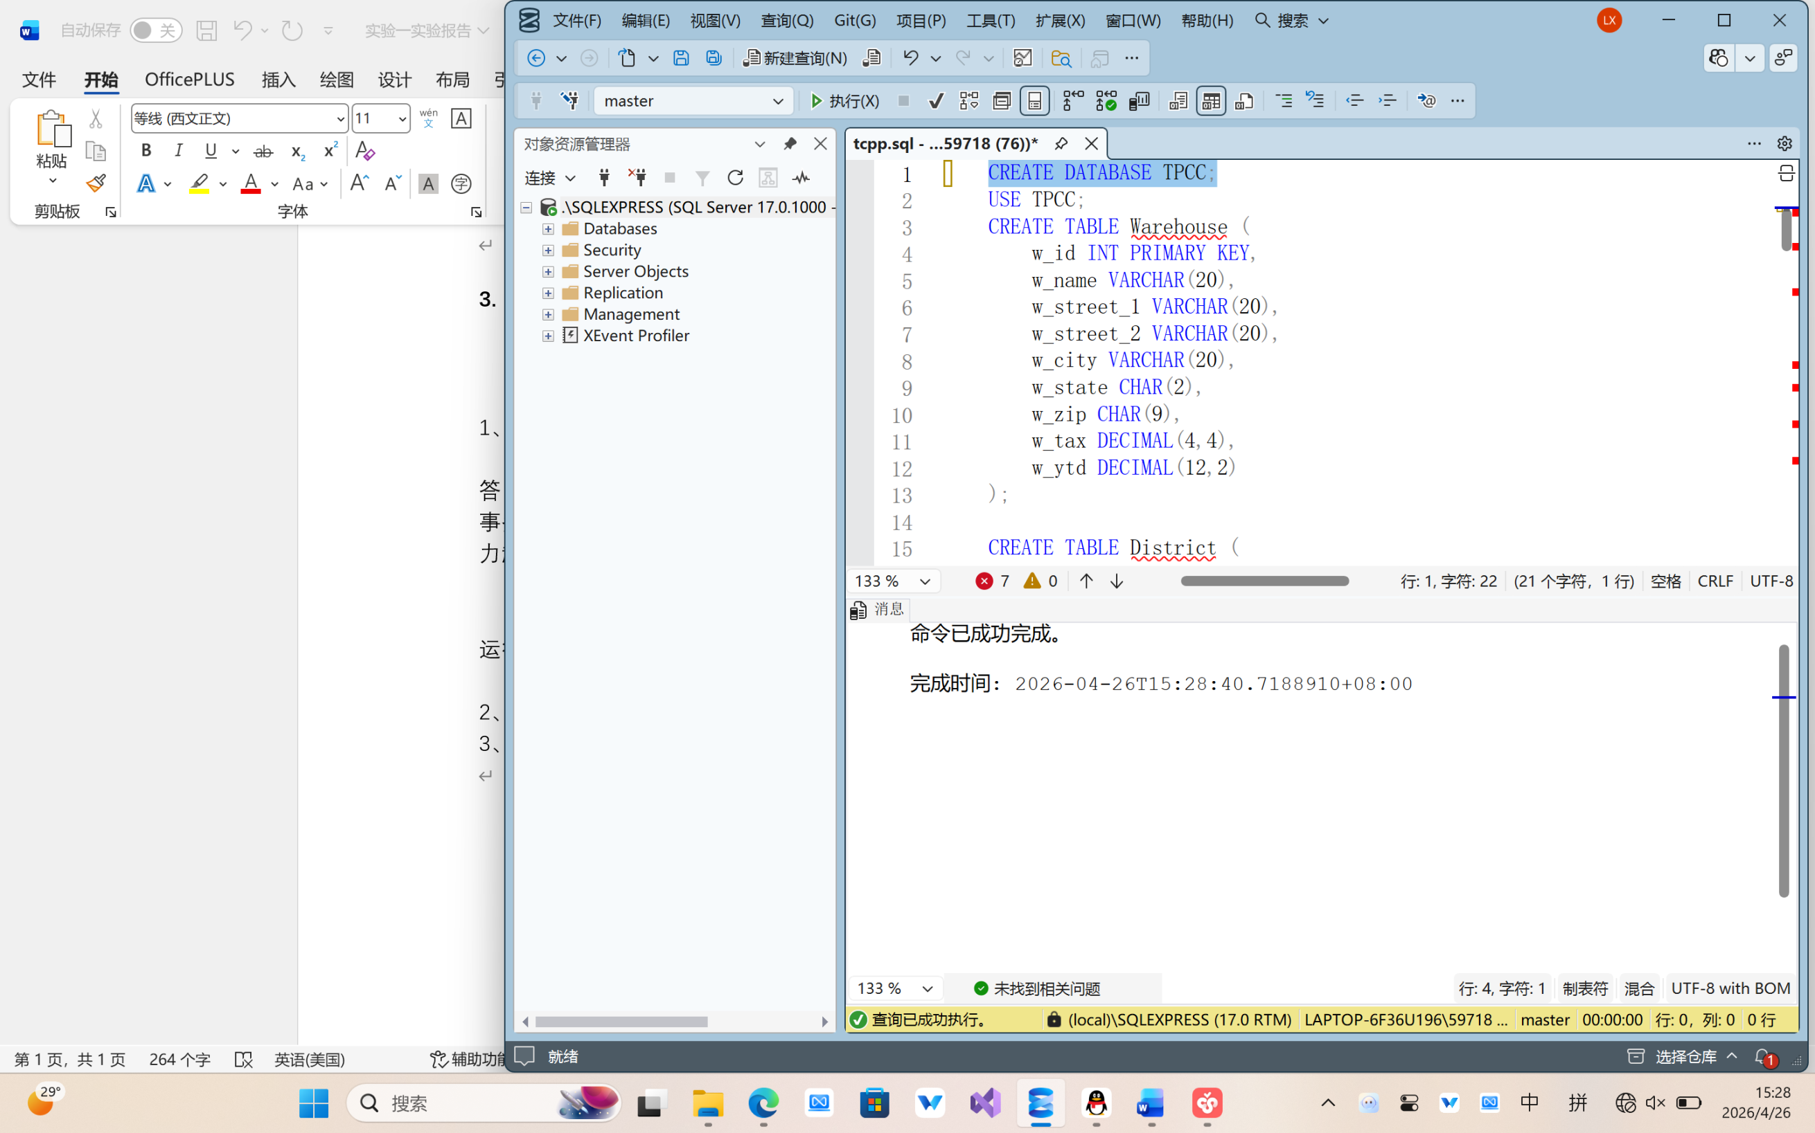
- 使用SQL语句创建TPCC场景所包含的多个关系。
代码：
CREATE TABLE Warehouse (
w_id INT PRIMARY KEY,
w_name VARCHAR(20),
w_street_1 VARCHAR(20),
w_street_2 VARCHAR(20),
w_city VARCHAR(20),
w_state CHAR(2),
w_zip CHAR(9),
w_tax DECIMAL(4,4),
w_ytd DECIMAL(12,2)
);

CREATE TABLE District (
d_id INT,
d_w_id INT,
d_name VARCHAR(20),
d_street_1 VARCHAR(20),
d_street_2 VARCHAR(20),
d_city VARCHAR(20),
d_state CHAR(2),
d_zip CHAR(9),
d_tax DECIMAL(4,4),
d_ytd DECIMAL(12,2),
d_next_o_id INT,
PRIMARY KEY (d_w_id, d_id),
FOREIGN KEY (d_w_id) REFERENCES Warehouse(w_id)
);

CREATE TABLE Customer (
c_id INT,
c_d_id INT,
c_w_id INT,
c_first VARCHAR(20),
c_middle CHAR(2),
c_last VARCHAR(20),
c_street_1 VARCHAR(20),
c_street_2 VARCHAR(20),
c_city VARCHAR(20),
c_state CHAR(2),
c_zip CHAR(9),
c_phone CHAR(16),
c_since DATETIME,
c_credit CHAR(2),
c_credit_lim DECIMAL(12,2),
c_discount DECIMAL(4,4),
c_balance DECIMAL(12,2),
c_ytd_payment DECIMAL(12,2),
c_payment_cnt INT,
c_delivery_cnt INT,
c_data VARCHAR(500),
PRIMARY KEY (c_w_id, c_d_id, c_id),
FOREIGN KEY (c_w_id, c_d_id) REFERENCES District(d_w_id, d_id)
);

CREATE TABLE Item (
i_id INT PRIMARY KEY,
i_im_id INT,
i_name VARCHAR(24),
i_price DECIMAL(5,2),
i_data VARCHAR(50)
);

CREATE TABLE Stock (
s_i_id INT,
s_w_id INT,
s_quantity INT,
s_ytd INT,
s_order_cnt INT,
s_remote_cnt INT,
s_data VARCHAR(50),
PRIMARY KEY (s_w_id, s_i_id),
FOREIGN KEY (s_w_id) REFERENCES Warehouse(w_id),
FOREIGN KEY (s_i_id) REFERENCES Item(i_id)
);

CREATE TABLE Orders (
o_id INT,
o_d_id INT,
o_w_id INT,
o_c_id INT,
o_entry_d DATETIME,
o_carrier_id INT,
o_ol_cnt INT,
o_all_local INT,
PRIMARY KEY (o_w_id, o_d_id, o_id),
FOREIGN KEY (o_w_id, o_d_id, o_c_id) REFERENCES Customer(c_w_id, c_d_id, c_id)
);

CREATE TABLE OrderLine (
ol_o_id INT,
ol_d_id INT,
ol_w_id INT,
ol_number INT,
ol_i_id INT,
ol_supply_w_id INT,
ol_delivery_d DATETIME,
ol_quantity INT,
ol_amount DECIMAL(6,2),
ol_dist_info CHAR(24),
PRIMARY KEY (ol_w_id, ol_d_id, ol_o_id, ol_number),
FOREIGN KEY (ol_w_id, ol_d_id, ol_o_id) REFERENCES Orders(o_w_id, o_d_id, o_id),
FOREIGN KEY (ol_i_id) REFERENCES Item(i_id)
);
运行结果：
- 了解TPCC测试的模拟场景和用于性能测试的事务类型。
TPC-C 模拟场景：
TPC-C 是面向OLTP 联机事务处理的标准性能测试基准，模拟大型商品批发分销企业业务场景，涵盖仓库、库存、客户、订单、结算、发货等完整业务；采用高并发、读写混合的真实交易模式，用来检测数据库并发处理、事务响应、数据更新与负载抗压能力。
TPC-C 五类测试事务类型：
- 新订单事务（New-Order）：客户创建新订单，扣减商品库存，多写操作，业务占比最高。
- 支付事务（Payment）：完成客户付款，更新客户账户余额，高频更新操作。
- 订单状态查询（Order-Status）：查询客户最新订单信息，以只读查询为主。
- 发货事务（Delivery）：批量更新订单发货状态，完成批量数据修改。
- 库存水位查询（Stock-Level）：统计仓库商品库存，检测库存余量、判断补货需求。

任务二：DML操作（CAP数据库）
- 创建数据库CAP，包含4张表Customers、Products、Agents和Orders，要求定义主外键和必要的完整性约束。
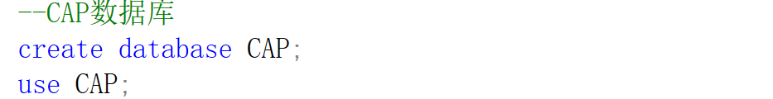
--1.创建表
create table Customers(
cid char(4) primary key,
cname varchar(50) not null ,
city varchar(50),
discnt decimal(5,2)default 0 check (discnt>=0)
);

create table Agents(
aid char(4)primary key,
aname varchar(50)not null,
city varchar(50),
percen decimal(5,2) check (percen>=0)
);

create table Products(
pid char(4) primary key,
pname varchar(50) not null,
city varchar(50),
quantity int check(quantity>=0),
price decimal(10,2)check(price>=0)
);

create table Orders(
ordno int primary key,
month varchar(10),
cid char(4),
aid char(4),
pid char(4),
qty int check(qty>0),
dollars decimal(10,2)check(dollars>=0),
foreign key(cid)references Customers(cid),
foreign key(aid)references Agents(aid),
foreign key(pid)references Products(pid)
);

运行结果：
- 创建一个CAP数据库的新用户，授予该用户对CAP数据库的所有操作权限。
--2.创建用户并授权
create login cap_user with password ='Cap@123456';
go
use CAP
go
create user cap_user for login cap_user;
go
alter role db_owner add member cap_user;
go
运行结果：
- 利用SQL语句向4张表中增加一些示例数据。
insert into Customers Values
('C001','TipTop','Duluth',10.00),
('C002','Basics','Dallas',12.00),
('C003', 'Allied', 'Dallas', 8.00),
('C004', 'ACME', 'Duluth', 8.00),
('C006', 'ACME', 'Kyoto', 0.00);
SELECT * FROM Customers;
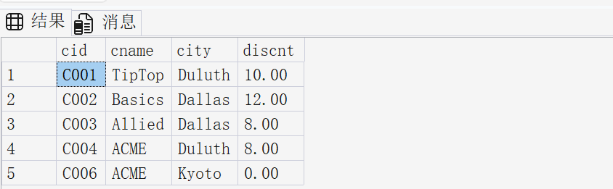
insert into Agents Values
('A01','smith','NewYork',6),
('A02', 'jones', 'Newark', 6),
('A03', 'Brown', 'Tokyo', 7),
('A04', 'Gray', 'New York', 6),
('A05', 'Otasi', 'Duluth', 5),
('A06', 'Smith', 'Dallas', 5);
select * from Agents;
运行结果：
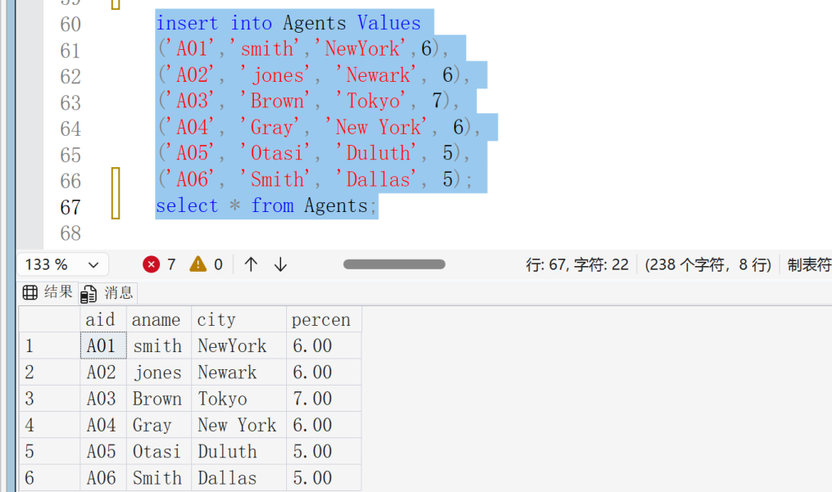
insert into Products values
('P01', 'comb', 'Dallas', 111400, 0.50),
('P02', 'brush', 'Newark', 203000, 0.50),
('P03', 'razor', 'Duluth', 150600, 1.00),
('P04', 'Pen', 'Duluth', 125300, 1.00),
('P05', 'pencil', 'Dallas', 221400, 1.00),
('P06', 'folder', 'Dallas', 123100, 2.00),
('P07', 'case', 'Newark', 100500, NULL);
select * from Products;
运行结果：
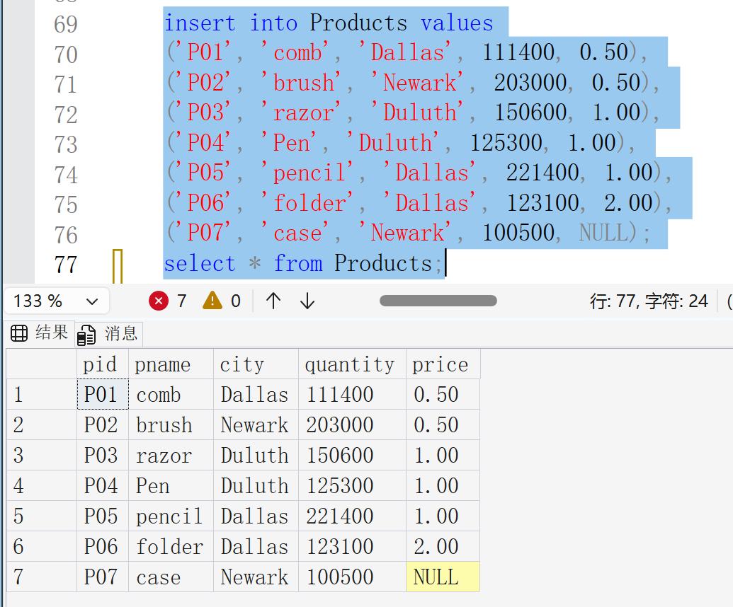
insert into Orders values
(1011, 'jan', 'C001', 'A01', 'P01', 1000, 450.00),
(1012, 'jan', 'C001', 'A01', 'P01', 1000, 450.00),
(1019, 'feb', 'C001', 'A02', 'P02', 400, 180.00),
(1017, 'feb', 'C001', 'A06', 'P03', 600, 540.00),
(1018, 'Feb', 'C001', 'A03', 'P04', 600, 540.00),
(1023, 'Mar', 'C001', 'A04', 'P05', 500, 450.00),
(1022, 'Mar', 'C001', 'A05', 'P06', 400, 720.00);
select * from Orders;
运行结果：
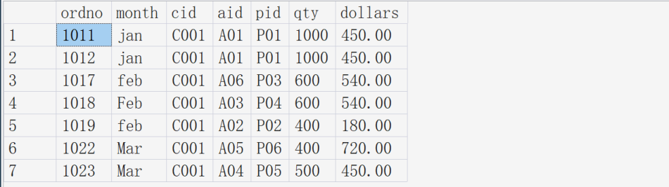
- 创建一张表Orders_Sta，表中包含月份，以及每个月的订单总数和订单总金额。从Orders表中查出对应的数据并写入Orders_Sta表中。
--4.创建 Orders_Sta 并统计每月订单数和总金额
create table Orders_Sta(
month varchar (10)primary key,
order_count int,
total_dollars decimal(10,2)
);

insert into Orders_Sta
select lower(month)as month,count(*)as order_count,sum(dollars)as total_dollars
from Orders
group by lower(month);

select * from Orders_Sta ;
运行结果：
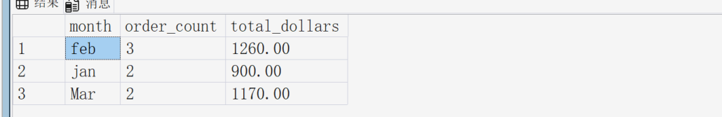
- 将Orders表中month为‘Jan’的订单记录全部删掉。
--5.删除month为Jan的订单
delete from Orders
where lower(month)='jan';

select*from Orders;
运行结果：
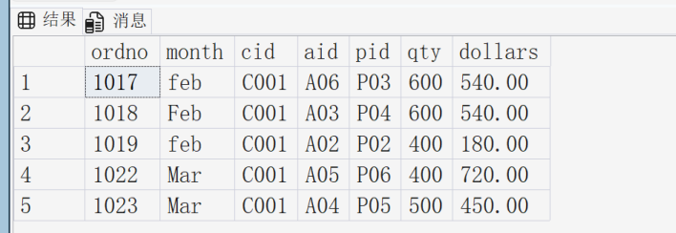
- 对曾经下过金额（dollars）大于500的订单的客户，将其discnt值增加2个百分点（+2）。
--6.曾下过 dollars > 500 订单的客户，折扣增加 2
update Customers
set discnt = discnt+2
where cid in(
select distinct cid
from Orders
where dollars>500
);

select * from Customers;
运行结果：
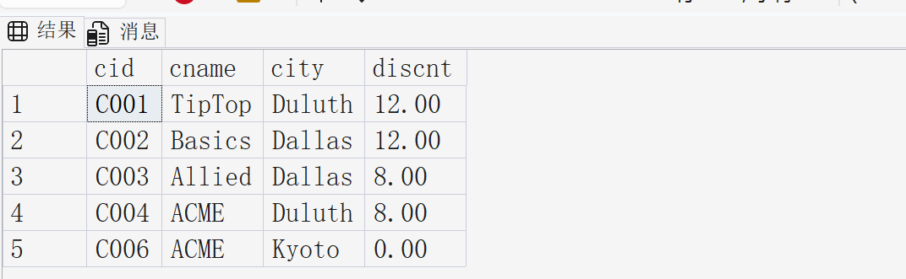
任务三：数据库查询（GlobalToyz数据库）
- 对GlobalToyz，创建数据库关系图。
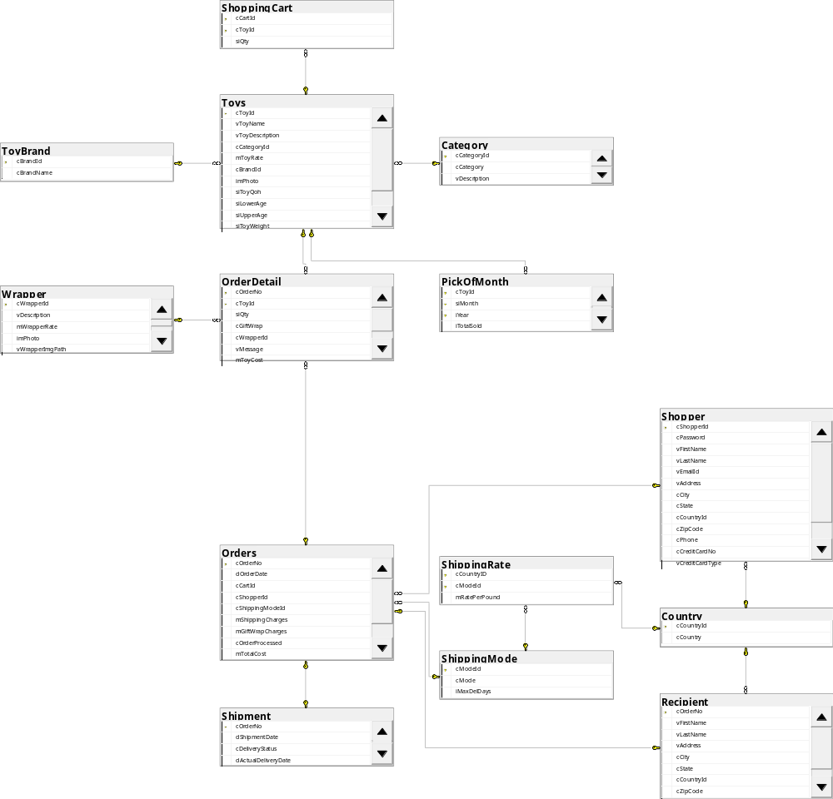
- 查找属于California州并且使用MasterCard支付的购物者的名、姓和邮件地址。
select vFirstname,vLastname,vEmailId
from Shopper
where vCreditCardType='Master Card'and cState = 'California';
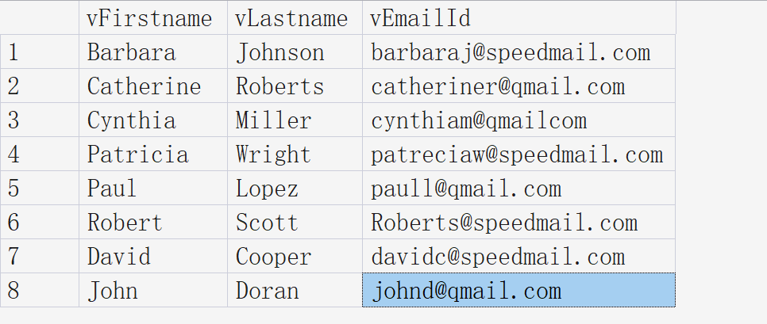
- 查找2021年，每个购物者的ID和定单总额，并以定单总额的升序排列。
select cShopperId,sum(mTotalCost)as 订单总额
from Orders
where year(dOrderDate)=2021
group by cShopperId
order by 订单总额 asc;
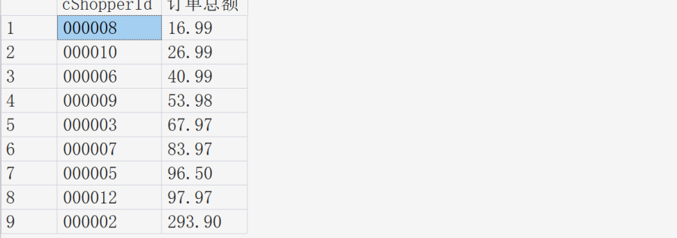
- 查找在orderDetail表中vMessage为空值的行。
select * from OrderDetail
where vMessage is null;
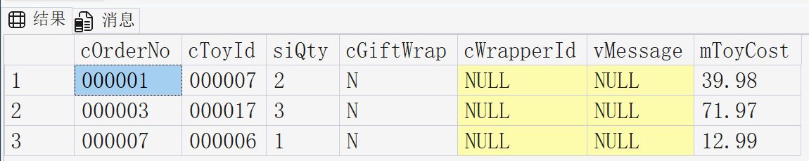
- 查找密码（password）长度不足6个字符的购买者的ID和姓名。
select vFirstname,vLastname,vEmailId
from Shopper
where len(cPassword)<6;
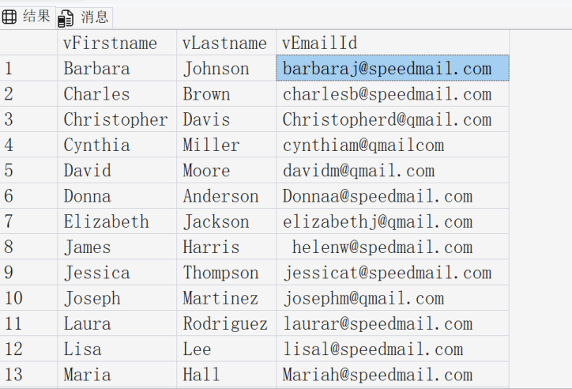
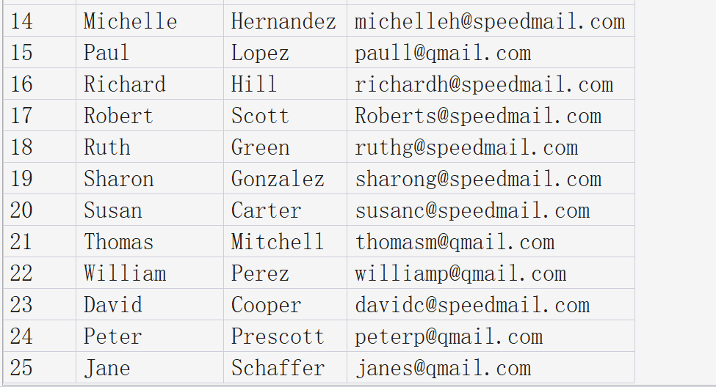
- 查找电话号码以“123”开头的收货人（Recipient）的姓名和所在的国家。
select r.vFirstName, r.vLastName, c.cCountry
from Recipient r
join Country c on r.cCountryId = c.cCountryId
where r.cPhone like '123%'
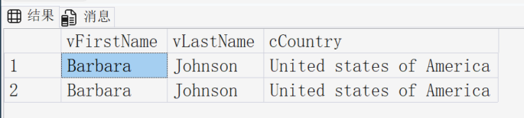
- 根据pickofmonth表，查找2020年销售总量排在前三名的玩具的ID。
select top 3 cToyId
from PickOfMonth
where iYear=2020
order by iTotalSold desc;
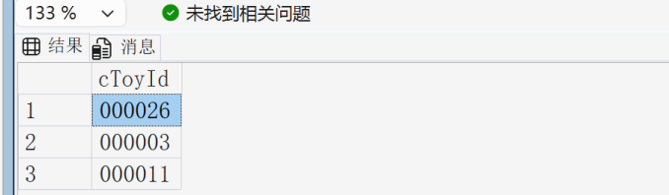
- 根据OrderDetail表，查找玩具总价值大于￥50的定单的号码和玩具总价值。
select cOrderNo,sum(mToyCost) 玩具总价值
from OrderDetail
group by cOrderNo having sum(mToyCost)>50;
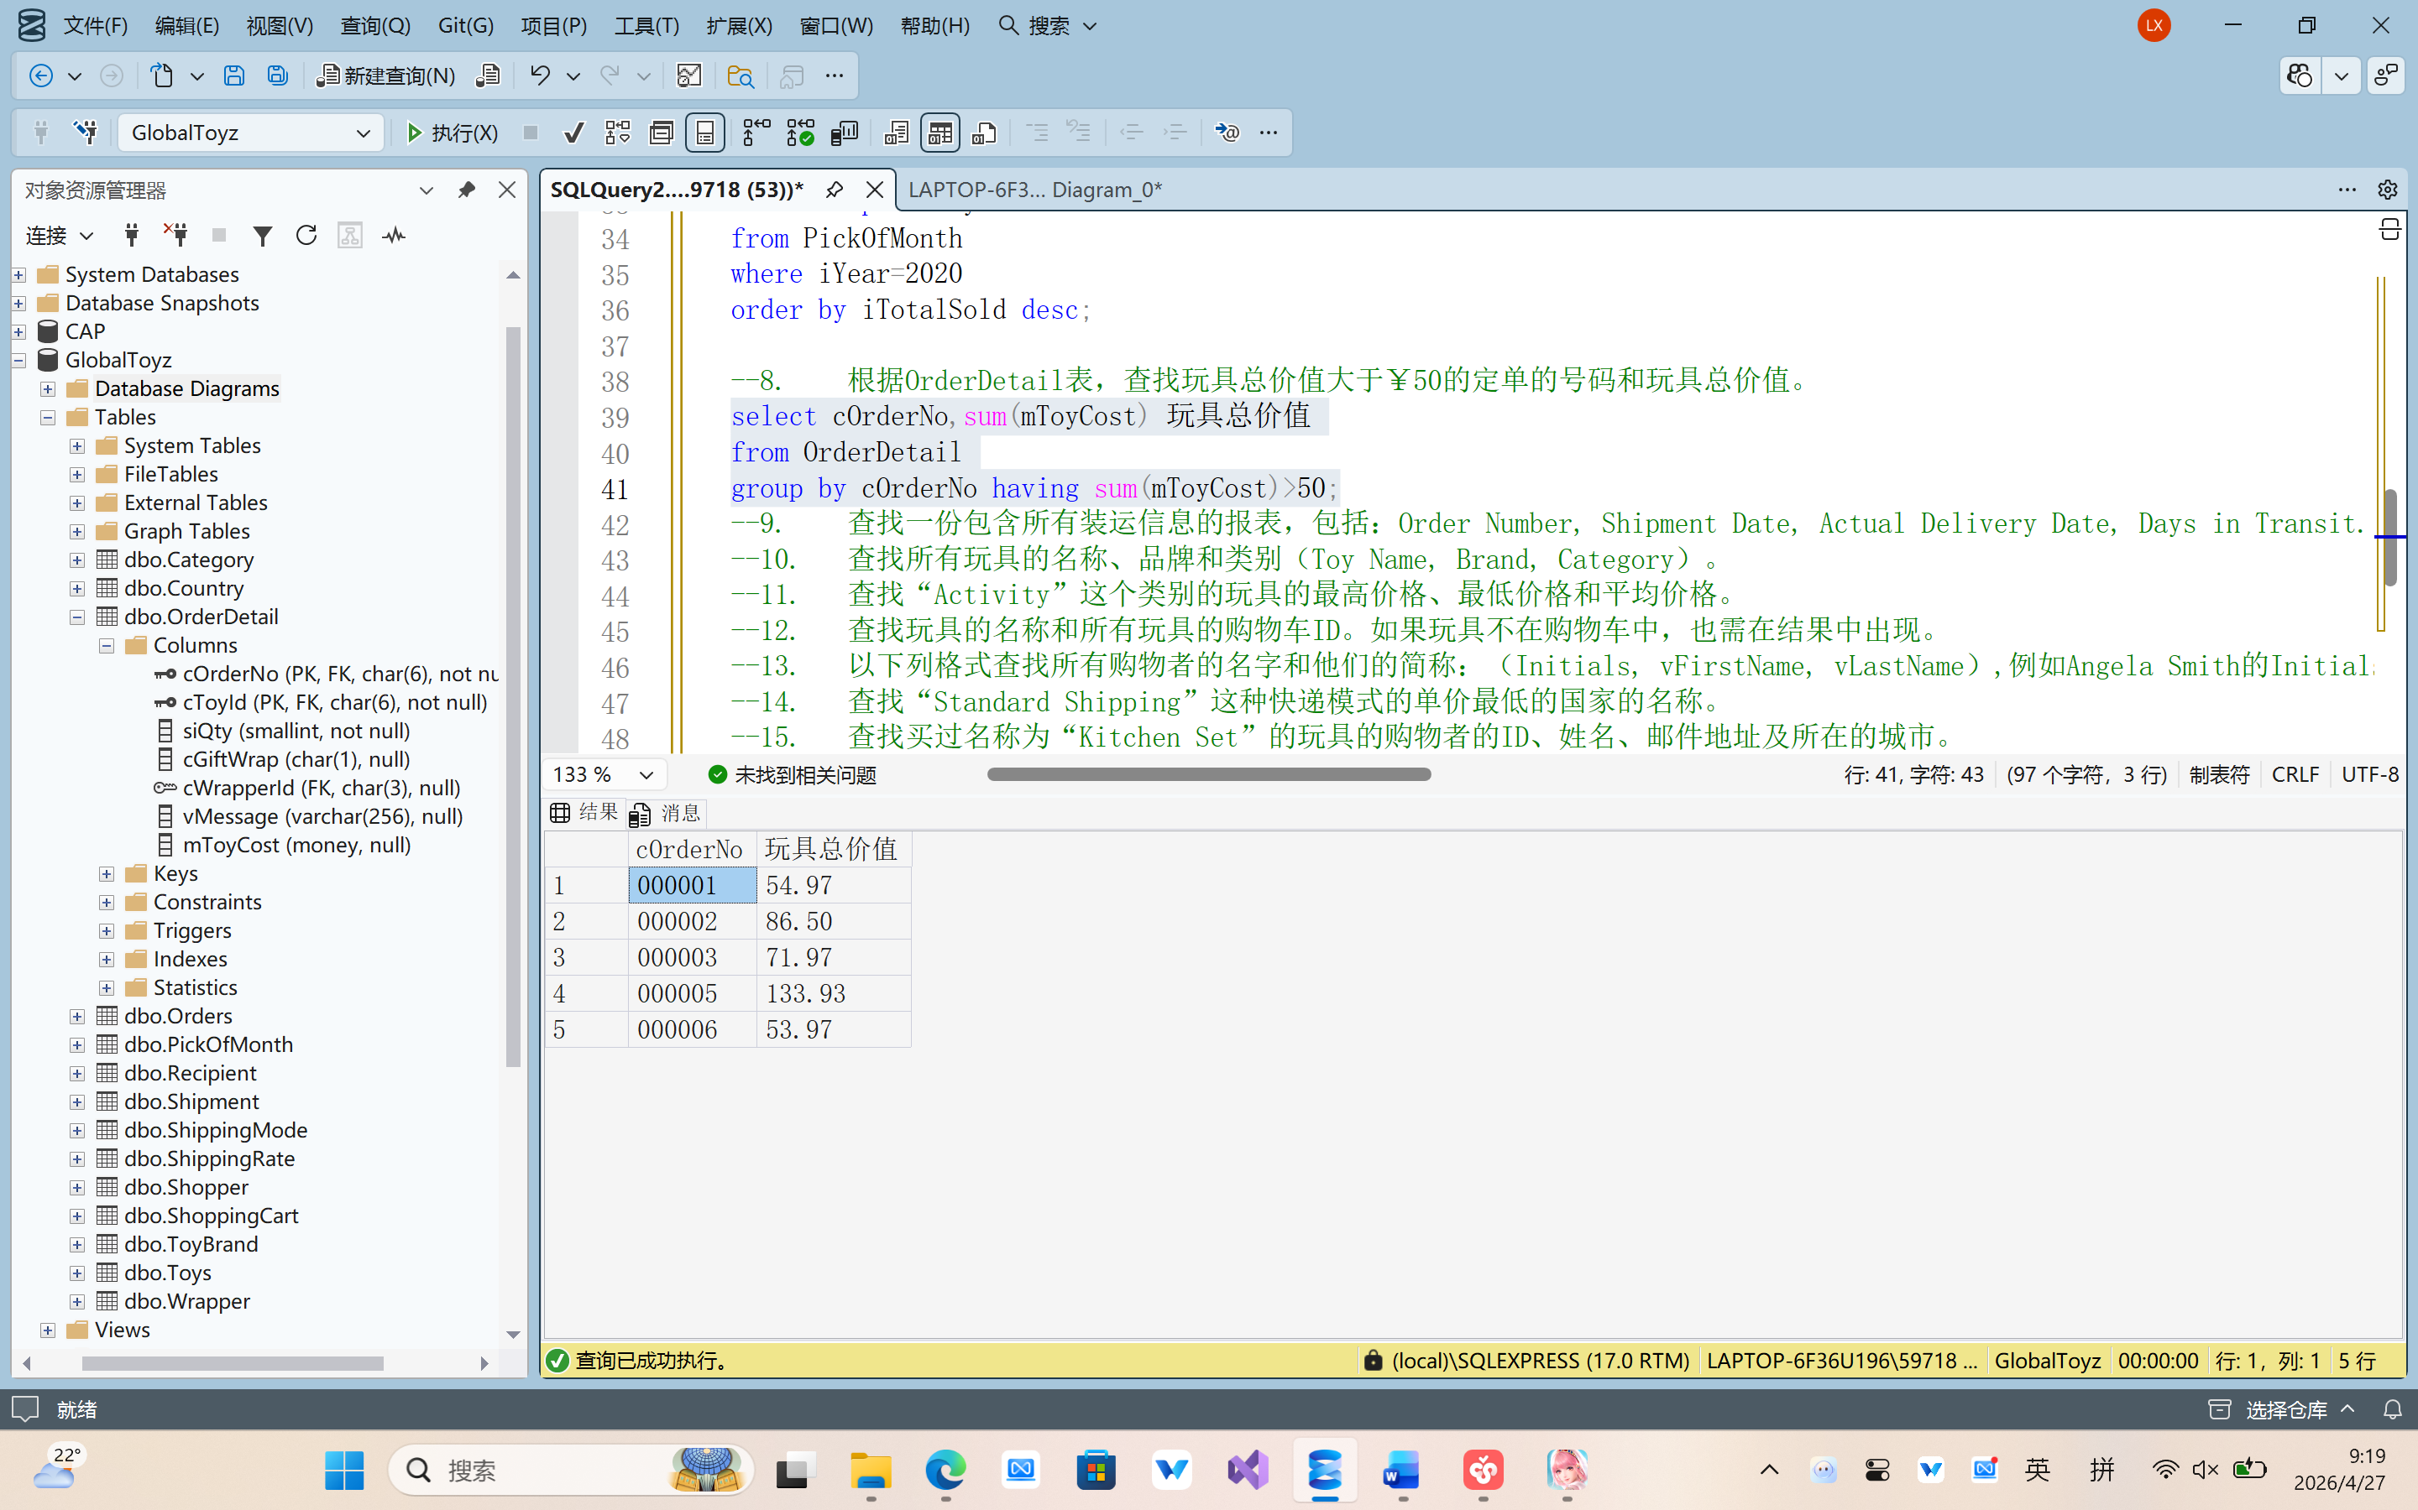
- 查找一份包含所有装运信息的报表，包括：Order Number, Shipment Date, Actual Delivery Date, Days in Transit. (提示：Days in Transit = Actual Delivery Date – Shipment Date)
select
cOrderNo as [Order Number],
dShipmentDate as [Shipment Date],
dActualDeliveryDate as [Actual Delivery Date],
DATEDIFF(DAY, dShipmentDate, dActualDeliveryDate) as [Days in Transit]
from Shipment;
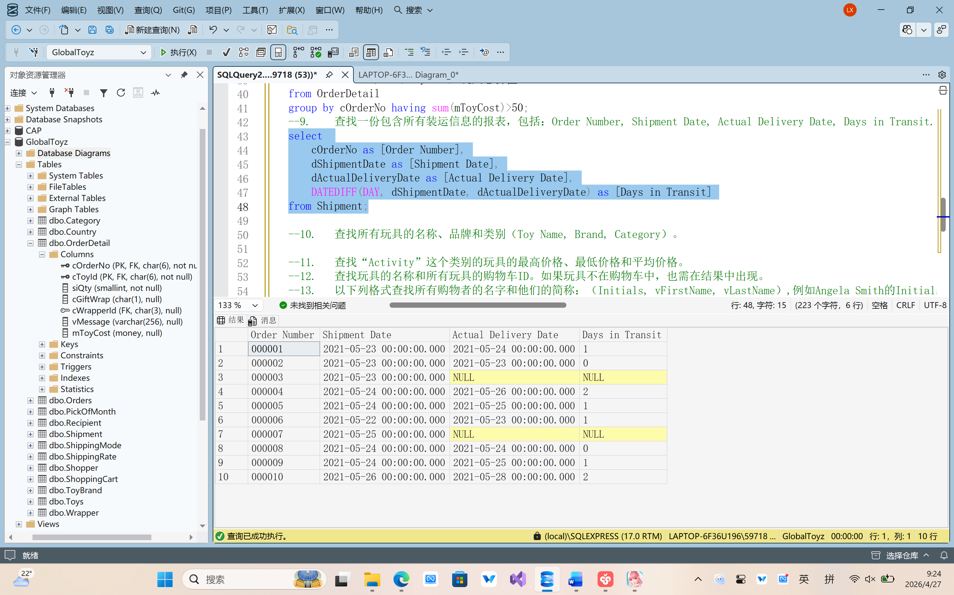
- 查找所有玩具的名称、品牌和类别（Toy Name, Brand, Category）。
SELECT
t.vToyName AS [Toy Name],
b.cBrandName AS [Brand],
c.cCategory AS [Category]
FROM Toys t
JOIN ToyBrand b ON t.cBrandId = b.cBrandId
JOIN Category c ON t.cCategoryId = c.cCategoryId;
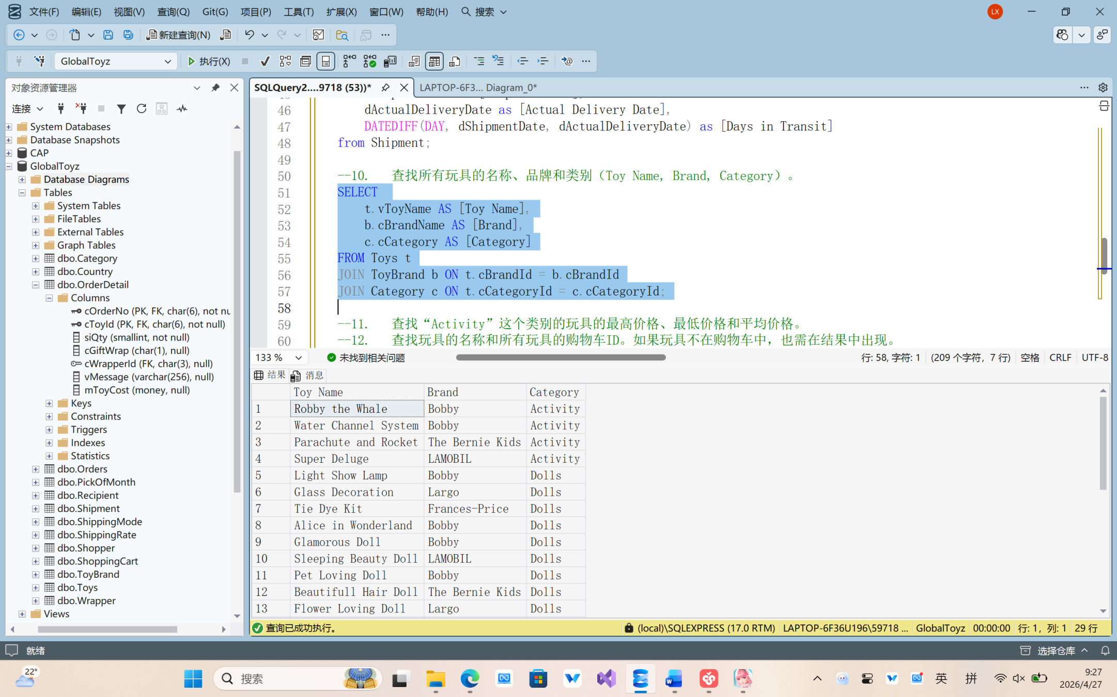
- 查找“Activity”这个类别的玩具的最高价格、最低价格和平均价格。
SELECT
MAX(t.mToyRate) AS MaxPrice,
MIN(t.mToyRate) AS MinPrice,
AVG(t.mToyRate) AS AvgPrice
FROM Toys t
JOIN Category c ON t.cCategoryId = c.cCategoryId
WHERE c.cCategory = 'Activity';
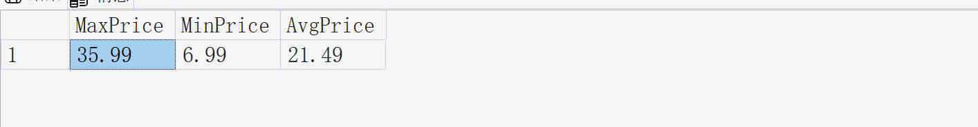
- 查找玩具的名称和所有玩具的购物车ID。如果玩具不在购物车中，也需在结果中出现。
SELECT
t.vToyName,
sc.cCartId
FROM Toys t
LEFT JOIN ShoppingCart sc ON t.cToyId = sc.cToyId;
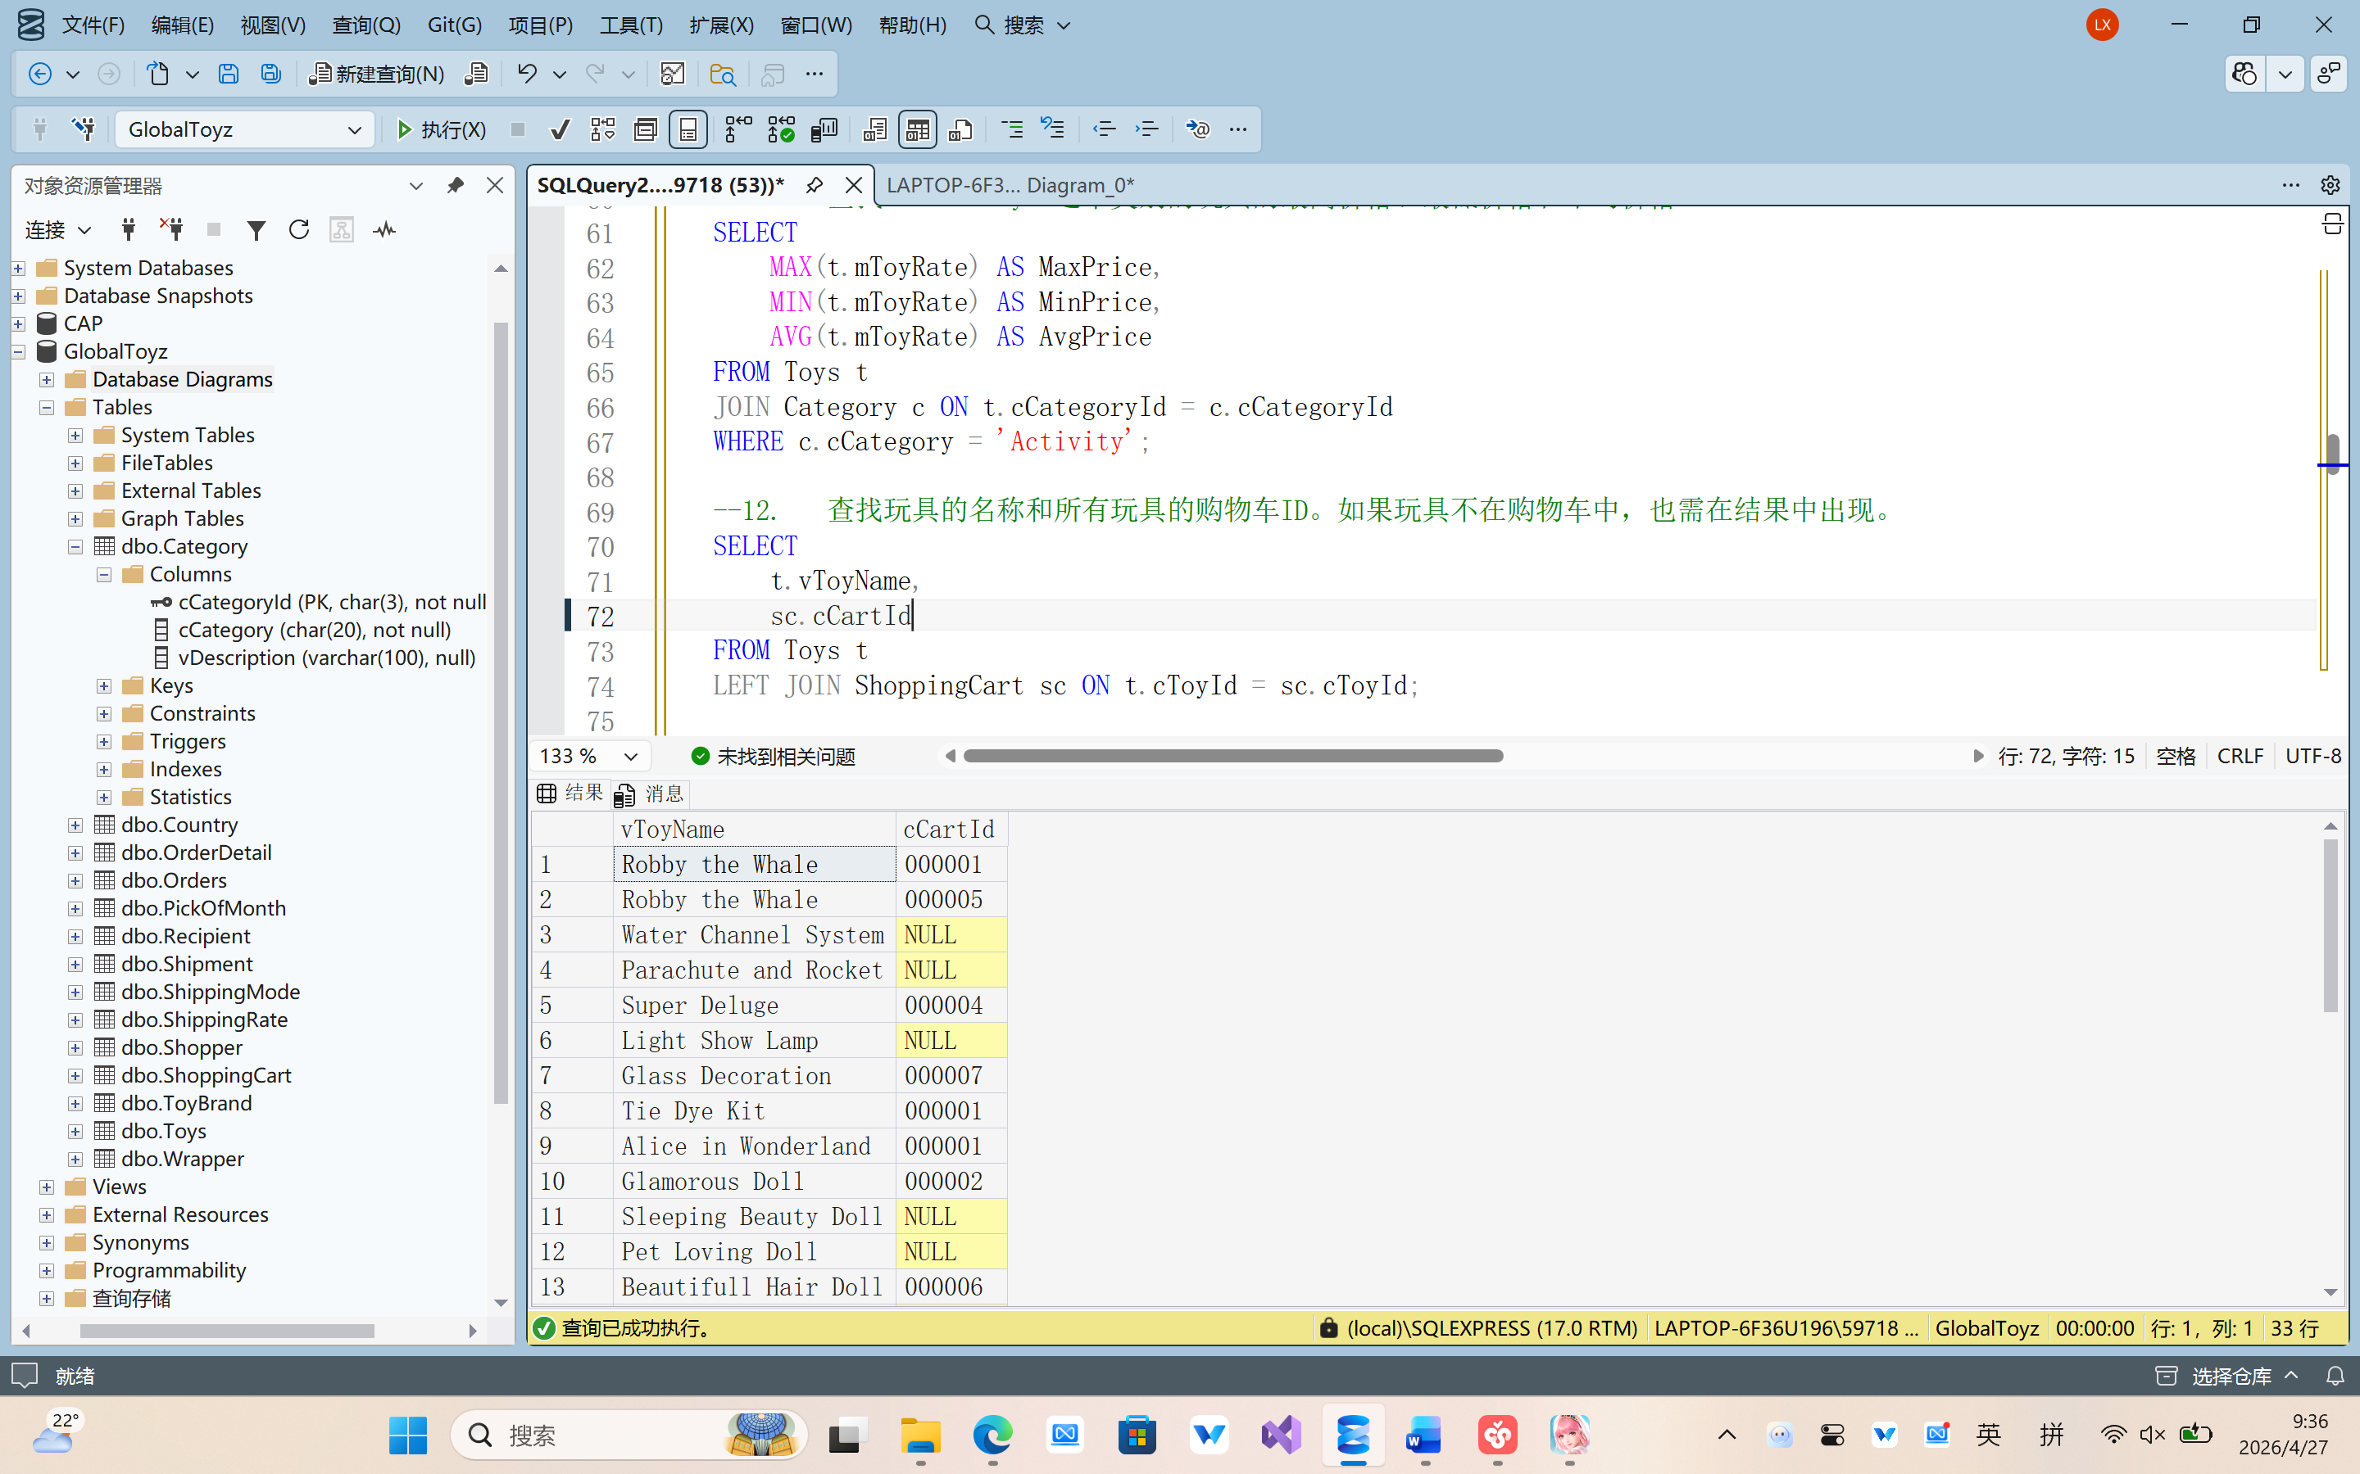
- 以下列格式查找所有购物者的名字和他们的简称：（Initials, vFirstName, vLastName）,例如Angela Smith的Initials为A.S。
SELECT
LEFT(vFirstName, 1) + '.' + LEFT(vLastName, 1) + '.' AS Initials,
vFirstName,
vLastName
FROM Shopper;
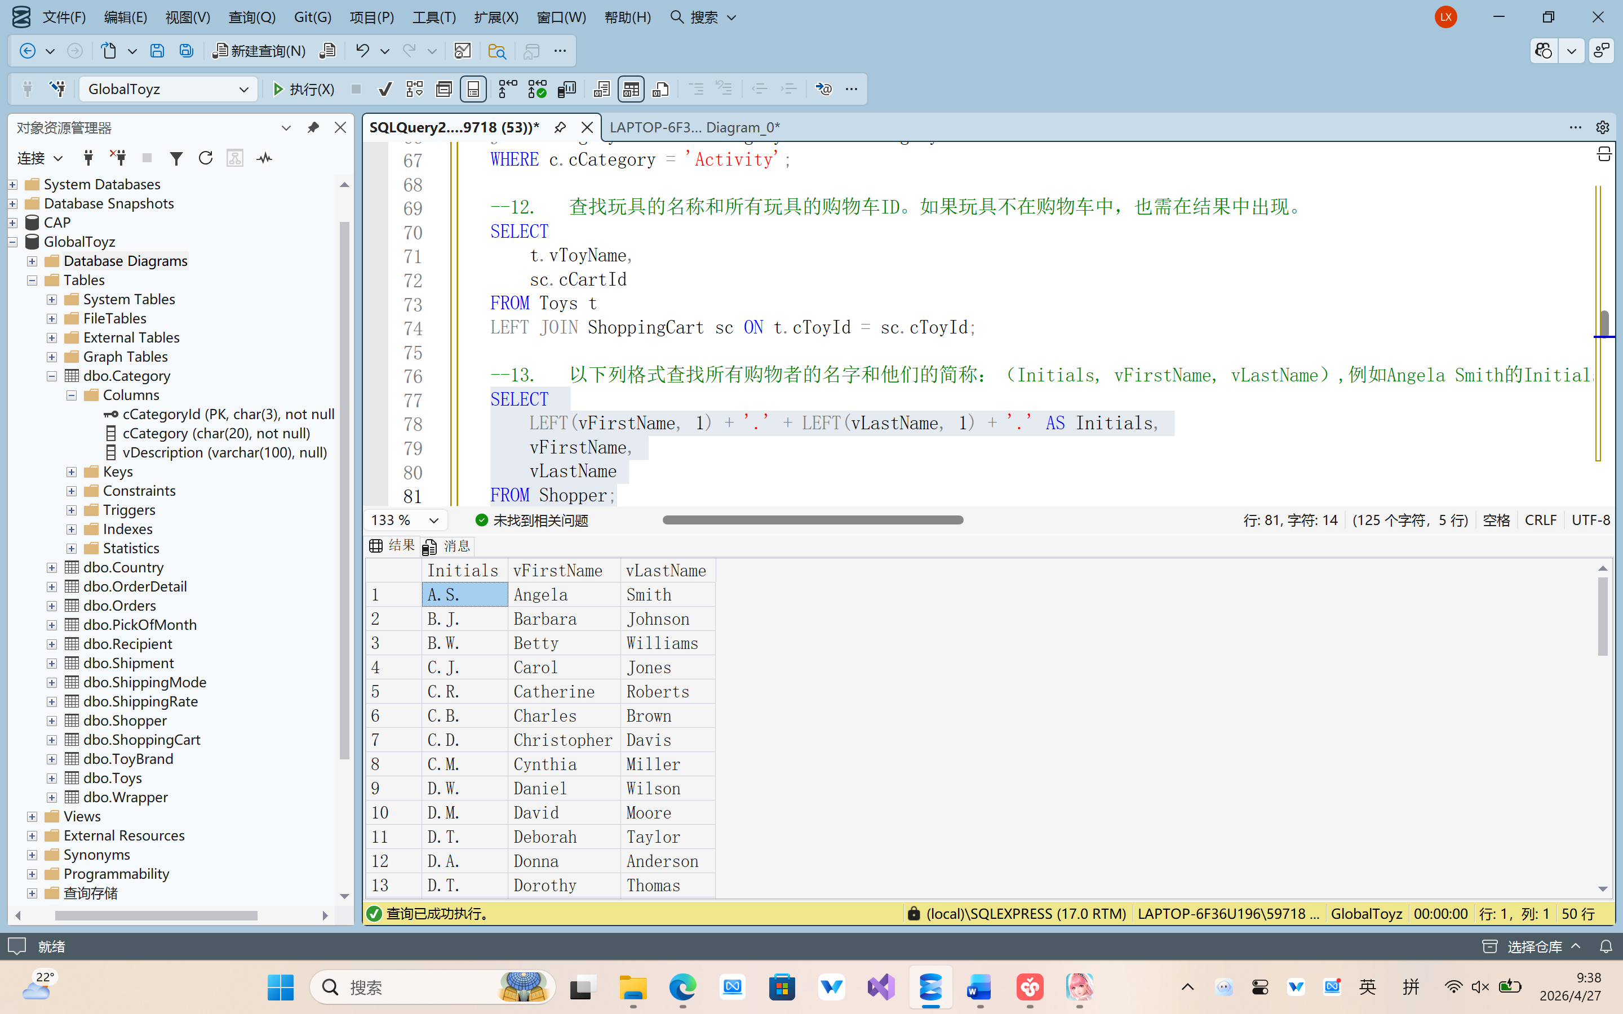
- 查找“Standard Shipping”这种快递模式的单价最低的国家的名称。
select top 1 c.cCountry
from ShippingRate sr
join Country c on sr.cCountryId = c.cCountryId
join ShippingMode sm on sr.cModeId = sm.cModeId
where sm.cMode = 'Standard Shipping'
order by sr.mRatePerPound ASC;
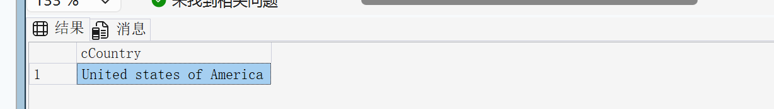
- 查找买过名称为“Kitchen Set”的玩具的购物者的ID、姓名、邮件地址及所在的城市。
SELECT DISTINCT
s.cShopperId,
s.vFirstName,
s.vLastName,
s.vEmailId,
s.cCity
FROM Shopper s
JOIN Orders o ON s.cShopperId = o.cShopperId
JOIN OrderDetail od ON o.cOrderNo = od.cOrderNo
JOIN Toys t ON od.cToyId = t.cToyId
WHERE t.vToyName = 'Kitchen Set';
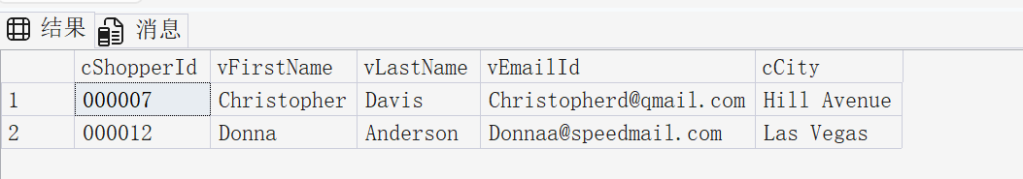
- 查找所有购物者和收货人的名、姓、地址和所在城市，要求保留结果中的重复记录。
SELECT vFirstName, vLastName, vAddress, cCity
FROM Shopper

UNION all

SELECT vFirstName, vLastName, vAddress, cCity
FROM Recipient;
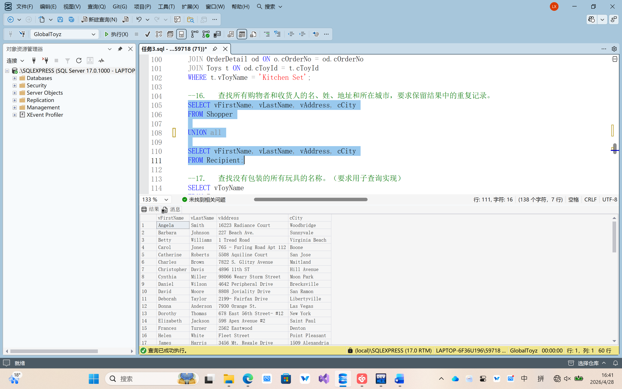
- 查找没有包装的所有玩具的名称。（要求用子查询实现）
SELECT vToyName
FROM Toys
WHERE cToyId NOT IN (
SELECT cToyId
FROM OrderDetail
WHERE cWrapperId IS NOT NULL
);
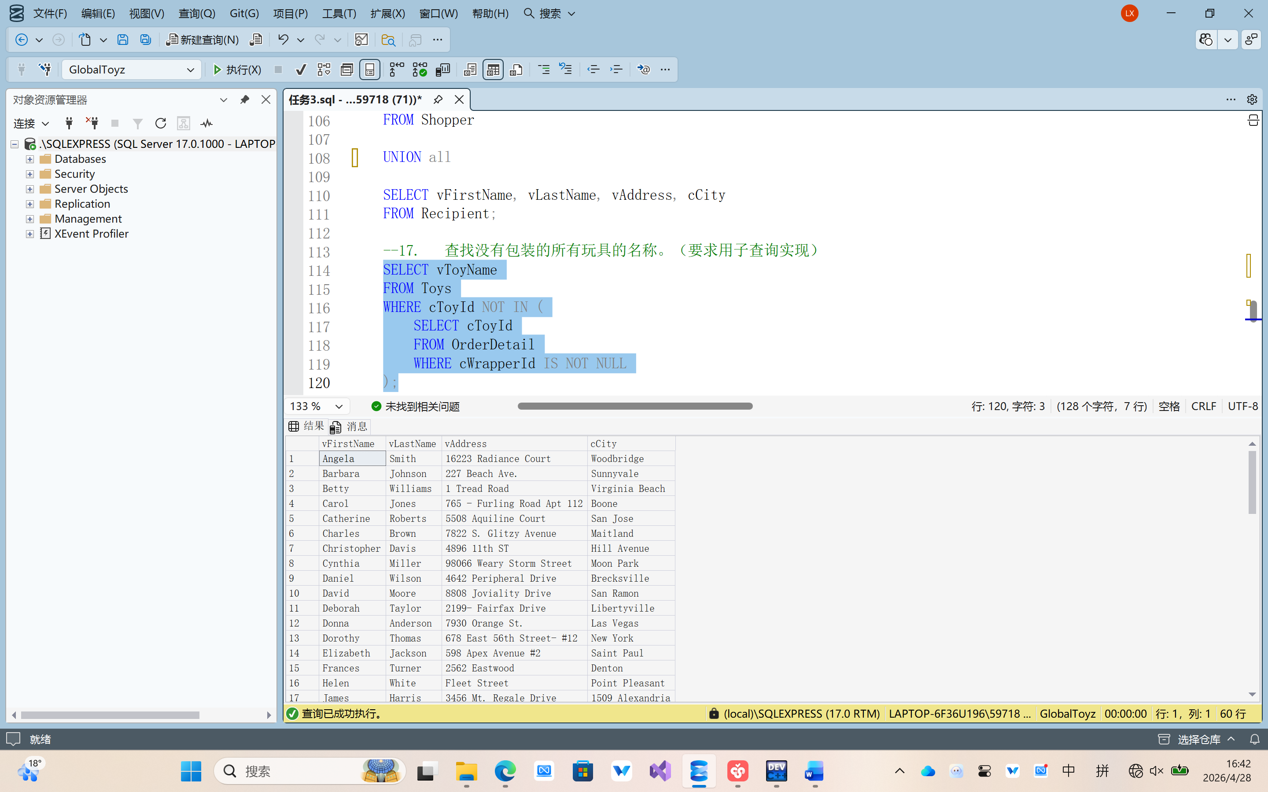
- 查找已收货定单的定单号码以及下定单的时间。（要求用子查询实现）
SELECT cOrderNo, dOrderDate
FROM Orders
WHERE cOrderNo IN (
SELECT cOrderNo
FROM Shipment
WHERE dActualDeliveryDate IS NOT NULL
);
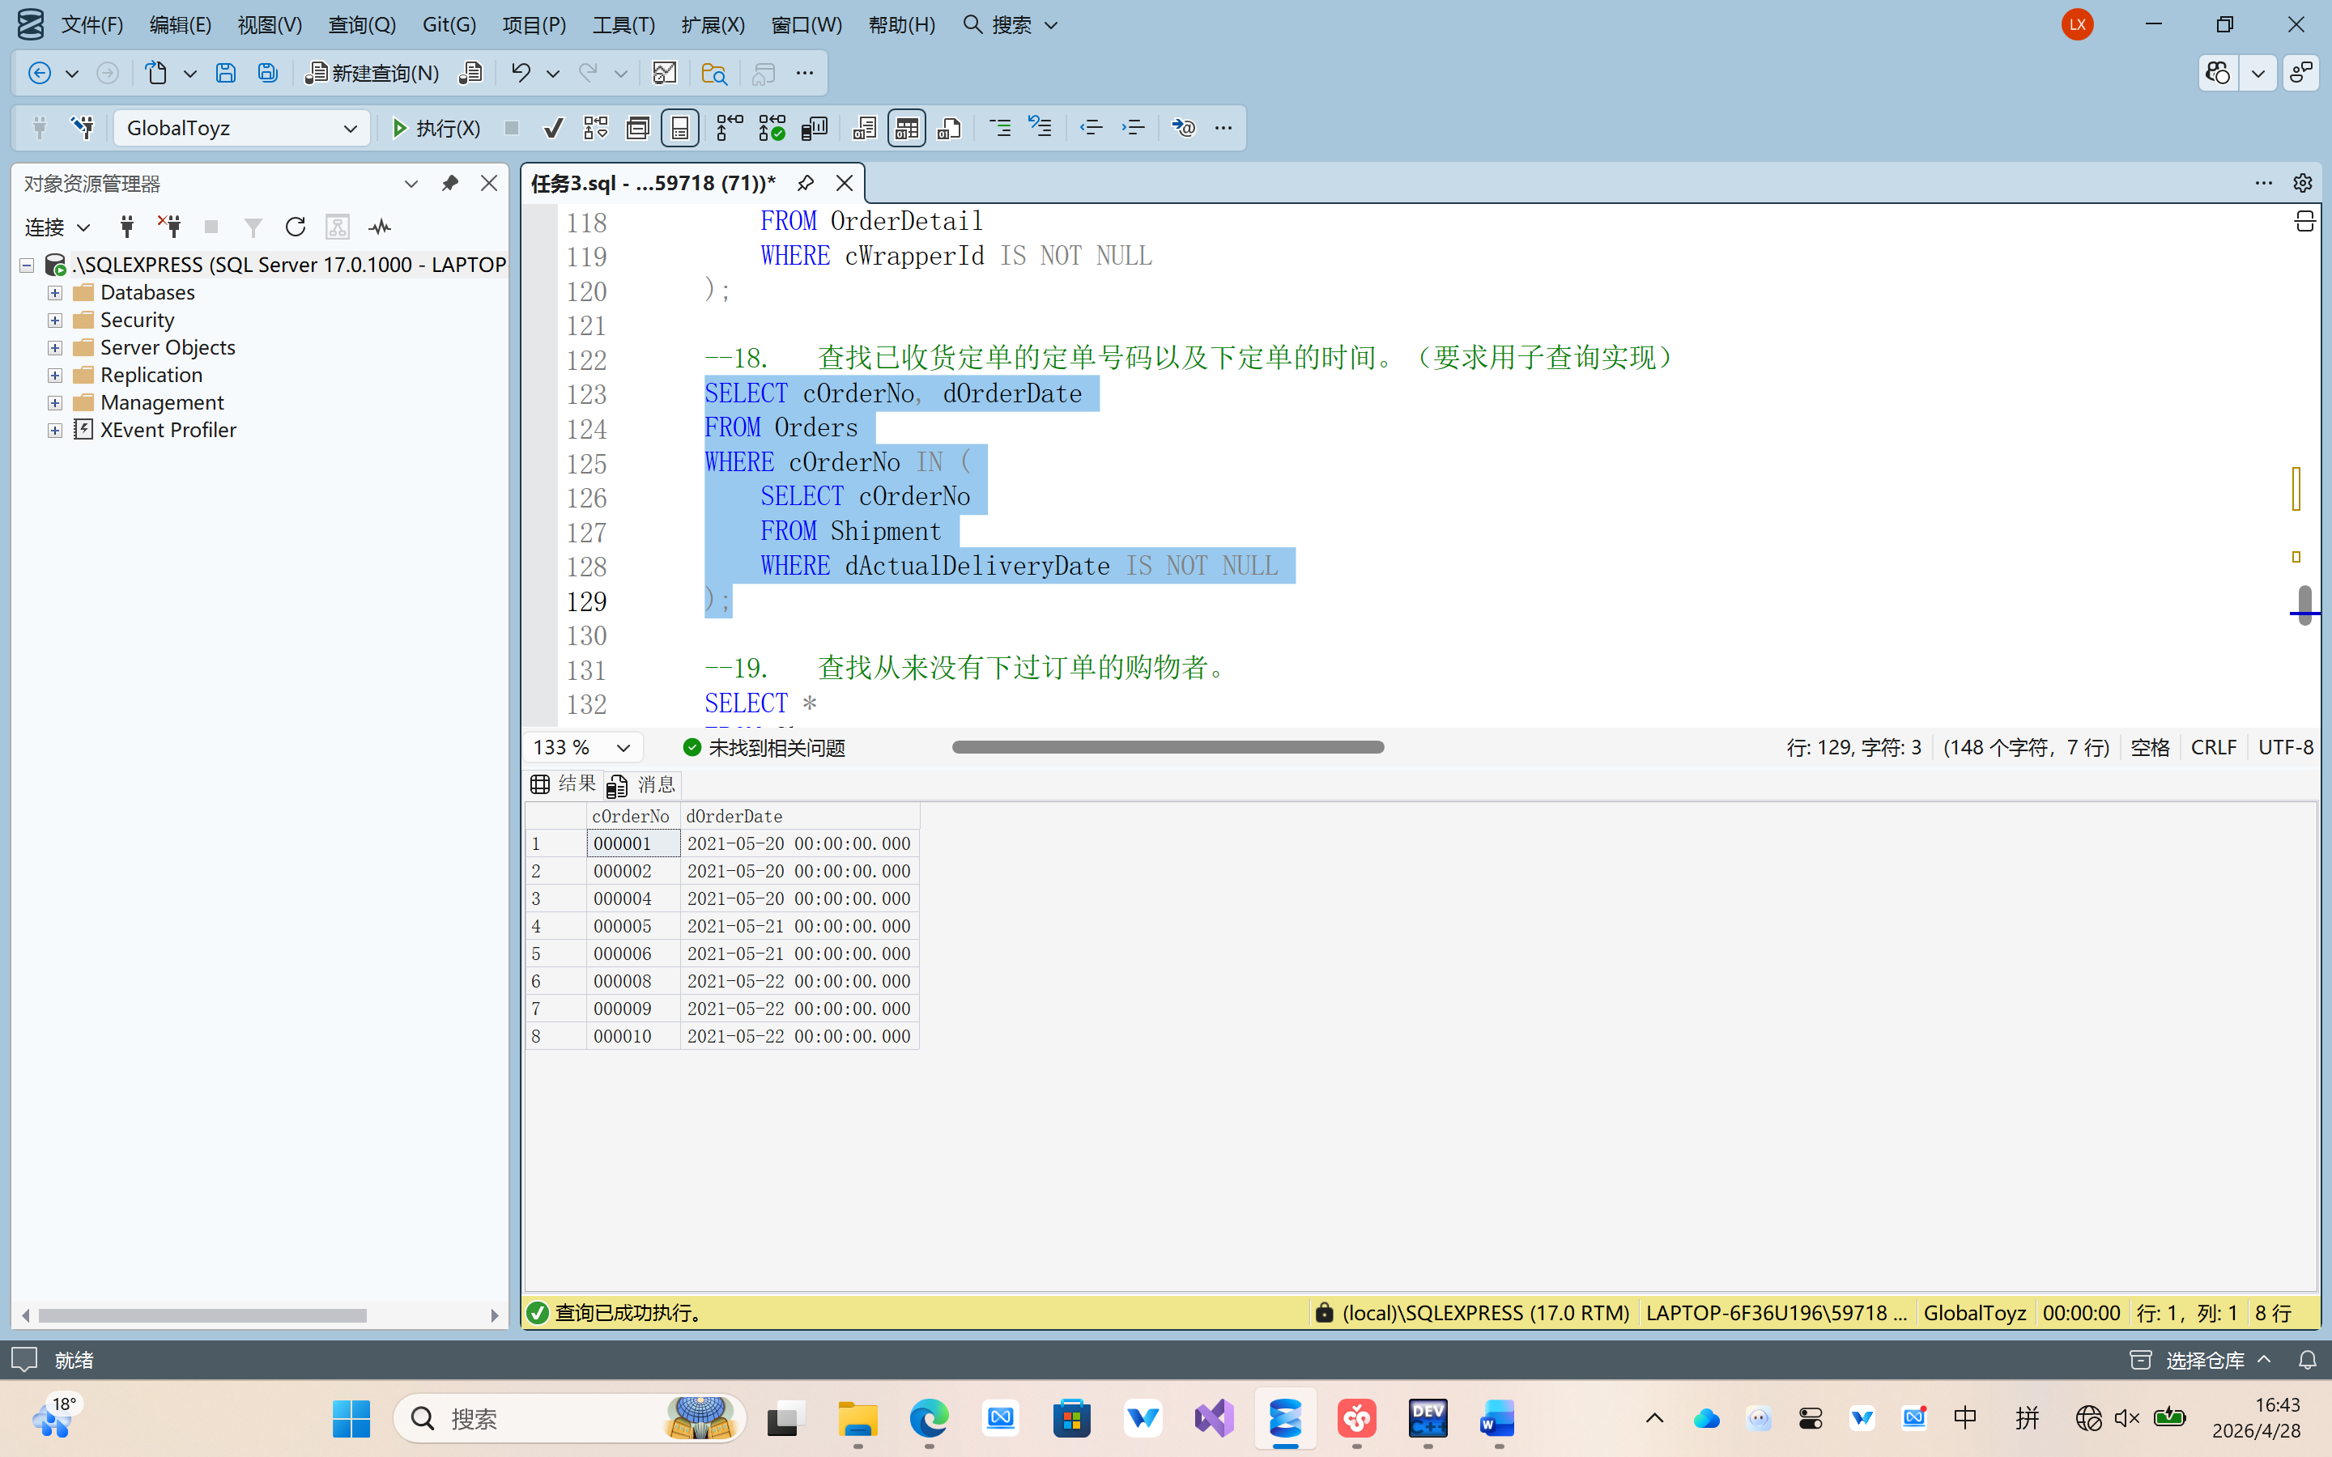
- 查找从来没有下过订单的购物者。
SELECT *
FROM Shopper
WHERE cShopperId NOT IN (
SELECT DISTINCT cShopperId
FROM Orders
);
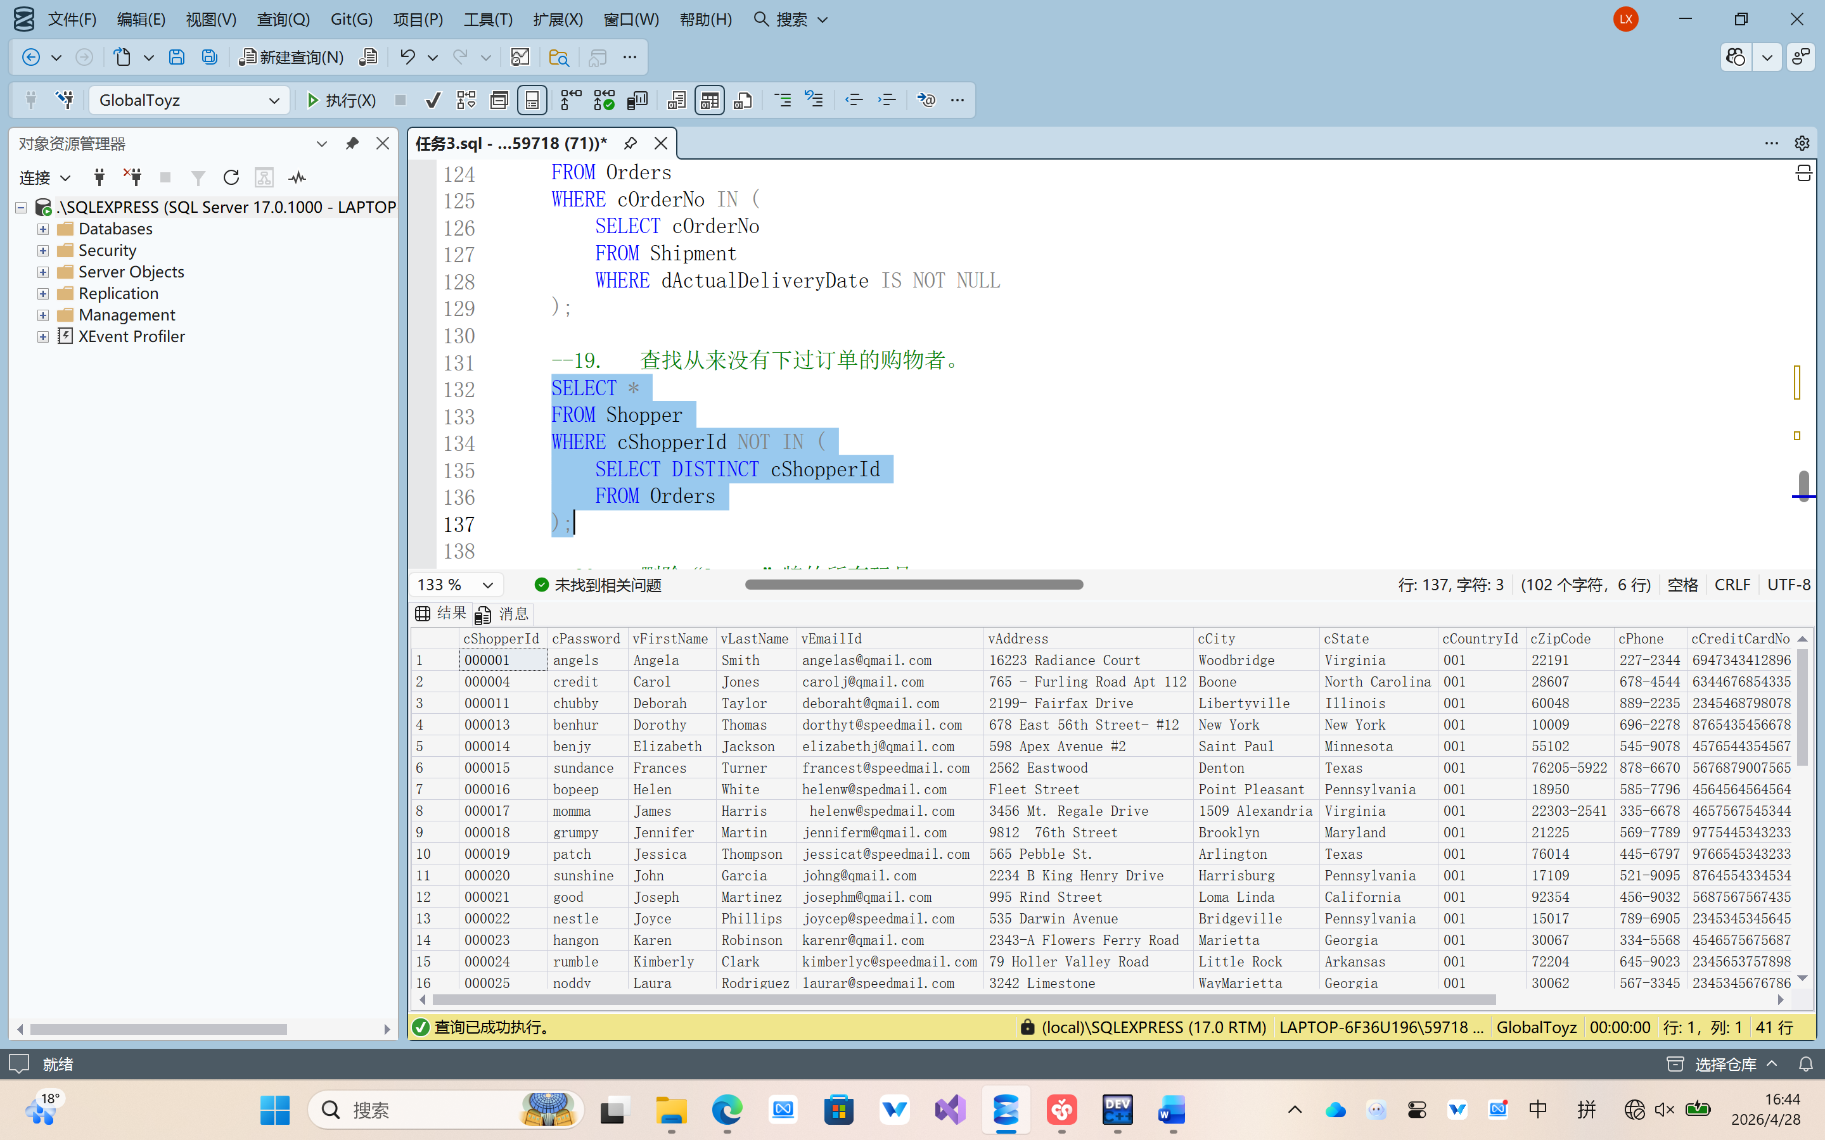
- 删除“Largo”牌的所有玩具。
DELETE FROM Toys
WHERE cBrandId IN (
SELECT cBrandId
FROM ToyBrand
WHERE cBrandName = 'Largo'
);
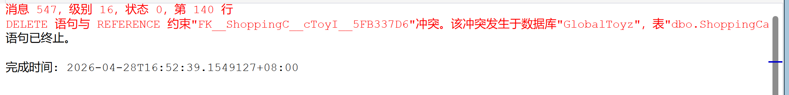
所以说：先删子表记录，再删父表记录。
DELETE pom
FROM PickOfMonth pom
JOIN Toys t ON pom.cToyId = t.cToyId
JOIN ToyBrand b ON t.cBrandId = b.cBrandId
WHERE b.cBrandName = 'Largo';

DELETE od
FROM OrderDetail od
JOIN Toys t ON od.cToyId = t.cToyId
JOIN ToyBrand b ON t.cBrandId = b.cBrandId
WHERE b.cBrandName = 'Largo';

DELETE sc
FROM ShoppingCart sc
JOIN Toys t ON sc.cToyId = t.cToyId
JOIN ToyBrand b ON t.cBrandId = b.cBrandId
WHERE b.cBrandName = 'Largo';

DELETE t
FROM Toys t
JOIN ToyBrand b ON t.cBrandId = b.cBrandId
WHERE b.cBrandName = 'Largo';
