VIGHNAX — BhaviṣyAdvaktā: World-Model Forecasting of Network Attack Progression
Architecture document · SIH 2026 · PS SIH26153 (NTRO) · AI-based Network Attack Forecasting from Network Traffic Data · Team VIGHNAX (Team ID 127364) · open source (MIT), fully offline

1. Idea
Instead of classifying flows one at a time, VIGHNAX learns how the state of a network evolves — the transition distribution P(St+1 | S≤t) — from flow-level and packet-level telemetry, then rolls that model forward K steps to estimate whether the current trajectory leads to compromise, which MITRE ATT&CK stage comes next, and which traffic features drive the prediction. One model is trained on all seven datasets named in the PS.

2. System architecture
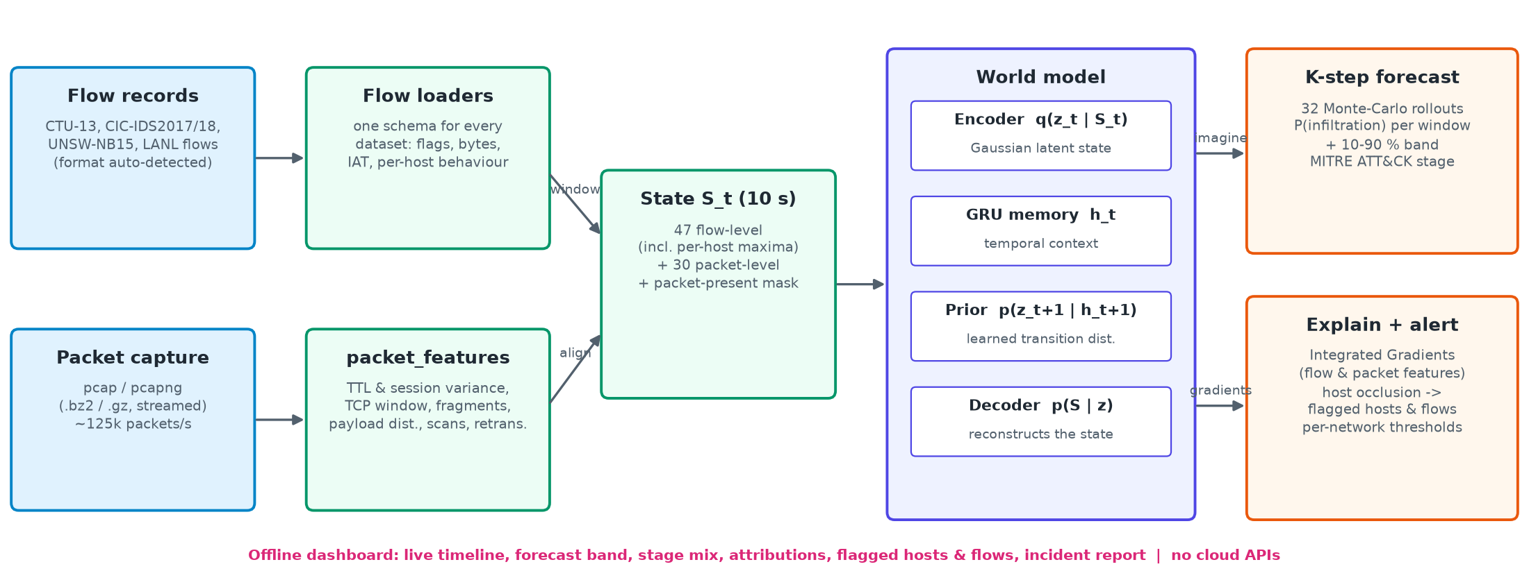

3. Components
- Ingestion. A universal loader reads every PS dataset's native format by content: CTU-13 Argus binetflow, CIC-IDS2017/2018 CICFlowMeter CSV, UNSW-NB15 records, LANL flows; packet captures (pcap/pcapng, .gz/.bz2) are streamed at ~125k packets/s with headers decoded directly (a Scapy reference parser is included).
- Network state S_t. Every 10 s window becomes a 78-dim vector: 47 flow-level features (5-tuple statistics, flags, bytes, packets, duration, IAT, fwd/bwd ratios, per-host maxima so one compromised host is not diluted) + 30 packet-level features (TTL mean and per-session variance, TCP window, IP fragment/DF flags, payload-size distribution, SYN-only/RST/ICMP shares, retransmissions, sequential-vs-randomised port-scan signatures) + a packet-present mask.
- World model. Encoder q(z_t|S_t) → Gaussian latent; GRU memory h_t; prior p(z_t+1|h_t+1) = learned transition distribution; decoder p(S|z). Heads on (h, z) give P(infiltration) and a 7-way ATT&CK stage distribution. Loss = reconstruction + KL(posterior‖prior) + attack/stage losses on observed states and on imagined K-step rollouts against the true future labels (supervised dynamics learning from each dataset's attack timeline). Modality dropout (CSV-only inputs), volume augmentation (network size) and dataset-balanced sampling (each epoch draws equally from all seven datasets).
- Forward simulation and explanations. 32 Monte-Carlo latent trajectories rolled K = 6 windows (60 s) ahead: per-window P(infiltration) with a 10–90 % band and the predicted stage mix with technique IDs. Integrated Gradients (Aumann–Shapley / SHAP family) attributes each forecast to flow- and packet-level features; leave-one-host-out occlusion flags the responsible hosts and flows.
- Interface. Offline Flask dashboard (bundled Chart.js and fonts). One drop zone for any mix of flow files, PCAPs or a .zip; the world model streams its forecast window by window; the timeline, forecast fan, attributions and flagged hosts update live at a selectable playback speed (1× = real time). Alert thresholds are calibrated per network (site profile).

4. Data and evaluation protocol
CTU-13 (flows + full packet captures), CIC-IDS2017 and CSE-CIC-IDS2018 (CICFlowMeter flows), UNSW-NB15 (flow records), LANL cyber1 (router flows + red-team events), DARPA 1999 (tcpdump + attack truth list) and CICIoT2023 (per-activity packet captures). Every test source is unseen in training: other botnet families (CTU-13), other days (CIC, UNSW, DARPA), another 12 h slice (LANL), other attack types (CICIoT2023). Validation = every 5th 5-minute block of the training sources. Labels map to ATT&CK stages by behaviour; all seven stages occur. The LR baseline uses the same state features and targets; operating thresholds are chosen per dataset on validation only (most detection with at most 5 % false alarms, same rule for both models).

5. Results on unseen test data (AUROC, world model / LR baseline)
Dataset (unseen test data) | Forecast WM / LR | Early warning WM / LR | Detection WM / LR
CTU-13 | 0.83 / 0.60 | 0.82 / 0.48 | 0.89 / 0.74
CIC-IDS2017 | 0.56 / 0.56 | 0.47 / 0.47 | 0.65 / 0.65
CSE-CIC-IDS2018 | 0.83 / 0.60 | 0.57 / 0.55 | 0.83 / 0.62
UNSW-NB15 | 0.95 / 0.99 | 0.63 / 0.71 | 1.00 / 0.95
LANL cyber1 | 0.37 / 0.56 | 0.34 / 0.57 | 0.40 / 0.55
DARPA 1999 | 0.63 / 0.69 | 0.60 / 0.61 | 0.69 / 0.81
CICIoT2023 | n/a | n/a | 0.99 / 0.76
Macro average (temporal) | 0.70 / 0.67 | 0.57 / 0.57 | 0.74 / 0.72

- Forecasting: world model ahead on 2 of 6 temporal datasets (macro AUROC 0.70 vs 0.67; LR ahead on UNSW-NB15, LANL cyber1, DARPA 1999); 54 of 201 attack onsets forecast before they began, vs 17 for LR. On validation the world model leads on every dataset; unseen days generalise less well.
- Stated plainly: detection of the current window: LR is better on LANL cyber1, DARPA 1999. CICIoT2023 episodes are composed (benign capture then attack capture) and scored for detection only. Thresholds must be calibrated per site; PCAP-only input relies on flows rebuilt from packets.
- Cost: 0.04 ms per 10 s window batched on GPU, ~8 ms streamed on a laptop CPU (32 rollouts); ~125k packets/s ingestion. Reproduce: fetch_datasets.sh → prepare_data.py / prepare_all.py → train.py → evaluate.py (seeded config).
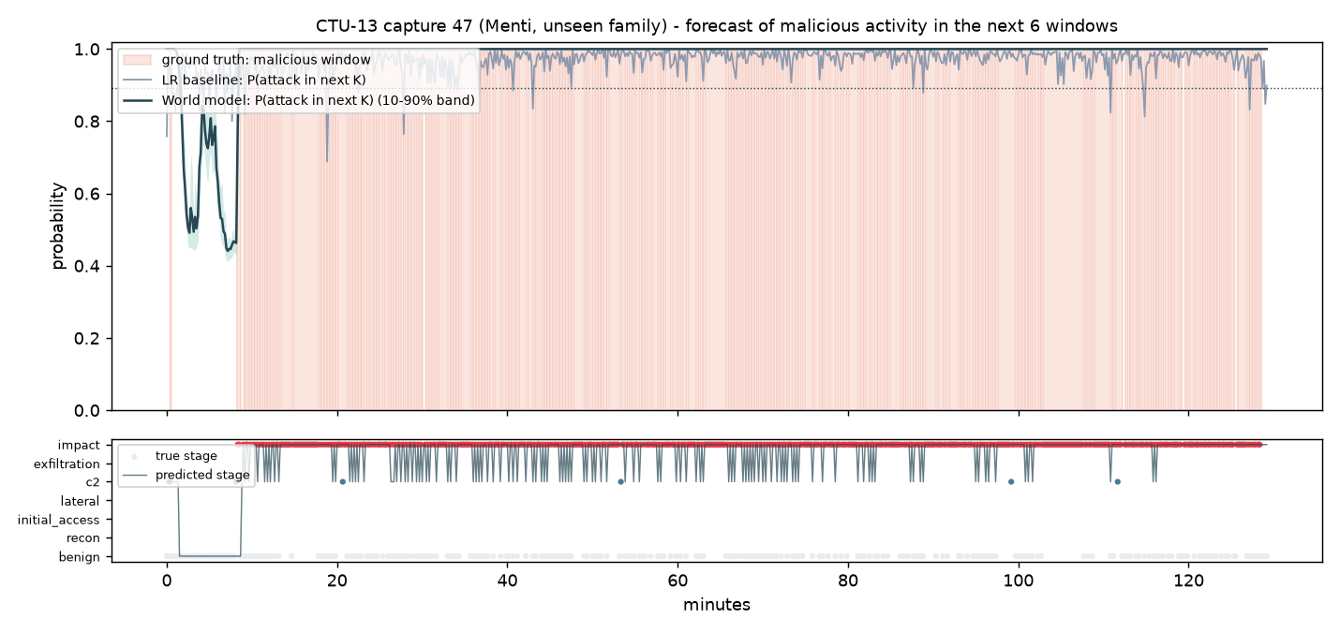
Figure: unseen CTU-13 Menti capture. Shaded = ground-truth malicious windows; dark = world-model P(attack within 60 s) with 10–90 % band; grey = LR baseline on the same features.

