Ex No :2.A Practice layouts

Date :

**Aim:**

1. To create a page(with proper data) for an application of your choice
2. To run the application in your emulator and take screen shots

**Code**

**Linear Layout**

<?xml version="1.0" encoding="utf-8"?>  
<LinearLayoutxmlns:android="http://schemas.android.com/apk/res/android"  
xmlns:tools="http://schemas.android.com/tools"  
android:layout_width="match_parent"  
android:layout_height="match_parent"  
android:orientation="vertical"  
android:gravity="center"  
tools:context=".MainActivity">  
<TextView  
android:layout_width="wrap_content"  
android:layout_height="wrap_content"  
android:textSize="30dp"  
android:text="Welcome"  
android:textAlignment="center"  
android:layout_margin="50dp"  
android:textStyle="bold"  
android:gravity="center_horizontal" />  
<TextView  
android:layout_width="wrap_content"  
android:layout_height="wrap_content"  
android:textSize="20dp"  
android:text="UserName"  
android:textAlignment="center"  
android:layout_margin="10dp"  
android:textStyle="bold"  
android:textAllCaps="true"  
android:gravity="center_horizontal" />  
<EditText  
android:id="@+id/editTextTextPersonName"  
android:layout_width="match_parent"  
android:layout_height="wrap_content"  
android:ems="10"  
android:inputType="textPersonName"  
android:layout_margin="10dp"  
android:hint="Enter Your Name..." />  
<TextView  
android:layout_width="wrap_content"  
android:layout_height="wrap_content"  
android:textSize="20dp"  
android:text="Password"  
android:textAlignment="center"  
android:layout_margin="10dp"  
android:textStyle="bold"  
android:gravity="center_horizontal" />  
<EditText  
android:id="@+id/pass"  
android:layout_width="match_parent"  
android:layout_height="wrap_content"  
android:ems="10"  
android:inputType="textPassword"  
android:layout_margin="10dp"  
android:hint="Enter Your Password..." />  
<Button  
android:id="@+id/button"  
android:layout_width="235dp"  
android:layout_height="wrap_content"  
android:layout_margin="30dp"  
android:text="Register" />  
</LinearLayout>

**Screen Shot - Linear Layout**

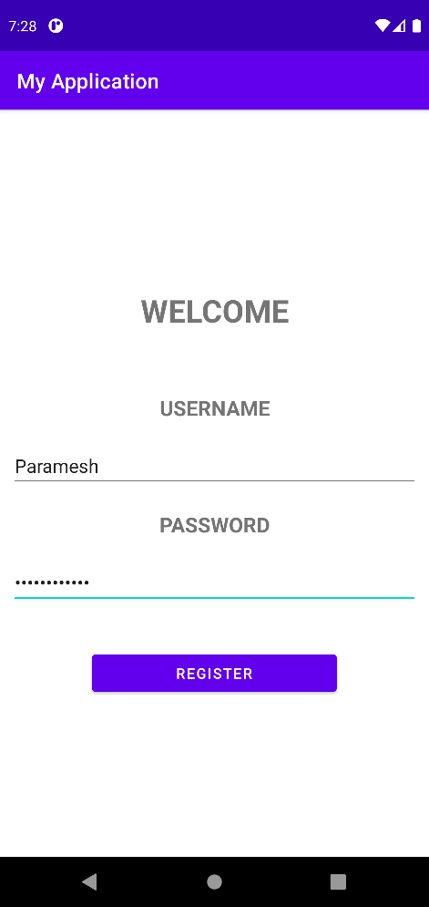

**Relative Layout**

<?xml version="1.0" encoding="utf-8"?>  
<RelativeLayoutxmlns:android="http://schemas.android.com/apk/res/android"  
xmlns:tools="http://schemas.android.com/tools"  
android:layout_width="fill_parent"  
android:layout_height="fill_parent"  
android:paddingLeft="16dp"  
android:paddingRight="16dp"  
tools:context=".MainActivity">  
  
<TextView  
android:id="@+id/name"  
android:text="Bikers Club"  
android:layout_margin="30dp"  
android:textStyle="bold"  
android:textSize="30dp"  
android:textAlignment="center"  
android:textAllCaps="true"  
android:layout_width="fill_parent"  
android:layout_height="wrap_content"  
android:gravity="center_horizontal" />  
  
<LinearLayout  
android:orientation="vertical"  
android:layout_width="fill_parent"  
android:layout_height="fill_parent"  
android:gravity="center"  
android:layout_alignParentStart="true"  
android:layout_below="@+id/name"  
android:layout_alignParentLeft="true">  
  
<TextView  
android:layout_width="wrap_content"  
android:layout_height="wrap_content"  
android:textSize="20dp"  
android:text="UserName"  
android:textAlignment="center"  
android:textStyle="bold"  
android:textAllCaps="true"  
android:gravity="center_horizontal" />  
  
<EditText  
android:id="@+id/editTextTextPersonName"  
android:layout_width="match_parent"  
android:layout_height="wrap_content"  
android:ems="10"  
android:inputType="textPersonName"  
android:layout_margin="10dp"  
android:hint="Enter Your Name..." />  
  
<TextView  
android:layout_width="wrap_content"  
android:layout_height="wrap_content"  
android:textSize="20dp"  
android:text="Email Address"  
android:textAlignment="center"  
android:layout_margin="10dp"  
android:textStyle="bold"  
android:textAllCaps="true"  
android:gravity="center_horizontal" />  
  
<EditText  
android:id="@+id/email"  
android:layout_width="match_parent"  
android:layout_height="wrap_content"  
android:ems="10"  
android:inputType="text"  
android:layout_margin="10dp"  
android:hint="Enter Your Email..."/>  
  
<TextView  
android:layout_width="wrap_content"  
android:layout_height="wrap_content"  
android:textSize="20dp"  
android:text="Password"  
android:textAlignment="center"  
android:layout_margin="10dp"  
android:textStyle="bold"  
android:textAllCaps="true"  
android:gravity="center_horizontal" />  
  
<EditText  
android:id="@+id/pass"  
android:layout_width="match_parent"  
android:layout_height="wrap_content"  
android:ems="10"  
android:inputType="textPassword"  
android:layout_margin="10dp"  
android:hint="Enter Your Password..."/>  
  
<Button  
android:id="@+id/button"  
android:layout_width="235dp"  
android:layout_height="wrap_content"  
android:layout_margin="30dp"  
android:text="Register"  
android:textAllCaps="true" />  
  
</LinearLayout>  
  
</RelativeLayout>

**Screen Shot**

**Linear Layout**

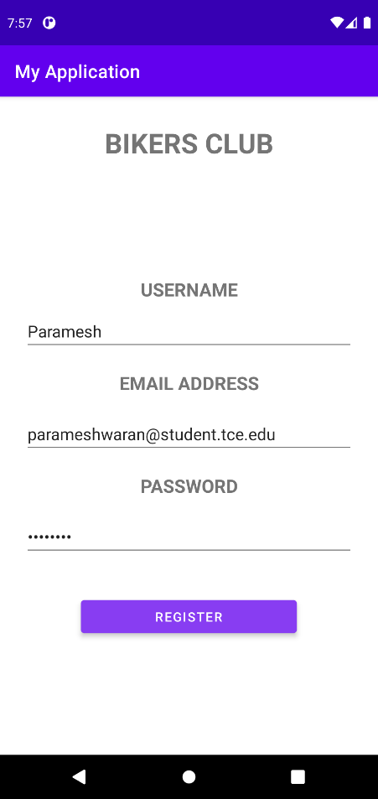

**Frame layout:**

<FrameLayoutxmlns:android="http://schemas.android.com/apk/res/android"  
android:id="@+id/frameLayout"  
android:layout_width="fill_parent"  
android:layout_height="fill_parent">  
<ImageView  
android:layout_width="match_parent"  
android:layout_height="match_parent"  
android:scaleType="fitXY"  
android:alpha="0.20"  
android:src="@drawable/lo" />  
<LinearLayout  
android:layout_width="wrap_content"  
android:layout_height="wrap_content">  
  
<RelativeLayoutxmlns:android="http://schemas.android.com/apk/res/android"  
xmlns:tools="http://schemas.android.com/tools"  
android:layout_width="fill_parent"  
android:layout_height="fill_parent"  
android:paddingLeft="16dp"  
android:paddingRight="16dp"  
tools:context=".MainActivity">  
  
<TextView  
android:id="@+id/name"  
android:text="Bikers Club"  
android:layout_margin="30dp"  
android:textStyle="bold"  
android:textSize="30dp"  
android:textAlignment="center"  
android:textAllCaps="true"  
android:layout_width="fill_parent"  
android:layout_height="wrap_content"  
android:gravity="center_horizontal" />  
  
<LinearLayout  
android:orientation="vertical"  
android:layout_width="fill_parent"  
android:layout_height="fill_parent"  
android:gravity="center"  
android:layout_alignParentStart="true"  
android:layout_below="@+id/name"  
android:layout_alignParentLeft="true">  
  
<TextView  
android:layout_width="wrap_content"  
android:layout_height="wrap_content"  
android:textSize="20dp"  
android:text="UserName"  
android:textAlignment="center"  
android:textStyle="bold"  
android:textAllCaps="true"  
android:gravity="center_horizontal" />  
  
<EditText  
android:id="@+id/editTextTextPersonName"  
android:layout_width="match_parent"  
android:layout_height="wrap_content"  
android:ems="10"  
android:inputType="textPersonName"  
android:layout_margin="10dp"  
android:hint="Enter Your Name..."  
 />  
  
<TextView  
android:layout_width="wrap_content"  
android:layout_height="wrap_content"  
android:textSize="20dp"  
android:text="Email Address"  
android:textAlignment="center"  
android:layout_margin="10dp"  
android:textStyle="bold"  
android:textAllCaps="true"  
android:gravity="center_horizontal" />  
  
<EditText  
android:id="@+id/email"  
android:layout_width="match_parent"  
android:layout_height="wrap_content"  
android:ems="10"  
android:inputType="text"  
android:layout_margin="10dp"  
android:hint="Enter Your Email..."  
 />  
  
<TextView  
android:layout_width="wrap_content"  
android:layout_height="wrap_content"  
android:textSize="20dp"  
android:text="Password"  
android:textAlignment="center"  
android:layout_margin="10dp"  
android:textStyle="bold"  
android:textAllCaps="true"  
android:gravity="center_horizontal" />  
  
<EditText  
android:id="@+id/pass"  
android:layout_width="match_parent"  
android:layout_height="wrap_content"  
android:ems="10"  
android:inputType="textPassword"  
android:layout_margin="10dp"  
android:hint="Enter Your Password..."  
 />  
  
<Button  
android:id="@+id/button"  
android:layout_width="235dp"  
android:layout_height="wrap_content"  
android:layout_margin="30dp"  
android:text="Register"  
android:textAllCaps="true" />

</LinearLayout>  
</RelativeLayout>  
</LinearLayout>  
</FrameLayout>

**Screenshot**

**Frame layout**

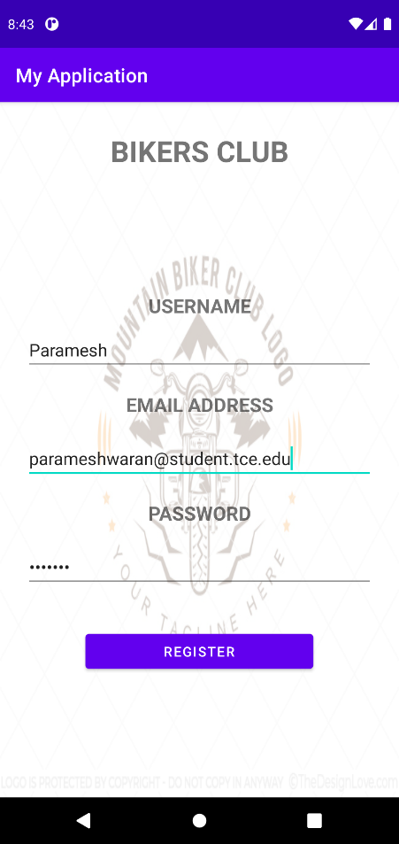

**Table layout:**

<TableLayoutxmlns:android="http://schemas.android.com/apk/res/android"  
xmlns:tools="http://schemas.android.com/tools"  
android:layout_width="match_parent"  
android:layout_height="match_parent"  
android:orientation="vertical"  
android:stretchColumns="1">  
  
<TableRowandroid:padding="5dip">  
<TextView  
android:layout_height="wrap_content"  
android:layout_marginBottom="20dp"  
android:layout_span="2"  
android:gravity="center_horizontal"  
android:text="Bikers Club"  
android:textSize="25dp"  
android:layout_margin="20dp"  
android:textStyle="bold" />

</TableRow>  
  
<TableRowandroid:padding="5dip">

<TextView  
android:layout_height="wrap_content"  
android:layout_marginBottom="20dp"  
android:layout_span="2"  
android:gravity="center_horizontal"  
android:text="Sign-in"  
android:textSize="25dp"  
android:textStyle="bold" />

</TableRow>  
  
<TableRow>

<TextView  
android:layout_height="wrap_content"  
android:layout_column="0"  
android:layout_marginLeft="10dp"  
android:text="User Name"  
android:textSize="20dp" />

<EditText  
android:id="@+id/userName"  
android:layout_height="wrap_content"  
android:layout_column="1"  
android:layout_marginLeft="10dp"  
android:hint="Enter name"  
android:padding="10dp"  
android:textColor="#000"  
tools:ignore="TouchTargetSizeCheck" />

</TableRow>

<TableRow>

<TextView  
android:layout_height="wrap_content"  
android:layout_column="0"  
android:layout_marginLeft="10dp"  
android:layout_marginTop="20dp"  
android:text="Password"  
android:textSize="20dp" />

<EditText  
android:id="@+id/password"  
android:layout_height="wrap_content"  
android:layout_column="1"  
android:layout_marginLeft="10dp"  
android:layout_marginTop="20dp"  
android:hint="Enter password"  
android:inputType="textPassword"  
android:padding="10dp"  
android:textColor="#000"  
tools:ignore="TouchTargetSizeCheck" />

</TableRow>  
  
<TableRowandroid:layout_marginTop="20dp">

<Button  
android:id="@+id/loginBtn"  
android:layout_height="wrap_content"  
android:layout_gravity="center"  
android:layout_span="2"  
android:background="#0ff"  
android:text="login"  
android:textColor="#000"  
android:textSize="20sp"  
android:textStyle="bold" />

</TableRow>

</TableLayout>

**Screenshot**

**Table layout**

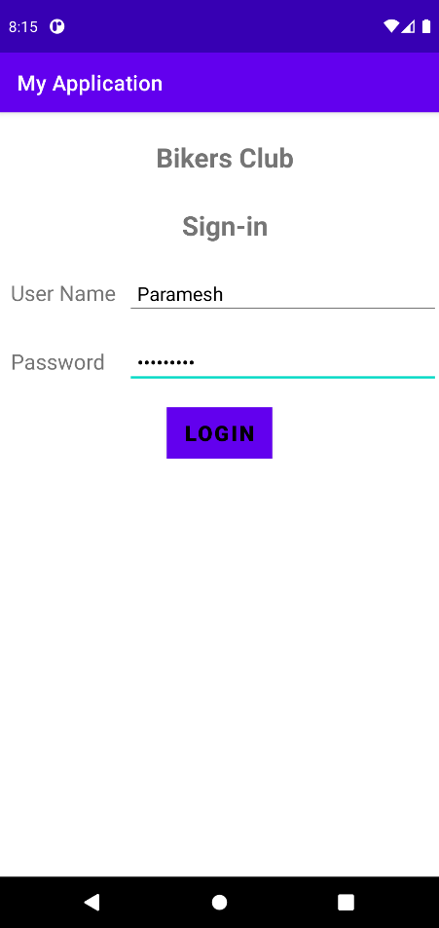

**Result**

Thus, the different layouts were developed for the chosen application and the results were verified.