**Selenium Locators Assignment:**

**Problem 1**- Open 4 web

|  |
| --- |
| [https://phptravels.net/api/uploads/globallogo.png](https://phptravels.net/api/uploads/global/logo.png) |

site and locate the following and Write xpath.

* PHPTRAVLES Logo : //*[@id="fadein"]/header/div[2]
* Home: //*[@id="fadein"]/comment()[6]
* Flights: //*[@id="fadein"]/section[3]/div/div[1]/div/div/h2
* Tours: //*[@id="fadein"]/section[5]
* Company: //*[@id="fadein"]/header/div[2]/div/div/div/div/div[2]/nav/ul/li[8]/a
* Signup Btn: //*[@id="fadein"]/div[1]/div/div[2]/div[2]/div/form/div[3]/div/div/a
* Login Btn: //*[@id="fadein"]/div[1]/div/div[2]/div[2]/div/form/div[3]/button
* Agents DropDown: //*[@id="fadein"]/section[3]/div[1]/div[1]/div[1]/div/ul/li[2]/strong/a

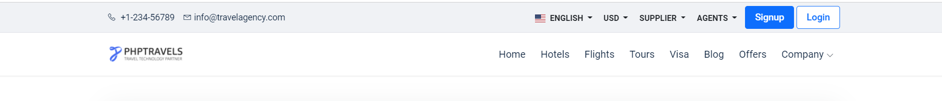

*Note - You have to use Id, Name, Class, CSS Selector, TagName and write Relative and absolute xpath*

**Problem 2**- Write **Xpath** for Below Web elements using Xpath Axes (such as preceding, following, ancestor, following-sibling etc..)

* Icon Check in - Calendar ://input[@id=’checkin’]
* Check Out – Calendar Icon://input[@id=’check out’]
* “- ” for Adults://i[contains(@class,’minus’)]//adult::div[contains(@class,’qtyDec’)]
* “+” for Adults://i[contains(@class,’plus’)]//adult::div[contains(@class,’qtyDec’)]
* “-“ for Childs://i[contains(@class,’minus’)]//parent::div[contains(@class,’qtyDec’)]
* “+” for Childs://i[contains(@class,’plus)]//parent::div[contains(@class,’qtyDec’)]

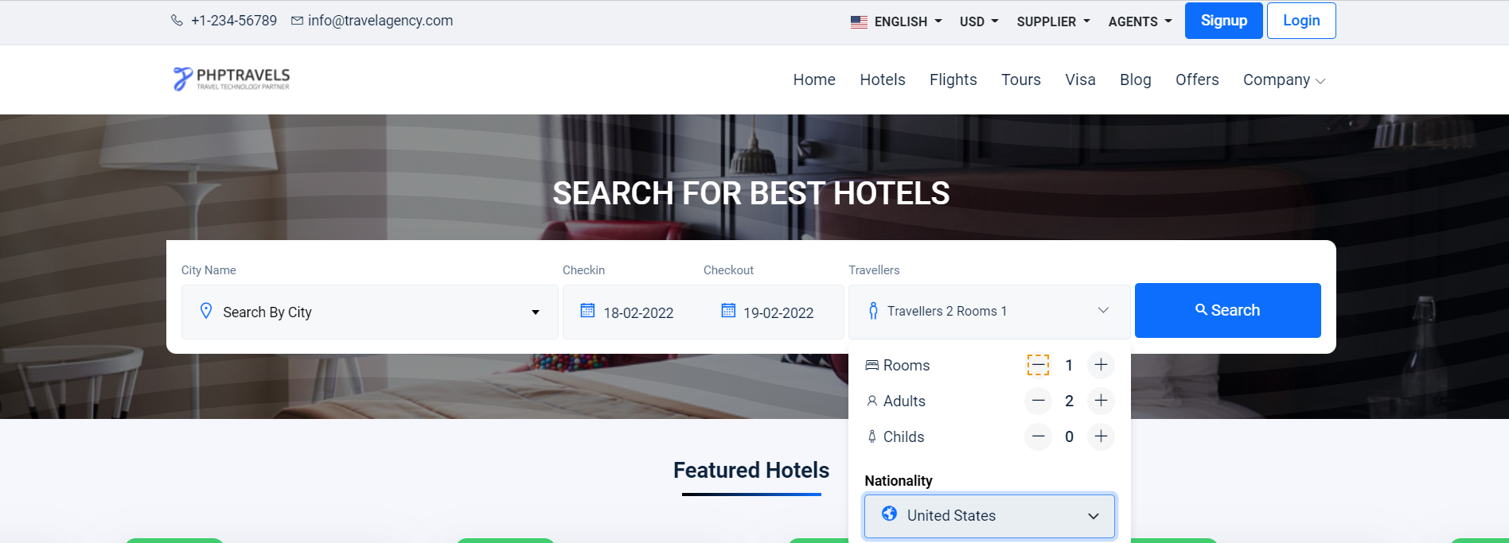

**Note : Don’t Use Indexes**