<https://join.slack.com/t/diplomaturafu-j2a6673/shared_invite/zt-1eqa5fi3m-dCikDfaIkSl4j5uUHavX_Q>

[snobile@frba.utn.edu.ar](mailto:snobile@frba.utn.edu.ar)

CURSADA DE YANEL

UINSTALACIÓM

<https://git-scm.com/>

HAY QUE TENER

<https://code.visualstudio.com/>

$ git config --global user.name "Nancy"

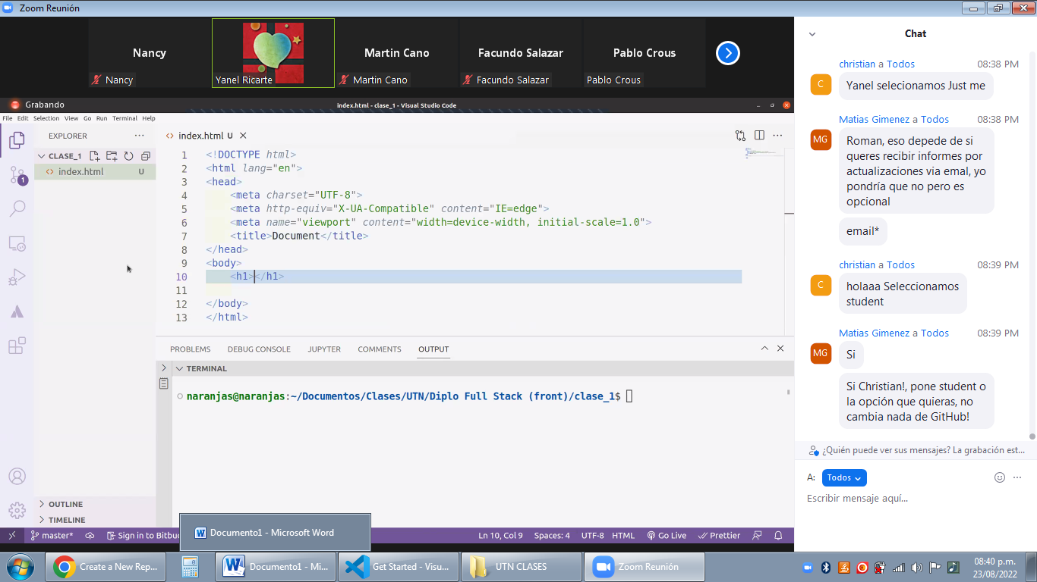

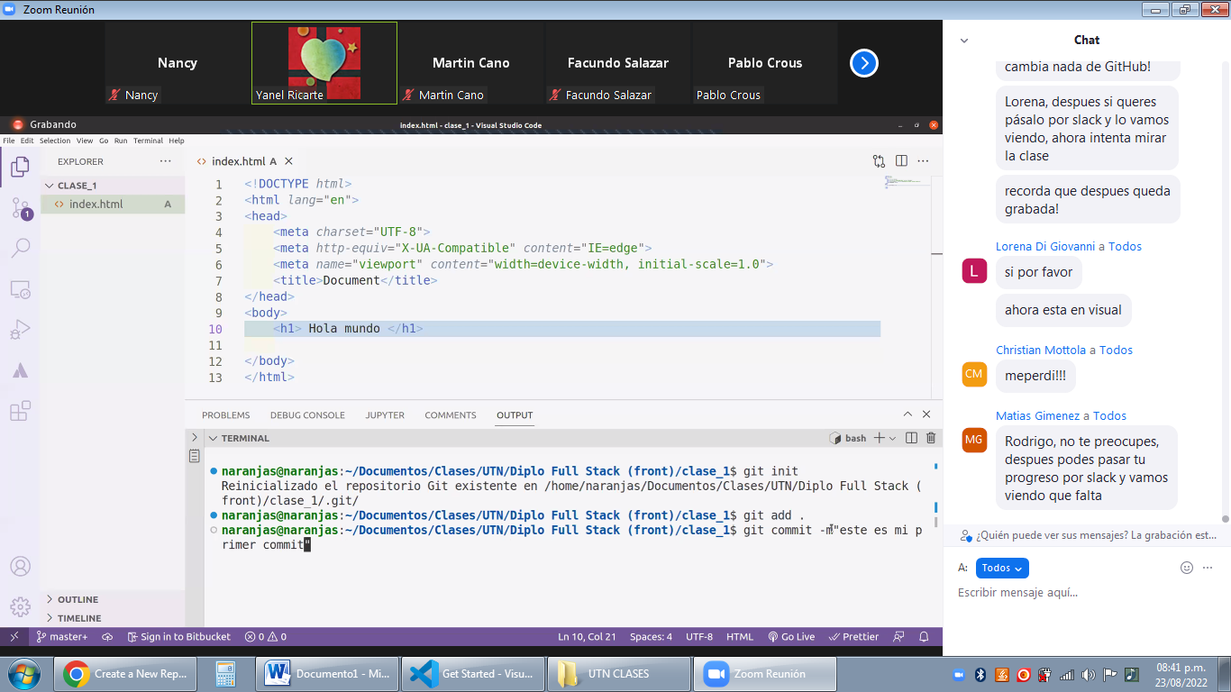

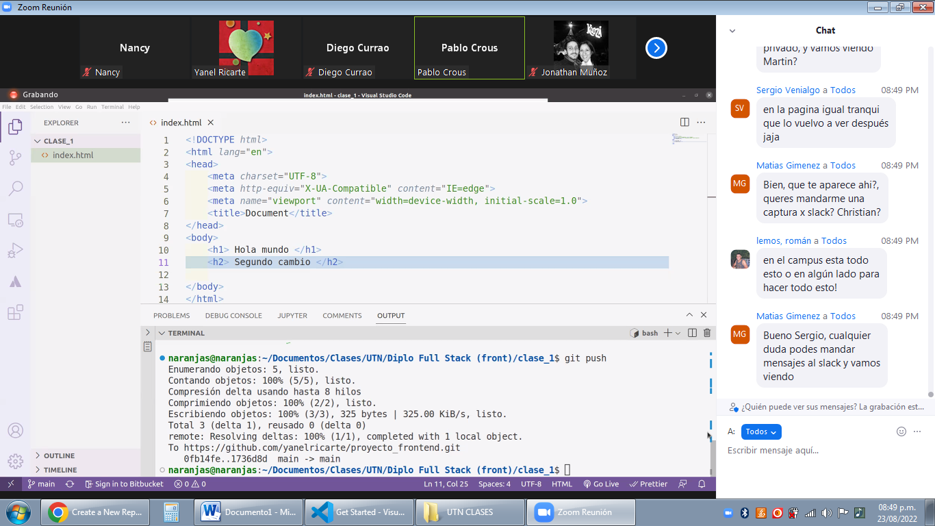

Filminas MATIAS <https://drive.google.com/drive/folders/12vdlfU5B-q9dDC4BX676jrJVUuf4AA40>

Para solucionar el error <https://www.youtube.com/watch?v=Yn-ANAtDQ_0>

