Financial Inclusion under Pradhan Mantri Jan-Dhan Yojana: A K-Means Clustering Study of Indian States and Union Territories
Nancy Singh
Department of Computer Science, [Ramanujan College] , University of Delhi, New Delhi, India | College Roll No.: 24570042 | E-mail: singhnancy6285@gmail.com | course: Machine Learning ,B.Sc. (H) Computer Science, Semester V | Supervisor: Mr. Nikhil Kumar | Problem No. 45 from ML_Application_Problems.xlsx | Article type: Original Research Article

ABSTRACT
Financial inclusion involves access to useful and affordable financial services. This study explores state- and union-territory-level variation in selected indicators reported under the Pradhan Mantri Jan-Dhan Yojana (PMJDY). A cross-sectional dataset of 36 States and Union Territories was analysed using four engineered features: log-transformed total beneficiaries, rural/semi-urban beneficiary share, average account balance per beneficiary, and RuPay cards issued per 100 beneficiaries. Features were standardised and K-Means clustering was evaluated for K=2 to K=6. Among the tested solutions, K=3 produced the highest silhouette score (0.315) and was selected for descriptive interpretation. The resulting groups contained 14, 2, and 20 States/UTs. Cluster profiles differed in beneficiary scale, rural participation, average balance, and RuPay card distribution. The silhouette score indicates modest separation, so the clusters are exploratory rather than definitive classifications. The analysis does not measure active account use, transaction frequency, or causal programme impact.
Keywords: Financial inclusion; PMJDY; K-Means; clustering; India; RuPay; regional analysis

1. Introduction
Financial inclusion concerns access to appropriate financial products and services, including savings, payments, credit, insurance and pension services. The Government of India launched the Pradhan Mantri Jan-Dhan Yojana (PMJDY) on 28 August 2014 as a national mission to expand access to basic banking facilities and related financial services. The Department of Financial Services describes the scheme as providing basic bank accounts, financial literacy and access to social-security-linked services [1].
National totals are useful for tracking programme reach, but they can conceal differences among States and Union Territories. This paper applies unsupervised machine learning to group 36 jurisdictions using selected PMJDY indicators. The purpose is descriptive: to identify broad similarities in the observed data, not to rank states or estimate the causal effect of PMJDY.

2. Research Questions
The study asks: (i) Can States and Union Territories be grouped using beneficiary scale and selected account-related indicators? (ii) How do the resulting groups differ in rural/semi-urban beneficiary share, average balance per beneficiary and RuPay card distribution? (iii) Which tested number of clusters provides the strongest silhouette score?

3. Data and Variables
The notebook loads a state-wise dataset with 36 rows and six source columns: State Name; beneficiaries at rural/semi-urban centre bank branches; beneficiaries at urban/metro centre bank branches; total beneficiaries; balance in beneficiary accounts (₹ crore); and number of RuPay cards issued. The values correspond to the PMJDY state-wise report dated 21 October 2026 on the official portal [2].
Cleaning checks in the notebook report 36 unique States/UTs, zero missing values after cleaning, zero duplicate state names and zero mismatches between the sum of rural/semi-urban and urban/metro beneficiaries and the reported total. Aggregate rows such as Total, Grand Total and All India are excluded.
Four features were used for clustering: (1) rural beneficiary share = rural/semi-urban beneficiaries divided by total beneficiaries × 100; (2) average balance per beneficiary = balance in crore converted to rupees and divided by total beneficiaries; (3) RuPay cards per 100 beneficiaries = cards issued divided by total beneficiaries × 100; and (4) log(1 + total beneficiaries), used to reduce the effect of very large beneficiary counts.
RuPay cards issued is a card-distribution/coverage indicator. It does not establish whether cards were activated or used for transactions. Average balance per beneficiary is an aggregate ratio and does not describe the distribution of balances among individual account holders.

4. Methodology
Data preparation and feature engineering were performed in Python using Pandas and NumPy. The four selected features were standardised using scikit-learn's StandardScaler so that differences in measurement units would not dominate distance calculations.
K-Means was evaluated for K values from 2 through 6. The notebook recorded inertia and silhouette score for each solution. The silhouette score compares the similarity of an observation to its assigned cluster with its similarity to other clusters; higher values generally indicate better-defined clusters [3].
K=3 was selected because it had the highest silhouette score among the tested values. The final model used KMeans with three clusters, random_state=42 and n_init=10. Principal Component Analysis (PCA) projected the four-dimensional standardised feature space into two dimensions for visual inspection. The first two components explained 69.75% of the variance, according to the notebook output.
Cluster identifiers (0, 1 and 2) are arbitrary algorithmic labels, not rankings.

Table 1. Model comparison
K | Inertia | Silhouette
2 | 103.010 | 0.278
3 | 79.081 | 0.315
4 | 57.125 | 0.283
5 | 46.647 | 0.297
6 | 39.086 | 0.240

5. Results
The model assigned all 36 States/UTs to three groups: Cluster 0 contained 14 jurisdictions (38.89%), Cluster 1 contained 2 (5.56%), and Cluster 2 contained 20 (55.56%).
Cluster 0 had 1,174,169.07 average beneficiaries, 80.81% average rural/semi-urban share, ₹8,094.40 average balance per beneficiary and 64.14 RuPay cards per 100 beneficiaries. Cluster 1 had 3,771,428.50 average beneficiaries, 11.98% average rural/semi-urban share, ₹6,070.42 average balance and 72.97 RuPay cards per 100 beneficiaries. Cluster 2 had 28,616,435.75 average beneficiaries, 75.60% average rural/semi-urban share, ₹5,242.76 average balance and 70.12 RuPay cards per 100 beneficiaries.
Cluster 1 comprises Chandigarh and Delhi in the state-assignment output. Its low rural/semi-urban share is consistent with the urban character of these jurisdictions, but its small size means the profile should not be generalised to all urban areas. Cluster 2 has the largest average beneficiary count, while Cluster 0 has the highest average balance per beneficiary and rural/semi-urban share.
The K=3 solution had the highest silhouette score (0.315) among the five tested solutions. This score indicates modest separation; the groups are best treated as exploratory patterns.

Table 2. Distribution of States/UTs
Cluster | States/UTs | Share
0 | 14 | 38.89%
1 | 2 | 5.56%
2 | 20 | 55.56%

Table 3. Cluster profiles
Indicator | Cluster 0 | Cluster 1 | Cluster 2
States/UTs | 14 | 2 | 20
Average beneficiaries | 1,174,169.07 | 3,771,428.50 | 28,616,435.75
Average rural share | 80.81% | 11.98% | 75.60%
Average balance/beneficiary | ₹8,094.40 | ₹6,070.42 | ₹5,242.76
RuPay cards per 100 beneficiaries | 64.14 | 72.97 | 70.12
Figure 1. Average beneficiary count by cluster.
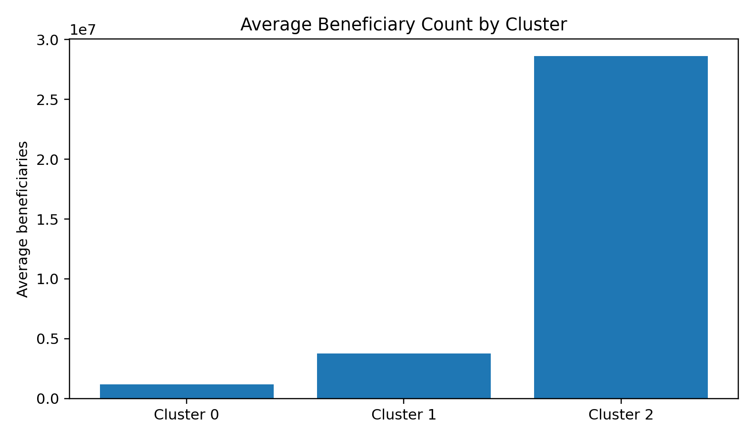
Figure 2. Average balance per beneficiary by cluster.
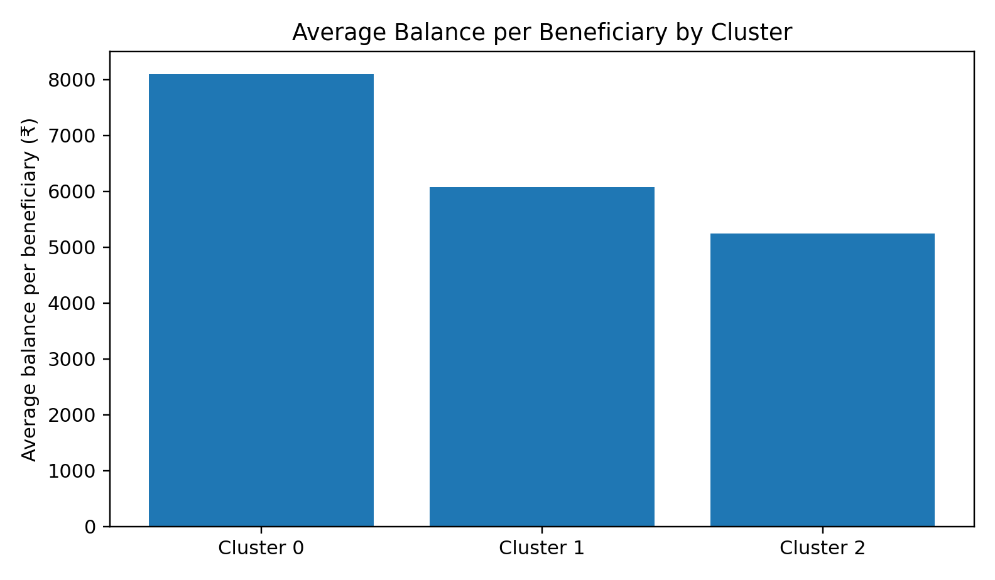
Figure 3. Average rural/semi-urban beneficiary share by cluster.
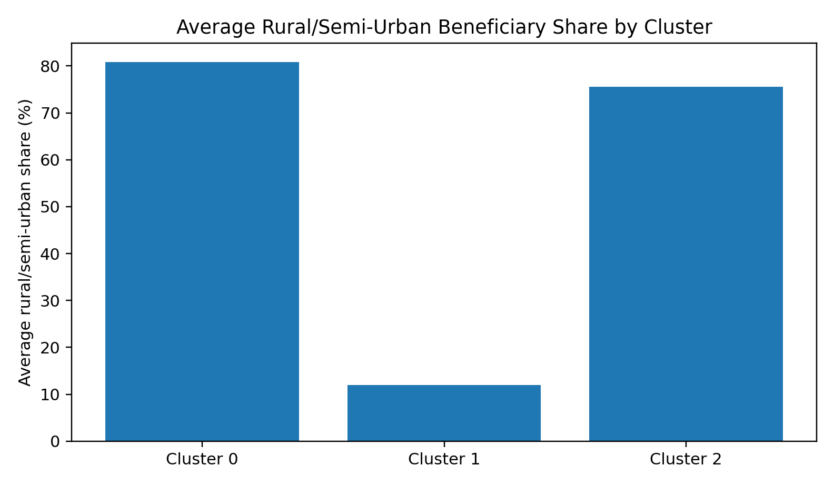

6. Discussion
The largest-beneficiary group is not the group with the highest average balance per beneficiary. This illustrates why total beneficiaries alone cannot fully describe regional differences. The two-jurisdiction cluster is distinctive in its low rural/semi-urban share and relatively high RuPay card indicator, but it should not be treated as a broad policy category.
The available indicators describe beneficiaries, deposits/balances and cards issued. They do not include transaction counts, account activity, dormant-account status, digital payment frequency or direct measures of financial literacy. Therefore, this study examines account uptake and selected account-related proxies, not actual usage behaviour.

7. Limitations
The analysis is cross-sectional and covers one reporting date; it cannot describe changes over time. It contains 36 aggregate observations, so results are sensitive to individual state/UT profiles. The selected variables are proxies and do not capture service quality, account dormancy, transaction activity, gender or income differences. The silhouette score is modest, indicating overlap among groups. PCA compresses information, and its two-dimensional representation does not preserve all variation in the original feature space.
Future work could use a time series of state-wise PMJDY data, include transaction and account-activity indicators where available, compare alternative clustering methods, assess stability across initialisations, and examine subgroup differences.

8. Conclusion
This study used K-Means clustering to explore variation in selected PMJDY indicators across 36 Indian States and Union Territories. After feature engineering and standardisation, K=3 achieved the highest silhouette score among the tested values (0.315). The resulting clusters differed in beneficiary scale, rural/semi-urban share, average balance per beneficiary and RuPay card distribution.
The findings offer an exploratory view of regional patterns, but should not be interpreted as a definitive ranking of financial inclusion or evidence of actual account usage. More detailed measures of account activity and longitudinal data would be required for stronger conclusions.

References
[1] Department of Financial Services, Ministry of Finance, Government of India. “Pradhan Mantri Jan-Dhan Yojana (PMJDY).” https://www.financialservices.gov.in/pradhan-mantri-jan-dhan-yojana-pmjdy (accessed 4 November 2026).
[2] Pradhan Mantri Jan-Dhan Yojana, Government of India. “Statewise account opening Report as on 21/10/2026.” https://pmjdy.gov.in/statewise-statistics (accessed 4 November 2026).
[3] scikit-learn developers. “silhouette_score.” scikit-learn documentation. https://scikit-learn.org/stable/modules/generated/sklearn.metrics.silhouette_score.html (accessed 4 November 2026).
[4] Singh, N. “Financial Inclusion under PMJDY: Clustering Indian States Based on Account Uptake and Usage Indicators.” Project notebook and supporting files, GitHub: https://github.com/NANCYSINGH6285/ML-PROJECT-PMJDY_FINANCIAL_INCLUSION (accessed 4 November 2026).
Academic project draft — verify the analysis and adapt the manuscript to your department's submission guidelines.

