How to push a local directories into GitHub remote

To push a local directory (your project folder) to a GitHub remote repository, follow these steps. I’ll show the complete workflow used by most developers. 🚀

1️⃣ Go to Your Project Folder
Open Git Bash and move into your local directory.
cd path/to/your/project
Example:
cd Desktop/my-project
Check files:
ls

2️⃣ Initialize Git
This tells Git that your folder is a repository.
git init
You will see:
Initialized empty Git repository

3️⃣ Add Files to Git Staging Area
This prepares files to be committed.
git add .
Why?
- . means add all files in the directory
Check status:
git status

4️⃣ Commit the Files
This saves a snapshot of your project.
git commit -m "Initial commit"
Example:
git commit -m "First version of project"

5️⃣ Create a Repository on GitHub
Go to GitHub → New Repository
Do NOT check:
- ❌ Add README
- ❌ Add .gitignore
Copy the repository URL.
Example:
https://github.com/username/project-name.git

6️⃣ Connect Local Repo to GitHub
Add the remote repository.
git remote add origin https://github.com/username/project-name.git
Check:
git remote -v

7️⃣ Push Your Code to GitHub
Now push the code.
git branch -M main
git push -u origin main
Explanation
Command | Meaning
git branch -M main | rename branch to main
git push | send code to GitHub
origin | remote repo name
-u | set upstream

8️⃣ Done 🎉
Refresh your GitHub repository page.
Your files will appear there.

🔁 After First Push (Future Updates)
When you update code:
git add .
git commit -m "update feature"
git push

💡 Example Full Workflow
cd myproject
git init
git add .
git commit -m "Initial commit"
git remote add origin https://github.com/username/project.git
git branch -M main
git push -u origin main

⚠️ Common Error
If you see:
remote contains work that you do not have locally
Run:
git pull origin main --allow-unrelated-histories
Then push again.

✅ Since you are learning open-source contribution, the next thing you should learn is the Professional Git Workflow used by Google & big companies:
Fork → Clone → Branch → Commit → Push → Pull Request
If you want, I can also show you the complete visual diagram + commands of the Git workflow used by senior developers.

Diff fork vs clone

When working with Git and GitHub, Fork and Clone are two different concepts. Understanding this is important for open-source contribution, which you are learning. 🚀

1️⃣ Fork
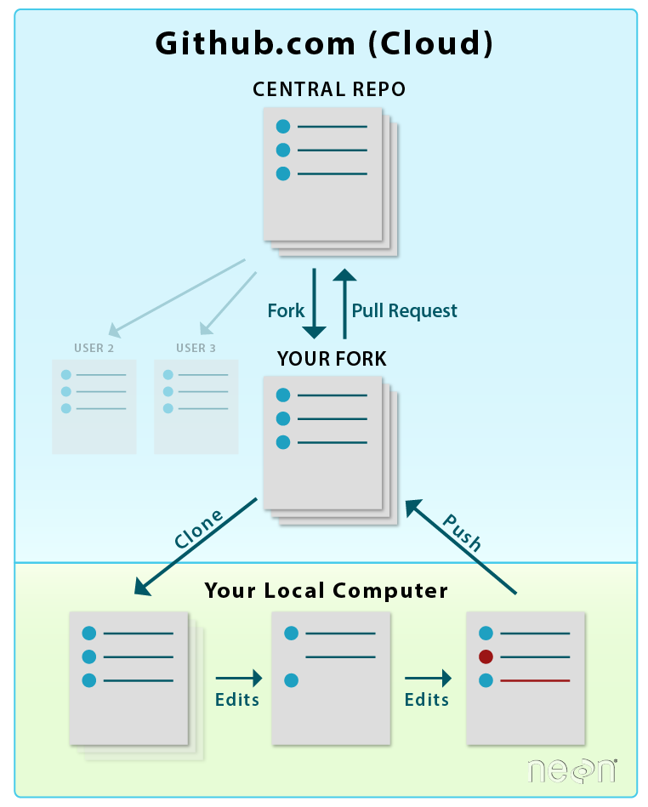
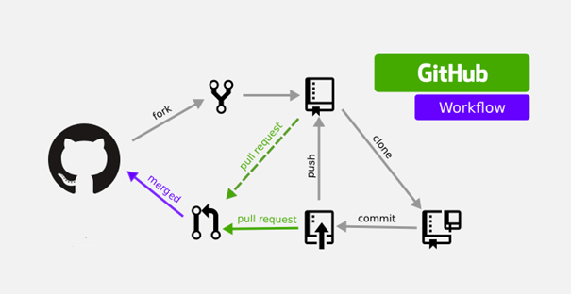
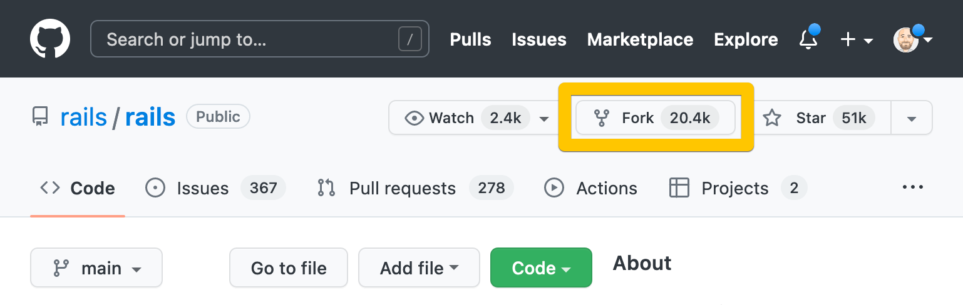
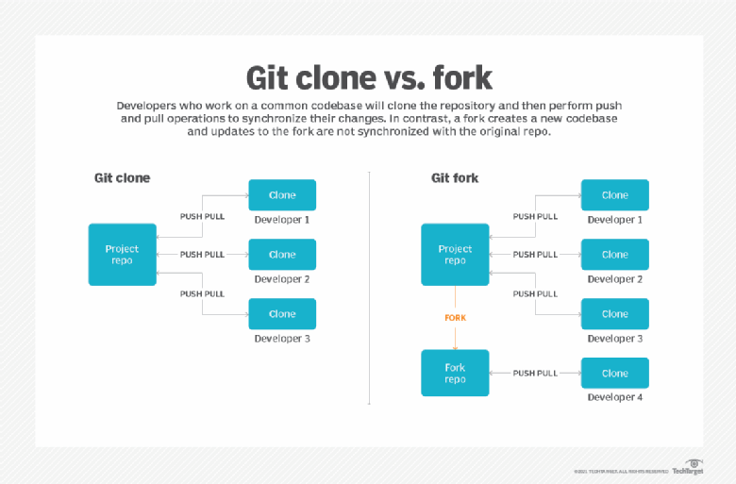
Fork means creating your own copy of someone else’s repository on your GitHub account.
Key Idea
- Copy exists on GitHub (remote).
- Used mainly for open-source contributions.
Example
Suppose you want to contribute to:
👉 github.com/facebook/react
You cannot directly push code there.
So you click Fork.
Now you get:
facebook/react → yourusername/react
You now control your own copy.
Workflow
Original Repo (owner)
↓
Fork
↓
Your GitHub Repo
When to Use Fork
Use fork when:
- Contributing to open-source projects
- You don’t have write permission
- You want your own version of a project

2️⃣ Clone
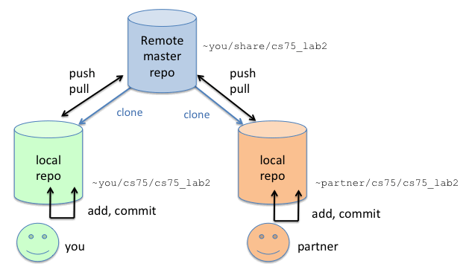

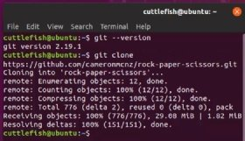
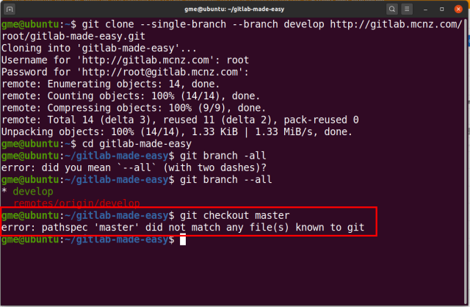
Clone means downloading a repository from GitHub to your local computer.
Key Idea
- Copy exists on your computer (local).
Command
git clone https://github.com/user/repo.git
Example:
git clone https://github.com/facebook/react.git
Now the repo exists in your PC.
GitHub Repo → Your Computer

🔑 Main Difference
Feature | Fork | Clone
Where copy is created | GitHub account | Local computer
Used for | Open-source contribution | Working on project locally
Permission needed | No | No
Command | Done on GitHub UI | git clone
Typical workflow | Fork → Clone | Clone → Work

🧠 Real Open-Source Workflow
Developers usually do this:
1. Fork repository
2. Clone forked repository
3. Create new branch
4. Make changes
5. Commit changes
6. Push to your fork
7. Create Pull Request
Example commands:
git clone https://github.com/yourusername/project.git
cd project
git checkout -b new-feature

✅ Simple analogy
Action | Real Life Example
Fork | Photocopy a book into your library
Clone | Bring the book from library to your desk

If you want, I can also show you:
🔥 The FULL Open-Source Contribution Workflow (Fork → Clone → Branch → PR) used by Google engineers step-by-step with commands.

Let us analyze the scenario. I am working on a current directory. I want to push the directory into the GitHub. How can I do that using Git Bash?

Let’s analyze your exact scenario step-by-step.
📂 Situation
- You already have a local directory (project folder)
- You want to upload/push it to a GitHub repository
- You are using Git Bash
This is the standard workflow developers use.

Step 1 — Go to the Current Directory
Open Git Bash inside your project folder or navigate to it.
cd path/to/your/project
Example:
cd Desktop/my-project
Check files:
ls

Step 2 — Initialize Git
Convert the directory into a Git repository.
git init
This creates a hidden .git folder that tracks changes.

Step 3 — Add Files to Staging Area
Tell Git which files should be tracked.
git add .
Meaning:
. = add all files in this directory
Check status:
git status

Step 4 — Commit the Files
Save a snapshot of your project.
git commit -m "Initial commit"
Example:
git commit -m "My first project upload"

Step 5 — Create a Repository on GitHub
Go to GitHub → New Repository
Example:
repo name: my-project
Copy the repository URL.
Example:
https://github.com/username/my-project.git

Step 6 — Connect Local Repo to GitHub
Add the remote repository.
git remote add origin https://github.com/username/my-project.git
Check:
git remote -v
You will see:
origin https://github.com/username/my-project.git

Step 7 — Push the Directory to GitHub
git branch -M main
git push -u origin main
Meaning:
Command | Purpose
git branch -M main | rename branch to main
git push | upload code
origin | remote repo
-u | set default remote

Final Workflow (All Commands Together)
cd my-project
git init
git add .
git commit -m "Initial commit"
git remote add origin https://github.com/username/my-project.git
git branch -M main
git push -u origin main
After this → refresh GitHub → your files appear.

Next Time You Update Code
You only need 3 commands.
git add .
git commit -m "update code"
git push

Common Error You May See
Error
remote contains work that you do not have locally
Fix:
git pull origin main --allow-unrelated-histories
git push

💡 Pro tip (important for open-source work):
Professional workflow:
Fork → Clone → Branch → Commit → Push → Pull Request

If you want, I can also show you the 3 different ways developers push a directory to GitHub:
1️⃣ Push existing local project
2️⃣ Push after cloning repo
3️⃣ Push to an already connected remote repo
Understanding these removes 95% of Git confusion.

In that scenario, I have working directly with other person. I want to contribute to that.

If you are working directly with another person on the same project, the workflow is a little different from open-source contributions. You usually do NOT fork. Instead, you clone the shared repository and push your changes (if you have permission). 🤝
Let’s analyze the correct scenario.

Scenario
- Your teammate created a GitHub repository
- They added you as a collaborator
- You want to contribute code

Step 1 — Clone the Repository
First download the shared repository to your computer.
git clone https://github.com/username/project.git
Example:
git clone https://github.com/john/library-manager.git
Now go into the folder:
cd project

Step 2 — Create Your Own Branch (Best Practice)
Never work directly on main.
git checkout -b feature-login
Example:
git checkout -b add-payment-api
This creates a separate branch for your feature.

Step 3 — Make Your Changes
Edit files in VS Code or your editor.
Check changes:
git status

Step 4 — Add the Changes
git add .

Step 5 — Commit the Changes
git commit -m "Added login feature"

Step 6 — Push Your Branch
git push origin feature-login
Now your branch is uploaded to GitHub.

Step 7 — Create Pull Request
Go to GitHub.
You will see:
Compare & Pull Request
Your teammate reviews and merges it.

Full Workflow (Team Collaboration)
Clone → Branch → Code → Add → Commit → Push → Pull Request
Commands together:
git clone https://github.com/user/project.git
cd project
git checkout -b new-feature
git add .
git commit -m "added feature"
git push origin new-feature

Important Rule in Team Projects ⚠️
Before starting work, always pull latest code.
git pull origin main
This prevents merge conflicts.

Example Team Workflow Diagram
Developer A → main branch
Developer B → feature branch
Developer C → feature branch
↓
Pull Requests
↓
main

💡 Since you are learning Git deeply for open-source and teamwork, the most important concept developers struggle with is:
- origin
- upstream
- main
- feature branches
If you want, I can explain these 4 Git concepts in a super clear visual way so Git becomes very easy to understand.

Why forking

Forking exists mainly for permission, safety, and independence when working with repositories you do not control. Let’s analyze why it is used. 🔍

1️⃣ Permission Problem (Main Reason)
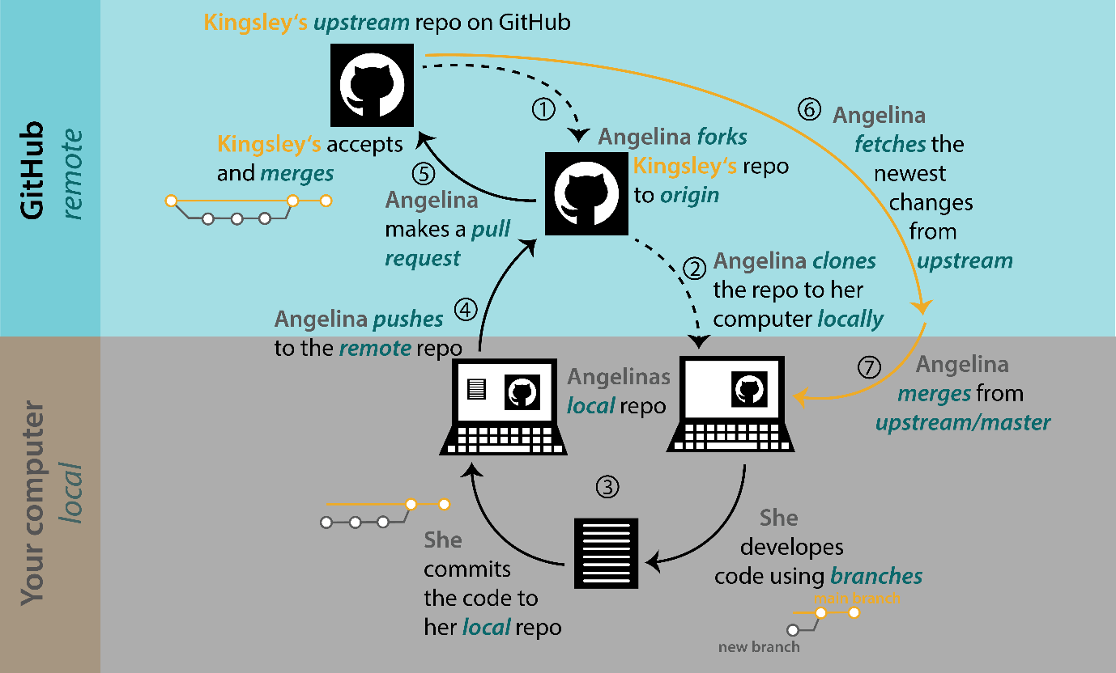
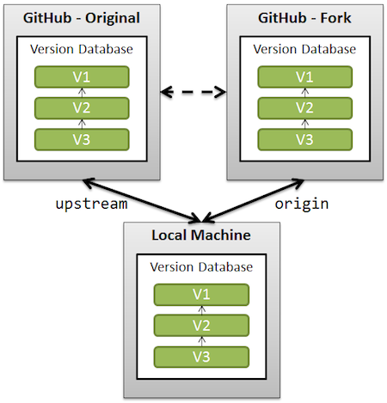
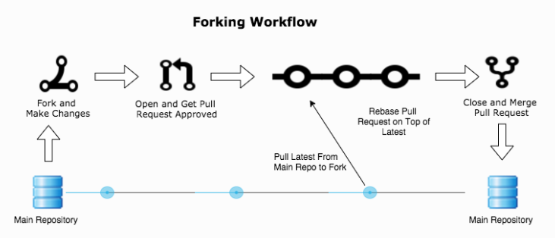
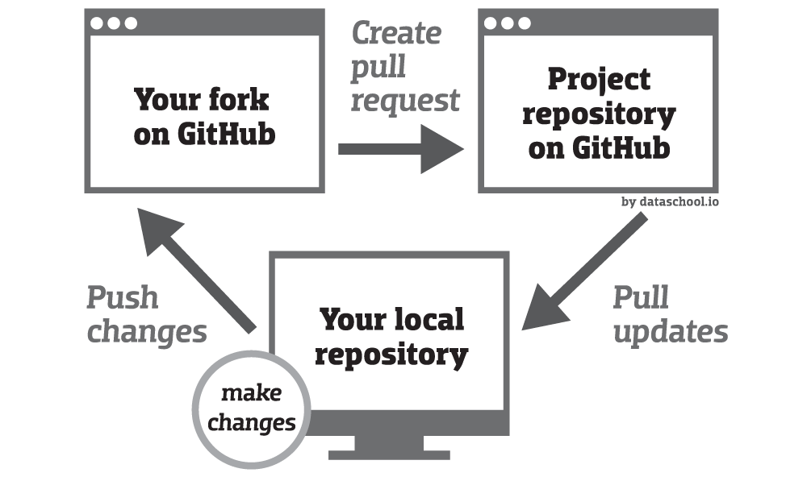
In many repositories (especially open-source), you do not have write access.
Example:
If you try to push directly to a repo like:
github.com/facebook/react
GitHub will block you ❌
Because only maintainers can push.
Solution
You fork the repository.
Original Repo (owner)
↓
Fork
↓
Your GitHub Repo
Now you have full control of your copy.

2️⃣ Safe Experimentation
Forking allows you to experiment without breaking the original project.
Example:
You want to:
- add a new feature
- fix a bug
- test something risky
Instead of modifying the main project, you work in your forked repository.
If something breaks → only your fork is affected.

3️⃣ Independent Development
Forking lets developers build their own version of a project.
Example:
Original project:
Project A
Your fork:
Project A → Your improved version
Many famous projects started as forks.
Example:
- LibreOffice → fork of OpenOffice
- MariaDB → fork of MySQL

4️⃣ Standard Open-Source Contribution Workflow
Most open-source contributions follow this process:
1. Fork repository
2. Clone fork
3. Create branch
4. Make changes
5. Push to your fork
6. Create Pull Request
Example commands:
git clone https://github.com/yourusername/project.git
cd project
git checkout -b fix-bug
Then push:
git push origin fix-bug
And create a Pull Request.

5️⃣ Maintainers Stay in Control
Forking ensures the original project remains protected.
Maintainers can:
- review contributions
- approve or reject pull requests
- maintain code quality

🔑 Fork vs Direct Collaboration
Situation | What to Use
Working with teammates in same repo | Clone
Contributing to open source | Fork
No write permission | Fork
You are collaborator | Clone

✅ Simple analogy
Concept | Real-world example
Fork | Photocopy someone’s book
Clone | Take the book to your desk

💡 Since you're learning Git deeply, the next concept that makes Git much clearer is:
origin vs upstream
Understanding this will help you master open-source workflows used by senior engineers.

Suppose iam contributing to open source give me step by step guide

Since you want to contribute to open source, here is the real step-by-step workflow used by developers. I’ll explain what to do and why so the logic becomes clear. 🚀

Open-Source Contribution Workflow
Find Project → Fork → Clone → Branch → Code → Commit → Push → Pull Request

1️⃣ Find an Open-Source Project
Go to and choose a project.
Good beginner labels:
- good first issue
- beginner friendly
- documentation
Example project:
https://github.com/project/repo

2️⃣ Fork the Repository
Click Fork.
Now GitHub creates:
Original Repo → Your GitHub Repo
Example:
github.com/original/project
↓
github.com/yourname/project
Why?
- You don’t have permission to push to the original repo.

3️⃣ Clone Your Fork to Your Computer
Copy the URL of your fork, then run:
git clone https://github.com/yourusername/project.git
Example:
git clone https://github.com/nandan/project.git
Move into the folder:
cd project

4️⃣ Add the Original Repository (Upstream)
This connects your fork to the original project.
git remote add upstream https://github.com/original/project.git
Check:
git remote -v
You will see:
origin → your fork
upstream → original repo

5️⃣ Create a New Branch
Never work on main.
git checkout -b fix-navbar-bug
Example:
git checkout -b add-login-page
Why?
Branches keep changes isolated and safe.

6️⃣ Make Changes
Edit the code.
Example:
fix bug
add feature
improve documentation
Check changes:
git status

7️⃣ Add the Changes
git add .
Or specific file:
git add index.js

8️⃣ Commit the Changes
git commit -m "Fix navbar alignment issue"
Good commit message example:
Fix: navbar alignment on mobile

9️⃣ Push the Branch to Your Fork
git push origin fix-navbar-bug
This uploads your work to your GitHub fork.

🔟 Create a Pull Request
Go to your fork on GitHub.
You will see:
Compare & Pull Request
Click it.
Write:
Description
What problem you solved
Screenshots (optional)
Then submit.

1️⃣1️⃣ Maintainer Reviews Your Code
The project maintainers will:
- review your code
- request changes (sometimes)
- merge your contribution
Once merged → 🎉 You become an open-source contributor.

Complete Command Workflow
# clone fork
git clone https://github.com/yourusername/project.git
cd project
# connect original repo
git remote add upstream https://github.com/original/project.git
# create branch
git checkout -b new-feature
# make changes
git add .
git commit -m "added new feature"
# push
git push origin new-feature
Then create Pull Request on GitHub.

Important Commands for Contributors
Pull latest changes from original repo:
git pull upstream main
Update your fork:
git push origin main

Pro Contributor Workflow
Fork
↓
Clone
↓
Add Upstream
↓
Create Branch
↓
Code
↓
Commit
↓
Push
↓
Pull Request

💡 Since you're trying to become a serious open-source contributor, the next thing that will help you a lot is learning the 7 Git commands used in 95% of real projects.
If you want, I can also show you:
The "Professional Git Cheat Sheet" used by Google engineers (only 12 commands to master Git).

The "Professional Git Cheat Sheet" used by Google engineers

Here is a Professional Git Cheat Sheet used by many experienced engineers (including those working on large projects like at ).
In reality, most developers use only ~12–15 Git commands daily. If you master these, you can handle 90% of Git workflows. 🚀

1️⃣ Repository Setup
Initialize a repository
git init
Creates a new Git repository in the current directory.
Clone a repository
git clone <repo-url>
Example:
git clone https://github.com/user/project.git
Downloads the project from .

2️⃣ Checking Repository State
Check status
git status
Shows:
- changed files
- staged files
- branch name

View commit history
git log
Useful shortcut:
git log --oneline
Shows a compact history of commits.

3️⃣ Adding Files
Add all files
git add .
Add specific file
git add index.js
Moves files into staging area.

4️⃣ Commit Changes
git commit -m "Fix login bug"
Creates a snapshot of your changes.
Good commit message structure:
type: short description
Example:
Fix: login API error

5️⃣ Branch Management
Create a new branch
git branch feature-login
Switch branch
git checkout feature-login
Shortcut (most used):
git checkout -b feature-login
Creates + switches branch.

6️⃣ Push Code to GitHub
git push origin main
Meaning:
Part | Meaning
push | upload commits
origin | remote repo
main | branch

7️⃣ Pull Latest Changes
git pull origin main
Downloads updates from the remote repository.

8️⃣ Fetch Updates (Safer than Pull)
git fetch
Downloads updates without merging automatically.

9️⃣ Merge Branches
git merge feature-login
Combines feature branch with current branch.

🔟 See Remote Repositories
git remote -v
Shows:
origin
upstream

1️⃣1️⃣ Undo Changes
Discard file changes:
git restore file.js
Unstage file:
git reset file.js

1️⃣2️⃣ Delete Branch
Delete local branch:
git branch -d feature-login
Delete remote branch:
git push origin --delete feature-login

🧠 The 12 Commands Developers Use Most
git clone
git status
git add
git commit
git push
git pull
git fetch
git branch
git checkout
git merge
git remote
git log
If you master these → Git becomes easy.

💡 Real Daily Workflow of Developers
git pull
git checkout -b new-feature
# write code
git add .
git commit -m "added feature"
git push origin new-feature
Then create a Pull Request on GitHub.

✅ Since you are trying to become an open-source contributor, the next thing that will help you a lot is learning:
🔥 The 10 Git mistakes beginners make (that break repositories) — knowing these will save you hours of debugging.

