Assignment 2

Name-Nandini
ROLL NO-2026010075

1. Write a C++ program to create a class Student with data members name and rollNo. Use a default constructor to initialize these values and display the student details.

#include <iostream>
using namespace std;
class student {
int rollno;
string name;
public:
student()
{name ="yashika";
rollno =29;}
void display()
{
cout <<"student name "<<name <<endl;
cout<<"student rollno "<< rollno<<endl;
}};
int main ()
{
student s;
s.display();}

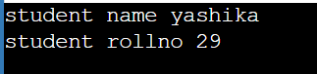

2. Create a class Rectangle having data members length and breadth. Use a parameterized constructor to initialize the values and display the area of the rectangle.

#include <iostream>
using namespace std;
class rectangle {
int length;
int breadth;
public:
rectangle(int l,int b)
{
l=length;
b=breadth;
}
void display()
{cout<<"area of reactangle is "<<length*breadth<<endl;}
};
int main()
{ rectangle r(5,10);
r.display();
return 0;}

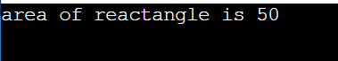

- Write a C++ program to create a class Employee with data members name, id, and salary. Initialize the data members using a parameterized constructor and display the employee details.
#include <iostream>
using namespace std;

class Employee
{
private:
string name;
int id;
float salary;

public:
Employee(string n, int i, float s)
{
name = n;
id = i;
salary = s;
}

void display()
{
cout << "Name: " << name << endl;
cout << "ID: " << id << endl;
cout << "Salary: " << salary << endl;
}
};

int main()
{
Employee e("Tishita", 101, 500000);

e.display();

return 0;}
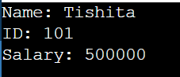

- Create a class Box with data members length, width, and height. Implement: • a default constructor, • a parameterized constructor, • a function to calculate and display volume.

#include <iostream>
using namespace std;

class Box{
private:
int length;
int width;
int height;

public:
Box()
{ length = 4;
width = 2;
height = 3;}

Box(int l, int w, int h)
{
length = l;
width = w;
height = h;
}

void volume()
{
cout << "Volume = " << length * width * height << endl;
}
};

int main()
{
Box b1;
Box b2(10, 5, 2);

cout << "Default constructor: ";
b1.volume();

cout << "Parameterized constructor: ";
b2.volume();

return 0;
}
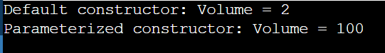

- Write a program to demonstrate constructor overloading using a class Student. Create: • a default constructor, • a constructor accepting name and roll number, • a constructor accepting name, roll number, and CGPA. Display the details of objects created using all three constructors.

#include <iostream>
using namespace std;

class Student{
private:
string name;
int rollNo;
float cgpa;

public:
Student()
{
name = "Nandini";
rollNo = 75;
cgpa = 9;
}

Student(string n, int r)
{
name = n;
rollNo = r;
cgpa = 9.8;
}

Student(string n, int r, float c)
{
name = n;
rollNo = r;
cgpa = c;
}

void display()
{
cout << "Name: " << name << endl;
cout << "Roll No: " << rollNo << endl;
cout << "CGPA: " << cgpa << endl;
cout << endl;
}
};

int main()
{
Student s1;
Student s2("Yashika", 101);
Student s3("Tishita", 102, 10);

cout << "Student 1:" << endl;
s1.display();
cout << "Student 2:" << endl;
s2.display();
cout << "Student 3:" << endl;
s3.display();

return 0;}
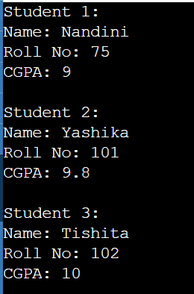

- Create a class Complex with real and imaginary data members. Implement: • a default constructor, • a parameterized constructor, • a display function.

#include <iostream>
using namespace std;

class Complex{
private:
float real;
float imaginary;

public:
Complex()
{ real = 0;
imaginary = 2;}

Complex(float r, float i)
{ real = r;
imaginary = I;}

void display()
{ cout << real << " + " << imaginary << "i" << endl;}};

int main(){
Complex c1;
Complex c2(3, 4);
cout << "Default constructor: ";
c1.display();
cout << "Parameterized constructor: ";
c2.display();

return 0;}
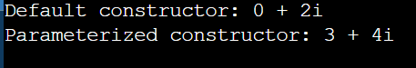

- Create a class Demo that displays a message when its constructor is called and another message when its destructor is called. Create multiple objects of the class and observe the order in which constructors and destructors execute.
#include <iostream>
using namespace std;

class Demo
{
public:

Demo()
{
cout << "Constructor called" << endl;
}

~Demo()
{
cout << "Destructor called" << endl;
}
};

int main()
{
Demo d1;
Demo d2;
Demo d3;

return 0;
}

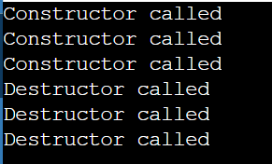

- Write a C++ program to demonstrate the execution order of constructors and destructors when objects are created inside main() and inside a separate function.
#include <iostream>
using namespace std;

class Demo{
public:

Demo()
{
cout << "Constructor called" << endl;
}

~Demo()
{
cout << "Destructor called" << endl;
}
};

void test(){
cout << "Inside test function" << endl;
Demo d2;
cout << "Leaving test function" << endl;}

int main()
{cout << "Inside main" << endl;
Demo d1;
cout << "Calling test function" << endl;
test();
cout << "Back to main" << endl;
return 0;
}



