Assignment 4

Name-Nandini
ROLL NO-2026010075

- Create a C++ program to demonstrate Single Inheritance. Create a base class Person with the following data members: Name Age Create a derived class Student having: Roll Number Course Implement member functions to accept and display the complete details of a student using inheritance.
#include <iostream>
using namespace std;
class person{
public:
string name;
int age;
};
class student:public person{
public:
int roll_no;
char course;
void getdata(){
cout<<"enter name"<<endl;
cin>>name;
cout<<"enter age"<<endl;
cin>>age;
cout<<"enter roll number "<<endl;
cin>>roll_no;
cout<<"enter course"<<endl;
cin>>course;
}
void display(){
cout<<"name:"<<name<<endl;
cout<<"age:"<<age<<endl;
cout<<"roll number:"<<roll_no<<endl;
cout<<"course:"<<course<<endl;}
};
int main (){
student s;
s.getdata();
s.display();
return 0;
};
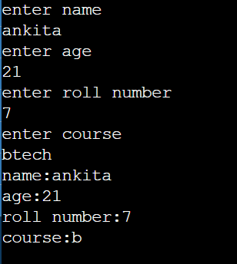
- Create a C++ program to demonstrate Multilevel Inheritance. Create three classes: Person → stores Name Employee → stores Employee ID Manager → stores Department Derive Employee from Person and Manager from Employee. Display all the details of the manager.
#include <iostream>
using namespace std;

class Person{
protected:
string name;

public:
void acceptPerson()
{cout << "Enter Name: ";
cin >> name;}};

class Employee : public Person{
protected:
int employeeID;

public:
void acceptEmployee(){
acceptPerson();

cout << "Enter Employee ID: ";
cin >> employeeID;}};

class Manager : public Employee
{private:
string department;

public:
void acceptManager()
{acceptEmployee();
cout << "Enter Department: ";
cin >> department;}

void display()
{cout << "\nName: " << name << endl;
cout << "Employee ID: " << employeeID << endl;
cout << "Department: " << department << endl;}};
int main(){
Manager m;
m.acceptManager();
m.display();
return 0;
}

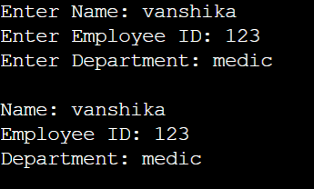
- Create a C++ program to demonstrate Multiple Inheritance. Create two base classes: Academic → stores Marks Sports → stores Sports Score Create a derived class Result that inherits from both classes and calculates the total score and displays the result.
#include <iostream>
using namespace std;

class Academic{
protected:
int marks;

public:
void acceptAcademic()
{cout << "Enter Academic Marks: ";
cin >> marks;}};
class Sports{
protected:
int sportsScore;

public:
void acceptSports()
{cout << "Enter Sports Score: ";
cin >> sportsScore;}};

class Result : public Academic, public Sports{
public:
void displayResult(){
int total = marks + sportsScore;

cout << "\nAcademic Marks: " << marks << endl;
cout << "Sports Score: " << sportsScore << endl;
cout << "Total Score: " << total << endl;}};

int main()
{ Result r;
r.acceptAcademic();
r.acceptSports();
r.displayResult();
return 0;}

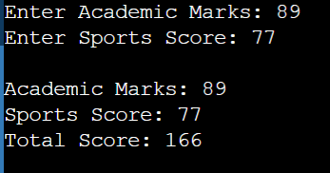
- Create a C++ program to demonstrate Hierarchical Inheritance. Create a base class Vehicle containing: Brand Model Create two derived classes: Car → Number of Doors Bike → Engine Capacity Create separate objects of Car and Bike and display their respective details.
#include <iostream>
using namespace std;

class Vehicle
{protected:
string brand;
string model;

public:
void acceptVehicle()
{cout << "Enter Brand: ";
cin >> brand;
cout << "Enter Model: ";
cin >> model;}};

class Car : public Vehicle{
private:
int numberOfDoors;

public:
void acceptCar()
{acceptVehicle();
cout << "Enter Number of Doors: ";
cin >> numberOfDoors;}

void display()
{
cout << "\nCar Details" << endl;
cout << "Brand: " << brand << endl;
cout << "Model: " << model << endl;
cout << "Number of Doors: " << numberOfDoors << endl;
}
};

class Bike : public Vehicle
{
private:
int engineCapacity;

public:
void acceptBike()
{acceptVehicle();

cout << "Enter Engine Capacity: ";
cin >> engineCapacity;}

void display()
{ cout << "\nBike Details" << endl;
cout << "Brand: " << brand << endl;
cout << "Model: " << model << endl;
cout << "Engine Capacity: " << engineCapacity << " cc" << endl;}};

int main()
{Car c;
Bike b;
c.acceptCar();
c.display();
b.acceptBike();
b.display();

return 0;}
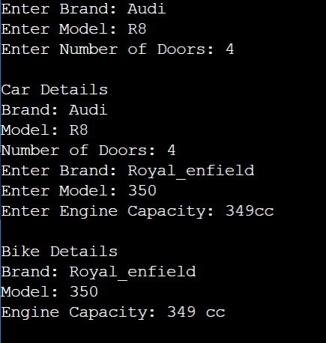

5. Create a base class College with a constructor that initializes the College Name. Create a derived class Department with a constructor that initializes the Department Name. Create an object of the derived class and display both college and department information to show the order of constructor execution.
#include <iostream>
using namespace std;
class College{
protected:
string collegeName;

public:
College(string c)
{collegeName = c;
cout << "College constructor called" << endl;}};

class Department : public College{
private:
string departmentName;

public:
Department(string c, string d) : College(c)
{ departmentName = d;
cout << "Department constructor called" << endl;}

void display()
{cout << "\nCollege: " << collegeName << endl;
cout << "Department: " << departmentName << endl;}};

int main()
{ Department d("tiet", "Computer Science");
d.display();
return 0;}


