Assignment 1

Name-Nandini
ROLL NO-2026010075

1.Write a program (WAP) to display "Hello World" on console display. WAP to implement the following control characters: ‘\n’ is for new line, or you can use endl – cout<<endl<<“message”; ‘\t’ is for tab ; ‘\a’ is an alarm sound; ‘\r’ is carriage return to go to the beginning of the current line

#include<iostream>
using namespace std;
int main(){
cout<<"hello world"<<endl;
cout<<"object\t oriented"<<endl;
cout<<"hi\a";}

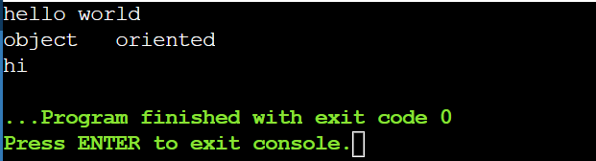

- Write a C++ program that will ask for a temperature in Celsius and display it in degree Fahrenheit.[F=9C/5+32]
#include<iostream>
using namespace std;
int main(){
int C;
int F;
cout<<"enter temprature in celsius"<<endl;
cin>>C;
F=9*C/5+32;
cout<<F;}
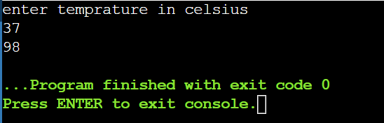

- WAP to demonstrate for, while, do-while (with all possible variations), like for loop can be demonstrated without giving initialization in for construct or without giving increment in for construct. Sample: for (int i=0; i<10; i++) i=0 for (; i<10; i++) i=0 for (; i<10;) i++
#include<iostream>
using namespace std;
int main(){
cout<<"case1 "<<endl;
for(int i=0;i<5;i++){
cout<<i<<endl;
}
cout<<"case2 ";
int i=0;
for(;i<3;i++){
cout<<i;
}
cout<<"\ncase3 ";
i=0;
for(;i<4;){
i++;
cout<<i;}

cout<<"\ncase4 ";
i=0;
while(i<5){
i++;
cout<<i;
}

cout<<"\ncase5 ";
i=0;
do{
i++;
cout<<i;
}
while(i<3);
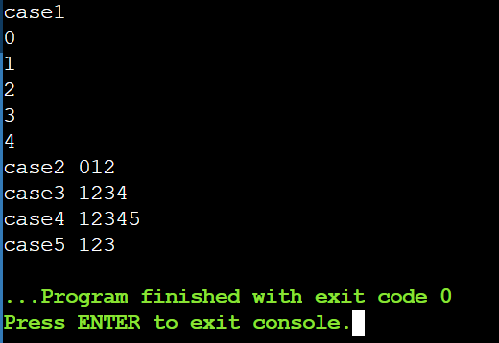
}
4 Create a structure in C++ containing the details of Students as details below and a main function to execute the structure.

.#include <iostream>
using namespace std;

struct Student {

string Name;
int RollNo;
string Degree;
string Hostel;
float CurrentCGPA;

void addDetails() {
cout << "Enter Name: ";
cin >> Name;
cout << "Enter Roll No: ";
cin >> RollNo;
cout << "Enter Degree: ";
cin >> Degree;
cout << "Enter Hostel: ";
cin >> Hostel;
cout << "Enter Current CGPA: ";
cin >> CurrentCGPA;}

void updateDetails() {
cout << "\nEnter updated Name: ";
cin >> Name;
cout << "\nEnter updated Roll No: ";
cin >> RollNo;
cout << "\nEnter updated Degree: ";
cin >> Degree;
}

void updateCGPA() {
cout << "Enter new CGPA: ";
cin >> CurrentCGPA; }

void updateHostel() {
cout << "Enter new Hostel: ";
cin >> Hostel;}

void displayDetails() {
cout << "\nStudent Details" << endl;
cout << "Name: " << Name << endl;
cout << "Roll No: " << RollNo << endl;
cout << "Degree: " << Degree << endl;
cout << "Hostel: " << Hostel << endl;
cout << "Current CGPA: " << CurrentCGPA << endl;
}
};

int main() {

Student s;

s.addDetails();

cout << "\nInitial Details:";
s.displayDetails();

s.updateCGPA();
s.updateHostel();

cout << "\nUpdated Details:";
s.displayDetails();

return 0;
}
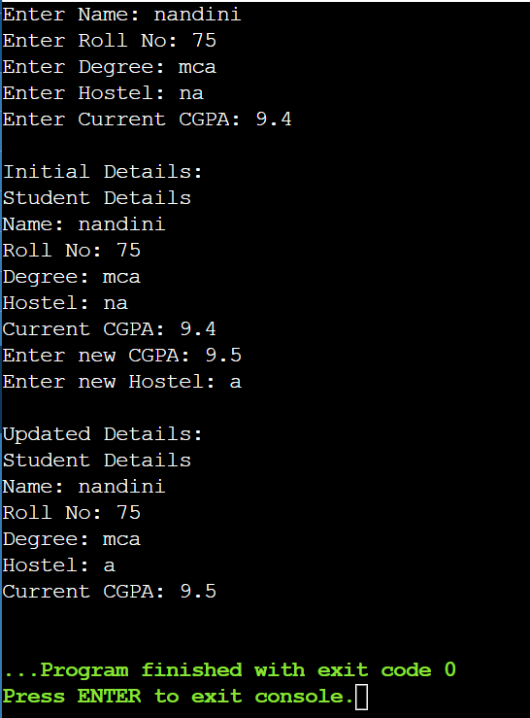

5. Differentiate between private and public access/scope. Perform the question no. 4 with class instead of structure with having the data members private and some member functions in private scope and some in public scope.

#include <iostream>
using namespace std;
class Student{
private:
string Name;
int RollNo;
string Degree;
string Hostel;
float CurrentCGPA;

void updateCGPA()
{ cout << "Enter new CGPA: ";
cin >> CurrentCGPA;}

void updateHostel()
{cout << "Enter new Hostel: ";
cin >> Hostel; }

public:
void addDetails()
{cout << "Enter Name: ";
cin >> Name;
cout << "Enter Roll No: ";
cin >> RollNo;
cout << "Enter Degree: ";
cin >> Degree;
cout << "Enter Hostel: ";
cin >> Hostel;
cout << "Enter Current CGPA: ";
cin >> CurrentCGPA;}

void updateDetails()
{cout << "Enter updated Name: ";
cin >> Name;
cout << "Enter updated Roll No: ";
cin >> RollNo;
cout << "Enter updated Degree: ";
cin >> Degree;}

void displayDetails()
{cout << "\nStudent Details" << endl;
cout << "Name: " << Name << endl;
cout << "Roll No: " << RollNo << endl;
cout << "Degree: " << Degree << endl;
cout << "Hostel: " << Hostel << endl;
cout << "Current CGPA: " << CurrentCGPA << endl;}

void updateStudent()
{updateCGPA();
updateHostel();}};

int main()
{
Student s;

s.addDetails();

cout << "\nInitial Details:";
s.displayDetails();
s.updateDetails();
s.updateStudent();
cout << "\nUpdated Details:";
s.displayDetails();

return 0;
}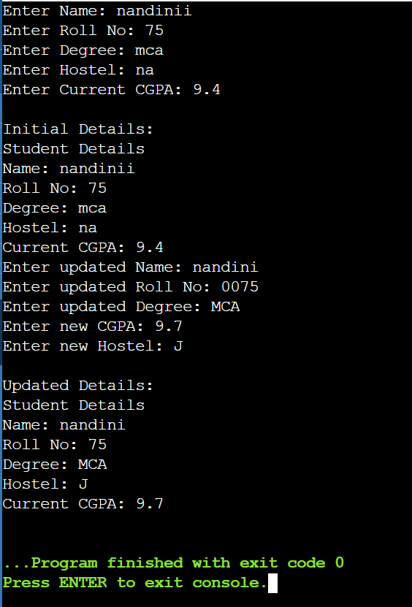

6. Create a code snippet that illustrates the following: a. Calling of private member functions inside public member function b. Access private member functions inside public member function

#include <iostream>
using namespace std;
class Student{
private:
void privateFunction()
{cout << "Private function is called." << endl;}
public:
void publicFunction()
{privateFunction();}};

int main()
{ Student s;
s.publicFunction();

return 0;
}
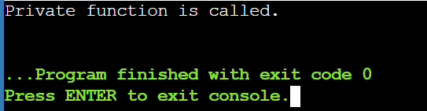

- Define a class named Complex with properties (real and imaginary) and methods as per following details. void set () to initialize object values. void display () to display complex number. Complex sum (Complex) or void sum (Complex) to add two complex numbers (objects of Complex class) and return complex_number (object of Complex class) as result. Properties (real and imaginary) of the code should have private access modifier and member functions should have public access modifier in C++ class.

#include <iostream>
using namespace std;

class Complex{
private:
float real;
float imaginary;

public:
void set()
{ cout << "Enter real part: ";
cin >> real;
cout << "Enter imaginary part: ";
cin >> imaginary;
}

void display()
{cout << real << " + " << imaginary << "i" << endl;}

Complex sum(Complex c)
{Complex result;

result.real = real + c.real;
result.imaginary = imaginary + c.imaginary;

return result;}};

int main()
{Complex c1, c2, c3;
cout << "Enter first complex number:" << endl;
c1.set();
cout << "Enter second complex number:" << endl;
c2.set();
c3 = c1.sum(c2);
cout << "\nFirst complex number: ";
c1.display();
cout << "Second complex number: ";
c2.display();
cout << "Sum: ";
c3.display();
return 0;
}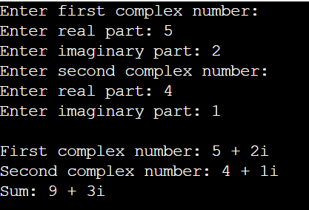

8. Implement namespace in a program to illustrate the use of same name variables and functions in different sections/libraries of the code.

#include <iostream>
using namespace std;

namespace First
{ int x = 10;
void display()
{cout << "First namespace: " << x << endl;}}

namespace Second
{int x = 20;
void display()
{cout << "Second namespace: " << x << endl;}}

int main()
{First::display();
Second::display();
cout << "First x = " << First::x << endl;
cout << "Second x = " << Second::x << endl;
return 0;}



