RESEARCH PAPER

Customer Segmentation & Churn Pattern Analytics in European Banking
Exploratory data analysis, segment insights, predictive risk scoring and retention recommendations
Dataset: European Bank customer file, 10,000 customers across France, Spain and Germany
Deliverables: this paper · Streamlit dashboard (app.py) · ML pipeline (ml_pipeline.py) · Executive summary
Prepared for: Unified Mentor – Machine Learning project submission

Abstract
Customer churn is a major hidden cost in retail banking. This study analyses 10,000 customers of a European retail bank to establish who leaves, where, and how much value leaves with them. The overall churn rate is 20.37% (2,037 customers). Churn is far from uniform: Germany churns at 32.4% versus 16.1% in France and 16.7% in Spain; customers aged 46–60 churn at 51.1%; inactive members churn at 26.9% versus 14.3% for active members; and customers holding 3 or 4 products churn at 82.7% and 100.0%. Credit score, tenure, salary and credit-card ownership show almost no relationship with churn. High-value customers (top 25% by balance) churn at 23.7% and account for 48% of all balances lost. A tuned gradient-boosting model, selected by cross-validation, reaches a held-out ROC-AUC of 0.88 and finds 4.2 times more churners in its top-risk decile than random targeting; its feature importance confirms that product count, age, activity, geography and balance carry the signal. The paper ends with targeted, segment-level retention recommendations.

1. Background and Context
Losing existing customers reduces lifetime value, raises acquisition costs and makes revenue unstable. Banks usually track a single headline churn rate, but that figure cannot say which customer groups are most at risk, how churn differs by country, age or financial profile, or whether churn is concentrated among high-value or low-value customers. Without that granularity, retention strategies remain generic, reactive and inefficient. This project closes that gap with a systematic, segmentation-driven analysis.

2. Problem Statement and Objectives

2.1 Primary objectives
- Measure the overall churn rate.
- Identify how churn is distributed across customer segments.
- Compare churn behaviour across European regions.

2.2 Secondary objectives
- Understand churn among high-value customers.
- Evaluate engagement and tenure patterns.
- Support strategic planning and marketing decisions.
- Build and validate a machine-learning model that predicts individual churn risk, and discover data-driven customer clusters.

3. Data Description and Validation
The dataset contains one row per customer with 14 fields: CustomerId, Surname, CreditScore, Geography, Gender, Age, Tenure, Balance, NumOfProducts, HasCrCard, IsActiveMember, EstimatedSalary, Exited (target) and a constant Year field (2025). Because the data is a single snapshot, all findings describe associations at one point in time.
Validation check | Result
Rows / columns | 10,000 / 14
Missing values | 0
Duplicate CustomerIds | 0
Binary fields (HasCrCard, IsActiveMember, Exited) only 0/1 | Pass
NumOfProducts range | 1 – 4
Geographies | France, Germany, Spain
Churn label values | 0, 1 (1 = exited)

The data passed every check. No imputation or row removal was needed. Surname (non-analytical, personal) and Year (constant) were dropped before analysis.

4. Analytical Methodology
The workflow follows the brief: ingestion and validation, cleaning and preparation, segmentation design, churn distribution analysis, comparative demographic analysis, high-value customer analysis, and KPI computation. A machine-learning layer (feature engineering, model comparison with cross-validation, hyper-parameter tuning, threshold selection, held-out evaluation, explainability and K-Means clustering) turns the segment findings into customer-level risk scores. All logic lives in churn_utils.py and analysis.py so results are reproducible.

4.1 Segmentation design
Dimension | Segments | Rule
Geography | France, Spain, Germany | As recorded
Age | <30, 30–45, 46–60, 60+ | Age in years
Credit score | Low, Medium, High | <580, 580–739, 740+
Tenure | New, Mid-term, Long-term | 0–2, 3–6, 7–10 years
Balance | Zero, Low, High | Zero = 0; Low/High split at the median non-zero balance (€119,840)
High-value | Premium customers | Balance ≥ €127,644 (top 25% of all customers)
Table 1 – Segment definitions (credit bands follow common industry cut-offs; thresholds are adjustable in the dashboard)

4.2 Metrics
- Segment churn rate = churned ÷ customers in the segment.
- Share of churn = segment's churners ÷ all churners; compared with its share of customers to show over- or under-representation.
- Relative risk = segment churn rate ÷ overall churn rate.
- Geographic Risk Index = country churn rate ÷ overall rate × 100 (100 = average).
- High-Value Churn Ratio = churn rate of high-value customers ÷ churn rate of all other customers.
- Engagement Drop Indicator = churn rate of inactive members ÷ churn rate of active members.

5. Results

5.1 Overall churn
Of 10,000 customers, 2,037 exited, an overall churn rate of 20.37%: roughly one in five. Churned customers held €185.6m in balances, equal to 24.3% of all balances in the bank.
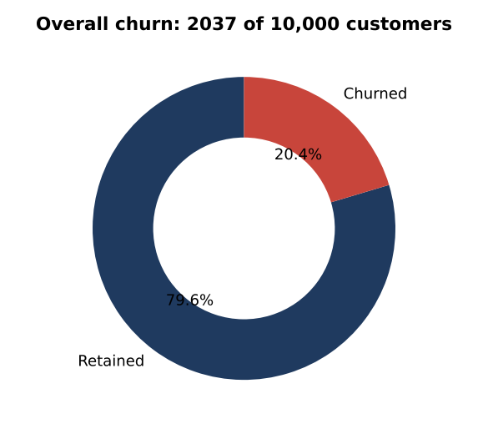

5.2 Churn across customer segments
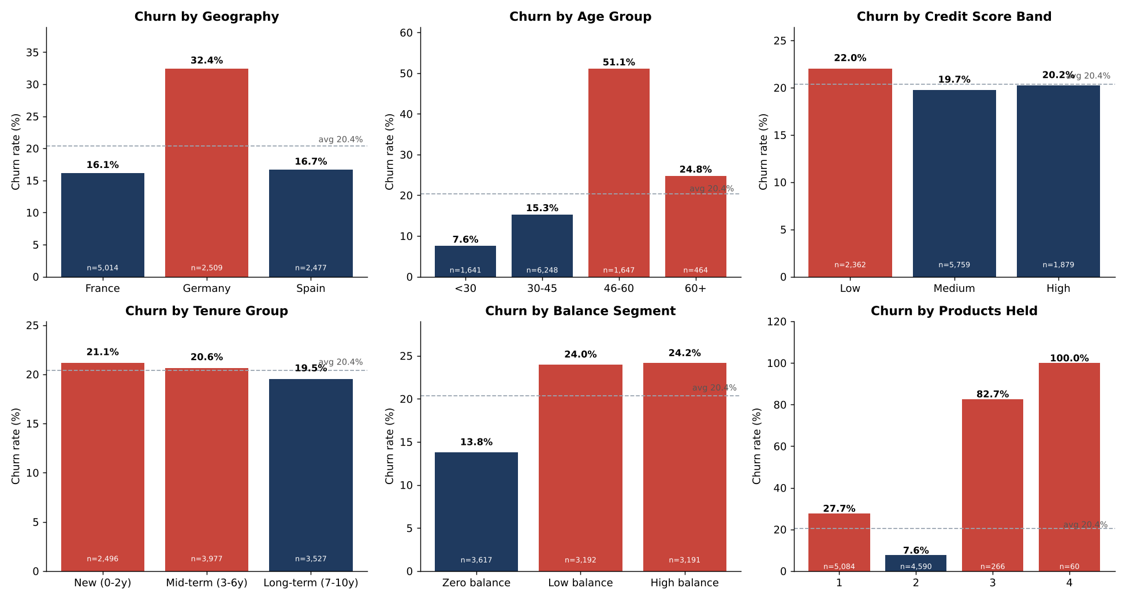
Figure 1 – Churn rate by segment (red bars exceed the bank average)
Geography. Germany is the clear outlier at 32.4%, double France (16.1%) and Spain (16.7%). Germany holds only 25% of customers but 40% of all churners, and its Geographic Risk Index is 159 against 79 for France and 82 for Spain.
Segment | Customers | Churned | Churn rate | Share of churn | Relative risk
France | 5,014 | 810 | 16.1% | 39.8% | 0.79x
Germany | 2,509 | 814 | 32.4% | 40.0% | 1.59x
Spain | 2,477 | 413 | 16.7% | 20.3% | 0.82x

Age. Churn is strongly non-linear in age. Customers under 30 rarely leave (7.6%); the 46–60 group leaves at 51.1%, 2.5 times the bank average. Although the group is only 16% of customers, it generates 41% of all churn. The 60+ group (24.8%) is also above average.
Segment | Customers | Churned | Churn rate | Share of churn | Relative risk
<30 | 1,641 | 124 | 7.6% | 6.1% | 0.37x
30-45 | 6,248 | 956 | 15.3% | 46.9% | 0.75x
46-60 | 1,647 | 842 | 51.1% | 41.3% | 2.51x
60+ | 464 | 115 | 24.8% | 5.7% | 1.22x

Credit score and tenure. Neither separates churners from stayers. Credit bands range only from 20.2% to 22.0%, and tenure groups from 19.5% to 21.1%. Long-standing customers are therefore not safer: loyalty built through time alone does not protect against churn.
Balance. Zero-balance customers churn least (13.8%); customers with money in the account churn at about 24% regardless of whether the balance is low or high.
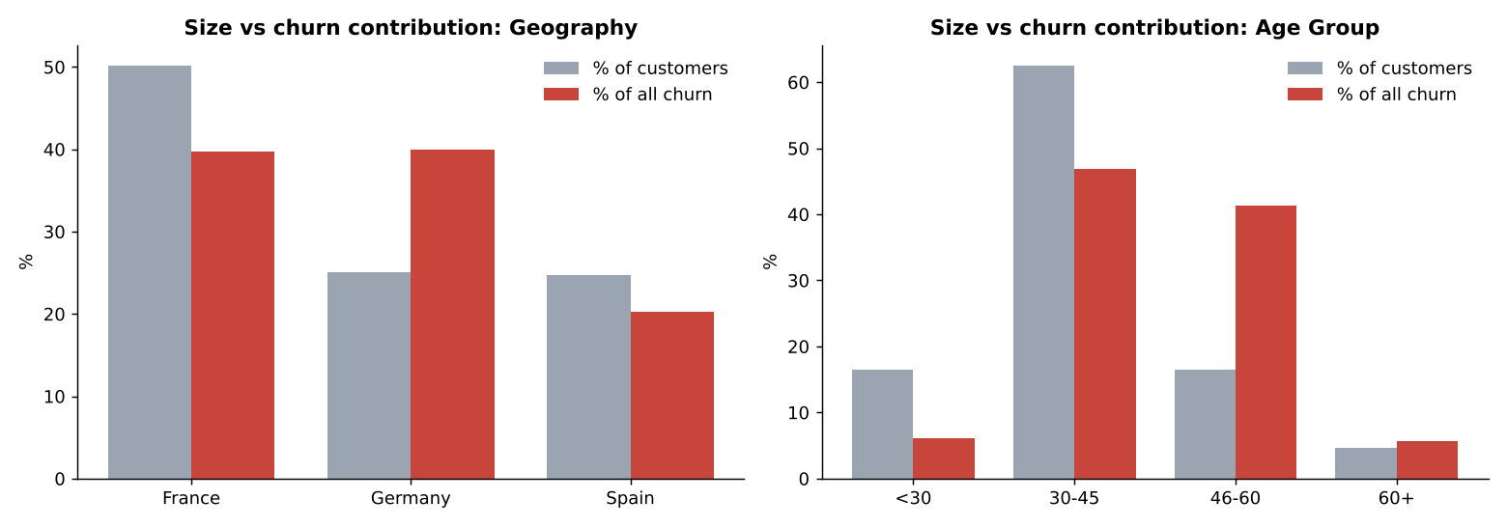
Figure 2 – Share of customers versus share of churn

5.3 Churned versus retained customers
Metric (mean) | Churned | Retained | Difference
CreditScore | 645.35 | 651.85 | -1%
Age | 44.84 | 37.41 | +19.9%
Tenure | 4.93 | 5.03 | -2%
Balance | 91,108.54 | 72,745.3 | +25.2%
NumOfProducts | 1.48 | 1.54 | -3.9%
EstimatedSalary | 101,465.68 | 99,738.39 | +1.7%
IsActiveMember | 0.36 | 0.55 | -34.5%
HasCrCard | 0.7 | 0.71 | -1.4%
Table 2 – Profile comparison
Churners are about 7.4 years older on average (44.8 vs 37.4), hold about 25% higher balances, and are about one third less likely to be active members. Salary and credit score are practically identical across the two groups, so financial stability measured by these two fields does not explain churn.
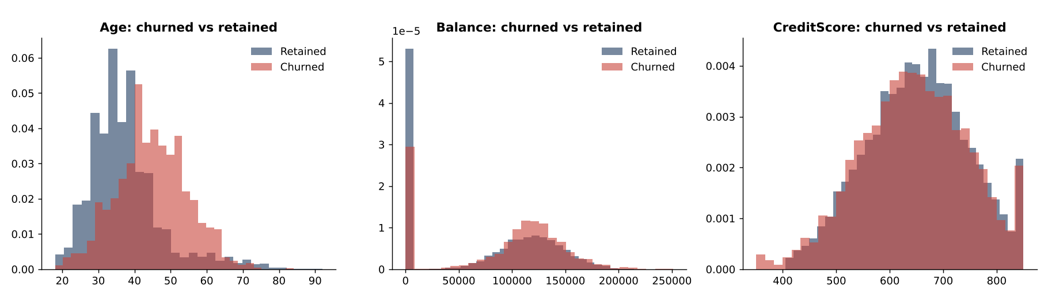
Figure 3 – Distribution of age, balance and credit score

5.4 Comparative demographic analysis
Gender. Female customers churn at 25.1% versus 16.5% for male customers, a gap of 8.6 percentage points. The gap appears in every country (France 20.3% vs 12.7%; Germany 37.5% vs 27.8%; Spain 21.2% vs 13.1%).
Geography × age. The age effect appears in all three countries but is amplified in Germany, where 67.3% of 46–60-year-olds churn, compared with 45.8% in France and 40.7% in Spain. Germany is higher than the other countries in every age band.
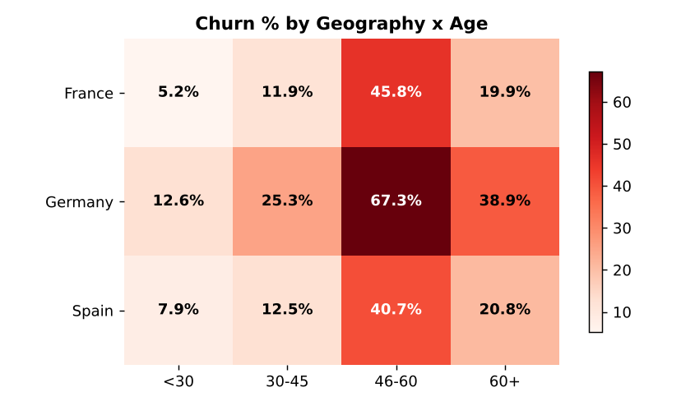
Figure 4 – Churn rate by geography and age group
Financial stability versus churn. Salary quartiles show a flat pattern (20.0%, 19.8%, 20.1%, 21.6% from lowest to highest), and credit-card ownership makes no difference (20.2% with card vs 20.8% without). Income does not predict churn; behaviour and life stage do.

5.5 Engagement and product holding
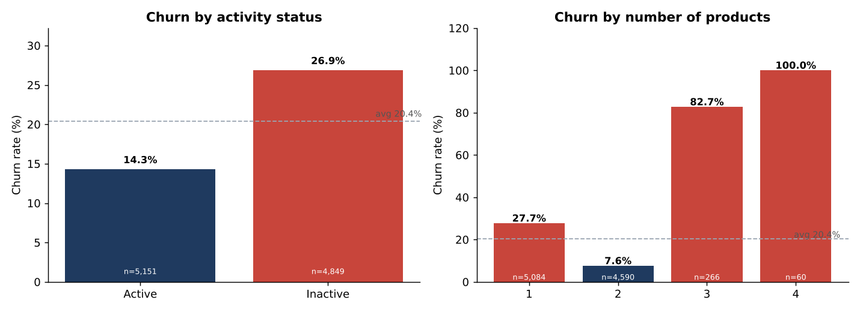
Figure 5 – Churn by activity status and number of products
Engagement. Inactive members churn at 26.9% versus 14.3% for active members. The Engagement Drop Indicator is 1.88x, and inactive members supply 64% of all churn. Inactivity roughly doubles churn in every balance segment.
Products. The relationship is U-shaped. Customers with two products are the most loyal (7.6%); single-product customers churn at 27.7%; and those with three or four products churn at 82.7% and 100.0%. The 3–4 product groups are small (326 customers) but the pattern is extreme enough to warrant investigation: possible causes include mis-selling, bundling friction or fee dissatisfaction. This is a hypothesis, not something the data proves.
Segment | Customers | Churned | Churn rate | Share of churn | Relative risk
1 | 5,084 | 1,409 | 27.7% | 69.2% | 1.36x
2 | 4,590 | 348 | 7.6% | 17.1% | 0.37x
3 | 266 | 220 | 82.7% | 10.8% | 4.06x
4 | 60 | 60 | 100.0% | 3.0% | 4.91x

5.6 High-value customer churn
High-value customers are defined as the top 25% by balance (≥ €127,644); there are 2,500 of them. 592 have churned (23.7%), giving a High-Value Churn Ratio of 1.23x: they leave about 23% more often than other customers. Because each carries a large balance, these 592 customers took €88.7m (48% of all churned balances) with them.
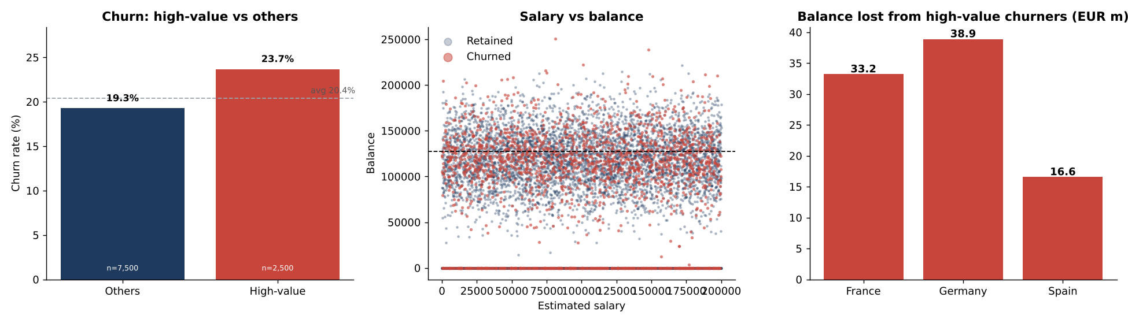
Figure 6 – High-value churn, salary versus balance, and balance lost by country
- Salary versus balance. High-value churners and stayers have nearly identical salaries (€101,078 vs €100,523). Salary does not distinguish them; the balance simply makes the loss larger.
- Germany accounts for 46% of high-value churners from 38% of high-value customers (29.0% churn rate).
- Inactivity is the dominant signal: 64% of high-value churners were inactive members (inactive HV churn 30.5% vs 16.9% for active).

5.7 Highest-risk combined segments
Geography | Age | Activity | Customers | Churned | Churn rate
Germany | 46-60 | Inactive | 276 | 223 | 80.8%
Spain | 46-60 | Inactive | 166 | 105 | 63.3%
France | 46-60 | Inactive | 345 | 210 | 60.9%
Germany | 46-60 | Active | 226 | 115 | 50.9%
France | 46-60 | Active | 404 | 133 | 32.9%
Germany | 30-45 | Inactive | 770 | 236 | 30.6%
Table 3 – Highest churn 3-way segments (minimum 50 customers)
The riskiest cell is Germany customers aged 46-60 who are inactive: 223 of 276 (81%) left. Age 46–60 combined with inactivity gives churn above 60% in all three countries.

5.8 KPI summary
KPI | Value | Interpretation
Overall Churn Rate | 20.37% | About 1 in 5 customers exited
Segment Churn Rate (range) | 7.6% – 51.1% | Age groups: widest spread of the core segments
High-Value Churn Ratio | 1.23x | HV churn 23.7% vs 19.3% others
Geographic Risk Index | DE 159 · ES 82 · FR 79 | Germany ≈ 1.6x average exposure
Engagement Drop Indicator | 1.88x | Inactive 26.9% vs active 14.3%
Table 4 – Key performance indicators

5.9 Machine-learning model for churn prediction
The segment analysis explains where churn concentrates; a supervised model turns that into a customer-level risk score. The data was split 75/25 with stratification (7,500 training, 2,500 test customers). Scaling and one-hot encoding sit inside a scikit-learn Pipeline so they are fitted only on training folds, which prevents data leakage. Three features were engineered: balance-to-salary ratio, tenure-to-age ratio and a zero-balance flag (13 model inputs in total).
Model selection. Four candidates were compared with stratified 5-fold cross-validation on the training set. Because churners are only about 20% of customers, PR-AUC is reported alongside ROC-AUC.
Model | CV ROC-AUC (± std) | CV PR-AUC | Test ROC-AUC
Logistic Regression | 0.761 ± 0.008 | 0.459 | 0.785
Random Forest | 0.857 ± 0.003 | 0.668 | 0.869
Gradient Boosting (default) | 0.855 ± 0.006 | 0.685 | 0.868
Gradient Boosting (tuned) | 0.862 ± 0.005 | 0.697 | 0.878
Table 5 – Model comparison
Tree-based models clearly beat logistic regression, indicating non-linear effects such as the age and product-count patterns found in Section 5.2. Gradient boosting was then tuned with a randomised search (25 configurations × 5 folds; best: learning rate 0.05, max depth 5, 8 leaves, 250 iterations, L2 = 5), lifting CV AUC to 0.862.
Decision threshold. Rather than the default 0.5, the threshold (0.32) was chosen by maximising F1 on out-of-fold predictions from the training data only, so the test set stays untouched.
Test metric | Value
ROC-AUC | 0.878
PR-AUC | 0.735
Recall (churners caught) | 65.6%
Precision (flags that are correct) | 63.6%
F1-score | 0.646
Accuracy (vs 79.6% for always predicting 'stay') | 85.4%
Top-decile churn rate / lift | 85.6% / 4.2x
Table 6 – Held-out test performance of the tuned gradient-boosting model
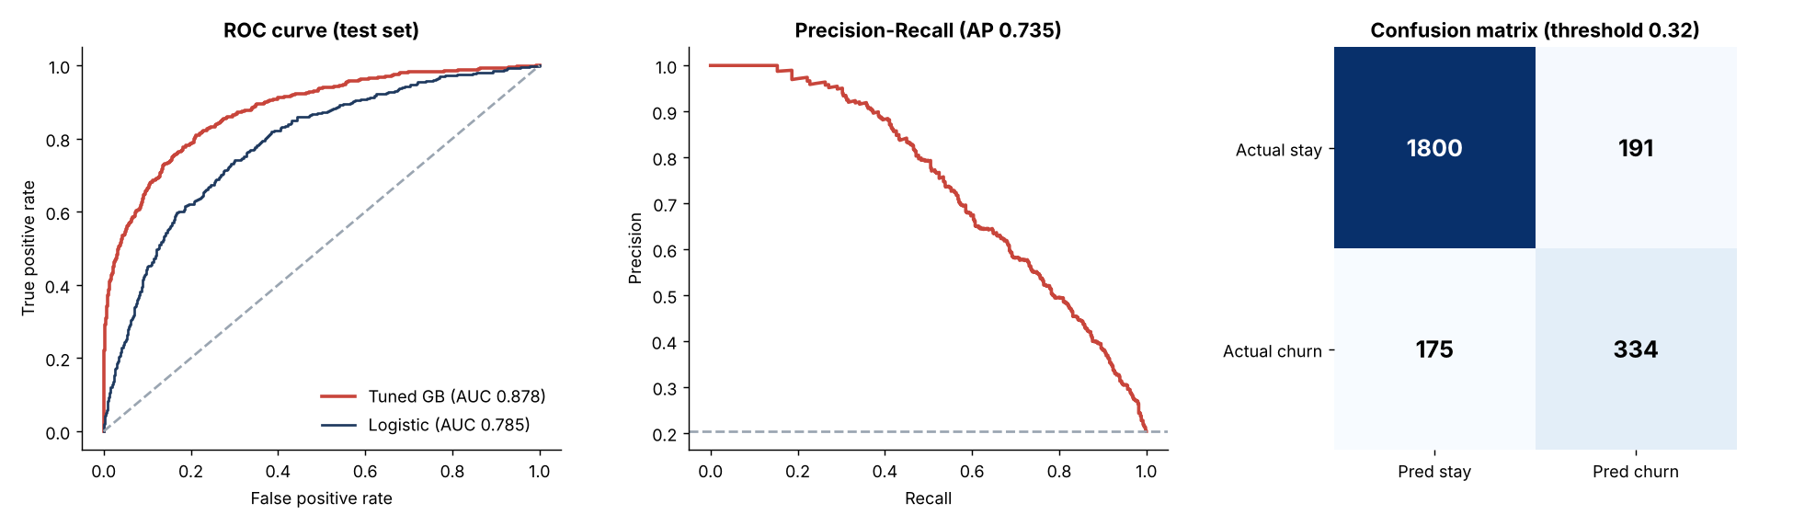
Figure 7 – ROC curve, precision-recall curve and confusion matrix on the test set
On the test set the model correctly identifies 334 of 509 churners (66%) with 191 false alarms. The 250 customers it ranks as riskiest churn at 86%, 4.2 times the base rate, so a retention team contacting only the top 10% would reach a far higher share of genuine churners than random outreach.
Explainability. Permutation importance on held-out data measures how much AUC drops when a feature is shuffled.
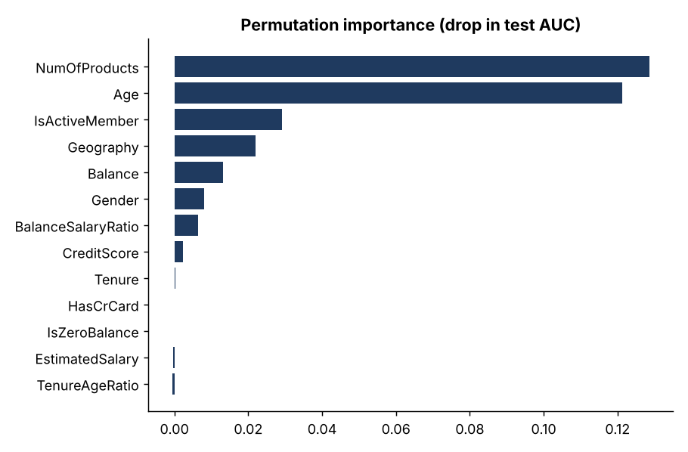
Figure 8 – Permutation feature importance
Number of products and age dominate, followed by activity status, geography and balance. Salary, tenure, credit card ownership and the other engineered ratios add essentially nothing, which agrees with the segment analysis in Sections 5.2 to 5.6. Two independent methods therefore reach the same conclusion.
Calibration of risk tiers. Every customer was scored out-of-fold (by a model that never saw them) and grouped into tiers. Actual churn rises steeply with the tier, which shows the scores are usable for prioritisation.
Risk tier | Customers | Actual churn rate
Low (<20%) | 7,003 | 7.2%
Medium (20–50%) | 1,715 | 32.5%
High (>50%) | 1,282 | 76.1%
Table 7 – Actual churn by predicted risk tier (out-of-fold)

5.10 Unsupervised segmentation with K-Means
Section 5.2 used rule-based segments. To check for natural groupings, K-Means was run on seven standardised variables (age, balance, products, activity, credit score, tenure, salary). The silhouette score was nearly flat across k = 3 to 7 (0.14, 0.15, 0.16, 0.16, 0.16), meaning customers form overlapping groups rather than sharply separated clusters; k = 5 was chosen for interpretability. The clusters should therefore be read as descriptive personas, not hard categories.
Cluster profile | Customers | Churn rate | Avg age | Avg products
C4: Older, mid-balance, active | 1,035 | 35.4% | 61 | 1.4
C1: Mid-age, high-balance, inactive | 2,621 | 28.0% | 38 | 1.3
C3: Mid-age, zero-balance, inactive, multi-product | 2,061 | 20.5% | 37 | 1.9
C2: Young, high-balance, active | 2,478 | 12.8% | 35 | 1.3
C0: Young, zero-balance, active, multi-product | 1,805 | 10.9% | 36 | 1.9
Table 8 – K-Means customer clusters, sorted by churn rate
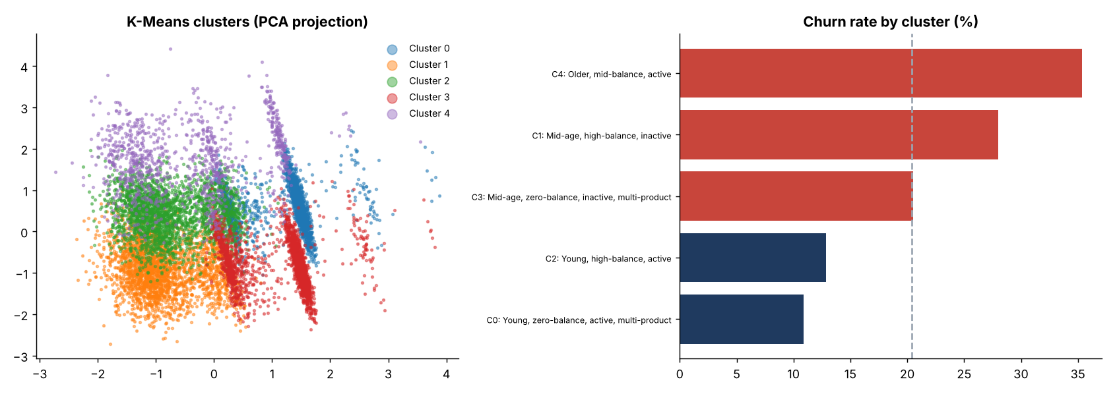
Figure 9 – Cluster projection and churn rate by cluster
The highest-churn cluster (35.4%) is older, active customers with mid-sized balances (average age 61), matching the 46–60 finding. The second (28.0%) is inactive, high-balance customers, the most valuable at-risk group. Young, active customers are the most loyal (10.9% to 12.8%).

6. Recommendations
- Launch a Germany retention programme. Germany has 32% churn, 1.6x average risk, and the largest share of high-value losses. Investigate local competition, pricing and service quality before choosing the intervention.
- Create a 46–60 "life-stage" proposition. This group produces 41% of churn from 16% of customers. Proactive relationship-manager contact, savings and retirement-planning offers are natural levers.
- Build an early-warning trigger on inactivity. Flag accounts that become inactive and contact them within a defined window; inactivity roughly doubles churn within every balance segment and accounts for 64% of high-value churn.
- Audit the 3–4 product bundles. Near-total churn among multi-product customers suggests a product, pricing or service problem. Review the sales process and fees before pushing further cross-sell.
- Protect high-value customers first. Prioritise inactive, German, 46–60 high-balance customers; they carry the most balance at risk (€88.7m already lost).
- Target by behaviour, not by income, credit score or tenure. These fields do not predict churn, so campaigns segmented on them will be poorly aimed.
- Use the risk-scoring model for outreach lists and measure its impact with an A/B test so retention spend can be linked to retained balances.
- Investigate the gender gap. Women churn roughly 8 to 10 points more than men in every country; review whether products, channels or service fit differ.

7. Limitations
- The dataset is a single-year snapshot, so findings are associations, not proven causes.
- The 3-product and 4-product groups contain only 266 and 60 customers; results for them are indicative.
- Balance is used as a proxy for customer value because revenue and margin data are not available; true lifetime value may differ.
- Credit-score and tenure cut-offs and the top-25% high-value threshold are analyst choices; the dashboard lets users vary the high-value threshold.
- Model precision is moderate (about 64%); the model should support prioritisation, not automatic decisions about individual customers. The dataset has no time dimension, so the model cannot be validated on future data.
- K-Means clusters overlap (low silhouette) and are descriptive rather than definitive.

8. Conclusion
Churn in this bank is concentrated, not general. A small number of identifiable segments (German customers, those aged 46–60, inactive members and customers with 3–4 products) generate a disproportionate share of exits, while income, credit score and tenure matter little. High-value churn is a material revenue risk, with €88.7m of balances lost from just 592 customers. Targeting retention at these segments, rather than at the customer base as a whole, is the most efficient route to reducing churn, and the accompanying dashboard lets decision-makers explore every cut of the data themselves.

