Factory-to-Customer Shipping Route Efficiency Analysis for Nassau Candy Distributor
Research Paper: Exploratory Data Analysis, Machine Learning, Insights and Recommendations
Prepared by: Nanda Kishore | Unified Mentor internship project | November 2026

Abstract
This paper analyses 10,194 order lines (8,549 shipments to 5,044 customers, orders placed 2 January 2024 to 31 December 2025) shipped from five Nassau Candy factories to customers in the United States and Canada. The aim is to identify which factory-to-customer routes are efficient, where delays concentrate, and how performance differs by region, state and ship mode. The analysis is accompanied by an interactive Streamlit dashboard.
A critical data-quality finding shapes every result. All 10,194 rows record a Ship Date between 904 and 1,642 days after the Order Date (median 1,274), and 95.3% of Ship Dates fall after the analysis date. These cannot be real shipping times. The recorded lead times cluster at roughly one-year spacing, which is consistent with a systematic date-processing offset. We therefore report results on two bases: the recorded values, and a clearly labelled, assumption-based "relative" lead time that removes whole 365-day cycles.
On the relative basis, ship mode is by far the strongest driver of lead time (it explains 62% of variance): Same Day averages 0.4 relative days and Standard Class 5.3. Differences between factories (p = 0.01) largely disappear once ship-mode mix is accounted for (p = 0.17), and customer regions do not differ significantly. Route-level variation does exceed what chance alone would produce, but it is small (about 0.4 relative days of spread between routes after mode adjustment). The routes most worth reviewing first are high-volume ones such as Lot's O' Nuts → New York and Wicked Choccy's → New York, and destinations such as Alberta that are slow from both of the two largest factories. We recommend validating the Ship Date source before any operational decision, and collecting freight-cost and delivery-date data that this dataset lacks.
Machine learning. We also tested whether lead time and delays can be predicted. Using five-fold cross-validation grouped by customer, no model (Ridge regression, random forest, gradient boosting) predicted lead time significantly better than simply using the average for each shipment's ship mode (R² 0.62, MAE 0.92 relative days). For classifying delayed shipments, logistic regression raised AUC from 0.726 to 0.745 (95% interval for the gain 0.008 to 0.028), a small but detectable improvement, while route information alone was nearly useless (R² -0.01, AUC 0.53). Route-level lead-time prediction is therefore not supported by this data.
Keywords: shipping lead time, route efficiency, logistics analytics, machine learning, cross-validation, data quality, supply chain, Streamlit.

1. Introduction
Nassau Candy Distributor ships products from several factories to customers across multiple regions. Shipping efficiency affects customer satisfaction, delays raise operating cost, and inefficient routes limit scalability. Although detailed order and shipment records exist, logistics decisions are often made without route-level efficiency information. The organisation therefore lacks clarity on four questions:
- Which factory-to-customer routes are consistently efficient?
- Which routes experience frequent delays?
- How does shipping performance vary by region, state and ship mode?
- Where do operational bottlenecks exist geographically?
This study answers these questions with the available data and is explicit about what the data can and cannot support. Its objectives are to (1) clean and validate the shipment records, (2) define and benchmark routes, (3) locate geographic bottlenecks, (4) compare ship modes descriptively, (5) provide data-backed recommendations that separate observed results from assumptions, and (6) test with machine learning whether lead time and delay can be predicted.

2. Data and Context

2.1 Dataset
The dataset contains 10,194 rows and 18 fields: Row ID, Order ID, Order Date, Ship Date, Ship Mode, Customer ID, Country/Region, City, State/Province, Postal Code, Division, Region, Product ID, Product Name, Sales, Units, Gross Profit and Cost. Gross Profit equals Sales minus Cost on every row, and Cost is the cost to manufacture the product. The file contains no freight cost, carrier, distance or delivery-date field. Customers are mostly in the United States (9,994 rows) with 200 rows in Canada. The four customer regions are Atlantic, Gulf, Interior and Pacific, and the four ship modes are Standard Class, Second Class, First Class and Same Day. Total sales are $141,784 and total gross profit $93,443 (65.9% margin).

2.2 Factories and product mapping
Each product is assigned to one of five factories using the mapping supplied in the project brief (Lot's O' Nuts, Wicked Choccy's, Sugar Shack, Secret Factory, The Other Factory), with the factory coordinates given in the brief. All 15 product names map to a factory; one spelling variant ("Wonka Bar -Scrumdiddlyumptious") is normalised before matching. A route is defined as Factory → Customer State (or Factory → Customer Region).

2.3 Units of analysis
Three units are used and always stated: a ROW is one order line; an ORDER is a unique Order ID; a SHIPMENT is a unique Order ID and Factory combination. Lead-time statistics are computed on shipments so that multi-line orders are not over-weighted, while sales and profit are summed over order lines. In this dataset every Order ID is served by a single factory, so there are 8,549 orders and 8,549 shipments (the two coincide), from 10,194 order lines.

3. Methodology

3.1 Cleaning and validation
No row is silently dropped. Every row receives flags, and rows excluded from analysis carry a recorded reason. Table 1 lists each decision and its outcome on this dataset.
Table 1. Data-quality checks and treatment
Check | Rows | Treatment
Unparseable Order/Ship Date | 0 | Excluded (none found)
Ship Date earlier than Order Date | 0 | Excluded (none found)
Product with no factory mapping | 0 | Excluded (none found)
Missing values in any column | 0 | Filled with 'Unknown' if found (none)
Lead time > 60 days (plausibility cap) | 10,194 | Flagged and kept; user toggle
Ship Date after analysis date (7 Nov 2026) | 9,713 | Flagged and kept
Rows identical to an earlier row except Row ID | 313 | Flagged and kept; optional exclusion
Orders with inconsistent ship date or mode | 0 | Informational
Canadian customer rows | 200 | Kept; plotted at province centroids

Dates are parsed by trying several formats and selecting the one that parses the most values (ties resolve to day-first); the detected format is day-month-year. Geographic fields are trimmed and title-cased. Because a plausibility cap of 60 days flags every row, removing flagged rows would delete the entire dataset, so flagged rows are retained and the problem is reported prominently instead.

3.2 Feature engineering and route metrics
Shipping lead time is Ship Date minus Order Date in days. Further features include factory and its coordinates, customer state and region, the route (Factory → State) and the Factory → Region route, a delay indicator, and route-level shipment volume, average and median lead time, lead-time standard deviation (variability) and average sales, cost and gross profit per shipment.
Delay indicator. A shipment is delayed if its lead time exceeds a user-set threshold. For the figures in this paper the threshold is 5 relative days, which is close to the 75th percentile of the data; it is illustrative and should be replaced by the company's own service target.
Route efficiency score. Score = 100 × (slowest average − route average) / (slowest average − fastest average), computed across routes with at least 5 shipments. A score of 100 is the fastest ranked route and 0 the slowest. The score is relative to the other routes in the data, not an absolute standard, and routes with fewer than 5 shipments are listed but not scored to avoid ranking on a handful of observations.
High-volume poor performers. Ranked routes whose shipment count is at or above the 75th percentile of route volumes and whose average lead time is above the median of ranked routes.

3.3 Relative lead time (assumption-based)
Because recorded lead times are implausible (Section 4), we also compute a relative lead time as (recorded lead time modulo 365) minus the smallest such remainder in the dataset. This removes whole-year offsets. It rests on an assumption, namely that Ship Dates carry a constant offset plus whole-year shifts, and it cannot recover true transit times; leap days add roughly one day of calendar noise (quantified in Section 7). It is used only to compare routes, modes and regions with each other.

3.4 Statistical checks
Group differences are tested with the Kruskal-Wallis test, which does not assume normal data. Because ship mode strongly affects lead time, we repeat the tests on mode-adjusted lead time (each shipment's lead time minus the mean for its ship mode). To test whether routes differ more than chance, we compare the spread of mode-adjusted route averages with a null distribution created by shuffling lead times within each ship mode (200 permutations, route sizes preserved).

3.5 Machine-learning methodology
Two supervised tasks are defined at shipment level on the relative basis: regression of the relative lead time, and classification of whether it exceeds the 5-day threshold (24.6% of 8,549 shipments). Inputs are factory, customer state, customer region, ship mode, division, order month, order weekday, units and the logarithm of sales. Ship Date and recorded lead time are never used as inputs because they would leak the target.
Validation. Five-fold GroupKFold cross-validation by Customer ID guarantees that no customer appears in both training and test folds. A time-based split was deliberately not used, because the relative lead time carries a calendar artifact that differs by order year (Section 7) and would confound it.
Models and baselines. The comparison set is: a global mean (or prior); a ship-mode baseline (the average lead time, or delay rate, for each ship mode); route-only models (factory, state and region without ship mode) that show how much route information alone predicts; and Ridge or logistic regression, a random forest (100 trees, minimum leaf size 5) and histogram gradient boosting using all inputs. Regression is scored by MAE, RMSE and R², and classification by ROC AUC, average precision and Brier score, all computed on pooled out-of-fold predictions. Differences from the baseline are assessed with a paired bootstrap (1,000 resamples of per-shipment absolute errors; 300 for AUC) and reported as 95% intervals. A model counts as better only if its interval excludes zero.
Importance and segmentation. Permutation importance is computed for a random forest on a held-out 25% of customers (10 shuffles per feature). Routes with at least 5 shipments are segmented by K-means (k from 2 to 6, chosen by silhouette score) on ship-mode-adjusted mean lead time, within-route spread, log volume and log average order value.

4. Data-Quality Finding: Implausible Ship Dates
Recorded lead times range from 904 to 1,642 days (mean 1,321, standard deviation 262). Ship Dates run from 2026-06-30 to 2030-06-28, and 9,713 rows (95.3%) are later than the analysis date. Figure 1 shows that the values form three tight clusters about one year apart: 2,051 rows near 908 days, 4,764 near 1,273 days and 3,379 near 1,639 days.
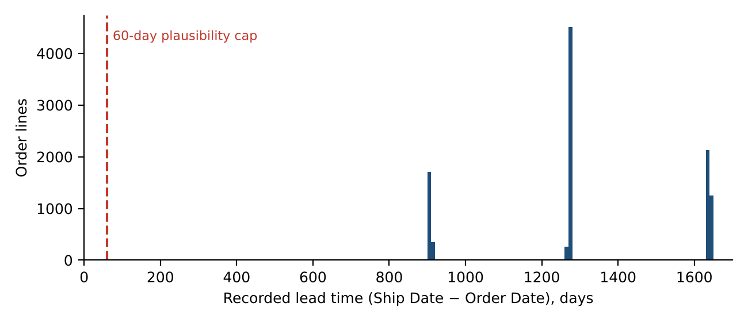
Figure 1. Distribution of recorded lead time (Ship Date minus Order Date). Every observation lies far to the right of the 60-day plausibility cap.
After removing whole 365-day cycles, the remainders occupy only 174 to 185 days, an 11-day range. Orders from 2024 are shipped in 2026, 2027 or 2028 and orders from 2025 in 2028, 2029 or 2030. This pattern suggests that Ship Dates were shifted by a constant of roughly six months plus a whole number of years. That is an inference, not a proven cause.
A plausibility check supports it. Faster ship modes should have shorter lead times. On the recorded values the ordering is wrong: Standard Class has the lowest average (1,317 days) and First Class the highest (1,337). On the relative basis the expected ordering appears exactly (Figure 2): Same Day 0.4, First Class 2.6, Second Class 3.5, Standard Class 5.3. This suggests the recorded dates still carry real ordering information after the offset is removed, although it does not prove it.
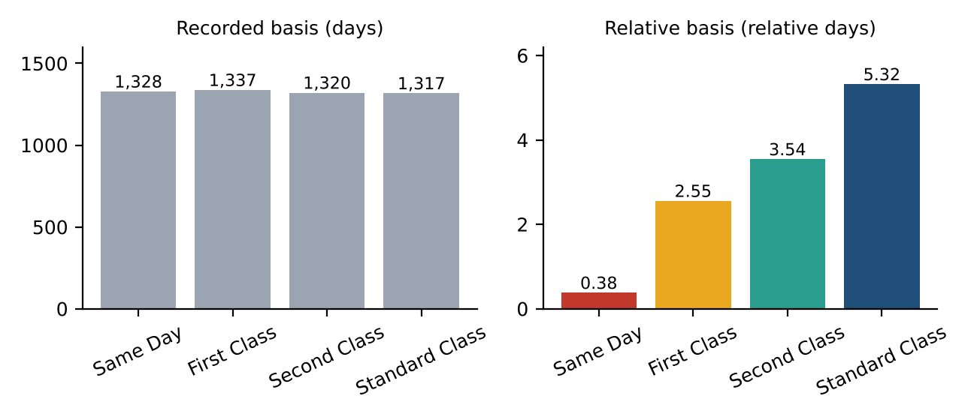
Figure 2. Mean shipment lead time by ship mode on the recorded basis (left) and the relative basis (right); axes start at zero. The recorded values are nearly identical across modes and in the wrong order; only the relative basis reproduces the expected service ordering.
Implication. Absolute lead times in this dataset should not be reported as real shipping times. Also, even a correct Ship Date minus Order Date measures order-to-dispatch time, not delivery time, because no delivery date is recorded. All results below use the relative basis and should be read as comparisons between routes, not as transit times. The Ship Date source should be confirmed with the data owner.

5. Results (relative-lead-time basis)

5.1 Overall performance
Across 8,549 shipments the mean relative lead time is 4.29 days (median 4.0, standard deviation 1.79). At the illustrative 5-day threshold, 24.6% of shipments are delayed. Standard Class carries 60.1% of shipments.

5.2 Ship mode
Table 2. Performance by ship mode (shipment basis)
Ship mode | Shipments | Avg lead | Median | Std dev | Delay rate | Sales | Gross margin
Same Day | 442 | 0.38 | 0.0 | 0.53 | 0.0% | $7,114 | 66.1%
First Class | 1,312 | 2.55 | 3.0 | 0.88 | 0.0% | $21,319 | 65.7%
Second Class | 1,653 | 3.54 | 3.0 | 1.26 | 6.7% | $27,860 | 65.7%
Standard Class | 5,142 | 5.32 | 5.0 | 1.12 | 38.8% | $85,490 | 66.0%

Grouping First Class, Second Class and Same Day as "expedited" (an assumption, since the data has no such label), expedited shipments average 2.75 days with a 3.2% delay rate, against 5.32 days and 38.8% for Standard Class. Gross margin is almost identical across modes (65.8% for expedited, 66.0% for standard), and average sales per shipment is similar (about $16 to $17). Because the data holds no freight cost, the cost side of the cost-time trade-off cannot be quantified; Sales, Cost and Gross Profit describe products, not shipping. Ship mode explains 62% of the variance in relative lead time (eta-squared = 0.62), so any route comparison must allow for ship-mode mix.

5.3 Factory
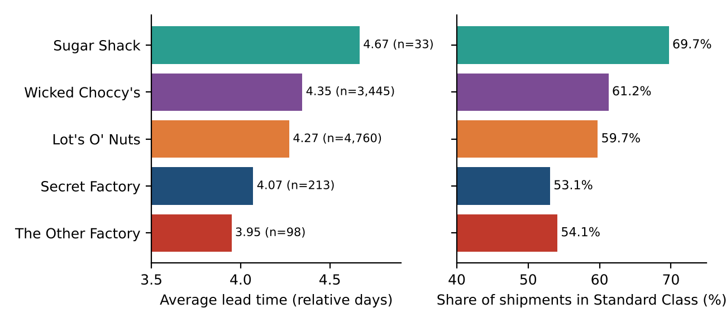
Figure 3. Average relative lead time by factory (left) and each factory's share of shipments sent by Standard Class (right).
Average lead time ranges from 3.95 days (The Other Factory) to 4.67 (Sugar Shack), though Sugar Shack and The Other Factory have only 33 and 98 shipments. Lot's O' Nuts (4,760 shipments, 4.27 days) and Wicked Choccy's (3,445, 4.34) account for most volume. The raw difference between factories is statistically detectable (Kruskal-Wallis p = 0.010), but the factory ordering mirrors each factory's Standard Class share (Sugar Shack 69.7%, The Other Factory 54.1%, Secret Factory 53.1%). After adjusting for ship mode the difference is no longer significant (p = 0.17). The data therefore does not support calling any factory a bottleneck.

5.4 Customer region and state
Table 3. Performance by customer region
Region | Shipments | Avg lead | Median | Delay rate | Sales
Atlantic | 2,476 | 4.26 | 4.0 | 23.5% | $41,197
Gulf | 1,350 | 4.29 | 4.0 | 24.0% | $22,247
Interior | 1,979 | 4.38 | 5.0 | 25.5% | $32,038
Pacific | 2,744 | 4.27 | 4.0 | 25.2% | $46,302

The four regions differ by only 0.12 days (4.26 to 4.38), and the difference is not statistically significant (p = 0.13; 0.16 after mode adjustment). Interior has the highest average and delay rate (25.5%), but the gap is small.
State-level results are more varied but rest on smaller samples. Among destinations with at least 5 shipments, the slowest are Newfoundland and Labrador (7.4 days, 5 shipments, 80% delayed), the District of Columbia (5.75, 8), South Dakota (5.38, 8), Prince Edward Island (5.25, 8), Alberta (5.14, 22), New Mexico (5.06, 34) and Minnesota (5.01, 75). The fastest are Ontario (3.44, 41), Louisiana (3.45, 38), Nebraska (3.64, 33), South Carolina (3.79, 34) and Rhode Island (3.80, 46). Minnesota, New Mexico and Alberta combine a meaningful volume with above-average lead times and are the most credible state-level slow spots; the very slowest states have too few shipments for firm conclusions.

5.5 Route ranking
There are 196 observed Factory → State routes, of which 118 have at least 5 shipments and are ranked. Figure 4 and Tables 4 and 5 show the ten fastest and ten slowest.
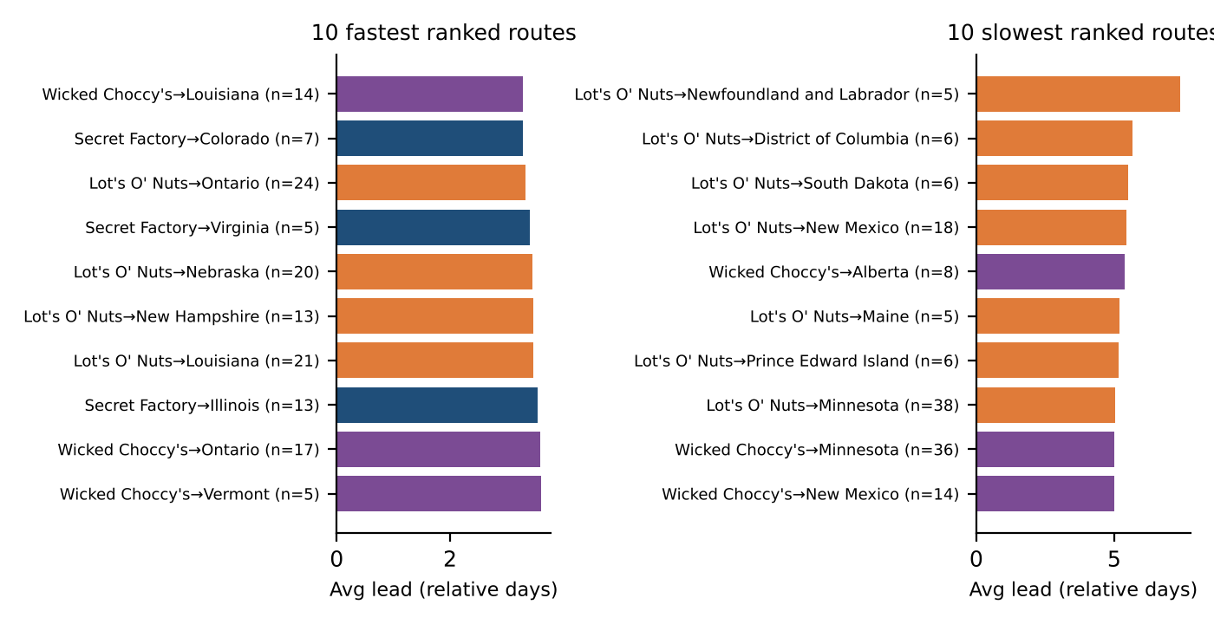
Figure 4. Fastest and slowest ranked routes by average relative lead time (n = shipments). Bar colour shows the factory.
Table 4. Ten most efficient routes
Route | Shipments | Avg lead | Std dev | Delay rate | Score
Wicked Choccy's → Louisiana | 14 | 3.29 | 1.49 | 7.1% | 100
Secret Factory → Colorado | 7 | 3.29 | 2.21 | 14.3% | 100
Lot's O' Nuts → Ontario | 24 | 3.33 | 1.27 | 0.0% | 99
Secret Factory → Virginia | 5 | 3.40 | 1.95 | 20.0% | 97
Lot's O' Nuts → Nebraska | 20 | 3.45 | 1.57 | 0.0% | 96
Lot's O' Nuts → New Hampshire | 13 | 3.46 | 1.33 | 0.0% | 96
Lot's O' Nuts → Louisiana | 21 | 3.48 | 1.75 | 4.8% | 95
Secret Factory → Illinois | 13 | 3.54 | 1.51 | 7.7% | 94
Wicked Choccy's → Ontario | 17 | 3.59 | 1.06 | 0.0% | 93
Wicked Choccy's → Vermont | 5 | 3.60 | 0.89 | 0.0% | 92
Table 5. Ten least efficient routes
Route | Shipments | Avg lead | Std dev | Delay rate | Score
Lot's O' Nuts → Newfoundland and Labrador | 5 | 7.40 | 2.30 | 80.0% | 0
Lot's O' Nuts → District of Columbia | 6 | 5.67 | 0.52 | 66.7% | 42
Lot's O' Nuts → South Dakota | 6 | 5.50 | 1.23 | 66.7% | 46
Lot's O' Nuts → New Mexico | 18 | 5.44 | 1.20 | 44.4% | 48
Wicked Choccy's → Alberta | 8 | 5.38 | 0.52 | 37.5% | 49
Lot's O' Nuts → Maine | 5 | 5.20 | 0.84 | 40.0% | 53
Lot's O' Nuts → Prince Edward Island | 6 | 5.17 | 0.75 | 33.3% | 54
Lot's O' Nuts → Minnesota | 38 | 5.03 | 1.48 | 26.3% | 58
Wicked Choccy's → Minnesota | 36 | 5.00 | 1.91 | 38.9% | 58
Wicked Choccy's → New Mexico | 14 | 5.00 | 1.36 | 28.6% | 58

About two-thirds of the ranked routes have 40 or fewer shipments (median 23), so single-route averages are noisy: with a typical within-route lead-time standard deviation of about 1.7 days, a route of 5 shipments has a standard error of roughly 0.75 days. The extremes (for example Lot's O' Nuts → Newfoundland and Labrador, 7.40 days on 5 shipments) should be treated as leads for investigation, not established facts. At the regional level (Factory → Region) the largest routes are Lot's O' Nuts → Interior (1,113 shipments, 4.36 days) and Wicked Choccy's → Interior (802, 4.44 days, 27.7% delayed); Sugar Shack → Atlantic is slowest at 5.00 days but has only 18 shipments.

5.6 High volume combined with poor performance
13 routes meet both criteria (Section 3.2). Figure 5 and Table 6 show the largest.
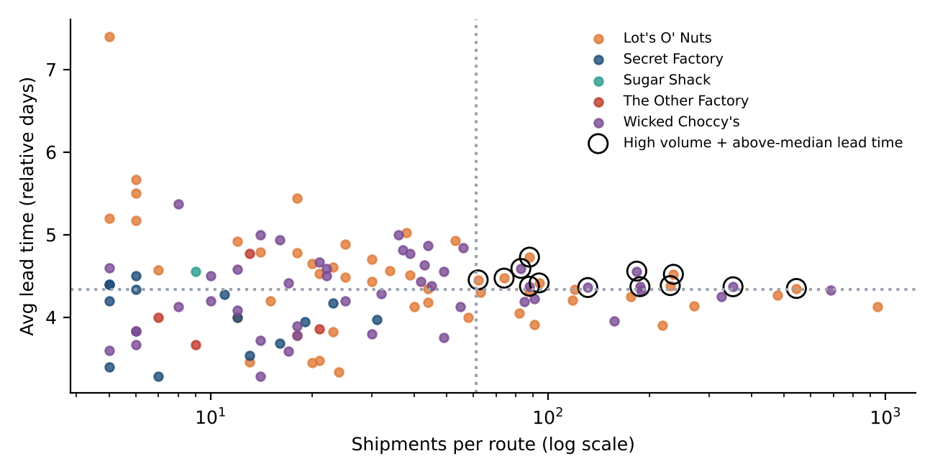
Figure 5. Route volume against average lead time. Circled routes combine high volume with above-median lead time.
Table 6. Highest-volume routes with above-median lead time
Route | Shipments | Avg lead | Delay rate | Score
Lot's O' Nuts → New York | 544 | 4.35 | 25.7% | 74
Wicked Choccy's → New York | 353 | 4.37 | 27.5% | 74
Lot's O' Nuts → Illinois | 235 | 4.52 | 23.0% | 70
Lot's O' Nuts → Washington | 230 | 4.38 | 25.2% | 73
Wicked Choccy's → Washington | 187 | 4.37 | 28.9% | 74
Wicked Choccy's → Illinois | 183 | 4.56 | 27.9% | 69
Wicked Choccy's → Florida | 131 | 4.36 | 31.3% | 74
Lot's O' Nuts → Arizona | 94 | 4.42 | 29.8% | 73

These routes are only modestly slower than average (4.35 to 4.56 days against a 4.29-day overall mean), but they carry the most shipments, so they offer the largest reach for any improvement. The two Illinois routes have the highest averages in this group (4.52 and 4.56 days), and Wicked Choccy's → Florida has the highest delay rate (31.3%).

5.7 Robustness: is the route variation real, or just ship-mode mix?
Because ship mode drives lead time, a route could look slow only because it uses more Standard Class shipments. We therefore compared each route's average with the average expected for its ship-mode mix. Raw and mode-adjusted route deviations are correlated (Spearman ρ = 0.63), and 6 of the 10 slowest routes remain in the adjusted bottom 10. The spread of mode-adjusted route averages (standard deviation 0.41 days) is larger than the null expected by chance (mean 0.27, 95th percentile 0.31; none of 200 permutations reached the observed value). So route-level differences are real within this data, but small: a typical route deviates by about 0.4 days from what its ship-mode mix predicts.
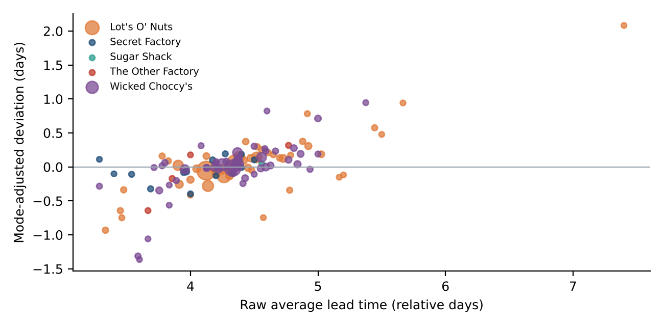
Figure 6. Raw average lead time against mode-adjusted deviation for ranked routes (marker size reflects shipments).
After adjustment, the most persistent slow routes are Lot's O' Nuts → Newfoundland and Labrador (+2.08 days, 5 shipments), Wicked Choccy's → Alberta (+0.95, 8), Lot's O' Nuts → District of Columbia (+0.94, 6) and Lot's O' Nuts → Alberta (+0.78, 12). Alberta is slower than expected from both of the two largest factories (Lot's O' Nuts and Wicked Choccy's), which hints at something about the destination rather than a single factory, although the data cannot say what. Ontario routes are the fastest after adjustment from both factories (−1.31 and −0.93 days).
Because the relative basis carries a calendar artifact (Section 7), the test was repeated while also controlling for order year and for whether the interval spans a 29 February. Table 7 shows that the conclusion does not change: in all four specifications the observed spread of route deviations (0.41 to 0.42 days) exceeds the 95th percentile of the null (0.29 to 0.31), with no permutation reaching it, while factory and region differences stay non-significant.
Table 7. Route-level variation under alternative adjustments (200 permutations each)
Adjusted for | Route SD (days) | Null mean | Null 95th pct | Perms ≥ observed | Factory p | Region p
ship mode | 0.41 | 0.27 | 0.31 | 0 / 200 | 0.17 | 0.16
ship mode x leap-day span | 0.42 | 0.26 | 0.30 | 0 / 200 | 0.24 | 0.28
ship mode x order year | 0.41 | 0.26 | 0.30 | 0 / 200 | 0.28 | 0.33
ship mode x order year x leap-day span | 0.41 | 0.26 | 0.29 | 0 / 200 | 0.28 | 0.34

5.8 Products and divisions
Chocolate accounts for 9,844 of 10,194 order lines (96.6%) and $131,693 of sales (92.9%). Average lead times are similar across divisions (Chocolate 4.30, Other 4.06, Sugar 4.53; the Sugar figure rests on only 40 lines), so product type does not appear to drive delays. As a side observation unrelated to shipping, Kazookles has a gross margin of only 7.7% against 65.9% overall, and the Other division's margin is 44.8%.

5.9 Predictive modelling (machine learning)
Figure 7 and Tables 8 and 9 compare every model with the ship-mode baseline using cross-validation grouped by customer (8,549 shipments).
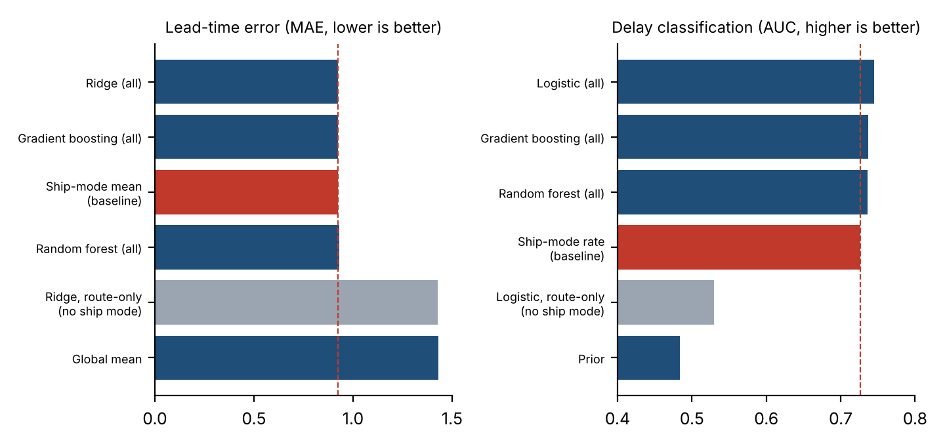
Figure 7. Cross-validated error for lead time (left) and AUC for delay classification (right). The red dashed line is the ship-mode baseline; grey bars are route-only models.
Table 8. Lead-time regression, 5-fold cross-validation (grouped by customer)
Model | MAE | RMSE | R² | MAE vs baseline (95% CI) | Verdict
Global mean | 1.430 | 1.790 | -0.002 | +0.505 (+0.482 to +0.528) | Worse
Ship-mode mean (baseline) | 0.925 | 1.097 | 0.624 | - | Baseline
Ridge, route-only (no ship mode) | 1.428 | 1.796 | -0.008 | +0.503 (+0.480 to +0.526) | Worse
Ridge, all features | 0.923 | 1.102 | 0.621 | −0.002 (−0.005 to +0.002) | No significant difference
Random forest, all features | 0.931 | 1.132 | 0.600 | +0.007 (−0.000 to +0.014) | No significant difference
Gradient boosting, all features | 0.924 | 1.112 | 0.614 | −0.000 (−0.006 to +0.005) | No significant difference
Table 9. Delay classification (lead time above threshold), 5-fold cross-validation
Model | ROC AUC | Avg precision | Brier | AUC vs baseline (95% CI) | Verdict
Prior (always base rate) | 0.483 | 0.238 | 0.186 | −0.243 (−0.256 to −0.229) | Worse
Ship-mode rate (baseline) | 0.726 | 0.375 | 0.155 | - | Baseline
Logistic, route-only (no ship mode) | 0.530 | 0.260 | 0.187 | −0.196 (−0.213 to −0.179) | Worse
Logistic, all features | 0.745 | 0.391 | 0.157 | +0.018 (+0.008 to +0.028) | Better
Random forest, all features | 0.736 | 0.375 | 0.158 | +0.009 (−0.001 to +0.019) | No significant difference
Gradient boosting, all features | 0.737 | 0.379 | 0.163 | +0.011 (−0.002 to +0.021) | No significant difference

Lead time. The ship-mode baseline reaches MAE 0.92 relative days and R² 0.62. Ridge regression, random forest and gradient boosting with all inputs reach R² of 0.62, 0.60 and 0.61; none differs significantly from the baseline, and the random forest is nominally worse. The route-only model has R² of -0.008: factory, state and region together carry no usable out-of-sample information about lead time.
Delay classification. Logistic regression with all inputs improves AUC from 0.726 to 0.745 (+0.018; 95% interval 0.008 to 0.028), and average precision from 0.375 to 0.391. This is statistically detectable but small. Random forest and gradient boosting (AUC 0.736 and 0.737) are not significantly different from the baseline. The route-only classifier reaches AUC 0.530, barely above chance (0.5).
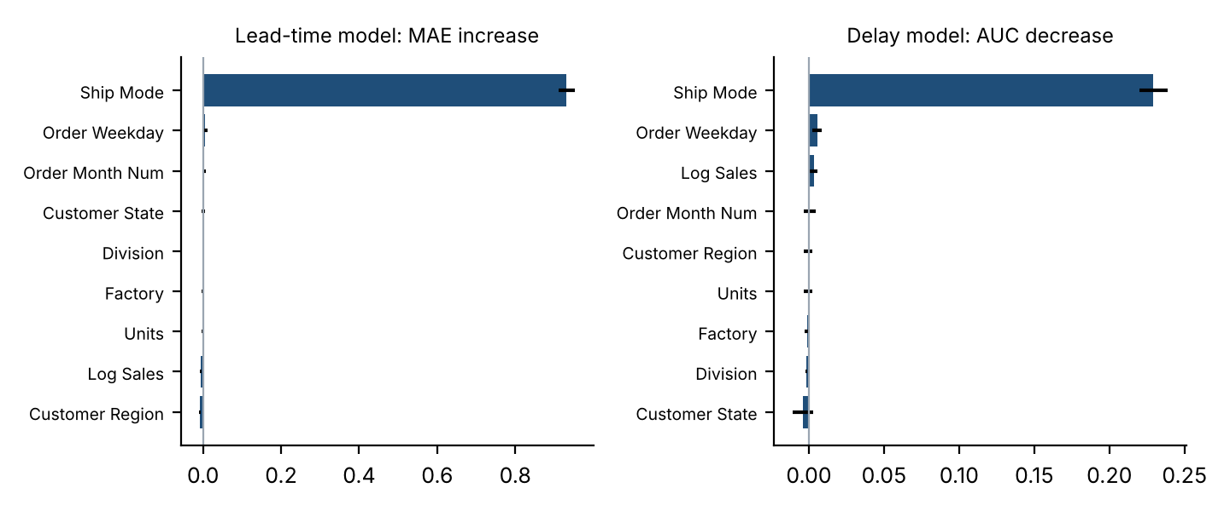
Figure 8. Permutation importance on held-out customers: increase in lead-time error (left) and decrease in delay AUC (right) when each input is shuffled. Error bars are one standard deviation over 10 shuffles.
Feature importance. Shuffling ship mode raises the lead-time MAE by 0.93 relative days and lowers the delay AUC by 0.23. Every other input changes the result by less than 0.006, which is comparable to the shuffle-to-shuffle variability. Order weekday and month show the largest of these tiny values; the data cannot show whether they are real, so they are not interpreted.
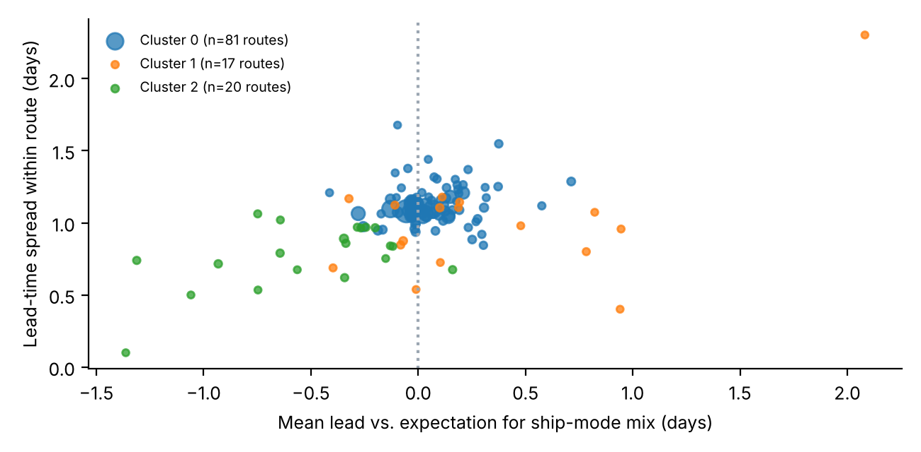
Figure 9. K-means route segments on ship-mode-adjusted behaviour (marker size reflects shipments).
Route segments. K-means selected k = 3 (silhouette 0.34, which indicates weak structure). The largest segment holds 81 routes and 7,916 shipments (93%) close to expectation (+0.07 days). A segment of 20 low-volume routes (284 shipments) is slightly faster than expected (−0.51 days) and less variable, and a segment of 17 routes (190 shipments) has a much higher average order value ($42 against $16) and is slightly slower (+0.34 days). Because the structure is weak and the small segments contain few shipments, the segmentation is exploratory; it separates mainly by order value and small-sample noise, not by a clear operational pattern.
Interpretation. The machine-learning results agree with the descriptive ones. Ship mode is the only strong and stable predictor; route differences are real but too small and noisy to predict new shipments. A prediction tool that uses route inputs would add essentially nothing beyond knowing the ship mode. Reporting that complex models do not beat a simple baseline is a substantive result: it shows where additional modelling effort would be wasted, and what data (carrier, distance, delivery date, freight cost) would be needed to make route-level prediction worthwhile.

6. Recommendations
Each recommendation states what was observed and what is assumed. None claims a cause of delay, because the dataset has no carrier, distance, weather or freight-cost information.
Table 10. Recommendations
Priority | Observed | Suggested action
1 (blocking) | Every recorded lead time is 904 to 1,642 days; modes only order correctly after removing whole-year cycles. | Confirm with the data owner how Ship Date is produced and obtain corrected dates before using absolute lead times for decisions.
2 | Standard Class is 60% of shipments and 39% exceed 5 relative days, versus 3% for expedited; margins are almost equal. | Collect freight cost per mode so the cost-time trade-off can be quantified, then test expediting on the highest-delay Standard Class routes.
3 | 13 high-volume routes have above-median lead time, led by Lot's O' Nuts → New York (544 shipments), Wicked Choccy's → New York (353) and the Illinois routes. | Review these routes first (dispatch timing, packing, mode mix). Gains are modest per shipment but apply to the largest volumes.
4 | Alberta is slower than expected for its ship-mode mix from both of the two largest factories (+0.95 and +0.78 days). Minnesota (75 shipments, 5.01 days) and New Mexico (34, 5.06) are also above average. | Place these destinations on a watch list and check carrier and service-level arrangements there.
5 | Factory differences are explained largely by ship-mode mix (p = 0.17 after adjustment); regions do not differ significantly. | Avoid factory-wide or region-wide corrective programmes; target specific routes instead.
6 | Several slowest routes (for example Newfoundland and Labrador) rest on 5 to 8 shipments. | Monitor small routes until more data accumulates before acting on them.
7 | The dataset has no delivery date, carrier, distance or freight cost. | Record dispatch and delivery timestamps, carrier and freight cost so true transit performance can be measured.
8 | No machine-learning model beats the ship-mode baseline for lead time, and route-only models have R² near zero (-0.008). | Do not build route-level lead-time prediction yet. Use ship mode plus monitoring, and revisit modelling once corrected dates and richer features are available.

7. Limitations
- Ship Date reliability. All results depend on dates that are demonstrably unreliable in absolute terms. The relative basis is an assumption-based transformation that cannot recover true transit times.
- Calendar artifact. 72% of order lines span a 29 February; they average 0.42 relative days higher than the rest, because the 365-day cycle ignores leap days. Relative lead times therefore carry roughly ±1 day of calendar noise and should not be compared across order years or read at single-day precision. The main route-level conclusions were re-tested with controls (Table 7) and held.
- Measure definition. Lead time is Ship Date minus Order Date (order to dispatch), not delivery time.
- No cost of shipping. Cost and Gross Profit are product measures. No claim is made about freight cost or the value of expediting.
- Small samples. Many routes have fewer than 25 shipments. Rankings of small routes are unstable.
- Illustrative threshold. The 5-day delay threshold is not a company service level, so delay rates change with the threshold.
- Observational data. Differences between routes may reflect factors not in the data (carrier, distance, customer type, order timing).
- Modelling limits. Models predict a transformed (relative) lead time with about one day of calendar noise, which caps achievable accuracy. Validation is grouped by customer, not by time, because no clean time split was possible; the models have not been tested on genuinely new periods.
- Geography. Maps use approximate state or province centroids; Canadian provinces are included although the brief describes US customers.

8. Conclusion
The project delivers a validated pipeline and dashboard that rank routes, locate slow destinations and compare ship modes. Its most important result is a warning: the recorded ship dates are not credible as real shipping times and must be verified. With a clearly labelled relative adjustment, the analysis shows that ship mode dominates lead time, that factory and regional differences are mostly an artefact of ship-mode mix, and that a smaller set of specific routes and destinations (the high-volume New York and Illinois routes, and Alberta, Minnesota and New Mexico) merit operational review. Machine-learning models confirm that ship mode is the only strong predictor and that route information adds almost nothing out of sample, so route-level prediction is not yet justified. Confirming the date source and adding delivery and freight-cost data would turn these findings into decisions that can be costed and verified.

Appendix A. Definitions
- Lead time: Ship Date − Order Date, in days.
- Relative lead time: (lead time mod 365) − minimum remainder in the dataset.
- Delay frequency: share of shipments with lead time above the chosen threshold.
- Route efficiency score: 100 × (max route average − route average) / (max − min), among routes with at least 5 shipments.
- Mode-adjusted lead time: shipment lead time minus the mean lead time of its ship mode.

Appendix B. Reproducibility
The analysis is implemented in Python (pandas, NumPy, SciPy, scikit-learn, Plotly, Streamlit). The code is organised into data_processing.py (loading, validation, features), analysis.py (aggregation, scoring, recommendations), ml_models.py (cross-validated models, importance, clustering), visualizations.py (charts and maps), config.py (factory coordinates, product mapping, thresholds) and app.py (dashboard). Automated tests cover date parsing, lead-time calculation, factory mapping, route aggregation, filters and empty selections. All statistics in this paper are computed from the source CSV with no manually entered results, and reports/paper_analysis.py regenerates them together with the underlying figures. The test suite contains 35 automated tests.

