FULL STACK APPLICATION DEVELOPMENT
NAME | CHINNAM SHIRIDI SAI
ID | 2400031075
SECTION | S-03
COURSE | FSAD

FSAD Skill - 7: REST API CRUD Operations using ResponseEntity

Aim

To implement REST APIs using Spring Boot for performing CRUD operations on Course data using ResponseEntity and test the endpoints using Postman.

Tasks

Create a Course entity with fields: courseId, title, duration, fee.
Course.java
package com.example.courseapi.entity;

import jakarta.persistence.Entity;
import jakarta.persistence.Id;

@Entity
public class Course {

@Id
private int courseId;
private String title;
private String duration;
private double fee;

public Course() {}

public int getCourseId() {
return courseId;
}

public void setCourseId(int courseId) {
this.courseId = courseId;
}

public String getTitle() {
return title;
}

public void setTitle(String title) {
this.title = title;
}

public String getDuration() {
return duration;
}

public void setDuration(String duration) {
this.duration = duration;
}

public double getFee() {
return fee;
}

public void setFee(double fee) {
this.fee = fee;
}
}

Create a Service layer that performs CRUD operations.
CourseRepository.java:
package com.example.courseapi.repository;

import java.util.List;
import org.springframework.data.jpa.repository.JpaRepository;
import com.example.courseapi.entity.Course;

public interface CourseRepository extends JpaRepository<Course,Integer> {

List<Course> findByTitle(String title);

}

Implement REST endpoints using @PostMapping, @PutMapping, @DeleteMapping, and @GetMapping.
CourseService.java:
package com.example.courseapi.service;

import java.util.List;
import org.springframework.beans.factory.annotation.Autowired;
import org.springframework.stereotype.Service;
import com.example.courseapi.entity.Course;
import com.example.courseapi.repository.CourseRepository;

@Service
public class CourseService {

@Autowired
private CourseRepository repository;

public Course addCourse(Course course) {
return repository.save(course);
}

public List<Course> getAllCourses() {
return repository.findAll();
}

public Course updateCourse(int id, Course course) {
Course c = repository.findById(id).orElse(null);

if (c != null) {
c.setTitle(course.getTitle());
c.setDuration(course.getDuration());
c.setFee(course.getFee());
return repository.save(c);
}

return null;
}

public boolean deleteCourse(int id) {

if (repository.existsById(id)) {
repository.deleteById(id);
return true;
}

return false;
}

public List<Course> searchCourse(String title) {
return repository.findByTitle(title);
}

}
4.use ResponseEntity to return success messages, error messages and status codes.
Course controller.java:
package com.example.courseapi.controller;

import java.util.List;

import org.springframework.beans.factory.annotation.Autowired;
import org.springframework.http.HttpStatus;
import org.springframework.http.ResponseEntity;
import org.springframework.web.bind.annotation.*;

import com.example.courseapi.entity.Course;
import com.example.courseapi.service.CourseService;

@RestController
@RequestMapping("/courses")
public class CourseController {

@Autowired
private CourseService service;

@PostMapping
public ResponseEntity<?> addCourse(@RequestBody Course course) {

Course c = service.addCourse(course);

return new ResponseEntity<>(c, HttpStatus.CREATED);
}

@GetMapping
public ResponseEntity<?> getCourses() {

List<Course> list = service.getAllCourses();

return new ResponseEntity<>(list, HttpStatus.OK);
}

@PutMapping("/{id}")
public ResponseEntity<?> updateCourse(@PathVariable int id, @RequestBody Course course) {

Course updated = service.updateCourse(id, course);

if (updated != null)
return new ResponseEntity<>(updated, HttpStatus.OK);

return new ResponseEntity<>("Course Not Found", HttpStatus.NOT_FOUND);
}

@DeleteMapping("/{id}")
public ResponseEntity<?> deleteCourse(@PathVariable int id) {

boolean deleted = service.deleteCourse(id);

if (deleted)
return new ResponseEntity<>("Course Deleted Successfully", HttpStatus.OK);

return new ResponseEntity<>("Course Not Found", HttpStatus.NOT_FOUND);
}

5.Add a search endpoint /courses/search/{title}.
@GetMapping("/search/{title}")
public ResponseEntity<?> searchCourse(@PathVariable String title) {

List<Course> courses = service.searchCourse(title);

if (courses.isEmpty())
return new ResponseEntity<>("No Course Found", HttpStatus.NOT_FOUND);

return new ResponseEntity<>(courses, HttpStatus.OK);
}
6. Test all endpoints using Postman.
package com.example.courseapi;

import org.springframework.boot.SpringApplication;
import org.springframework.boot.autoconfigure.SpringBootApplication;

@SpringBootApplication
public class CourseApiApplication {

public static void main(String[] args) {
SpringApplication.run(CourseApiApplication.class, args);
}

Applications,properties:
spring.datasource.url=jdbc:h2:mem:testdb
spring.datasource.driverClassName=org.h2.Driver
spring.jpa.database-platform=org.hibernate.dialect.H2Dialect
spring.jpa.hibernate.ddl-auto=update
spring.h2.console.enabled=true
Outputs (Postman):

Add Course API Output:

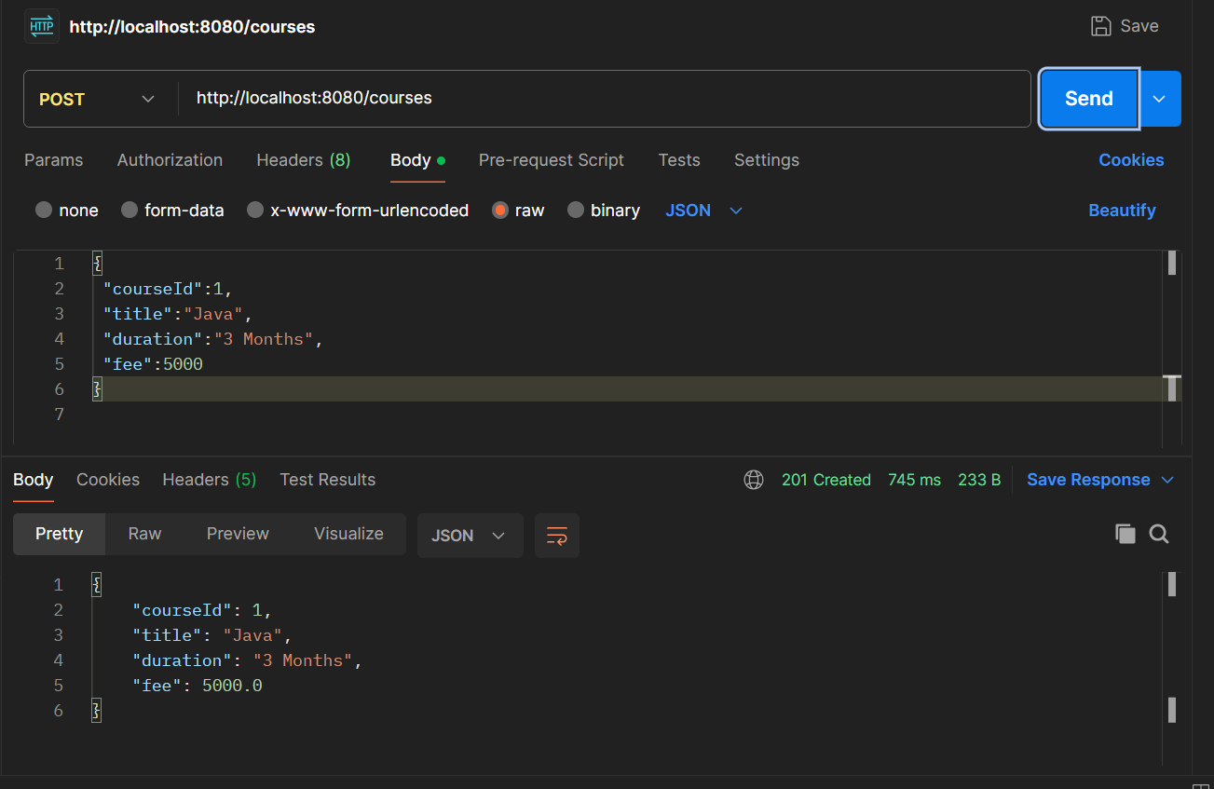

View Courses API Output:

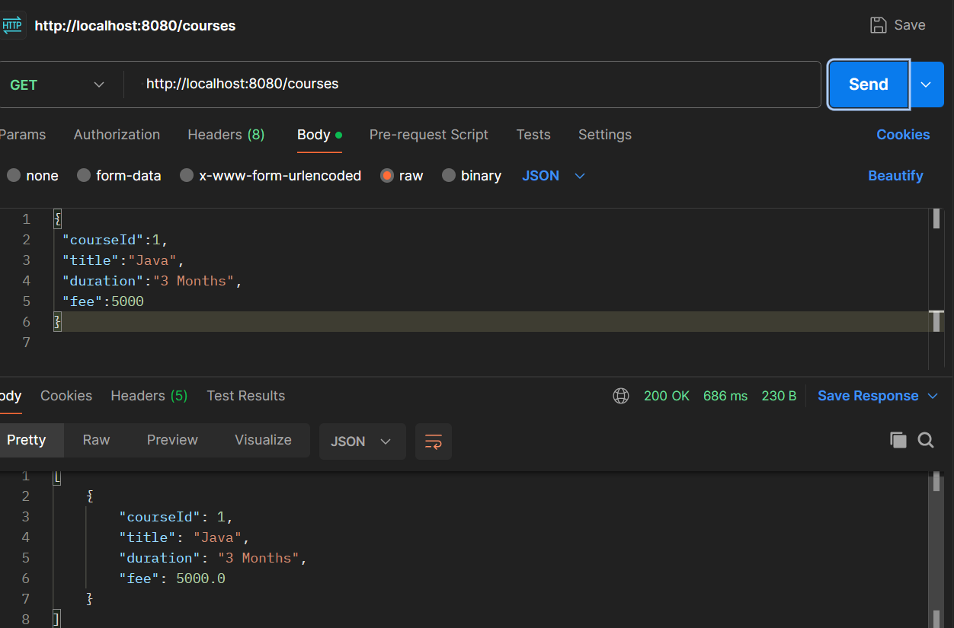

Search Course API Output:

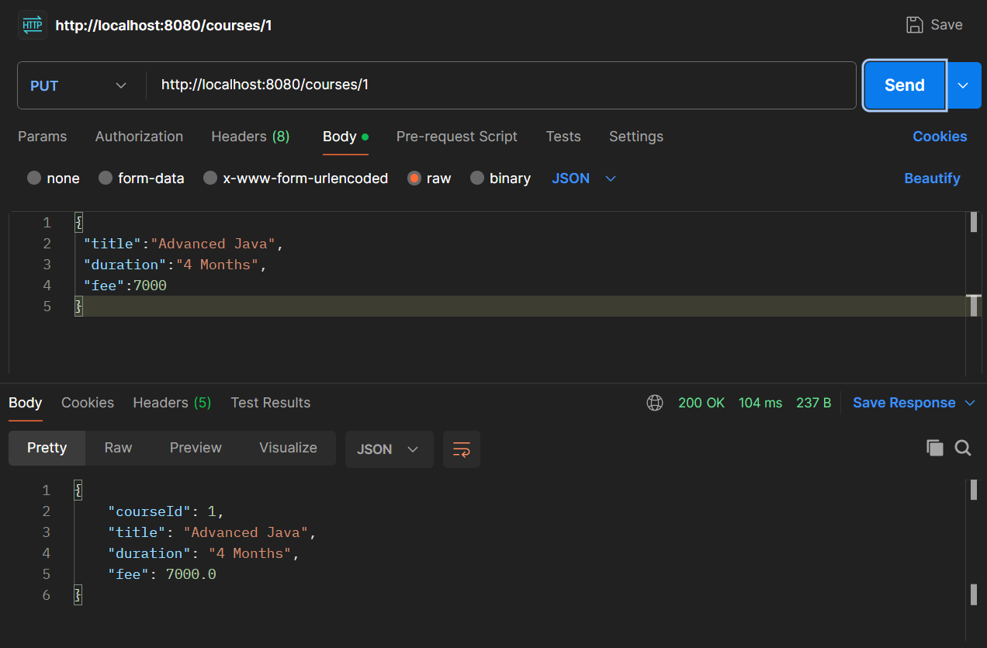

Delete:
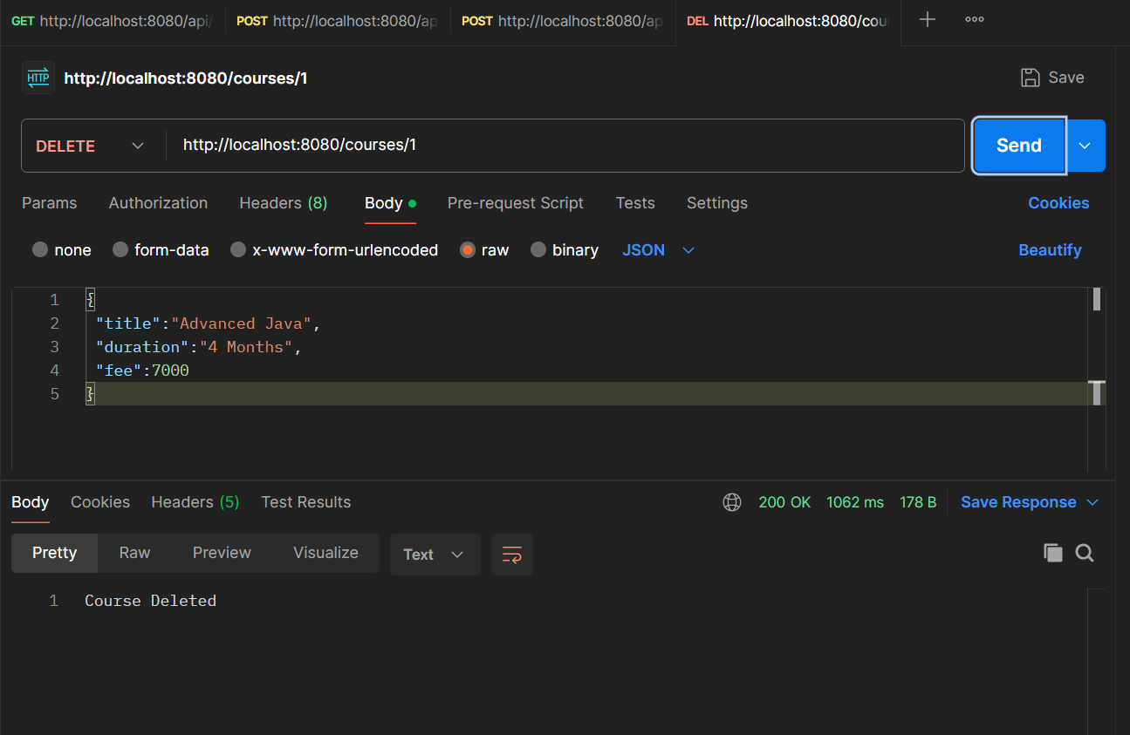
Search:
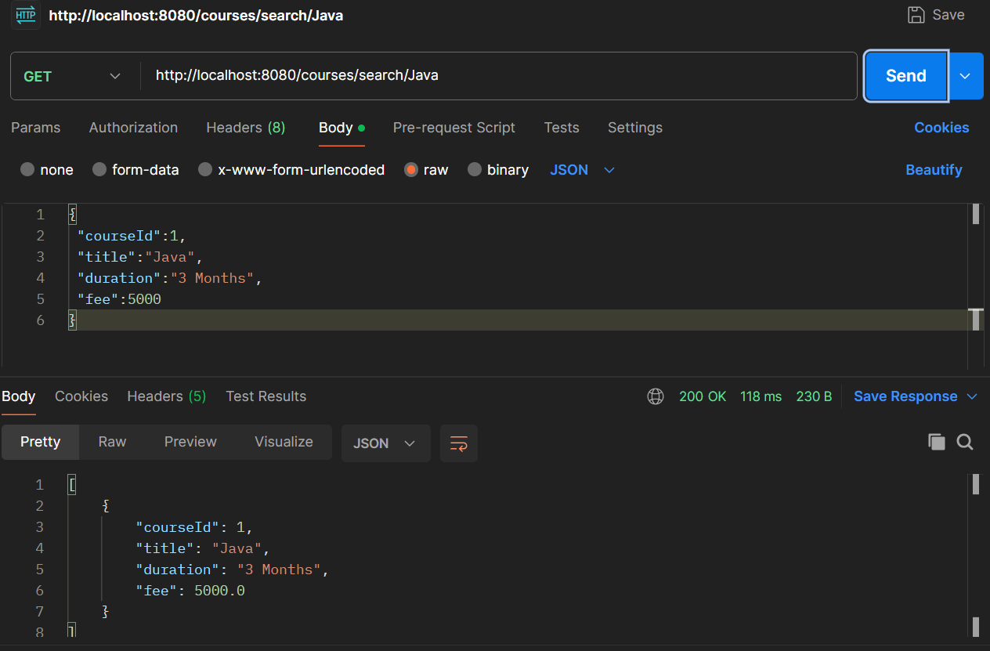

Github screenshot:
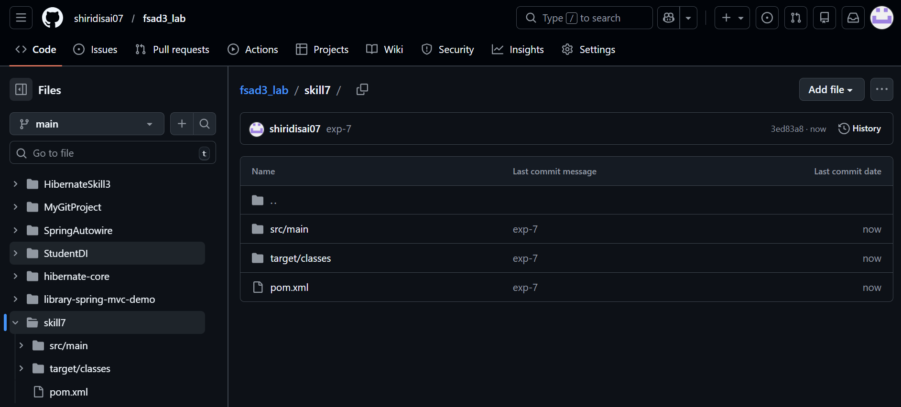
Github url:
https://github.com/shiridisai07/fsad3_lab/tree/main/skill7

Conclusion

The REST API for Course management was successfully implemented using Spring Boot. CRUD operations were tested using Postman and correct HTTP status codes were returned using ResponseEntity.
1. What is ResponseEntity used for?
Answer:
ResponseEntity is used in Spring Boot to represent the entire HTTP response.
It allows the developer to return:
- Response body (data)
- HTTP status code
- HTTP headers
This helps in controlling the response sent from the server to the client.

2. What is the difference between @PostMapping and @PutMapping?
Answer:
Annotation | Purpose
@PostMapping | Used to create or add new data in the server
@PutMapping | Used to update existing data in the server
Example:
- POST /courses → Adds a new course
- PUT /courses/{id} → Updates an existing course

3. Why are HTTP status codes important in REST APIs?
Answer:
HTTP status codes indicate the result of an API request.
They help the client understand whether the request was successful or not.
Examples:
- 200 OK → Request successful
- 201 CREATED → Resource created successfully
- 404 NOT FOUND → Resource not found
- 400 BAD REQUEST → Invalid request

4. What happens if an invalid ID is passed to an endpoint?
Answer:
If an invalid ID is passed, the system cannot find the resource in the database.
In such cases, the API returns:
- Error message (e.g., "Course Not Found")
- HTTP status code 404 NOT_FOUND
This informs the client that the requested resource does not exist.

5. Can ResponseEntity return both data and status codes together?
Answer:
Yes. ResponseEntity can return both response data and HTTP status code together.
Example:
return new ResponseEntity<>(course, HttpStatus.OK);
Here:
- course → response data
- HttpStatus.OK → HTTP status code

