INNOVATION COVID-19 CASES ANALYSIS

Project Title: Covid-19 Cases Analysis

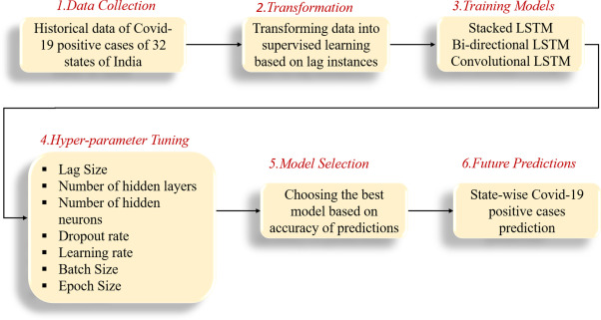

INTRODUCTION:

Recently, the world gained rapid progression in technology and it shows an important role in the developed countries. Nowadays all daily life sectors such as education, business, marketing, militaries, and communications, engineering, and health sectors are dependent on the new technology applications. The health care center is a crucial field that strongly needs to apply the new technologies from defining the symptoms to the accurate diagnosis and digital patient's triage.

\*\*DATA COLLECTION :

The Covid-19 pandemic is the most important health disaster that has surrounded the world for the past eight months. There is no clear date yet on when it will end. As of 18 September 2020, more than 31 million people have been infected worldwide. Predicting the Covid-19 trend has become a challenging issue. In this study, data of COVID-19 between 20/01/2020 and 18/09/2020 for USA, Germany and the global was obtained from World Health Organization. Dataset consist of weekly confirmed cases and weekly cumulative confirmed cases for 35 weeks.

\*\*TRANSFORMATION:

Current evidence suggests that the virus spreads mainly between people who are in close contact with each other, for example at a conversational distance. The virus can spread from an infected person’s mouth or nose in small liquid particles when they cough, sneeze, speak, sing or breathe. Another person can then contract the virus when infectious particles that pass through the air are inhaled at short range (this is often called short-range aerosol or short-range airborne transmission) or if infectious particles come into direct contact with the eyes, nose, or mouth (droplet transmission).

\*\*TRAINING MODELS :

Creating a COVID-19 cases analysis training model involves using data related to the COVID-19 pandemic and machine learning techniques to gain insights or make predictions. I'll outline the steps involved in creating such a model:

1. Data Collection:

Gather relevant data, such as COVID-19 case counts, testing data, vaccination data, demographic information, and other related datasets. You can obtain this data from sources like government health agencies, research organizations, or public data repositories.

2. Data Preprocessing:

Clean and prepare the data for analysis. This may include handling missing values, normalizing data, and aggregating data at appropriate levels (daily, weekly, by location, etc.).

3. Feature Engineering:

Create meaningful features from the data that can help in the analysis. For example, calculate growth rates, test positivity rates, or other relevant indicators.

4. Exploratory Data Analysis (EDA):

Perform EDA to understand the data's patterns, trends, and correlations. Visualizations and summary statistics can be helpful for this stage.

5. Model Selection:

Choose a suitable machine learning or statistical model. For COVID-19 analysis, time series forecasting models, regression models, or deep learning models can be used depending on the task.

6.Model Training:

Train the chosen model using a portion of the data. For time series data, you might use historical data to predict future cases, while regression models can be trained to understand relationships between variables.

\*\*HYPER-PARAMETER TUNING FOR COVID-19 CASES ANALYSIS:

Select the Model:

Start with a choice of the machine learning model or algorithm. For time series data, models like ARIMA, SARIMA, or Prophet are common. For regression or classification tasks, you might use linear regression, decision trees, random forests, or deep learning models.

\*\*MODEL SELECTION :

Selecting an appropriate model for COVID-19 cases analysis involves understanding the nature of the data, the research questions you want to answer, and the specific goals of your analysis. Here are some model selection guidelines for analyzing COVID-19 cases:

Time Series Analysis:

ARIMA (Auto Regressive Integrated Moving Average):

ARIMA models are commonly used for time series data. They can be effective for forecasting and analyzing trends in daily or weekly COVID-19 case data.

Machine Learning Models:

Regression Models: You can use linear or nonlinear regression models to understand the relationship between COVID-19 cases and various factors like population density, policy measures, or vaccination rates.

\*\*FUTURE PREDICTIONS:

Predicting future COVID-19 cases is a complex task and requires data, modeling, and expertise in epidemiology. I can provide some information on the general principles and methods used for such predictions, but please note that any specific predictions or analysis I provide are purely speculative and not based on real-time data beyond my knowledge cutoff date in September 2021.

Here are some steps and factors considered in COVID-19 case analysis and future predictions:

1. Data Collection: To make predictions, you need access to accurate and up-to-date data on COVID-19 cases, including the number of cases, recoveries, and deaths. Data quality is crucial for accurate predictions.

2. Epidemiological Models: Epidemiologists use various mathematical models to predict future cases, such as the SIR (Susceptible-Infectious-Recovered) model, SEIR (Susceptible-Exposed-Infectious-Recovered) model, and more. These models consider factors like transmission rates, incubation periods, and the impact of interventions (e.g., lockdowns or vaccination campaigns).

3. Historical Trends: Analyzing historical data and trends can help in understanding how the virus has spread in the past and making short-term predictions based on current conditions.

4. Interventions and Vaccination: The success and coverage of vaccination campaigns, as well as the effectiveness of public health measures (such as mask mandates and lockdowns), play a significant role in determining future case numbers.

5. Variants: Monitoring and understanding the impact of new COVID-19 variants is essential, as some variants may be more transmissible or resistant to immunity from previous infections or vaccinations.

6. Public Behavior: How people behave in response to the virus, such as mask-wearing, social distancing, and travel restrictions, also influences future case numbers.

7. Seasonality: Some diseases, including respiratory viruses like COVID-19, can exhibit seasonal patterns, which need to be considered in predictions.

8. Uncertainty: Predictions typically come with a level of uncertainty. This uncertainty can be due to changing variables, human behavior, data quality, and other factors.

THANK YOU!