**Lab Exercise**

**Index.html**

**code:**

<html>

    <head>

        <style>

            *{

                padding:0rem;

            }

            body{

                background-color:pink;color:black;

                display:flex;

                flex-direction: column;

                align-items:center;

                justify-content: space-evenly;

            }

            .main {

                width:100%;

                display: flex;

                flex-direction: column;

                align-items: center;

                justify-content: center;

                background-color:green;

            }

            .images{

                display: flex;

                height: 30vh;

            }

            a{

                text-decoration: none;

                font-weight: bold;

                padding:1rem 1.5rem;

                border-radius: 1rem;

                color:azure;

                background-color: rgb(247, 132, 151);

            }

            img{

                margin: 0rem 1rem;

                flex:1;

                height:100%;

                width:100%;

            }

        </style>

    </head>

<body>

    <nav>

        <p style="text-align:left;">Home

        <span style="padding:20px;">Personal</span>

        <span style="padding:40px;">Bussiness</span>

        <span style="padding:50px;">Priority</span>

        <span style="padding:60px;">Support</span>

        <hr style="border-color:pink">

    </nav>

    <div class="main">

        <h1>AXIS BANK</h1>

        <p >(Perundurai,Erode)</p>

    </div>

    <hr>

    <h2>KEY UPDATES:</h2>

    <div class="images">

        <img src="digital1.jpg">

        <img src="digital2.jpg">

        <img src="digital3.jpg">

    </div>

    <h2>PRODUCTS TO MEET YOUR LIFE GOALS....</h2>

    <ul>

        <li>Digital savings account</li>

        <li>Express fd</li>

        <li>Credit cards</li>

        <li>Personal loan</li>

    </ul>

    <br>

    <a href="form.html">OPEN DIGITAL A/C</a>

    <br>

    <h3>CONTACT US </h3>

    <h5>CONTACT US

    Call: 1800-419-5959

    SMS BAL to 56161600 or +918691000002

    to get your Account Balance<br>

    Call: 1800-419-6969

    to get your Mini Statement

    </h5>

</body>

</html>

**Output:**

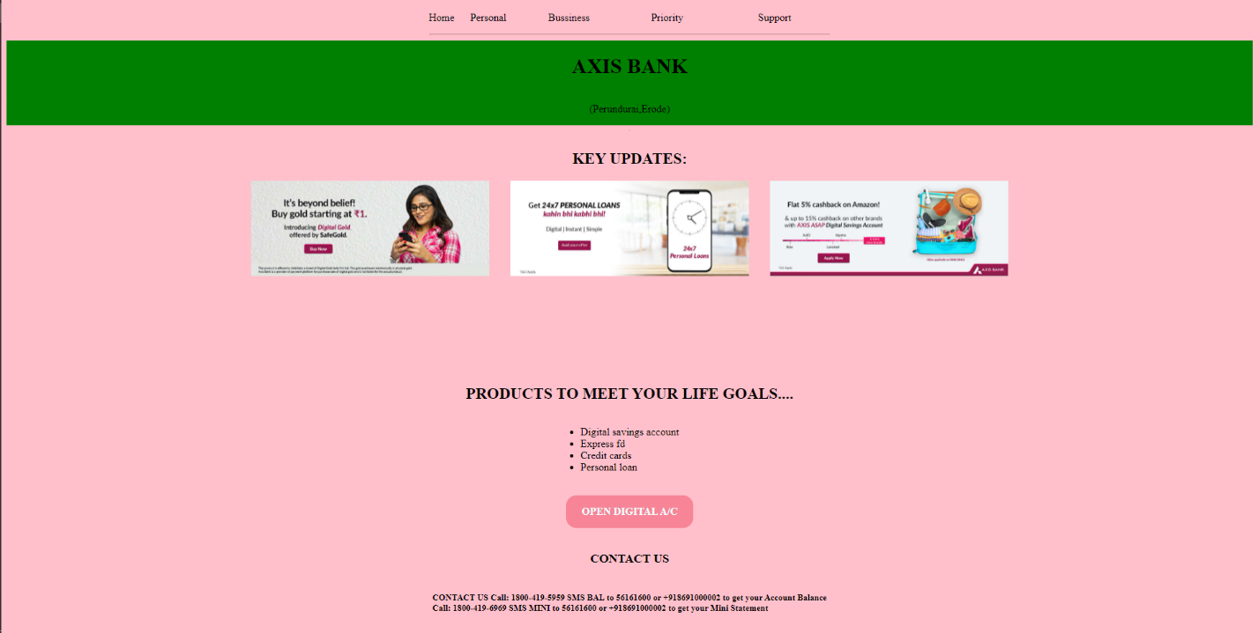

**Form.html**

**Code:**

<html>

    <head>

        <style>

        body{

            background-image: url("digital4.jpg");

            background-repeat:no-repeat;

            background-position: center;

            background-size: contain;

        }

        label{

            padding:1rem;

        }

        a{

                text-decoration: none;

                font-weight: bold;

                padding:1rem 1.5rem;

                border-radius: 1rem;

                color:azure;

                background-color: rgb(247, 132, 151);

            }

        </style>

    </head>

    <body>

        <h1 style="background-color:PINK;color:BLACK">SAVINGS BANK ACOOUNT FORM</h1>

        <hr>

        <fieldset>

        <legend><b>PERSONAL DETAILS</b></legend>

        <label><b>FIRST NAME:</b></label>

        <input type="text" name="fname" placeholder="firstname required" width="50%"  pattern="[A-Z.A-Za-z]{1,}"align="middle"><br><br>

        <label><b> MIDDLE NAME:</b></label>

        <input type="text" name="mname"><br><br>

        <label><b> LAST NAME:</b></label>

        <input type="text" name="lname" placeholder="lastname required" ><br><br>

        <label><b>MOBILE NO:</b></label>

        <input type="number" name="no" size="10" pattern=" pattern="[0-9]{3}-[0-9]{3}-[0-9]{4}" placeholder="91" name="countrycode"  required><br><br>

        <label><b>EMAIL ID:</b></label>

        <input type="email" name="email" pattern="xxx@yyy.com" size="20" width="50%" required><br><br>

        <label><b>FATHER'S NAME:</b></label>

        <input type="text" name="fAname" ><br><br>

        <label><b>MOTHER'S NAME:</b></label>

        <input type="text" name="maname"><br><br>

        <label><b>AADHAR NO:</b></label>

        <input type="number"><br><br>

        <label><b>PAN NO:</b></label>

        <input type="number"><br><br>

        <label><b>DATE OF BIRTH:</b></label>

        <input type="date"><br><br>

        <label><b>PASSWORD</b></label>

        <input type="password" id="psw" name="psw" pattern="(?=.*\d)(?=.*[a-z])(?=.*[A-Z]).{8,}" value="Must contain at least one number and one uppercase and lowercase letter, and at least 8 or more characters" required><br>

        </fieldset>

        <fieldset>

        <legend><b>ADDRESS DETAILS<b></legend>

        <label> COMMUNICATION RESIDENCE ADDRESS:</label>

        <textarea  rows="6" cols="50" name="addr" wrap="on"></textarea>

        <label> PERMANENT  ADDRESS:</label>

        <textarea  rows="6" cols="50" name="addr" wrap="on"></textarea><br><br>

        <p><b>RESIDENCE TYPE:</b>

        <input type="radio" id="OWNED" name="house">

        <label> OWNED</label>

        <input type="radio" id="RENTED/LEASED" name="house">

        <label>RENTED/LEASED</label>

        <input type="radio" id="ANCESTRAL/PARENTAL" name="house">

        <label> ANCESTRAL/PARENTAL</label>

        <input type="radio" id="COMPANY PROVIDED" name="house">

        <label>COMPANY PROVIDED</label></p>

        </fieldset>

        <fieldset>

        <legend><b>CUSTOMER INFORMATION (MANDATORY):</b></legend>

        <p><b>STATUS:</b>

        <input type="radio" id="BLIND" name="class">

        <label> BLIND</label>

        <input type="radio" id="PHYSICALLY CHALLENGED" name="class">

        <label> PHYSICALLY CHALLENGED</label>

        <input type="radio" id="NORMAL" name="class">

        <label> NORMAL</label>

        </fieldset>

        <fieldset>

        <legend>DOCUMENTS FOR VERIFICATION</legend>

        <label>RATIONCARD</label>

        <input type="checkbox" id="RATION CARD" name="DOCUMENT" VALUE="RATION CARD">

        <label>AADHARCARD</label>

        <input type="checkbox" id="AADHARCARD" name="DOCUMENT" VALUE="AADHARCARD">

        <label>PAN CARD</label>

        <input type="checkbox" id="PAN CARD" name="DOCUMENT" VALUE="PAN CARD">

        <label>EMPLOYEE ID CARD</label>

        <input type="checkbox" id="EMPLOYEE ID CARD" name="DOCUMENT" VALUE="EMPLOYEE ID CARD">

        <label>VOTER ID CARD</label>

        <input type="checkbox" id="VOTER ID CARD" name="DOCUMENT" VALUE="VOTER ID CARD">

        </fieldset>

        <center>

        <button type="submit" value="submit"><b>SUBMIT</b></button>

        <button type="submit" value="reset"><b>RESET</b></button></center>

        <a href="index.html">BACK TO HOME</a>

    </body>

</html>

**Output:**

