LAB # 4(Report)

Circuit I/O:

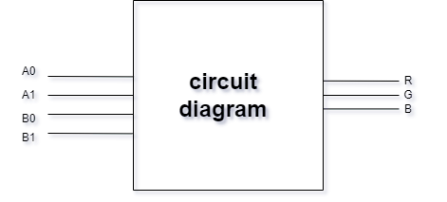

Truth Table:

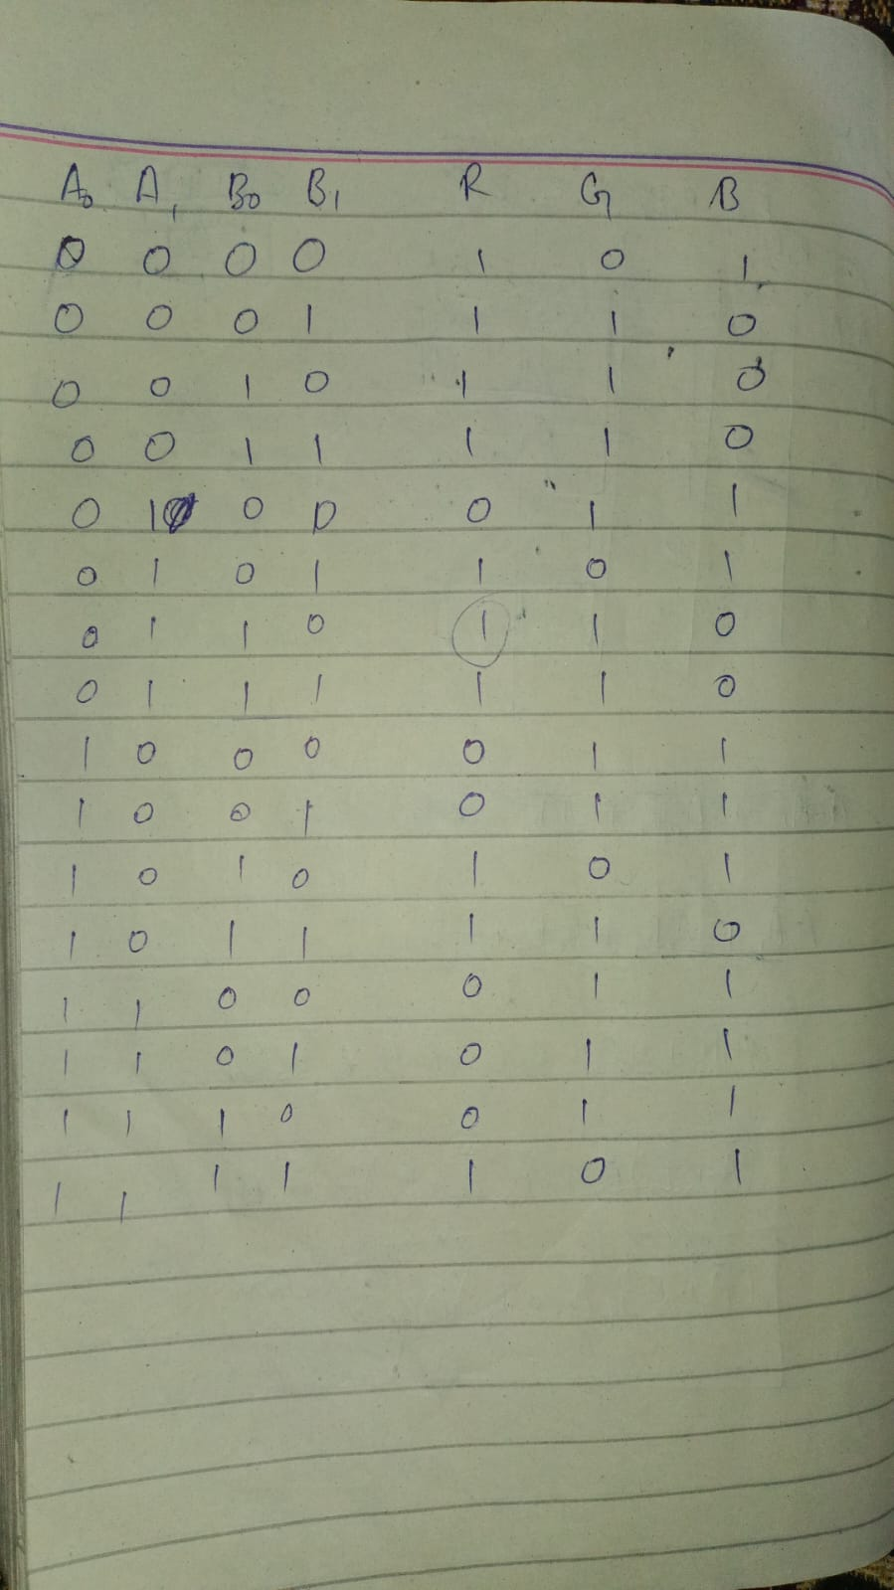

K-Maps:

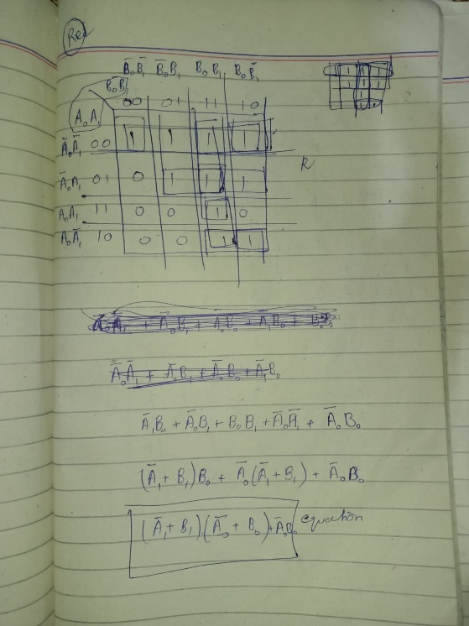

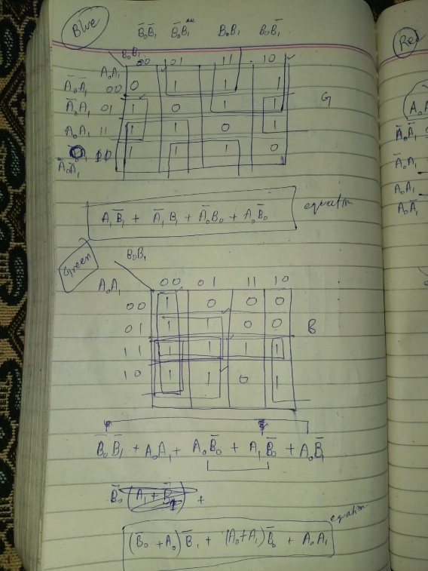

So, these are the three K-maps and their equations.

Structural Modeling (.sv file):

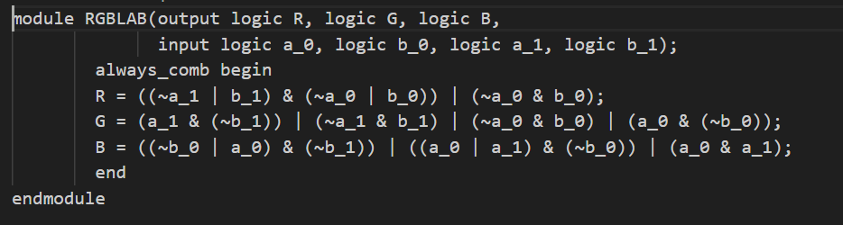

Combinational delays:

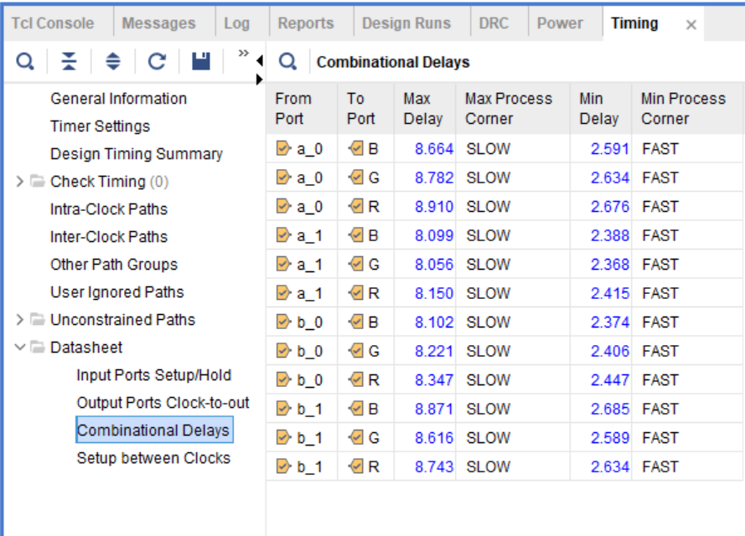

Propagational delay is 8.910ns from a_0 to R and Conteminational delay is 2.685ns from b_1 to B.

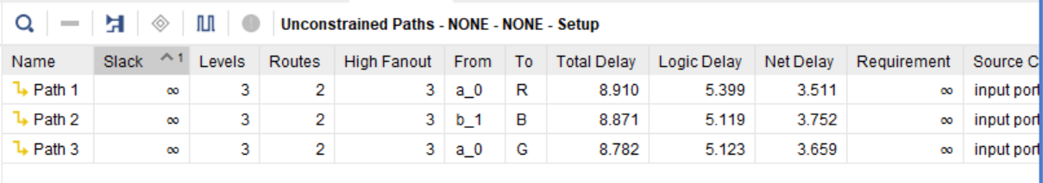

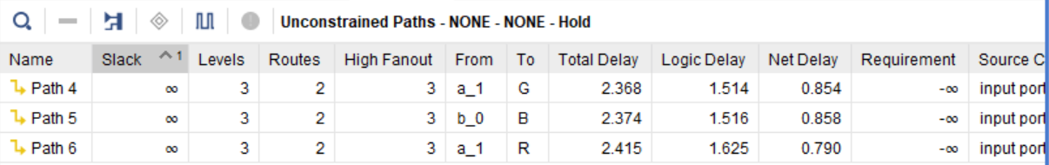

Power consumption:

Here is some power consumption summary:

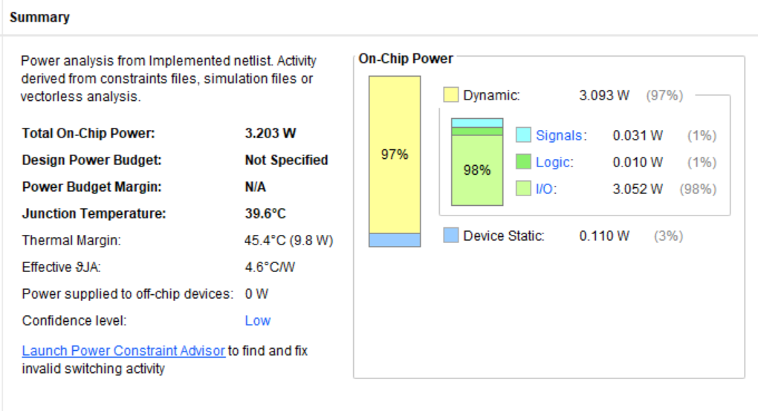

Resource utilization:

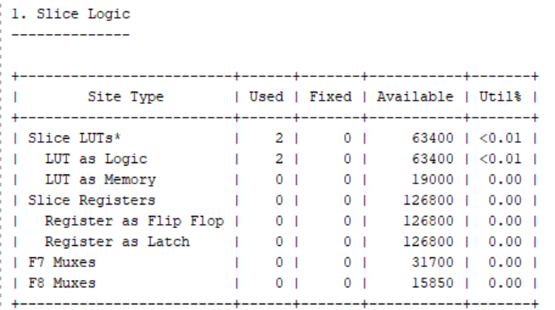

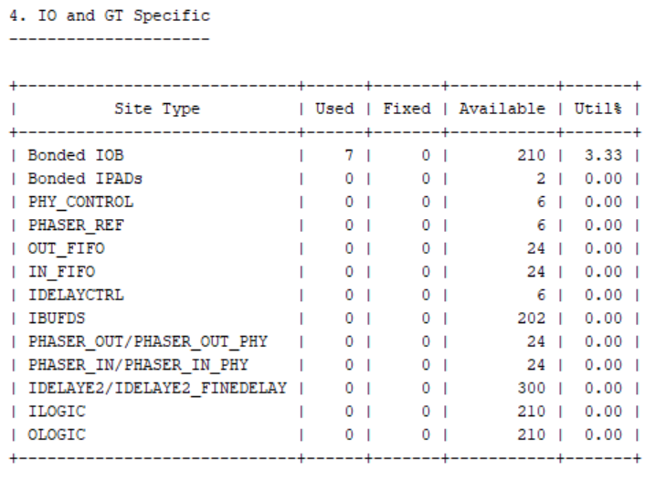

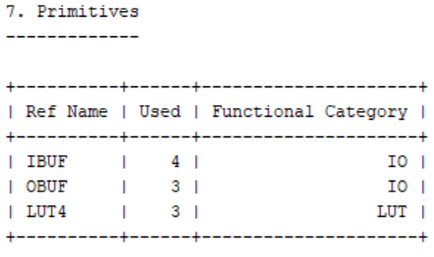

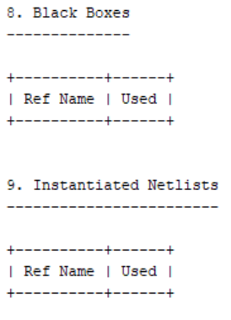

Here, two LUT slice logics, 7 Bonded IOB, 4 IBUF, 3 OBUF, 3 LUT4… have been used.

Circuit Diagram:

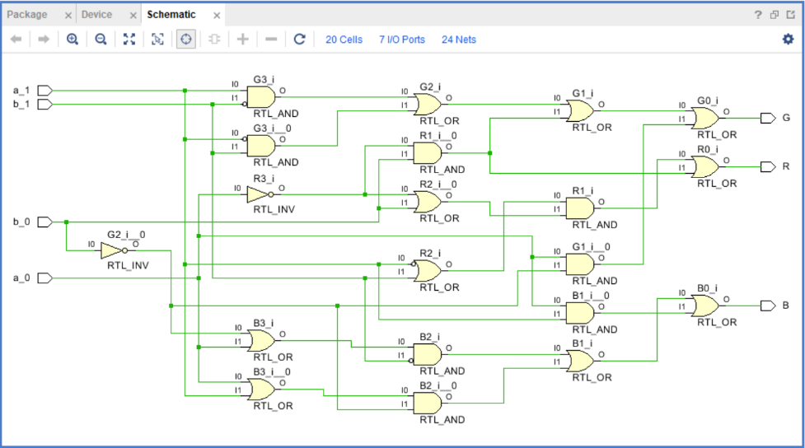

So, this is the circuit diagram.

Simulation Results:

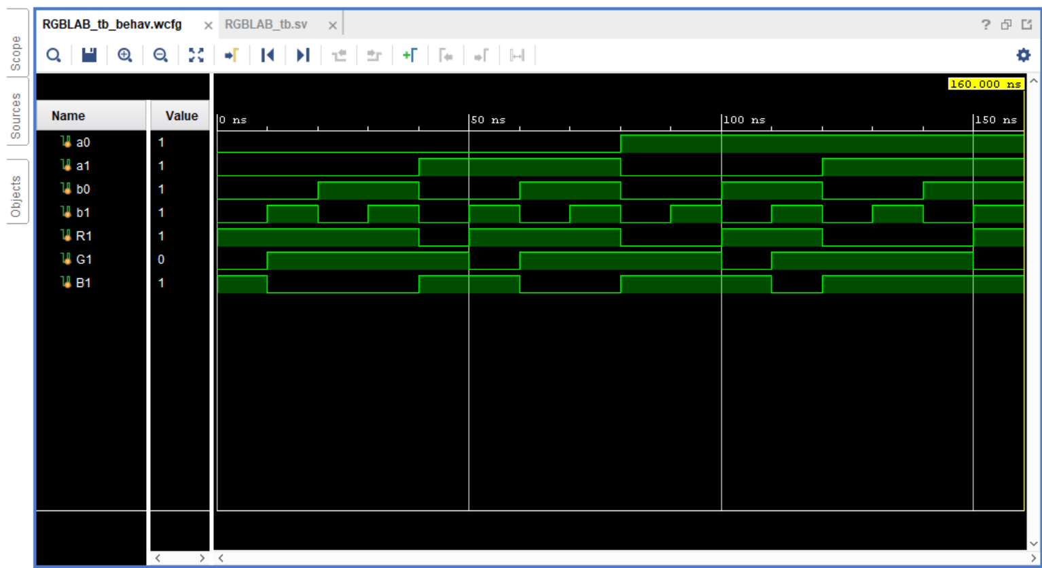

Here is our simulation result.