1. Project Title : Credit Card Approval Predictor (AI-Powered System)
2. Abstract :
The Credit Card Approval Predictor is an AI-powered machine learning web application designed to automate the credit card approval decision process. The system predicts whether a credit card application should be Approved or Rejected based on 21 financial and demographic attributes provided by the applicant.
The application is developed using Python 3.11 and Flask with an integrated machine learning pipeline that includes data generation, data preprocessing, feature engineering, model training, evaluation, and prediction. Multiple machine learning algorithms such as Logistic Regression, Decision Tree, Random Forest, Support Vector Machine, K-Nearest Neighbors, and Gradient Boosting are trained and compared. The best-performing model is automatically selected and saved for real-time predictions.
The system provides additional features such as Explainable AI-based prediction analysis, PDF audit report generation, bulk CSV prediction, user authentication, admin analytics dashboard, and database management. The application uses SQLite for storing user details, prediction history, system logs, and configuration data.
This project aims to improve the efficiency, accuracy, and transparency of credit risk assessment while reducing manual errors in the approval process.
3. Problem Statement :
Traditional credit card approval processes rely heavily on manual verification and rule-based systems, which can be time-consuming, inconsistent, and prone to human errors. Financial institutions need an automated system that can analyze applicant information quickly and provide accurate approval predictions.
The objective of this project is to develop a machine learning-based credit card approval prediction system that:
- Automates the credit approval decision process.
- Improves prediction accuracy using machine learning algorithms.
- Reduces manual effort and processing time.
- Provides transparent explanations for prediction results.
- Maintains applicant records and generates audit reports.
- Supports processing of multiple applications through bulk CSV uploads.
4. Features :
The Credit Card Approval Predictor provides the following features:
AI-Based Credit Approval Prediction
- Predicts whether an application should be Approved or Rejected.
- Uses trained machine learning models for decision support.
Machine Learning Model Comparison
- Trains and evaluates multiple algorithms:
  - Logistic Regression
  - Decision Tree
  - Random Forest
  - Support Vector Machine
  - K-Nearest Neighbors
  - Gradient Boosting
Explainable AI
- Provides reasons behind predictions.
- Displays positive and negative feature contributions.
- Gives suggestions for improving approval chances.
User Authentication
- Secure user registration and login.
- Session management.
- User activity tracking.
Admin Dashboard
- User management.
- Prediction statistics.
- Analytics visualization.
- System log monitoring.
Bulk Prediction
- Upload CSV files containing multiple applications.
- Generate predictions for multiple users simultaneously.
Report Generation
- Generates downloadable PDF and Excel reports.
- Reports include:
  - Applicant details
  - Prediction result
  - Confidence score
  - Feature explanations
  - Date and time
Database Management
- Stores:
  - User accounts
  - Login history
  - Prediction records
  - Audit logs
  - Configuration settings
User Interface
- Modern dark-mode glassmorphism design.
- Responsive interface for desktop and mobile devices.
Deployment Support
- Docker-based deployment.
- Automated testing support.
5. Tech Stack :
Programming Language
- Python 3.11
Backend Framework
- Flask 3.0
Frontend Technologies
- HTML5
- CSS3
- JavaScript
- Bootstrap 5
- Chart.js
Machine Learning Libraries
- Scikit-learn
- Pandas
- NumPy
- Imbalanced-learn (SMOTE)
- Joblib
Database
- SQLite
- SQLAlchemy ORM
Machine Learning Techniques
- Data Cleaning
- Feature Engineering
- Label Encoding
- Standard Scaling
- SMOTE Class Balancing
- Hyperparameter Tuning using GridSearchCV
- Model Evaluation
Deployment Tools
- Docker
Testing
- Automated Unit Testing Framework
6. Installation Steps :
Step 1: Clone the Project Repository
Download or clone the project files into your local system.
Step 2: Install Python
Install Python version 3.11 or above.
Step 3: Create Virtual Environment
Create and activate a virtual environment:
python -m venv venv
Activate the environment:
Windows:
venv\Scripts\activate
Linux/Mac:
source venv/bin/activate
Step 4: Install Required Dependencies
Install all required packages:
pip install -r requirements.txt
Step 5: Configure Application Settings
Update configuration details in:
config.py
Configure:
- Database path
- Secret key
- Upload folder
- Model location
Step 6: Train Machine Learning Model
Run the training pipeline:
python training/trainer.py
The best-performing model will be saved for prediction.
Step 7: Start the Flask Application
Run:
python app.py
The application will start on the local server.
7. Usage Instructions :
- Open the application in a web browser.
- Register a new user account.
- Login using user credentials.
- Enter applicant financial and demographic details.
- Submit the application information.
- The system processes the input data.
- The trained machine learning model predicts:
  - Approved
  - Rejected
- View:
  - Prediction result
  - Confidence score
  - Feature contribution explanation
- Download PDF/Excel reports if required.
- Admin users can access:
- Analytics dashboard
- User records
- Prediction history
- System logs
8. Screenshots :
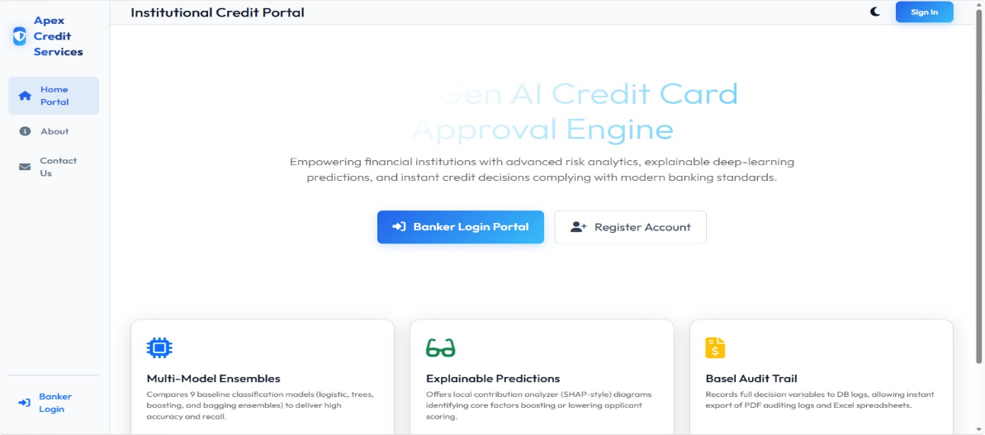

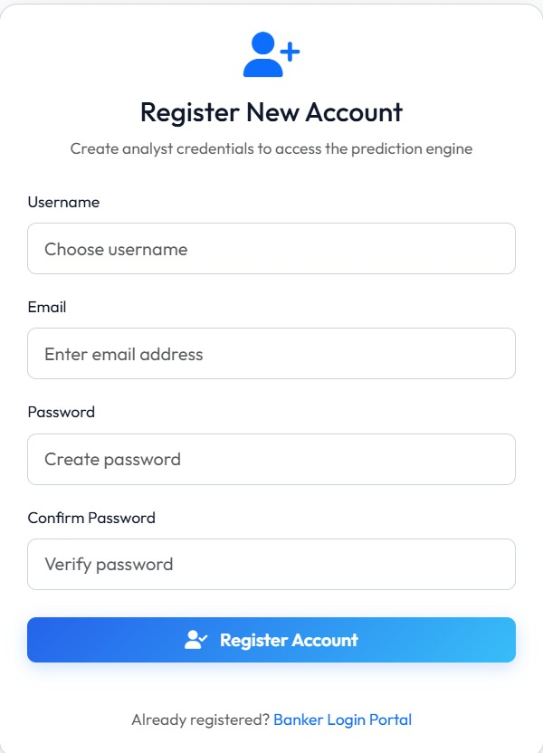

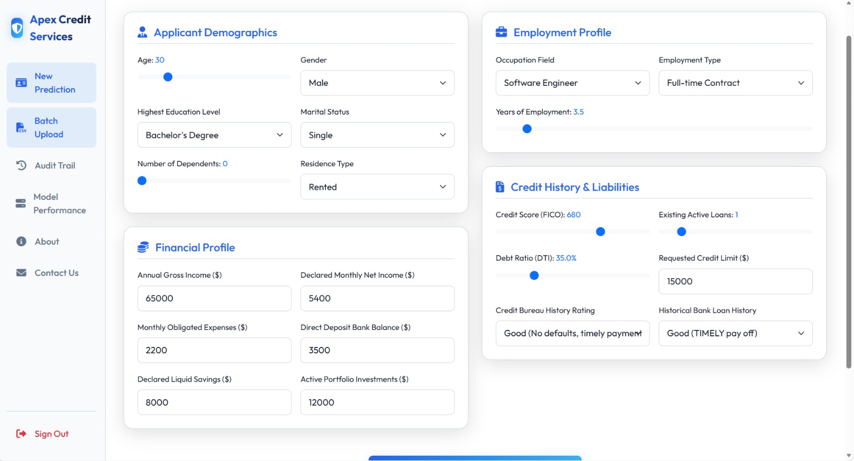

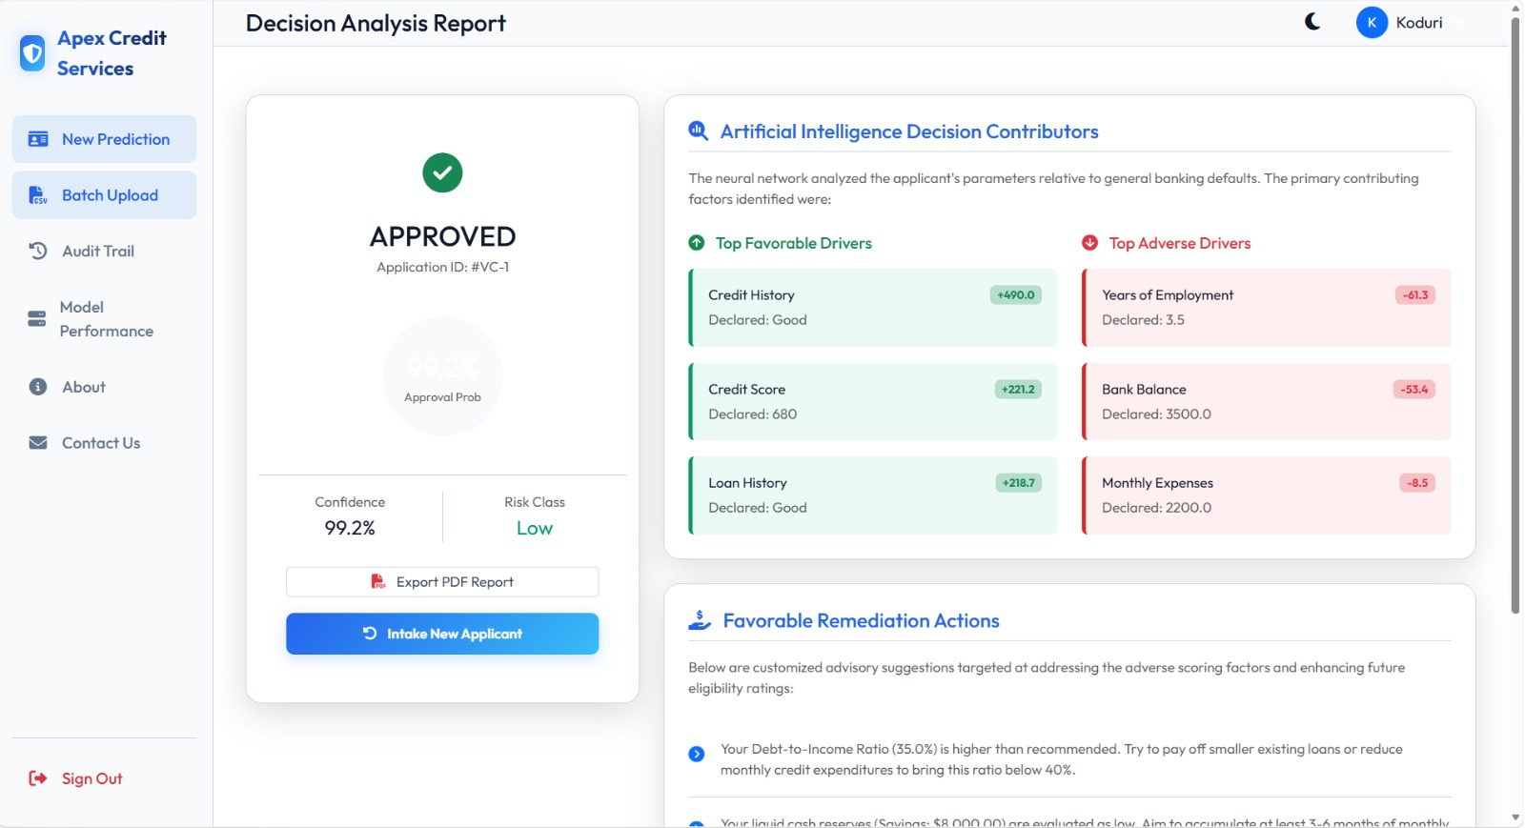
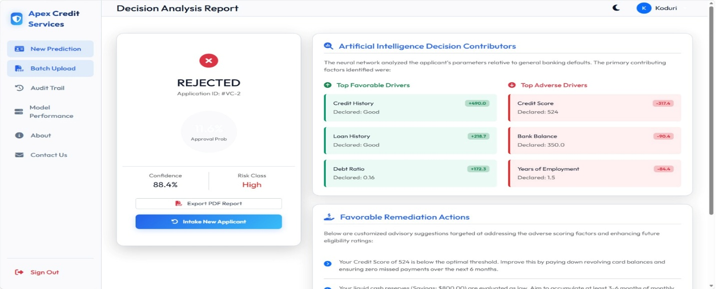
9. Future Scope :
The project can be enhanced with the following improvements:
- Integration with real banking datasets.
- Deployment on cloud platforms such as AWS, Azure, or Google Cloud.
- Implementation of deep learning models for improved prediction accuracy.
- Real-time integration with banking systems.
- Advanced fraud detection capabilities.
- Mobile application development.
- Improved AI explanations using advanced explainability methods.
- Multi-language support.
- Real-time credit score monitoring.
- Integration with external financial APIs.
10. Team Member Details :
Team Leader : Koduri Venkata Narasimha Reddy
Team Members : Archana Choppa
Abdul Nadeem Tousif
Midathana Muktananda
Dadi Yasaswi

