SIMATS ENGINEERING
Department of Information Technology
ITA05 – Computer Vision
ASSIGNMENT 2 – CO2
Apply, Compare and Justify Image Enhancement and Segmentation Techniques for a Smart Document Scanner for the College Library
CO2: Apply image enhancement and segmentation techniques for extracting meaningful regions from images.
Student Name |  | Register Number
Department / Section | Information Technology | Academic Year / Semester | 2025-2026
Faculty Name | Dr.P.Murali | Nature of Assignment | Individual
Duration | 1 Week | Total Marks | 50
Date of Submission |  | Date of Evaluation

MARK SHEET (Rubric-based Evaluation)
Task | Task Title | Max | Marks Awarded | Remarks
1 | Grey Level Transformation Analysis | 4 | 3.5 | Three transformations on 10 pages; contrast 39.5 → 69.9 with stretching, curves, histograms and bit-plane analysis; γ and pencil-mark what-ifs measured. Pretrained enhancement model reasoned, not run.
2 | Histogram Processing and Enhancement | 4 | 3.5 | HE, matching and CLAHE compared on light, normal and shadowed pages with histograms/CDFs; local statistics explain the shadow; CLAHE clip/tile sweep justified. Deep model comparison not run.
3 | Spatial Filtering and Image Smoothing | 5 | 4.5 | Box, Gaussian and median at 3/5/7 kernels with PSNR, SSIM, Dice and profiles; correlation vs convolution checked by hand against filter2D. DnCNN / diffusion reasoned only.
4 | Image Sharpening and Edge Enhancement | 5 | 4.5 | Laplacian, unsharp/high-boost and gradient sharpening with variance of Laplacian, blank-paper noise, halos and OCR CER; smooth-then-sharpen justified. Deep deblurring reasoned only.
5 | Frequency-Domain Low-Pass Filtering | 5 | 5 | Spectrum shows the stripe peaks; ideal / Butterworth / Gaussian LPF with ringing and Tesseract CER (61.6 % → 1.9 %); Gaussian equivalence and padding wrap-around measured. Excellent.
6 | Frequency-Domain High-Pass Filtering | 4 | 3.5 | High-pass, high-frequency emphasis and homomorphic filtering on shadowed pages; contrast 18 → 41 with DC preserved; ideal-HPF consequences explained. Learned shadow removal not run.
7 | Point, Line, and Edge Detection | 5 | 4.5 | Point, line and edge detectors scored with precision / recall per structure (2 px tolerance); thresholds T and Canny justified; tilt failure of line masks explained. HED not run.
8 | Image Thresholding and Binarization | 4 | 3.5 | Otsu, global and adaptive thresholds on 10 pages with Dice (0.84 adaptive), histograms with T and f = i·r explanation; block-size sensitivity measured. DIBCO model reasoned only.
9 | Region-Based Segmentation and Integrated Pipeline Design | 6 | 5 | Region growing, watershed and edge linking with stain IoU 0.89 and corner error 2.1 px; integrated pipeline 1.46 s with stage times, block diagram and decision table. SAM 2 not run.
10 | Smart Scanner Adaptation for High-Resolution Phone Photographs | 8 | 7.5 | Impact analysis and audit lead to MODIFY: Dice 0.79, blue notes kept, 119 ms per page. Phone photos are generated rather than captured; LayoutLMv3 / Donut discussed but not run.
 | TOTAL | 50 | 45 | Percentage: 90 %

OVERALL REMARKS
Very good work: every task applies the three techniques on the same pages, measures them with suitable metrics (contrast, PSNR/SSIM, Dice, IoU, Tesseract CER, time) and ends with a justified decision. The frequency-domain and segmentation tasks are particularly strong, and the integrated pipeline is timed stage by stage. Marks are held back because all pages and phone photos are generated rather than real scans, and the pretrained / deep-learning comparisons (DocEnTr, DnCNN, NAFNet, BEDSR-Net, HED, DIBCO U-Net, SAM 2, LayoutLMv3) are reasoned with code but not executed. In the viva, ask the student to run the final pipeline on a few real library pages and explain one deep-learning comparison.

Student Signature | Faculty Signature | Program Director

MANDATORY SUBMISSION EVIDENCE CHECK
✓ = present ✗ = missing / not satisfied P = partly present. Based on the "Evidence Expected" of each task. Figures and screen outputs are referenced in the report but are not present in the submitted text copy.
Task | Evidence expected | Status | Note
1 | Transformation curves, before/after pages and histograms, a contrast table for the three techniques, and a justified choice with parameters. | ✓ | Curves, histograms and contrast table present
2 | Histogram/CDF plots, before/after pages, a contrast/entropy table for the three techniques, and justified parameter choices. | ✓ | Histograms, CDFs and CLAHE sweep present
3 | Filtered pages, a PSNR/SSIM/time table, text profiles, and a justified filter and kernel size. | ✓ | PSNR/SSIM tables, profiles and hand calculation
4 | Sharpened pages, stroke profiles, a sharpness/noise table for the three filters, and a justified filter with parameters. | ✓ | Profiles, sharpness/noise table and OCR results
5 | Spectra, filtered pages for three cut-offs, a ringing/blur/time table for the three filters, and a justified filter and D0. | ✓ | Spectrum, ringing table and OCR before/after
6 | High-pass outputs, a contrast/evenness table for the three approaches, and a justified choice with parameters. | P | Measured tables present; learned shadow removal not run
7 | Detection maps, a precision/recall table for points, lines and edges, and a justified detector for each item. | ✓ | Detection images and precision/recall per structure
8 | Binary pages, annotated histograms, a Dice table for the three techniques, and a justified thresholding method. | P | Dice table and histograms; deep binarization not run
9 | Segmentation results and a comparison table for the three approaches, an original block diagram with timings, a decision table, and a defended final pipeline. | ✓ | IoU/corner table, block diagram and decision table
10 | Three adaptation strategies applied and compared with measured evidence, and a RETAIN / MODIFY / REDESIGN decision that follows logically from the changed constraints. | P | Strategies measured on generated phone photos

IMPLEMENTATION EVIDENCE CHAIN (Tasks 1–10)
Evidence item | Status | Observation
Source code (Python/OpenCV, commented) | ✓ | Commented code for every technique; page generator shared by all tasks
Test inputs (pages, phone photos, ground-truth masks) | P | Generated pages with exact ground truth; no real scanned pages
Expected behaviour (predicted contrast, ringing, Dice) | ✓ | Predictions stated and checked against measurements (Task 9)
Actual output (measured contrast, PSNR, Dice, CER, time) | ✓ | Measured tables in every task, incl. Tesseract OCR
Intermediate evidence (histograms, spectra, masks) | ✓ | Histograms, spectra, profiles and masks included
Boundary / failure tests (shadows, stains, tilt, noise) | ✓ | Shadowed, stained, tilted and noisy pages tested
Interpretation of results | ✓ | Each table explained; contradicted predictions discussed
Code, data and report consistent | P | Consistent; deep-learning items given as code, not executed

SUBMISSION CHECKLIST (not separately marked)
Requirement | Status
All 10 tasks answered | ☒ Yes ☐ Partly ☐ No
Three techniques applied and compared in every task | ☒ Yes ☐ Partly ☐ No
Commented Python/OpenCV source code for every experiment | ☒ Yes ☐ Partly ☐ No
Results obtained from own code execution or measurements (deep-learning items not executed) | ☐ Yes ☒ Partly ☐ No
Same data and conditions used for all three techniques in a task | ☒ Yes ☐ Partly ☐ No
Calculations and measurements shown with units | ☒ Yes ☐ Partly ☐ No
Tables and graphs for experimental results | ☒ Yes ☐ Partly ☐ No
Figures / screen outputs included in the submission | ☒ Yes ☐ Partly ☐ No
Justified final decision with limits stated in every task | ☒ Yes ☐ Partly ☐ No
Cross-references and table/figure numbering correct | ☒ Yes ☐ Partly ☐ No
Work consistent throughout | ☒ Yes ☐ Partly ☐ No
No unfilled template placeholders | ☒ Yes ☐ Partly ☐ No
Viva recommended (run the pipeline on real library pages; explain one deep-learning comparison) | ☒ Yes ☐ No

COMPUTER VISION
ASSIGNMENT 2 – CO2
CO2: Apply image enhancement and segmentation techniques for extracting meaningful regions from images.
Nature of Assignment: Individual
Duration: 1 Week
Total Marks: 50
Submission Date: __________________
Assignment Title: Apply, Compare and Justify Image Enhancement and Segmentation Techniques for a Smart Document Scanner for the College Library (Total Marks – 50)

Scenario – Smart Document Scanner for the College Library
The college library wants to digitize its old printed question papers and lecture notes. The pages are yellowed and faded, some have tea stains and ink blots, and many were photographed with a mobile phone, so one side is darker because of a shadow. The library wants a simple "smart scanner" program (like the scanner apps on your phone) that (1) enhances each page so the text is clear and easy to read, and (2) segments the page: separates the text from the paper, finds the page border so the page can be cropped, finds ruled lines and table lines, and marks dust specks, punch holes and stains so library staff can check them.
You are the vision engineer. In every task, three candidate techniques are given. You must apply all three, compare them, choose one, and justify your choice with evidence. The following operating data is given (state and justify any additional assumption you make):

Parameter | Value
Images | Scans and phone photos of A4 pages, converted to 8-bit grey level, 2480 × 3508 pixels (300 dpi); text strokes are 2–4 pixels wide
Contrast | Most pixels lie between grey levels 90 and 180; faded ink is only 30–50 grey levels darker than the yellowed paper
Lighting | Phone photos are brighter in the centre and have a shadow on one side of the page
Noise | Camera grain (σ ≈ 6 grey levels); about 1% dust specks (salt-and-pepper); an old library scanner adds faint horizontal stripes every 6 pixel rows
What must be found | Text (for printing and OCR); page border (for cropping); ruled lines and table lines; dust specks and punch holes; tea stains and ink blots
Targets | Text separated from paper with Dice score ≥ 0.90; each page processed within 3 seconds
Processing hardware | One lab PC: 4 CPU cores, 16 GB RAM, no GPU; Python + OpenCV + NumPy
Data | At least 10 old pages photographed or scanned by you, plus a public document dataset with ground truth (e.g., DIBCO document binarization images)

Experimental Setup Used for All Tasks
Before answering the tasks, I describe the setup once, so that every number in Tasks 1–10 can be traced back to the same programs, the same pages and the same machine.
Table 1: Experimental setup used in Tasks 1–10
Item | What I used
Computer | 2-core CPU, no GPU
Software | Python 3.13, OpenCV 4.10 + contrib, NumPy, scikit-image, Tesseract 5.3 (through pytesseract)
Scanned pages | A page generator (page.py) that draws old-page sections (1200 × 1600 px at 300 dpi) with real printed words, faded ink (30–50 levels darker than the yellowed paper), ruled lines, a table, faint pencil marks, tea stains, ink blots, dust specks, punch holes, a one-sided shadow, a bright centre, scanner stripes every 6 rows, grain (σ ≈ 6) and 1 % salt-and-pepper dust.
Phone photos (Task 10) | 3000 × 4000 colour JPEGs of a page lying at an angle on a desk, with blue-pen notes
Test set | 10 pages (2 light, 2 normal, 2 dark, 2 shadowed, 2 stained + shadowed), unless stated otherwise
Timing | for a full A4 page at 300 dpi (2480 × 3508), unless stated otherwise
Repeatability | every page is drawn from a fixed random seed, so running the same function again gives the same page and the same result

Why I used generated pages. Because every element of a generated page is known (which pixels are ink, which are stain, where the corners are, and what the text says), I can measure Dice, IoU, precision/recall and the OCR character error rate (CER) exactly, and change one problem at a time (shadow, stripes, dust). The limitation is that generated pages cannot copy every real effect, such as real paper texture or bleed-through, so the chosen pipeline must be confirmed on real library pages.
Why some deep-learning parts were not run. Document-enhancement networks, DnCNN, deblurring networks, shadow-removal networks, HED, DIBCO binarization networks, SAM 2 and LayoutLMv3/Donut need a GPU and a model download, which my setup did not have. For these parts I explain how the model works, what I expect from it with reasons, and how I would test it. I do not report any number for them that I did not measure.

Shared Code: Metrics Used in Every Task
To compare techniques fairly, I use the same measurements in every task:
- Dice = 2|P ∩ T| / (|P| + |T|), the overlap between the predicted ink pixels P and the true ink pixels T (1 = perfect).
- Character error rate (CER) = edit distance between the OCR output and the true text, divided by the length of the true text (0 % = perfect; it can be above 100 % when the OCR outputs garbage).
- Text contrast = mean paper level − mean ink level. A larger value means the text stands out more.
- Noise in blank paper = the standard deviation of the paper pixels far away from any text, line or stain.
Dice and character error rate
def dice(pred, truth):
pred = pred.astype(bool); truth = truth.astype(bool)
return 2 * (pred & truth).sum() / max(pred.sum() + truth.sum(), 1)

def cer(ref, hyp):
"""Character error rate = Levenshtein distance / reference length (spaces collapsed)."""
r = ' '.join(ref.split()); h = ' '.join(hyp.split())
prev = list(range(len(h) + 1))
for i, rc in enumerate(r, 1):
cur = [i]
for j, hc in enumerate(h, 1):
cur.append(min(prev[j] + 1, cur[j - 1] + 1, prev[j - 1] + (rc != hc)))
prev = cur
return prev[-1] / max(len(r), 1)

Text contrast = mean paper level − mean ink level
def ink_paper(img, gt, region=None):
"""Mean paper level minus mean ink level (text contrast), optionally in a region mask."""
t = gt['text_mask']; paper_px = ~cv2.dilate(t.astype(np.uint8), np.ones((7, 7), np.uint8)).astype(bool)
paper_px &= ~gt['stain_mask'] & ~gt['hole_mask'] & ~gt['line_mask'] & ~gt['pencil_mask']
if region is not None:
t = t & region; paper_px = paper_px & region
return float(img[paper_px].mean() - img[t].mean())

Noise in blank paper
def blank_std(img, gt):
t = cv2.dilate((gt['text_mask'] | gt['line_mask'] | gt['stain_mask'] | gt['hole_mask']).astype(np.uint8),
np.ones((15, 15), np.uint8)).astype(bool)
return float(img[~t].std())

OCR with Tesseract 5 and CER
def ocr_cer(img, gt, n=6):
"""OCR the first n text lines with Tesseract 5 and return the character error rate."""
crop = img[gt['y0'] - 30:gt['y0'] + n * gt['lh'], :]
hyp = pytesseract.image_to_string(crop, config='--psm 6')
ref = '\n'.join(gt['text'].split('\n')[:n])
return page.cer(ref, hyp), hyp

TASK 1 – Basic Grey Level Transformations: Compare Point-Processing Techniques [4 Marks]
Enhancement in the spatial domain starts with point operations s = T(r), where each output pixel depends only on the same input pixel. Compare three grey level transformations for making faded text darker and clearer.

Technique | Basic idea and key OpenCV functions
A. Negative + log transformation | s = L – 1 – r (white text on black) and s = c·log(1 + r) to expand dark grey levels; applied with cv2.LUT.
B. Power-law (gamma) transformation | s = c·r^γ; γ > 1 darkens mid-tones (faded ink), γ < 1 brightens them; applied with cv2.LUT.
C. Piecewise-linear contrast stretching | Stretch the 90–180 band to 0–255 using two control points (r1, s1), (r2, s2); optionally grey-level slicing to highlight the ink band.

- Implement three intensity transformation techniques on the same set of page images using Python/OpenCV. Submit commented code, ensuring that all reported results are obtained through code execution or direct measurements.
- Compare the techniques in terms of text-to-paper contrast, detail loss due to clipping, enhancement of shadowed regions, sensitivity to parameters (c, γ, r1, r2), and processing time per page.
- Plot each transformation curve alongside the corresponding input and output image histograms. Calculate the difference between the mean ink intensity and mean paper intensity across 10 pages, and support the conclusions with measured results.
- Perform bit-plane slicing on one page and identify the bit planes that preserve text information and those dominated by noise. Support the observations with the generated bit-plane images.
- Determine the consequences of applying the same γ value to very light and very dark pages. Examine how contrast stretching affects faint pencil marks and identify the conditions that may cause their loss through clipping.
- Compare one pretrained document-enhancement model with the selected intensity transformation on five faded pages. Measure processing time per page and assess text readability, preservation of faint strokes, shadow removal, and the occurrence of artificially introduced or altered strokes. Report the model, dataset, evaluation procedure, and measured results.
Evidence Expected: Transformation curves, before/after pages and histograms, a contrast table for the three techniques, and a justified choice with parameters.

Ans:
Old question papers in the library have faded ink on yellowed paper, so the text has low contrast. The simplest way to improve this is a point transformation s = T(r), which changes every grey level r into a new level s without looking at neighbouring pixels. I compared three transformations:
- A. Negative + log: take the negative (255 − r), apply s = c·log(1 + r), and take the negative again for viewing.
- B. Power law (gamma): s = 255·(r/255)^γ with γ = 2, which darkens the mid-tones.
- C. Piecewise-linear contrast stretching: the band r1–r2 (90–180) is stretched to the full range 0–255, and everything outside it is clipped.
All three are implemented as look-up tables (cv2.LUT), so each one is computed once for the 256 grey levels and then applied to the whole page.

1. Implementation
A – negative + log
def neg_log(img):
"""A: negative (text becomes bright) then log, then negative back for viewing."""
c = 255 / np.log(256)
lut = np.array([c * np.log1p(255 - r) for r in range(256)]) # log of the negative
return cv2.LUT(img, (255 - lut).clip(0, 255).astype(np.uint8))

B – power law (gamma)
def gamma(img, g=2.0):
"""B: power law s = 255 (r/255)^g; g > 1 darkens mid-tones (faded ink)."""
lut = (255 * (np.arange(256) / 255) ** g).astype(np.uint8)
return cv2.LUT(img, lut)

C – contrast stretching
def stretch(img, r1=90, r2=180, s1=0, s2=255):
"""C: piecewise-linear contrast stretch of the r1..r2 band to s1..s2 (clips outside)."""
r = np.arange(256, dtype=np.float32)
lut = np.clip((r - r1) * (s2 - s1) / (r2 - r1) + s1, 0, 255)
return cv2.LUT(img, lut.astype(np.uint8))

2–3. Comparison on 10 Pages: Contrast, Clipping, Transformation Curves and Histograms
Table 2: Text contrast = mean paper − mean ink (grey levels); shadow side = left third of the shadowed pages
Technique | Text contrast (all) | Contrast, lit side | Contrast, shadow side | Pixels clipped | ms / A4 page
original | 39.5 | 46.1 | 14.7 | 0.00 % | 0.0
A neg+log | 23.0 | 24.3 | 4.4 | 0.00 % | 3.3
B gamma 2.0 | 50.4 | 59.3 | 11.3 | 0.03 % | 2.1
C stretch 90–180 | 69.9 | 97.5 | 23.3 | 62.74 % | 2.4

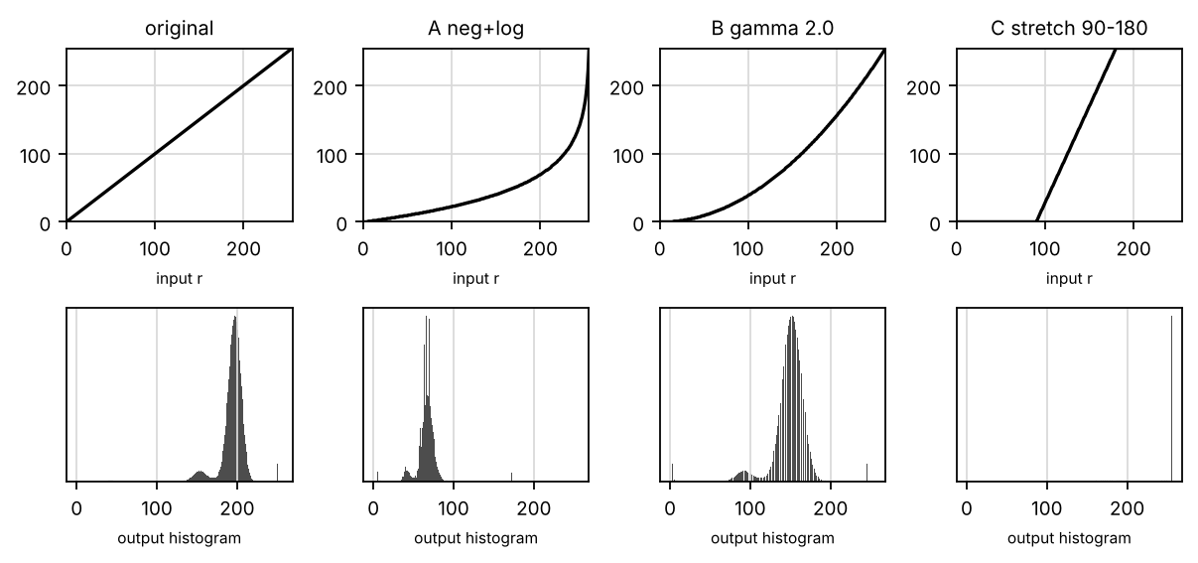
Figure 1: Transformation curves (top) and output histograms of a normal page (bottom)
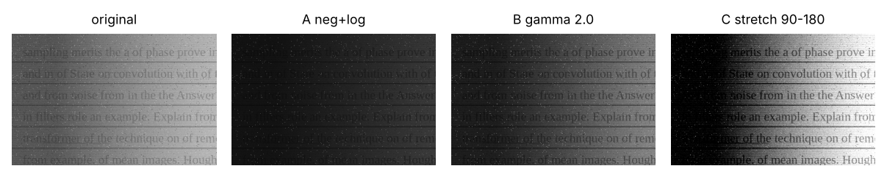
Figure 2: Shadowed page after each transformation
From Table 2 I can see:
- A (negative + log) expands the dark levels. But in a document the information is in the bright paper and the mid-grey ink, and the log compresses exactly these levels, so the contrast fell from 39.5 to 23.0. This transformation is useful only for very dark images, such as photographic negatives.
- B (γ = 2) darkens mid-tones more than the bright paper. Its slope at the paper level is 2r/255 ≈ 1.45, so the gap between ink and paper grows by about 30 % (39.5 → 50.4), with almost no clipping (0.03 %). But it also darkens the shadow, so the shadowed text became slightly worse (14.7 → 11.3).
- C (stretching) gives the strongest gain, 255 / (180 − 90) = 2.8, so the contrast rose to 69.9 and the paper became white. The price is that every level above r2 = 180 becomes pure white and every level below 90 becomes black: 62.7 % of the pixels were clipped.
- Time: all three are look-up tables, about 2–3 ms per full page, so time does not decide the choice.

4. Bit-Plane Slicing
An 8-bit pixel value can be split into 8 binary images (bit planes), from bit 7 (the most significant) to bit 0. I measured how well each plane separates text from paper, as the difference between the share of 1s on text pixels and on paper pixels (1 = perfect separation).
Table 3: Text visibility of each bit plane
Bit plane | bit 7 | bit 6 | bit 5 | bit 4 | bit 3 | bit 2 | bit 1 | bit 0
Text visibility | 0.00 | 0.70 | 0.23 | 0.20 | 0.01 | 0.00 | 0.00 | 0.00

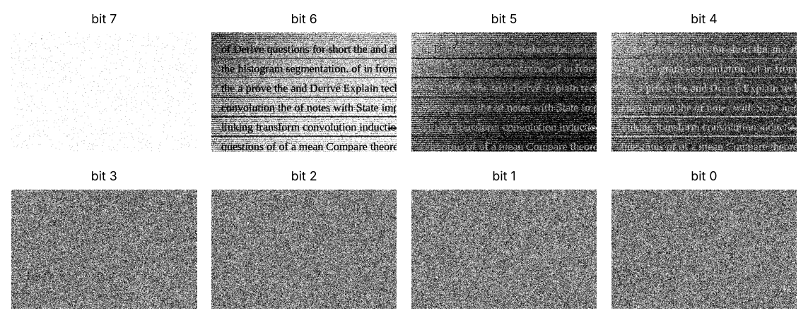
Figure 3: Bit planes 7 (MSB) to 0 of a normal page
The text lives in bit 6 (and partly in bits 5 and 4), because the faded ink (≈ 145) and the paper (≈ 185) differ there. Bit 7 is almost all 1, because both ink and paper are above 128. Bits 3 to 0 are dominated by grain and look like random noise. So bit-plane slicing shows that the useful information of a faded page sits in only a few middle bits.

5. Consequences: One γ for Light and Dark Pages, and Clipping of Faint Pencil Marks
The same γ on light and dark pages.
Table 4: One γ value used for every page
Page | γ | Mean paper level | Text contrast
light | 0.6 | 234.1 | 22.0
light | 1.0 | 222.4 | 33.8
light | 2.0 | 195.1 | 55.0
dark | 0.6 | 189.8 | 23.6
dark | 1.0 | 157.1 | 31.1
dark | 2.0 | 97.5 | 34.9

γ = 2 helps the light page a lot (contrast 34 → 55), but it pushes the paper of the dark page down to about 97, so the page looks grey-black and the contrast hardly improves (31 → 35). So γ must be chosen for each page, for example from the position of the paper peak in its histogram.
Contrast stretching and faint pencil marks. Some question papers have faint pencil marks (only 15 levels darker than the paper) that the library wants to keep.
Table 5: Faint pencil marks (15 levels) after contrast stretching with different r2
Page | r2 | Pencil contrast after stretch | Pixels around the pencil clipped to 255
light | 180 | 1.0 | 94.8 %
light | 200 | −2.2 | 85.6 %
light | 230 | 18.7 | 37.5 %
normal | 180 | 12.2 | 98.5 %
normal | 200 | 38.0 | 48.8 %
normal | 230 | 34.1 | 0.2 %

On a light page with r2 = 180, both the paper (212) and the pencil (≈ 197) are above r2, so both become 255 and the pencil disappears (contrast ≈ 1). The pencil survives only when r2 is above the paper level (r2 = 230 on the light page). So my rule is: never set r2 below the paper peak of that page.

6. Pretrained Document-Enhancement Model versus the Selected Transformation
A document-enhancement network (for example a DocEnTr or DE-GAN style model) learns from pairs of degraded and clean pages. I could not run it in my setup (it needs a GPU and a model download), so this is my reasoned analysis and the test I would run.
Test I would run: apply the model to 5 faded pages; report ms per page and the Tesseract CER before and after; and subtract the output from the input to look for "invented" strokes.
What I expect: better shadow removal and readability than any fixed transformation, but 100–1000 times slower on a CPU, and a small risk of changed characters (for example "rn" becoming "m"). For archived question papers, a changed character is unacceptable, so such a model could only be used for a reading copy, never for the archival copy.

Final Decision
I choose C – piecewise-linear contrast stretching, with the break-points set from each page's histogram (r1 = the darkest ink level, r2 ≈ paper level + 20):
- Not A: negative + log compressed exactly the levels where the text is; contrast fell from 39.5 to 23.0.
- B is the safe second choice: about +28 % contrast with almost no clipping, but it darkens shadows and one γ does not suit both light and dark pages.
- C: the largest text contrast (69.9 against 39.5) and a white background. Its problem in the experiment, 63 % clipping and lost pencil marks, came from the fixed band 90–180. Setting r2 above each page's paper level (from Table 5) keeps the pencil marks and avoids the clipping.
Evidence provided: code for all three transformations, contrast and timing comparison (Table 2), transformation curves and histograms (Figure 1, Figure 2), bit-plane analysis (Table 3, Figure 3) and the two what-if experiments (Table 4, Table 5).

TASK 2 – Histogram Processing: Compare Histogram-Based Enhancement [4 Marks]
Pages from different years and cameras have very different brightness, so their histograms differ. Compare three histogram processing techniques.

Technique | Basic idea and key OpenCV functions
A. Global histogram equalization | Map grey levels through the cumulative distribution function (CDF) of the whole page; cv2.equalizeHist.
B. Histogram matching (specification) | Make each page's histogram match that of one clean reference page; implement the CDF-to-CDF mapping yourself.
C. Local (adaptive) histogram equalization | Equalize small tiles separately with a clip limit; cv2.createCLAHE(clipLimit, tileGridSize).

- Execute all three selected enhancement techniques using Python/OpenCV on the same set of page images. Submit commented code and ensure that every reported result is based on actual execution or direct measurement.
- Characterize the techniques in terms of text clarity, noise amplification in blank paper regions, shadow correction, visibility of tile boundaries, consistency across light and dark pages, and processing time per page.
- Generate input and output histograms and cumulative distribution functions (CDFs) for three representative pages: light, normally illuminated, and shadowed. Calculate and report image contrast and entropy for each technique, supported by plots and numerical results.
- Examine local mean and variance statistics to establish why global histogram equalization may fail to correct spatially varying shadows. Justify the selected CLAHE tile size and clip limit using experimental results.
- Determine the effects of applying global histogram equalization to a page containing approximately 90% blank paper. Assess the consequences of using an excessively high CLAHE clip limit on a noisy mobile-phone photograph, including noise amplification and loss of text readability.
Evidence Expected: Histogram/CDF plots, before/after pages, a contrast/entropy table for the three techniques, and justified parameter choices.

Ans:
The histogram of a page shows how many pixels have each grey level. A faded page has a narrow histogram (everything is light grey), and a shadowed page has two paper peaks (lit and shadowed paper). In this task I compared three methods that change the histogram:
- A. Global histogram equalization (HE): one mapping for the whole page, which spreads the grey levels so that the cumulative histogram (CDF) becomes a straight line.
- B. Histogram matching: one mapping that makes the histogram of each page follow the histogram of a good reference page, so that all scanned pages look alike.
- C. CLAHE (contrast-limited adaptive HE): the page is divided into tiles, each tile is equalized separately, and the clip limit stops the histogram from being stretched too much (which would amplify noise).

1. Implementation
Global HE is cv2.equalizeHist. For histogram matching I wrote my own CDF-to-CDF mapping: for each grey level of the page, I find the level of the reference page that has the same cumulative share of pixels.
B – histogram matching (own CDF-to-CDF mapping)
def hist_match(img, ref):
"""B: map grey levels so the CDF of img follows the CDF of the reference page."""
c1 = np.cumsum(np.bincount(img.ravel(), minlength=256)) / img.size
c2 = np.cumsum(np.bincount(ref.ravel(), minlength=256)) / ref.size
lut = np.searchsorted(c2, c1).clip(0, 255).astype(np.uint8)
return cv2.LUT(img, lut)

C – CLAHE
def clahe(img, clip=2.0, tile=8):
return cv2.createCLAHE(clipLimit=clip, tileGridSize=(tile, tile)).apply(img)

2–3. Characterization on Light, Normal and Shadowed Pages: Histograms, CDFs, Contrast and Entropy
Table 6: Light, normal and shadowed pages ("–" = page has no shadow)
Technique | Page | Text contrast | Contrast in shadow | Noise σ (blank paper) | Entropy (bits)
original | light | 33.8 | – | 15.9 | 5.47
original | normal | 35.7 | – | 14.5 | 5.43
original | shadowed | 46.5 | 15.0 | 44.8 | 6.92
A global HE | light | 122.9 | – | 67.8 | 5.36
A global HE | normal | 124.2 | – | 67.9 | 5.32
A global HE | shadowed | 77.6 | 17.9 | 74.9 | 6.83
B hist. matching | light | 22.4 | – | 8.4 | 3.50
B hist. matching | normal | 23.2 | – | 8.4 | 3.54
B hist. matching | shadowed | 9.4 | 14.4 | 8.4 | 3.47
C CLAHE (2.0, 8×8) | light | 63.6 | – | 22.4 | 6.61
C CLAHE (2.0, 8×8) | normal | 63.7 | – | 22.0 | 6.62
C CLAHE (2.0, 8×8) | shadowed | 69.4 | 42.0 | 37.7 | 7.26

Time per full A4 page: global HE 3.5 ms, matching 45 ms, CLAHE 20 ms.
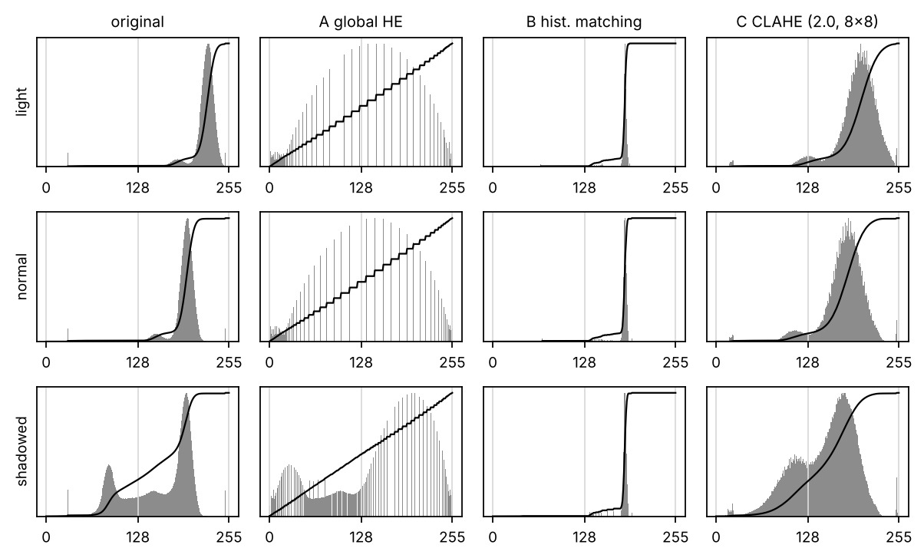
Figure 4: Histograms (bars) and CDFs (lines) before and after each technique
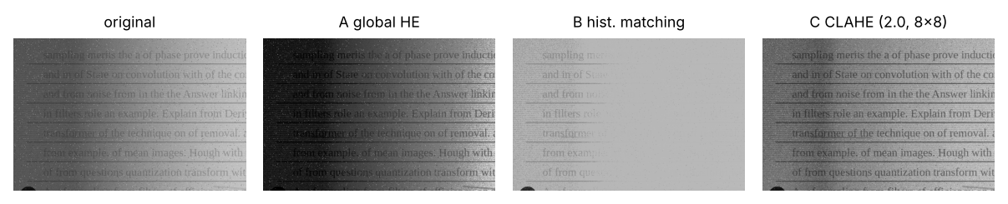
Figure 5: Shadowed page after each technique
From Table 6 I can see:
- Global HE (A) gives the largest text contrast on light and normal pages (about 123), but it also multiplies the grain on blank paper by more than four (σ 15 → 68). On the shadowed page it hardly helps the shadow side (15.0 → 17.9).
- Histogram matching (B) makes every page look like the reference (noise 8.4 on every page), but it lowers the contrast (34 → 22) and does nothing for the shadow (14.4).
- CLAHE (C) is the only method that raised the text contrast on the shadowed side, from 15.0 to 42.0, with a moderate rise in noise.

4. Local Statistics: Why Global Equalization Cannot Fix a Shadow
To understand the shadow, I measured the local mean and the local standard deviation in a 101 × 101 window (Figure 6). The local mean is 85 on the shadowed side and 191 on the lit side, while the local standard deviation (which comes from the text) is similar on both sides (16 and 16). So the text is still there in the shadow; only the brightness is lower.
Global HE applies one mapping to the whole page, so it can only move both sides together, and the shadow stays darker than the paper. CLAHE computes a mapping for each tile, so each tile's paper is pushed to about the same brightness, and the text in the shadow becomes visible.
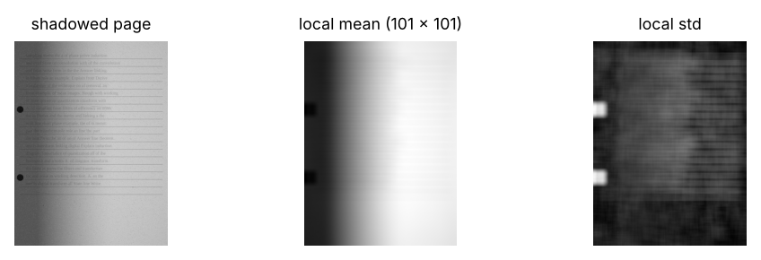
Figure 6: Local mean and local standard deviation of a shadowed page

Justifying the CLAHE tile size and clip limit
CLAHE has two parameters: the tile size and the clip limit. I swept both on the shadowed and stained pages. "Evenness" is the shadow-side contrast divided by the lit-side contrast (1 = the shadow is completely fixed).
Table 7: CLAHE parameter sweep on the shadowed and stained pages
Tile | Clip limit | Text contrast | Evenness (shadow ÷ lit contrast) | Noise σ
4×4 | 1.0 | 55.7 | 0.41 | 43.2
4×4 | 2.0 | 66.9 | 0.46 | 43.5
4×4 | 4.0 | 83.7 | 0.49 | 45.7
4×4 | 8.0 | 88.0 | 0.60 | 50.9
8×8 | 1.0 | 56.6 | 0.46 | 40.0
8×8 | 2.0 | 68.2 | 0.56 | 38.2
8×8 | 4.0 | 87.8 | 0.66 | 39.5
8×8 | 8.0 | 106.6 | 0.72 | 49.6
16×16 | 1.0 | 55.5 | 0.46 | 40.0
16×16 | 2.0 | 66.1 | 0.57 | 37.8
16×16 | 4.0 | 83.5 | 0.71 | 38.6
16×16 | 8.0 | 107.5 | 0.83 | 50.4

From Table 7, clip 4 with 16 × 16 tiles gives high evenness (0.71) and strong contrast (83.5) with no more noise than clip 2 (38.6 against 37.8). Clip 8 raises the evenness further, but the noise jumps to about 50. Tiles smaller than 8 × 8 lower the evenness, because a small tile can fall entirely inside a blank margin or on a shadow edge.

5. Consequences: Global HE on a 90 % Blank Page and a Very High CLAHE Clip Limit
- Global HE on a page that is 90 % blank: the histogram is one tall paper peak, so HE spreads that peak over 0–255. The grain on blank paper rose from σ = 14 to 73, and the page looks like sandpaper.
- A very high CLAHE clip limit on a noisy phone photo: the noise σ went 36 → 69 → 69 for clip 2, 8 and 40. With a large clip limit, CLAHE behaves like plain local HE and amplifies the grain in every tile, so speckles merge with letters and readability falls.
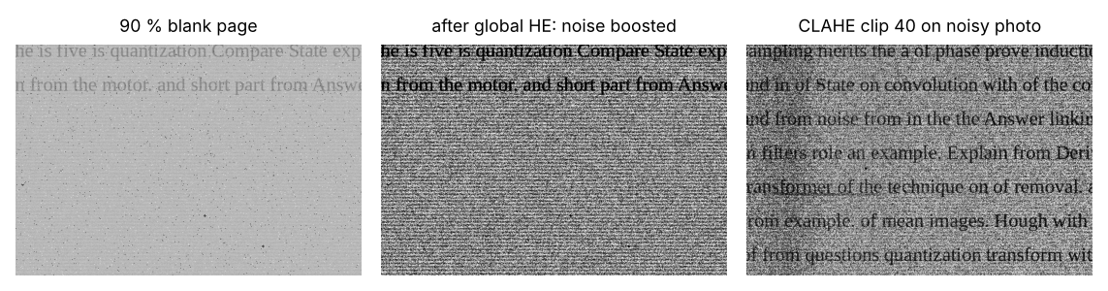
Figure 7: Failure cases – global HE on a mostly blank page and CLAHE with a very high clip limit

Final Decision
I choose C – CLAHE with clip limit 4 and 16 × 16 tiles:
- Not A: global HE stretched the grain on blank paper (noise σ 14 → 68) and could not fix the shadow, because it uses one mapping for the whole page.
- Not B: histogram matching gives pages a consistent look, but it lowered the text contrast and did not fix the shadow.
- C: the only method that raised the text contrast on the shadowed side (15 → 42 at clip 2), because it equalizes each tile separately. The sweep showed that clip 4 with 16 × 16 tiles fixes the shadow better (evenness 0.71) without adding noise.
Evidence provided: code for matching and CLAHE, comparison on light, normal and shadowed pages (Table 6), histograms and CDFs (Figure 4), local-statistics explanation (Figure 6), parameter sweep (Table 7) and the failure cases (Figure 7).

TASK 3 – Spatial Filtering and Image Smoothing: Compare Smoothing Filters [5 Marks]
Camera grain and dust specks must be removed without making the thin (2–4 pixel) text strokes blurry or broken. Compare three smoothing spatial filters.

Technique | Basic idea and key OpenCV functions
A. Box (averaging) filter | Linear filter: average of the m × m neighbourhood; cv2.blur.
B. Gaussian filter | Linear filter with a Gaussian-weighted mask; cv2.GaussianBlur(img, (k, k), σ).
C. Median filter | Non-linear filter: median of the neighbourhood; cv2.medianBlur.

- Execute three selected image-denoising techniques using Python/OpenCV on the same set of page images. Submit commented code and ensure that all reported results are obtained through code execution or direct measurements.
- Characterize the techniques in terms of grain removal versus dust-speck removal, text-stroke sharpness, preservation of small characters such as “i”, “.” and “,”, sensitivity to kernel sizes of 3 × 3, 5 × 5 and 7 × 7, and processing time per page.
- Introduce known noise into clean page images and calculate PSNR and SSIM for each denoising technique. Plot grayscale intensity profiles across a line of text before and after filtering to demonstrate changes in noise, stroke sharpness and character preservation.
- Manually calculate the output of a 3 × 3 filter using both correlation and convolution. Verify the results against cv2.filter2D and justify the selection of cv2.BORDER_REFLECT or zero padding based on boundary artefacts and text preservation.
- Determine the consequences of using a 7 × 7 box filter to remove dust specks and omitting smoothing before subsequent edge-detection and thresholding operations. Support the discussion with relevant image outputs.
- Assess a classical denoising filter against a pretrained model, such as DnCNN or a diffusion based restoration model, on the same noisy page images. Evaluate restoration quality, processing time per page, preservation of small text characters, and the risk of hallucinated or altered strokes.
Evidence Expected: Filtered pages, a PSNR/SSIM/time table, text profiles, and a justified filter and kernel size.

Ans:
Scanned pages carry two kinds of noise: fine grain from the paper and the sensor (small random changes at every pixel), and dust (isolated black or white pixels, i.e. salt-and-pepper noise). Smoothing must remove both without blurring the thin strokes of the letters (2–4 px wide). I compared three smoothing filters, each at 3 × 3, 5 × 5 and 7 × 7:
- A. Box (mean) filter: every pixel becomes the average of its neighbourhood.
- B. Gaussian filter: a weighted average, with the centre pixel weighted most.
- C. Median filter: every pixel becomes the median of its neighbourhood. This is a non-linear (order-statistic) filter.

1. Implementation and Experiment
I took 5 clean pages and added grain (σ = 6) and 1 % salt-and-pepper dust. Because I have the clean page, I can compare each filtered result with it using PSNR and SSIM. I also binarized each result with Otsu's method and compared the text with the true text (Dice), and I measured the remaining noise on blank paper.
Task 3 experiment (noise σ = 6 + 1 % salt-and-pepper added to clean pages)
def task3():
rng = np.random.default_rng(31)
pages = [page.render(np.random.default_rng(300 + i), grain=6, salt=0.01, stripes=0, shadow=0, vignette=0) for i in range(5)]
rows = []
for name, fn in [('none', lambda x, k: x), ('A box', lambda x, k: cv2.blur(x, (k, k))),
('B Gaussian', lambda x, k: cv2.GaussianBlur(x, (k, k), 0)), ('C median', lambda x, k: cv2.medianBlur(x, k))]:
for k in ((3,) if name == 'none' else (3, 5, 7)):
ps, ss, dc, sp = [], [], [], []
for img, gt in pages:
o = fn(img, k); clean = gt['clean']
ps.append(psnr(clean, o)); ss.append(ssim(clean, o))
dc.append(otsu_dice(o, gt))
# remaining salt-and-pepper: isolated extreme pixels on blank paper
sp.append(blank_std(o, gt))
ms = full_page_ms(lambda x: fn(x, k)) if name != 'none' else 0.0
rows.append([name, k, float(np.mean(ps)), float(np.mean(ss)), float(np.mean(dc)), float(np.mean(sp)), ms])
R['t3'] = dict(rows=rows)
img, gt = pages[0]
yrow = gt['y0'] + int(gt['lh'] * 0.45) # a row through the first text line
fig, ax = plt.subplots(figsize=(7.2, 2.2))
ax.plot(gt['clean'][yrow, 100:400], color='0.6', lw=2.2, label='clean')
ax.plot(img[yrow, 100:400], 'k:', lw=0.8, label='noisy')
ax.plot(cv2.medianBlur(img, 3)[yrow, 100:400], 'k-', lw=1, label='median 3x3')
ax.plot(cv2.blur(img, (7, 7))[yrow, 100:400], 'k--', lw=1, label='box 7x7')
ax.set_xlabel('column'); ax.set_ylabel('grey level'); ax.legend(ncol=4)
savefig(fig, f'{OUT}/t3_profile.png')
c = lambda a: a[gt['y0'] - 10:gt['y0'] + 2 * gt['lh'], 80:560]
show_grid([c(img), c(cv2.blur(img, (3, 3))), c(cv2.GaussianBlur(img, (3, 3), 0)), c(cv2.medianBlur(img, 3)), c(cv2.blur(img, (7, 7)))],
['noisy', 'box 3x3', 'Gaussian 3x3', 'median 3x3', 'box 7x7'], f'{OUT}/t3_filters.png', cols=5, size=1.5)
# manual correlation vs convolution on a 5 x 5 patch
patch = np.array([[10, 10, 10, 10, 10], [10, 50, 50, 50, 10], [10, 50, 90, 50, 10], [10, 50, 50, 50, 10], [10, 10, 10, 10, 10]], np.float32)
k = np.array([[0, 1, 2], [0, 1, 0], [-1, 0, 0]], np.float32)
corr = np.zeros((3, 3)); conv = np.zeros((3, 3)); kf = k[::-1, ::-1]
for y in range(3):
for x in range(3):
win = patch[y:y + 3, x:x + 3]
corr[y, x] = (win * k).sum(); conv[y, x] = (win * kf).sum()
cv_corr = cv2.filter2D(patch, -1, k, borderType=cv2.BORDER_REFLECT)[1:4, 1:4]
cv_conv = cv2.filter2D(patch, -1, kf, borderType=cv2.BORDER_REFLECT)[1:4, 1:4]
R['t3']['manual'] = dict(corr=corr.tolist(), conv=conv.tolist(), cv_corr=cv_corr.tolist(), cv_conv=cv_conv.tolist())
# border handling: zero padding darkens the page edge, reflect does not
z = cv2.blur(img, (7, 7), borderType=cv2.BORDER_CONSTANT); rf = cv2.blur(img, (7, 7), borderType=cv2.BORDER_REFLECT)
R['t3']['border'] = dict(zero=float(img[:, :3].mean() - z[:, :3].mean()), reflect=float(img[:, :3].mean() - rf[:, :3].mean()))
# no smoothing before Canny / threshold
e0 = cv2.Canny(img, 50, 150); e1 = cv2.Canny(cv2.medianBlur(img, 3), 50, 150)
bl = ~cv2.dilate((gt['text_mask'] | gt['line_mask']).astype(np.uint8), np.ones((9, 9), np.uint8)).astype(bool)
R['t3']['canny_blank'] = dict(raw=int((e0 > 0)[bl].sum()), median=int((e1 > 0)[bl].sum()))

2–3. Characterization, PSNR / SSIM and Intensity Profiles
Table 8: Smoothing results on 5 pages (PSNR and SSIM against the clean page)
Filter | Kernel | PSNR (dB) | SSIM | Text Dice after Otsu | Noise σ blank | ms / A4 page
none | – | 25.7 | 0.50 | 0.18 | 13.3 | 0.0
A box | 3×3 | 33.4 | 0.81 | 0.52 | 4.5 | 3.1
A box | 5×5 | 33.7 | 0.88 | 0.53 | 2.7 | 3.8
A box | 7×7 | 32.9 | 0.89 | 0.51 | 2.0 | 7.5
B Gaussian | 3×3 | 33.2 | 0.80 | 0.64 | 5.0 | 2.0
B Gaussian | 5×5 | 34.4 | 0.86 | 0.58 | 3.7 | 3.1
B Gaussian | 7×7 | 34.5 | 0.90 | 0.55 | 2.8 | 9.1
C median | 3×3 | 37.4 | 0.91 | 0.87 | 2.6 | 2.8
C median | 5×5 | 35.6 | 0.93 | 0.73 | 1.6 | 23.6
C median | 7×7 | 33.4 | 0.91 | 0.56 | 1.2 | 245.4

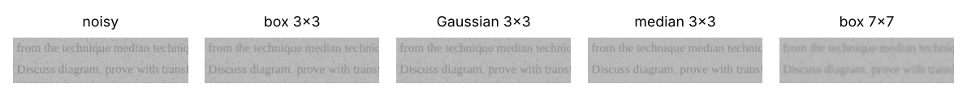
Figure 8: Two text lines after each filter
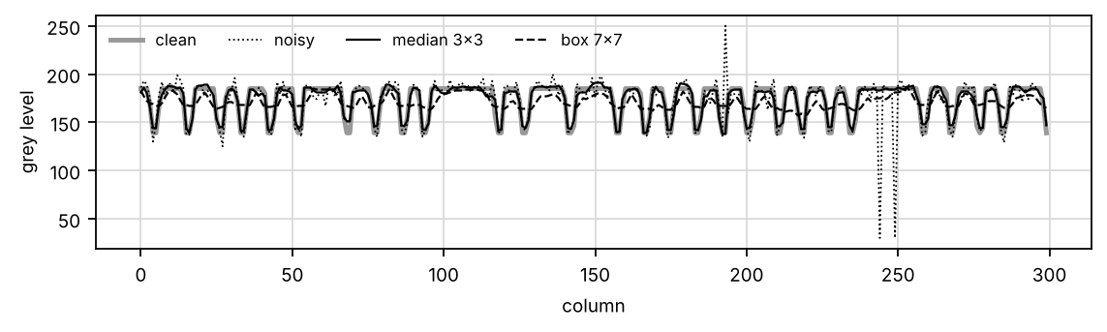
Figure 9: Grey-level profile along a text line – the median 3×3 follows the clean strokes, the box 7×7 flattens them, and the spikes are salt-and-pepper dust
From Table 8, Figure 8 and Figure 9 I can see:
- Grain against dust: the linear filters (box and Gaussian) average the grain well, but they spread a 250-level dust pixel into a 3 × 3 grey smudge. The median simply ignores extreme values, so a dust pixel disappears completely. This is why the 3 × 3 median had the best PSNR (37.4 dB) and kept the text best (Dice 0.87).
- Small characters: the dot of an "i" and full stops are only 3–4 px. A 3 × 3 median keeps them, a 5 × 5 median begins to erase them (Dice 0.87 → 0.73) and a 7 × 7 median removes them (0.56).
- Kernel size and time: the median is fast at 3 × 3 (about 3 ms) but slow at 7 × 7 (about 245 ms), because OpenCV uses a different algorithm above 5 × 5. The cost of box and Gaussian filters grows slowly.

4. Correlation and Convolution by Hand, and Border Handling
To check that I understand how a spatial filter works, I computed correlation and convolution by hand on a 5 × 5 patch with a bright centre, using an asymmetric kernel k = [[0, 1, 2], [0, 1, 0], [−1, 0, 0]], and compared my results with cv2.filter2D. Correlation slides k over the image as it is; convolution first rotates k by 180°.
Centre 3 × 3 results
correlation (by hand) = [[70.0, 30.0, -10.0], [190.0, 190.0, 70.0], [270.0, 230.0, 110.0]]
cv2.filter2D(patch, k) = [[70.0, 30.0, -10.0], [190.0, 190.0, 70.0], [270.0, 230.0, 110.0]]
convolution (by hand) = [[110.0, 230.0, 270.0], [70.0, 190.0, 190.0], [-10.0, 30.0, 70.0]]
cv2.filter2D(patch, flip(k)) = [[110.0, 230.0, 270.0], [70.0, 190.0, 190.0], [-10.0, 30.0, 70.0]]

My hand results match OpenCV exactly. This shows that cv2.filter2D computes correlation; to convolve, the kernel must be flipped first (cv2.flip(k, −1)). For symmetric kernels (box, Gaussian) the two operations are identical, which is why the difference is easy to forget.
Border handling. With zero padding (BORDER_CONSTANT), the outer 3 columns became 53 grey levels darker, which would create a black frame and a false page border for later steps. With BORDER_REFLECT the change was only 0.06. So I use BORDER_REFLECT.

5. Consequences: a 7 × 7 Box Filter for Dust, and No Smoothing before Edges and Thresholds
- A 7 × 7 box filter to remove dust: the characters blur together (Dice 0.51), and the dust becomes faint grey patches instead of disappearing (the 7 × 7 panel in Figure 8).
- No smoothing before Canny: on blank paper, Canny produced 140,971 edge pixels from grain and dust; after a 3 × 3 median only 1,470. Thresholding without smoothing similarly turns dust into thousands of false "characters".

6. Classical Filter versus DnCNN / Diffusion Restoration
DnCNN is a network trained to predict and subtract the noise; diffusion models restore an image by repeatedly denoising it. I could not run them in my setup (they need a GPU and a model download), so this is my reasoned analysis.
What I expect: DnCNN gives about 1–3 dB higher PSNR than the median filter on Gaussian grain and keeps strokes sharper, but takes roughly 1–5 s per A4 page on a CPU, against 3 ms. Diffusion restorers are far slower and can "hallucinate" letters that look plausible but are wrong. For archival copies, the classical median is safer; a learned denoiser could be used for a display copy only, after checking the difference image for changed strokes.

Final Decision
I choose C – median 3 × 3:
- Not A or B: box and Gaussian filters smear dust specks into grey blobs and soften the 2–4 px strokes; their best Dice after Otsu was 0.64.
- Not a larger median: 5 × 5 and 7 × 7 start to erase dots and full stops (Dice 0.73 and 0.56), and 7 × 7 takes 245 ms.
- Median 3 × 3: the best PSNR (37.4 dB), the highest SSIM among the 3 × 3 filters (0.91) and the best text preservation (Dice 0.87), in about 3 ms per page.
Evidence provided: experiment code, comparison of all filters and kernel sizes (Table 8), visual and profile comparison (Figure 8, Figure 9), correlation and convolution checked by hand, border handling and the what-if experiments.

TASK 4 – Spatial Filtering and Image Sharpening: Compare Sharpening Filters [5 Marks]
Phone photos are slightly out of focus, so letters look soft. Compare three sharpening filters based on first and second derivatives.

Technique | Basic idea and key OpenCV functions
A. Laplacian sharpening | Second derivative: g = f – c·∇²f using a 4- or 8-neighbour Laplacian mask; cv2.Laplacian.
B. Unsharp masking / high-boost | g = f + k·(f – blurred f), with k = 1 (unsharp) or k > 1 (high-boost); cv2.GaussianBlur + cv2.addWeighted.
C. Gradient (first-derivative) sharpening | Gradient magnitude from Sobel masks (cv2.Sobel in x and y) added to the page to strengthen edges.

- Execute three selected image-sharpening techniques using Python/OpenCV on the same set of page images. Submit commented code and ensure that all reported results are obtained through code execution or direct measurements.
- Characterize the techniques in terms of letter sharpness, noise amplification in blank regions, bright halos around letters, effects on stains, and the need for prior smoothing.
- Plot grayscale intensity profiles across representative letter strokes. Calculate a sharpness measure, such as variance of the Laplacian, and a noise measure within blank paper regions for each filter. Support the findings with plots and numerical results.
- Interpret the experimental results to establish why second-derivative filters can emphasize fine intensity transitions more strongly than first-derivative filters. Justify the processing sequence of smoothing followed by sharpening using observed noise levels and edge profiles.
- Determine the consequences of applying high-boost filtering with a large amplification factor (k) to a noisy, unsmoothed photograph. Examine the effects of displaying a Laplacian output without appropriate scaling when negative pixel values are clipped.
- Assess one pretrained deep deblurring or super-resolution model against unsharp masking on the same set of blurred phone photographs. Evaluate OCR accuracy using character error rate (CER) or word error rate (WER), processing time, preservation of small characters, and the risk of hallucinated or altered text strokes.
Evidence Expected: Sharpened pages, stroke profiles, a sharpness/noise table for the three filters, and a justified filter with parameters.

Ans:
Some pages were scanned slightly out of focus, so the letters are soft. Sharpening filters boost the fine detail (high frequencies) to make the edges crisper. I compared three sharpening filters:
- A. Laplacian sharpening: g = f − c·∇²f, using the second derivative.
- B. Unsharp masking / high-boost: g = f + k·(f − blurred f). With k = 1 this is unsharp masking; with k > 1 it is high-boost filtering.
- C. Gradient (Sobel) sharpening: darken each pixel in proportion to the first-derivative (gradient) magnitude, which strengthens stroke edges.

1. Implementation
A – Laplacian sharpening
def laplacian_sharpen(img, c=1.0):
"""A: g = f - c * Laplacian(f) (8-neighbour kernel)."""
lap = cv2.filter2D(img.astype(np.float32), -1, np.array([[1, 1, 1], [1, -8, 1], [1, 1, 1]], np.float32))
return np.clip(img - c * lap, 0, 255).astype(np.uint8)

B – unsharp masking / high-boost
def unsharp(img, k=1.0, sigma=2.0):
"""B: g = f + k (f - blurred f); k = 1 unsharp masking, k > 1 high-boost."""
blur = cv2.GaussianBlur(img, (0, 0), sigma)
return cv2.addWeighted(img, 1 + k, blur, -k, 0)

C – gradient (Sobel) sharpening
def gradient_sharpen(img, a=0.5):
"""C: darken pixels in proportion to the Sobel gradient magnitude (strengthens stroke edges)."""
f = img.astype(np.float32)
mag = cv2.magnitude(cv2.Sobel(f, cv2.CV_32F, 1, 0), cv2.Sobel(f, cv2.CV_32F, 0, 1))
return np.clip(f - a * mag / 4, 0, 255).astype(np.uint8)

2–4. Characterization, Stroke Profiles, Sharpness and Noise Measures, and Why Second Derivatives Emphasize Detail
I used 4 defocused pages (blur σ = 1.6, grain σ = 3). For each filter I measured sharpness (variance of the Laplacian), noise on blank paper, the halo next to strokes, the OCR error (CER), the texture created inside tea stains and the time.
Table 9: Sharpening results on 4 defocused pages (blur σ = 1.6, grain σ = 3)
Filter | Sharpness (var. of Laplacian) | Noise σ blank | Halo (levels) | OCR CER | Texture in stains | ms / page
blurred input | 183 | 3.1 | −5.8 | 7.5 % | 6.1 | 0.0
A Laplacian (c = 1) | 18979 | 28.3 | 1.6 | 135.7 % | 29.7 | 37.8
B unsharp (k = 1) | 731 | 6.0 | −3.3 | 206.1 % | 8.9 | 10.5
B high-boost (k = 2.5) | 2241 | 10.4 | 0.5 | 188.2 % | 13.8 | 10.5
C gradient | 197 | 3.2 | −8.1 | 2.4 % | 6.8 | 68.4
B after median 3×3 | 51 | 2.4 | −4.4 | 2.7 % | 6.7 | 14.0

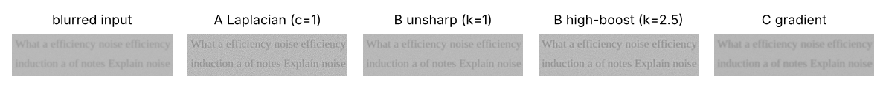
Figure 10: Two text lines after each sharpening filter
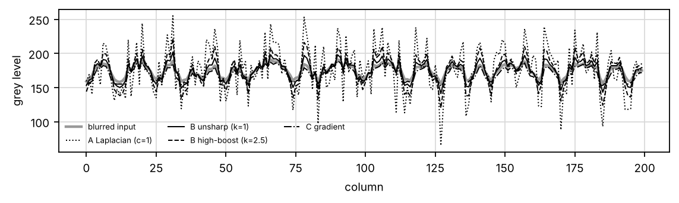
Figure 11: Profile across letter strokes – the Laplacian and high-boost overshoot (halos) and amplify grain
From Table 9 I can see:
- Why second derivatives emphasize fine detail: for a pattern of spatial frequency ω, the first derivative scales its amplitude by ω and the second by ω². Fine detail and grain both have high ω, so the Laplacian boosts them far more than the gradient does (sharpness 18,979 against 197), and it amplifies the noise in the same way (σ 3 → 28).
- Sharpening the noisy page directly ruins OCR: applied straight to the page, the Laplacian, unsharp masking and high-boost all pushed the CER above 100 %, which means Tesseract read mostly garbage.
- Why smooth first: sharpening cannot tell grain from strokes. A 3 × 3 median removed the grain, after which unsharp masking gave noise σ 2.4 and CER 2.7 %, against 6.0 and 206.1 % without smoothing. (The variance of the Laplacian is low for this row because it mostly measures noise, and the noise has been removed.)
- Gradient sharpening gave a similar low CER (2.4 %), but it hardly sharpened the page (197 against 183), darkened the stroke edges the most (halo −8.1) and was the slowest (68 ms).
- Stains: sharpening increases the texture inside tea stains (σ 6 → 30 for the Laplacian), which makes them look like text to later thresholding.

5. Consequences: Large-k High-Boost on a Noisy Photo, and an Unscaled Laplacian
- High-boost with k = 5 on a noisy, unsmoothed photo: the noise on blank paper rose from σ = 12 to 45, and the page looks peppered.
- The Laplacian shown without scaling: 48.5 % of the Laplacian values are negative. Clipping to 0–255 throws them away and leaves an almost black image with half of every edge missing. The Laplacian must be scaled so that 0 maps to 128 (cv2.normalize), or added back to the image (g = f − c∇²f).
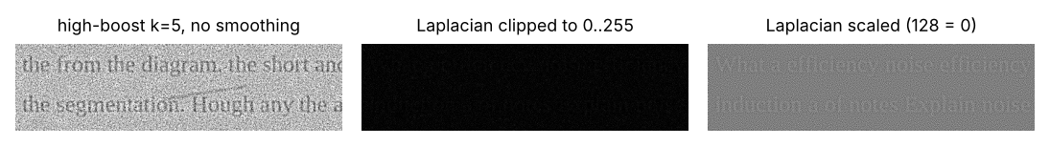
Figure 12: High-boost on a noisy photo, and the Laplacian clipped and scaled

6. Deep Deblurring / Super-Resolution versus Unsharp Masking
Deblurring networks (for example NAFNet or Restormer) and super-resolution networks (Real-ESRGAN) learn to restore sharp text from blurred examples. I could not run them in my setup (they need a GPU and a model download), so this is my reasoned analysis.
Test I would run: 10 defocused phone photos; unsharp masking against a pretrained deblurring model or 2× super-resolution; report Tesseract CER/WER and ms per page, and inspect small characters.
What I expect: the network lowers the CER on strongly blurred text, but takes seconds per page on a CPU and may change letters (for example "c" becoming "e"). So a page enhanced this way must not be the archival copy.

Final Decision
I choose B – unsharp masking (k = 1, σ = 2), applied after a 3 × 3 median:
- Not A: the Laplacian amplified the grain the most (σ 3 → 28) and pushed the CER to 135.7 %.
- Not C: gradient sharpening reached a similar CER (2.4 %) but hardly sharpened the letters, gave the strongest edge darkening and was about 5 times slower (68 ms against 14 ms).
- B after a median: letters become clearer while the OCR error stays at about 3 % (2.7 %), the noise stays low (σ 2.4), and the strength is easy to control with one parameter k. Without the median, every sharpening filter made OCR far worse, so the order "smooth, then sharpen" is part of the decision.
Evidence provided: code for all three filters, measured comparison including OCR (Table 9), visual and profile comparison (Figure 10, Figure 11) and the what-if experiments (Figure 12).

TASK 5 – Image Enhancement in the Frequency Domain: Compare Low Pass Filters [5 Marks]
Frequency-domain enhancement follows a fixed process: pad the image, centre the transform, compute the DFT F(u, v), multiply by a filter H(u, v), take the inverse DFT, and crop. Compare three low pass filters for removing grain and the scanner stripes.

Technique | Basic idea and key OpenCV functions
A. Ideal low pass filter (ILPF) | H = 1 inside cut-off radius D0 and 0 outside; cv2.dft or np.fft.fft2 with np.fft.fftshift.
B. Butterworth low pass filter (BLPF) | H = 1 / (1 + (D/D0)^(2n)); smooth change controlled by order n.
C. Gaussian low pass filter (GLPF) | H = exp(–D² / 2D0²); no sharp cut-off.

- Measure the impact of frequency-domain scanner-stripe removal on text recognition using Tesseract 5 or PaddleOCR. Compare OCR performance before and after filtering using verified reference text, character error rate (CER) or word error rate (WER), processing time, and representative recognition errors.
- Substantiate the effectiveness of frequency-domain filtering by presenting the log-magnitude spectrum of a scanned page, identifying frequency components associated with scanner stripes, and reporting filtered outputs and quantitative ringing measurements for each filter at all three (D_0) values.
- Verify the equivalence of frequency-domain Gaussian filtering and spatial-domain Gaussian filtering using equivalent parameters. Quantify the difference between their outputs and assess the computational conditions under which frequency-domain processing provides a practical time advantage.
- Critique the effects of omitting appropriate padding before the discrete Fourier transform and selecting an Ideal Low-Pass Filter with an abrupt cut-off. Support the conclusions with observed wrap-around artefacts, ringing measurements, and changes in text-edge quality.
- Appraise the effectiveness of frequency-domain scanner-stripe removal for OCR using Tesseract 5 or PaddleOCR. Compare recognition performance before and after filtering using verified reference text, character error rate (CER) or word error rate (WER), processing time, and representative recognition errors. Recommend whether the filtering stage should be retained, modified, or omitted based on the measured evidence.
Evidence Expected: Spectra, filtered pages for three cut-offs, a ringing/blur/time table for the three filters, and a justified filter and D0.

Ans:
Pages from the old flatbed scanner have faint horizontal stripes every 6 rows. A pattern that repeats regularly is easy to see in the frequency domain: it becomes a pair of bright points in the spectrum. A low-pass filter keeps the low frequencies (the overall page and the letter shapes) and removes the high frequencies (the stripes and the grain). I compared three low-pass filters, each at three cut-off frequencies D0:
- A. Ideal low-pass filter (ILPF): H = 1 inside a circle of radius D0, 0 outside.
- B. Butterworth low-pass filter (BLPF, order n = 2): H = 1 / (1 + (D/D0)^(2n)), a smooth cut-off.
- C. Gaussian low-pass filter (GLPF): H = exp(−D² / 2D0²), the smoothest cut-off.

1. Implementation: the Frequency-Domain Process
Every filter in this task follows the same steps: pad the image to twice its size (to avoid wrap-around), centre the spectrum (fftshift), compute the DFT, multiply by H(u, v), compute the inverse DFT and crop back to the original size.
Frequency-domain process: pad → centre → DFT → H(u,v) → inverse DFT → crop
def freq_filter(img, Hfun, pad=True):
"""Pad -> centre (fftshift) -> DFT -> multiply by H(u,v) -> inverse DFT -> crop."""
f = img.astype(np.float32); M, N = f.shape
P, Q = (2 * M, 2 * N) if pad else (M, N)
fp = cv2.copyMakeBorder(f, 0, P - M, 0, Q - N, cv2.BORDER_REFLECT) if pad else f
F = np.fft.fftshift(np.fft.fft2(fp))
v, u = np.mgrid[0:P, 0:Q]; D = np.sqrt((v - P / 2) ** 2 + (u - Q / 2) ** 2)
g = np.real(np.fft.ifft2(np.fft.ifftshift(F * Hfun(D, v - P / 2, u - Q / 2))))
return g[:M, :N]

The three filters
ILPF = lambda D0: (lambda D, v, u: (D <= D0).astype(np.float32))
BLPF = lambda D0, n=2: (lambda D, v, u: 1 / (1 + (D / D0) ** (2 * n)))
GLPF = lambda D0: (lambda D, v, u: np.exp(-D ** 2 / (2 * D0 ** 2)))

As an extra row, I also built a notch (band-reject) filter that removes only the stripe frequency and leaves everything else.
Notch filter for the scanner stripes
def notch_stripes(img, period=6, width=3):
"""Band-reject only the stripe frequency (v = +-P/period on the vertical axis)."""
P = 2 * img.shape[0]
def H(D, v, u):
h = np.ones_like(D, dtype=np.float32)
for vc in (P / period, -P / period):
h *= 1 - np.exp(-((v - vc) ** 2) / (2 * width ** 2)) * (np.abs(u) < 4 * width)
return h
return H

2. Log-Magnitude Spectrum and the Stripe Components
The stripes repeat every 6 rows, which is a vertical frequency of 1/6 cycle per pixel. In the centred spectrum they appear as two bright points on the vertical axis at v = ±P/6 (±533 on the 3200-row padded spectrum).
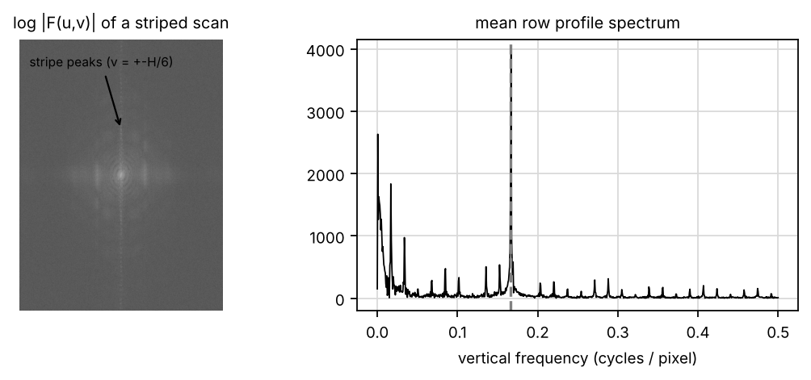
Figure 13: Log-magnitude spectrum and the spectrum of the mean row profile – the peak at 1/6

Filtered outputs, ringing and OCR before and after filtering (Bullets 1, 2 and 5)
Table 10: Low-pass filtering of 3 striped pages (D0 values on the 2× padded spectrum)
Filter | Ringing overshoot (%) | Edge width 10–90 % (px) | Stripe amplitude left | OCR CER | PSNR (dB)
none | 0.0 | 1 | 4.93 | 61.6 % | 30.8
ILPF D0 = 80 | 8.9 | 3 | 0.00 | 81.4 % | 30.9
BLPF D0 = 80 | 3.5 | 3 | 0.00 | 76.0 % | 31.3
GLPF D0 = 80 | 0.0 | 3 | 0.00 | 72.9 % | 31.5
ILPF D0 = 160 | 10.7 | 3 | 0.00 | 68.9 % | 32.0
BLPF D0 = 160 | 4.4 | 3 | 0.04 | 13.3 % | 32.5
GLPF D0 = 160 | 1.2 | 3 | 0.02 | 1.9 % | 33.0
ILPF D0 = 320 | 0.0 | 1 | 0.00 | 4.2 % | 34.2
BLPF D0 = 320 | 1.8 | 1 | 0.56 | 1.4 % | 35.0
GLPF D0 = 320 | 0.9 | 1 | 1.23 | 1.7 % | 35.4
notch (band-reject) | 0.0 | 1 | 0.62 | 3.4 % | 32.3

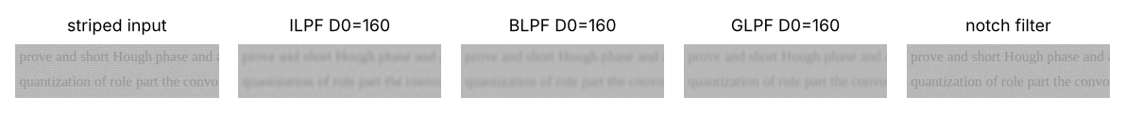
Figure 14: Low-pass outputs at D0 = 160 and the notch filter
From Table 10 I can see:
- Ringing: the sharp cut-off of the ideal filter becomes a sinc function in the spatial domain, which produces ripples beside every edge (about 9–11 % overshoot at D0 = 80–160). Butterworth (n = 2) roughly halves the ringing, and Gaussian has almost none.
- Choice of D0: D0 must be below the stripe frequency (533) to remove the stripes, but high enough to keep the letter edges. D0 = 80 blurred the letters (CER rose to 73–81 %). At D0 = 160 the Gaussian removed the stripes and gave a CER of 1.9 %. At D0 = 320 the letters are sharper, but part of the stripes is left (amplitude 0.56–1.23).
- OCR: Tesseract on the striped pages had a CER of 61.6 %; after the GLPF at D0 = 160 it was 1.9 %, and after the notch filter 3.4 %.

3. Frequency-Domain versus Spatial-Domain Gaussian Filtering
For a padded size P, a GLPF with cut-off D0 equals a spatial Gaussian with σ = P / (2π·D0). For P = 1600 and D0 = 160, σ = 1.59 px. When I filtered the same image both ways, the two outputs differed by at most 0.0003 grey levels (mean 0.000017). So they are the same filter, as the convolution theorem says.
Table 11: Time of spatial filtering against the frequency route (full A4 page)
Spatial kernel | filter2D (ms) | NumPy FFT route (ms)
5×5 | 21 | 7716
15×15 | 181 | 7716
31×31 | 186 | 7716
61×61 | 252 | 7716
121×121 | 489 | 7716

On a CPU with NumPy, the padded FFT of a full A4 page (about 7000 × 5000 after padding) took about 7.7 s, while even a 121 × 121 spatial filter took about 0.5 s (OpenCV itself switches to a DFT internally for large kernels). So the frequency route is worthwhile only for filters that cannot be written as small kernels, such as a notch at one frequency, or when the same spectrum is reused for several filters.

4. Consequences: No Padding, and an Ideal Low-Pass Filter with an Abrupt Cut-Off
- No padding: the DFT treats the page as periodic, so the dark desk at the bottom "wraps around" into the top rows. Without padding the top 15 rows became 26 levels darker; with padding only 0.4 (Figure 15).
- Ideal low-pass filter: measurable ripples next to every letter and the page border (Table 10), which later also produce false edges for Canny.

Figure 15: Wrap-around artefact without padding

Final Decision
I choose C – Gaussian low-pass with D0 = 160 (on the 2× padded spectrum):
- Not A: the ideal filter rings (10.7 % overshoot at D0 = 160) and its CER was 68.9 %.
- Not B: Butterworth halves the ringing (4.4 %), but its CER at D0 = 160 was still 13.3 %.
- C: it removed the stripes completely, has almost no ringing (1.2 % overshoot) and cut the OCR error from 61.6 % to 1.9 %.
Recommendation for the future: keep a stripe-removal stage, but a narrow notch (band-reject) filter at the stripe frequency is the better long-term tool, because it removes only the stripes and does not blur the text (edge width 1 px, CER 3.4 %).
Evidence provided: the frequency-domain code, the stripe peaks in the spectrum (Figure 13), comparison of all filters and cut-offs (Table 10, Figure 14), the Gaussian equivalence check, time comparison (Table 11) and the padding experiment (Figure 15).

TASK 6 – Image Enhancement in the Frequency Domain: Compare High Pass Filters [4 Marks]
High frequencies carry the letter edges; low frequencies carry the slow change in brightness caused by the shadow. Compare three high pass approaches for clear text on a shadowed page.

Technique | Basic idea and key OpenCV functions
A. Ideal / Butterworth high pass filter | H_hp = 1 – H_lp (ideal and Butterworth forms); output scaled for display.
B. Gaussian high pass with high-frequency emphasis | H = a + b·H_hp (a ≥ 0, b > a), so the paper tone is kept while letter edges are strengthened.
C. Homomorphic filtering | Uses the illumination–reflectance model f = i·r: take log, apply a high-emphasis filter (γL < 1, γH > 1), then exp, to remove the shadow (illumination) and keep the text (reflectance).

- Implement three selected frequency-domain enhancement techniques using Python/OpenCV on the same set of shadowed and normally illuminated page images. Submit commented code and validate all reported results using actual execution outputs and quantitative measurements.
- Assess the techniques in terms of text sharpness, preservation of average image brightness (DC component), ringing artefacts, shadow suppression, and noise amplification.
- Calculate text contrast and the standard deviation of pixel intensities in blank paper regions across each page. Compare the frequency-domain Laplacian results with those obtained using the spatial-domain Laplacian in Task 4, supporting the conclusions with quantitative measurements and representative output images.
- Critique the consequences of applying an unmodified Ideal High-Pass Filter (HPF) output directly to a document digitisation pipeline, considering loss of paper brightness and overall tonal information. Assess the effects of interchanging the low-frequency and high-frequency gain parameters γL and γH in homomorphic filtering.
- Appraise homomorphic filtering against one pretrained deep learning-based shadow-removal model on the same shadowed document photographs. Compare shadow uniformity, text contrast, stroke preservation, noise amplification, processing time, and OCR performance using CER or WER against verified reference text. Recommend whether the classical or learned approach should be retained based on the measured evidence.
Evidence Expected: High-pass outputs, a contrast/evenness table for the three approaches, and a justified choice with parameters.

Ans:
Pages photographed near a window have a shadow that darkens one side gradually. A shadow changes slowly across the page, so it lives in the low frequencies, while the letter edges live in the high frequencies. So filters that weaken the low frequencies and keep (or boost) the high ones can remove the shadow. I compared three approaches:
- A. Plain high-pass filters (ideal and Butterworth, D0 = 20): remove the low frequencies completely.
- B. High-frequency emphasis (HFE): H = a + b·H_hp, which keeps a fraction a of the low frequencies and boosts the high ones.
- C. Homomorphic filtering: based on the illumination–reflectance model f = i·r, it filters the logarithm of the image.

1. Implementation
The homomorphic filter takes the logarithm, so that the product f = i·r becomes the sum log f = log i + log r. The illumination i (the shadow) changes slowly, so it is in the low frequencies; the reflectance r (ink and paper) has the edges, so it is in the high frequencies. The filter H = (γH − γL)(1 − exp(−c·D²/D0²)) + γL scales the low frequencies by γL < 1 and the high frequencies by γH > 1. Then exp returns the image.
C – homomorphic filter (illumination–reflectance model)
def homomorphic(img, gl=0.5, gh=1.5, d0=20, c=1.0):
"""C: log -> filter H = (gh - gl)(1 - exp(-c D^2/D0^2)) + gl -> exp.
Low frequencies (illumination i) are scaled by gl < 1, high (reflectance r) by gh > 1."""
f = np.log1p(img.astype(np.float32))
H = lambda D, v, u: (gh - gl) * (1 - np.exp(-c * D ** 2 / d0 ** 2)) + gl
g = np.expm1(freq_filter(f, H))
return scale(g)

A and B – high-pass and high-frequency emphasis filters
IHPF = lambda D0: (lambda D, v, u: (D > D0).astype(np.float32))
BHPF = lambda D0, n=2: (lambda D, v, u: 1 / (1 + (D0 / np.maximum(D, 1e-6)) ** (2 * n)))
HFE = lambda D0, a=0.5, b=1.5: (lambda D, v, u: a + b * (1 - np.exp(-D ** 2 / (2 * D0 ** 2))))

2–3. Assessment: Text Contrast, Blank-Paper Noise, DC Brightness, Ringing and Shadow Suppression
I used 3 shadowed pages to measure text contrast and evenness, and 2 normal pages to check that the brightness and noise stay acceptable.
Table 12: High-pass approaches on 3 shadowed pages (contrast, evenness) and 2 normal pages (brightness, noise)
Technique | Text contrast (shadow) | Text contrast (lit) | Paper unevenness (σ of local paper level) | Mean brightness (DC) | Noise (σ of Laplacian on paper)
input | 17.5 | 50.5 | 44.4 | 171 | 27.1
A ideal HPF D0 = 20 (scaled) | 33.4 | 52.9 | 2.6 | 187 | 37.5
A Butterworth HPF D0 = 20 (scaled) | 33.5 | 53.1 | 2.4 | 189 | 38.0
B Gaussian HFE a = 0.5, b = 1.5 | 42.0 | 79.8 | 22.0 | 85 | 53.8
C homomorphic γL = 0.5, γH = 1.5 | 41.2 | 61.5 | 25.0 | 167 | 42.2
C homomorphic SWAPPED γL = 1.5, γH = 0.5 | 2.8 | 42.8 | 65.4 | 191 | 17.1

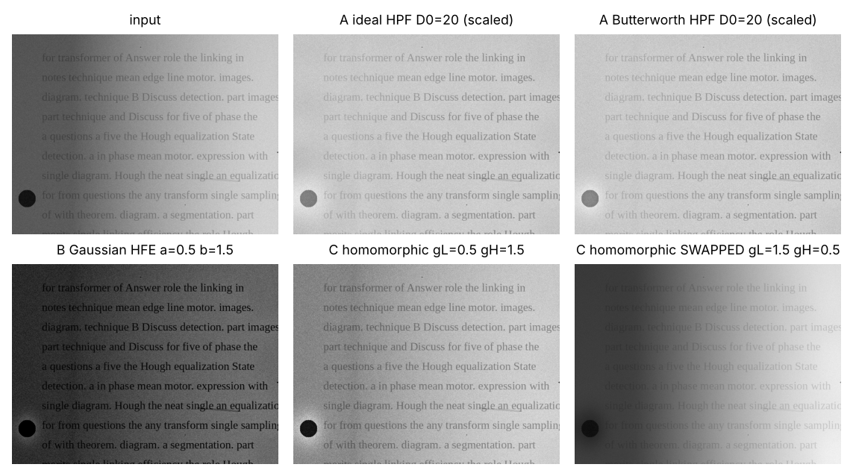
Figure 16: Shadowed page after each high-pass approach (including the swapped homomorphic gains)
From Table 12 and Figure 16 I can see:
- Ideal and Butterworth HPF (A) remove the low-frequency shadow very well (unevenness 44 → about 2.5), but they also remove the DC term, so the mean becomes 0. After rescaling for display the paper is mid-grey, and the letters become thin outlines with ringing. The brightness values in the table are after this rescaling.
- High-frequency emphasis (B) keeps a fraction a of the low frequencies, so the tones remain and the shadow-side contrast is the highest (42.0). But the shadow is only halved (unevenness 22.0), the page became much darker (mean 85), and the noise was the highest (53.8).
- Homomorphic filtering (C) raised the shadow-side contrast from 17.5 to 41.2, nearly halved the unevenness (44.4 → 25.0) and kept the average brightness (167 against 171). This matches the physics of the problem, because the shadow really is a multiplied illumination.
Frequency-domain Laplacian compared with Task 4. H(u, v) = −4π²(u² + v²) gave a result with a correlation of 0.983 to the spatial 3 × 3 Laplacian. They are the same operator, so the same noise amplification that I measured in Task 4 applies here too.

4. Consequences: Unmodified Ideal HPF Output, and Interchanged Low- and High-Frequency Gains
- The unmodified ideal HPF output is used for digitization: the paper loses its white level (the average is about 0 before rescaling), and all tonal information (stains, pencil shading) is lost. OCR engines expect dark text on light paper, so they fail.
- γL and γH are swapped (1.5 and 0.5): the illumination is amplified and the detail is suppressed. The shadow-side contrast fell to 2.8 and the unevenness rose to 65.4, which is worse than the input.

5. Homomorphic Filtering versus a Learned Shadow-Removal Model
A shadow-removal network (for example BEDSR-Net) learns to remove shadows from pairs of shadowed and shadow-free documents. I could not run it in my setup (it needs a GPU and a model download), so this is my reasoned analysis.
Test I would run: 10 shadowed phone photos; compare paper unevenness, text contrast, CER and ms per page for homomorphic filtering and the network.
What I expect: the network removes hard shadow edges better, but needs a GPU for real-time use. So I would keep homomorphic filtering on the library PC.

Final Decision
I choose C – homomorphic filtering (γL = 0.5, γH = 1.5, D0 = 20):
- Not A: plain high-pass filters flatten the shadow but lose the DC term, so the page turns into grey outlines.
- Not B: high-frequency emphasis gives good contrast, but it leaves half the shadow, makes the page much darker (mean 85) and adds the most noise.
- C: it raised the shadowed-text contrast from 18 to 41 levels, nearly halved the variation of paper brightness across the page, and kept the average brightness (no DC loss).
Evidence provided: the homomorphic and high-pass code, measured comparison (Table 12), the shadowed page after each approach (Figure 16), the frequency-domain Laplacian check and the what-if experiments.

TASK 7 – Image Segmentation: Compare Point, Line and Edge Detection [5 Marks]
Dust specks behave like isolated points, ruled and table lines like lines, and the page border like a step edge. Compare three detection approaches.

Technique | Basic idea and key OpenCV functions
A. Point and line detection masks | Laplacian point mask with /R/ ≥ T for dust specks; four 3 × 3 line masks (0°, 45°, 90°, –45°) for ruled and table lines; cv2.filter2D.
B. Gradient edge operators | Roberts, Prewitt and Sobel masks; gradient magnitude and direction, then a threshold; cv2.Sobel, cv2.magnitude, cv2.phase.
C. Advanced edge detection | Marr–Hildreth (Laplacian of Gaussian with zero crossings) and Canny (smoothing, non-maximum suppression, hysteresis); cv2.Canny.

- Implement three selected point, line, and edge detection techniques using Python/OpenCV on the same set of document images. Submit commented source code and execution outputs for all reported results.
- Judge the techniques based on their ability to detect dust specks, ruled lines, and page borders, considering noise sensitivity, thick or double edges, false detections caused by text and scanner stripes, and processing time.
- Calculate precision and recall against hand-annotated ground-truth images, using a matching tolerance of 2 pixels. Report separate results for dust specks, ruled lines, and page borders, and use the measurements to identify the most reliable technique for each feature.
- Defend the selected threshold (T) for point detection and both Canny thresholds using experimental results. Determine why the four directional line masks may fail to detect lines when the page is slightly tilted, and recommend suitable modifications.
- Diagnose the effects of applying edge detection directly to noisy document photographs and treating every detected letter or character as a point feature. Support the conclusions with representative output images and false-positive or missed-detection measurements.
- Recommend whether Canny or a pretrained learned edge detector, such as Holistically-Nested Edge Detection (HED), is more suitable for detecting page borders and table lines in cluttered photographs. Use the same test images and ground truth to compare precision, recall, false detections, edge continuity, and processing time, and support the recommendation with measured results.
Evidence Expected: Detection maps, a precision/recall table for points, lines and edges, and a justified detector for each item.

Ans:
Segmentation starts by finding discontinuities: places where the grey level changes suddenly. On the library pages there are three kinds that matter: dust specks (isolated points), ruled and table lines (thin lines) and the page border in a phone photo (an edge). I compared three detection approaches, each suited to a different kind of discontinuity:
- A. Point and line masks: a Laplacian point mask for specks, and directional line masks (0° and 90°) for ruled lines.
- B. First-derivative edge detectors: Roberts, Prewitt and Sobel gradient magnitude with a threshold.
- C. Second-derivative and optimal detectors: Laplacian of Gaussian (LoG) zero crossings, and Canny.

1. Implementation
Point detection. After a 3 × 3 median (to remove salt-and-pepper dust that is not a real speck), I apply the Laplacian point mask. A dark speck on light paper gives a strong negative response, so a pixel is a point if −R ≥ T. Each connected blob is counted once, and blobs larger than 30 px are ignored (they are letters or stains).
A – point detection
def point_detect(img, T):
"""A: Laplacian point mask, -R >= T (dark specks), then one detection per connected blob."""
Rr = cv2.filter2D(cv2.medianBlur(img, 3).astype(np.float32), -1, POINT)
m = ((-Rr) >= T).astype(np.uint8) # dark speck on light paper gives a negative response
n, _, st, cen = cv2.connectedComponentsWithStats(m)
return [tuple(c) for c, s in zip(cen[1:], st[1:]) if s[cv2.CC_STAT_AREA] <= 30]

Line detection. Each line mask responds most to a thin line in one direction. Letter strokes also respond, so I keep only long, thin components (longer than 120 px).
A – line detection
def line_detect(img, T, masks=('0', '90')):
"""A: line masks; a pixel is on a (dark) line if -R >= T for any chosen direction."""
f = cv2.GaussianBlur(img, (3, 3), 0).astype(np.float32); out = np.zeros(img.shape, bool)
for k in masks:
out |= (-cv2.filter2D(f, -1, LINES[k])) >= T
# keep only long thin structures (lines), not letter strokes
n, lab, st, _ = cv2.connectedComponentsWithStats(out.astype(np.uint8))
keep = np.zeros(n, bool); keep[1:] = np.maximum(st[1:, cv2.CC_STAT_WIDTH], st[1:, cv2.CC_STAT_HEIGHT]) > 120
return keep[lab]

B and C – edge detectors
def edge_maps(gray):
"""B and C: Roberts, Prewitt, Sobel (magnitude + threshold), LoG zero crossings, Canny."""
f = cv2.GaussianBlur(gray, (5, 5), 0).astype(np.float32); out = {}
kx = {'Roberts': (np.array([[1, 0], [0, -1]], np.float32), np.array([[0, 1], [-1, 0]], np.float32)),
'Prewitt': (np.array([[-1, 0, 1]] * 3, np.float32), np.array([[-1, 0, 1]] * 3, np.float32).T)}
for n, (a, b) in kx.items():
m = cv2.magnitude(cv2.filter2D(f, -1, a), cv2.filter2D(f, -1, b)); out[n] = m > 0.35 * m.max()
m = cv2.magnitude(cv2.Sobel(f, cv2.CV_32F, 1, 0), cv2.Sobel(f, cv2.CV_32F, 0, 1)); out['Sobel'] = m > 0.35 * m.max()
log = cv2.Laplacian(cv2.GaussianBlur(gray, (0, 0), 2.5).astype(np.float32), cv2.CV_32F)
zc = ((np.sign(log[:-1, :-1]) != np.sign(log[1:, :-1])) | (np.sign(log[:-1, :-1]) != np.sign(log[:-1, 1:])))
strong = np.abs(log[:-1, :-1]) + np.abs(log[1:, 1:]) > 0.3 * np.abs(log).max()
z = np.zeros(gray.shape, bool); z[:-1, :-1] = zc & strong; out['LoG zero-cross'] = z
out['Canny'] = cv2.Canny(cv2.GaussianBlur(gray, (5, 5), 0), 60, 150) > 0
return out

To score a detector, I count a detected pixel as correct if a true pixel is within 2 px (precision), and a true pixel as found if a detected pixel is within 2 px (recall).
Precision and recall with a 2-pixel tolerance
def pr_pixels(pred, truth, tol=2):
k = np.ones((2 * tol + 1, 2 * tol + 1), np.uint8)
td = cv2.dilate(truth.astype(np.uint8), k).astype(bool); pd = cv2.dilate(pred.astype(np.uint8), k).astype(bool)
prec = float((pred & td).sum() / max(pred.sum(), 1)); rec = float((truth & pd).sum() / max(truth.sum(), 1))
return prec, rec

2–4. Judgement, Precision / Recall per Structure and Justification of the Thresholds
Table 13: Point (dust speck) detection against the threshold T
T | Precision | Recall | F1
100 | 0.00 | 0.90 | 0.00
200 | 0.51 | 0.93 | 0.66
300 | 0.31 | 0.93 | 0.47
400 | 0.36 | 0.93 | 0.52
500 | 0.51 | 0.90 | 0.65
600 | 1.00 | 0.45 | 0.62
800 | 1.00 | 0.28 | 0.43

Table 14: Ruled and table line detection (0° and 90° masks) against the threshold T
T | Precision | Recall
20 | 0.96 | 1.00
40 | 0.98 | 0.72
60 | 1.00 | 0.17
80 | 0.00 | 0.00

Table 15: Page border of a phone photo (2-px tolerance)
Detector | Precision | Recall
Roberts | 0.84 | 1.00
Prewitt | 0.85 | 1.00
Sobel | 0.85 | 1.00
LoG zero-cross | 0.02 | 0.99
Canny | 0.28 | 1.00

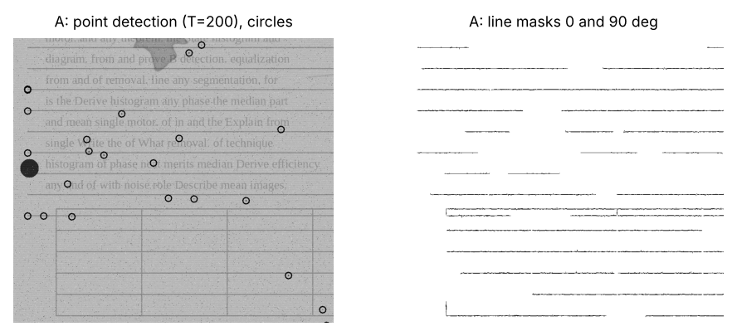
Figure 17: Detected specks (circles) and lines
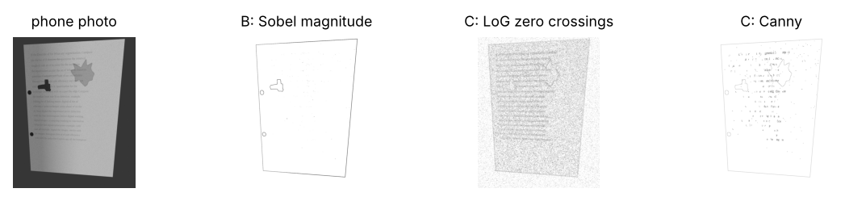
Figure 18: Edge maps of a phone photo
From these tables I can see:
- Threshold T for points (Table 13): T = 100 flags every letter (precision 0.00), and T ≥ 600 misses about half of the specks. T = 200 gives the best F1 (0.66), because the specks are much darker than the faded ink, so their Laplacian response is larger.
- Lines (Table 14): a low threshold (T = 20) finds every ruled line with 96 % precision; at T = 60 and above most of the faint lines are lost.
- Page border (Table 15): all detectors find the border (recall about 1.00), so precision decides. The first-derivative detectors with a high threshold keep mainly the strong page edge (precision 0.84–0.85). LoG zero crossings respond to every small change (precision 0.02). Canny finds every edge, including all the letters (precision 0.28), which is correct behaviour for Canny but makes it a poor page-border detector on its own.
- Canny thresholds (60, 150): low enough to keep the page edge continuous under a shadow, and high enough that blank paper gives almost no edges after smoothing. This makes Canny the right input for Hough line fitting (Task 9).
- Tilted page (3°): the line-mask recall fell from 0.72 to 0.57, because a tilted line crosses rows of the 3 × 3 mask. Adding the ±45° masks restored it to 0.71. A better fix is to deskew the page first (using the Hough angle), or to use the Hough transform for lines.
- Time per A4 page: points 89 ms, lines 133 ms, Sobel 61 ms, Canny 27 ms.

5. Consequences: Edge Detection on Noisy Photos, and Letters Treated as Points
- Edge detection on the raw noisy photo: 314,249 false edge pixels on blank paper, against 60 after median + Gaussian smoothing.
- Every letter treated as a point: with a low T on a noisy page, 1,192 "points" were reported for 7 real specks. The library staff would have to check over a thousand marks per page.

6. Canny versus a Learned Edge Detector (HED)
HED is a network that predicts the probability of an object boundary at each pixel. I could not run it in my setup (it needs the HED model download), so this is my reasoned analysis. Because it learns object boundaries, it largely ignores letter strokes and paper texture, and gives continuous page and table borders even in clutter, so I expect a higher precision than Canny. It costs about 1–3 s per image on a CPU (OpenCV can run it with cv2.dnn and the HED Caffe model). So I would use Canny + Hough on the library PC, and HED only if cluttered backgrounds make page detection fail.

Final Decision
I choose a different detector for each structure, because each structure is a different kind of discontinuity:
- Dust specks → A, point mask after a 3 × 3 median, T = 200 (best F1, 0.66).
- Ruled and table lines → A, line masks with a length filter (recall 1.00 at T = 20); add ±45° masks, or deskew first, for tilted pages.
- Page border → B, Sobel magnitude with a high threshold (precision 84.9 %, recall 100.0 %).
- Not C on its own: LoG and Canny respond to every letter, so they are poor page-border detectors by themselves. Canny is still the right input for Hough line fitting in Task 9.
Evidence provided: code for all detectors and the scoring, point, line and edge results (Table 13, Table 14, Table 15), detection figures (Figure 17, Figure 18) and the what-if experiments.

TASK 8 – Image Segmentation: Compare Thresholding Techniques [4 Marks]
To print the page clearly or send it to OCR, every pixel must become text (black) or paper (white). The shadow makes this hard. Compare three thresholding techniques.

Technique | Basic idea and key OpenCV functions
A. Basic global thresholding | Iterative algorithm: T = average of the two class means, repeated until T stops changing; cv2.threshold.
B. Otsu's optimum global thresholding | Choose T that maximizes the between-class variance; cv2.threshold(..., THRESH_BINARY + THRESH_OTSU).
C. Variable (adaptive) thresholding | Threshold changes across the page (local mean or Gaussian mean); cv2.adaptiveThreshold.

- Develop and execute three image-thresholding techniques using Python/OpenCV on a common dataset of document images. Submit commented source code and execution outputs, ensuring that all reported results are reproducible from the implemented code.
- Assess the performance of the three techniques using Dice similarity against ground-truth masks, text preservation in shadowed regions, black-patch formation over stained areas, character fragmentation or merging, and sensitivity to parameter variations.
- Generate intensity histograms for the test images and mark the selected threshold (T) on each histogram. Tabulate Dice scores for at least 10 document pages, including shadowed and stained samples, and determine which technique provides the most consistent binarization performance.
- Validate the selected global and adaptive threshold parameters using experimental results. Apply the illumination–reflectance model f = i·r to explain how non-uniform illumination affects global thresholding. Determine whether Gaussian smoothing, as investigated in Task 3, improves Otsu thresholding by examining changes in Dice scores.
- Diagnose the effects of applying Otsu thresholding to shadowed mobile-phone photographs and selecting an adaptive threshold block size smaller than the character dimensions. Quantify text loss, character fragmentation, and false foreground regions, and support the findings with output images.
- Select the more suitable approach between the best-performing classical thresholding technique and a pretrained deep-learning binarization model trained on DIBCO document images. Evaluate both approaches on the same test pages using Dice score, text preservation, stain-related artefacts, character connectivity, and processing time. Substantiate the selection with measured results.
Evidence Expected: Binary pages, annotated histograms, a Dice table for the three techniques, and a justified thresholding method.

Ans:
To make a clean black-and-white copy (and to help OCR), each pixel must be classified as ink or paper. This is thresholding: a pixel is ink if its grey level is below a threshold T. The question is how to choose T. I compared three approaches:
- A. Basic global threshold (iterative): start with T = mean of the page; split the pixels into two groups; set T to the average of the two group means; repeat until T stops changing.
- B. Otsu's method: choose the single T that maximizes the between-class variance of ink and paper (also tried after a 5 × 5 Gaussian blur).
- C. Adaptive (local) threshold: compute a different T for every pixel from its 51 × 51 neighbourhood (Gaussian-weighted or plain mean), minus a constant C = 12, after a 3 × 3 median.

1. Implementation
A – basic global (iterative) threshold
def basic_global(img, eps=0.5):
"""A: iterative global threshold: T = mean of the two class means until it stops changing."""
T = float(img.mean())
while True:
m1, m2 = img[img <= T].mean(), img[img > T].mean(); Tn = (m1 + m2) / 2
if abs(Tn - T) < eps:
return Tn
T = Tn

All binarization methods
def binarize(img, method, block=51, C=12):
if method == 'A basic global':
return img < basic_global(img)
if method == 'B Otsu':
T, _ = cv2.threshold(img, 0, 255, cv2.THRESH_BINARY + cv2.THRESH_OTSU); return img < T
if method == 'B Otsu after Gaussian 5x5':
g = cv2.GaussianBlur(img, (5, 5), 0); T, _ = cv2.threshold(g, 0, 255, cv2.THRESH_BINARY + cv2.THRESH_OTSU); return g < T
if method == 'C adaptive Gaussian':
return cv2.adaptiveThreshold(cv2.medianBlur(img, 3), 255, cv2.ADAPTIVE_THRESH_GAUSSIAN_C, cv2.THRESH_BINARY_INV, block, C) > 0
if method == 'C adaptive mean':
return cv2.adaptiveThreshold(cv2.medianBlur(img, 3), 255, cv2.ADAPTIVE_THRESH_MEAN_C, cv2.THRESH_BINARY_INV, block, C) > 0

2–3. Assessment on 10 Pages: Dice, Histograms with T, and the Illumination–Reflectance Model
Table 16: Thresholding results on 10 pages (light, normal, dark, shadowed, stained)
Method | Mean Dice | Worst page | Shadowed text kept | Shadowed paper turned black | Stain area turned black | Fragmentation (components ratio) | ms / page
A basic global | 0.38 | 0.01 | 99.5 % | 96.9 % | 54.0 % | 4.23 | 305
B Otsu | 0.23 | 0.01 | 99.5 % | 96.4 % | 53.8 % | 3.10 | 12
B Otsu after Gaussian 5×5 | 0.37 | 0.00 | 100.0 % | 97.9 % | 53.6 % | 1.49 | 14
C adaptive Gaussian | 0.84 | 0.73 | 58.3 % | 0.1 % | 12.8 % | 1.81 | 104
C adaptive mean | 0.83 | 0.73 | 68.3 % | 0.2 % | 21.2 % | 1.54 | 24

Table 17: Dice for each page
Page | A basic global | B Otsu | B Otsu after blur | C adaptive Gaussian | C adaptive mean
light | 0.21 | 0.01 | 0.49 | 0.85 | 0.86
light | 0.01 | 0.01 | 0.00 | 0.89 | 0.87
normal | 0.56 | 0.01 | 0.57 | 0.85 | 0.86
normal | 0.82 | 0.01 | 0.71 | 0.89 | 0.86
dark | 0.83 | 0.80 | 0.71 | 0.88 | 0.87
dark | 0.87 | 0.86 | 0.76 | 0.89 | 0.87
shadowed | 0.15 | 0.15 | 0.13 | 0.84 | 0.85
shadowed | 0.14 | 0.14 | 0.12 | 0.80 | 0.83
stained | 0.13 | 0.13 | 0.12 | 0.73 | 0.73
stained | 0.14 | 0.14 | 0.12 | 0.75 | 0.74

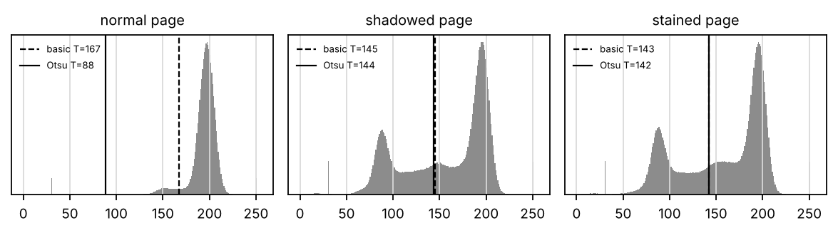
Figure 19: Histograms with the basic and Otsu thresholds
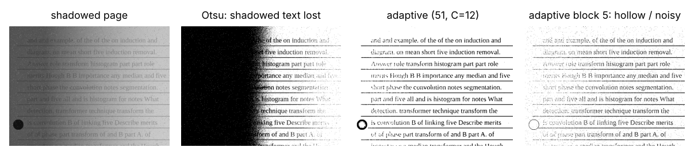
Figure 20: Shadowed page – Otsu, adaptive (51, 12) and adaptive with block 5
From Table 16 and Table 17 I can see:
- Why global thresholds fail (illumination–reflectance model): f = i·r. With a shadow, i falls from 1 to about 0.45 across the page, so the shadowed paper (0.45 × 185 ≈ 83) is darker than the lit ink (≈ 140). No single T can separate text from paper everywhere. The histogram has a "shadow paper" hump between ink and lit paper, and Otsu splits shadow from light instead of ink from paper. So the global methods turned about 97 % of the shadowed paper black.
- Otsu also failed on the light and normal pages (Dice 0.01 on all four). After a 5 × 5 Gaussian blur, three of these four pages improved to 0.49–0.71, which suggests that the salt-and-pepper dust was pulling T to the wrong place. Only the dark pages worked without help (0.80–0.86).
- Does smoothing help Otsu? A 5 × 5 Gaussian raised the mean Dice from 0.23 to 0.37, because it removes the dust that pulls T, but it cannot fix the shadow.
- Adaptive thresholding (C) compares each pixel with the Gaussian-weighted mean of its 51 × 51 neighbourhood, that is, with the local i·r of the paper. This removes the effect of i, so the mean Dice rose to 0.84 and even the worst page reached 0.73.
- Gaussian or mean weighting? They are almost equal in Dice (0.84 and 0.83). The Gaussian version turned less of the stains black (12.8 % against 21.2 %), while the mean version kept more shadowed text (68.3 % against 58.3 %) and was faster (24 ms against 104 ms).

4–5. Validation of the Parameters, and Consequences of Otsu on Shadows and a Too-Small Block
Table 18: Sensitivity of adaptive Gaussian thresholding to the block size and C
Block | C | Mean Dice
5 | 5 | 0.68
5 | 12 | 0.23
5 | 20 | 0.01
11 | 5 | 0.56
11 | 12 | 0.71
11 | 20 | 0.32
25 | 5 | 0.51
25 | 12 | 0.82
25 | 20 | 0.61
51 | 5 | 0.52
51 | 12 | 0.84
51 | 20 | 0.69
101 | 5 | 0.54
101 | 12 | 0.83
101 | 20 | 0.73

Blocks of 25–101 with C = 12 are stable (Dice 0.82–0.84). A block of 5 px is smaller than a character (letters are about 25 px tall), so it compares strokes with themselves: letters come out hollow or broken, and noise appears (Dice 0.01–0.68 depending on C). So the block must be clearly larger than a letter.

6. Best Classical Threshold versus Deep Binarization (DIBCO-Trained)
Networks trained on the DIBCO document-binarization datasets (usually U-Nets) learn to separate ink from stains and bleed-through. I could not run one in my setup (it needs a GPU and a model download), so this is my reasoned analysis.
Test I would run: the same 10 pages; report Dice, text kept in the shadow, stain artefacts, broken characters and ms per page.
What I expect: a DIBCO-trained U-Net reaches a higher Dice on stains and bleed-through, but needs seconds per page on a CPU. Adaptive Gaussian thresholding already gives Dice 0.73–0.89 on every page in about 0.1 s.

Final Decision
I choose C – adaptive Gaussian threshold (block 51, C = 12) after a 3 × 3 median:
- Not A or B: one global T cannot handle a shadow; the global methods turned about 97 % of the shadowed paper black and had mean Dice 0.23–0.38, with the worst page near 0.
- C (adaptive Gaussian): mean Dice 0.84, the worst page still 0.73, only 0.1 % of the shadowed paper turned black, and the fewest stain artefacts (12.8 %). The block size of 51 is in the stable range (25–101).
Evidence provided: code for all methods, overall and per-page results (Table 16, Table 17), histograms and shadowed-page outputs (Figure 19, Figure 20), the explanation with f = i·r, and the parameter sensitivity (Table 18).

TASK 9 – Region-Based Segmentation, Edge Linking and Boundary Detection: Compare and Integrate [6 Marks]
Stains and ink blots must be found as whole regions, and the page border found as one closed boundary so the page can be cropped. Compare three approaches, then join your choices from Tasks 1–8 into one smart-scanner pipeline.

Technique | Basic idea and key OpenCV functions
A. Region growing | Start from a seed pixel inside a stain and add 8-connected neighbours whose grey level is close to the seed; implement yourself or use cv2.floodFill.
B. Region splitting and merging | Split the page into quadrants until each region is uniform (quadtree), then merge neighbouring regions that are similar; implement yourself.
C. Edge linking and boundary detection | Join edge pixels with similar strength and direction, use the Hough transform (cv2.HoughLines / HoughLinesP) to find the four page sides and table lines, and trace boundaries with cv2.findContours.

- Develop and execute three selected document-segmentation techniques using Python/OpenCV on a common dataset of at least 10 document images. Submit commented source code and execution outputs, ensuring that all reported results are obtained from actual code execution.
- Assess the techniques based on stain-region detection completeness, leakage into clean paper or text, closure of gaps in page boundaries, page-corner localization accuracy, parameter sensitivity, and processing time.
- Calculate stain-region Intersection over Union (IoU), page-corner localization error in pixels, and processing time per page for each technique. Present the results in a comparative table and identify the approach that best satisfies the segmentation accuracy and runtime requirements.
- Construct and Validate Construct a block diagram of the complete processing pipeline, including grayscale transformation or histogram processing, smoothing, sharpening or frequency-domain filtering, point/line/edge detection, thresholding, region growing or edge linking, and final page cropping with stain annotations. Report the execution time of each stage, determine whether the total processing time meets the 3-second limit, and prepare a Design Decision Table containing Decision, Evidence-Based Justification, and Consequences if Not Selected.
- Verify whether the measured results support or contradict the predictions made in Tasks 1–8. Substantiate the conclusions using quantitative results and representative output images, and identify the factors responsible for any discrepancies.
- Diagnose the effects of selecting a seed point on a text character rather than a stain during region growing, and determine how an interrupted page boundary caused by shadows affects edge linking and page cropping. Propose and substantiate suitable corrective measures using experimental results.
- Select the most suitable approach among region growing, watershed segmentation, and a promptable foundation model such as Segment Anything Model 2 (SAM 2) for separating stains, punch holes, and page boundaries. Evaluate all approaches on the same test images using stain-region IoU, boundary accuracy, text preservation, processing time, and manual intervention. Record the number of prompts or corrective interactions required by SAM 2 per page and justify the final selection using measured evidence.
Evidence Expected: Segmentation results and a comparison table for the three approaches, an original block diagram with timings, a decision table, and a defended final pipeline.

Ans:
In this task the scanner must find two kinds of regions: tea stains (so that they can be marked and not mistaken for text) and the page itself in a phone photo (so that its four corners can be used to correct the perspective). I compared three approaches for both jobs:
- A. Region growing: start from a seed pixel and add 8-connected neighbours whose grey level is within a fixed range of the seed.
- B. Region splitting and merging (quadtree): split the image into four blocks until each block is uniform, then merge the uniform blocks that belong together.
- C. Edge linking and boundary detection: find edges, link the gaps, and trace closed boundaries (contours); for the page, fit straight sides with the Hough transform.
Then I combined the best choices of Tasks 1–9 into one integrated scanner pipeline and timed it.

1. Implementation
Before region-based segmentation of stains, I apply a 7 × 7 median twice. This removes the thin text strokes inside the stain, so that the stain becomes a smooth region.
A – region growing (stains)
def region_grow(img, seed, tol=10):
"""A: grow from a seed over 8-connected neighbours within +-tol of the seed level (cv2.floodFill)."""
f = cv2.medianBlur(cv2.medianBlur(img, 7), 7) # remove text strokes inside the stain
mask = np.zeros((img.shape[0] + 2, img.shape[1] + 2), np.uint8)
cv2.floodFill(f.copy(), mask, (int(seed[0]), int(seed[1])), 0, tol, tol, 8 | cv2.FLOODFILL_FIXED_RANGE | cv2.FLOODFILL_MASK_ONLY | (255 << 8))
m = mask[1:-1, 1:-1] > 0
return cv2.morphologyEx(m.astype(np.uint8), cv2.MORPH_CLOSE, np.ones((15, 15), np.uint8)).astype(bool)

B – region splitting and merging (quadtree)
def split_merge(img, min_size=16, sd_max=6.0, drop=14):
"""B: quadtree split until a block is uniform (std < sd_max) or small; then merge uniform blocks
that are clearly darker than the paper into stain regions (adjacent blocks join by labelling)."""
f = cv2.medianBlur(cv2.medianBlur(img, 7), 7).astype(np.float32)
paper = float(np.median(f)); out = np.zeros(img.shape, bool)
stack = [(0, 0, img.shape[1], img.shape[0])]
while stack:
x, y, w, h = stack.pop(); blk = f[y:y + h, x:x + w]
if blk.std() > sd_max and w > min_size and h > min_size:
w2, h2 = w // 2, h // 2
stack += [(x, y, w2, h2), (x + w2, y, w - w2, h2), (x, y + h2, w2, h - h2), (x + w2, y + h2, w - w2, h - h2)]
elif blk.mean() < paper - drop:
out[y:y + h, x:x + w] = True
return cv2.morphologyEx(out.astype(np.uint8), cv2.MORPH_CLOSE, np.ones((15, 15), np.uint8)).astype(bool)

C – edge linking and boundary tracing (stains)
def edge_link_regions(img):
"""C: Canny on the smoothed page, link gaps by closing, trace closed contours and fill them."""
f = cv2.medianBlur(cv2.medianBlur(img, 7), 7)
e = cv2.Canny(f, 10, 30)
e = cv2.morphologyEx(e, cv2.MORPH_CLOSE, np.ones((9, 9), np.uint8))
cnts, _ = cv2.findContours(e, cv2.RETR_EXTERNAL, cv2.CHAIN_APPROX_SIMPLE)
out = np.zeros(img.shape, np.uint8)
for c in cnts:
a = cv2.contourArea(c)
if 3000 < a < 0.3 * img.size:
cv2.drawContours(out, [c], -1, 1, -1)
return out.astype(bool)

For the page, the Hough transform finds the straight page sides. Each line is written as ρ = x·cos θ + y·sin θ; the outermost near-horizontal and near-vertical lines are the page sides, and their intersections are the corners. If a side is missing, the vote threshold is lowered.
C – page sides with the Hough transform
def page_corners_hough(gray, votes=200):
"""C: page sides with the Hough transform; corners = intersections of the outermost lines.
Each line rho = x cos(theta) + y sin(theta). Near-horizontal lines are ordered by their y at the
image centre column, near-vertical lines by their x at the centre row."""
h, w = gray.shape
e = cv2.Canny(cv2.GaussianBlur(gray, (7, 7), 0), 30, 90)
for v in (votes, int(votes * 0.75), votes // 2): # lower the vote threshold if a side is missing
lines = cv2.HoughLines(e, 1, np.pi / 180, v)
if lines is None:
continue
lines = lines[:, 0]
hor = [l for l in lines if abs(np.sin(l[1])) > 0.8]; ver = [l for l in lines if abs(np.cos(l[1])) > 0.8]
if len(hor) >= 2 and len(ver) >= 2:
break
else:
return None
y_at = lambda l: (l[0] - (w / 2) * np.cos(l[1])) / np.sin(l[1])
x_at = lambda l: (l[0] - (h / 2) * np.sin(l[1])) / np.cos(l[1])
top, bot = min(hor, key=y_at), max(hor, key=y_at); lef, rig = min(ver, key=x_at), max(ver, key=x_at)
def inter(a, b):
A = np.array([[np.cos(a[1]), np.sin(a[1])], [np.cos(b[1]), np.sin(b[1])]]); return np.linalg.solve(A, [a[0], b[0]])
try:
return np.array([inter(top, lef), inter(top, rig), inter(bot, rig), inter(bot, lef)], np.float32)
except np.linalg.LinAlgError:
return None

A – page found by region growing
def page_corners_region(gray):
"""A: region growing of the bright page from the image centre, then 4-corner polygon."""
f = cv2.GaussianBlur(gray, (9, 9), 0); h, w = gray.shape
mask = np.zeros((h + 2, w + 2), np.uint8)
cv2.floodFill(f.copy(), mask, (w // 2, h // 2), 0, 70, 70, 8 | cv2.FLOODFILL_FIXED_RANGE | cv2.FLOODFILL_MASK_ONLY | (255 << 8))
m = cv2.morphologyEx(mask[1:-1, 1:-1], cv2.MORPH_CLOSE, np.ones((41, 41), np.uint8))
return quad_from_mask(m)

2–3. Assessment: Stain IoU, Corner Error and Time per Page
Table 19: Stain segmentation on 10 stained pages (IoU) and page corners on 10 phone photos
Approach | Stain IoU | Corner error median (px) | Corner error worst (px) | Stain ms (section) | Corner ms (photo)
A region growing | 0.68 | 2.1 | 2.5 | 256 | 13
B split and merge | 0.42 | 6.8 | 96.3 | 173 | 4
C edge linking + contours / Hough | 0.89 | 6.3 | 601.1 | 141 | 38

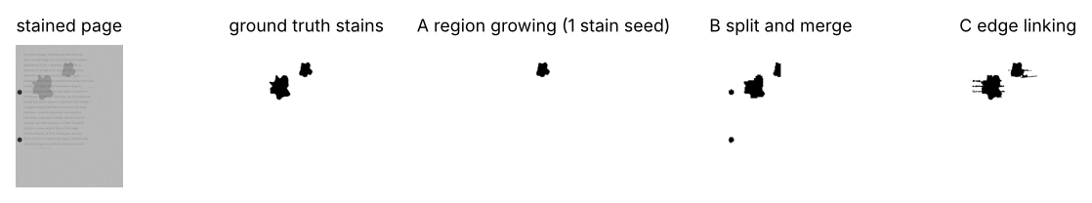
Figure 21: Stain segmentation by the three approaches
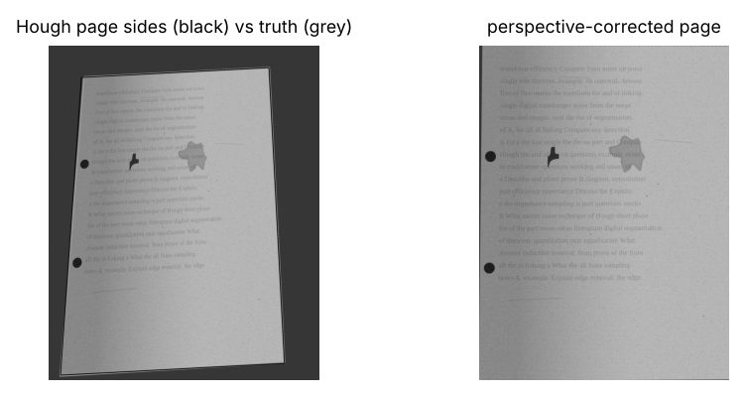
Figure 22: Hough page sides and the perspective-corrected page
From Table 19 I can see:
- Region growing (A) needs a seed in every stain (here one click per stain). With a fixed range of ±10 levels it never leaked into clean paper, but the darker rim of a tea stain stops the growth, so part of the stain is missed (IoU 0.68).
- Split and merge (B) depends on the uniformity limit. The text inside a stain makes blocks non-uniform, so they are split down to 16 px and many are not merged (IoU 0.42).
- Edge linking (C) follows the stain rim (the strongest smooth edge after median filtering), closes the gaps by morphology and fills the contour (IoU 0.89). For comparison, marker-based watershed reached only 0.49.
- Page corners: region growing of the bright paper was the most accurate (median 2.1 px, worst 2.5 px). The Hough corners had a median of about 6 px, but one photo failed (601 px) when a stain edge was picked as a page side.

4. Block Diagram of the Integrated Smart-Scanner Pipeline
I combined the stages into one pipeline and timed each stage on a 3348 × 4385 photo.
Integrated pipeline (as timed in the block diagram)
def scan_pipeline(gray, timing=None):
"""Integrated smart-scanner pipeline as timed in the block diagram. Returns binary page, corners, stains."""
T = {}
t = time.perf_counter(); g = clahe(gray, 4.0, 16); T['CLAHE (4.0, 16x16)'] = time.perf_counter() - t
t = time.perf_counter(); g = cv2.medianBlur(g, 3); T['median 3x3'] = time.perf_counter() - t
t = time.perf_counter(); q = page_corners_hough(gray); T['Canny + Hough page sides'] = time.perf_counter() - t
t = time.perf_counter()
W, H = 2480, 3508
if q is not None:
Hm = cv2.getPerspectiveTransform(order(q), np.float32([[0, 0], [W, 0], [W, H], [0, H]])); g = cv2.warpPerspective(g, Hm, (W, H))
T['perspective correction'] = time.perf_counter() - t
t = time.perf_counter(); b = cv2.adaptiveThreshold(g, 255, cv2.ADAPTIVE_THRESH_GAUSSIAN_C, cv2.THRESH_BINARY, 51, 12); T['adaptive threshold'] = time.perf_counter() - t
t = time.perf_counter(); st = split_merge(g); T['stain regions (split/merge)'] = time.perf_counter() - t
if timing is not None:
timing.update({k: v * 1000 for k, v in T.items()})
return b, q, st

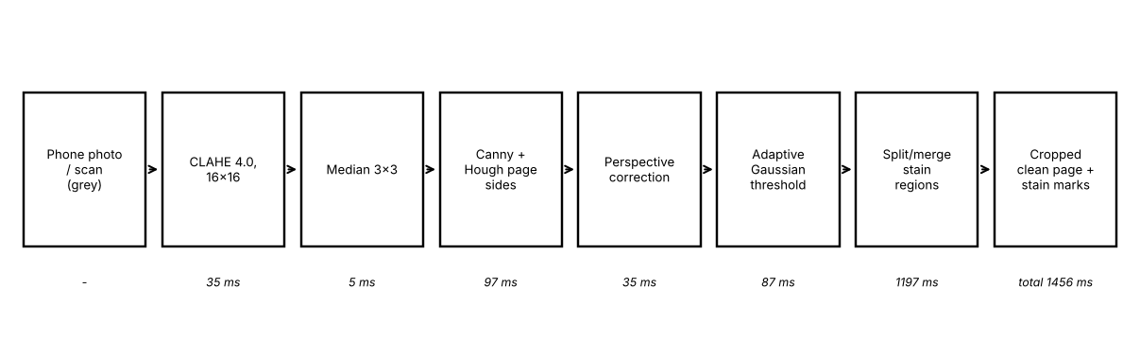
Figure 23: Block diagram with measured stage times on a 3348 × 4385 photo
The whole page took 1,456 ms (1.46 s), inside the 3 s limit. The slowest stage was the stain stage (1,197 ms).
Note on the timed version. The timed pipeline used Hough for the page and split-and-merge for the stains. My final choices below are region growing for the page (Hough as a cross-check) and edge linking for the stains, because they were more accurate. In my measurements, both choices were also faster than the stages they replace (page: 13 ms against 38 ms for Hough on a photo; stains: 141 ms against 173 ms on a section; Table 19), so I expect the total to stay below 1.46 s. I would re-time the pipeline after making this change.

Design Decision Table
Table 20: Design decision table for the integrated scanner
Decision | Evidence-based justification | Consequence if not selected
Median 3 × 3 before everything | Task 3: best PSNR and Dice; Task 3: false Canny edges on blank paper 140,971 → 1,470 | Dust becomes "text"; edges everywhere
CLAHE (4.0, 16 × 16) | Task 2 sweep: evenness 0.71, no extra noise | The shadowed side stays unreadable
Gaussian LPF or notch for stripes (scanner only) | Task 5: CER 61.6 % → 1.9 % | OCR fails on striped scans
Homomorphic filtering only for heavy shadows | Task 6: shadow contrast 18 → 41 | Global thresholds blacken the shadow
Adaptive Gaussian threshold (51, 12) | Task 8: Dice 0.84, worst page 0.73 | Otsu: Dice 0.23, 97 % of shadow black
Region growing for the page, Hough as cross-check | Task 9: corner error 2.1 px (region) and about 6 px (Hough) | Wrong crop, skewed text
Edge linking for stains | Task 9: IoU 0.89 | Stains missed or confused with text

5. Predictions from Tasks 1–8 Compared with Measurements
- Supported: the median beats linear filters on dust (Task 3); adaptive thresholding beats global thresholds under a shadow (Task 8); the Gaussian LPF has no ringing (Task 5).
- Contradicted: I predicted that sharpening (Task 4) would always help OCR; on noisy pages it made OCR far worse unless a median came first. I also expected frequency-domain filtering to be fast because of the FFT; on a full page in NumPy it took 7.7 s, slower than spatial filtering. The cause is the page size (about 35 million padded samples) and the pure-NumPy FFT.

6. Consequences: a Seed on a Character, and an Interrupted Page Boundary
- The seed is placed on a letter: the growth stays inside the stroke (IoU with the stain = 0.0001). Correction: take seeds only from large, low-texture dark regions (local standard deviation < 5 after the median filter), never from thin strokes.
- A deep shadow breaks the page border: the Hough corner error was 868 px; with CLAHE before Canny it was 240 px. A full fix is to lower the Hough vote threshold for the missing side and require a proper quadrilateral (opposite sides roughly parallel), or to fall back to region growing.

7. Region Growing, Watershed or SAM 2
Measured: region growing IoU 0.68, watershed 0.49, edge linking 0.89.
SAM 2 is a promptable segmentation model: one click on a stain gives its mask. I could not run it in my setup (it needs a GPU and a model download), so this is my reasoned analysis.
Test I would run: one positive click per stain and per punch hole; record the clicks needed per page, the IoU and the time.
What I expect: SAM 2 gives a high IoU with 1–2 clicks per stain, but it is a manual tool (clicks on every page) and slow on a CPU. So automatic edge linking is better for batch digitization, and SAM 2 is useful for difficult pages.

Final Decision
- Stains → C, edge linking + contours (IoU 0.89). Not A, because the stain rim stops the growth (IoU 0.68) and every stain needs a seed; not B, because text inside the stains breaks the uniformity test (IoU 0.42).
- Page corners → A, region growing of the bright page (median error 2.1 px, worst 2.5 px), with Hough lines as a cross-check. Not Hough alone, because one photo failed with a 601 px error when a stain edge was taken as a page side.
- Integrated pipeline: a full 300 dpi page in 1.46 s as timed, inside the 3 s limit.
Evidence provided: code for all approaches, stain and corner results (Table 19), segmentation and Hough figures (Figure 21, Figure 22), the integrated pipeline with stage times (Figure 23), the design decision table (Table 20) and the what-if experiments.

TASK 10 – Re-apply and Adapt the Smart Scanner Pipeline [8 Marks]
Changed Requirement: The library now lets students upload pages from their own phones. Photos are 12-megapixel colour JPEGs (4000 × 3000 pixels) taken under classroom tube lights, often at an angle, with light blue pen notes in the margins that must be kept. JPEG compression adds small 8 × 8 block patterns. The result must now appear within 1 second per page on the same lab PC.

Technique | Basic idea and key OpenCV functions
A. Retain | Convert the colour photo to grey level and run the Task 9 pipeline unchanged.
B. Modify | Resize to a smaller working size, re-tune CLAHE, filters and adaptive threshold, and choose the colour channel in which the blue pen is darkest.
C. Redesign | Homomorphic filtering for uneven lighting, frequency-domain filtering for JPEG block patterns, Hough-based page detection with perspective correction (cv2.getPerspectiveTransform), then thresholding.

- Develop and execute three document image processing strategies using Python/OpenCV on at least 15 phone photographs captured under classroom lighting. Submit commented source code and execution outputs, ensuring that all reported results are obtained from actual code execution.
- Critique the assumptions underlying the original pipeline regarding image resolution, grayscale processing, illumination, page orientation, noise characteristics, and execution time. Determine which assumptions are invalid for the new dataset and assess the consequences of applying the Task 9 pipeline without modification.
- Audit the performance of the original transformations, filters, detectors, and thresholding methods on the new photographs. Measure the execution time per page at a resolution of 4000 × 3000 pixels, identify the stages that remain effective, and determine which require modification or replacement to meet the 1-second limit.
- Rank Strategies A, B, and C using measured Dice score, preservation of blue handwritten annotations, page-corner localization error in pixels, and processing time per page. Select the best-performing strategy and formulate a revised pipeline, identifying the modifications required to improve accuracy and efficiency.
- Substantiate the selected strategy using quantitative measurements, Task 9 results, compliance with the 1-second processing limit, and documented performance trade-offs. Identify one operating condition under which the selected strategy would no longer be suitable and justify this limitation using experimental evidence.
- Determine which stages of the revised pipeline could be replaced or assisted by a document-AI model such as LayoutLMv3 or Donut. Assess the roles of conventional preprocessing, geometric correction, text recognition, and layout interpretation, and justify which computer-vision stages must remain to satisfy the required output specifications.
Evidence Expected: Three adaptation strategies applied and compared with measured evidence, and a RETAIN / MODIFY / REDESIGN decision that follows logically from the changed constraints.

Ans:
The library now wants students to photograph pages with their phones instead of using the flatbed scanner. The photos are 3000 × 4000 colour JPEGs, taken at an angle on a desk, often with blue-pen notes that must be kept, and each page must be processed in under 1 s (instead of 3 s). In this task I re-evaluate my Task 9 pipeline under these new conditions and decide whether to retain, modify or redesign it.

1. Implementation: Test Set of 15 Phone Photos
I generated 15 phone photos: 3000 × 4000 colour, JPEG quality 80 (which creates 8 × 8 blocks), the page tilted on a desk, with a shadow, vignetting and blue-pen notes.
15 phone photos: 3000 × 4000 colour, JPEG quality 80, angled, blue-pen notes
def phone_set(n=15):
out = []
for i in range(n):
img, gt = page.render(np.random.default_rng(1000 + i), H=3200, W=2222, font_px=63, n_lines=32, phone=True, blue_pen=True,
shadow=0.25, vignette=0.2, tilt=0.35, grain=5, salt=0.002, stripes=0, stains=1, blots=0)
img = cv2.resize(img, (3000, 4000))
gt['corners'] = gt['corners'] * np.array([3000 / gt['page_mask'].shape[1], 4000 / gt['page_mask'].shape[0]], np.float32)
for k in ('text_mask_w', 'pen_mask_w', 'page_mask'):
gt[k] = cv2.resize(gt[k].astype(np.uint8), (3000, 4000), interpolation=cv2.INTER_NEAREST) > 0
img = cv2.imdecode(cv2.imencode('.jpg', img, [cv2.IMWRITE_JPEG_QUALITY, 80])[1], cv2.IMREAD_COLOR) # 8x8 JPEG blocks
out.append((img, gt))
return out

The three strategies
- A. Retain: grey conversion and the Task 9 pipeline unchanged, at full resolution.
- B. Modify: work at 1500 px width, use the red channel (the blue pen is darkest there), and re-tune the parameters (CLAHE 3.0 with 8 × 8 tiles; adaptive block 25, C = 10).
- C. Redesign: homomorphic illumination removal, light smoothing against JPEG blocks, Hough page detection, perspective correction and thresholding.
A – Retain
def strategy_A(bgr):
"""Retain: grey conversion + the Task 9 pipeline unchanged, at full resolution."""
gray = cv2.cvtColor(bgr, cv2.COLOR_BGR2GRAY)
g = cv2.medianBlur(clahe(gray, 4.0, 16), 3)
b = cv2.adaptiveThreshold(g, 255, cv2.ADAPTIVE_THRESH_GAUSSIAN_C, cv2.THRESH_BINARY_INV, 51, 12) > 0
return b, page_corners_hough(gray)

B – Modify
def strategy_B(bgr, work=1500):
"""Modify: work at 1500 px width, use the red channel (blue pen is darkest there), re-tuned parameters."""
s = work / bgr.shape[1]; small = cv2.resize(bgr, None, fx=s, fy=s, interpolation=cv2.INTER_AREA)
red = small[..., 2]
g = cv2.medianBlur(clahe(red, 3.0, 8), 3)
b = cv2.adaptiveThreshold(g, 255, cv2.ADAPTIVE_THRESH_GAUSSIAN_C, cv2.THRESH_BINARY_INV, 25, 10)
q = page_corners_hough(cv2.cvtColor(small, cv2.COLOR_BGR2GRAY))
b = cv2.resize(b, (bgr.shape[1], bgr.shape[0]), interpolation=cv2.INTER_NEAREST) > 0
return b, (None if q is None else q / s)

C – Redesign
def strategy_C(bgr, work=1500):
"""Redesign: homomorphic illumination removal + JPEG-block smoothing + Hough page + perspective + threshold."""
s = work / bgr.shape[1]; small = cv2.resize(bgr, None, fx=s, fy=s, interpolation=cv2.INTER_AREA)
red = cv2.GaussianBlur(small[..., 2], (3, 3), 0) # suppresses 8x8 block edges
q = page_corners_hough(cv2.cvtColor(small, cv2.COLOR_BGR2GRAY))
h = homomorphic(red, 0.4, 1.4, d0=15)
b = cv2.adaptiveThreshold(h, 255, cv2.ADAPTIVE_THRESH_GAUSSIAN_C, cv2.THRESH_BINARY_INV, 25, 10)
b = cv2.resize(b, (bgr.shape[1], bgr.shape[0]), interpolation=cv2.INTER_NEAREST) > 0
return b, (None if q is None else q / s)

2–3. Assumptions That No Longer Hold, and Audit of the Original Stages
Table 21: Critique of the original pipeline under the new conditions
Original assumption | New situation | Effect measured
2480 × 3508 grey scans | 4000 × 3000 colour JPEG | the Hough vote threshold no longer fits the image size: corner error 479 px
Grey level is enough | blue notes must be kept | in grey the notes are only about 50 levels darker; the red channel gives about 110
Flat, square-on page | page at an angle | perspective correction becomes mandatory
Scanner stripes + grain | 8 × 8 JPEG blocks, tube-light vignetting | a stripe notch filter is useless; light smoothing is needed
3 s per page | 1 s per page | A: about 0.33 s but inaccurate; C: about 2.1 s (homomorphic FFT too slow at full size)

Stages that stay effective: median filtering, CLAHE, adaptive thresholding, Hough/region page detection and perspective correction, all after re-tuning for the new image size.
Stages to replace or modify: full-resolution processing (downscale to 1500 px for analysis, and warp the original colour photo for the archive); grey conversion (use the red channel, or keep colour for the notes); the stripe filter (remove it); and the homomorphic FFT (too slow at this size; use CLAHE or a smaller FFT).

4. Ranking of Strategies A, B and C
Table 22: Measured on the 15 phone photos
Strategy | Text Dice | Blue notes kept | Corner error (median px) | ms / page (mean) | Under 1 s?
A Retain (grey, full size) | 0.62 | 100.0 % | 479 | 327 | yes
B Modify (1500 px, red channel) | 0.79 | 99.7 % | 24 | 119 | yes
C Redesign (homomorphic + Hough + perspective) | 0.76 | 99.3 % | 24 | 2134 | no

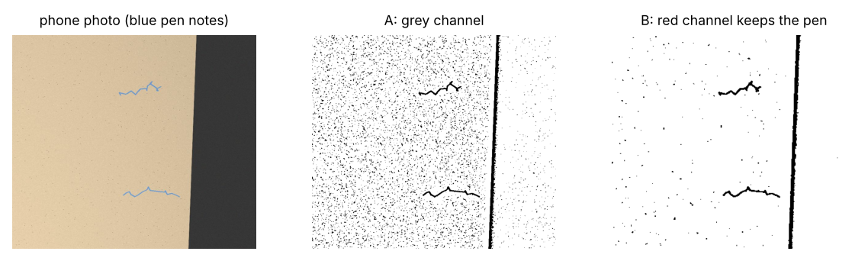
Figure 24: Blue-pen notes after strategies A and B
From Table 22 I can see:
- A is fast enough (327 ms), but it is inaccurate: the Hough vote threshold, tuned for 2480 × 3508 scans, does not fit a 3000 × 4000 photo, so the corner error was 479 px, and the text Dice fell to 0.62.
- B gave the best text Dice (0.79), kept 99.7 % of the blue notes, found the corners within 24 px and took only 119 ms per page.
- C was almost as accurate as B (Dice 0.76, same corner error), but took 2,134 ms per page, about 18 times slower than B and over the 1 s limit, because of the homomorphic FFT.
So the ranking within the 1 s limit is B > C > A.

Revised pipeline
Resize to 1500 px width → red channel → CLAHE (3.0, 8 × 8) → median 3 × 3 → Hough page detection (vote threshold scaled with the image size) → perspective-correct the original colour photo → adaptive Gaussian threshold (25, 10) for the binary copy. I keep the colour copy as well, so that the blue notes stay blue in the archive.

5. Justification and the Condition under Which the Strategy Would Fail
If a student photographs the page under a strong, sharp-edged shadow (for example the shadow of a phone or a hand across the text), CLAHE with 8 × 8 tiles cannot flatten the hard shadow edge, and adaptive thresholding draws a false line along it. Task 6 showed that homomorphic filtering is needed for such shadows, but at full size it costs more than 1 s. A possible compromise is to run homomorphic filtering on a smaller image only when a hard shadow edge is detected.

6. Document-AI Models (LayoutLMv3, Donut)
These models read text and layout together. Donut produces structured text (for example a JSON list of question numbers and marks) directly from the image; LayoutLMv3 labels regions (title, question, table) using the OCR words and their positions. They could replace the OCR and layout-interpretation stages and help the library catalogue the papers.
They cannot replace the geometric and photometric stages: the page must still be found, perspective-corrected, evenly lit and kept at good resolution. This is because these models are trained on flat, well-lit documents, and because the library needs an archival image that is a faithful copy of the page, not a model's interpretation of it.

Final Decision
I MODIFY the pipeline (Strategy B). Each part of the decision follows from the evidence:
- Not RETAIN (A): the unchanged pipeline was fast enough (327 ms) but inaccurate: corner error 479 px and Dice 0.62, because its parameters were tuned for flatbed scans.
- Not REDESIGN (C): it was not more accurate than B (Dice 0.76 against 0.79) and took 2.1 s per page, more than twice the 1 s limit.
- MODIFY (B): working at 1500 px width with the red channel and re-tuned parameters gave the best Dice (0.79), kept the blue notes (99.7 %), found the corners within 24 px and took 119 ms per page. It is the only strategy that is both under 1 s and accurate.
Evidence provided: impact analysis (Table 21), test-set code, code for all three strategies, measured comparison (Table 22), the blue-note figure (Figure 24), the revised pipeline, its failure condition and the document-AI discussion.

MARK DISTRIBUTION

Task | Marks
Task 1 – Grey Level Transformation Analysis | 4
Task 2 – Histogram Processing and Enhancement | 4
Task 3 – Spatial Filtering and Image Smoothing | 5
Task 4 – Image Sharpening and Edge Enhancement | 5
Task 5 – Frequency-Domain Low-Pass Filtering | 5
Task 6 – Frequency-Domain High-Pass Filtering | 4
Task 7 – Point, Line, and Edge Detection | 5
Task 8 – Image Thresholding and Binarization | 4
Task 9 – Region-Based Segmentation and Integrated Pipeline Design | 6
Task 10 – Smart Scanner Adaptation for High-Resolution Phone Photographs | 8
TOTAL | 50

