SIMATS ENGINEERING (SAVEETHA SCHOOL OF ENGINEERING)

Department of Artificial Intelligence and Data Science
CO1-ASSESSMENT TOOL 1 – APPLICATION BASED QUESTIONS

Course Code: | DSA0311 | Course Title: | Natural Language Processing
CO Assessed: | CO1 – Imitation (L1) | Assessment: | Assessment Tool 1 – Application Based Questions
Weightage: | 40% of CIA
CO1 Statement: | Analyse NLP models, regular expression patterns, finite state automata, morphological processing techniques and to interpret language processing. (BL-3)
Student Name: | T.Narasimha Reddy | Reg. No.: | 192425190
Section / Batch: | AIML | Date: | 10-10-2026
Code of Conduct
I A.Manohar / 192425360 (Name / Reg No) certify that this submission is my original work and that I have adhered to the guidelines specified for this assessment. I understand that any violation of academic integrity rules will result in disciplinary action.
Signature of the Student : A.Manohar
Instructions
- Develop a modular and efficient Python program that satisfies all the functional requirements specified in the problem statement.
- Demonstrate the correctness of the implementation using suitable test cases and justify the output obtained.
- Follow good programming practices, including meaningful variable names, proper code indentation, comments, and error handling wherever applicable.
- Duration: 30 minutes.

Section / Topic | Focus | Q Nos
Information Extraction | Regex-Based Information Extraction | 1
Pattern Matching | Regex Pattern Matching | 2
Regular Expression Patterns | Regex-Based Input Validation | 3

Annexure A – Application Based Questions
Section 1: Regular Expressions – Resume Information Extraction

1. A multinational recruitment company receives thousands of resumes every day in text format. The HR department requires an automated system to extract candidate information for shortlisting.
Design and implement a Python-based resume information extraction system using Regular Expressions that performs the following tasks:
Extract the candidate's name. Identify email addresses.
Extract mobile numbers.
Detect technical skills (Python, Java, SQL, Machine Learning, NLP). Extract years of experience.
Generate a structured summary of the candidate's profile.
Display candidates who satisfy the minimum eligibility criteria (minimum 2 years of experience and Python skill).
Section 2: Regular Expressions – Product Search System

2. An e-commerce company plans to enhance its product search engine to improve customer experience through flexible keyword matching.
Design and implement a Python-based product search system using Regular Expressions that performs the following tasks:

Search products using an exact keyword. Perform prefix-based searches.
Perform suffix-based searches. Search using partial keywords. Perform case-insensitive searches. Display all matching product names.
Generate a report showing the total number of matching products for each search.

Section 3: Regular Expressions – University Registration System

A university is developing an automated online registration portal to verify student information before course enrollment.
Design and implement a Python-based validation system using Regular Expressions that performs the following tasks:

Validate the student register number. Validate the institutional email address. Validate the course code.
Validate the semester information. Validate the student's mobile number.
Display appropriate validation messages for each field.
Generate a final registration status report indicating whether the registration is successful.

Rubrics for Calculation

Criteria | Weightag e | Level 4 – Exemplary | Level 3 – Proficient | Level 2 – Developing | Level 1 – Beginning
Understandin g of Problem Context | 20 | Clearly understands the problem and accurately identifies all requirements | Good understanding with minor gaps | Basic understanding; some requirements unclear | Poor understanding or misinterpretation of the problem
Application of Concepts | 30 | Accurately applies appropriate concepts to solve  complex problems | Applies relevant concepts correctly with minor errors | Applies basic concepts with limited accuracy | Fails to apply appropriate concepts
Problem-Solving Approach | 20 | Logical, well-structured, and efficient approach | Mostly logical approach with minor gaps | Basic approach with some inconsistencies | Illogical or unclear approach
Accuracy of Solution | 20 | Completely correct solution with proper justification | Mostly correct with minor errors | Partially correct solution | Incorrect or incomplete solution
Clarity | 10 | Clear, well-organized, and properly explained solution | Understandable with minor clarity issues | Limited clarity and explanation | Poorly presented and difficult to understand

Q. No. / Criteria | Understandi ng of Problem Context | Application of Concepts | Problem-Solving Approach | Accuracy of Solution | Clarity | Sub. Total | Total  %
1
2
3

Faculty In-charge | Course Coordinator | Program Director
Signature: | Signature: | Signature:
Date: | Date: | Date:

NLP ASSESSMENT-1

Application-Based Questions Using Python Regular Expressions
Resume Information Extraction • Product Search • University Registration Validation

Introduction
Regular Expressions (Regex) are patterns used to search, extract, and validate text. Python provides the re module for operations such as search(), findall(), fullmatch(), and IGNORECASE. This document presents three application-based solutions using Regex.
Note: The interface images in this document are illustrative website-style mockups for presentation. They are not screenshots of a deployed or running website. The Python programs below are the implementations.

Objectives
- Extract useful information from resume text.
- Search a product catalogue using exact, prefix, suffix, partial, and case-insensitive matching.
- Validate student registration fields and report whether the registration is successful.

Section 1: Resume Information Extraction

Problem Statement
A recruitment company receives resumes in text format. The system must extract the candidate's name, email address, mobile number, technical skills, and years of experience, generate a short profile summary, and identify candidates with at least two years of experience and Python skill.

Objective
To automate basic resume screening using Python Regular Expressions.

Algorithm
  - Read the resume as plain text.
  - Use Regex patterns to find email, phone number, experience, and supported technical skills.
  - Infer a candidate name from the first non-empty line when it is not an email or heading.
  - Create a short profile summary.
  - Mark the candidate eligible if experience is at least two years and Python is among the detected skills.

Python Program
import re

resume = """ Alex Johnson
Email: alex.johnson@example.com Phone: +1 415-555-0182
Experienced Software Engineer with 3 years of experience.
Skills: Python, Java, SQL, Machine Learning, NLP """

email_match = re.search(
r"\b[A-Za-z0-9._%+-]+@[A-Za-z0-9.-]+\.[A-Za-z]{2,}\b",
resume
)
phone_match = re.search(
r"(?<!\w)(?:\+?\d{1,3}[-.\s]?)?(?:\(?\d{3}\)?[-.\s]?)\d{3}[-.\s]?\d{4}\b",
resume
)
experience_match =
re.search( r"(\d+(?:\.\d+)?)\s*\+?\s*years?\s+(?:of\s+)?experien ce", resume, re.IGNORECASE
)

lines = [line.strip() for line in resume.splitlines() if line.strip()] name = lines[0] if lines and "@" not in lines[0] else "Not found"

skill_patterns =
{ "Python":
r"\bPython\b", "Java":
r"\bJava\b", "SQL": r"\bSQL\b",
"Machine Learning": r"\bMachine Learning\b", "NLP": r"\bNLP\b"
}
skills = [
skill for skill, pattern in skill_patterns.items()
if re.search(pattern, resume, re.IGNORECASE)
]

email = email_match.group() if email_match else "Not found" phone = phone_match.group() if phone_match else "Not found" years = float(experience_match.group(1)) if experience_match else 0

summary = (
f"{name} has {years:g} years of experience and skills in " f"{', '.join(skills) if skills else 'no listed technical skills'}."
)
eligible = years >= 2 and "Python" in skills

print("Candidate Name:", name) print("Email:", email) print("Mobile:", phone)
print("Technical Skills:", ", ".join(skills) if skills else "None found") print("Years of Experience:", years)
print("Profile Summary:", summary)
print("Eligibility:", "Eligible" if eligible else "Not eligible")

Sample Output
Candidate Name: Alex Johnson Email: alex.johnson@example.com Mobile: +1 415-555-0182
Technical Skills: Python, Java, SQL, Machine Learning, NLP Years of Experience: 3

Profile Summary: Alex Johnson has 3 years of experience and skills in Python, Java, SQL, Machine Learning, NLP. Eligibility: Eligible

Interface Illustration
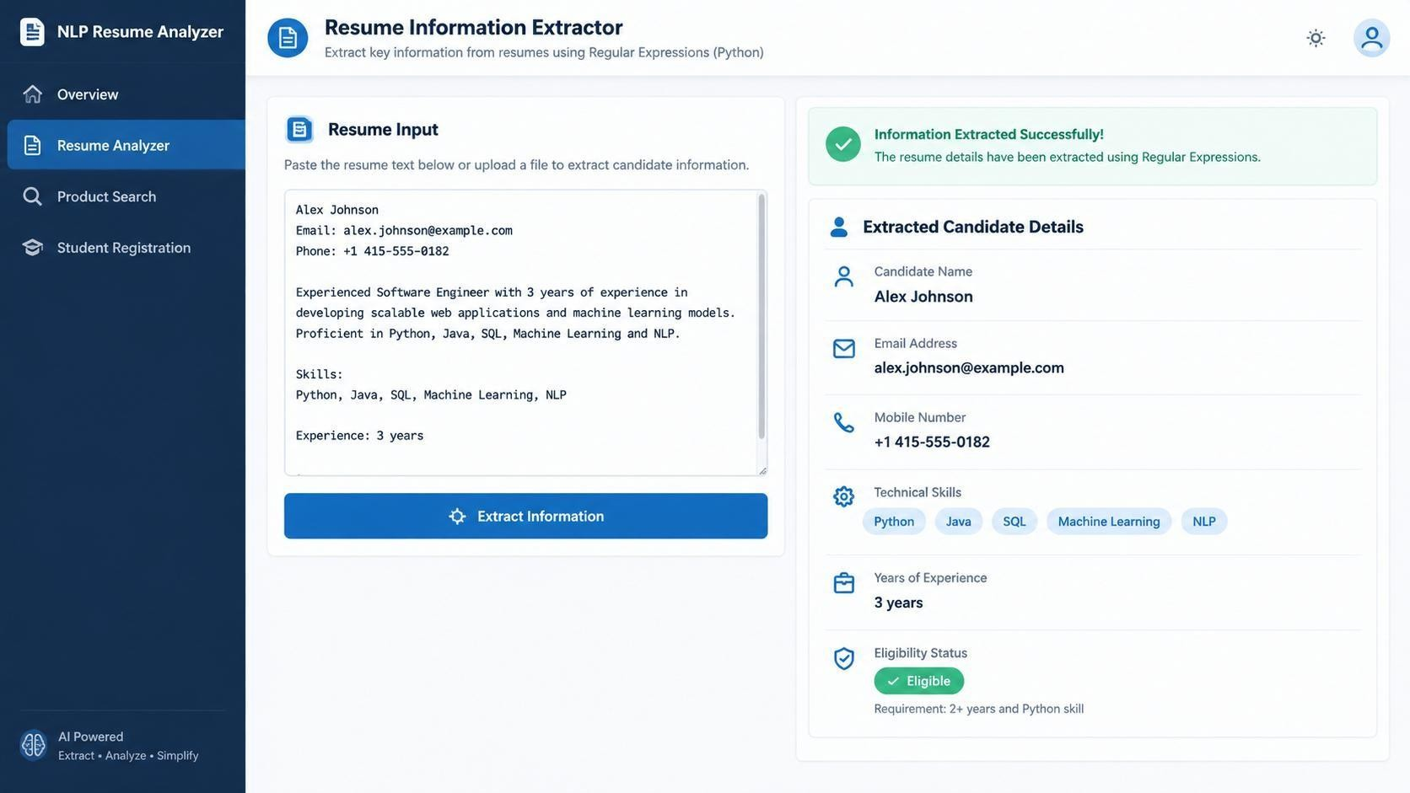
Figure 1: Illustrative Resume Information Extractor interface (mockup).

Result and Conclusion
The program extracts common resume fields and checks the minimum eligibility condition. Regex-based extraction depends on the format of the resume; a production system should handle varied layouts, international phone formats, and names more robustly.

Section 2: Product Search System

Problem Statement
An e-commerce catalogue needs flexible product search. The system must support exact, prefix, suffix, partial-keyword, and case-insensitive searches, display all matches, and report the number of matches.

Objective
To implement multiple keyword-matching modes using Regex.

Algorithm
  - Store product names in a list.
  - Read the keyword and selected search mode.
  - Escape the keyword with re.escape() so special characters are treated literally.
  - Build the corresponding Regex pattern for exact, prefix, suffix, or partial matching.
  - Use re.IGNORECASE when case-insensitive matching is selected.
  - Display the matching product names and total count.

Python Program
import re

products =
[ "Laptop Pro 14", "Laptop Stand",
"Wireless Mouse", "Gaming Laptop", "Laptop Backpack", "USB Keyboard", "Smartphone"
]

def search_products(keyword, mode="partial", case_insensitive=True): keyword = keyword.strip()
if not keyword:
return []

escaped = re.escape(keyword) patterns = {
"exact": rf"^{escaped}$",
"prefix": rf"^{escaped}",
"suffix": rf"{escaped}$",
"partial": rf"{escaped}"
}

pattern = patterns.get(mode, patterns["partial"]) flags = re.IGNORECASE if case_insensitive else 0 return [product for product in products
if re.search(pattern, product, flags)]

keyword = input("Enter product keyword: ")
mode = input("Choose exact/prefix/suffix/partial: ").strip().lower() case_choice = input("Ignore case? (y/n): ").strip().lower() ignore_case = case_choice == "y"
matches = search_products(keyword, mode, ignore_case) print("\nMatching Products:")
if matches:

print("-", item)
else:
print("No matching products found.")

print("Total matching products:", len(matches))

Sample Runs
Input:
Enter product keyword: laptop
Choose exact/prefix/suffix/partial: partial Ignore case? (y/n): y

Matching Products:
- Laptop Pro 14
- Laptop Stand
- Gaming Laptop
- Laptop Backpack
Total matching products: 4
Examples of search modes: exact matches the entire product name; prefix matches names starting with the keyword; suffix matches names ending with the keyword; partial matches the keyword anywhere in the name.

Interface Illustration
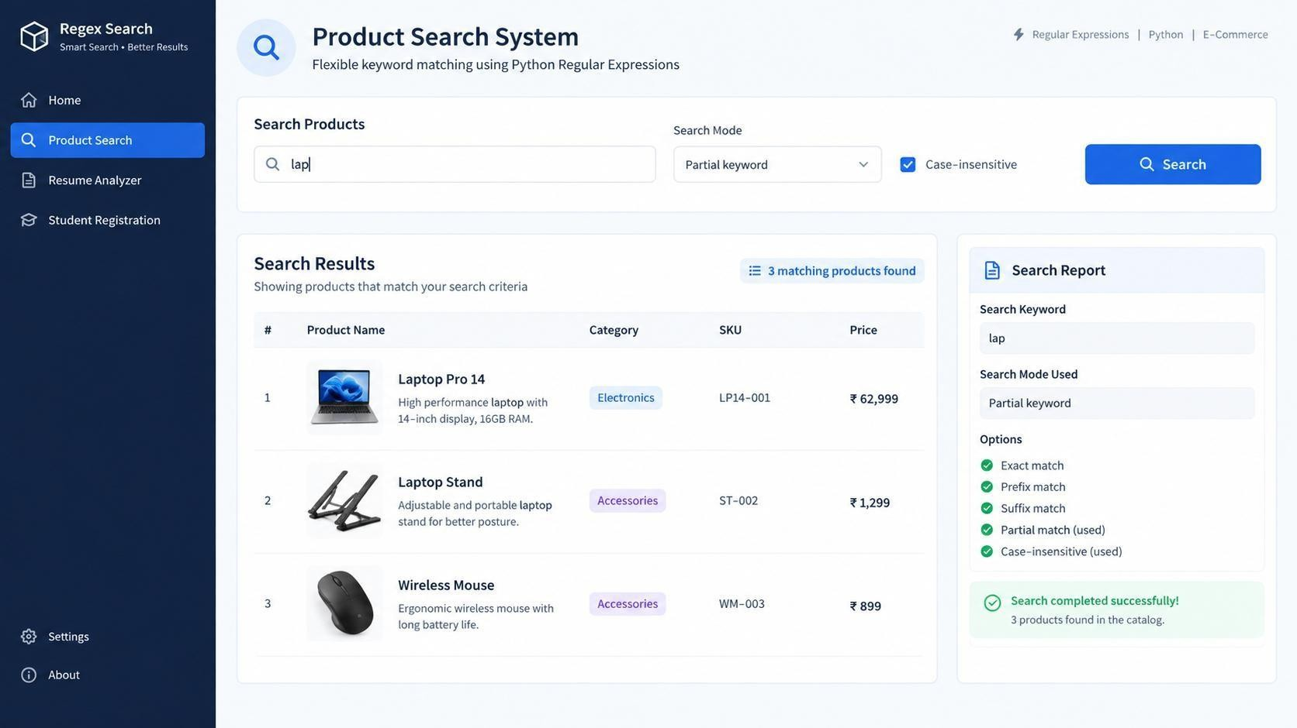
Figure 2: Illustrative Product Search System interface (mockup).

Result and Conclusion
The program supports four matching modes and optional case-insensitive matching. The report displays every matching product and the total count, helping users find products flexibly.

Section 3: University Registration Validation

Problem Statement
A university registration portal must validate the student register number, institutional email, course code, semester, and mobile number. It must display field-wise messages and produce a final registration status.

Objective
To validate registration fields with Regex patterns and simple range checks.

Validation Rules
  - Register number: SIMATS + four-digit year + one letter + three digits (example: SIMATS2026A104).
  - Institutional email: username followed by @saveetha.com.
  - Course code: four letters followed by three digits (example: AIML301).
  - Semester: integer from 1 to 8.
  - Mobile number: 10 digits, beginning with 6, 7, 8, or 9.

Python Program
import re

register_no = input("Register number: ").strip() email = input("Institutional email: ").strip() course_code = input("Course code: ").strip().upper() semester = input("Semester (1-8): ").strip()
mobile = input("Mobile number: ").strip()

checks = {
"Register Number": bool(re.fullmatch(
r"SIMATS\d{4}[A-Z]\d{3}", register_no, re.IGNORECASE
)),
"Institutional Email": bool(re.fullmatch(
r"[A-Za-z0-9._%+-]+@saveetha\.com", email, re.IGNORECASE
)),
"Course Code":
bool(re.fullmatch( r"[A-Z]{4}\d{3}", course_code
)),
"Semester": bool(re.fullmatch(r"[1-8]", semester)),
"Mobile Number": bool(re.fullmatch(r"[6-9]\d{9}", mobile))
}

print("\nValidation Report")
for field, valid in checks.items():
print(f"{field}: {'Valid' if valid else 'Invalid'}")

if all(checks.values()):
print("Final Status: Registration Successful") else:

Sample Run
Register number: SIMATS2026A104 Institutional email: student@saveetha.com Course code: AIML301
Semester (1-8): 5
Mobile number: 9876543210

Validation Report Register Number: Valid Institutional Email: Valid

Course Code: Valid Semester: Valid Mobile Number: Valid
Final Status: Registration Successful

Interface Illustration
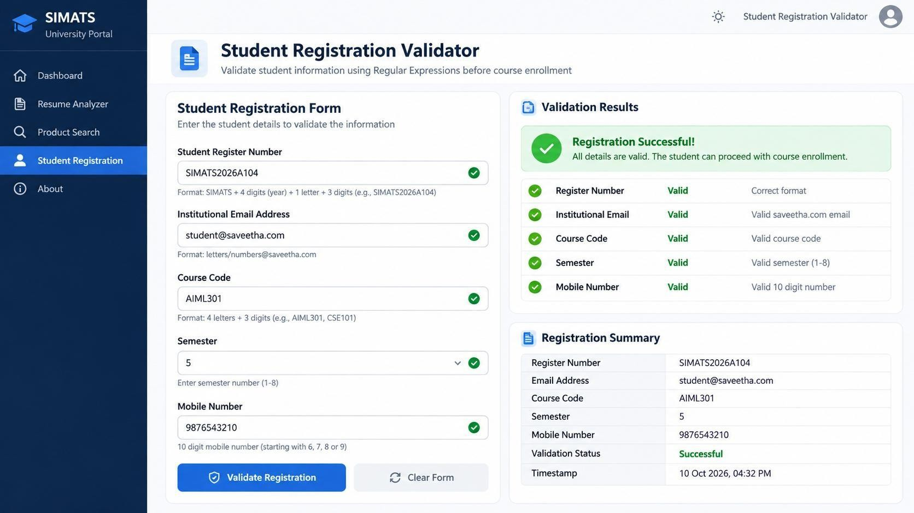
Figure 3: Illustrative Student Registration Validator interface (mockup).

Result and Conclusion
The program checks all five fields and reports each field's status. Registration is successful only when every validation passes. The register-number and course-code formats are examples based on the stated assumptions; they should be adjusted to match the university's official format.

Overall Conclusion
This assessment demonstrates three practical uses of Python Regular Expressions: information extraction, flexible product searching, and input validation. Patterns, re.search(), re.fullmatch(), re.IGNORECASE, and re.escape() help automate text-processing tasks. Correctness depends on clearly defined patterns and testing against valid and invalid examples.

References
Python Software Foundation. “re — Regular expression operations.” https://docs.python.org/3/library/re.html Python Software Foundation. “Regular Expression HOWTO.” https://docs.python.org/3/howto/regex.html

