S3

Lambda

Crawler

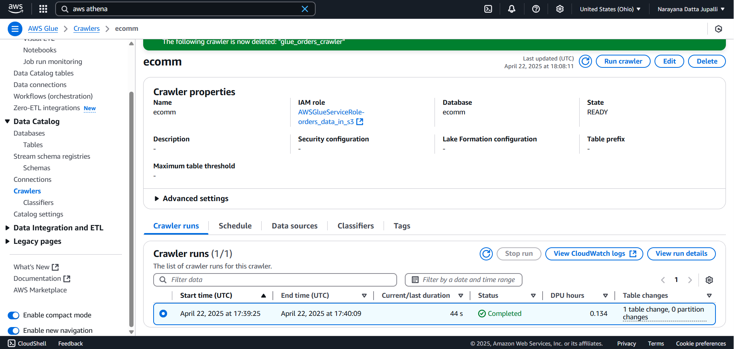

Athena

