# STATE OF CHARGE ESTIMATION FOR LITHIUM-ION BATTERIES USING ARTIFICIAL NEURAL NETWORK

*Report submitted to the SASTRA Deemed to be University as the requirement for the course*

**Course Code: MINI PROJECT**

*Submitted by*

**NAME : NARAYANAN.G**

**(Reg. No.: 124150030)**

**November 2023**



**SCHOOL OF ARTS, SCIENCES, HUMANITIES AND EDUCATION**

**THANJAVUR, TAMIL NADU, INDIA – 613 401**



**SCHOOL OF ARTS, SCIENCES, HUMANITIES AND EDUCATION**

**THANJAVUR – 613 401**

## Bonafide Certificate

This is to certify that the report titled “ State Of Charge Estimation For Lithium-Ion Batteries Using Artificial Neural Network” submitted as a requirement for the course, **Course Code: MINI PROJECT** for M.Sc. Data Science programme, is a bona fide record of the work done by **Mr./Ms. NARAYANAN.G Reg.No.124150030** during the academic year 2023-24, in the School of Arts, Sciences, Humanities and Education, under my supervision.

**Signature of Project Supervisor :**

**Name with Affiliation :**

**Date :**

Project *Viva voc*e held on ________________

**Examiner 1 Examiner 2**



**SCHOOL OF ARTS, SCIENCES, HUMANITIES AND EDUCATION**

**THANJAVUR – 613 401**

## Declaration

I declare that the report titled “State Of Charge Estimation For Lithium-Ion Batteries Using Artificial Neural Network” submitted by me/us is an original work done by me/us under the guidance of **Dr.V.Swaminathan, Designation, School of Arts, Sciences, Humanities and Education, SASTRA Deemed to be University** during the third semester of the academic year 2022-23, in the School of Arts, Sciences, Humanities and Education. The work is original and wherever I have used materials from other sources, I have given due credit and cited them in the text of the report. This report has not formed the basis for the award of any degree, diploma, associate-ship, fellowship or other similar title to any candidate of any University.

**Signature of the candidate(s) :**

**Name of the candidate(s) :**

**Date :**

**Acknowledgements**

# Table of Contents

**Title Page No.**

Bona-fide Certificate ii

Declaration iii

Certificate (if any) for external projects iv

Acknowledgements v

List of Figures vi

List of Tables vii

Nomenclature viii

Abstract ix

1. Introduction
   1. ******* 1
   2. ******* 2
   3. ******* 3
   4. ******* 4
   5. ******* 5
   6. Motivation 5
2. Objectives 7
3. Experimental Work / Methodology
   1. ******* 8
   2. ******* 8
   3. ******* 8
4. Results and Discussion
   1. Effect of ******* 9
   2. Effect of ******* 16
   3. ******* 17
5. Conclusions and Further Work 19
6. References 21
7. Appendix 23
   1. Similarity Check Report

➢ **If Table of Contents continues into two or more pages: mention - Table of**

**Contents Continued - on top of second and subsequent pages**

# List of Figures

|  |  |  |
| --- | --- | --- |
| **Figure No.** | **Title** | **Page No.** |
|  |  |  |
|  |  |  |
|  |  |  |
|  |  |  |
|  |  |  |
|  |  |  |

➢

**If**

**List of Figures continues into two or more pages: mention - List of Figures**

**Continued - on top of second and subsequent pages**

# List of Tables

|  |  |  |
| --- | --- | --- |
| **Table No.** | **Table name** | **Page No.** |
| 1.1 | Efficiency Tables | 27 |
| 1.2 | Efficiency of devices in rodents | 28 |
| 1.3 | Efficiency of devices in monkeys | 29 |

➢ **If List of Tables continues into two or more pages: mention - List of Tables**

**Continued - on top of second and subsequent pages**

# Abstract

In future is going to full of electric vehicles, achieving accurate State of Charge (SOC) estimation for lithium-ion batteries is crucial for efficient resource management. I've introduced an innovative SOC estimation method that specifically tackles temperature-related challenges. Utilizing a timeseries dataset with various temperatures, I've integrated WaveNet with GRU (WaveNet-GRU) in my project. While WaveNet is designed for waveform generation, the GRU network effectively models sequential patterns in time series data. Furthermore, I've conducted a comparison with the CNN-LSTM approach, merging Convolutional Neural Networks' spatial feature capturing with Long Short-Term Memory's temporal dependency modelling. This hybrid method overcomes the vanishing gradient problem commonly encountered by LSTM in handling lengthy sequences. Through systematic weight adjustments to enhance the network's performance across various temperatures, the resulting model proves to be robust, accurate, and adaptable. SOC estimations under diverse conditions confirm its superiority over other networks, showcasing excellent metrics such as root-mean-squared-error (RMSE), mean-squared-error (MSE), mean-absolute-error (MAE), stability, and adaptability to varying initial SOC conditions. Notably, the proposed WaveNet-GRU network outperforms LSTM, CNN, and CNN-LSTM algorithms in SOC estimation. Experimental results consistently demonstrate exceptional performance with an RMSE consistently below 0.0002%, significantly lower than the compared models. Looking ahead, my future goals involve expanding this approach to explore the integration of trending optimization techniques with the hybrid network. Ultimately, I aim to develop a fused or hybridized algorithm for optimal SOC estimation, underscoring the significance of electric vehicles in our future.

**CHAPTER 1**

# INTRODUCTION

The transformative integration of electric vehicles (EVs) into the automotive landscape has played a pivotal role in reshaping the transportation sector. Central to this revolution is the widespread adoption of lithium-ion batteries, renowned for their high energy density, longevity, and efficiency. These batteries have become the cornerstone of the electrified future of transportation, driving technological advancements and influencing the automotive industry on a global scale.

As the world navigates a paradigm shift away from traditional internal combustion engines, the rise of electric vehicles has become a focal point. Propelled by electric motors and powered by advanced energy storage systems, EVs have emerged as a cleaner and more sustainable alternative to conventional gas-powered vehicles. This transition is spurred by a convergence of factors, including growing environmental concerns, regulatory initiatives, and continuous advancements in battery technology.

In contrast to traditional internal combustion engines, lithium-ion batteries in electric vehicles offer a more environmentally friendly solution. Operating without the production of harmful emissions during use, these batteries contribute significantly to reducing air pollutants and greenhouse gas emissions. Furthermore, ongoing advancements in recycling technologies are enhancing the eco-friendliness of lithium-ion batteries, minimizing their environmental impact.

The landscape of lithium-ion battery technology is characterized by dynamic and continuous research and development efforts. Innovations in battery chemistries, electrode materials, and manufacturing processes are propelling the evolution of lithium-ion batteries for electric vehicles. This symbiotic relationship between electric vehicles and lithium-ion batteries is not only fostering innovation but is also steering the automotive industry towards cleaner and more sustainable mobility solutions.

As electric vehicles continue to gain traction and market share, the evolution of lithium-ion batteries remains a forefront concern in technological advancements. This interconnected relationship is reshaping the automotive industry, encouraging innovation, and driving the development of more sustainable mobility solutions. Subsequent sections will delve into specific aspects of lithium-ion batteries for electric vehicles, exploring topics such as battery management systems, charging infrastructure, and the challenges and opportunities on the horizon. Through this exploration, a comprehensive understanding of the intricate interplay between lithium-ion batteries and the electrified future of transportation will be provided.

In the dynamic realm of electric vehicles (EVs), efficient energy storage utilization hinges on precise State of Charge (SOC) estimation within the vehicle's battery. SOC, representing the remaining capacity as a percentage of the total rated capacity, is a critical metric influencing the range, performance, and overall reliability of electric vehicles. This introduction delves into the significance of SOC estimation in the context of EVs, exploring the challenges, methodologies, and transformative impact on the EV ecosystem.

As the automotive industry undergoes a profound shift towards electrification, the focus on energy management becomes pivotal. Unlike traditional internal combustion vehicles relying on fuel gauges for gasoline indication, electric vehicles require a sophisticated SOC estimation system due to the unique characteristics of battery-powered propulsion.

SOC, a percentage representation of the charge remaining in the battery, provides EV drivers with crucial information about available energy and remaining driving range. Accurate SOC estimation empowers drivers to make informed decisions, plan routes effectively, and alleviate concerns related to range anxiety—a prevalent challenge in the early adoption stages of electric vehicles.

However, estimating SOC directly proves elusive due to its intrinsic nature as an internal parameter of lithium-ion batteries. Thus, indirect estimation through external parameters like voltage, current, and temperature becomes necessary. Inherent measurement errors in battery sensors contribute to SOC estimation inaccuracies, exacerbated in low-temperature environments where the chemical reaction rate diminishes. Winter temperatures in many regions can plummet to 0°C or even lower, emphasizing the need to enhance precision and robustness of SOC estimation in these conditions.

Recent advancements in high-performance materials and manufacturing technology have spurred research into low-temperature SOC estimation for lithium-ion batteries. For instance, leveraging metal-organic frameworks to enhance energy density and exploring topological materials and functional separators are among the proposed solutions. Despite these efforts, comprehensive studies on SOC estimation for lithium-ion batteries in low-temperature environments remain scarce.

This paper introduces a novel hybrid method, integrating Convolutional Neural Network (CNN) and Bidirectional Weighted Gated Recurrent Unit (BWGRU), to achieve precise and stable SOC estimation in low temperatures. The method employs a "multi-moment input" structure, enhancing the neural network input through a window sliding technique for comprehensive optimization of battery information. The integration of CNN facilitates spatial feature extraction without manual feature parameter design, while bidirectional weighted GRU dynamically controls battery information, enhancing estimation efficiency. The hybrid CNN-BWGRU method outperforms single-network approaches by learning "multi-moment inputs" and exploiting bidirectional correlations, significantly improving estimation accuracy, particularly in low-temperature environments. The paper concludes with detailed insights into the proposed methods, an overview of experimental and data-related work, and a comprehensive presentation and comparison of estimation results.

**CHAPTER 2**

**METHODOLOGY**

Data Description:

Dataset name : LG HG2

This dataset taken reading at different temperature with charging and discharging rate

So first I am Taking the charge and discharge in content 25 degree temperature

This dataset contain the Data columns:

Time (time in seconds)

TimeStamp (timestamp in MM/DD/YYYY HH:MM:SS AM format)

Voltage (measured cell terminal voltage, sense leads welded directly to battery terminal)

Current (measure current in amps)

Ah (measured amp-hours, with Ah counter typically reset after each charge, test, or drive cycle)

Wh (measured watt-hours, with Wh counter reset after each charge, test, or drive cycle)

Power (measure power in watts)

Battery_Temp_degC (battery case temperature, at middle of battery, in degrees Celsius measured with a AD592 +/-1degC accuracy temperature sensor)

Data processing:

In this project using the LG HG2 lithium-ion battery dataset. This dataset records the voltage, current, temperature, from various temperture and is suitable for this experiment.The dataset was organized under electric vehicle driving conditions at various temperatures.In actual operation, a single working condition cannot accurately reflect the actual operating state of an electric vehicle. Therefore, we taken LG HG2 dataset temperatures from − 20 ◦C to + 40 ◦C.the LG HG2 dataset are used as the learning data for the CNN network. During training, 20% of the data is divided into validation data. Meanwhile, we use data from various temperture − 20 ◦C to + 40 ◦C as testing data to evaluate the proposed method. The SOC is 0–100, while the voltage, current, and temperature values vary widely. The SOC estimation my project uses the " multi-time input” structure to window the input data. The window size is set to 32as a normal candle size in timeseries.depicts the “multi-time input” structure. The input at the moment k includes all voltage, current, and temperature data within that window. SOCk is relevant for all data. This method can make the most effective use of the influence of all previous data on the results and improve the

estimation and robustness.

Convolutional Neural Networks (CNNs):

A CNN comprises layers such as convolutional layers, pooling layers, and fully connected layers.The convolutional layer is the core building block of a CNN. It involves applying a convolution operation to the input, using learnable filters or kernels that slide over the input to extract features.

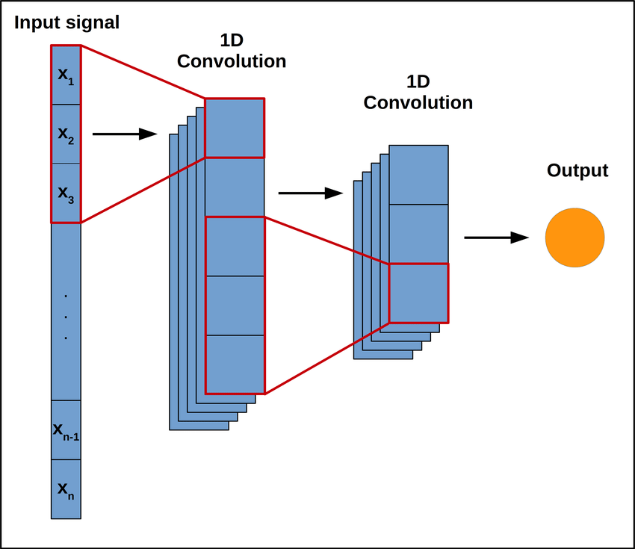

In a one-dimensional scenario with three inputs, the convolution operation can be expressed as follows:

$$(h*x)(t)=∑a=13​h(a)⋅x(t-a+1)$$

Where:

h is the filter (or kernel) with its own learnable parameters.

x(t) represents the input at position t.

Here, the filter h slides over the input x, and at each position t, the dot product is computed, capturing local patterns in the data.

Activation Function:

Following the convolution operation, a nonlinear activation function is usually applied element-wise to introduce nonlinearity to the model. Common choices include the Rectified Linear Unit (ReLU):

$$ReLU(z)=max(0,z)$$

Parameters Update:

The parameters (weights) of the filters are updated during the training process using backpropagation and optimization algorithms like stochastic gradient descent (SGD).

This is a simplified explanation of the convolutional layer in a CNN with a one-dimensional input. In real-world applications, CNNs are extended to handle multi-dimensional data such as images, where filters slide over both width and height dimensions, capturing spatial hierarchies and patterns.

Long Short Term Memory (LSTM):

LSTMs have a more complex structure than standard neural networks, incorporating memory cells and three gates: the input gate, forget gate, and output gate. These gates regulate the flow of information into and out of the memory cell.

Memory Cell State Update:

The memory cell state, often denoted as Ct, is updated through the following equations:

$$ft=σ\left(Wf⋅\left[ht-1,xt\right]+bf\right)$$

it=σ(Wi⋅[ht-1,xt]+bi)

tanh⁡ (WC⋅[ht-1,xt]+bC)

Ct=ft⋅Ct-1+it⋅C~t

3.3. Evaluation standard

The root mean square error (RMSE) and the mean absolute error (MAE) are used to verify the estimation accuracy of the CNN-BWGRU network and are calculated by Equations (8) and (9), respectively. $RMSE = \overline{\overline{\overline{\overline{\overline{\overline{\overline{\overline{\overline{\overline{\overline{\overline{\overline{\overline{\overline{\overline{\overline{\overline{\overline{\overline{\overline{\overline{\overline{\overline{\overline{\overline{\overline{\overline{\overline{\overline{}}}}}}}}}}}}}}}}}}}}}}}}}}}}}}\overline{\overline{\overline{\overline{\overline{\overline{\overline{\overline{\overline{\overline{\overline{\overline{\overline{\overline{\overline{\sqrt{\frac{1}{N}}}}}}}}}}}}}}}}} ∑N k=1 (SOCk - SOCk ' ) 2 √√√√$ (8) MAE = 1 N ∑N k=1 |SOCk − SOCk ′ | (9) Where N is the number of windows, SOCk is the actual value, and SOCk ′ is the value estimated by the proposed network. To further demonstrate the fitting performance of the CNN-BWGRU network proposed in this paper, the R2 determination coefficient is used as the evaluation standard. The closer to 1, the better the performance of the network. SOC is the arithmetic mean of the actual SOC value.

Neuropros thetic devices are in great demand world wide . Quality of life for patients suffering from neurodegenerative diseases, stroke, brain and spinal cord injuries and limb amputees can be dramatically improved by suitable neuroprosthetic devices. However, there are several challenges that need to be overcome before such devices can be a reality. To be able to design neuroprosthetic devices a multidisciplinary approach involving expertise from basic neuroscience, physiology, medicine, engineering and material sciences will be required. Hence it is imperative that more and more laboratories across the world should focus their efforts to resolve these hurdles and develop neuroprosthetics. Several approaches have been taken towards the development of neuroprosthetics suitable for specific purpose. Neuromuscular eleCtrical stimulation (NMES) has been used for direCt stimulation of muscles in patients having upper motor neuron injuries due to stroke or spinal cord damage (Knutson *et al*. 2015). Peripheral nerve interfaces (PNIs) are being developed for upper-limb amputees (Ghafoor *et al*. 2017). Intracortical microstimulation (ICMS) is used to provide artificial stimulation to the primary somatosensory cortex that mimics the sensation of touch and proprioception (Bensmaia 2015, Tabot *et al*. 2015). Cortical Brain Machine Interfaces (BMIs) help paralyzed subjeCts to control a robotic arm or wheel chair (Andersen *et al*. 2014, Slutzky and Flint 2017). These devices are summarized in table 1.1 below.

Table 1.1 Neuroprosthetic devices and their applications

|  |  |  |  |  |
| --- | --- | --- | --- | --- |
| Neuroprosthetics | NMES | PNIs | ICMS | BMIs |
| Application | Upper motor neuron injuries | Upper limb amputees | Peripheral nerve injuries | Paralysis |

NMES, neuromuscular eleCtrical stimulation; PNIs, peripheral nerve interfaces; ICMS, intracortical microstimulation; BMIs, brain machine interfaces

Neuroprosthetic interfaces have been designed to facilitate communication between the nervous system (central or peripheral) and a prosthetic device such as a robotic arm or leg (Adewole *et al*. 2016). The design of a neuroprosthetic interface depends on its specific application. However, some of the desired charaCteristics that all neuroprosthetic interfaces must possess are biocompatibility, high resolution/seleCtivity and long-term reliability/stability (Adewole *et al*. 2016). In addition, these devices must be affordable for people belonging to poor economic background.

Biocompatibility can be tested in preclinical studies using rodents and monkeys. Cost of these devices can be greatly reduced by using material that is locally available rather than importing them from other countries. Also, one needs to test these devices in the local settings to check the effeCt of different weather conditions and the specific application for which these devices will be used.

In the present study we have designed neuroprosthetic for patients suffering from peripheral nerve injuries using material available locally. We also tested these devices in rats and monkeys for any immunological reaCtions, tissue injuries and discomfort. Our preliminary results suggest that these devices can be used for manipulating robotic arms or prosthetic limbs without any obvious discomfort to the subjeCt for at least six months. At the end of six months, the efficiency of these devices is as good as at the beginning of the experiments. Results from one of our tests are shown in Fig. 1.1 below. Further studies to test these devices in clinical settings need to be carried out to examine their suitability for human subjeCts.

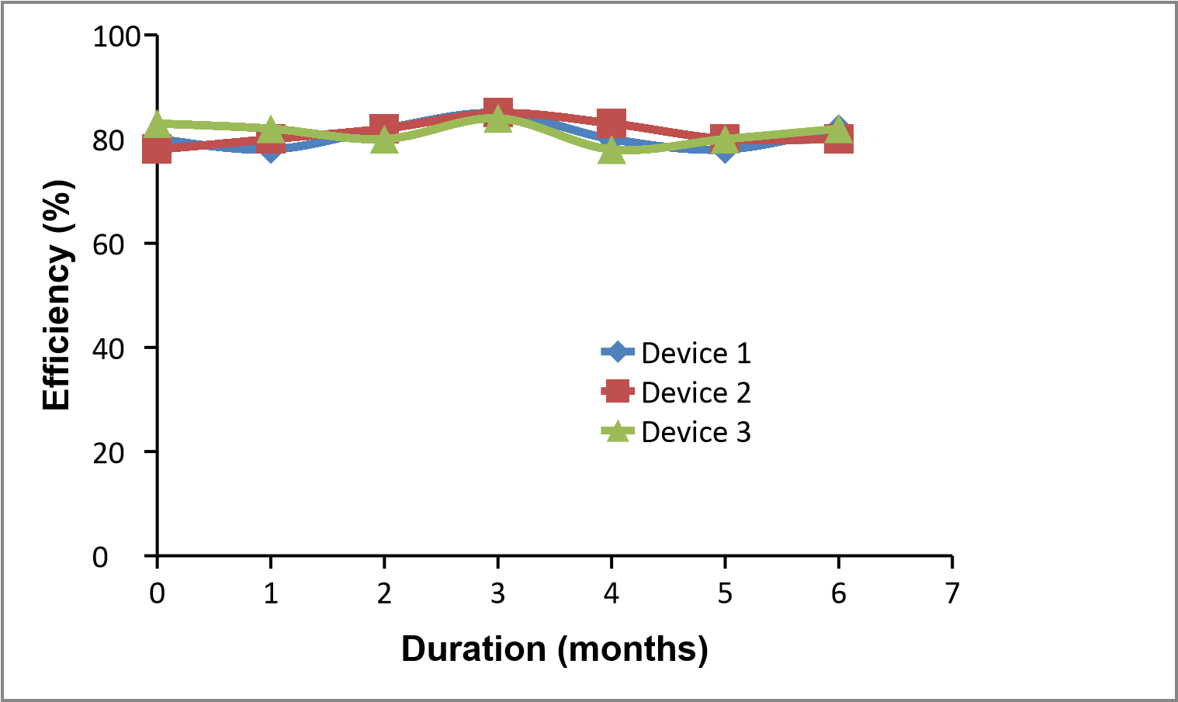

Fig. 1.1 Stability of the neuroprosthetics

# REFERENCES

Adewole DO, Serruya MD, Harris TP, Burrell JC, Petrov D, Chen HI, Wolf JA and Cullen DK (2016) The evolution of neuroprosthetic interfaces. *Critical Reviews in Biomedical Engineering, 44, 123-152.*

Andersen RA, Kellis S, Klaes C and Aflao T (2014) Toward more versatile and intuitive cortical brain-machine interfaces. *Current Biology, 24, R885-R897*.

Bensmaia SJ (2015) Biological and bionic hand: natural neural coding and artificial perception. *Philosophical TransaCtions of the Royal Society London B Biological Sciences*, 19, 370 (1677).

Ghafoor U, Kim S and Hong KS (2017) SeleCtivity and longevity of peripheral nerve and machine interfaces: A review. *Frontiers in Neurorobotics, 11, 59*.

Knutson JS, Fu MJ, Sheffler LR and Chae J (2015) Neuromuscular eleCtrical stimulation for motor restoration in hemiplegia. *Physical Medicine and Rehabilitation Clinics of North America, 26 (4), 729-745.*

Sanchez JC (2016) Neuroprosthetics: Principles and Applications. *CRC Press (USA)*.

Slutzky MW and Flint RD (2017) Physiological properties of brain-machine interface input signals. *Journal of Neurophysiology, 118, 1329-1343.*

Tabot GA, Kim SS, Winberry JE and Bensmaia SJ (2015) Restoring taCtile and proprioceptive sensation through a brain interface. *Neurobiology of Disease, 83, 191-198*.

**APPENDIX- A SIMILRITY INDEX PAGE FROM PLGIARISM CHECK**

**APPENDIX- B**

**ANY OTHER RELEVANT SUPPORTING INFORMATION**

**(e.g. IAEC APPROVAL, IF APPLICABLE)**

In the ever-evolving landscape of energy storage and eleCtric mobility, the precise monitoring and management of lithium-ion batteries play a pivotal role in ensuring their optimal performance and longevity. At the heart of this endeavor lies the critical parameter known as State of Charge (SOC), a fundamental metric representing the ratio of a battery's remaining capacity to its rated capacity. Accurate SOC estimation is indispensable for various applications, ranging from eleCtric vehicles and portable eleCtronic devices to renewable energy storage systems.

Lithium-ion batteries have emerged as the frontrunners in the realm of energy storage, championed for their high energy density, environmental friendliness, and versatility. As these batteries continue to dominate the market, the need for robust SOC estimation methodologies becomes increasingly imperative. SOC serves as a key determinant in diCtating the operational boundaries of a lithium-ion battery, influencing its charging and discharging cycles, overall efficiency, and, consequently, its lifespan.

However, the challenge lies in the faCt that SOC cannot be measured direCtly; rather, it necessitates estimation through external parameters such as voltage, current, and temperature. The accuracy of SOC estimation becomes even more crucial in dynamic environments, where faCtors like temperature variations, operational loads, and aging effeCts can significantly impaCt a battery's behavior.

This introduction sets the stage for the exploration of SOC estimation in the context of lithium-ion batteries, delving into the intricacies of why this parameter holds such prominence, the challenges associated with its accurate determination, and the overarching significance of developing precise SOC estimation techniques for the continued advancement of energy storage technologies.