PROJECT REPORT
FOR
Foundations of Artificial Intelligence
AI BASED FAKE NEWS DETECTION SYSTEM
A PROJECT REPORT
Submitted by
240701291 – LOGESHWARAN S
240701624 – NARENDARAN K

October, 2026

BONAFIDE CERTIFICATE
Certified that this project report “AI BASED FAKE NEWS DETECTION SYSTEM” is the bonafide work of “LOGESHWARAN.S & NARENDARAN.K” who carried out the project work under my supervision.
SIGNATURE OF THE FACULTY INCHARGE

Submitted for the Practical Examination held on ____________________

SIGNATURE OF THE INTERNAL EXAMINER

TABLE OF CONTENTS
CHAPTER NO. | TITLE | PAGE NO.
 | Abstract | 4
1 | Introduction | 5
2 | Literature Review | 7
2.1 | Fake News and Artificial Intelligence | 7
2.2 | Text Preprocessing and TF-IDF | 7
2.3 | Classification Algorithms | 7
2.4 | Related Work | 7
2.5 | Motivation for the Proposed System | 8
3 | Proposed System | 9
3.1 | System Workflow | 9
3.2 | Dataset | 9
3.3 | Algorithms Used | 9
3.4 | Architecture Diagram | 10
4 | Modules Description | 11
4.1 | Data Loading Module | 11
4.2 | Text Preprocessing Module | 11
4.3 | Feature Extraction Module | 11
4.4 | Model Training Module | 12
4.5 | Evaluation Module | 12
4.6 | Prediction API Module | 12
4.7 | Web Interface Module | 13
5 | Implementation and Result | 15
5.1 | Experimental Setup | 15
5.2 | Results | 16
6 | Conclusion and Future Work | 19
6.1 | Conclusion | 19
6.2 | Future Work | 19
7 | References | 20

ABSTRACT
Fake news is false or misleading information that is presented as genuine news. It spreads quickly through websites and social media, and it is difficult to verify manually because of the very large volume of online content. This project presents an AI Based Fake News Detection System that reads a news headline or article and predicts whether it is real or fake.
The system uses Natural Language Processing and Machine Learning. News text is cleaned and converted into numerical features using the TF-IDF (Term Frequency – Inverse Document Frequency) technique. Two supervised classification algorithms, Logistic Regression and Multinomial Naive Bayes, are trained on a labeled dataset of real and fake news articles and compared using accuracy, precision, recall and F1-score.
The trained model is deployed through a web application. The backend is developed using Python and Flask, and the frontend is developed using HTML, CSS and JavaScript. A user can paste news text into the interface and receive a Real or Fake prediction with a confidence percentage and the words that influenced the decision. The application also displays the performance metrics and the confusion matrix of the model.
The main objective of the project is to demonstrate how Artificial Intelligence, text processing and web technologies can be combined to support readers in judging the reliability of online news. The system analyses writing patterns and does not verify facts, so it is intended as a decision-support tool and not as a replacement for professional fact-checking.
Keywords: Fake News Detection, Artificial Intelligence, Natural Language Processing, TF-IDF, Logistic Regression, Naive Bayes, Text Classification, Flask, Web Application.

Chapter-1

INTRODUCTION
- The internet and social media have made it possible for news to reach millions of people within minutes. This speed also allows false information to spread widely before it can be corrected. Fake news can influence public opinion, create panic and damage trust in genuine sources.
- Manual fact-checking requires trained reviewers and a lot of time, so it cannot cover every article published online. Artificial Intelligence offers a practical way to give readers a quick first indication of whether a piece of news looks reliable.
- The objective of this project is to implement an AI Based Fake News Detection System as an interactive web application. The system takes news text from the user, processes it using Natural Language Processing techniques and uses a trained machine learning classifier to predict whether the news is real or fake.
The application provides the following main features:
1. Text Input
Users can paste any news headline or article into the web interface.
2. Text Preprocessing
The system converts text to lowercase and removes links, punctuation and stop words.
3. TF-IDF Features
Text is converted into numerical vectors that represent the importance of each word.
4. Machine Learning Classifier
Logistic Regression and Naive Bayes models are trained for classification.
5. Real or Fake Prediction
The system displays the predicted label for the news text.
6. Confidence Score
The system shows the probability of the prediction as a percentage.
7. Explanation of Result
The words that influenced the prediction are displayed to the user.
8. Performance Metrics
Accuracy, precision, recall, F1-score and the confusion matrix are shown.
9. Recent Checks
The interface keeps a short history of the latest predictions.
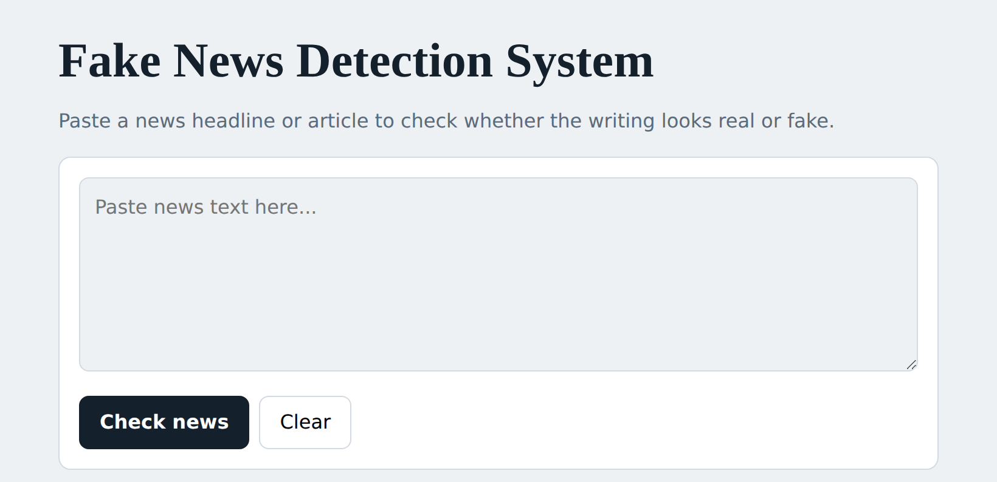
Fig 1.1 Home page

Chapter-2

LITERATURE REVIEW

2.1 Fake News and Artificial Intelligence
- Fake news detection is commonly treated as a text classification problem. Each article is a text sample and the aim is to assign it a label such as real or fake based on its content.
- Machine learning is suitable for this problem because fake and real articles often differ in vocabulary, tone and writing style. A supervised model can learn these patterns from many labeled examples.

2.2 Text Preprocessing and TF-IDF
- Raw text cannot be given directly to a machine learning model. It must first be cleaned and converted into numbers. Common preprocessing steps are lowercasing, removing links and punctuation, and removing stop words such as “the”, “is” and “of”.
- TF-IDF measures how important a word is to a document in a collection. Term Frequency counts how often a word appears in a document, and Inverse Document Frequency reduces the weight of words that appear in many documents. Words that are frequent in one article but rare overall receive higher weights.
The TF-IDF process can be summarised as:
- Split each article into words (tokens).
- Count how often each word appears in the article.
- Reduce the weight of words that appear in most articles.
- Create a numerical vector for the article.
- Provide the vector to the classifier.

2.3 Classification Algorithms
- Multinomial Naive Bayes is a probabilistic classifier based on Bayes’ theorem. It assumes that words occur independently and calculates the probability of each class from word counts. It is fast and works well for text.
- Logistic Regression is a linear classifier that assigns a weight to every word feature and converts the weighted sum into a probability. Because each word has a weight, the model can explain which words pushed the prediction towards real or fake.

2.4 Related Work
Several researchers have studied automatic fake news detection. Shu et al. (2017) surveyed fake news detection on social media from a data mining perspective and described the use of content-based and social-context features. Ahmed, Traore and Saad (2017) used n-gram features with TF-IDF and linear classifiers and showed that simple text features can perform well on fake news data. Pérez-Rosas et al. (2018) studied linguistic differences between fake and real articles and showed that writing style carries useful signals.
Wang (2017) introduced the LIAR dataset of short political statements and showed that detection from text alone is a difficult task. More recently, deep language models such as BERT (Devlin et al., 2019) have improved language understanding, but they need more data and computing power and are harder to explain than linear models.

2.5 Motivation for the Proposed System
Deep learning systems give strong results but are often complex to build and difficult to explain. For a course-level project, a lighter system that clearly shows each step – preprocessing, feature extraction, training, evaluation and deployment – is easier to understand and to demonstrate.
Therefore, the proposed system combines TF-IDF features with Logistic Regression and Naive Bayes classifiers and delivers the result through a simple web application that explains its prediction.
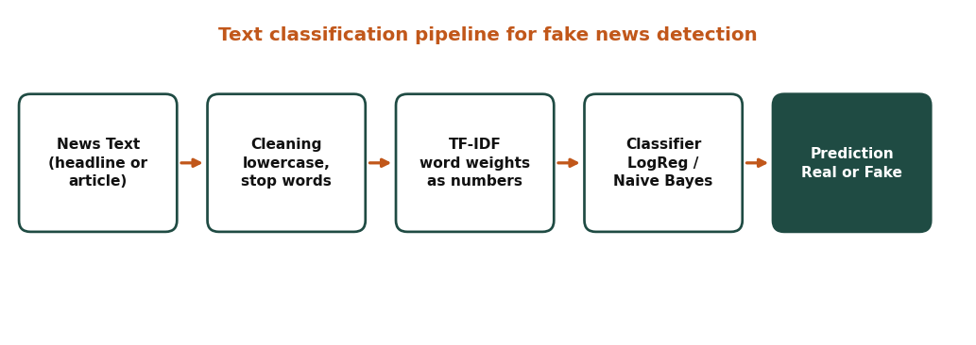
Fig 2.1 Overview of text classification for fake news

Chapter-3

PROPOSED SYSTEM
The proposed system is a web-based fake news detector. It has two phases. In the training phase, a labeled dataset is cleaned, converted into TF-IDF features and used to train the classifiers. In the prediction phase, the saved model is loaded by a Flask backend and used to classify the news text that a user enters in the web interface.

3.1 System Workflow
The general workflow of the system is:
- The dataset of real and fake news is loaded.
- Title and text of each article are combined and cleaned.
- The data is split into training (80%) and testing (20%) sets.
- TF-IDF features are extracted from the training text.
- Logistic Regression and Naive Bayes models are trained.
- The models are evaluated on the test set.
- The final model and the metrics are saved.
- The user opens the web application and enters news text.
- The backend cleans the text, creates TF-IDF features and predicts the class.
- The interface displays the label, confidence and influencing words.

3.2 Dataset
The project uses the Fake and Real News dataset (ISOT) available on Kaggle. It contains about 44,000 articles in two files: Fake.csv, which contains fake news articles, and True.csv, which contains real news articles. Each record has a title, text, subject and date. Real articles are labeled 1 and fake articles are labeled 0.
Many real articles in this dataset begin with the source tag “(Reuters)”. To prevent the model from learning this tag as a shortcut, the tag is removed during preprocessing. Duplicate articles are also removed.

3.3 Algorithms Used
TF-IDF Vectorizer
Uses English stop word removal, unigrams and bigrams, a maximum of 50,000 features, and ignores words that appear in more than 70% or fewer than 2 documents.
Logistic Regression
The final model used by the application. Its word weights are used to explain each prediction.
Multinomial Naive Bayes
A second model trained for comparison with Logistic Regression.

3.4 Architecture Diagram
The architecture consists of the training phase and the prediction phase. The training phase prepares the data and produces a saved model. The prediction phase uses this saved model through the Flask backend to respond to requests from the web interface.
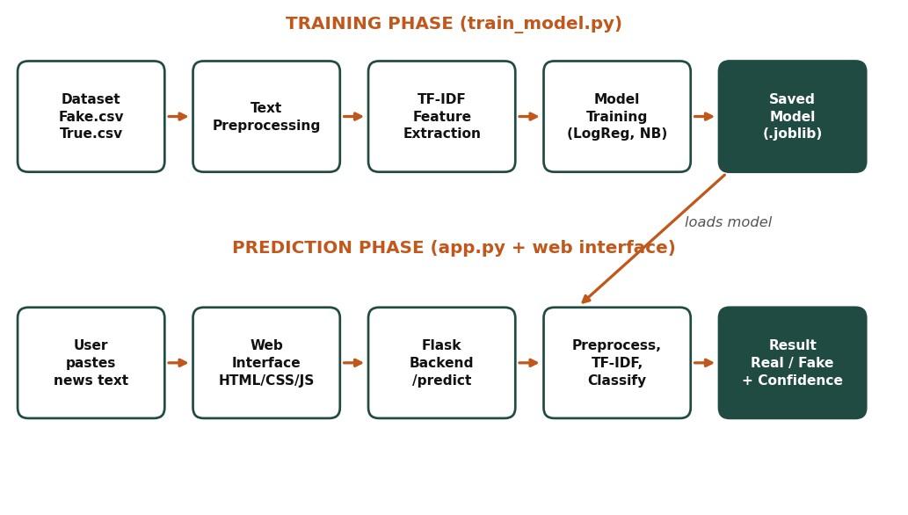
Figure 3.1: System Architecture

Chapter-4

MODULES DESCRIPTION

4.1 Data Loading Module
The Data Loading Module reads the dataset files and prepares them for training. It assigns the label 0 to fake news and 1 to real news, joins the two sets, and shuffles the records.
The module performs the following tasks:
- Reading Fake.csv and True.csv.
- Combining the title and text of each article.
- Removing empty and duplicate records.
- Shuffling the data randomly.
Main Functions
- Load dataset files.
- Assign class labels.
- Remove duplicates.
- Provide clean records to the next module.

4.2 Text Preprocessing Module
The Text Preprocessing Module cleans the text so that the model learns from meaningful words. The same function is used during training and during prediction so that both receive text in the same format.
The cleaning steps are:
- Convert text to lowercase.
- Remove the “(Reuters)” source tag.
- Remove web links.
- Remove numbers and punctuation.
- Remove extra spaces.
Main Functions
- Clean training text.
- Clean user input text.
- Prevent shortcut learning.

4.3 Feature Extraction Module
This module converts the cleaned text into numerical vectors using the TF-IDF Vectorizer. Stop words are removed and both single words and two-word phrases are used as features.
Main Functions
- Fit the vectorizer on training text.
- Transform training, testing and user text.
- Provide feature names for explanations.

4.4 Model Training Module
The Model Training Module trains the Logistic Regression and Multinomial Naive Bayes classifiers on the training features. The Logistic Regression model is saved together with the vectorizer as the final model.
Main Functions
- Train both classifiers.
- Compare their performance.
- Save the model using joblib.

4.5 Evaluation Module
The Evaluation Module tests the models on data that was not used for training. It calculates the following measures:
Metrics calculated:
- Accuracy – the share of all predictions that are correct.
- Precision – the share of articles predicted real that are actually real.
- Recall – the share of real articles that are correctly found.
- F1-score – the balance between precision and recall.
- Confusion matrix – a table of correct and wrong predictions for each class.
Main Functions
- Calculate metrics.
- Create the confusion matrix image.
- Store the results in metrics.json.

4.6 Prediction API Module
The Prediction API Module is developed using Flask. It loads the saved model and provides the routes used by the web interface.
The routes are:
- / – displays the web page.
- /predict – receives news text and returns the label, confidence and influencing words.
- /metrics – returns the stored performance results.
Main Functions
- Validate the input text.
- Clean and vectorize the text.
- Predict the class and probability.
- Calculate the contribution of each word to the result.

4.7 Web Interface Module
The Web Interface Module is the part that the user sees. It is developed using HTML, CSS and JavaScript. The user pastes news text and clicks the Check news button. The script sends the text to the backend and shows the response.
The interface displays:
- The predicted label (Looks real or Looks fake).
- The confidence percentage and probability bar.
- The words that influenced the prediction.
- The model performance table and confusion matrix.
- The latest five checks.
Main Functions
- Collect user input.
- Show error messages for short text.
- Display the result and explanation.
- Show model metrics.
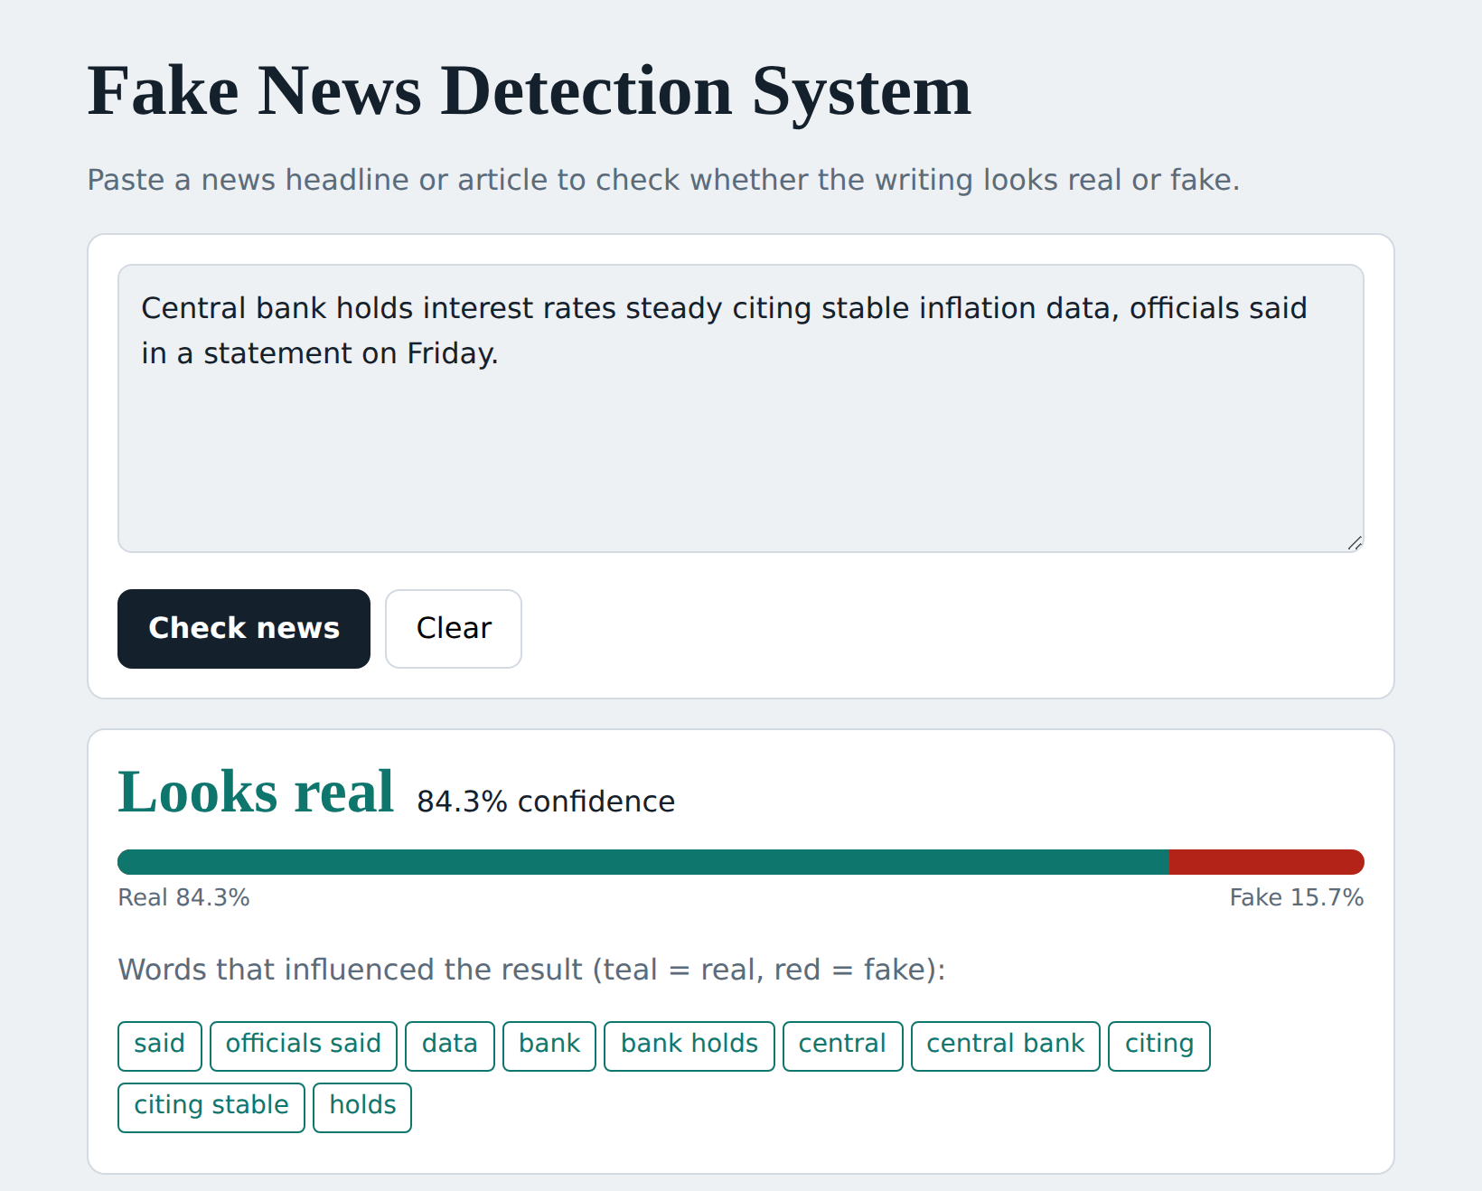
Fig 4.1 Prediction result page

Chapter-5

IMPLEMENTATION AND RESULT

5.1 Experimental Setup
The system was developed in Python using Visual Studio Code and tested on a local computer. The software and hardware used are listed below.
Item | Details
Programming language | Python 3
Libraries | scikit-learn, pandas, joblib, matplotlib, Flask
Frontend | HTML, CSS, JavaScript
Editor | Visual Studio Code
Dataset | Fake and Real News (ISOT), Kaggle
Data split | 80% training, 20% testing (stratified)
Processor / RAM | your processor / your RAM
The testing process included the following test cases:
Test Case 1 – Fake news text
The user enters a sensational and unverified claim.
Expected result: The system predicts Fake with a confidence score.
Test Case 2 – Real news text
The user enters a factual news report.
Expected result: The system predicts Real with a confidence score.
Test Case 3 – Short input
The user enters fewer than eight words.
Expected result: The system shows an error message asking for more text.
Test Case 4 – Influencing words
The user checks a news item.
Expected result: The system lists the words that influenced the result.
Test Case 5 – Metrics display
The page is opened after training.
Expected result: The model performance table and confusion matrix are displayed.
Test Case 6 – Recent checks
The user checks several news items.
Expected result: The latest checks are listed on the page.
Test Case 7 – Clear option
The user clicks the Clear button.
Expected result: The text box and the result are cleared.

5.2 Results
The model was trained on the training set and evaluated on the test set. The measured values are given in Table 5.1. These values are produced by running python train_model.py and are stored in model/metrics.json.
Table 5.1 Performance of the models
Model | Accuracy | Precision | Recall | F1-score
Logistic Regression
Multinomial Naive Bayes
The results show that text-based classification can separate real and fake news in this dataset with high accuracy. Add one or two sentences comparing your two models using your own numbers.
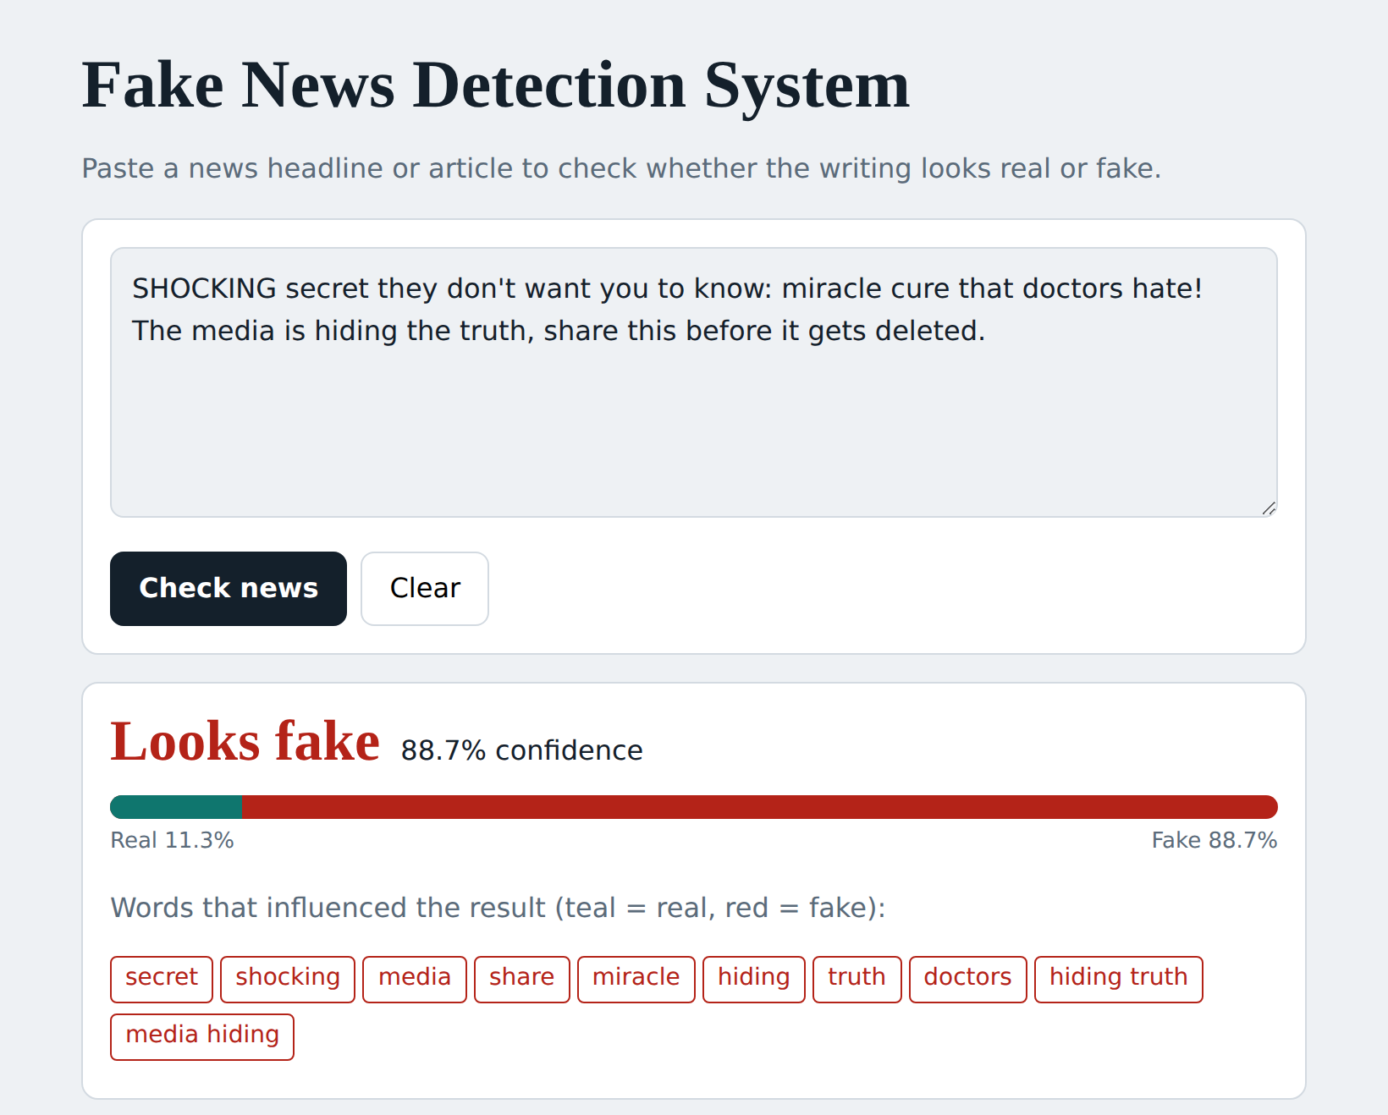
Figure 5.2.2 Fake news prediction

Figure 5.2.3 Real news prediction
The implemented system provides:
- News text input and validation.
- Automatic text preprocessing.
- TF-IDF feature extraction.
- Logistic Regression and Naive Bayes classification.
- Real or Fake prediction with confidence.
- Explanation using influencing words.
- Performance table and confusion matrix.
- History of recent checks.
The system works only on writing style and does not verify facts. It can make mistakes on satire, on very new topics, and on false news that is written in a formal style.

Chapter-6

CONCLUSION AND FUTURE WORK

6.1 Conclusion
- The AI Based Fake News Detection System classifies news text as real or fake using Natural Language Processing and Machine Learning. It combines text preprocessing, TF-IDF feature extraction and supervised classification in a single web application.
- The system trains Logistic Regression and Naive Bayes models, evaluates them using accuracy, precision, recall, F1-score and a confusion matrix, and deploys the final model through a Flask backend and an HTML, CSS and JavaScript frontend.
- By showing the confidence and the influencing words, the system helps users understand why a prediction was made.
- The project demonstrates the practical use of Artificial Intelligence in addressing the problem of misinformation. It also shows the limits of style-based detection, since the model does not check whether the claims are true.

6.2 Future Work
The project can be enhanced in several ways:
1. Deep Learning Models
LSTM or BERT models can be used to understand the meaning of sentences better.
2. Fact Verification
Claims can be checked against trusted sources or fact-checking databases.
3. More Datasets
Training on news from many sources and topics can improve generalisation.
4. Multiple Languages
Support for Tamil, Hindi and other languages can be added.
5. Link Input
The system can accept a news URL and extract the article text automatically.
6. Source Credibility
The reliability of the website or author can be added as a feature.

REFERENCES
- K. Shu, A. Sliva, S. Wang, J. Tang and H. Liu, “Fake News Detection on Social Media: A Data Mining Perspective,” ACM SIGKDD Explorations Newsletter, vol. 19, no. 1, 2017.
- H. Ahmed, I. Traore and S. Saad, “Detection of Online Fake News Using N-Gram Analysis and Machine Learning Techniques,” in Intelligent, Secure, and Dependable Systems in Distributed and Cloud Environments (ISDDC), Springer, 2017.
- V. Pérez-Rosas, B. Kleinberg, A. Lefevre and R. Mihalcea, “Automatic Detection of Fake News,” Proceedings of COLING, 2018.
- W. Y. Wang, “‘Liar, Liar Pants on Fire’: A New Benchmark Dataset for Fake News Detection,” Proceedings of ACL, 2017.
- J. Devlin, M.-W. Chang, K. Lee and K. Toutanova, “BERT: Pre-training of Deep Bidirectional Transformers for Language Understanding,” Proceedings of NAACL-HLT, 2019.
- F. Pedregosa et al., “Scikit-learn: Machine Learning in Python,” Journal of Machine Learning Research, vol. 12, 2011.
- Fake and Real News Dataset (ISOT), Kaggle. Available: https://www.kaggle.com/datasets/clmentbisaillon/fake-and-real-news-dataset

