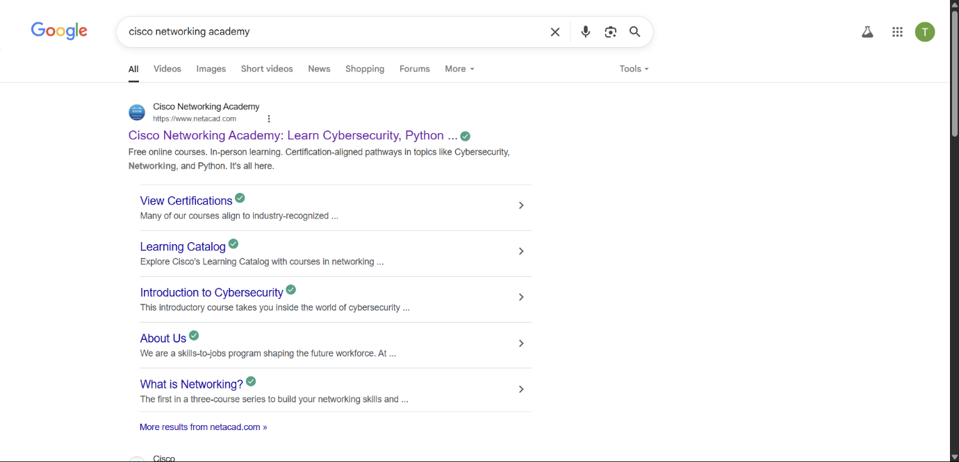Search Cisco Networking Academy on Google

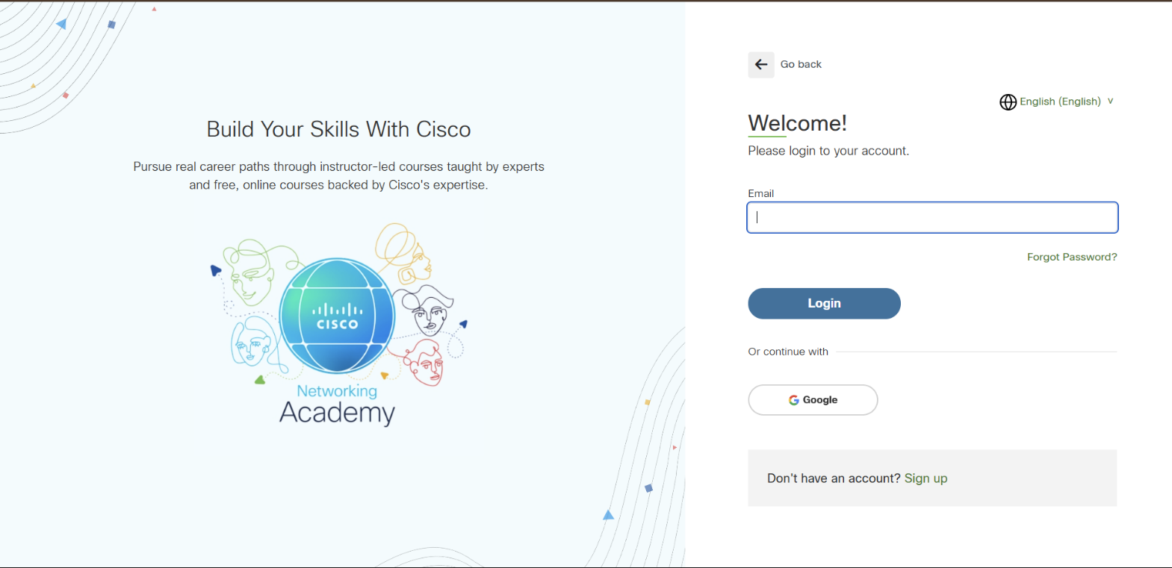Create an Account using Google

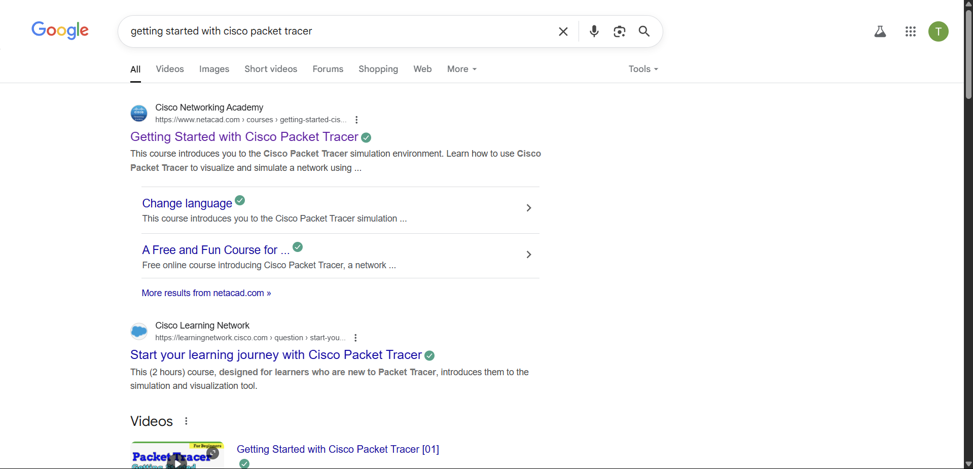  
Search getting started with cisco packet tracer on google

Enrol for the course

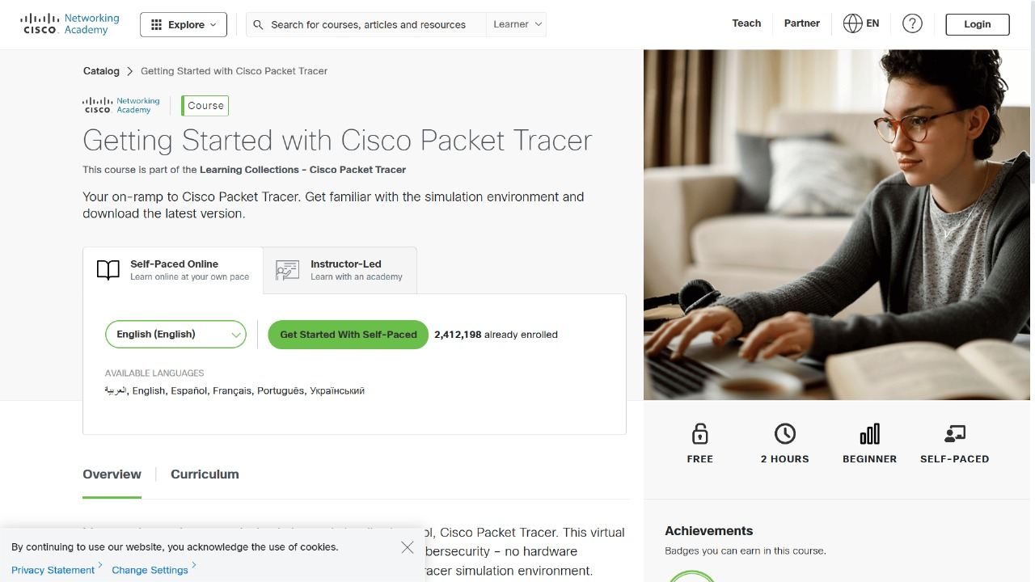  
  
  
  
  
  
Install Cisco Package Tracer

