 MANGALORE INSTITUTE OF TECHNOLOGY & ENGINEERING

(A unit of Rajalaxmi Education Trust ®, Mangalore)

**Autonomous Institute affiliated to V.T.U., Belagavi , Approved by AICTE, New Delhi**

Accredited by NAAC with A+ Grade & ISO 9001:2015 Certified Institution

**DEPARTMENT OF MANAGEMENT STUDIES**

**SOCIETAL RESEARCH REPORT (2023-24)**

**Empowering Futures: Skill Enhancement Program Workshop for Government School Students**

|  |  |  |  |
| --- | --- | --- | --- |
| **SL.NO** | **STUDENT NAME** | **USN** | **SIGNATURE** |
| 1 | Maneesh S | 4MT23BA064 |  |
| 2 | Monika N S | 4MT23BA066 |  |
| 3 | Naresh | 4MT23BA068 |  |
| 4 | Nikhitha | 4MT23BA071 |  |
| 5 | Nikhitha | 4MT23BA072 |  |
| 6 | Niveditha M Kotian | 4MT23BA074 |  |

GUIDE

Name: Ms.Ramya Bharadwaj B S

Signature:

Date: Signature of the HOD

**INTRODUCTION**

In today’s fast-paced and ever-evolving educational landscape, school students should be given better opportunities to enhance their skills and foster positive relationships with teachers and peers. This ensures that students remain engaged and motivated, minimizing stress and conflicts. Given how quickly the educational landscape is changing, it is now critical to provide students with the necessary abilities. With the growing academic and social demands placed on kids, skill development programs provide a proactive way to promote their overall development. These programs emphasize critical thinking, emotional intelligence, and interpersonal skills in addition to academic performance. These initiatives are being included into schools in an effort to address the widespread problem of student stress and how it affects overall performance. These initiatives assist the development of resilience and adaptation in students by creating a supportive atmosphere. Enhancing one's skills helps students in and out of the classroom by preparing them for obstacles they may face in the workforce and in further education. As educational establishments pursue excellence, the importance of student welfare and skill enhancement cannot be overstated. This research explores the several aspects of skill development initiatives, how they are implemented, and the positive outcomes that are observed.

Students need for skill development has grown in the quickly changing educational environment. Students who participate in programs that emphasize communication and confidence are better prepared to take on obstacles and use creative, out-of-the-box thinking to find lasting solutions. These programs, which place a strong emphasis on cooperation, educate students how to collaborate so that no arguments, conflicts, or disagreements get in the way of their success. Through the cultivation of constructive team dynamics, students acquire an appreciation for varied viewpoints and contributions. As they grow, these skills ensure they maintain a positive outlook towards teamwork and work cordially with others. Enhanced communication abilities enable students to express their ideas clearly and effectively, facilitating better understanding and collaboration. The ultimate objective is to equip students for the challenges of higher education and professional life, in addition to academic accomplishment. Students develop into well-rounded people with the ability to meaningfully contribute to their communities and beyond through skill enhancement.

**Need for Skill Enhancement:**

Enhancing skills is essential for students' development because it gives them the self-assurance and communication abilities, they need to successfully handle social and academic problems. It also encourages collaborative problem-solving and original thinking, guaranteeing that students are adequately equipped for their future academic and personal achievements.

* To build self-confidence and essential communication skills, enabling students to express their ideas clearly.
* To teach students to collaborate harmoniously, fostering positive attitudes towards teamwork essential for future professional environments.
* To emphasize creative, out-of-the-box thinking, preparing students to tackle problems innovatively and effectively.
* To prepare them for both academic success and personal and professional challenges.

**OBJECTIVES**

* Build self-confidence and improve communication skills for clear expression of ideas.
* Foster positive teamwork attitudes to prepare students for professional environments.
* Develop innovative problem-solving abilities for academic, personal, and professional challenges.

**PROJECT PLAN**

**Date:** 10th July, 2024

**Locations:**

* Karnataka Public School, MIJAR SECONDARY Moodabidri, DK - 574225
* Govt. Pre-University College (High School Section) Malpe, Udupi - 576108
* Government Highschool Baikampady, Meenakaliya - 575010

The overall objective of the skill enhancement program is to empower students by enhancing their communication abilities, boosting their self-confidence, and encouraging teamwork in the three schools it was designed for. To ensure a more profound influence and effective connections, the team decided to concentrate on just three of the five schools with which it had originally intended to work. The program's objective was to help students acquire creative problem-solving skills that they may use in their academic, social, and professional lives. We split the team up into three groups so that the workshops and other activities could be carried out effectively. Through interactive sessions led by each group, clear communication of ideas and teamwork through joint projects were encouraged. Activities included creative problem-solving challenges that prompted students to think critically and innovate.

**DETAILED DESCRIPTION:**

The Govt. Pre-University College (High School Section) Malpe, Udupi, Karnataka Public School, MIJAR SECONDARY Moodabidri, and Government Highschool Baikampady, Meenakaliya were the three government schools where the July 10th Skill Enhancement Workshop was held. The main goals of the workshop were to help students develop their innovative problem-solving skills, communication skills, self-confidence, and teamwork. This aim of this program was to give students the fundamental abilities needed to succeed in both academic and professional settings. The goal of the workshop was to establish a positive learning environment that promoted student involvement and creativity through a range of captivating activities and interactive sessions.

**Workshop Activities:**

* **Confidence Communication Skills:**

In this session, students participated in exercises that focused on verbal communication skills. They practiced articulating their thoughts clearly through structured discussions. Non-verbal communication techniques were introduced, emphasizing the significance of body language and facial expressions. Students were given the opportunity to present on various topics in front of their peers, which significantly helped in building their public speaking confidence. Also, feedback was provided for them regarding their talk as to encourage their improvement in the future.

* **Fostering Creativity and Innovative Problem Solving:**

Later, we engaged the students in a creative problem-solving exercise where they had to construct a towering tower out of balloons and cello tape. They had to create a structure that could withstand wind that was not real, which forced them to consider their design decisions carefully. Students brainstormed creative solutions in small groups, talking over several approaches to make sure their buildings stayed sturdy. They had to experiment with various setups and methods for this practical assignment, which encouraged a trial-and-error atmosphere. Along with developing their creative thinking and cooperation abilities, students built their towers by considering innovative ways to use basic resources. They gained important knowledge about engineering concepts like balance and weight distribution throughout the exercise. The competition inspired students to push boundaries and improve their designs by bringing enthusiasm to the process. In the end, this interesting exercise fostered a sense of accomplishment as they skilfully constructed their towers and strengthened teamwork.

* **Team Building:**

Attempting to improve student collaboration and highlight the value of working well as a team, team-building activities were held. Students had to rely on one another to complete group challenges, which improved trust and communication among their teams. Through these group projects, students were able to put their cooperation and communication abilities to use in real-world scenarios. They worked on given tasks in small groups, which encouraged imaginative cooperation and a feeling of shared accountability. One of the assignments required the students to use newspaper, chart paper, scissors, glue, and other materials to make a collage on a theme of their choice. Through this practical exercise, they were inspired to think creatively and extensively, converting ordinary materials into expressive artwork. Students conversed, shared ideas, and encouraged one another's contributions while they worked on their collages. In the end, their displays of diverse collages on various subjects demonstrated not only their creative ability but also the important cooperative skills they acquired during the activity.

**Program Overview:**

We held a skill-development session at Government High School with the aim of developing the collaborative, communicative, and creative thinking abilities of the students. This program is a subset of a larger project in which we conducted comparable seminars in several schools, guaranteeing a profound effect on the development of the kids as individuals. Every program included engaging activities intended to keep students interested and develop critical abilities outside of the classroom. Our goal was to empower kids and provide them with a comprehensive education by fostering a friendly environment. Our objective was to provide with useful information to the students that improves their general competency and ability to contribute to society.

* **Confidence Communication Skills:**

During the confidence communication session at Government High School, students actively engaged in verbal communication activities designed to enhance their speaking skills. Through structured conversations, they developed clear-thinking abilities and learned the significance of nonverbal communication, such as facial expressions and body language. Students also had the opportunity to present on various topics, which significantly boosted their confidence in public speaking. Overall, the session received positive feedback, with students expressing noticeable improvements in their communication skills and eagerness to continue developing further.

1. **Karnataka Public School, Mijar secondary Moodabidri**

Students were given themes including Covid-19, online learning, and the Internet for the "Pick and Speak" assignment, and they had to speak for a few minutes without any preparation. The goal of this spontaneous speaking challenge was to increase their self-assurance and public speaking abilities while promoting audience participation and clear expression.  
**Observation:** Every student actively participated and demonstrated a desire to talk about their subjects. Their confidence and articulation increased as the activity went on, which helped them make stronger eye contact and communicate with their peers during presentations.

**Result:** The "Pick and Speak" activity greatly increased the students' confidence in voicing their opinions and improved their public speaking skills. Students showed enhanced communication abilities by the end of the program, which will help them in their future speaking engagements.

1. **Govt. Pre-University College (High School Section) Malpe, Udupi**

Students at the government school had discussions on five key subjects during the confidence communication session: the use of money, recycling, the effects of war, environmental awareness, and electric vehicles. The first group talked about waste management and conservation initiatives while emphasizing the value of the environment. The second group looked at the subject of war, examining its social consequences and encouraging responsibility. The third group focused on recycling and stressed how important it is for preserving the environment. The fourth group discussed how electric vehicles contribute to sustainability and pollution reduction while examining their effects. The fifth group, which focused on making wise financial decisions for the future, finally talked about how money may be used to better society. This wide range of subjects was intended to promote critical thinking while improving student participation and communication abilities.

**Observation:**

Each student showed a great eagerness to learn about and share their ideas about the topics they were assigned, as seen by their enthusiastic participation in the discussions. With time, their self-assurance increased, which resulted in less anxiousness and a more passionate delivery of their presentations. Throughout the session, students fostered a collaborative environment by effectively communicating their thoughts.

**Result:**

Participants showed notable gains in their communication skills and a significant reduction in stage fright. Students demonstrated improved mental clarity by the end of the session, laying a solid basis for any future communication difficulties. All things considered, the workshop was rather effective in increasing their self-assurance and collaboration abilities.

1. **Government Highschool Baikampady, Meenakaliya**

We held a confidence communication session at the government school on July 10, 2024, with three main themes: the environment, living in an urban or rural setting, and the efficient use of fifty lakhs. Every subject was designed to get students talking and to help them think about what they were saying. The first lesson's focus was environmental awareness, which made students think about topics like sustainability and conservation. The second topic sparked discussion about the benefits and drawbacks of living in an urban or rural area. Ultimately, the debate on the use of fifty lakhs pushed students to consider innovative ways to enhance both society and themselves.

**Team Discussion:**

Throughout the session, every student engaged in active participation in the discussions, exhibiting excitement and teamwork. Team leaders created an environment of support and encouragement by effectively motivating their peers. The students' sense of community and dynamic interactions were a result of their teamwork.

**Observation:**

Positive results from the program included students demonstrating enhanced public speaking confidence and communication skills. By the end, attendees said they were more eager to contribute their thoughts and participate in talks in the future. All things considered, the exercise was effective in improving their communication and cooperation skills.

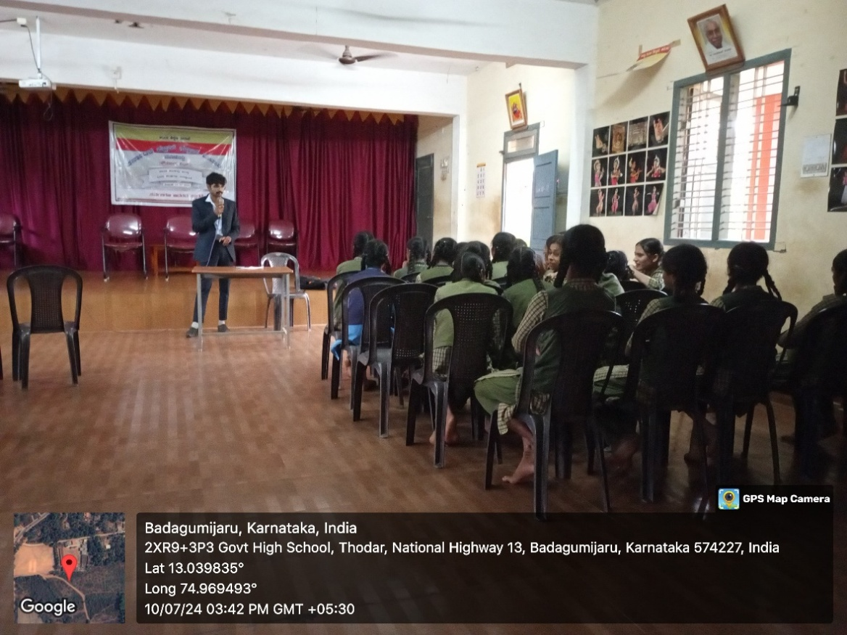

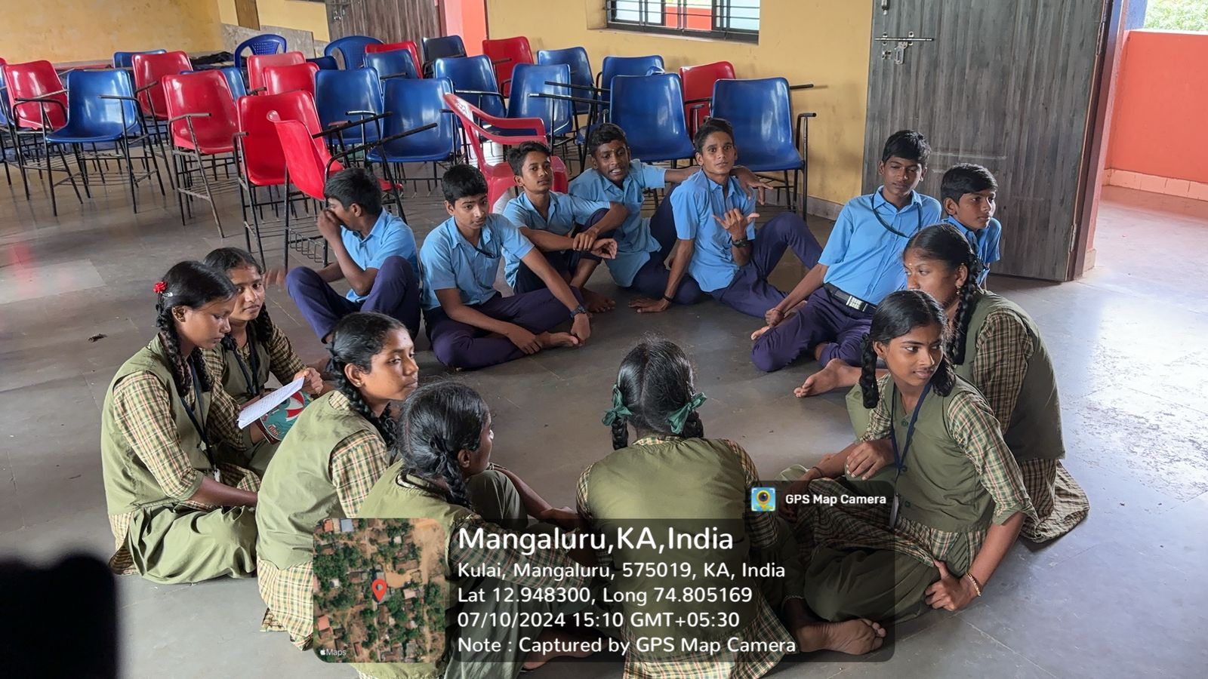

***Educating students about the communication skills***

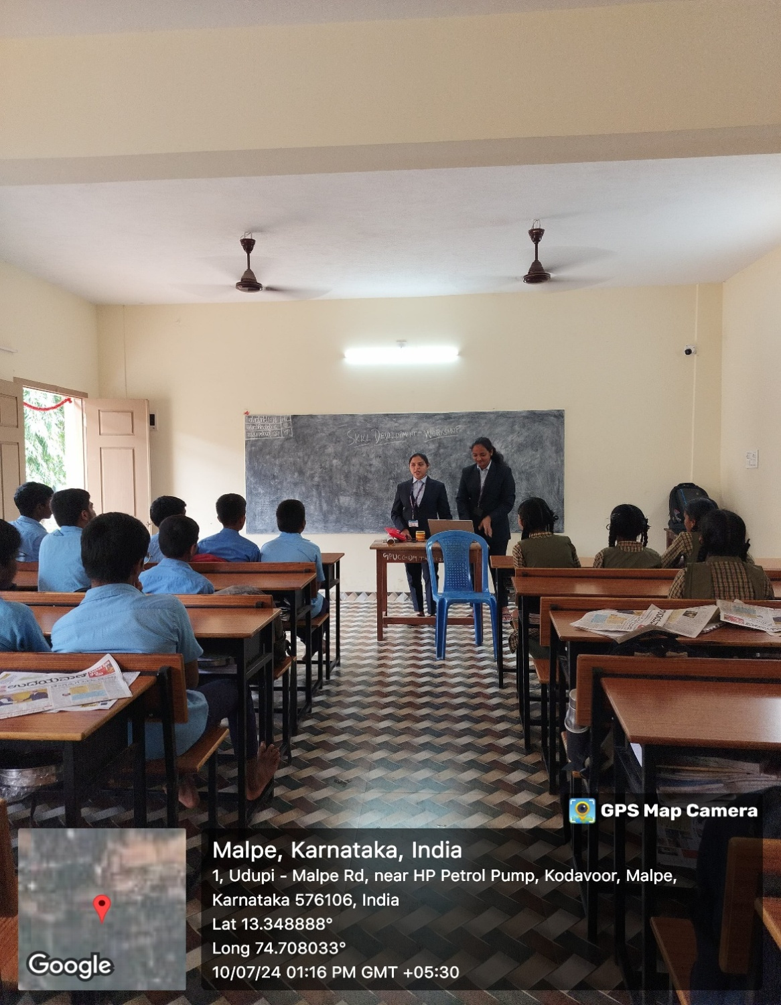

* **Creativity and Innovation:**

Students at Government High School eagerly get into teamwork as they construct the tallest tower out of balloons and tape during the balloon tower construction activity. Their creativity is sparked by this intriguing assignment, which forces them to come up with creative concepts in a constrained amount of time. Students improve their collaboration abilities when they actively interact and assist one another while working together. Excitement permeates the air, making everyone interested in the distinctive constructions they will build together.

1. **Karnataka Public School, Mijar secondary Moodabidri**

We visited three schools as part of our skill-enhancement program. First up was Karnataka Public School in Mijar. Students were divided into teams for the balloon tower construction activity, and their goal was to use tape and balloons to construct the tallest structure possible. Each group embraced this task with great passion and showed amazing innovation as they experimented with various concepts and building techniques. They collaborated well, communicating their ideas with assurance and clarity as they described their procedures. Their creative potential was stimulated and teamwork was fostered by this interactive event. Students had developed their teamwork abilities and discovered a newfound love for the process by the end of the session, which made for an interesting learning environment.

1. **Govt. Pre-University College (High School Section) Malpe, Udupi**

We next headed to the Govt. Pre-University College in Malpe, where students had to construct the tallest structure in under 15 minutes. Every team displayed their inventiveness, frequently going above and above with their original creations. Students successfully expressed their thought processes and articulated their thoughts in clear and concise ways when working together. They were able to unleash their creative potential and think creatively thanks to this practical exercise, which led to an engaging session that showcased their problem-solving and collaboration abilities. Students acquired important experience working together under time constraints and were proud of their products by the end of the activity.

1. **Government Highschool Baikampady, Meenakaliya**

Subsequently, we used a similar exercise at Government High School in Baikampady to concentrate on innovation and team development. Pupils were instructed to build a structure in 15 minutes using balloons and tape. Throughout the exercise, we stressed the value of cooperation and clear communication, which helped the students understand how important innovation is to group projects. They discovered how to openly exchange ideas and rely on each other's talents as they collaborated. Their creativity was boosted by this experience, which also reaffirmed the need of teamwork. All things considered, the classes at all three schools gave the students interesting chances to grow their abilities in a memorable and enjoyable way.

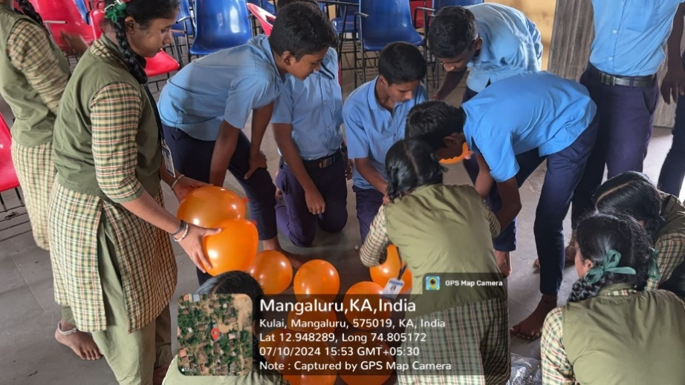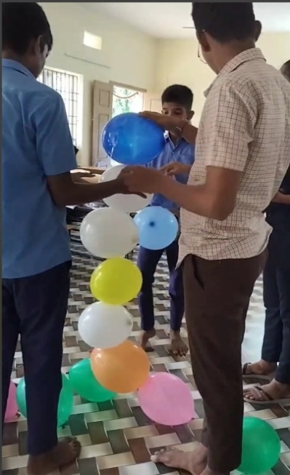

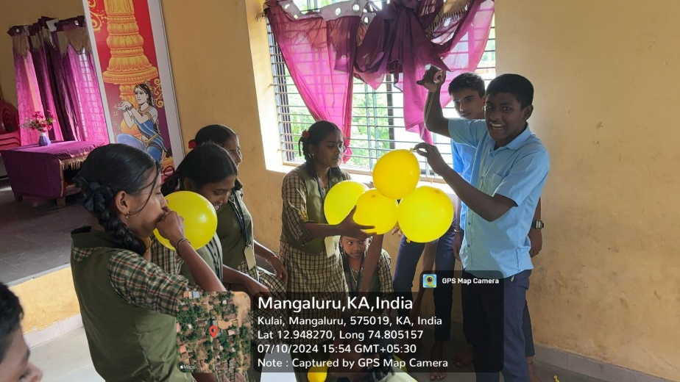

*Building Pillars with Balloons: A Collaborative Team-Building Activity*

* **Team Building:**

During the collage-making session in the government schools, newspapers and charts were given to the students so they could make original artwork and share social messages. In order to develop their ideas and finish their projects, students worked closely together in this activity that highlighted collaboration. They discovered the value of cooperation and communication in reaching a common objective as they cut, organized, and adhered their materials. Students were prompted to think creatively and unconventionally by the hands-on project, which resulted in the transformation of common materials into expressive artwork. By the end of the session, kids had demonstrated their artistic abilities and learned important lessons about collaboration and teamwork, making for a fruitful and enjoyable learning environment.

1. **Karnataka Public School, Mijar secondary Moodabidri**

We visited three schools as part of our skill-enhancement program to encourage student collaboration and innovation. Students at Mijar's Karnataka Public School had fifteen minutes to work with charts and newspapers to construct original creations. Team members worked well together during this exercise as they supported and exchanged ideas. Pupils demonstrated observable gains in their ability to solve problems and work cooperatively to overcome obstacles. They learned the value of cooperation and strategic planning from the session, which greatly improved their capacity to cooperate to achieve a common objective.

1. **Govt. Pre-University College (High School Section) Malpe, Udupi**

Moving on, at Govt. Pre-University College in Malpe, a 15-minute collage-making exercise was used to emphasize the development of soft skills. Here, kids created significant messages for society using newspapers, which encouraged productive conversations and group brainstorming. They gained a deeper comprehension of societal concerns and a wider range of employment alternatives thanks to this practical approach. They were better able to understand industry demands by the end of the session, which helped them make more educated career decisions.

1. **Government Highschool Baikampady, Meenakaliya**

Finally, we had a 15-minute talk about the value of teamwork at Government High School in Baikampady. We assisted kids in realizing that in order to accomplish goals, good communication, creativity, and teamwork are all necessary. By the end of the session, they had acquired useful teamwork skills and had promised to use them in next projects. Every school shown a great deal of excitement for the events, underscoring their dedication to provide students with dynamic and interesting learning opportunities that foster the development of critical life skills. In general, all three schools benefited from the program's excellent promotion of creativity and teamwork.

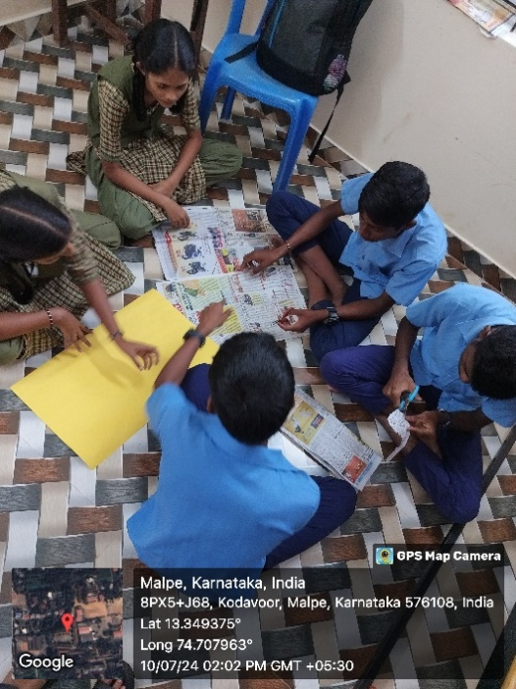

*Newspaper Collage Activity: A Creative Expression*

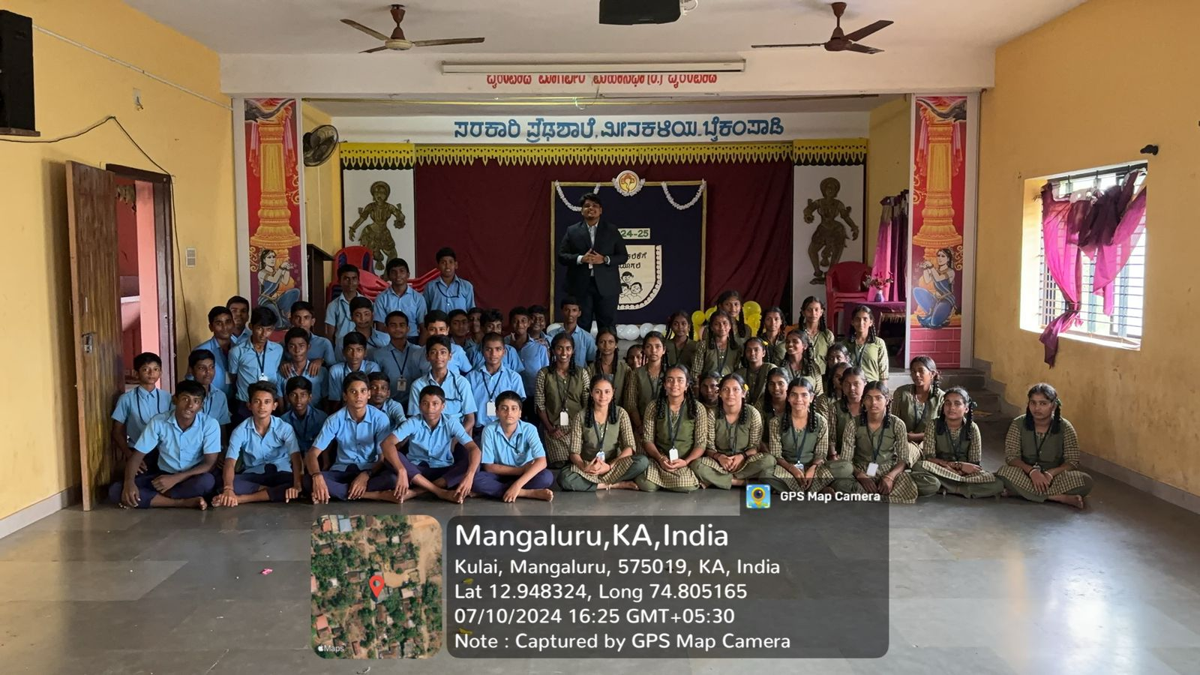

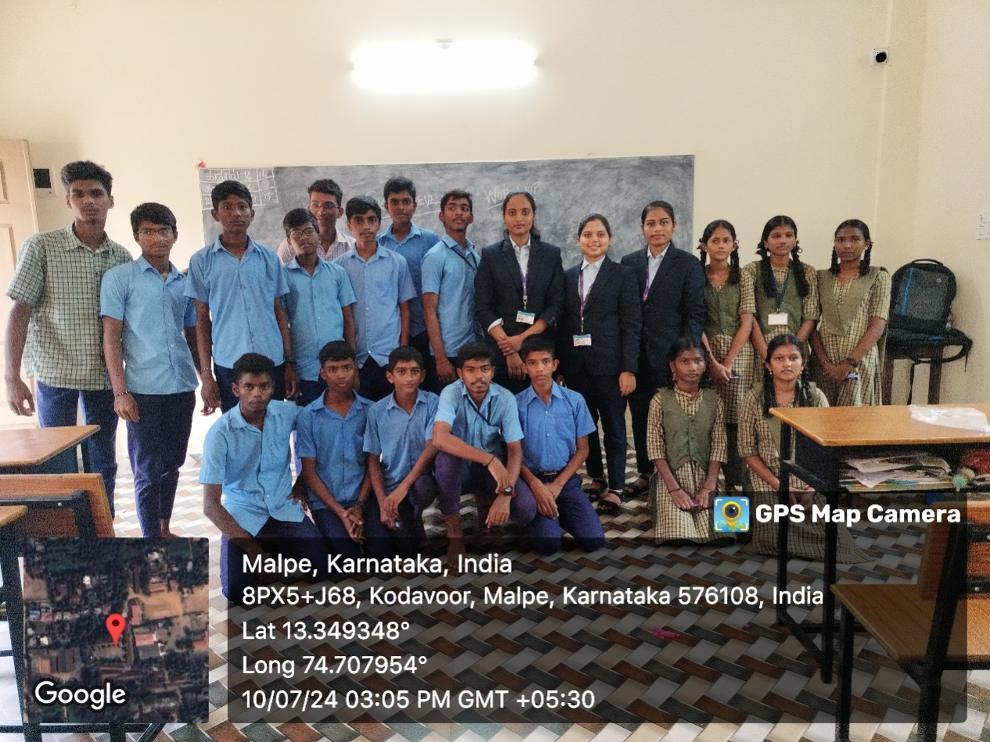

**OUTCOME**

The students' communication, creative thinking, and team-building skills were significantly boosted by the skill enhancement program at Karnataka Public School, MIJAR Secondary Moodabidri; Govt. Pre-University College (High School Section), Malpe, Udupi; and Government High School Baikampady, Meenakaliya. All of the students enthusiastically participated in the "Pick and Speak" exercise, showing a noticeable improvement in their public speaking skills that resulted in improved confidence and articulation. Students demonstrated exceptional ingenuity and teamwork in the "Balloon Tower Construction" challenge, working together to construct eye-catching towers and proving their capacity for creative problem-solving. The "Creativity out of Newspaper and Chart" exercise greatly improved the team members' ability to work together and solve problems, as well as their comprehension of strategic planning. Students deeply engaged with a range of social subjects during these events, including the effects of electric vehicles and environmental awareness, which encouraged civic involvement and a sense of responsibility. Students were able to acquire a more sophisticated understanding of societal concerns through the debates surrounding recycling and efficient resource use. Overall, participants showed impressive improvements in active listening and a reduction in stage fright, which is indicative of their increasing self-assurance and participation in group discussions. The program encouraged students to make wise decisions for their personal and professional lives in addition to preparing them for future career possibilities. Responses revealed a good change in the way the students interacted, demonstrating their preparedness for productive teamwork. Ultimately, the program's success highlights how crucial it is to provide ongoing assistance and other efforts of a similar nature in order to promote students' holistic development and provide them with the fundamental skills they will need for their future endeavours.

**LEARNINGS**

Within our capacity as the Skill Development Program presenter, we learned a number of important lessons that will improve our work in engagement and education going forward. First and foremost, we came to understand how crucial it is to foster a secure space for children to express themselves, as doing so greatly increases their self-assurance and participation readiness. Seeing how students interacted with one another highlighted the importance of carefully planned exercises that foster cooperation among participants in addition to creativity. Practical exercises, like "Balloon Tower Construction," have been shown to be useful in fostering increased collaborative abilities and imaginative thinking.

Additionally, we discovered how important it is to have defined positions in teams, such as team leaders, as this promotes accountability and improves group dynamics. Students' discussions on a wide range of subjects, from professional goals to environmental concerns, proved how successful it is to make learning applicable and tied to current events. It was found that brainstorming sessions helped to foster deeper interactions and gave students a greater knowledge of societal concerns.

In order to successfully assist students and reinforce learning objectives, we also realized how important it is to provide ongoing feedback during tasks. The difficulties in team dynamics highlighted the necessity of providing clear training in communication and cooperation skills, which are critical for accomplishing common objectives. This experience made us realize how important it is to be patient and flexible when teaching because every lesson brought new difficulties that needed to be addressed right away.

Going forward, we are aware of how important it is to provide students with continued support in order to guarantee that the abilities they have learned during workshops are consistently strengthened and improved. We can make a big difference in students’ overall development by fostering a culture of growth and cooperation and giving them the tools they need for success in the future. All things considered, this program has strengthened our resolve to provide kids with memorable, stimulating learning opportunities.

**CONCLUSION**

There are significant effects on students and society from the skill-enhancement program that is being implemented in Government High School, Govt. Pre-University College, and Karnataka Public School. Through the development of self-assurance in communication, creativity, and teamwork, the project gives children vital life skills that they may use outside of the classroom. Students who are more proficient in public speaking are better able to articulate their opinions, which increases community and civic involvement.

Students are encouraged to think critically about societal issues as a result of the program's emphasis on important subjects like environmental awareness and social responsibility. This helps to create a generation that is both knowledgeable and driven to effect change. Collaborative exercises such as "Balloon Tower Construction" and collage-making classes help kids learn the value of cooperation and common objectives. This kind of cooperation is essential in a society where, solving complicated problems together is becoming more and more necessary.

Furthermore, the participants' improved confidence and decreased stage fright indicate a favourable change in their preparedness for participating in public discussion. This increased self-assurance may result in more engaged involvement in neighbourhood projects and conversations, which will ultimately improve society discourse. By fostering these abilities, the curriculum encourages students to make wise decisions that are advantageous to their communities and establishes the groundwork for responsible citizenship.

The program's overall success serves as a reminder of the need for ongoing funding for these kinds of educational projects. We can raise a future generation that has the abilities and perspective required to make valuable contributions to society by creating conditions that encourage development and cooperation. Essentially, the curriculum equips students to become proactive change agents in their communities in addition to preparing them for personal achievement.

**VIDEO LINK:**

[**https://drive.google.com/file/d/12iXhJ1-cZMVeGHllNCZrPult_dXVetV9/view?usp=drive_link**](https://drive.google.com/file/d/12iXhJ1-cZMVeGHllNCZrPult_dXVetV9/view?usp=drive_link)

**ANNEXURE**

**Appreciation letters given by the schools**

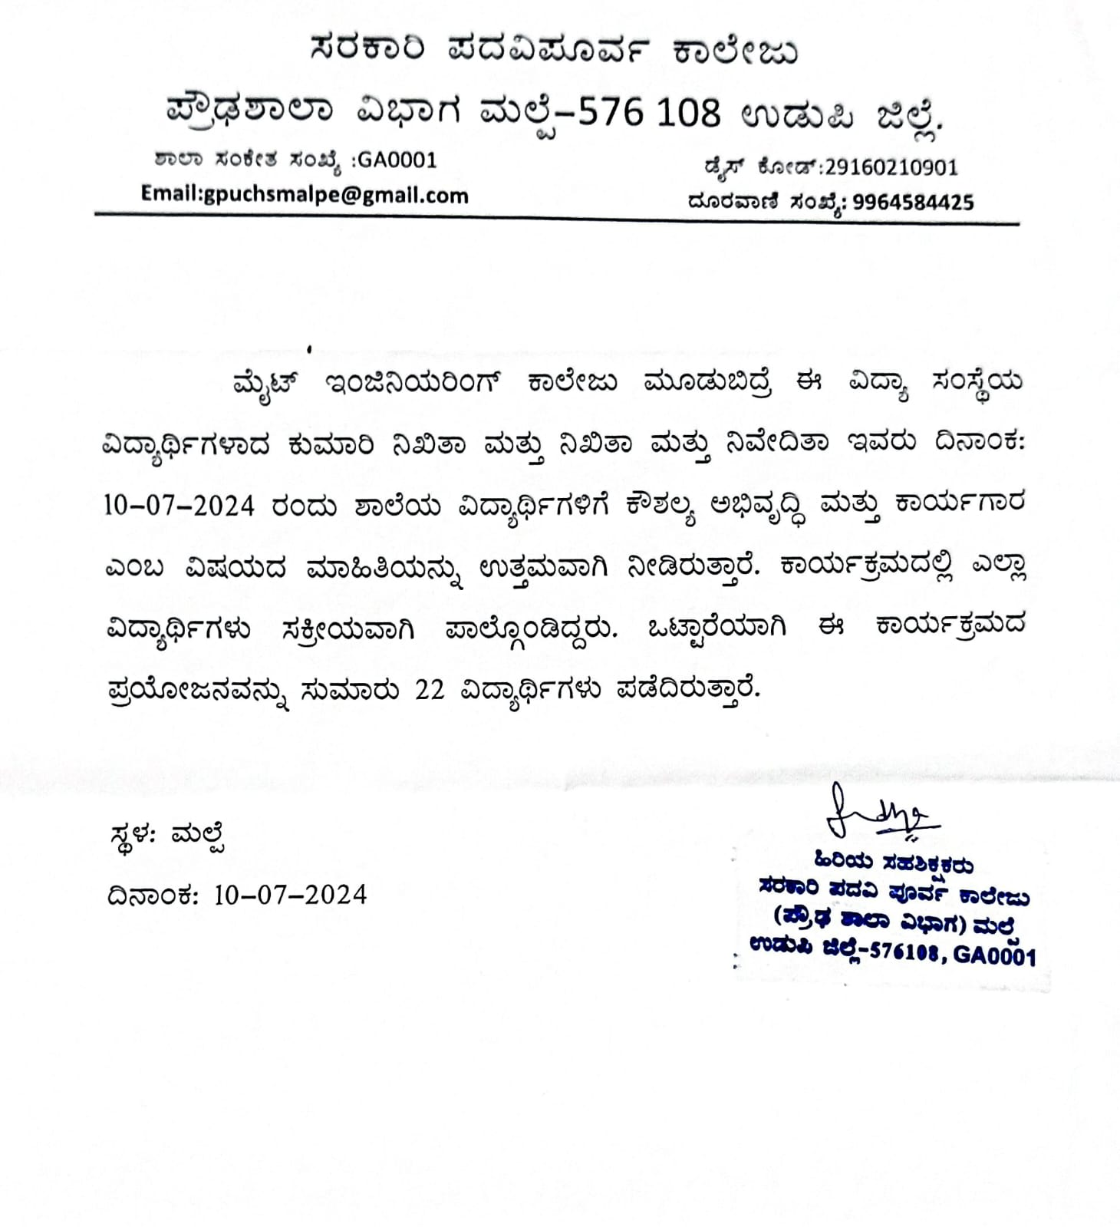

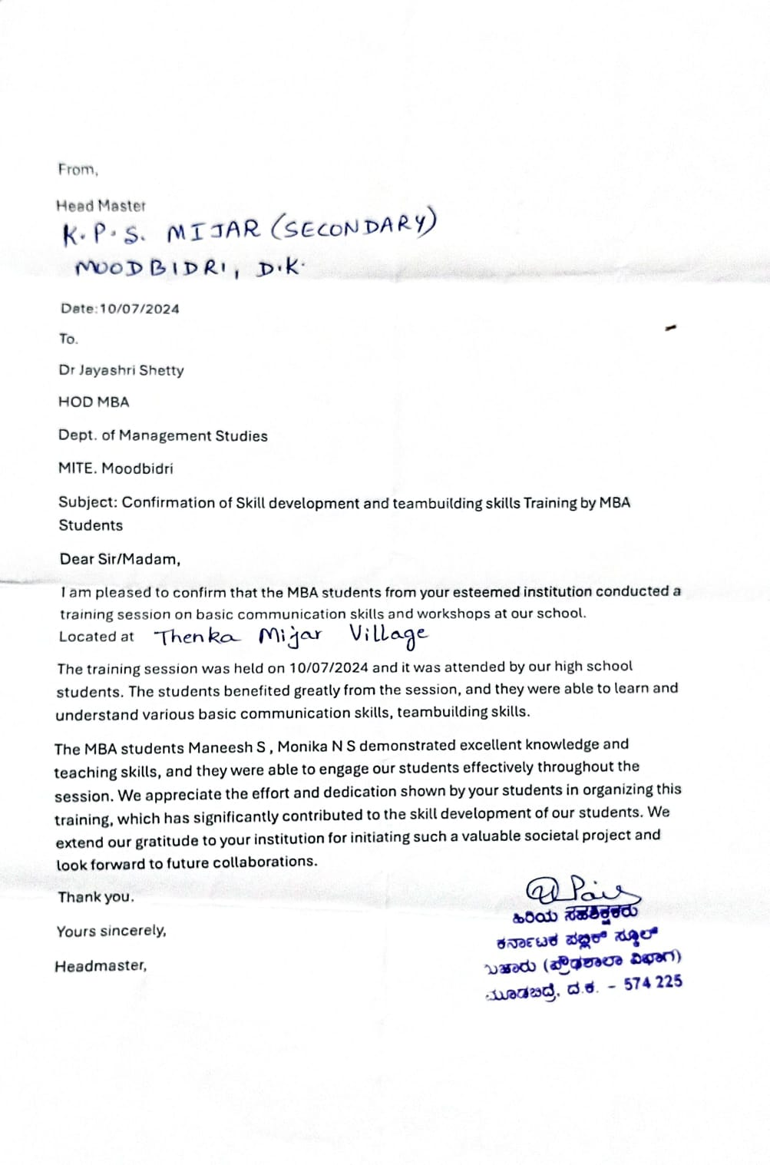

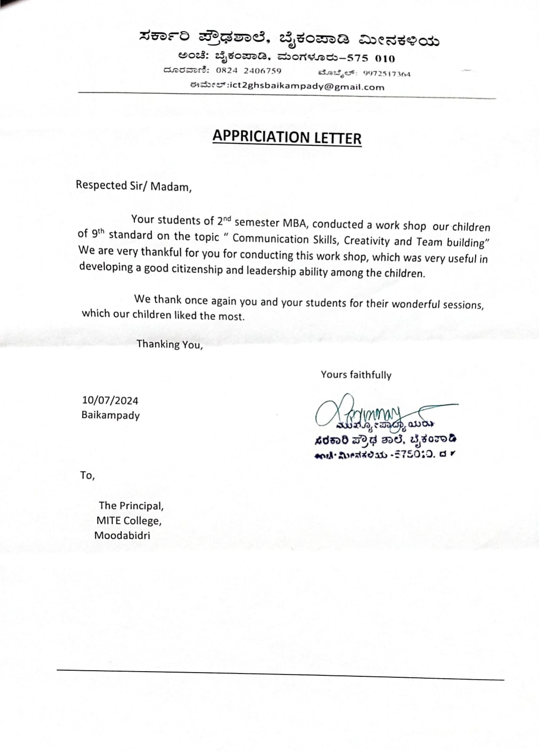

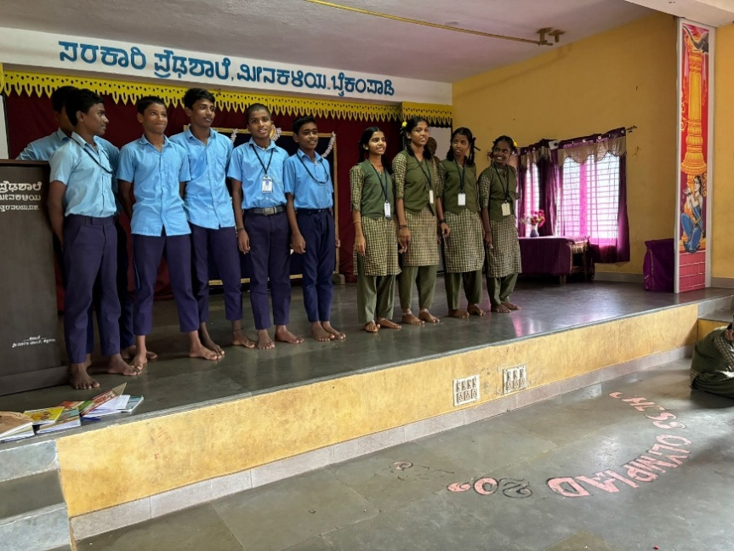

*Pick and Speak Activity: Enhancing Public Speaking and Critical Thinking*

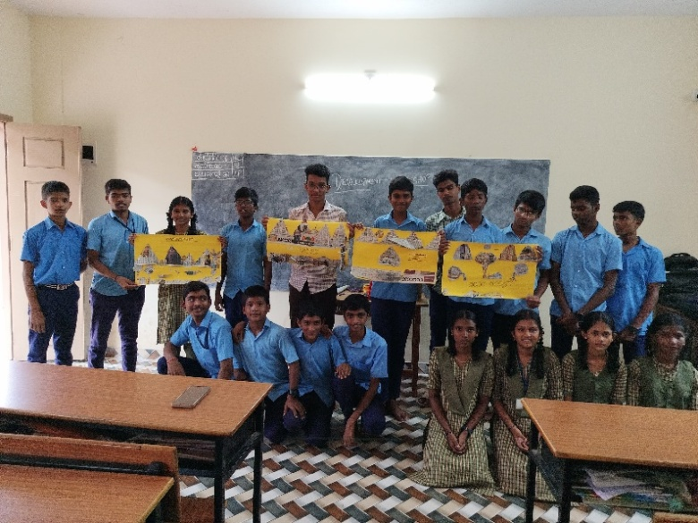

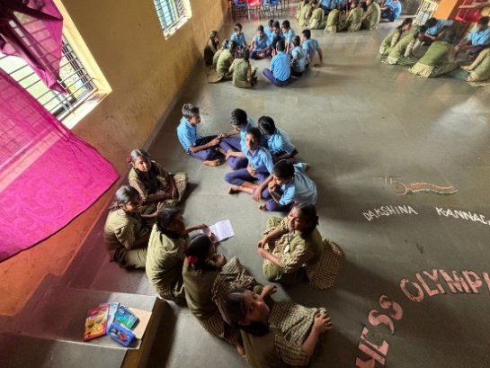

*Newspaper Collage Activity: A Creative Expression*

