# Automated Network Request Management in ServiceNow

## Project Overview

This project is designed to develop and implement an automated and streamlined solution for managing network-related service requests within the ServiceNow platform. It focuses on providing a seamless experience for end users to submit, track, and receive updates on network service requests through a user-friendly self-service portal. The solution leverages ServiceNow's powerful workflow engine, customizable service catalog, and approval processes to ensure that requests are accurately captured, validated, routed, and fulfilled efficiently. Where applicable, the system integrates with network automation tools and scripts to automate the fulfillment of standard requests, reducing manual efforts and minimizing errors.

## Objectives

* Provide a centralized and user-friendly self-service portal for network service requests.
* Automate the request intake process using dynamic forms tailored to specific network services.
* Implement approval workflows to ensure compliance and proper governance.
* Enable real-time communication and status updates for both requesters and technicians.
* Integrate with existing network automation or orchestration tools to automate routine tasks.

### Technical Architecture

* **ServiceNow Platform:** Utilizes ServiceNow's Service Catalog, Workflow Engine, and Notification Modules.
* **Workflow Engine**: Automates routing, approvals, task assignments, and escalations.
* **Integration Layer:** REST APIs, MID Server, or custom scripts to interface with network automation tools.
* **Self-Service Portal:** User interface for submitting requests, viewing status, and receiving notifications.
* **Security:** Role-based access controls for request submission, approval, and task fulfillment.

## Benefits

* **Efficiency:** Automates manual network request handling, reducing processing time.
* **Accuracy:** Ensures requests are complete and compliant before fulfillment.
* **Visibility:** Provides transparent status tracking for both users and IT teams.
* **Scalability:** Easily extendable to add new request types or integrate additional automation tools.
* **User Experience:** Simplifies the network service request process through an intuitive portal.

## Process and Procedure

This section outlines the step-by-step process and internal procedures followed from request submission to fulfillment, ensuring automation and governance within ServiceNow.

### 1. Request Submission

* **User Access:** End users access the ServiceNow self-service portal to submit network-related service requests.
* **Service Catalog Selection:** Users select the appropriate network service catalog item (e.g., IP address allocation, VPN access, firewall rule change).
* **Dynamic Form Completion:** Users fill out dynamic forms tailored to the request type. These forms capture all necessary details such as requester info, device IPs, VLAN IDs, business justification, and any special requirements.
* 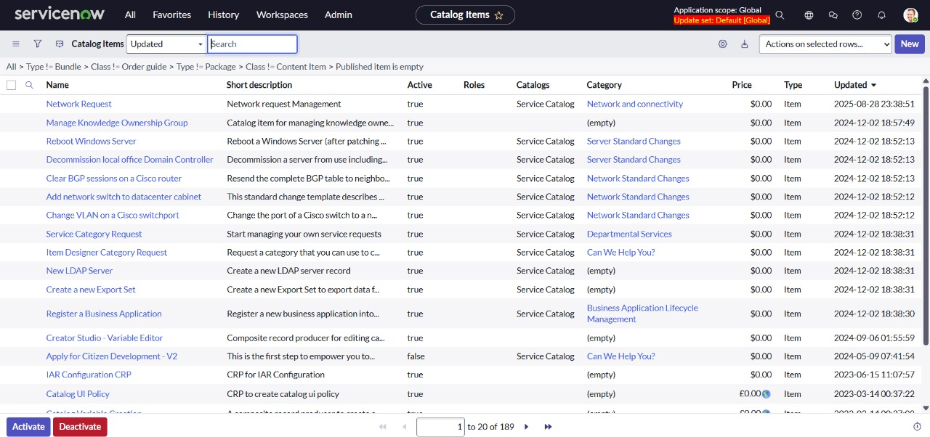**Validation:** Real-time validation checks ensure mandatory fields are filled, data formats are correct, and any conditional logic is in place.

### 2.Request Validation and Logging

* **Automatic Logging**: Once submitted, the request is automatically logged in the ServiceNow Incident/Request Management module with a unique tracking ID.
* **Initial Validation:** The system performs automated checks (e.g., duplicate request detection, compliance with network policies) and flags issues for manual review if necessary.

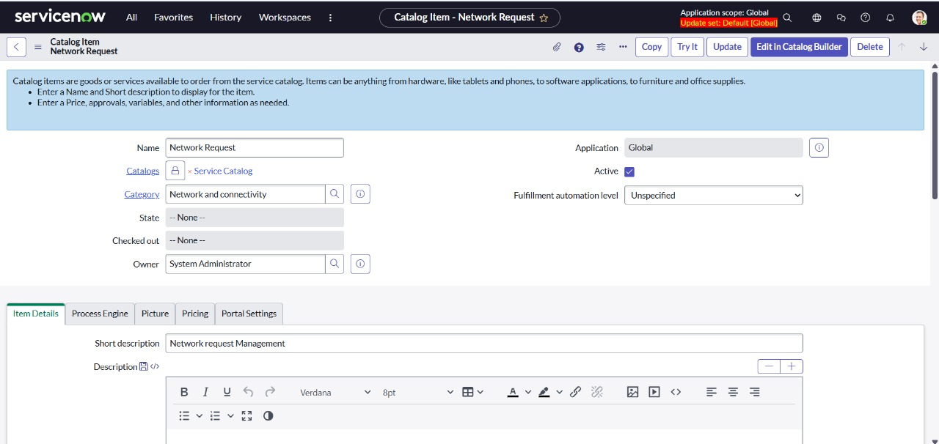

### 

### 

### 

### 3.Approval Workflow

* **Route for Approval:** Based on the request type and sensitivity, the system triggers a predefined approval workflow. For example:
* Low-risk requests may require a single-level approval from the network team lead.
* High-risk or sensitive requests trigger multi-level approvals (e.g., security officer, network manager).
* **Approval Notifications:** Approvers receive notifications via email and ServiceNow dashboards, including request details and action buttons (approve/reject/comment).
* **Escalations and Reminders:** If approvals are not actioned within defined SLAs, automated reminders and escalations are triggered.
* **Approval Outcome:** If approved, the request proceeds to fulfillment. If rejected, the requester is notified with comments and may be prompted to modify and resubmit.

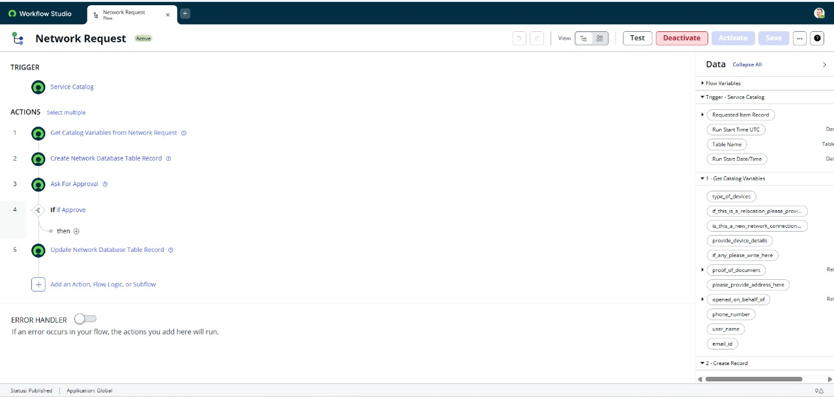

### 4. Fulfillment Process

* **Task Assignment:** Upon approval, ServiceNow creates fulfillment tasks and assigns them to the appropriate network operations team or automation system.
* **Automated Execution (Optional):** For standard, repeatable requests, ServiceNow integrates with network automation tools (like Ansible, Cisco DNA Center) to automatically apply configurations or changes.
* **Manual Execution:** For requests requiring manual intervention, technicians receive task details and perform the required changes.
* **Status Updates:** As tasks progress, ServiceNow updates the request status in real-time, notifying the requester and updating dashboards.

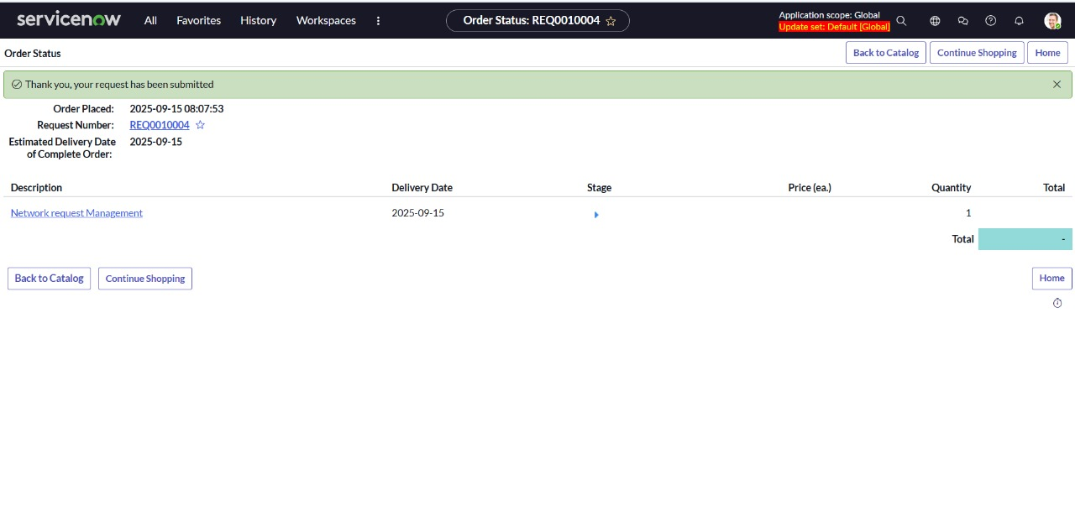

### 5. Completion and Closure

* **Verification:** Technicians confirm the successful completion of the request, documenting any relevant notes or issues encountered.
* **Requester Confirmation:** In some cases, the requester is asked to verify that the network service is working as expected.
* **Request Closure:** The request is marked as completed and closed within ServiceNow. All related data is archived for audit and reporting purposes.
* **Feedback Collection:** Optionally, users may be prompted to provide feedback on the service experience for continuous improvement.

### 6. Monitoring and Reporting

* **Dashboard Monitoring:** Network and IT managers monitor real-time dashboards for pending requests, approval bottlenecks, SLA compliance, and fulfillment efficiency.
* **Periodic Reporting:** Automated reports on request volume, approval times, fulfillment duration, and customer satisfaction are generated and shared with stakeholders.
* **Audit and Compliance:** All request workflows, approvals, and fulfillment actions are logged.

#### Summary Flowchart (High-Level)

User submits request → Validation → Approval workflow → Fulfillment (automated/manual) → Completion → Feedback → Reporting

### Conclusion

The Automated Network Request Management project will significantly enhance how network service requests are handled within the organization by leveraging ServiceNow's automation capabilities. This initiative aims to reduce manual effort, improve turnaround times, and increase overall user satisfaction by providing a transparent and automated request management system.

### Output Screen:

