Mars 2020 (M2020)
Software Interface Specification

Interface Title: Autolook and Quicklook Data Products Software Interface Specification

Mission: Mars 2020 Date: November 10, 2020
Module ID: D-105237
Module Type : MIS
Reference Module ID: N/A Date: N/A
Signatures
Instrument Generating Elements:
Mars 2020 Instrument Operations Team Chief
Justin Maki ____________________________________________________
Team Chief Date

Science Receiving Elements:
Mars 2020 Deputy Project Scientist
Katie Stack ____________________________________________________
Deputy Project Scientist Date

GDS Receiving Elements:
Mars 2020 Ground Delivery Subsystem Manager
Maher Hanna ____________________________________________________
GDS Manager Date

Mars 2020 Project

Software Interface Specification (SIS)

Autolook and Quicklook Data Products

Version 0.7
DRAFT

Contributors:
Amy Culver
Justin Maki
Stirling Algermissen
Ivair Gontijo
Galen Hollins
Rob Tapella

JPL D-105237

November 10, 2020

Jet Propulsion Laboratory
California Institute of Technology

CHANGE LOG
DATE | SECTIONS CHANGED | REVISION
2020-09-08 | Initial Release for external review | 0.3
2020-09-04 | Updated with input from Instrument teams. | 0.4
2020-09-23 | - Added new product type formats under “Data Product Formats => Documents” in section 4.1  - Added expected product types from ECAM, IDSO, MEDA, PIXL, RIMFAX, SHERLOC, SCAM and ZCAM to “Product Types” table in section 5.0  - Added links to released versions of OCS catalog, ElasticSearch field datatypes, ocs_lambda_ingester, How-To defining OCS object type JPL internal pages  - Expanded SIS to include Closerlooks  - Clarified IDSO-generated products conform to M2020 Camera EDR SIS including file naming conventions  - Clarified movie and sound formats | 0.5
2020-11-04 | - Proposed Required Metadata changes for G6.8, see Section 4.2 | 0/6
2020-11-10 | - Updated Required Metadata based on IO Team feedback, see Section 4.2. Guidance for ORT-11 and changes planned in G6.8 are identified. | 0.7

- Purpose and Scope of Document

This document specifies the Autolook, Quicklook and Closerlook formats for products generated by the Mars 2020 (M2020) instrument teams, including the Instrument Data System Operations team (IDSO). Both types of products are generated on the Tactical Downlink operations timeline and are required for Uplink planning.

M2020 Autolook products are generated automatically by instrument data processing pipelines, without operator review. See OIA-IO-PDL-001 for Autolook delivery location and timing details.

M2020 Quicklook products are also based on tactical processing of downlink data but may involve human-in-the-loop review and processing. Quicklook products may also incorporate older data, for instance, by adding the most recent data to a time series in order to show trends. For the purpose of this SIS, “Closer Look” products are encompassed in the specification applicable to Quicklook products. See OIA-IO-PDL-002 for Quicklook and Closerlook delivery location and timing details.

- References / Appendix

- OIA-IO-PDL-001: Autolook Data Products (under development)
- OIA-IO-PDL-002: Quicklook Data Products (under development)
- Operational Cloud Store / Data Lake Documentation
- GDS G6.5 Documentation
- EOP Framework
- M2020 Camera EDR SIS (for products to be displayed in ASTTRO and IDSO generated Autolooks/Quicklooks/Closerlooks)
- Appendix A: Ground Data Subsystem (GDS) Processing Architecture

- Relationships with Other Interfaces

GDS tools that read or write Autolook, Quicklook and Closerlook products (including the Operational Cloud Store (OCS), DataDrive, Marsviewer and ASTTRO) shall conform to this interface specification.

  - GDS Tools Supporting Autolook, Quicklook and Closerlook Products

    - DataDrive supports all Autolook and Quicklook formats
    - Marsviewer supports all formats, with the exception of movies, sound files, others (TBS)
    - ASTTRO supports IMG formatted files. For more information on the IMG format, see the M2020 Camera EDR SIS

- Data Product Standards

M2020 Autolook and Quicklook data products consist of two parts, the data file and the associated metadata.

  - Acceptable Data Product Formats

- Images
  - PNG
  - JPEG
  - IMG
  - TIF
- Animations
  - GIF
  - APNG
- Documents
  - PDF
  - HTML
  - CSV
  - TXT
  - PowerPoint, Word, Excel
- Movies
- Encoder (lossy) CODECs: AAC and H.264, as described here: https://pds.nasa.gov/datastandards/documents/archiving/MP4-H264-ACC.pdf
- Containers:
  - Quicktime
  - MPEG movie files
- Sound
  - WAV

  - Required Metadata

The GDS tools rely on metadata identified in Operational Cloud Store (OCS) object types. Refer to the OCS Object Type / Data Lake Documentation for additional information about OCS object types and how they are utilized by the GDS. This metadata is provided via a json file when the products are registered with the quicklook product type. See also OCS and DataDrive Metadata Searching for additional information.

The following table lists the keywords for the m20-quicklook OCS product type. These fields are in addition to the system OCS metadata fields which are automatically added to every indexed package object.

NOTES for ORT-11:
- the time1and subsystem fields are required
- target field should be populated with target_id information
- activity field should be populated with activity_id
- OCS CLI should set:
is_source_product = true
group_id = true (for use with Marsviewer)
instrument_id

The following table defines the m20-quicklook object type as it is expected to be implemented in G6.8 (the GDS release available at landing).

Field Name | Changes in G6.8 |  |  | Type | Array | Comments | Required? No, unless otherwise indicated | Applicability?  CLI is implied, GUI where identified
year |  |  |  | integer | ?
time1 |  |  |  | long | Y | DOY or sol. Marsviewer interprets as sol | Yes | GUI
sol |  | new |  | long | Y | sol (duplicate of time1), used post-landing to populate the “common” Sol field for search | Yes | Auto-fill by GUI, based on time1
time1_doy |  |  |  | boolean | Y
time2 |  |  |  | long | Y | SCLK
site |  |  |  | integer | N |  |  | GUI
drive |  |  |  | keyword | Y |  |  | GUI
subsystem |  |  |  | keyword |  | Valid values for consistency with APSS and DataDrive: ECAM, MEDA, MOXIE, PIXL, RIMFAX, SCAM, SHERLOC, ZCAM | Yes: Enables combined searches across products + QLs | GUI
instrument_id |  |  |  | keyword |  | Valid Values: ecam, meda, moxi, pixl, rfax, scam, srlc, zcam |  | Auto-filled by GUI, based on value of subsystem
producer |  |  |  | keyword |  | This is free text of whoever “produced” this autolook/quicklook. In the GUI we could potentially provide autocomplete suggestions based on the existing values in OCS/DD |  | GUI
description |  |  |  | text |  |  |  | GUI
supplemental_description |  |  | remove | text |  | Not clear to me the benefit of two different description fields
target_id |  |  | new | keyword | Y | This can be used to link into a target database |  | GUI
activity_id |  |  | new | Keyword | Y | This can be used to link into the Science Intent Database |  | GUI
target |  |  | remove | keyword |  | Suggest replacing with target_id
activity |  |  | remove | keyword |  | Suggest replacing with activity_id
seqid |  |  |  | keyword | Y | Need to decide which “sequence ID” this is—e.g. sequence_id, vicar_label.identification.sequence_ID, seqid? |  | GUI
campaign |  |  | remove | keyword |  | activity_id will let us dynamically pull in this info
goal |  |  | remove | text |  | activity_id will let us dynamically pull in this info
task |  |  | remove | text |  | activity_id will let us dynamically pull in this info
activity_notes |  |  | remove | text |  | Not sure if this is in the Science Intent DB or if this is free-text just for Quicklooks |  | GUI
color_filter |  |  |  | keyword |  | Should this be a checklist, or radio list of set options?
product_id |  |  |  | keyword
actual_compression |  |  |  | keyword
is_source_product |  |  |  | boolean |  | Required to be true for Marsviewer | Yes | Auto-set to true via GUI
image_type |  |  |  | keyword
ext |  |  |  | keyword
thumbnail |  |  |  | keyword
product_version |  |  |  | short
size_type |  |  |  | keyword
overlayable |  |  |  | boolean
mission_venue |  |  |  | keyword
group_id |  |  |  | keyword |  | should be unique to that file but doesn’t matter what it is, a random string or s3 path should be fine, needed for Marsviewer searching/result collapsing | Yes | Auto-set to s3 path
ocs_etag |  |  |  |  |  | OCS automatically makes a checksum-ish thing called etag. Use this instead of a checksum? |  | Auto-set to s3 etag
checksum |  |  | new | text |  | checksum_md5 |  | GUI

Mapping of Subsystem to Instrument:
Subsystem | Instrument
ECAM | ECAM
SCAM | SCAM
ZCAM | ZCAM
MEDA | MEDA
MOXIE | MOXI
PIXL | PIXL
RIMFAX | RFAX
SHERLOC | SRLC

Notes:
        - The same object type currently supports Autolook, Quicklook and Closerlook products
        - Additional fields may be added to the m20-quicklook.json file upon request to the GDS
        - To define a new OCS object type see GDS G6.5 Documentation, ocs-documentation-G6.5.html in the “How to Define a New Object Type”

  - File Naming Convention for Instrument Team Generated Products

Autolook products are named:

A<instrument>_SOL<sol>_<descriptor>.<extension>

Quicklook products are named:

Q<instrument>_SOL<sol>_<descriptor>.<extension>

Closerlook products are named:

C<instrument>_SOL<sol>_<descriptor>.<extension>

For Autolook, Quicklook and Closerlook products, the bracketed fields represent:

- <instrument>: the group responsible for generating the product. This may be an instrument team (i.e. RFAX) or a theme group (i.e. LTP (long-term planning)). The <instrument> field should follow one of the following instrument abbreviations:

- ECAM
- MEDA
- MOXIE
- PIXL
- RFAX
- SCAM
- SRLC
- ZCAM

- <sol>: the starting sol when the data upon which the product is based was acquired.
- If the product involves multiple sols, the format <start_sol>_<end_sol> (start sol followed by an underscore character followed by end sol) may be used if preferred, otherwise the start sol should be used
- If the product pertains to no particular sol, the string “UNK” must be used
- Sol value consists of four digits: <xxxxx>

- <descriptor>: a free-form text field:
- Makes the filename unique with respect to all other Autolook, Quicklook and Closerlook data product files for the sol and subsystem and data type in question
- Is comprised only of alphanumeric text or underscore characters
- No spaces are allowed
- Multiple underscores and mixed-case text are permitted

- <extension>: the appropriate conventional filename extension for the document type, e.g. PDF, .PNG, .JPG, etc. The <extension> should be either all upper- or all lower-case

- The entire filename can have as many as 255 characters. Only ASCII characters are allowed in filenames (specifically, do not use Unicode).

- IDSO-generated products conform to the M2020 Camera EDR SIS for content and file naming conventions.

Data Storage Convention

    - Autolook, Quicklook and Closerlook products generated by the Instrument teams are stored in OCS with the following paths:

/ods/surface/sol/<sol number>/soas/ autolook | quicklook | closerlook /inst/

where “inst” is one of the following: ecam, meda, moxie, pixl, rfax, srlc, scam, zcam

    - Autolook, Quicklook and Closerlook products generated by the IDSO team are stored in OCS with two types of paths:

      - Nominal Products

/ods/surface/sol/<sol number>/ids/ autolook | quicklook | closerlook /inst/

      - Outreach Products (governed by OIA-IO-IDSO-003: Images to Outreach Website)

/ods/surface/sol/<sol number>/ids/edr/browse/<inst>/

- Product Types

Source | Product Name | Type | Description | Format | Sample filename
ECAM | Tile Finder Mosaic | Autolook | Graphic illustrating location and resolution for all tiles acquired at a given site/drive index for Navcam, Front Hazcam, and Rear Hazcam | PNG | AECAM_<CAMERA>_SOL0000_<SITE>_<DRIVE_TILE_FINDER_J00.png
IDSO | Browse Images | Autolook | Raw images from ECAM, (SCAM, WATSON, MCC, MEDA, ZCAM) pushed to public facing Outreach website | JPG  PNG | FRB_0000T0666955014_774ECM_T0010008AUT_04096_00_0I1J01.png
IDSO | Targeting Mosaics | Autolook | Simple cylindrical projected Navcam mosaic for current site/drive location | IMG  PNG  JPG | N_LRGB_0252_RASF0010000_CYL_S_AUTLOOKJ01.png
IDSO | Navcam Colorglyph and Anaglyph Mosaics | Autolook | Cylindrical perspective projected Navcam mosaic for 3D visualization at a given site/drive. Supports color and mono images. | IMG  PNG | Anaglyph: N_ARGB_0252_RASF0010000_CYL_S_AUTLOOKJ01.png  Colorglyph: N_CRGB_0252_RASF0010000_CYL_S_AUTLOOKJ01.png
IDSO | Orthorectified / DEM Mosaics | Autolook | DEM and accompanying orthorectified mosaic generated at a given site/drive using Navcam stereo data. | PNG  TIF  IMG | Ortho: N_LRGB_0252_RASF0010000_ORR_S_AUTLOOKJ01.IMG  DEM: N_LRGB_0252_DEMF0010000_ORR_S_AUTLOOKJ01.IMG
MEDA | Evolution of atmospheric magnitudes | Quicklook | Time series plots of the atmospheric magnitudes (a single file contains all the plots) | PDF | QMEDA_SOL0342_0344_atm.pdf
MEDA | Evolution of atmospheric magnitudes | Quicklook | Time series plots of the atmospheric magnitudes (a single file contains all the plots) | HTML | QMEDA_SOL0342_0344_atm.html
MEDA | Cloud motion movies | Quicklook | SkyCam cloud motion movies | GIF | QMEDA_SOL0342_141000_cloud_motion.gif
MOXIE
PIXL | PIXL basic SOH and measurement information | Autolook | An overview of PIXL observation, including:  o MCC image with X-ray beam locations  o map overview (e.g. real/live time, map dimensions, count rate)  o SDD and source SOH  o Annotated bulk summed spectra  o Annotated max value spectra | PDF | APIXL_SOL0077_PAL_0637741109_000_0010036_000983561_00640___J01.PDF  (APIXL_SOL<SOL>_PAL_<SCLK>_<time3>_<site><drive>_<RTT>_<PIXL_specific_fields>_<producer><version>.PDF)
PIXL | PIXL elemental distribution maps and bulk quantification | Quicklook | Preliminary quantification results from a PIXL observation:  o MCC image with X-ray beam locations  o Total bulk spectrum with labeled peaks  o pseudo-intensity maps for 22 elements  o preliminary quantification results for major and trace elements | PDF | QPIXL_ SOL0077_PQL_0637741109_000_0010036_000983561_00640___J01.PDF  (QPIXL_SOL<SOL>_PQL_<SCLK>_<time3>_<site><drive>_<RTT>_<PIXL_specific_fields>_<producer><version>.PDF)
PIXL | PIXL engineering state of health report | Autolook | The state of health of PIXL, including:  o off-nominal parameters detected (out of operational range)  o scan log  o SDD and source status (e.g. temperature, voltages, count rate)  o X-ray beam location map  o Derived topographic map of target  o power, thermal, and mechanical instrument trends | PDF | APIXL_ SOL0077_SOH_0637741109_000_0010036_000983561_00640___J01.PDF  (APIXL_SOL<SOL>_SOH_<SCLK>_<time3>_<site><drive>_<RTT>_<PIXL_specific_fields>_<producer><version>.PDF)
RIMFAX | Rimfax Autolook | Autolook | Housekeeping checking and trends, including temperature and voltages. Automatically generated plots of radar measurements using pre-defined processing steps. | PDF | ARFAX_SOL0001_NOMINAL.PDF
RIMFAX | Rimfax Quicklook | Quicklook | Manually generated and annotated plots of radar measurements with descriptive text. | PDF | QRFAX_SOL0001_Traverse.PDF
SCAM | Raster Overview | Quicklook | Overview of a raster activity on a given target: annotated plots of the data produced by the different techniques. Very first interpretation of the data. Pre-quicklook is produced in PPT format automatically and then revisited/commented by the sPDL before conversion to PDF. | PPT, PDF | QSCAM_SOLN_MyTargetName_v0.pdf
SCAM | Microphone Recording | Autolook | Microphone recording | WAV | ASCAM_SOLN_0624853330_998CA2__0010094scam15215_____01M00.wav
SCAM | Single LIBS spectral plot | Autolook | Plot of average spectrum obtained with a single LIBS observation. Spectrum is calibrated in wavelength and radiance. Annotated with main elemental lines. Main parameters of the observations are displayed. | PNG | ASCAM_ SOLN _0624853330_998CL2__0010094scam15215_____01M00.png
SCAM | Single RAMAN spectral plot | Autolook | Plot of average spectrum obtained with a single RAMAN observation. Spectrum is calibrated in wavenumber corrected for the instrument response. Annotated with main mineral bands. Main parameters of the observations are displayed. | PNG | ASCAM_ SOLN _0624853330_998CR2__0010094scam15215_____01M00.png
SCAM | Single TRLS spectral plot | Autolook | Plot of average spectra (one per delay used) obtained with a single TRLS observation. is calibrated in wavenumber corrected for the instrument response. Main parameters of the observations are displayed. | PNG | ASCAM_ SOLN _0624853330_998CT2__0010094scam15215_____01M00.png
SCAM | Single RMI plot | Autolook | Single RMI display. Image have been flat-fielded, cleaned and a preliminary color balance have been applied. Main parameters of the observations are displayed. | PNG | ASCAM_ SOLN _0624853330_998CI2__0010094scam15215_____01M00.png
SCAM | Single VIS spectral plot | Autolook | TBD (Chip / Tim / Jeff)… | PNG | ASCAM_ SOLN _0624853330_998CP1__0010094scam15215_____01M00.png
SCAM | Single IRS spectral plot | Autolook | Plot of single IRS spectrum, wavelength calibrated and corrected for the atmosphere opacity, and ratio to the solar spectrum. Annotated with main IR bands. Main parameters of the observations are displayed. | PNG | ASCAM_ SOLN _0624853330_998CP2__0010094scam15215_____01M00.png
SCAM | Single Microphone plot | Autolook | Plot of audio recording time series from a single observation. Calibrated in pressure. Power spectrum and spectrograph are also displayed. Main parameters of the observations are displayed. | PNG | ASCAM_ SOLN _0624853330_998CA2__0010094scam15215_____01M00.png
SCAM | Single Autofocus spectral plot | Autolook | Plot of autofocus curve result (CWL or RMI) as a function of the motor position. Main parameters of the observations are displayed. | PNG | ASCAM_ SOLN _0624853330_998CF1__0010094scam15215_____01M00.png
SHERLOC | SHERLOC Raman and fluorescence spectral intensity distribution. | Autolook | An overview of a SHERLOC spectrum observation, including:  o metadata table  o ACI image  o WATSON image  o average spectrum  o Raman region spectrum  o dark spectrum frame  o laser intensity map  o laser spot position map  o spectrum intensity map | PDF | ASRLC_SOL0004_SAL_0631370804_235_0010256_srlc07305_W0__CGN_J01.PDF  (ASRLC_SOL<SOL>_SAL_<SCLK>_<time3>_<site><drive>_<seqID>_<processing_flags>_<producer><version>.PDF)
SHERLOC | SHERLOC mineral and organic intensity distribution | Quicklook | An annotated Autolook PDF product with spectral peak identifications, notable textural features in images, and spectral map regions of interest | PDF | QSRLC_SOL0004_SQL_0631370804_235_0010256_srlc07305_W0__CGN_J01.PDF  (QSRLC_SOL<SOL>_SQL_<SCLK>_<time3>_<site><drive>_<seqID>_<processing_flags>_<producer><version>.PDF)
SHERLOC | SHERLOC engineering state of health report | Autolook | The state of health of SHERLOC, including:  o off-nominal parameters detected (out of operational range)  o laser performance  o scanner position map (current, error, and position)  o condition codes  o status flags  o power, thermal, and mechanical instrument trends | PDF | ASRLC_SOL0004_SOH_0631370804_235_0010256_srlc07305_W0__CGN_J01.PDF  (ASRLC_SOL<SOL>_SOH_<SCLK>_<time3>_<site><drive>_<seqID>_<processing_flags>_<producer><version>.PDF)
ZCAM | Autolook product | Autolook | EDR generated by IDS or ASU from a single raw .dat file. Used for quick analysis of image quality and completeness.  Note that nominally the ZCam autolook products will be the IDS-generated EDR files. In the event that the IDS process is unavailable, the Mastcam-Z PDL will create EDRs from the raw .dat files. | PNG IMG
ZCAM | Name will depend on filters used. (currently TBD) | Quicklook | Multispectral products used for chemical analysis of a scene. Created whenever relevant multispectral sequences are acquired. | IMG
ZCAM | Targeting mosaic | Quicklook | Mosaic product created from multiple frames. Created when sequences allow for image mosaicking. | IMG
ZCAM | Anaglyph stereo product | Quicklook | Red/blue anaglyph created from stereo observations. | IMG
ZCAM |  | Closerlook | Template file based on an autolook or a quicklook that is given to a science team member for annotation to assist with Science planning. | PNG

APPENDIX A – Ground Data Subsystem (GDS) Processing Architecture

- Event-based Autolook/Quicklook Generation

The M2020 GDS provides an event-based system for triggering Autolook/Quicklook generation of downlinked data products. The diagram below is a high-level, developer-centric view of the data flow architecture. Its purpose is to show how the various parts of the data system connect to each other. It is a generic connection diagram, not intended to represent the process for any specific instrument. It is not intended to be read as a process flowchart.

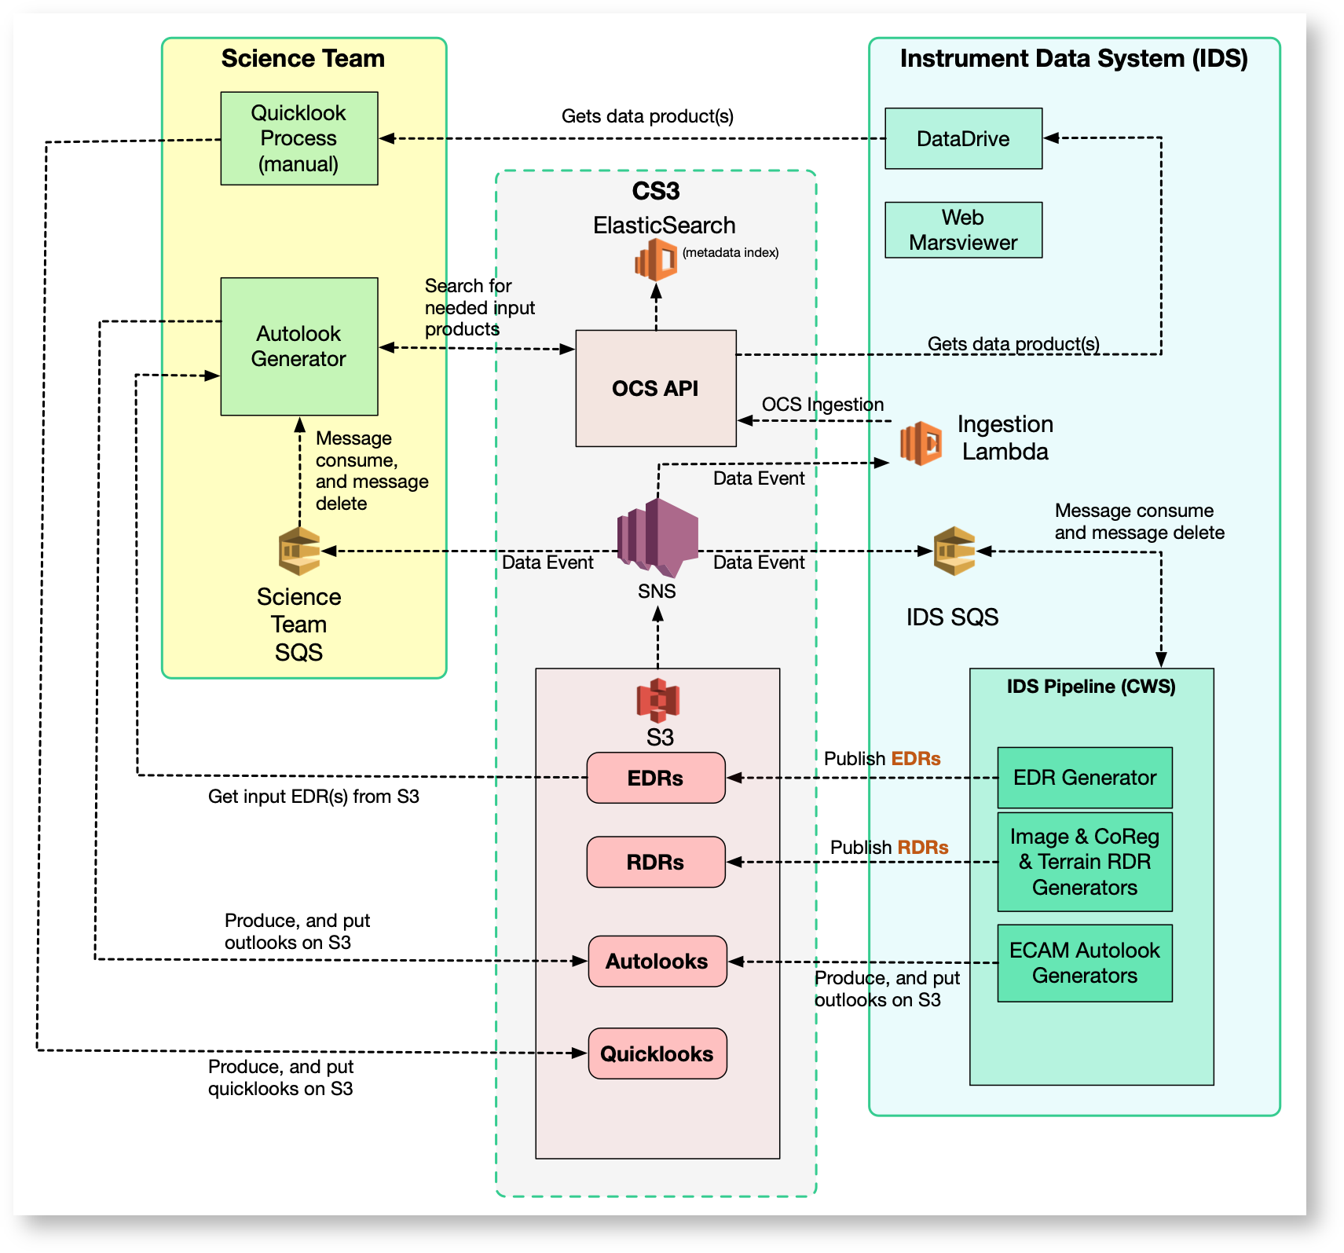

In general, the event-based Autolook/Quicklook data flow is:

    - The IDS pipeline produces an EDR or RDR and delivers it to AWS S3
    - The EDR/RDR data product is registered with OCS
    - The science and/or instrument team’s Autolook/Quicklook pipeline automatically receives an event through AWS SNS that EDRs and/or other inputs are available on S3. Alternatively, the science/instrument team can use the DataDrive subscription tool to download necessary inputs as they are generated and trigger processing
    - The Autolook/Quicklook product is delivered to S3 and registered with OCS
    - The Autolook/Quicklook product is made available in relevant GDS tools (DataDrive, Marsviewer, ASTTRO)

- End-of-pass Autolook/Quicklook Generation

In addition to event-based Autolook/Quicklook triggering, instrument teams can optionally use the GDS end-of-pass system to receive notification when raw data products (.dat/.emd pairs) for a downlink have been processed and are available in the AWS cloud. End-of-pass triggering is managed by EAS and further information is available in this wiki page.

