**FiSSH START-UP TUTORIAL**

Southern California Water Resources II // Summer 2018 // JPL

*Standalone Installation*

1. Download and open the “MyAppInstaller_web.exe” file.
2. Give the installer permission to run.
3. Once the splash screen disappears and the installer opens, click “Next”.
4. Choose the desired installation folder for the FiSSH app, then click “Next”.

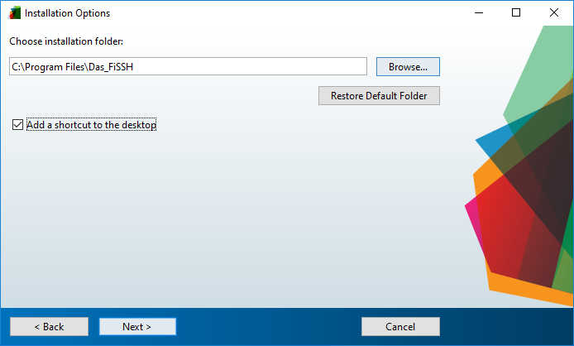

1. Choose the installation folder for the MATLAB Runtime shell, then click “Next”.

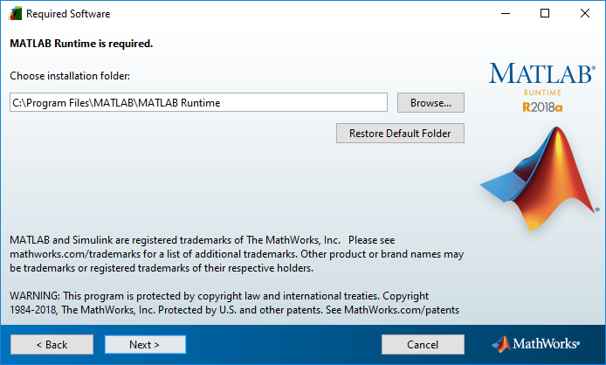

1. Continue through the install wizard, and begin the installation process. Once complete, there will be an application folder at the desired install location, containing the executable FiSSH application itself.

*MATLAB Installation*

1. Download the FiSSH MATLAB application installer file, “FiSSH.mlappinstall”.
2. Open the file, and when prompted, click “Install” to add FiSSH to “My Apps”.

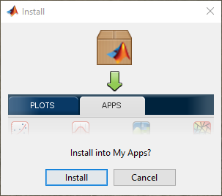

1. Once installed, FiSSH will be available in the “APPS” tab of the menu bar.

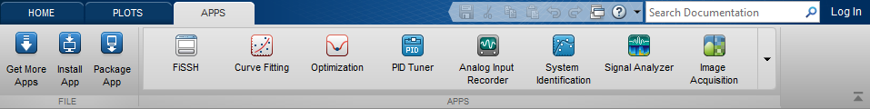

*Using FiSSH: FiSSH*

1. The first tab of the FiSSH application allows the user to choose a beach, select a timeframe, and input values for certain oceanic parameters in order to search the Grunion Greeter database. FiSSH then finds the runs most similar to the input conditions, and then displays them along with their associated Walker and oceanic factor values.

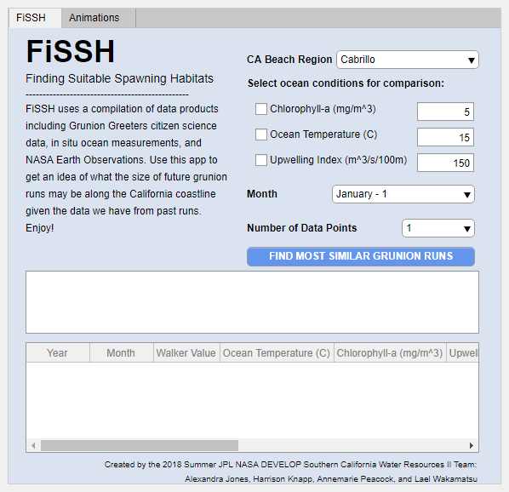

1. To start, check the boxes for the factors by which you wish to search, and change their values as desired.
2. Then select a beach and month, followed by the number of data points you wish to view.
3. Select the “FIND MOST SIMILAR GRUNION RUNS” button to search the database and output the data.
4. Repeat as desire.

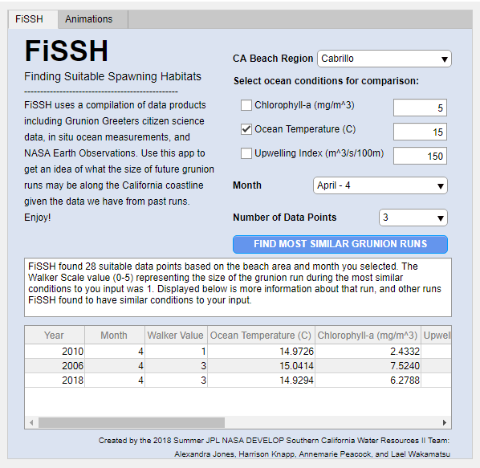

*Using FiSSH: Animations*

1. The second tab of the FiSSH application allows the user to create animations of given oceanic factors over time.
2. To begin, select the desired dataset.
3. Then select the starting year and month, followed by the ending year and month.
4. Select whether or not to include grunion run indicators.

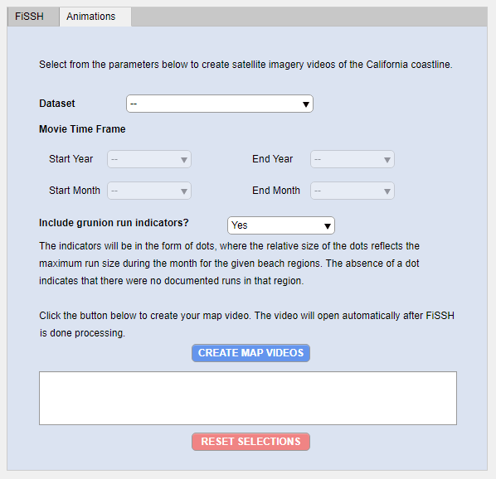

1. Click the “CREATE MAP VIDEOS” button to begin the process of creating the animation.
2. **WARNING:** this process takes time! Do not click until the video has been outputted (a window will pop up containing the animation).
3. If after a while, if the application appears to have frozen, close everything and restart the process (FiSSH is currently in beta and may have small bugs).

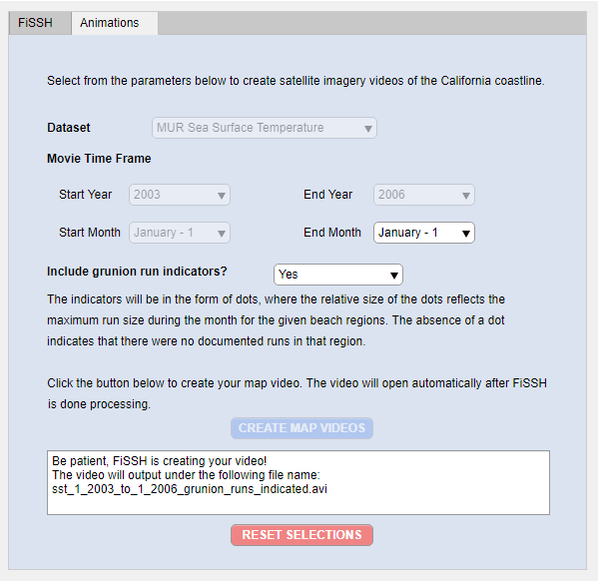

1. In addition to displaying the video (with interactable controls), FiSSH also saves a copy of the animation as a .avi file in the directory where the application is currently being held. If that is in your computer’s program files, it will be found there. However, if you installed the application onto your desktop, then the app will output the file there.
2. If you encounter trouble finding the video, simply reinstall the app to the desktop and the video files should be found there.
3. Below are examples of output figures:

