**Surface Water Identification and Forecasting Tool (SWIFT): User Tutorial**

NASA DEVELOP – Summer 2021

Southwest Water Resources, ID Pocatello Node

**0. Graphical User Interface Orientation**

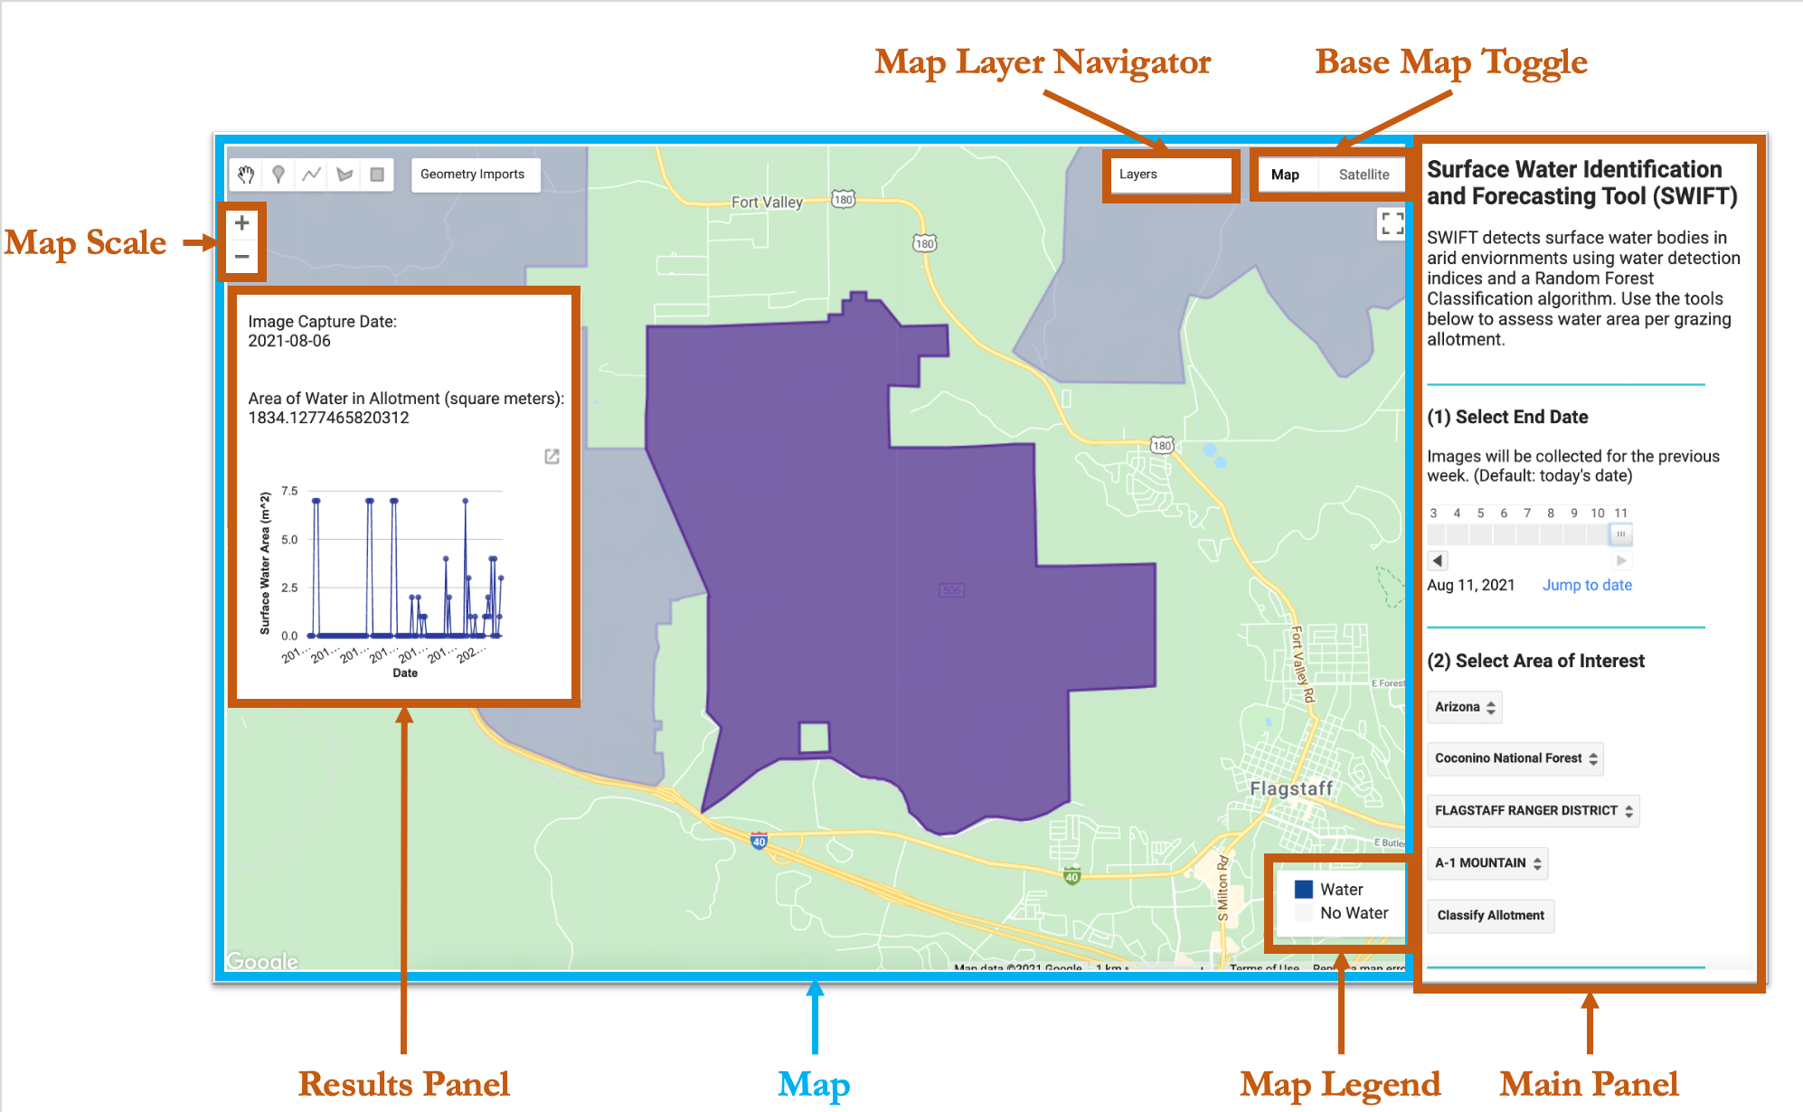

1. **Select End Date** from the main panel.All images captured within the previous week of the selected date will be collected for classification.

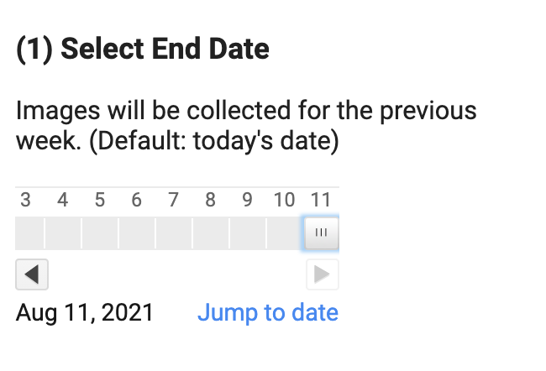

To select from more dates in a calendar view, click “Jump to date.” Click on the desired end date.

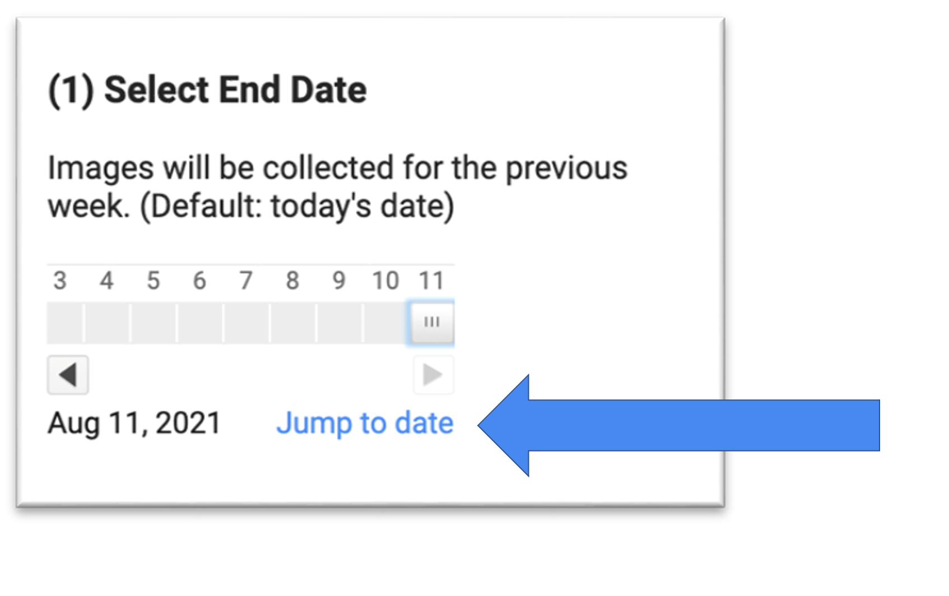

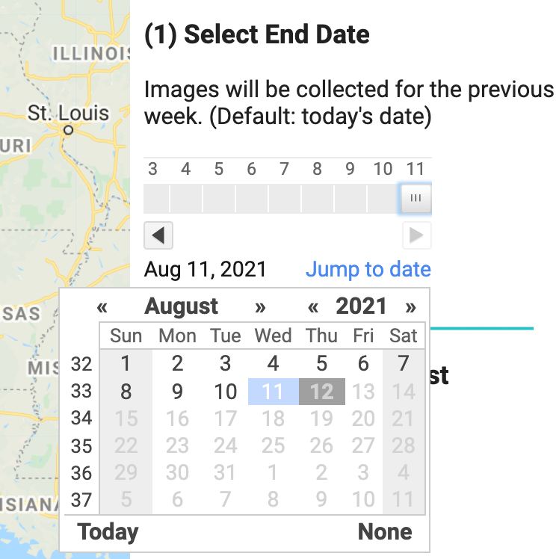

1. **Select Grazing Allotment.** Click on each drop-down bar to select the Area of Interest (AOI). The AOI must be selected from the main panel in the order listed. Is the map is running very slowly, you can deselect various layers from the Map Layer Navigator to increase processing time.

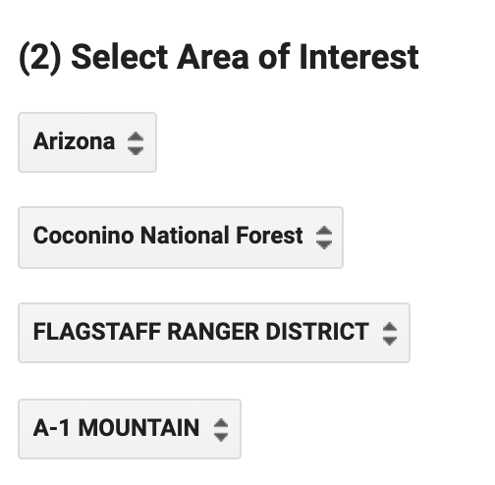

1. **Classify imagery.** When the desired end date and grazing allotment are selected, click the “Classify” Button in the main panel. This will take a few minutes to process as images are classified and plotted to the map.

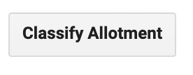

1. **View results.** Once images are classified, the Image Capture Date, Area of Water in Allotment for the dates selected, and the historical time series of area of water in the selected allotment will appear on the results panel. The classified and true color images will also be displayed on the map. Use the Map Layer Manager to switch between layers.

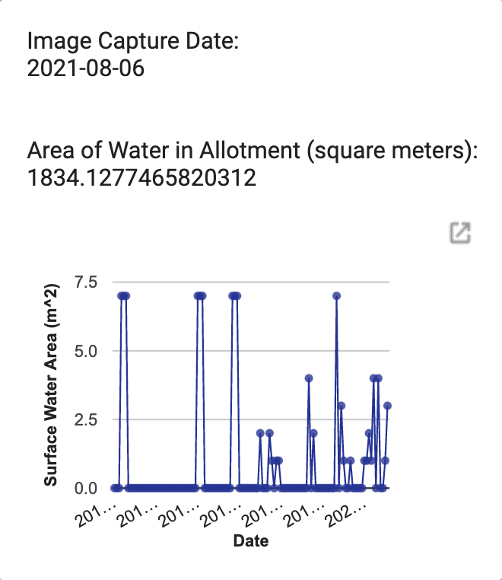

1. **View chart in separate window.** The resulting chart can be viewed in a separate window and downloaded as a CSV, SVG, or PNG file for further user analyses. In the separate window, you can also click on individual points to view exact values.

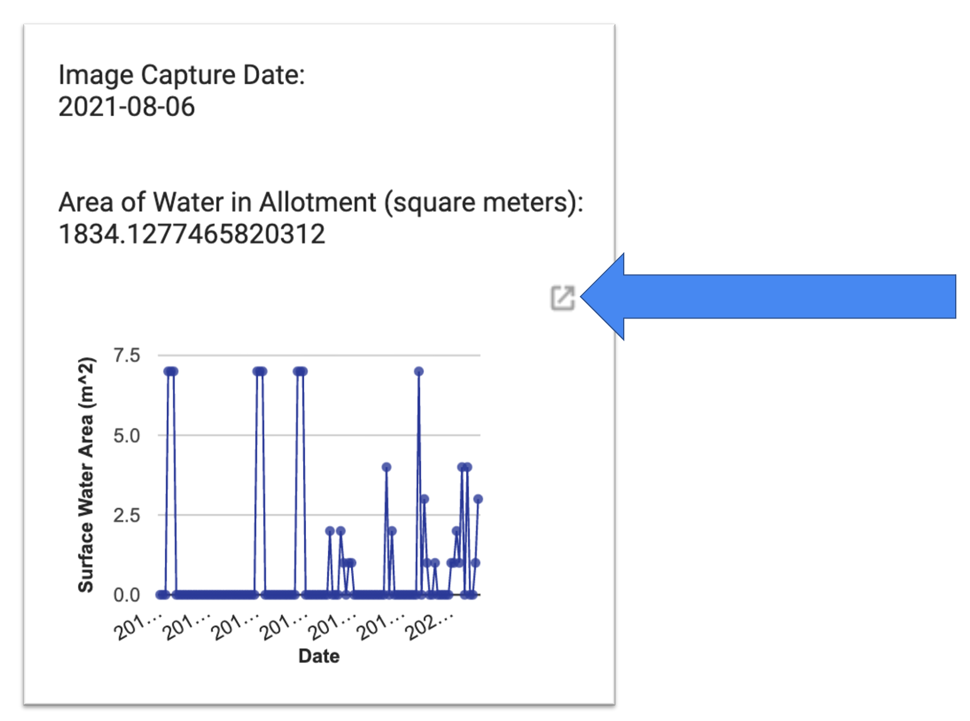

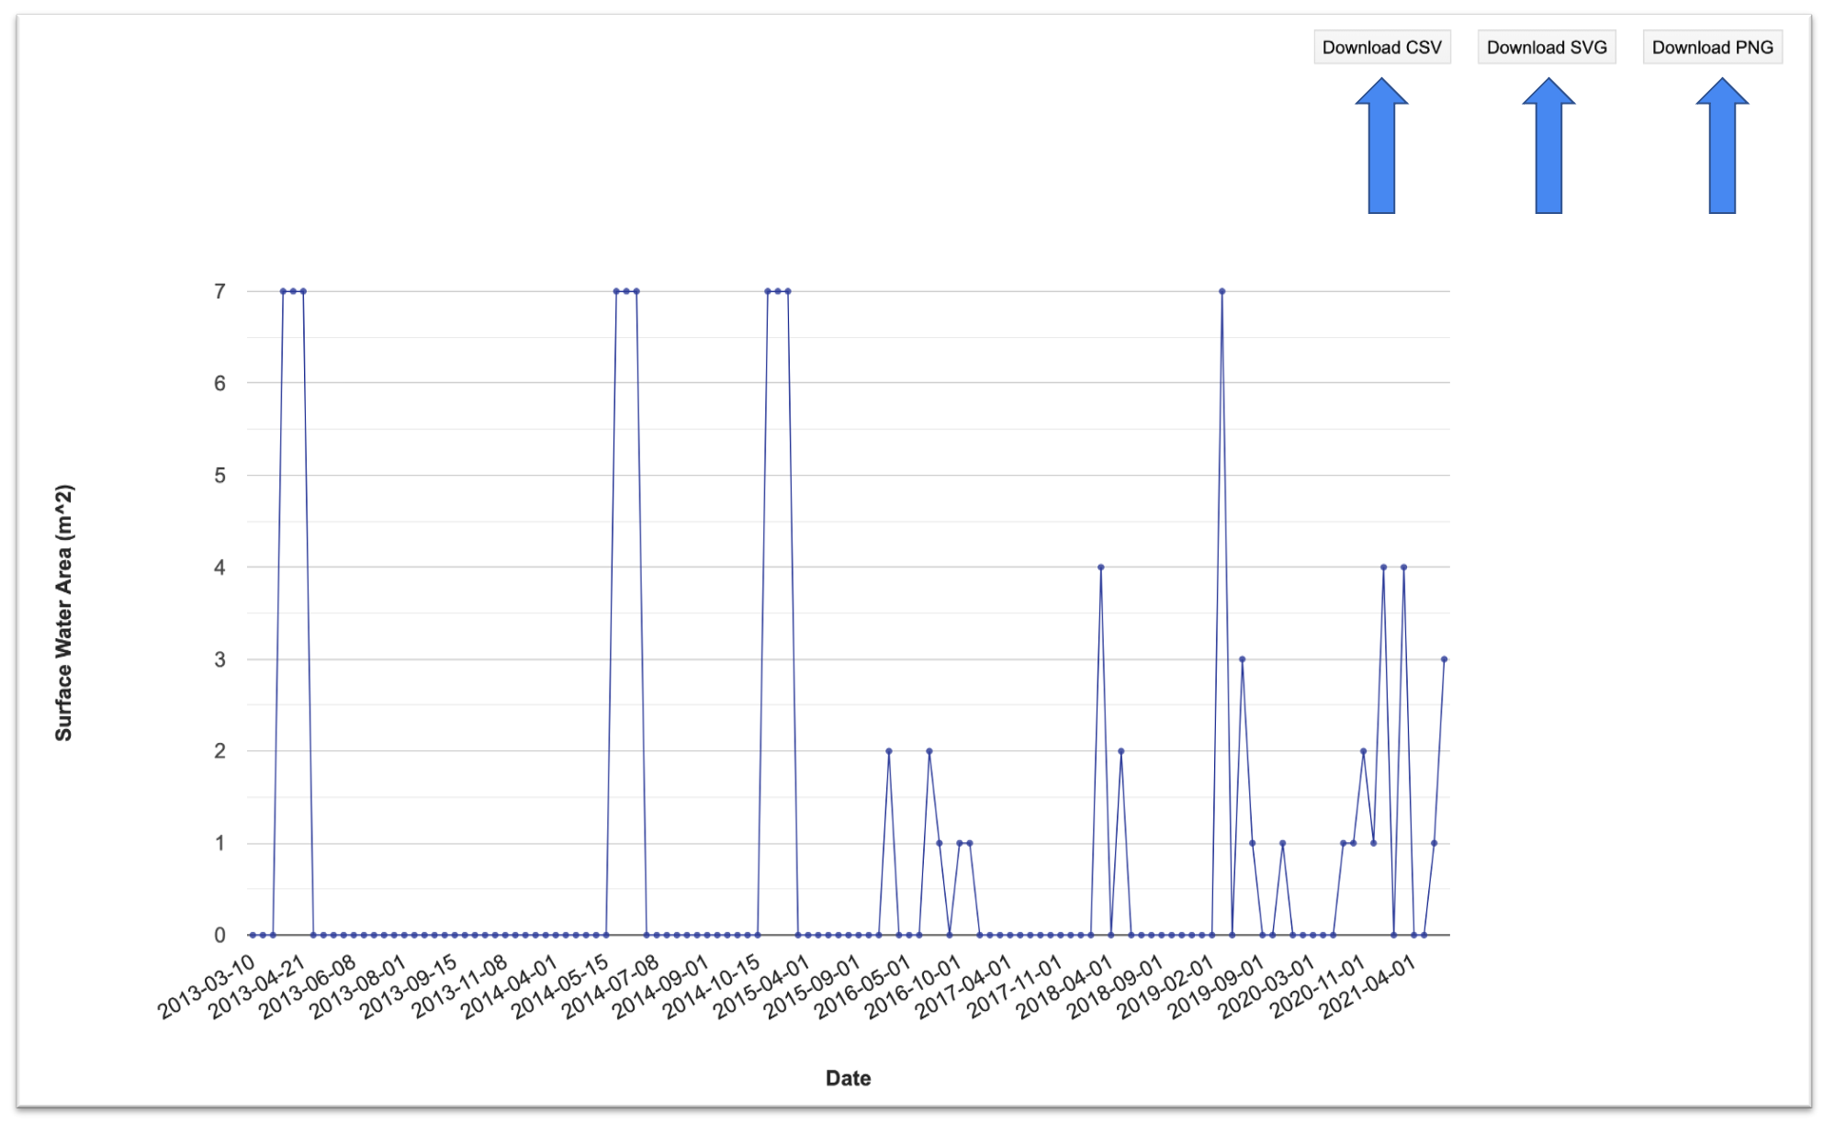

1. **Conduct further analyses.** To re-run the analyses for a new date range or grazing allotment, select the “Run” button above the map. This step may be slightly different if code has been published as an application.

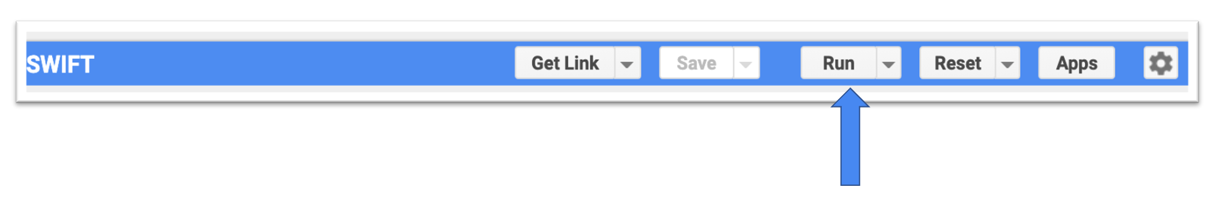

Team contact information:

Brandy Nisbet-Wilcox – [brandynisbet@gmail.com](mailto:brandynisbet@gmail.com) (DEVELOP ID Fellow)

Rainey Aberle – [raineyaberle@u.boisestate.edu](mailto:raineyaberle@u.boisestate.edu) (Southwest Project Lead)

Rebecca Bernat – [rebeccabernat@email.arizona.edu](mailto:rebeccabernat@email.arizona.edu)

Michael Corley – [mcorley@utexas.edu](mailto:mcorley@utexas.edu)

Lukman Fashina – [fashinal@mail.etsu.edu](mailto:fashinal@mail.etsu.edu)

Kyle Paulekas – [kylepaulekas@isu.edu](mailto:kylepaulekas@isu.edu)