NASA EnAACT Field Campaign Dashboard
Data Collection & AI-Powered Scheduling System

Project Context
NASA launched the TEMPO satellite in 2023 to measure air quality data in Earth's atmosphere. However, satellite measurements have limited spatial resolution and read at the top layer of the atmosphere. Prathap Ramamurthy (my PI) won a NASA grant to collect ground-level air quality data across New York City, compare it against TEMPO's satellite readings, and use machine learning to improve the satellite's resolution over urban areas. We collect this data by walking backpack-mounted sensors across NYC neighborhoods to gather this data. The field campaign officially began at the beginning of March and is anticipated to run through spring 2027.

The Challenge & Solution
Coordinating field data collection across 10+ student researchers is complex. The project required:
- Assigning walking routes to collectors based on their availability and location when available
- Accounting for weather conditions (cloud cover & precipitation, which both impact data quality)
- Considering transit logistics (subway schedules and accessibility to neighborhoods)
- Tracking which routes have been completed and load-balancing assignments
Rather than creating a spreadsheet (the initial request), I designed and built an integrated system that combines multiple data sources: real-time weather forecasts, our collection history, NYC Subway network data, and collector availability. These feed into a scheduling algorithm that recommends optimal walk assignments. The system then visualizes results in an interactive web dashboard that I built and deployed to Google Cloud Run.
All code in this project was generated by Claude Code (AI), at my explicit direction. I do not possess a deep skillset in coding but did conceive of all ideas that made their way into the website and fully understand how the codebase functions. The site is still a workurruu in progress.

System Overview
The resulting website consists of two main sections, one for monitoring the progress of the campaign (labeled as “Campaign Monitor”), and the other for visualizing/generating scheduling assignments for fellow researchers (labeled as “Scheduling”).
Included below is a screenshot of each portion of the site, and a brief description of the intended function. The website can be accessed here: NASA EnAACT Field Campaign Data Desk

Campaign Monitoring

Map
All routes are displayed on a map view and colored according to their completion level. Clicking on an individual route opens a menu of its specific attributes (pictured on right side).
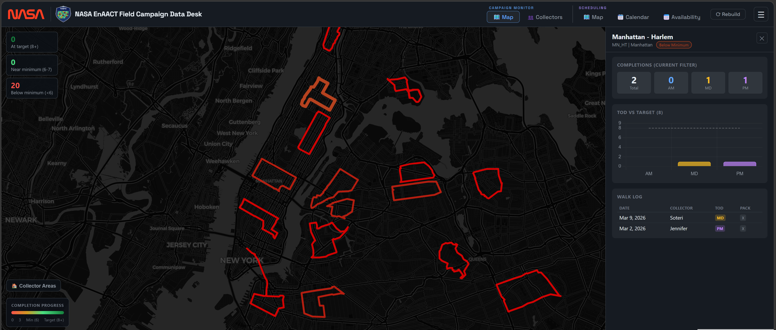

Collectors
As opposed to viewing the progress of the campaign by how much data has been collected, the Collectors tab allows to view who has collected it and when. Clicking any collector name opens a menu of related data analytics (seen at bottom of page and extended beyond).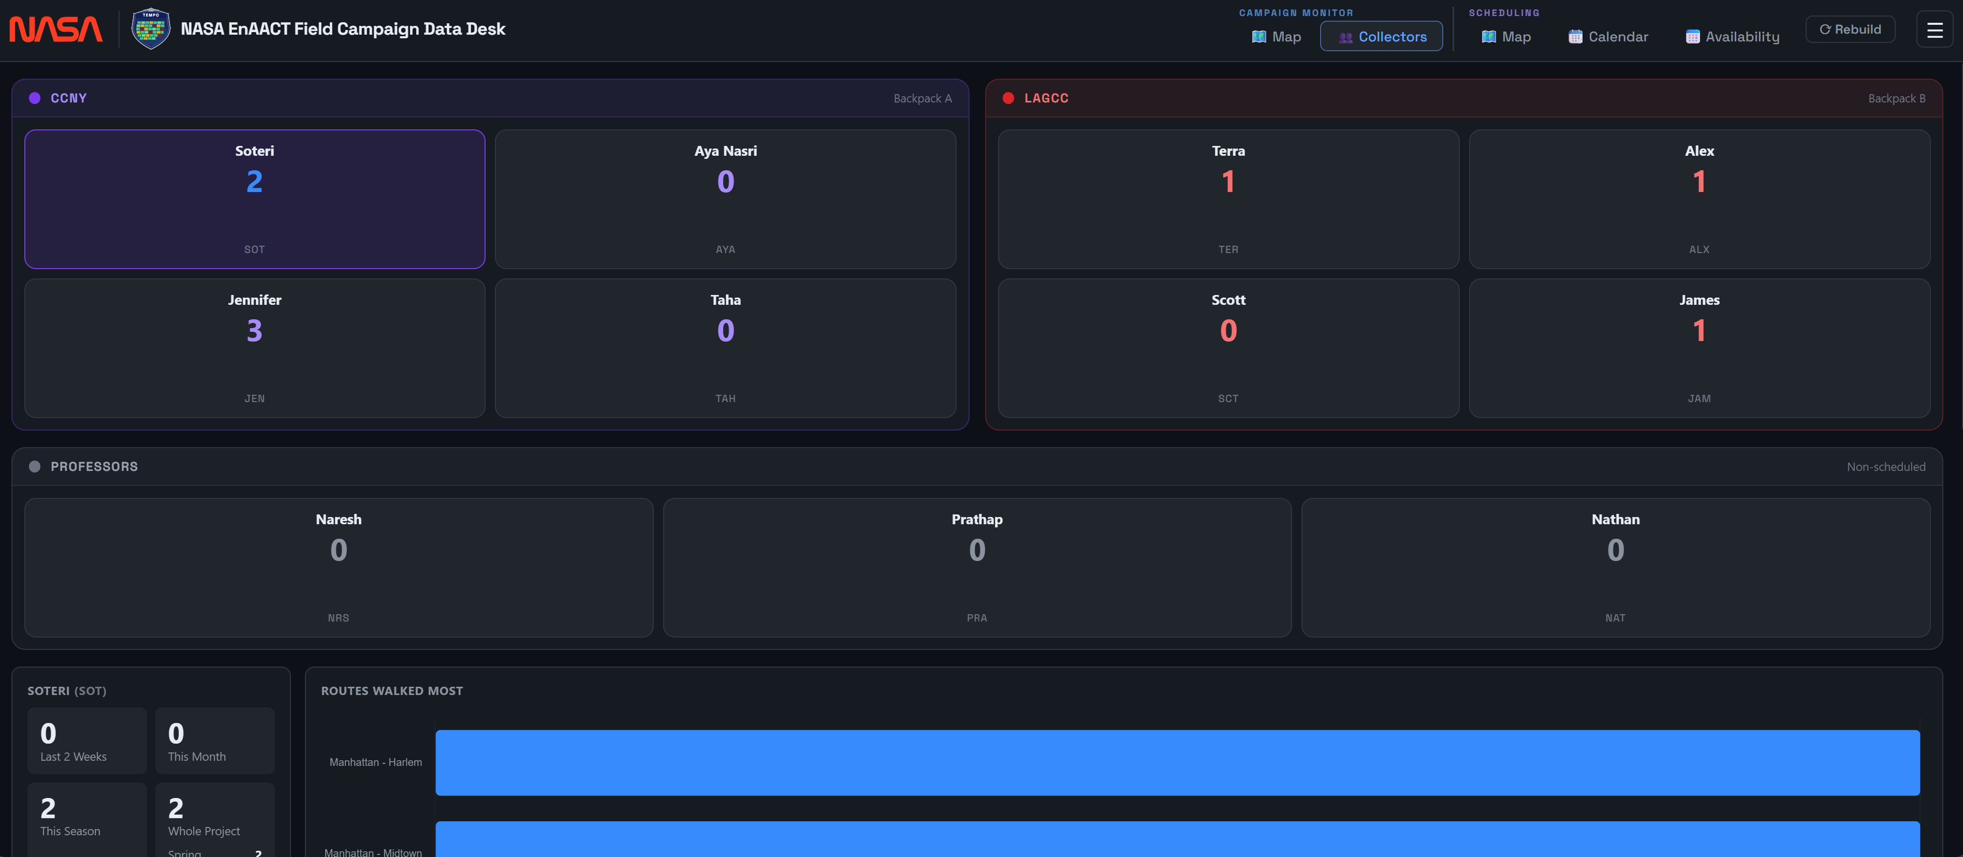

Scheduling

Map
This tab is intended to represent schedule assignments over the progress of the week, allowing for a visual check of the schedule generated by the algorithm. Due to the incompleteness of the algorithm itself, this tab is not refined and not worth a deeper understanding at this time; No image included for this reason.

Calendar
All scheduling assignments generated by the algorithm are displayed on this page, in addition to the inclusion of bad weather limitations imposed by high cloud cover. The visualization of calendar assignments is one of the most important things in this website project. Note that due to equipment repairs, no completed data collections are displayed for this past week.
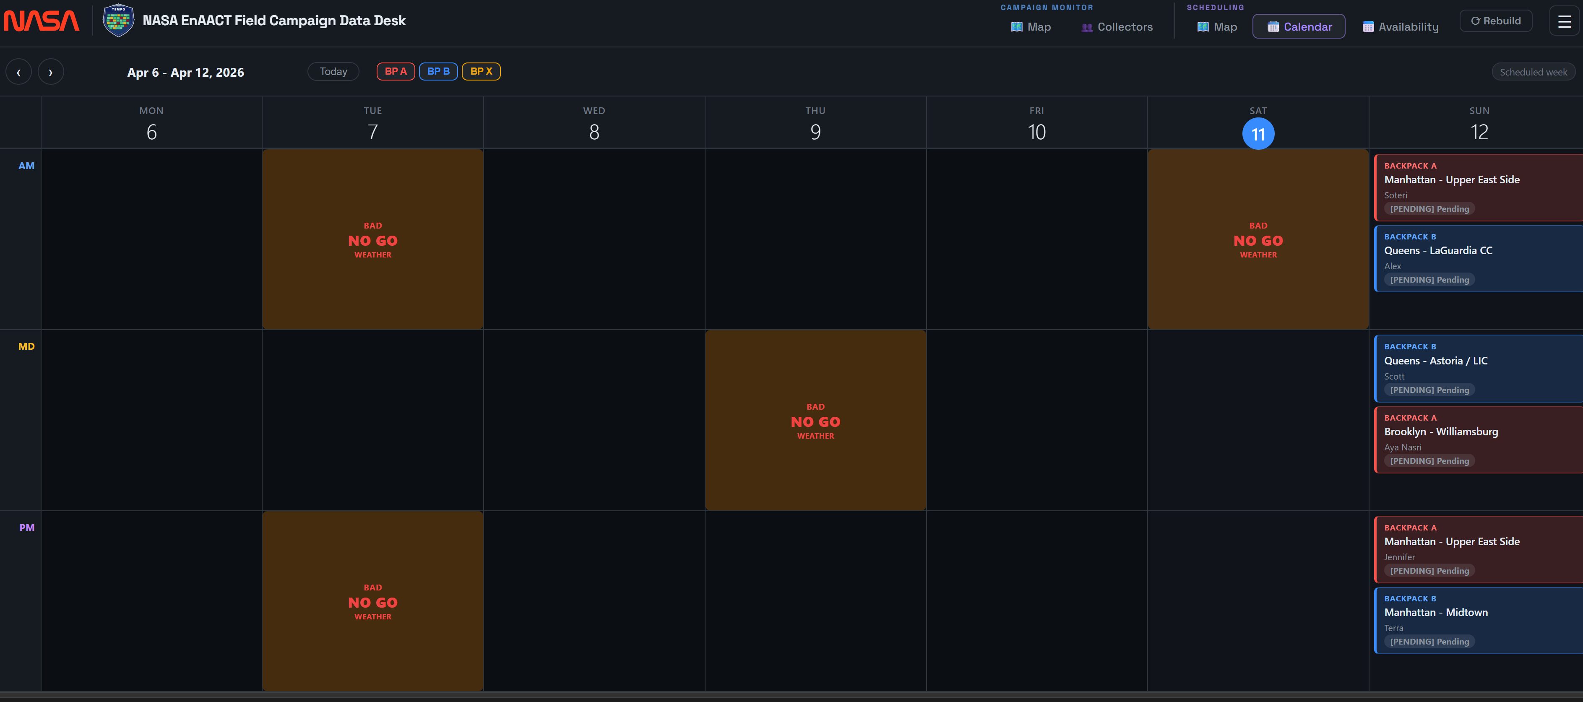

Availability
Each student’s regular availability for each data collection period throughout the week is compiled and overlayed here, allowing for an easily informed manual reassignment when needed.

