# **NASA Openscapes Summary Report**

August 1, 2024 - July 31, 2025

**Openscapes LLC**

Julia Lowndes PhD

This report is publicly available at <https://github.com/NASA-Openscapes/how_we_work>.

# Table of Contents

**NASA Openscapes Summary Report 1**

**Table of Contents 1**

**Executive Summary 2**

Key Performance Indicators 2

**Value statement 3**

**Background 3**

**Statement of Work Activities 4**

1. Manage & support activities in coordination with the DAACs 4

Host biweekly Mentor Calls with agendas co-designed with DAAC Mentors 4

Host recurring Hackdays: 2i2c policy; earthaccess; workshop planning; Cookbook 5

2. Coordinate to host cloud hackathons and workshops 6

3. Create common tutorials, host and manage communities of practice for teaching and mentoring 7

4. “Imagine What’s Possible” talks 8

5. Coordinate cloud coding skills workshops 10

6. Coordinate NASA-specific data cloud workshops 11

7. Provide coordinated workshops to raise the skill levels 11

8. Lead & manage Champions mentorship program 12

9. Define Key Performance Indicators 13

Definition 13

Numbers & sources 14

10. Maintain a web presence 15

11. Ensure AWS costs are within allocated NASA funding 16

AWS Costs By Month 16

# Executive Summary

**NASA Openscapes is the main access point for NASA Earth science & tutorial development on the Cloud.** Openscapes is not extra work for the DAAC staff who participate as mentors, it’s the “how” of doing open, collaborative, reproducible work aligned with DAAC goals to enable users/science. Building from successes and momentum 2021-2023 co-led by Julia Lowndes (Openscapes) and Erin Robinson (Metadata Game Changers, in 2024 and 2025 we have continued teaching staff & researchers, helping us all grow as open science leaders & aligned with DAAC activities. This is vital to the shift to Earthdata Cloud and to NASA’s values for open science and equity. Our 2025 focus is strengthening NASA networks between DAACs, missions, training programs, and applications, aligned with SPD-41a open science, as we continue to support users through developing skills and tools. The Mentors have developed this focus together during our Fall 2024 Mentors Retreat. Specific activities for 2025, co-developed with the Mentors:

* User support and co-development
* earthaccess python library
* Champions Cohort (Fall 2025)
* Earthdata Cloud Cookbook

**We met all deliverables and exceeded the number of events required**. The official deliverables we met are detailed in the Statement of Work Activities section. They include 6 “Imagine What’s Possible” webinars, 4 coding skills workshops, 2 NASA-Specific Data Workshop to different scientific and data audiences.

**Additionally, we have collaborated on writing lessons learned from NASA Openscapes**. We have written blog posts including [Onboarding and “fledging”: How NASA Openscapes supports NASA Earthdata users in the Cloud](https://nasa-openscapes.github.io/news/2024-08-30-esip-summer-2024/) that wrote up the successful session we led with Mentors at ESIP in July 2024; [openscapes.cloud: A central place for Openscapes JupyterHubs and documentation](https://nasa-openscapes.github.io/news/2025-01-09-openscapes.cloud/) that describes a stand-alone website for cloud admins and users that is separate from the Earthdata Cloud Cookbook; and [What we’re learning about cloud costs for Earth science workflows in our JupyterHub](https://nasa-openscapes.github.io/news/2025-05-01-community-call-hub-cloud-costs/) following a Community Call about this topic, co-presented with Mentors from the Alaska Satellite Facility and 2i2c. This was part of our ongoing efforts to support “fledging” to answer the question “where do users go when they leave the Openscapes 2i2c JupyterHub.

## Key Performance Indicators

These are defined and sources indicated in the Statement of Work Activities section 9.

| **KPI Definition** | **Notes** | **KPI Achieved**  **(8/1/24-7/31/25)** |
| --- | --- | --- |
| **Teaching Numbers** | | |
| Number of Cloud participants in the JupyterHub | This reflects the number of hands-on workshops hosted by the NASA Mentors | 530 |
| Number of new teaching slides and tutorials | This reflects the Champions program lessons as well as new tutorial books. Note that we reuse lessons across workshops. | 4 |
| Number of talks “imagine what’s possible” conducted | This reflects talks that are not hands-on (and do not provide access JupyterHub) | 6 |
| **Engineering Numbers** | | |
| Number of contributors to earthaccess | This is currently taken from GitHub contributor count | 40 |
| Number of dependents on earthaccess | This is taken from the GitHub “used by” count | 205 |
| Number of stars for earthaccess | This is taken from the GitHub count of users that opt-in to "starring" earthaccess and saving it to their favorites list | 500 |
| Number of contributors to Cookbook | This is also taken from GitHub contributor count | 35 |
| Number of contributors to GitHub docker image | This is also taken from GitHub contributor count | 12 |
| Number of items in workshop-planning GitHub Issues (open cross-DAAC planning) | This shows activities proposed and pursued across the community. It does not distinguish between which were completed versus considered but gives an idea of scope | 152 |
| Number of cloud infrastructure hackdays (2i2c, environments, etc) | This gives an idea of engagement and regular progress across the NASA Openscapes community goals | 43 |

# Value statement

**NASA Openscapes is the main access point for NASA Earth science & tutorial development on the Cloud.** Openscapes provides a critical service of building the cross-DAAC mentor community with a shared user-centered teaching & development approach that is networked with the broader open science community – and further coordinates, role-models, and teaches Open Science through technical and leadership skillbuilding via Mentors and Champions programs, in this project to support the DAACs to achieve NASA’s goals of data usage enablement through Open Science. Further, we are co-creating open source tooling for JupyterHub cost monitoring, reporting, and management that is useful to users (scientists) and administrators (NASA staff, as well as science team leads).

# Background

**NASA Openscapes** is an activity through the NASA Earth Science Data and Information System (ESDIS) Project, which manages the science systems of the Earth Observing System Data and Information System (EOSDIS) that provides science data to a wide community of users for NASA's Science Mission Directorate. NASA Openscapes supports data usage enablement through Open Science with a focus on exploiting commercial cloud through training, mentoring, and community engagement (Category 5) – by building a teaching community across the NASA Distributed Active Archive Centers (DAACs) and collaborating with the broader open science community.

**This Year 4-5 (Year 4 Q3-Q4, Year 5 Q1-Q2) Summary Report** builds upon the work of the NASA Openscapes initiative from 2021-2023 co-led by Julia Lowndes (Openscapes) and Erin Robinson (Metadata Game Changers), with these three main objectives:

* Train and develop leaders and champions to enable and advocate for the transition of the NASA science community toward Open Science goals and leveraging new capabilities in a cloud environment. Systematically develop and grow the skillsets of these leaders to increasingly participate in and conduct activities such that the Open Science initiatives continue to grow and expand into a sustainable process.
* Build and grow a community to motivate NASA researchers to transition their workflows to the cloud through routine engagement and training. The approach should be remote-by-design, extensible, scalable, and address the time constraints, hardware and processing constraints and other needs that confront researchers with varying computational capabilities and needs.
* Create opportunities to collaborate with working groups to develop cohesive cloud training materials and work with researchers to develop coding, cloud computing, and open science skills.

# Statement of Work Activities

The following are numbered from the NASA Openscapes Statement of Work (SOW).

## 

## 1. Manage & support activities in coordination with the DAACs

### Host biweekly Mentor Calls with agendas co-designed with DAAC Mentors

### 

**2024:**

* **Mentor Calls. Aug 7 & 21:** SE TIM talk planning, “good enough” open science practices & leadership discussions. Lighter schedule for summer.
* **Mentor Calls. Sep 4 & 18**: Following up with Earthdata Search team about earthaccess integration, 3-month Check-In from 2024 spring NASA Champions Cohort
  + **JupyterHub monthly usage reports walkthrough** - Openscapes team walked through reusable workflow they are developing for transparency in monthly cost reports (described above). This workflow includes R code, a quarto document (.qmd), GitHub version control and GitHub Actions, and is generalizable and reusable for Mentors and builds from our Quarto Contributing Clinic held in spring. From this walkthrough we also received feedback from Mentors for user needs at their DAACs during biweekly Mentor call.
* **Mentor Calls. Oct 2**: Following up with shared password approach, discussing retreat design and how to describe impact of NASA Openscapes Mentors work. Oct 16 takeover by Retreat
* **Mentor Calls. Oct 30, Nov 13**: Following the Retreat we re-established Mentor Calls as learning-sharing-time and skills-time. Mentors bring topics important to them along, including ideas around merging common tutorials to earthdata.nasa.gov, and preparing for UN TIM. Skills focused on communication strategies for messaging and storytelling.
* **Mentor Calls. Dec 11**: Only one during this period due to the Thanksgiving holiday, and coinciding with AGU where ~15 Mentors were in person.

**2025:**

* **Mentor Calls. Jan 22**: Only one during this period due to the winter holiday; check in on shared activities.
* **Mentor Calls. Feb 5, 19**: Focused on earthaccess ESDIS meeting and developing communication skills for presenting
* **Mentor Calls. Mar 5, 19**: Focusing on setting and communicating 2025 Goals, building from 2024 Fall Retreat to support users. Working on updating Mentors page and sharing with DAAC Managers and ESDIS; will work on reporting with Mentors as well
* **Mentor Calls. Apr 2, 16**: Refocusing on Cookbook: updating onboarding and contributing; adding tutorials from recent workshops; updating earthaccess features
* **Mentor Calls. Apr 30, May 14:** Refocusing on Cookbook: updating onboarding and contributing
* **Mentor Calls. May 28, June 11**: Developing Cookbook author and reviewer guides from Danny Kaufman (ASDC Mentor) walked through his review process; identifying opportunities to link to Cookbook from earthdata.nasa.gov and drafted text for Andi Thomas (lead of the website unification efforts)

### **Host** r**ecurring Hackdays:** 2i2c policy; earthaccess; workshop planning; Cookbook

* **Earthaccess hackdays** occur twice-monthly, and have consistently had ~10 people each time, from NSIDC and beyond. Creating an open source community of practice. Priorities are set based on user requests (from Mentors and users) via GitHub and the community is developing code review processes that will be documented.
  + Biweekly reportouts: <https://github.com/nsidc/earthaccess/discussions>
* **Cloud infrastructure hackdays evolved from 2i2c policy hackdays:** We continue to support collaboration across NASA and the open science community to work on specific projects that have emerged. We consolidated the monthly 2i2c policy hackdays with biweekly cloud infrastructure hackdays as the focus expanded and community interest grew. Note: after hosting these for 10 months we are pausing for the summer 2025.
  + Biweekly reportouts: [github.com/Openscapes/openscapes.cloud/discussions](https://github.com/Openscapes/openscapes.cloud/discussions)
  + Adding functionality to [earthdatalogin](https://github.com/boettiger-lab/earthdatalogin/) to access NASA STAC catalogues.
    - Mike Gangl’s (PO.DAAC)’s CMR work to align with earthaccess: huge for making earthaccess usable across NASA datasets & tooling <https://github.com/podaac/cmr-mcp>
* **Cookbook (biweekly, reinstated)**
  + R updates:
    - Working with NASA Mentors to update Earthdata [Cookbook R tutorials](https://nasa-openscapes.github.io/earthdata-cloud-cookbook/in-development/CMR-STAC-Search.html)
* **Cross-NASA JuptyerHub meetup (monthly)** - coordinated by Tasha Snow
  + co-authoring a white paper to describe what is common and different across the JupyterHubs at NASA.

## 2. Coordinate to host cloud hackathons and workshops

**Engineering work to support cloud hackathons and workshops, including work to inform “fledging” (answering the question of “where do users go when they leave our Openscapes 2i2c JupyterHub that is meant for training?”)**

**August 2024**

* **Working on monthly cost reports to inform us as hub admins and fledging scientists.** We’re creating a monthly PDF posted on GitHub; August was first automatically generated. ([aws-usage-report](https://github.com/NASA-Openscapes/2i2cAccessPolicies/tree/main/aws-usage-report)). This involves working closely with developers at 2i2c and combining their data with AWS cost information. We will request feedback and iterate once we have a useful first report. This includes: are Monthly PDFs a useful time-chunk and format? We are designing this way to compliment 2i2c reporting and any generic interactive dashboard; concreteness in PDF seemed useful but we are interested to iterate. We presented briefly about this during our ESIP session in July ([slides](https://docs.google.com/presentation/d/1-TiPN8bfY6iDL5EVcEuCQSjqFMs3jPSX2MlNWA6no2E/edit#slide=id.g2eae202a90f_1_26) 42+).
* **Shifting JupyterHub access policy from Cookbook** - access setup, admin and ultimately costs can be more organized at [openscapes.cloud](https://openscapes.cloud); Cookbook will refocus on science workflows. This shift will also make it easier to find, reuse, and share admin policy for different groups using 2i2c or JupyterHub infrastructure, including NASA and now also NOAA Fisheries.

**October 2024**

* **Cost monitoring and reporting** - in continued collaboration with 2i2c, we are exploring cost monitoring quotas/guardrails and reporting. In our first biweekly cloud-infrastructure hackday, Jenny Wong gave an overview of the new cost monitoring dashboards in Grafana, that 2i2c are piloting on the NASA Openscapes Hub and rolling out across AWS hubs soon. These dashboards break costs by hubs (if there are multiple) and by component (compute, home storage, backup, networking, object storage, and fixed). Dashboards can be shared/exported for users who don't have a Grafana account.
  + Jenny shared [new docs](https://docs.2i2c.org/admin/howto/monitoring/prometheus-access/) in the 2i2c documentation for accessing prometheus data sources outside Grafana.

**February 2025**

* **Cost monitoring and reporting -** in continued collaboration with 2i2c, we are working on cost monitoring quotas/guardrails, reporting, and documentation. Have streamlined where this lives now, no longer some in a GitHub repo and some in the Earthdata Cookbook: <https://openscapes.cloud/usage-reporting#monthly-nasa-reports>

**March 2025**

* **Cost monitoring and reporting** - Common cost/usage reporting framework for [NASA and NOAA](https://openscapes.cloud/usage-reporting.html) (‘[jupycost](https://github.com/Openscapes/jupycost)’ R package).

**June 2025**

* **JupyterHub work on unanticipated cost and storage work; user management.** Openscapes team working closely with 2i2c engineers to understand storage and usage costs and build out a quota/guardrails system and cost per workflow. Also involves reaching out 1:1 with users. This will help admins plan for costs, as well as scientists budget for costs to include in grant proposals.

## 3. Create common tutorials, host and manage communities of practice for teaching and mentoring

In addition to supporting Mentors’ contributions to the NASA Earthdata Cloud Cookbook, we focused on development and tutorials for Cloud infrastructure, workshop planning & automating.

### 

**Cloud infrastructure, workshop planning & automating:**

**January 2025**

* **Zarr in R** - we are exploring limitations on using Zarr files from the programming language R. We are collaborating with others in the open source community (geospatial and R community folks) to scope the work to be done to make Zarr file access possible in R. This will support a growing number of NASA Earthdata users that use R.
* **Investigating sharing JupyterHubs** - we are exploring how to run workflows on ASF’s OpenScienceLab and Openscapes 2i2c JupyterHub. This will include a cloud costs of an individual science pipeline ([GitHub issue](https://github.com/NASA-Openscapes/workshop-planning/issues/139))

**February 2025**

* **Zarr in R** - liaised R geospatial developers with EarthMover to work on supporting Zarr files from the programming language R.
* **Investigating sharing JupyterHubs** - more progress on how to run workflows on ASF’s OpenScienceLab and Openscapes 2i2c JupyterHub – working on slides to present and share

**March 2025**

* **Investigating sharing JupyterHubs** - more progress on how to run workflows on ASF’s OpenScienceLab and Openscapes 2i2c JupyterHub – working on slides to present and share
* **Earthaccess ESDIS proposal** - Contributing to an NSIDC led effort following the February discussion with ESDIS to support DAAC staff to contribute to earthaccess.

**May 2025**

* **JupyterHub white paper led by Tasha Snow**, exploring what’s common and different across different NASA JupyterHubs

**June 2025**

* **Earthaccess ESDIS proposal** - Contributing to an NSIDC led effort following the February discussion with ESDIS to support DAAC staff to contribute to earthaccess. Earthaccess now has 500 stars on GitHub! <https://github.com/nsidc/earthaccess/stargazers>
  + The proposal is being led by Amy Steiker (NSIDC Mentor) and Amanda Leon, collaborating across DAACs to identify feature ideas and staffing needs.
  + Luis Lopez noted that the pull request in IceChunk was merged! “we are testing VirtualiZarr integrations [with earthaccess] and one of the most recurrent questions has been "can we test it with Icechunk?" and our data doesn't allow egress with S3(NASA Earth).” Luis then said “when bearer token is supported (and released) we will be able to build an Icechunk store with http access for NASA data!” <https://github.com/earth-mover/icechunk/pull/938/#issuecomment-2977601990> !!
* **JupyterHub whitepaper** - collaborating on cross-NASA lessons learned, led by Tasha Snow

## 4. “Imagine What’s Possible” talks

These talks connect and build the open science community, highlighting researchers who are already working in the cloud.

**August 2024**

* **earthaccess talk at Posit Conference by Luis Lopez on Aug 14.** Posit is an open source data science conference, with roots in R and now Python via tools like tidyverse, RMarkdown, Quarto. Lowndes knows this community well (10-year collaborator; keynoted in 2022); first-time-attendee Lopez represented NSIDC and NASA open source work and met new scientists and engineers; little overlap with SciPy community so great visibility for earthaccess & NASA. (ETD-241)
  + Session where Luis presented:<https://reg.conf.posit.co/flow/posit/positconf24/publiccatalog/page/publiccatalog/session/1711986820020001vWw8>
  + Slides that Luis presented:[POSITconf](https://docs.google.com/presentation/d/1Ot879tfrjhok3BzSwSUr2Xpd26dX-hyVGHQzATLVRTo/edit?pli=1#slide=id.g6c52a2e8d8_0_177)

**September 2024**

* **PI Planning plenary** - Lowndes has been iterating the talking points of “forking as a worldview” with other cross-government and academic audiences, following the plenary at PI Planning. Slides: [Forking as a Worldview: A big idea that frames Openscapes thinking](https://docs.google.com/presentation/d/1u0pQ3p3eNMxPn44GsZF0OKxhnJem7MD_3MWp8W_qXp8/edit#slide=id.g2f7acce46f8_0_0). Lowndes talked about forking as reusing what works in new places, with examples of earthaccess forking the open source software dev approach into government, and NASA Openscapes and then NOAA Fisheries Openscapes forking open source frameworks to tackle big challenges (cloud migration, data modernization). She shared what people can do to develop forking as a worldview through centering inclusion, and real challenges as individuals and orgs make these shifts. And, why it’s worth it: so we can tackle big challenges together and increase morale for teams doing this hard work. So much here from what the whole Openscapes community is doing, cross-org! (Sept 10, 240 participants, "Imagine What's Possible" Webinar ETD-242)
  + **Openscapes recognized at The White House** -PI Lowndes kicked off remarks with a quote from Justin Rice at 2023 ESDSWG saying “the impact that Openscapes has had in the last 2 years is unprecedented at NASA”. This quote is about culture shifts in the way NASA Mentors teach collaboratively and openly, and is possible because of years and years of resourced coordinating and engineering work at NASA. Sharing this showcases work that is inspiring to many people on such a big stage. Following this quote, Lowndes shared about specifics the NASA Openscapes Mentors community has achieved, including the Earthdata Cloud Cookbook, earthaccess python library, and centering kindness and inclusion, and how other groups including NOAA Fisheries has seen NASA’s momentum and said “we can do that too” while supporting data modernization, upskilling the workforce, and extending the Openscapes Pathways to Open Science program. These remarks in presence of 13 federal agencies at the “Celebration of the OSTP Year of Open Science Recognition Challenge Winners” on Sept 19.

**December 2024**

* **AGU fall meeting** **9 talks & 10 posters** - supported December 9-14 in Washington DC, most listed were NASA Openscapes Mentors but also cross-government mentors from NOAA Fisheries and EPA ([https://github.com/NASA-Openscapes/2024-agu-planning](https://github.com/NASA-Openscapes/2024-agu-planning/)). Lowndes co-presented a poster with NASA Mentors “Supporting NASA Earthdata users in the Cloud: NASA Openscapes JupyterHub and User Onboarding & Fledging” (Dec 9, 50 viewers, "Imagine What's Possible" ETD-243)
  + Lowndes stepped in to give Brianna Pagán’s invited talk “Beyond Open Data” when Pagán had to return home due to a fast-approaching wildfire.
* **Talks with NSF, NOAA Fisheries, National Institute of Standards and Tech, RLadies** - Lowndes shares NASA Openscapes work with US federal & international open communities

**February 2025**

* **Openscapes Briefing for NASA HQ Earth Action** - invited to showcase with Amy Steiker, Luis López (NSIDC DAAC), Ian Carroll (OB.DAAC), Chris Battisto (GES DISC), ([slides](https://docs.google.com/presentation/d/11tB43uq1E31lKjLk4HtyKy_J5v7BpGErVpoFlS0KSs8/edit#slide=id.p)) (Feb 27, 17 participants, "Imagine What's Possible" Webinar #5 ETD-244)

**May 2025**

* **USGS Community for Data Integration (CDI) Workshop - Invited plenary** re NASA Openscapes work ([slides](https://docs.google.com/presentation/d/1DJq0lrGYgcxRiPGYM1z8-EBwB7eZSthymzZNNdcrHuk/edit?slide=id.p#slide=id.p)) (April 29, 100 participants, "Imagine What's Possible" Webinar #5 ETD-245)
* **ESIP talk about earthaccess in the session Crossing the Chasm: amplifying success stories about co-creating across institutions.** This talk will be alongside stories from NOAA Fisheries, the Texas High Performance Computing Center, and 2i2c (July 25, imagine what’s possible webinar #6 (ETD-246)).

**July 2025**

* **earthaccess talk at 2025 ESIP session “Crossing the chasm”** - Lowndes and NSIDC Mentor Amy Steiker presented a talk about earthaccess within the framework of the Diffusion of Innovation theory of how ideas spread within a system, using earthaccess as an indicator of earthdata cloud (upcoming July 25, ~40 participants, "Imagine What's Possible" Webinar #6 ETD-246)

## 5. Coordinate cloud coding skills workshops

The workshops focus on hand-on training including “hackathons”, leveraging, to the extent possible, resources from the DAACs.

**September 2024**

* **PACE Hackweek** (NASA Plankton, Aerosol, Cloud, ocean Ecosystem [PACE] Hackweek) was a social-coding sprint led by OB DAAC. This event was collaboratively led with the CryoCloud community and leveraged their tutorials and JupyterHub. Three PACE Hackweek leads are Openscapes Mentors/Champions; Anna Windle was a 2024 Champion and reported at the 3-month Checkin on Sept 18 that she is better equipped to access & analyze new PACE data. She “used what we learned in Openscapes in the PACE hackweek - referred to Cookbook at lot”. During coworking, Mentor Ian Carroll contributed to the Cookbook and this hackweek is now listed at [https://nasa-openscapes.github.io/earthdata-cloud-cookbook/workshops](https://nasa-openscapes.github.io/earthdata-cloud-cookbook/workshops/). Mentor Eli Holmes is the third; she is from NOAA Fisheries (and was a participant in the 2021 Cloud Hackathon; a good example of cross-government engagement). (August 4-8, 41 participants, coding skills workshop, ETD-247)

**December 2024**

* **earthaccess at Pangeo** **hackday** ~8 NASA Openscapes Mentors joined the Pangeo hackday in Washington DC hosted at the DevelopmentSeed offices to continue developing and sharing earthaccess features to connect NASA Earthdata and open source infrastructure, including VirtualiZarr, user-facing docs. (Dec 14, 30 participants, "Coding Skills Workshop" ETD-248)

**February 2025**

* **Biospace workshop in Italy -** Openscapes Mentors from ORNL led workshop using 2i2c, earthaccess, and Cookbook resources(Feb 12, 50 participants, Coding Skills Workshop ETD-249) [www.conftool.pro/biospace25/index.php?page=browseSessions&form_session=77](https://www.conftool.pro/biospace25/index.php?page=browseSessions&form_session=77)

**July 2025**

* Create yaml files for datasets in AWS’ opendata registry. Specifically, adding yaml files for some of our top datasets here: https://github.com/awslabs/open-data-registry. (July 1-31, requested to satisfy Conduct Code Skills Workshop #4 ETD-250)

## 

## 6. Coordinate NASA-specific data cloud workshops

The workshops focus on hand-on training including “hackathons”.

**October 2024**

* **Fall 2024 Mentors Retreat** - remote, October 16-17 - we met our goals of reconnecting and rejuvenating our community, to share progress, barriers, onboard more of our growing community as contributors, and refine our shared vision for momentum forward. Much of preceding weeks was focused on coordinating Mentors and securing time approval, designing meaningful time together including storytelling and sensemaking skills that Mentors put into practice through an informal conversation with NASA/ESDIS leadership. (24 participants, NASA-Specific Data Workshop ETD-251)
* **BioSCape Campaign workshop in South Africa** - October. Mentors Michele Thornton & Rupesh Shrestha (ORNL) taught in person, saying “Without my exposure to hubs and earthaccess and all the incredible things that Openscapes [mentor community] has taught me, I don't know that I would have been able to contribute to the South Africa workshop in the same manner without you all. We've received a lot of very positive feedback from the range of workshop participants, other instructors including NASA PI's and South African collaborators/ academics, and NASA Program-level support. I am deeply indebted to Openscapes.”

**May 2025**

* **SBG Workshops (Surface Biology & Geology)** - Co-led by Michele Thornton & Rupesh Shrestha (ORNL) Erik Bolch & Mahsa Jami (LP), these two workshops had sign-ons using the shared password method using AVIRIS and HyTES data ([tutorials](https://ornldaac.github.io/airborne/events/2025-SBG/README.html#)). May 20 & 21, 200 participants, Conduct NASA-Specific Data Workshop #2 ETD-252)

## 7. Provide coordinated workshops to raise the skill levels

These are specific events to support emerging leaders with the goal to expand the skills to teach and support users with why and when to use the cloud.

**October 2024**

* **Fall 2024 Mentors Retreat Planning** - remote, October - with the purpose of reconnecting and rejuvenating our community, to share progress, barriers, onboard more of our growing community as contributors, and refine our shared vision for momentum forward. Working with Justin Rice for Mentor time approval, plus co-design with Mentors and Liz Neeley ([Liminal](https://www.liminalcreations.com/)), a hero-expert in science communication and sensemaking and who has been getting to know Mentors and their work over the past months.

**February 2025**

* **Earthaccess ESDIS meeting** - Supported earthaccess team to prepare for discussion with ESDIS on facilitating growth and sustainment
* **Group Coaching for Mentors** - NASA Mentors joined Openscapes Mentors from NOAA Fisheries, California Water Boards, Fred Hutch Cancer Center, and more to develop coaching skills that can help us as mentors and professionals – skills like listening rather than solutioneering, asking open-ended questions that empower people to find their own agency and meet their needs. With a specific goal of networking and connecting NOAA Fisheries Mentors with others in the open source community, invite other groups to skill-build together. There were 5 virtual sessions, theory, demos, breakout rooms to practice, reflections between weeks. Topics: listening and powerful questions 101, Listening & powerful questions 201, Values, Future Self, Saboteurs.

**April 2025**

* **Openscapes Community Call: What we’re learning about cloud costs for Earth science workflows in our JupyterHub** led on April 22. [Blog post](https://nasa-openscapes.github.io/news/2025-05-01-community-call-hub-cloud-costs/), with link to slides and recording. The purpose of this Community Call was to share what we’ve learned so far: tools and processes to explore cloud costs, as well as figures like the basic costs for hosting a hub, cost per user, cost per science workflow, and what it costs to run a workshop in the hub.
  + One punchline: yes it is possible to run real science workflows in different Hubs – and we can estimate the costs. An example workflow transported from Alaska Satellite Facility (ASF) OpenSARLab to NASA Openscapes Hub cost $0.74. This cost does not reflect the cost of technical infrastructure & development, plus the training and upskilling the researcher needs. When comparing costs, it is important to keep in mind that different JupyterHubs have different focuses (e.g., data type(s) and usage patterns) and, consequently, different architectures that can greatly affect costs even for similar workflows. Yet, it is an exciting step in understanding the cost of earth science workflows in the cloud

**June 2025**

* **NOAA Fisheries/NASA Mentors Joint Hackdays – Summer ML/LLM series** -
  + During these stand-alone informal sessions we will get introduced to a variety of tools for ocean data access and analysis in Python and R. We will be using the NOAA Fisheries Openscapes Jupyter Hub and you will not need to install anything. Please register (free, open to all). <https://nmfs-openscapes.github.io/live-coworking>

## 8. Lead & manage Champions mentorship program

**Openscapes Champions Program -** We lead this program remotely over 2 months; we helped NASA Openscapes Mentors from the DAACs recruit science teams that were interested in transitioning workflows to the cloud that Mentors wanted to work with. We met individually with the 9 teams that signed up and helped them prepare. We have Mentors teaching all lessons, collaborating to adapt core lessons for Cloud based, and getting feedback asynchronously and via dry runs. We also invited a guest teacher for the kick-off call: a real-life example of a scientist working in the Cloud. We continue to plan/practice/give feedback on the lessons for the remaining calls.

**Planning 2025 Champions:** after discussing with the Mentors in February-March 2025, we decided we will lead this year's Cohort in Fall 2025, giving time to align with ESDIS and NASA Earth Action’s goals and communities. Champions this year will likely be a lighter-weight version that would enable more participation. A full Champions Cohort, like we’ve co-led with Mentors 3 times (2022-2024) gives Mentors a deep understanding of user needs while supporting users in real time; outcomes from Champions included earthaccess, cheatsheets, and R and MatLab support. But they are a heavy lift for Mentors and Participants (Champions’ 1x/week over 10 weeks is equivalent to a week-long Hackweek); and limited at 40 participants to build trust and relationships as they work on their own science with support from Mentors. A lighter weight version will require less time from NASA Openscapes Mentors (seems necessary since they have not had time to commit to cross-DAAC Openscapes activities) and include more users, albeit with less engagement and opportunity to work with Mentors. We will spend the spring and summer strengthening NASA networks between DAACs, missions, training programs, and applications – including Earth Action, ARSET, DEVELOP – and exploring shaping the Fall Champions to meet broader community needs. Work in the meantime on developing earthaccess; to support Virtualizarr lessons. We are also working on cost management infrastructure, guardrails.

## 9. Define Key Performance Indicators

This is publicly available at ​​<https://github.com/NASA-Openscapes/how_we_work>.

These are the updated 2024 definitions of Key Performance Indicators (KPIs) to evaluate the progress of the Enabling Science in the Cloud initiative including the impact on targeted communities. In the subsections below we define the KPIs and thinking behind them (including critique to consider whether these are the best way to capture what we want to), and then provide numbers for August 1 2024 - July 31 2025. For previous work about describing impact of NASA Openscapes beyond-the-numbers, see [Communicating impact: NASA Openscapes](https://docs.google.com/presentation/d/14iEGfbipt5HBlVyyf3kvjyxas4lBoRlbT8u8iFr2VNw/edit#slide=id.g1b5922f14f8_0_83) by Lowndes, Robinson, & Rice, ESDSWG 2023.

### Definition

**Teaching numbers**

* # participants in the workshops/champions using the Hub - this reflects the number of hands-on workshops hosted by the NASA Mentors. Current numbers come from the [Shared Password Feature we co-developed with 2i2c](https://2i2c.org/blog/2024/openscapes-sbg-workshop/), and no longer from the GitHub Teams approach that we used in 2024 (which only saw a small increase since this method was only lightly used in 2025. Source: <https://github.com/orgs/nasa-openscapes-workshops/teams>, private)
* # new teaching slides and tutorials - this reflects the Champions program lessons (which we did not lead yet in 2025) as well as two new tutorial books. Since we focus so much on reuse and adapting, it can be difficult to decide what to include. Also, do you count a workshop or the individual tutorials within it? Below we have included the number of individual tutorials.
* # talks “imagine what’s possible” - this reflects talks that are not hands-on (and do not provide access to 2i2c JupyterHub). It’s important to share the science and teamwork of what’s possible

**Engineering numbers**

* # contributors to earthaccess - this is from GitHub contributor count, which has been criticized for not including contributions that are notGitHub commits. For example, scientists who have posted Issues/Discussions on GitHub asking questions that have led to engineering to fix a bug or add a feature are not included on this list.
* # dependents on earthaccess - this is from the GitHub “used by” count, which GitHub has started tracking to network across GitHub projects.
* # stars for earthaccess on GitHub - this is an indication of how many people have voluntarily found earthaccess useful enough to add a star, which means it is also now listed in their favorites so that they can come back to it again.
* # contributors to Cookbook - this is also from GitHub contributor count, with challenges listed above
* # contributors to Hub docker image - this is also from GitHub contributor count, with challenges listed above
* # items in workshop-planning GitHub Issues (open cross-DAAC planning) - this shows activities proposed and pursued across the community. Does not distinguish between which were completed versus considered but gives an idea of scope
* # earthaccess and cloud infrastructure hackdays (2i2c, environments, etc) - this gives an idea of engagement and regular progress across the NASA Openscapes community goals

### Numbers & sources

**Teaching numbers**

* 530 Cloud users in 2025
  + This increased from 367 users last year. There have been 937 distinct users ever.
* 4 new teaching slides and tutorials.
  + Note that we reuse and build on previous tutorials so these numbers are small for that reason. Additionally, we have postponed the 2025 Champions Cohort so those lessons are not included here.
  + 2 from source: [BioSpace2025](https://ornldaac.github.io/airborne/docs/datasets.html)
  + 2 from source: [2025 AMS Earthdata Workshop for Increasing Participation of Minority Serving Institutions in Earth Science Division Surface-Based Measurement Networks (IPMSI)](https://zenodo.org/records/14611304)
* 6 talks “imagine what’s possible”
  + source: SOW deliverables

**Engineering numbers**

* 40 contributors to earthaccess on GitHub
  + source: <https://github.com/nsidc/earthaccess>, accessed July 1, 2025
* 205 dependents on earthaccess (“used by”) on GitHub
  + source: <https://github.com/nsidc/earthaccess>, accessed July 1, 2025
* 500 stars for earthaccess on GitHub
  + source: <https://github.com/nsidc/earthaccess>, accessed July 1, 2025
* 35 contributors to Cookbook
  + source: <https://github.com/nasa-openscapes/earthdata-cloud-cookbook>, accessed July 1, 2025
* 12 contributors to Hub docker image
  + source: <https://github.com/nasa-openscapes/corn>, accessed July 1, 2025
* 152 items in workshop-planning GitHub Issues (open cross-DAAC planning)
  + source: <https://github.com/NASA-Openscapes/workshop-planning/issues> 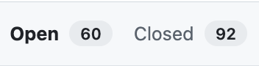
* 43 earthaccess and cloud infrastructure hackdays (2i2c, environments, etc)
  + source: earthaccess (n=23) <https://github.com/nsidc/earthaccess/discussions>
  + source: 2i2c (n=9) <https://github.com/Openscapes/openscapes.cloud/discussions>
  + source: JupyterHub hackdays led by Tasha Snow (n=11)

## 10. Maintain a web presence

We maintained the web presence and the web accessible resources provided through the current Openscapes website ([openscapes.org](https://urldefense.com/v3/__https:/openscapes.org/__;!!MvWE!BgcRp6h8QU3QAyZsa45WyWZD9xMpRJMR5yLW0GxRDkEgG3CTSBN8Tw1-47_4xXiSC8p2yWBPHI1E1h9wKS8xHxI$)), as well as the NASA project website [https://nasa-openscapes.github.io](https://urldefense.com/v3/__https:/nasa-openscapes.github.io__;!!MvWE!Hv-umhSEuNVGJX69zcPanS5_ZVgaDrwY6JaGBa24JT0ZBOqPfranNbLKJvxh2ciiFJq4i0pdBgs6kw$). We contributed to the NASA Earthdata Cloud Cookbook <https://nasa-openscapes.github.io/earthdata-cloud-cookbook>.

Additionally, earthaccess is now a webpage on the unified NASA Earthdata website: <https://www.earthdata.nasa.gov/data/tools/earthaccess>!

## 11. Ensure AWS costs are within allocated NASA funding

### AWS Costs By Month

**Aug 1-23, 2024**

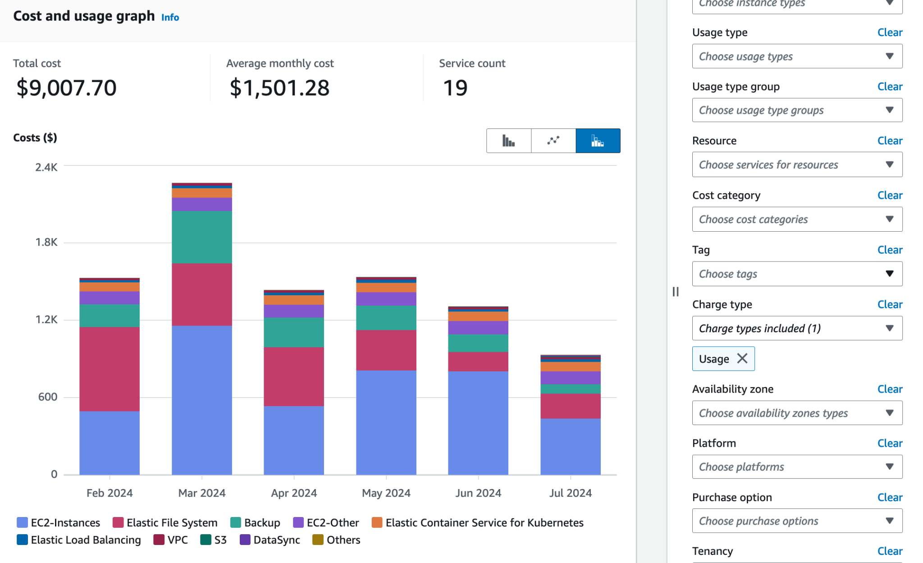

**Aug 24 - Sept 23, 2024**

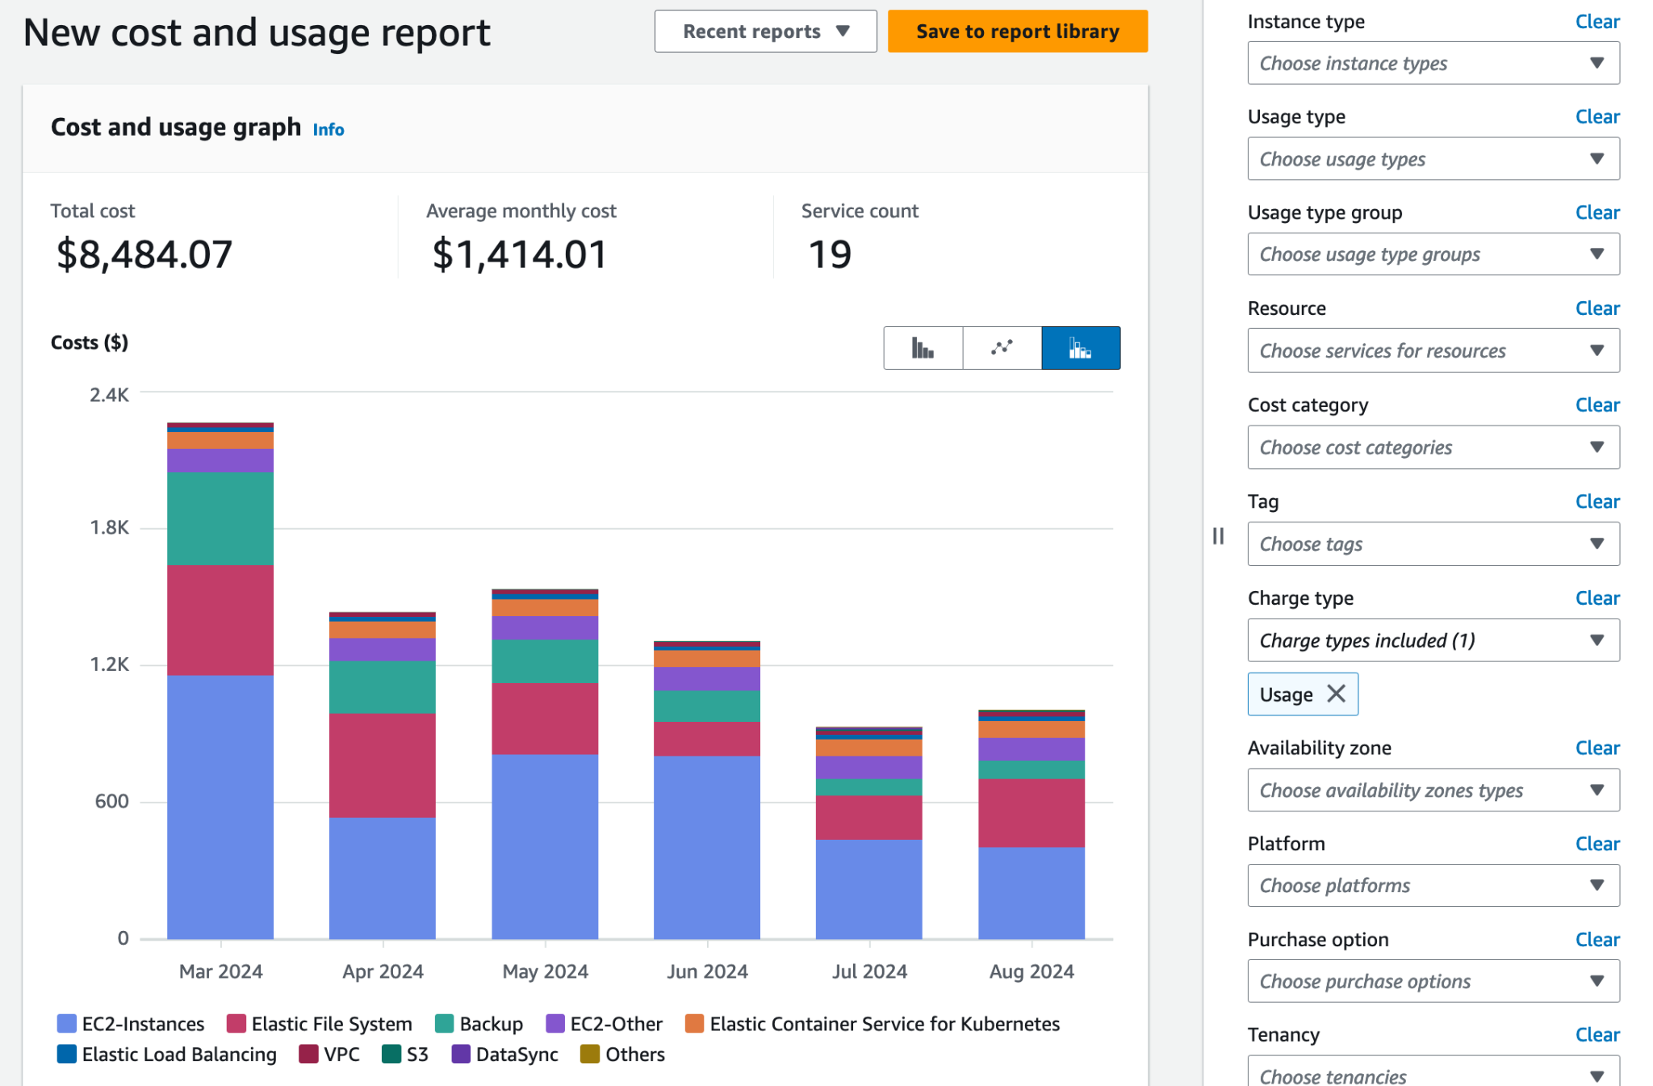

**Sept 24 - Oct 21, 2024**

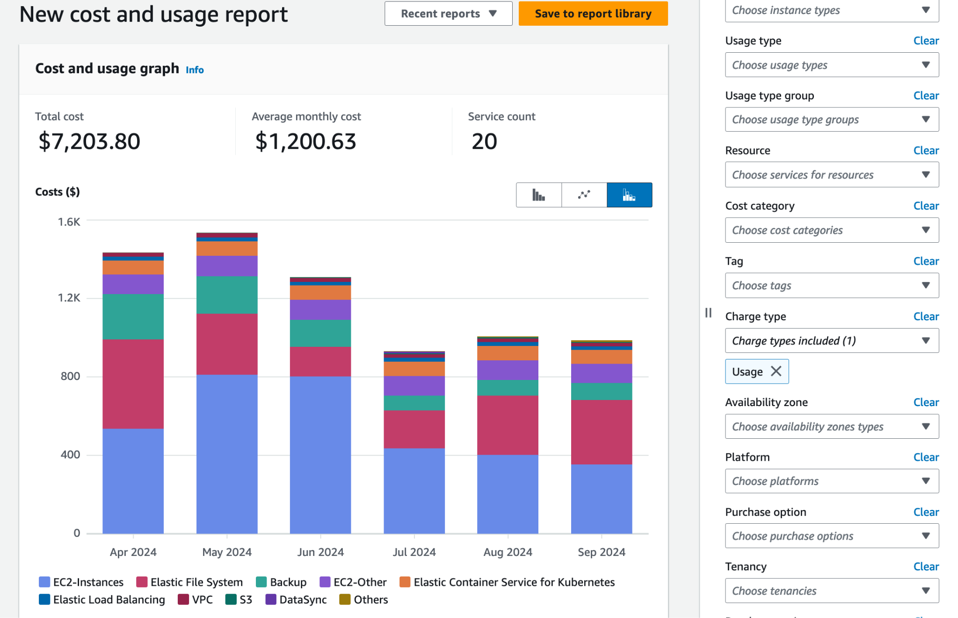

**Oct 22 - Nov 23, 2024**

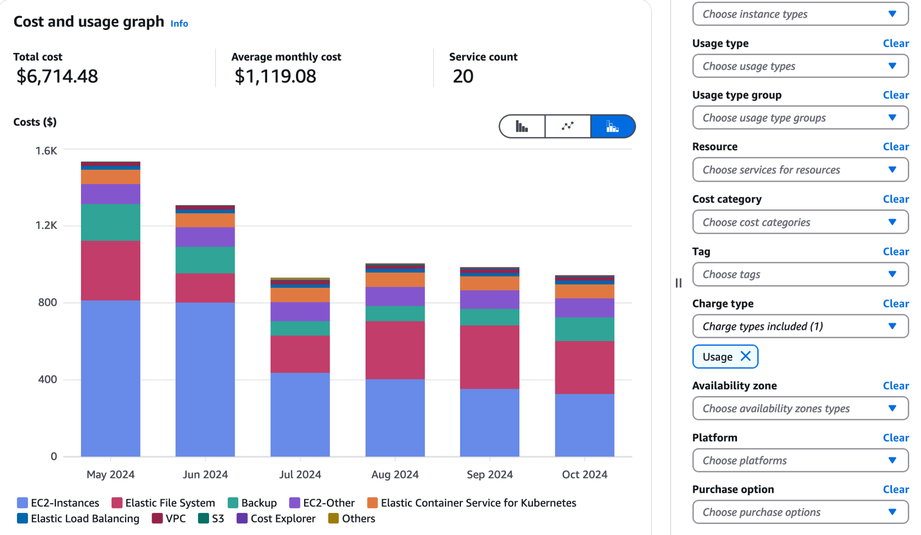

**Nov 23-Dec 16, 2024**

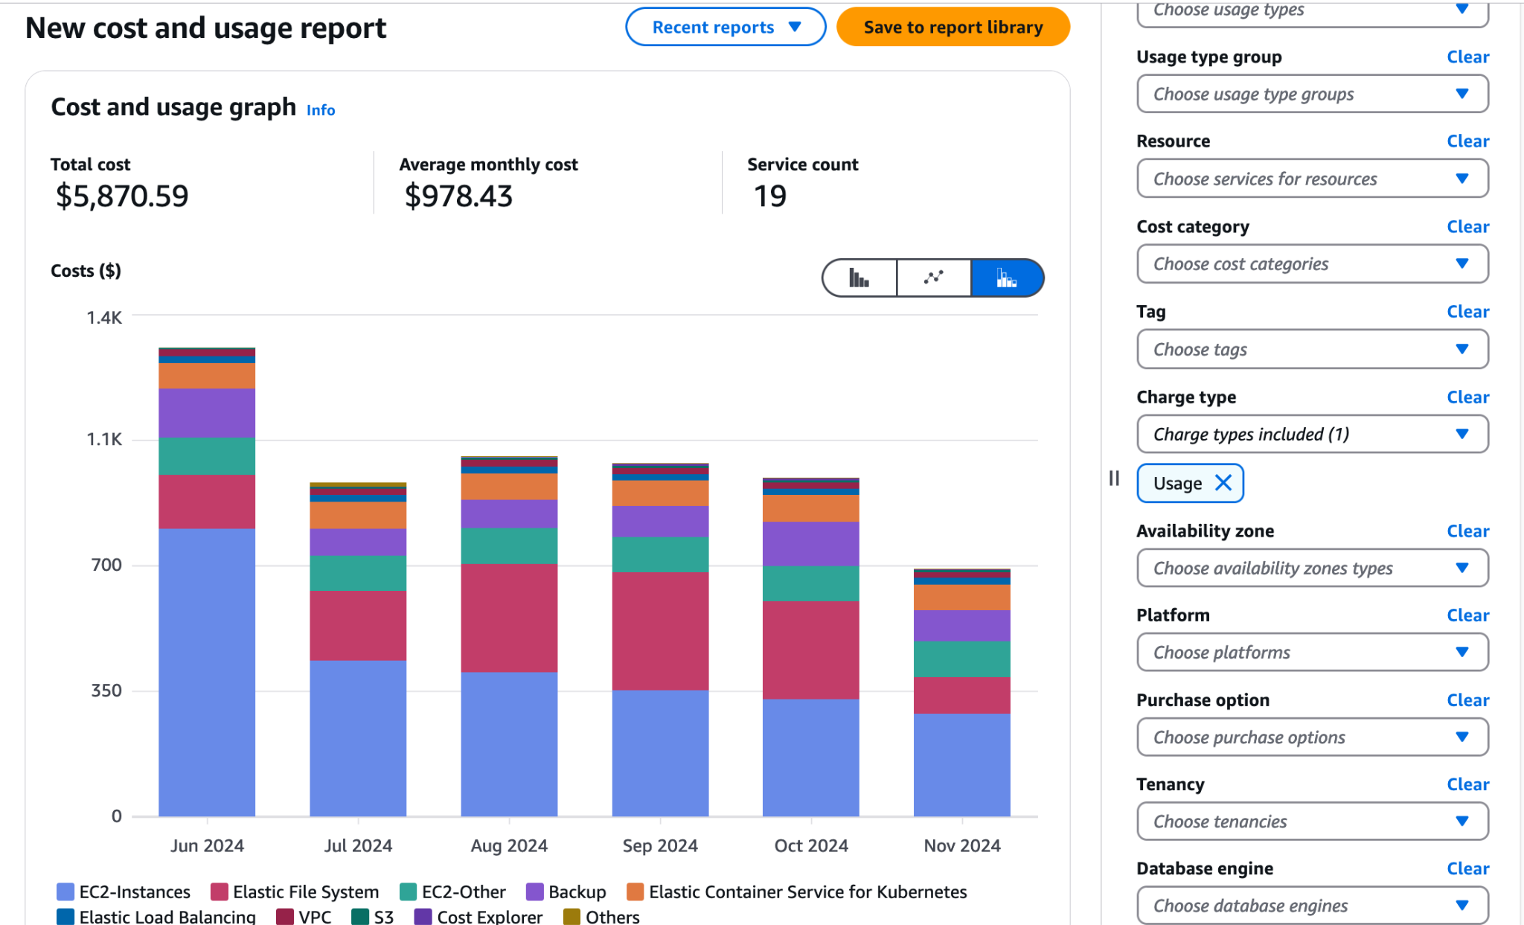

**Dec 17 - Jan 22, 2025**

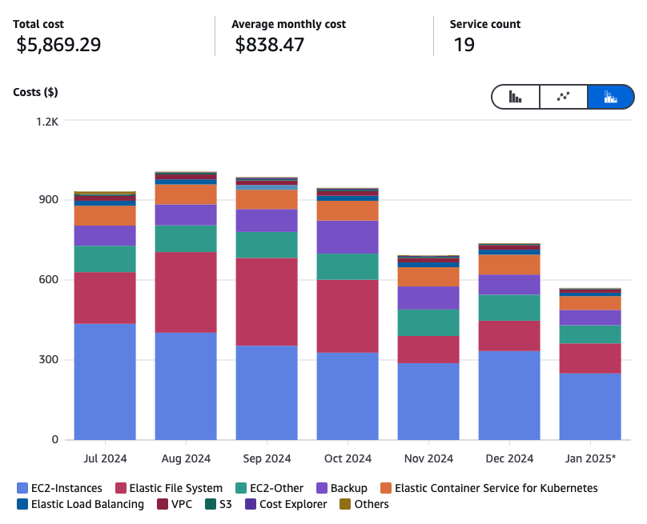

**Jan 23 - Feb 17, 2025**

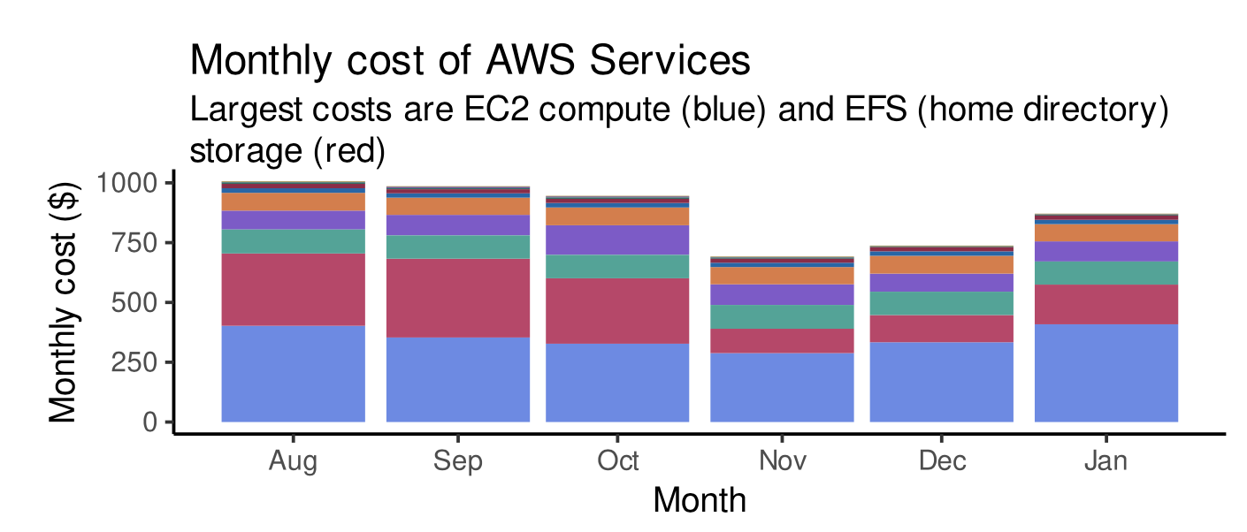

**Feb 17 - Mar 11, 2025**

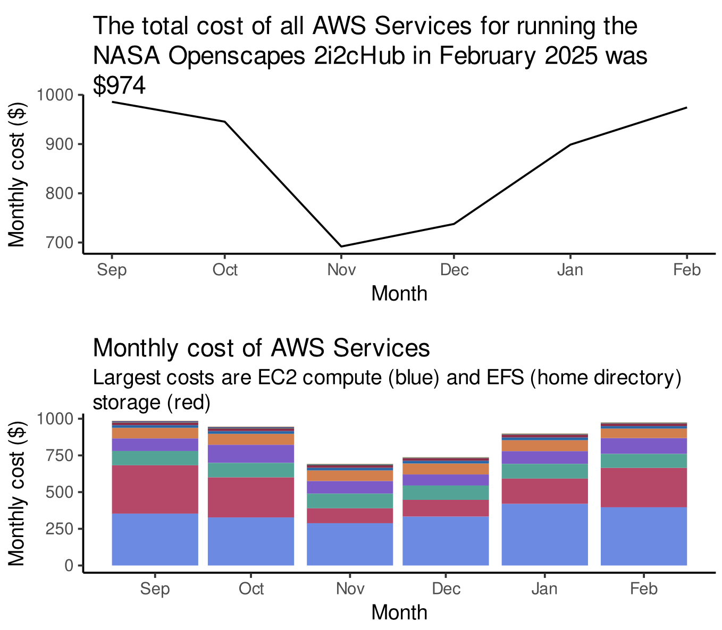

**Mar 12 - Apr 21, 2025**

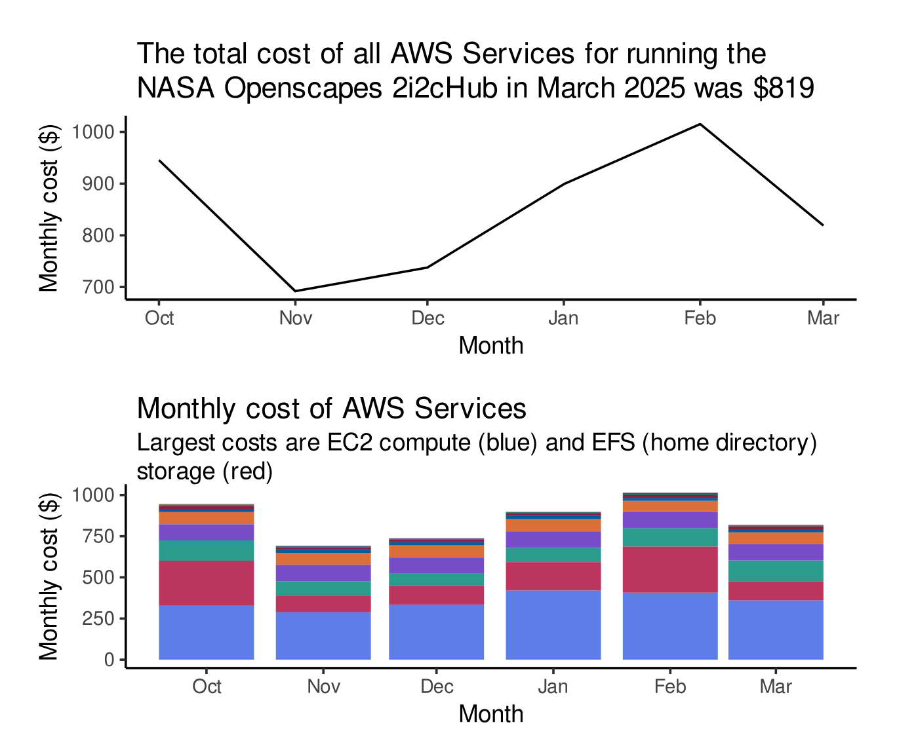

**Apr 22-May 22, 2025**

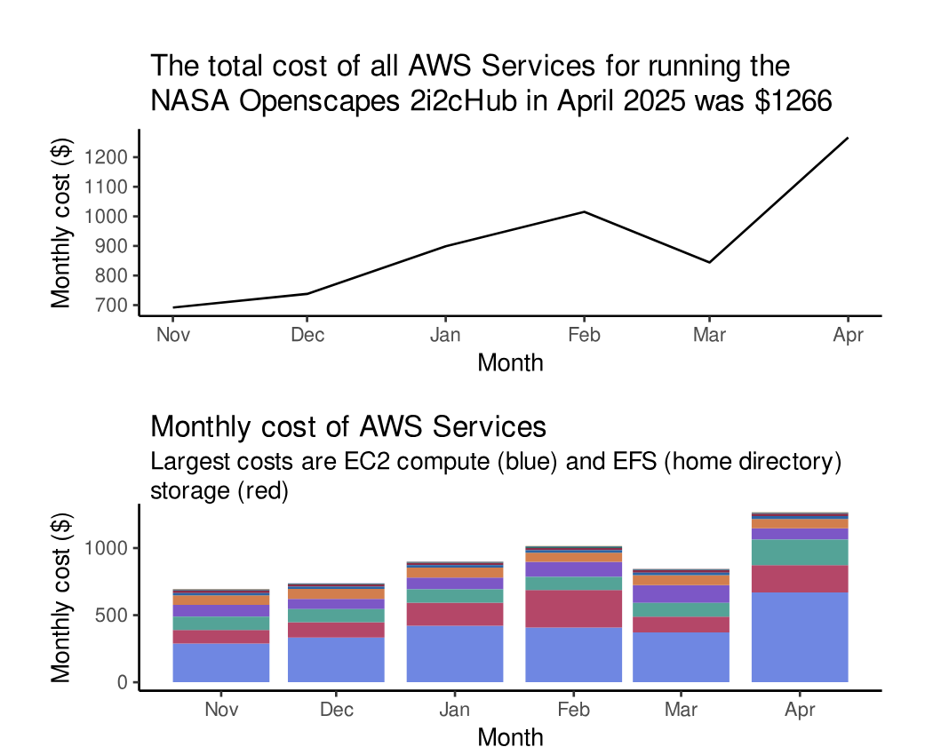

**May 23-June 22**



 