qpid
http://ec2-184-72-145-164.compute-1.amazonaws.com:10001/index.html
node 1
https://ec2-184-72-145-164.compute-1.amazonaws.com/NetworkNode1/test/
partner client1
mysql without decision module
https://ec2-184-72-145-164.compute-1.amazonaws.com:8071/
node2
https://ec2-54-204-204-159.compute-1.amazonaws.com/NetworkNode2/test/
partner client2
redis with decision module
https://ec2-54-204-204-159.compute-1.amazonaws.com:8071/
decision module
http://ec2-54-204-204-159.compute-1.amazonaws.com:10001/
study
http://ec2-184-72-145-164.compute-1.amazonaws.com:8070
admin user
admin/admin
root/root
normal user
test/test

You can create user when login as admin/admin
http://ec2-184-72-145-164.compute-1.amazonaws.com:8070/admin/auth/user/

1
open
http://ec2-184-72-145-164.compute-1.amazonaws.com:8070/login/
and login as admin/admin
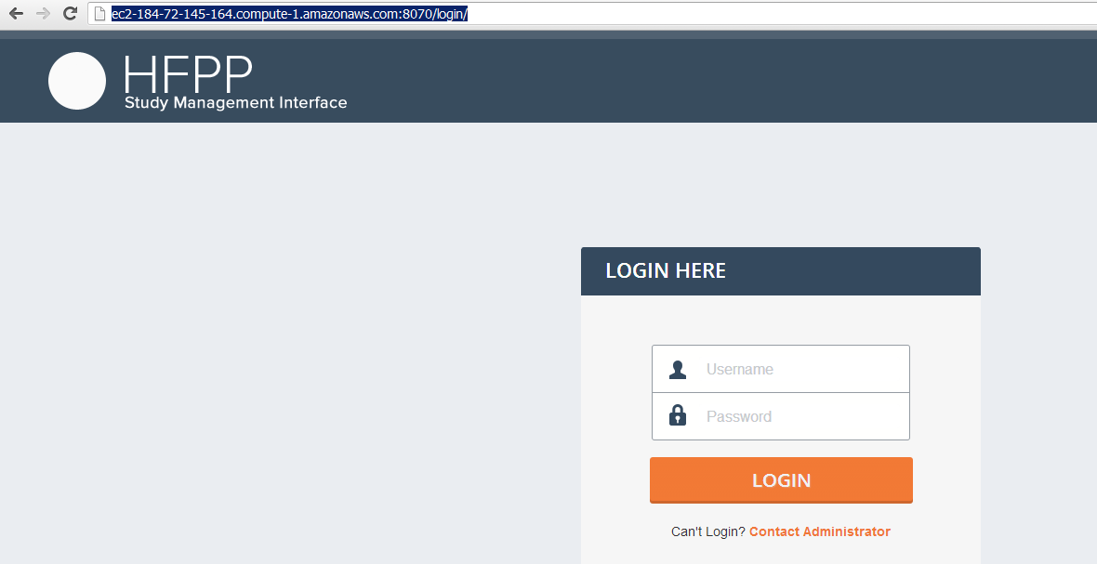
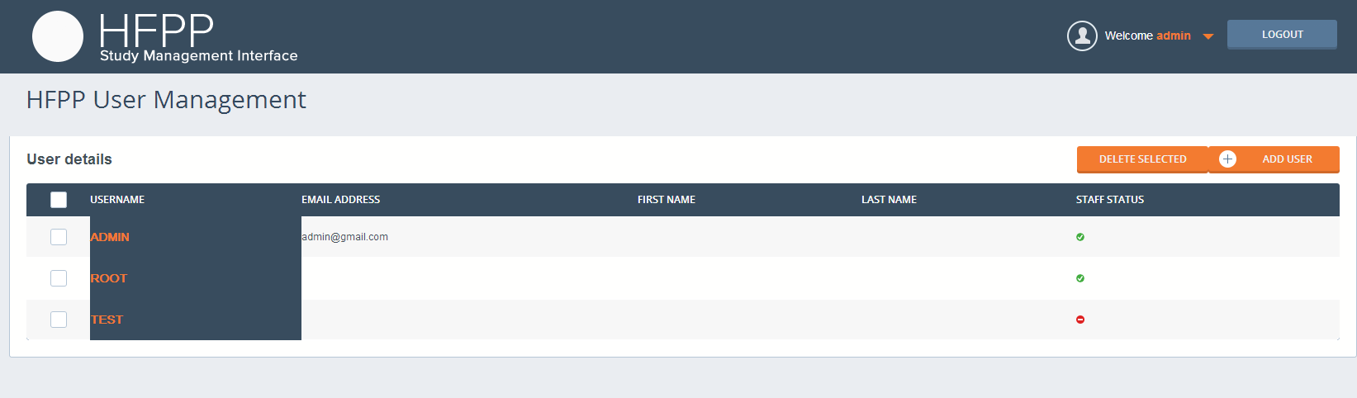

2
open
http://ec2-184-72-145-164.compute-1.amazonaws.com:8070/darc_emails
and input your email address
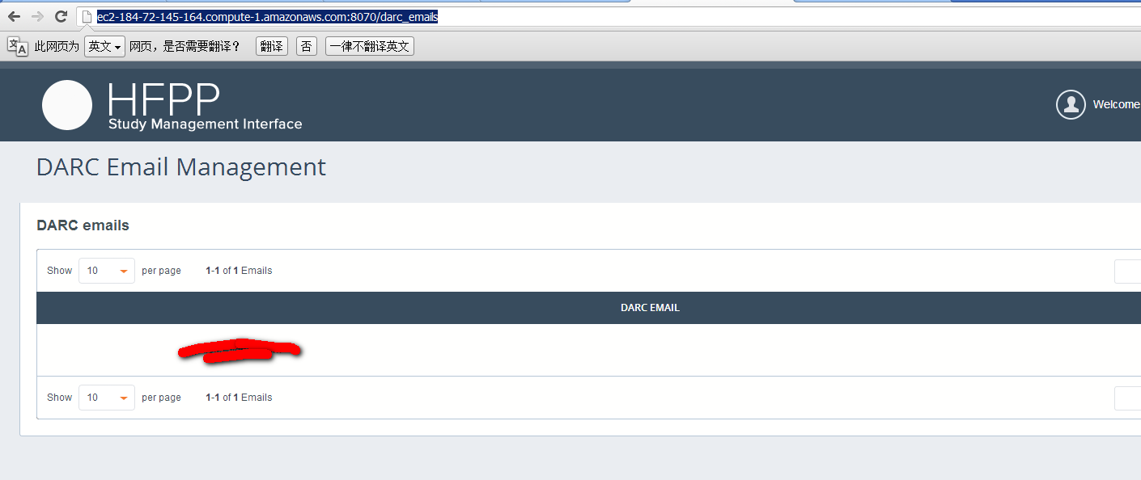
3
open
http://ec2-184-72-145-164.compute-1.amazonaws.com:8070/studies/create
create all date field with less than date in 2013
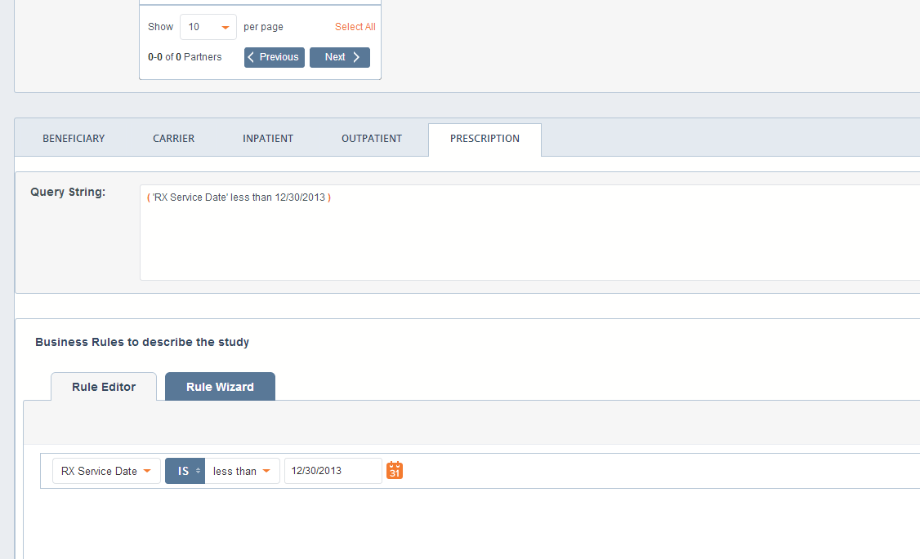
4
you can see study in progress tab and is 50%
test query
beneficiary: ( 'Date of Birth' less than 12/29/2013 ) carrier: ( 'Claim start date' less than 12/30/2013 ) inpatient: ( 'Claims start date' less than 12/30/2013 ) outpatient: ( 'Claims start date' less than 12/29/2013 ) prescription: ( 'RX Service Date' less than 12/30/2013 )
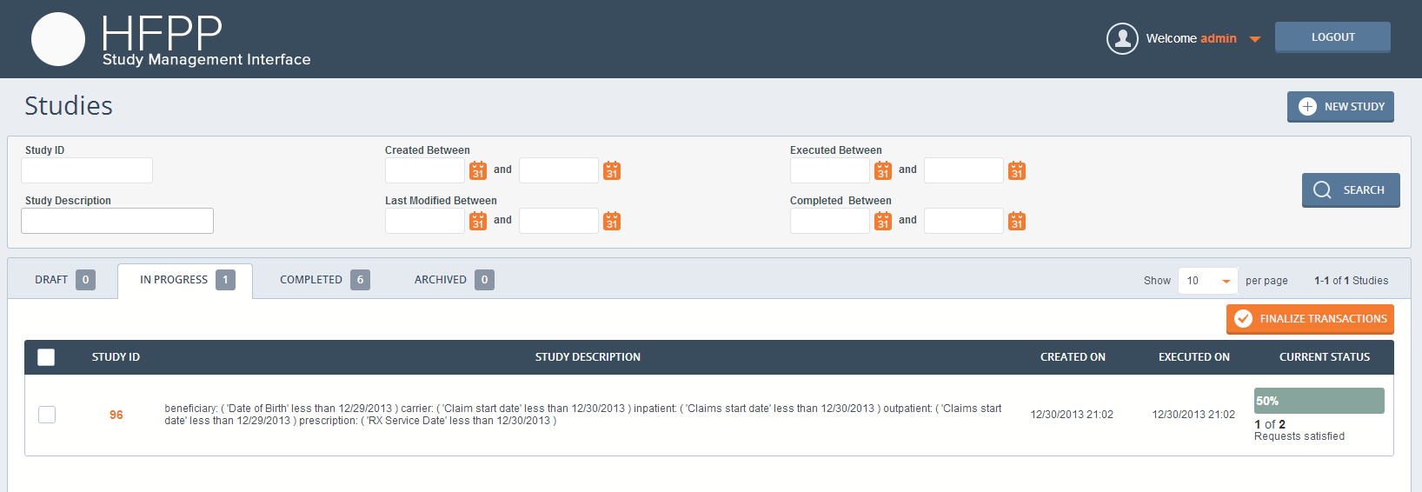
5
open
http://ec2-54-204-204-159.compute-1.amazonaws.com:10001/
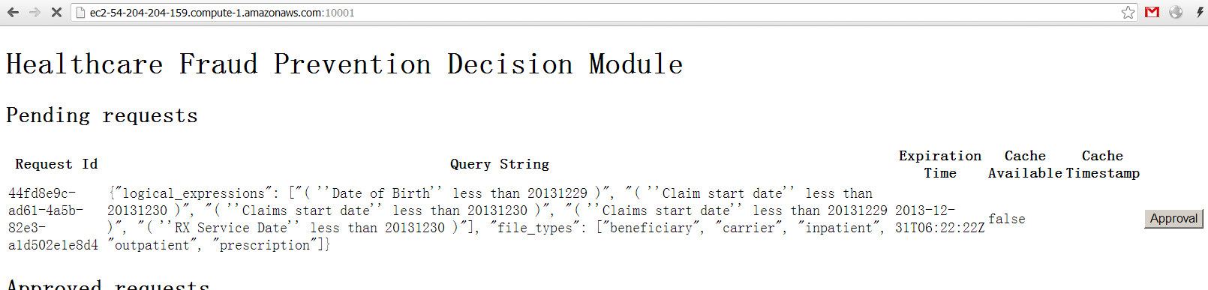
6
open
http://ec2-184-72-145-164.compute-1.amazonaws.com:8070/studies
and click IN PROGESS tab
you can find it change to 100%
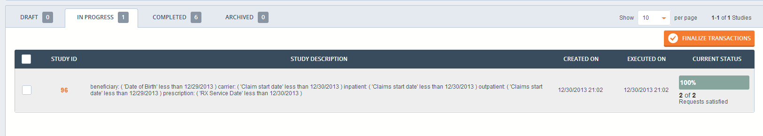
7
Then check and click FINALIZE you can find it in COMPLETED tab
IN PROGRESS tab
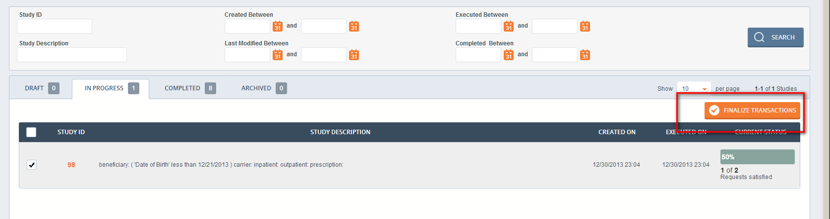

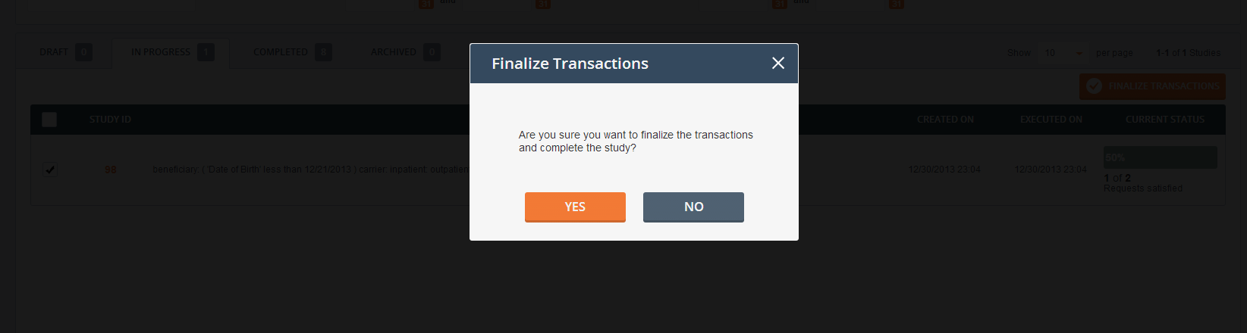
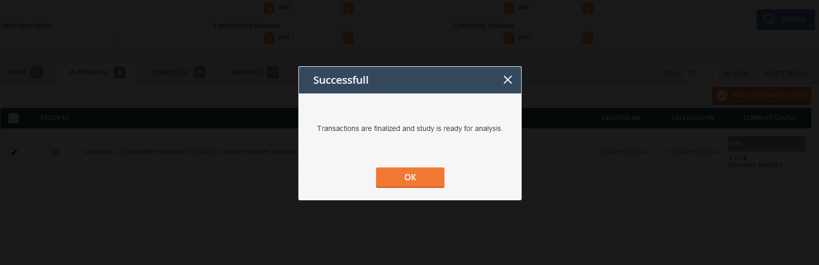
Now in COMPLETED tab
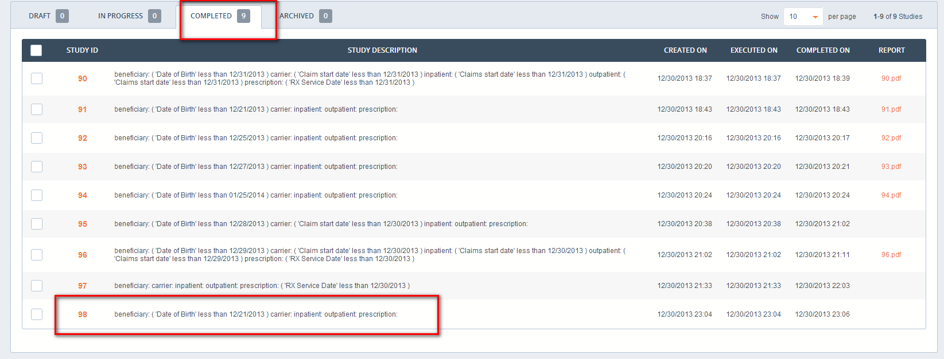
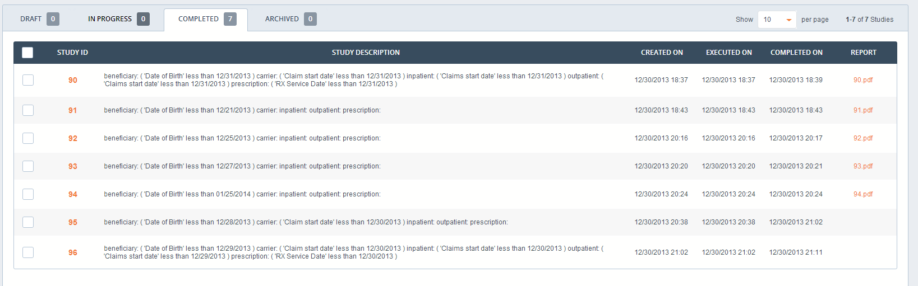
8
open
http://ec2-184-72-145-164.compute-1.amazonaws.com:8070/studies/96/results
you can find results
because it is from two partners you can find 8 or 6 records normally one partner exist 4 or 3 records
BENEFICIARY
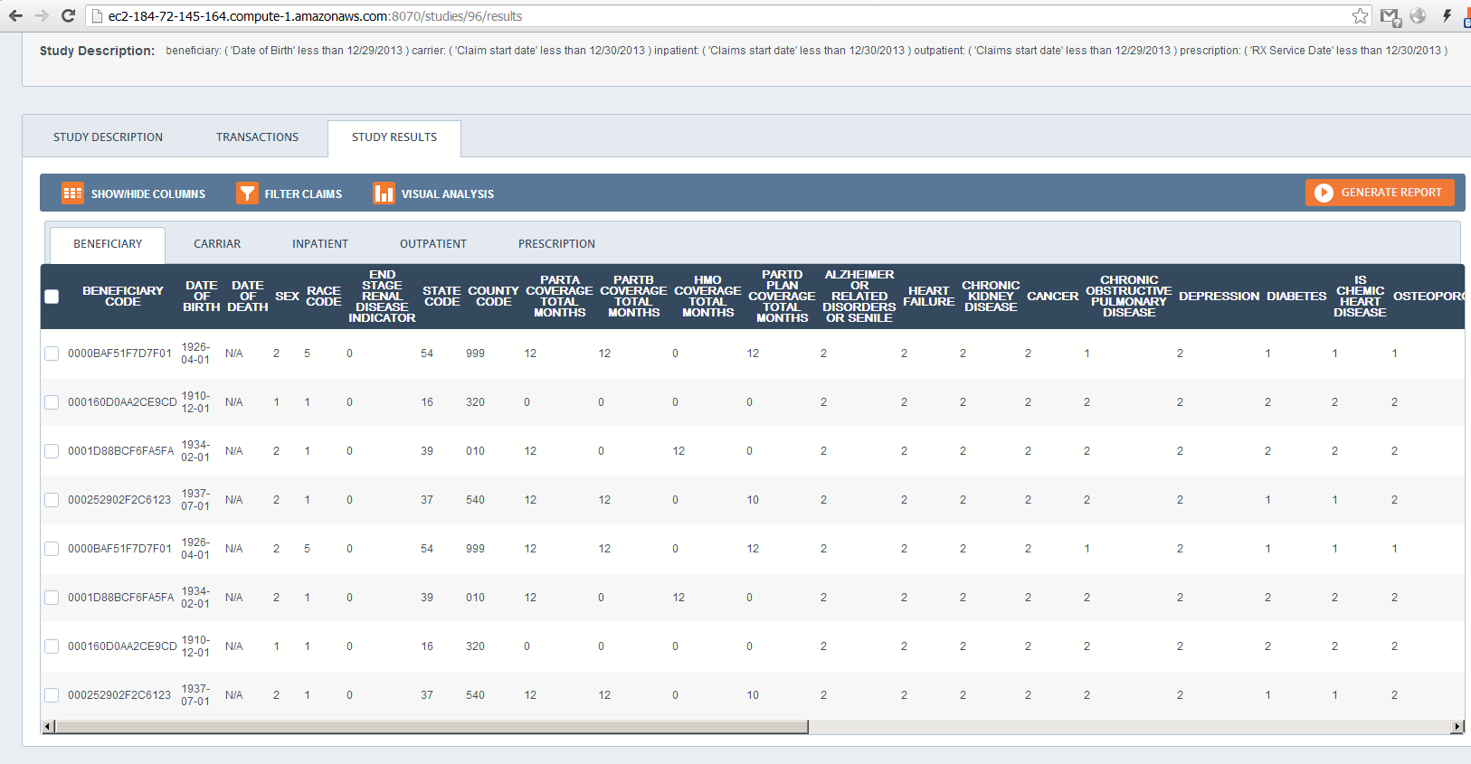
CARRIER
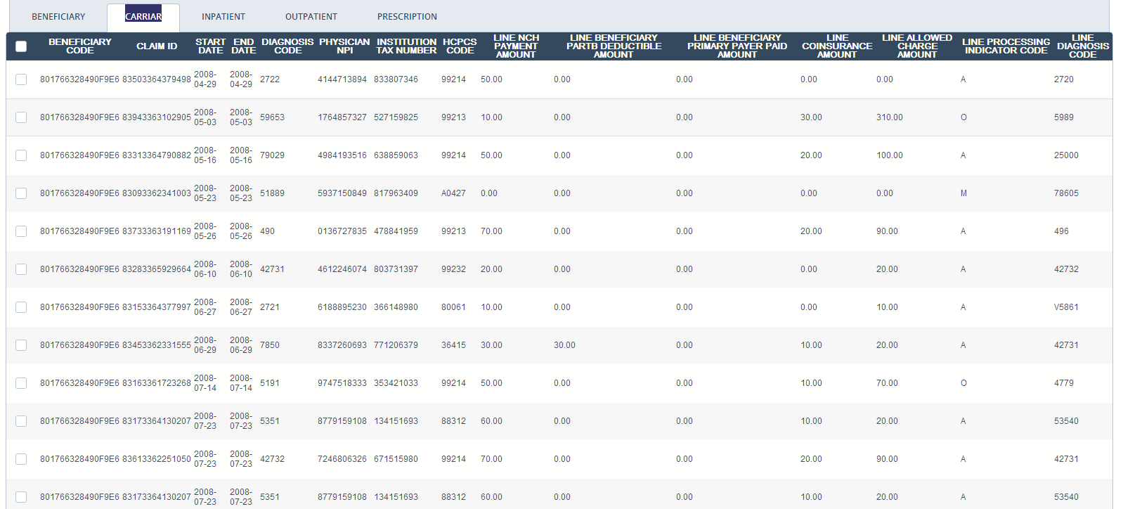
INPATIENT
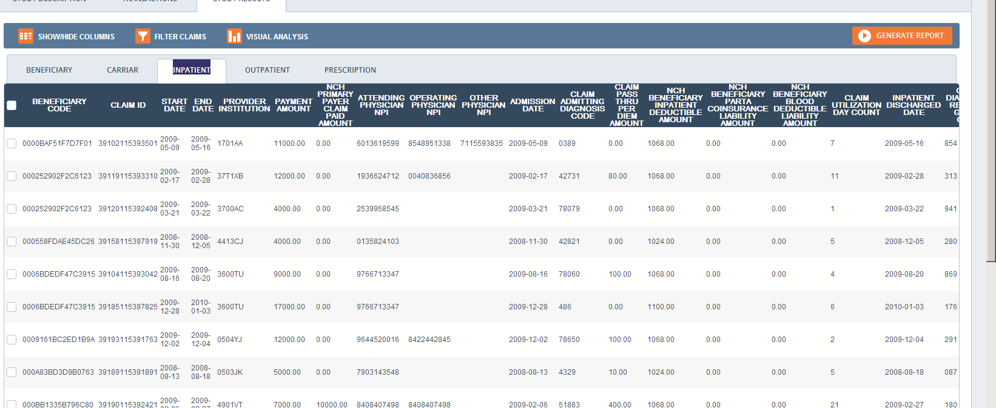
OUTPATIENT
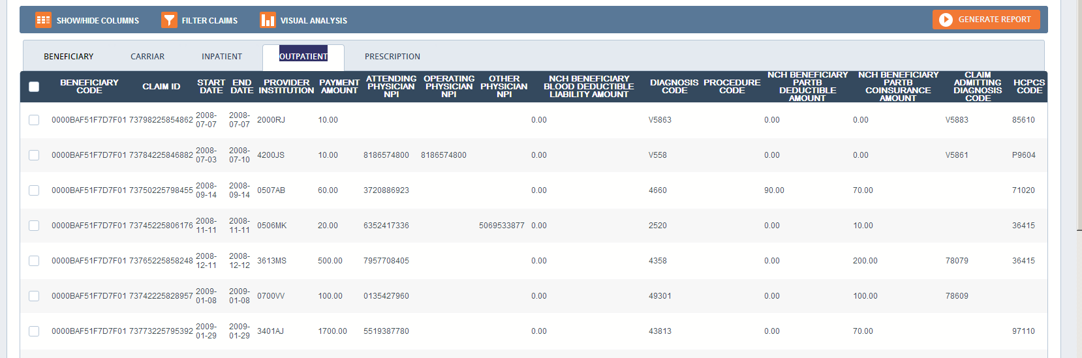
PRESCRIPTION
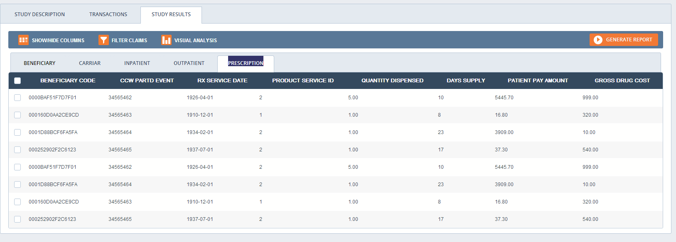
9
Check records and then click Generate report
and check Send Report to DARC
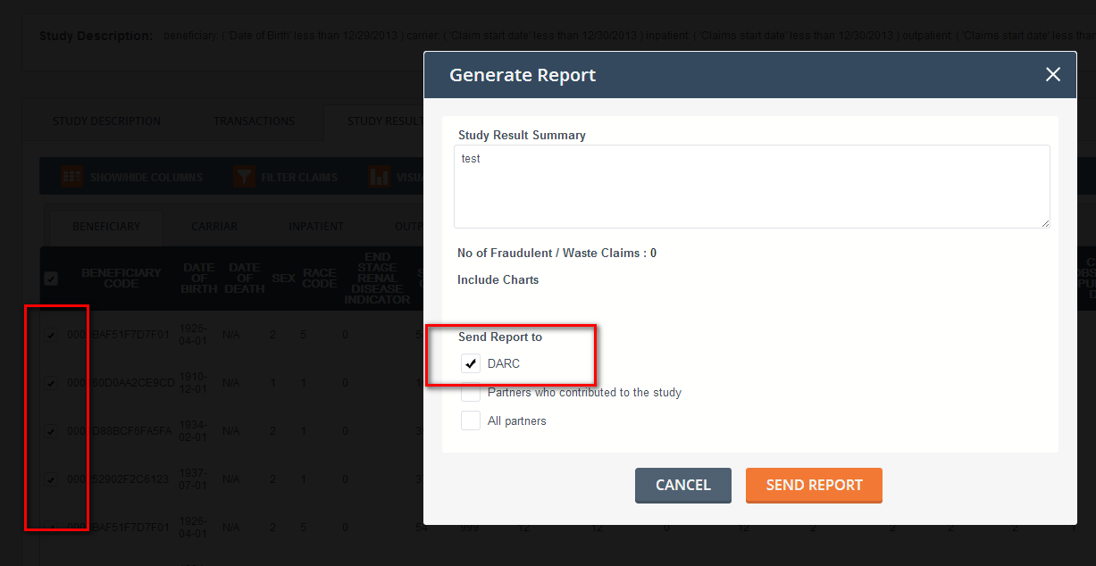
10
after that you can download pdf
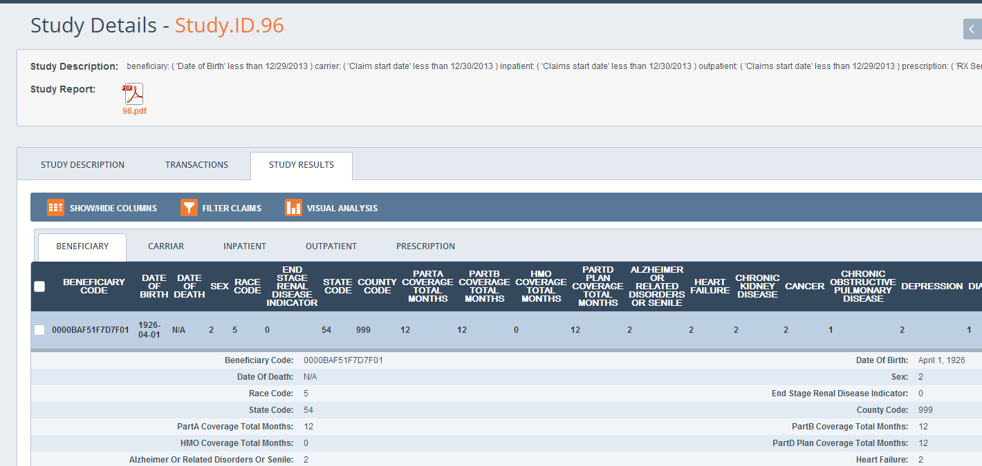
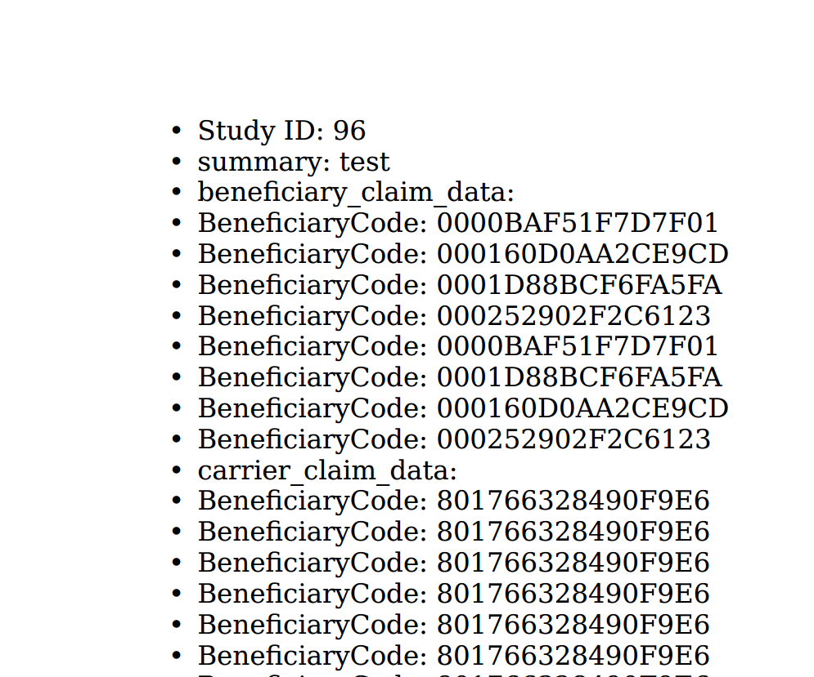
Check your email box
You can find email with query and report as attachment
